Downscaling Urban Built-Up Surface from 1 km to 10 m Using EO Embeddings and Binary Settlement Priors
Evgeny Noiª*, Laurence Hawkerª, Andrew Tatem^{b}
ª School of Geographical Sciences, University of Bristol, Bristol, UK;
^{b} School of Geography and Environmental Science, University of Southampton, Southampton, UK;
*Corresponding author (evgeny.noi@bristol.ac.uk)
Fine-resolution built-up maps are essential for urban analysis, exposure assessment, and spatial planning, yet many widely used built-up products remain available only at coarse resolution. Building on work in remote-sensing downscaling, dasymetric redistribution, and super-resolution mapping, we ask two questions: (1) do Earth observation (EO) embeddings contain sufficient sub-kilometer information to reconstruct fine-scale urban built-up structure, and (2) does adding a binary settlement prior improve that reconstruction? We address these questions in a prototype experiment for Accra, Ghana, by downscaling 2019 built-up surface from 1 km to 10 m (Atkinson, 2013).
Our framework combines a coarse mass-preserving constraint with fine-scale EO information. We use annual 10 m Google Satellite Embedding V1 features (Brown et al., 2025), reduced from 64 to 8 dimensions using PCA, together with the 10 m World Settlement Footprint (WSF) 2019 binary settlement (Marconcini et al., 2021) mask and GHSL built-up surface (Schiavina et al., 2023) products as coarse and fine reference layers. The learned models are lightweight fully convolutional networks with positive outputs. Training is driven by a coarse aggregation loss that matches the sum of 10 m predictions to the GHSL total within each 1 km cell, augmented by total-variation regularization and, in the guided model, a penalty on allocations outside WSF support. Final predictions are renormalized within each coarse cell to preserve the adjusted GHSL built-up total exactly.
We compare three increasingly informative strategies: a support-only redistribution over settlement pixels, an embeddings-only convolutional downscaler, and a guided model that combines embeddings with WSF-derived predictors and the outside-WSF penalty. The comparison reveals a clear division of strengths. The support-only approach sharply reproduces settlement morphology but acts largely as a literal redistribution of the binary mask. The embeddings-only model recovers broader intra-urban gradients and coherent large-scale spatial structure, demonstrating that EO embeddings alone contain meaningful fine-scale urban signal. The guided model combines these advantages: before renormalization it achieves a coarse-cell mean absolute error of about 5.4% and RMSE of about 6.8% relative to the mean adjusted 1 km built-up total, and after renormalization allocates 93.5% of predicted built-up mass within WSF support. Comparison against a 10 m GHSL reference shows that the guided model recovers substantially sharper urban form than the embeddings-only baseline while preserving city-scale intensity patterns better than the support-only benchmark.
These results show that EO embeddings and binary settlement priors are complementary for fine-scale urban downscaling and provide a practical route toward higher-resolution built-up mapping where continuous fine-scale labels are limited.
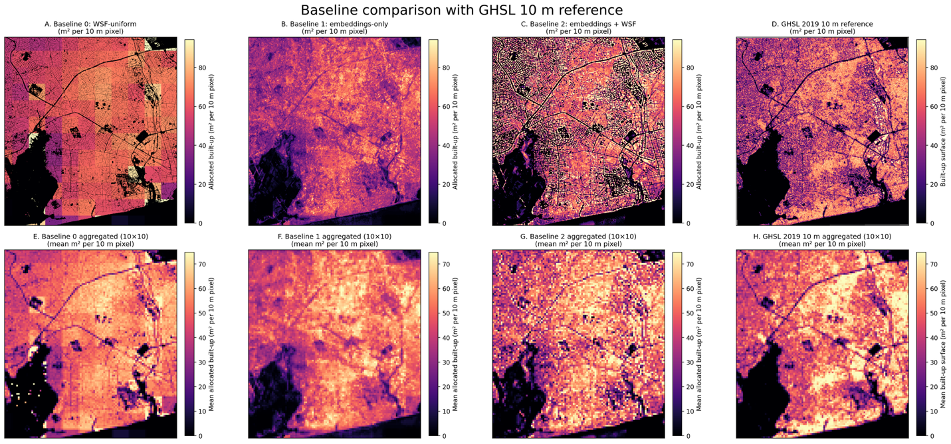
Figure 1: Comparison of three urban built-up downscaling baselines against a 10 m GHSL reference in Accra.

References
Atkinson, P. M. (2013). Downscaling in remote sensing. International Journal of Applied Earth Observation and Geoinformation, 22, 106-114.
Brown, C. F., Kazmierski, M. R., Pasquarella, V. J., Rucklidge, W. J., Samsikova, M., Zhang, C., ... & Kohli, P. (2025). Alphaearth foundations: An embedding field model for accurate and efficient global mapping from sparse label data. arXiv preprint arXiv:2507.22291.
Marconcini, M., Metz-Marconcini, A., Üreyen, S., Palacios-Lopez, D., Benz, S., Bachofer, F., & Esch, T. (2021). World Settlement Footprint (WSF) 2019 [Data set]. German Aerospace Center (DLR). https://geoservice.dlr.de/web/datasets/wsf_2019
Schiavina, M., Melchiorri, M., Pesaresi, M., Politis, P., Freire, S., Maffenini, L., Florio, P., Ehrlich, D., Goch, K., Tommasi, P., & Kemper, T. (2023). GHSL Data Package 2023 (JRC133256). Publications Office of the European Union. https://publications.jrc.ec.europa.eu/repository/handle/JRC133256

