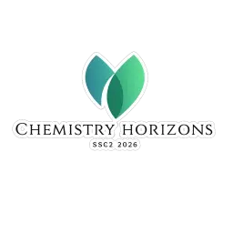
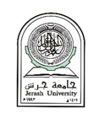
CERTIFICATE OF ATTENDANCE
This is to certify that
[Participant Name]

has successfully attended the
the Second Scientific Conference of the Faculty of Science
Chemistry Horizons

held on April 28-29, 2026, at Jerash University.
We sincerely appreciate their participation and contribution to the success of this conference.

Prof. Dr. Mohammad Brake
Dean of College of Science Conference Chair
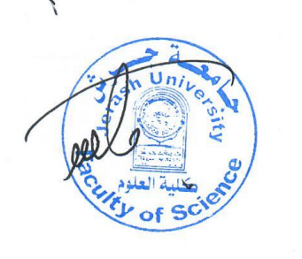
Jerash University

