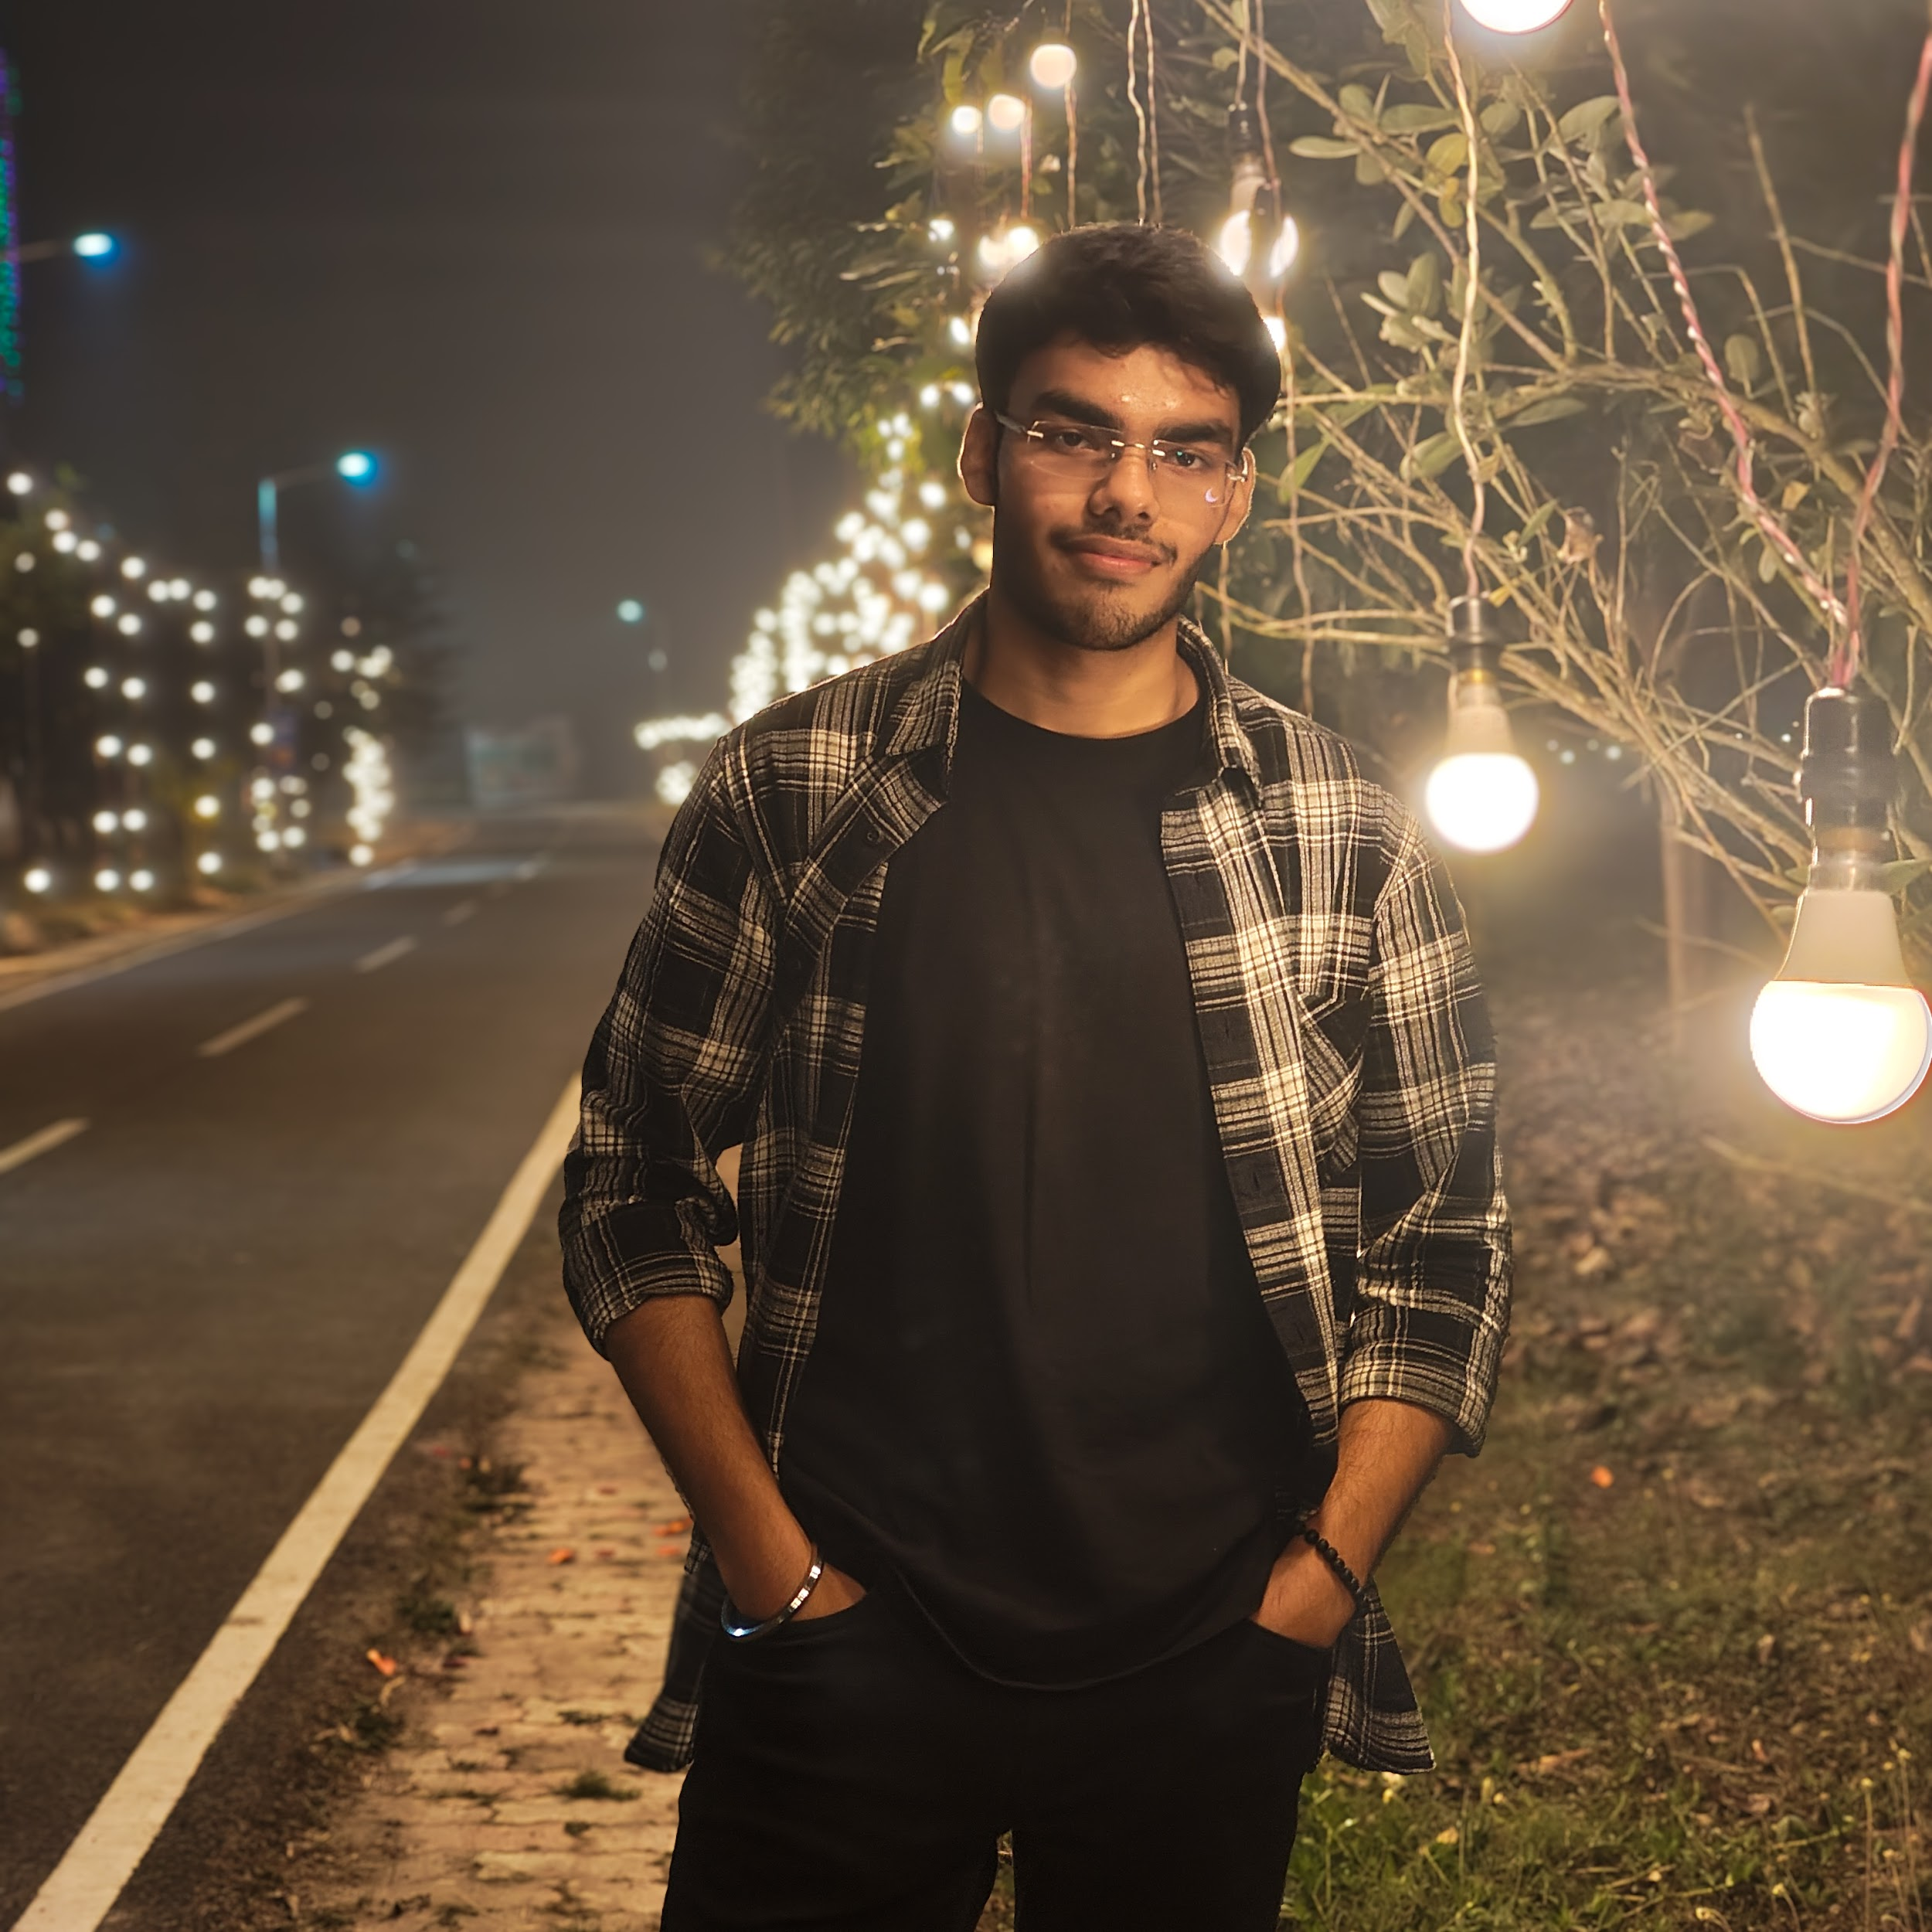Name: Aditya Bramhbhatt

Position(s):

• Wing Representative, 2nd Floor, F Block

Profile:
I am Aditya Bramhbhatt (23MS270), a fourth year BS-MS student in the Department of Biological Sciences at IISER Kolkata. I currently serve as the Wing Representative of the 2nd Floor, F Block. Through this role, I work to facilitate effective communication between students and the administration, address concerns raised by residents, and contribute to maintaining a supportive and inclusive hostel environment.

Contact Information:
Email: ab23ms270@iiserkol.ac.in
Phone: 8602214341

