(i) Full Name: Sneha Chakrabarti
(ii) Designation: Wing Representative
(iii)Short Bio/Introduction: BSMS (4th year in Academic Year 2026-27), Physics Major.
(iv) Email Address: sc23ms114@iiserkol.ac.in
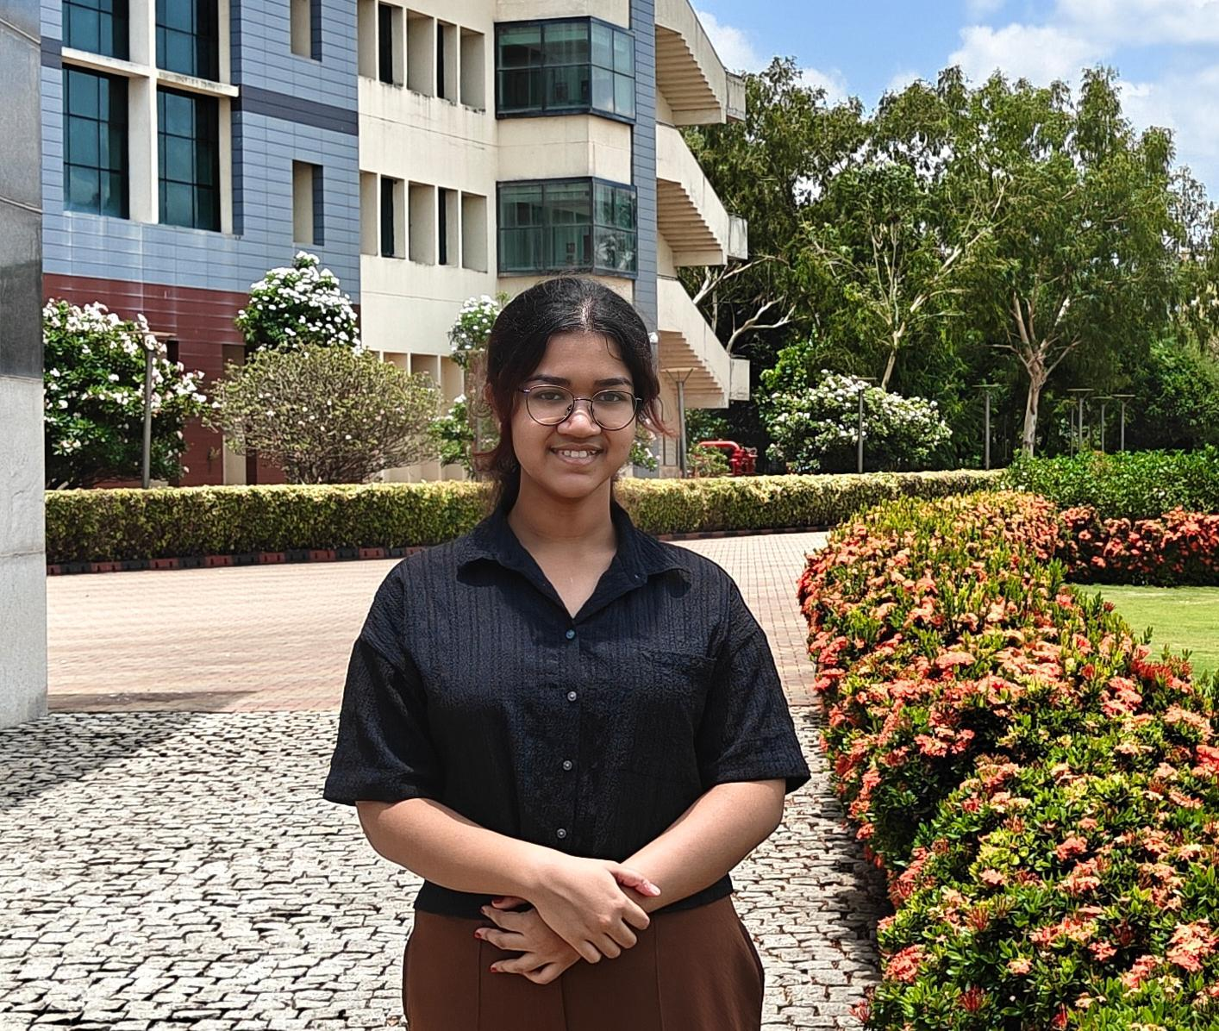
(v) Photo:

