CIA 3 — Software Application Development using OOP & Database

FITPRO
GYM MANAGEMENT SYSTEM
A Comprehensive Desktop Application

Developed with Java 17 • JavaFX • MySQL • JDBC • DAO Pattern
Submitted By  Megh Bari, Kuunal Mistry, Manvith Rai  App ID: 2410232, 2410130, 2410286 | Subject  Software Application Development  using OOP & Database
Tech Stack  Java 17 | JavaFX | MySQL 8.0 | JDBC | DAO | Academic Year  2024 – 2025

Confidential Academic Project • Not for redistribution

Index

No. | Chapter / Section | Page
1 | Introduction | 3
2 | Problem Statement | 4
3 | Objectives | 5
4 | System Design & Architecture | 6
5 | Features of Application | 8
6 | OOP Concepts Used | 10
7 | Database Design | 14
8 | Project File Structure | 17
9 | Tools & Technologies Used | 18
10 | Exception Handling & Validation | 19
11 | Security & Role-Based Access | 20
12 | Conclusion | 21
13 | References | 22

1. Introduction
The FitPro Gym Management System is a comprehensive, full-featured desktop application developed using Java 17, JavaFX, MySQL 8.0, JDBC, and the DAO (Data Access Object) design pattern. It is designed to automate and streamline all core gym operations — from member registration and trainer management to workout assignment and session scheduling — within a centralized, structured platform.

Modern fitness centers handle dozens of daily operations manually: maintaining member records in spreadsheets, tracking trainer assignments, scheduling sessions by hand, and managing membership expiry dates. This approach introduces data redundancy, human error, difficulty in searching records, and an overall inefficiency that scales poorly as the gym grows. FitPro addresses all of these challenges.

The application is architected around Object-Oriented Programming principles, ensuring the codebase is modular, scalable, and maintainable. A clean layered architecture separates the Presentation Layer (JavaFX FXML), Controller Layer, Business/Model Layer, DAO Layer, and Database Layer. Each layer has a single responsibility and communicates through well-defined interfaces.

Why FitPro?
FitPro was built to demonstrate that academic OOP concepts — encapsulation, inheritance, abstraction, polymorphism, constructors, and collections — have direct, practical applications in production-grade software. Every feature of this system maps directly to a concrete OOP principle used in the codebase.

The system supports three distinct user roles — Admin, Trainer, and Member — each with role-specific views and permissions enforced at login. A dark-themed modern JavaFX UI provides an intuitive, professional experience, while the MySQL backend ensures all data is persistent and integrity-constrained via primary and foreign keys.

2. Problem Statement
In traditional gym management, most operations are handled manually or through unstructured tools. This creates a wide range of operational and data-quality problems that grow more severe as membership scales.

2.1 Current Challenges in Gym Operations
Challenge | Impact | Severity
Manual record-keeping in paper registers | Data loss, illegibility, no backup | High
Excel spreadsheets for member tracking | No relational linking, version conflicts | High
No automated membership expiry tracking | Members use gym past expiry undetected | High
Trainer assignments done verbally | No audit trail, double-booking conflicts | Medium
Workout plans not formally recorded | Cannot track member progress over time | Medium
No role-based access | Staff access all data; privacy risk | High
No search or filter capability | Finding records takes minutes per query | Medium
No input validation | Invalid data (wrong age, bad email) stored | Medium

2.2 Proposed Solution
The FitPro Gym Management System addresses each of the above challenges through:
- A centralized MySQL relational database with proper normalization and foreign key constraints to eliminate data redundancy and ensure integrity.
- A JavaFX desktop application providing real-time CRUD operations on all entities — members, trainers, workouts, and schedules.
- Role-based login (Admin / Trainer / Member) restricting access to only relevant modules.
- Input validation at the controller layer preventing invalid data from ever reaching the database.
- A schedule management module that formally records every trainer-member session with date, time, type, and status.
- Search and filter functionality allowing instant record lookup by name, email, or phone.

3. Objectives
The primary objectives of this project are listed below, each mapped to a concrete implementation decision:

Objective | Implementation
Full CRUD operations on all entities | MemberDAO, TrainerDAO, WorkoutDAO, ScheduleDAO each implement add, getAll, update, delete
Apply OOP principles throughout | Abstract User class, Member/Trainer inheritance, abstract getRole(), method overriding
MySQL database integration via JDBC | DatabaseConnection singleton using isValid() ping, PreparedStatement for all queries
Modern JavaFX UI (not Swing) | FXML-based views with dark CSS theme, TableView, ComboBox, DatePicker, ScrollPane
Layered / DAO architecture | 5-layer architecture: UI → Controller → Model → DAO → DB
Role-based access control | SessionManager holds authenticated User; Dashboard disables buttons per role
Input validation & exception handling | ValidationUtil class; try-catch in every DAO method and Controller action
Collections usage (ArrayList) | All DAO getAll* methods return ArrayList<T>; UI uses ObservableList wrapper
Data integrity constraints | PRIMARY KEY, FOREIGN KEY with ON DELETE CASCADE on workouts and schedule tables
Parameterized constructors | Every model class (Member, Trainer, Workout, Schedule) has multiple constructors

4. System Design & Architecture

4.1 Layered Architecture
The FitPro system is designed around a 5-layer architecture that enforces strict separation of concerns. No layer communicates directly with a layer more than one level away — all data flows through well-defined interfaces.

PRESENTATION LAYER
JavaFX UI | LoginView | DashboardView | MembersView | TrainersView | WorkoutsView | ScheduleView
CONTROLLER LAYER
LoginController | DashboardController | MembersController | TrainersController | WorkoutsController | ScheduleController
BUSINESS / MODEL LAYER
User (abstract) ← Member | Trainer | Admin | Workout | Schedule
DATA ACCESS LAYER (DAO)
MemberDAO | TrainerDAO | WorkoutDAO | ScheduleDAO | AdminDAO
UTILITY LAYER
DatabaseConnection | SessionManager | ValidationUtil
DATABASE LAYER
MySQL 8.0 | gymdb | members | trainers | workouts | schedule | admins

4.2 Layer Responsibilities
Layer | Classes / Files | Responsibility
Presentation | *.fxml files (LoginView, DashboardView, MembersView, TrainersView, WorkoutsView, ScheduleView) | Defines UI layout, controls, and component IDs via JavaFX FXML
Controller | LoginController, DashboardController, MembersController, TrainersController, WorkoutsController, ScheduleController | Handles user events, validates input, calls DAO methods, updates UI
Model | User (abstract), Member, Trainer, Admin, Workout, Schedule | Represents domain entities; enforces OOP via encapsulation and inheritance
DAO | MemberDAO, TrainerDAO, WorkoutDAO, ScheduleDAO, AdminDAO | Executes all SQL via JDBC PreparedStatement; returns ArrayList<T>
Utility | DatabaseConnection, SessionManager, ValidationUtil | Cross-cutting concerns: DB connection pooling, session state, input rules
Database | MySQL 8.0 (gym_management) | Persistent storage with PK/FK constraints and referential integrity

4.3 Data Flow — Add Member Example
The following illustrates how a complete user action flows through all five layers:

Step-by-step: User clicks 'Add Member'
1. User fills form fields and clicks 'Add Member' button in MembersView.fxml 2. MembersController.handleAdd() fires (onAction="#handleAdd") 3. Controller calls ValidationUtil.isValidEmail(), isValidPhone(), etc. 4. If valid: constructs new Member object via parameterized constructor 5. Calls MemberDAO.addMember(member) 6. DAO builds SQL INSERT, calls DatabaseConnection.getConnection() 7. Executes PreparedStatement, returns boolean success 8. Controller shows success/error label, calls loadAll() to refresh TableView

5. Features of Application

5.1 Feature Overview
Module | Operations | Role Access
Login System | Authenticate by email + password + role | Admin, Trainer, Member
Dashboard | View live stats: total members, trainers, workouts, sessions | All roles
Member Management | Add, View (table), Update, Delete, Search (name/email/phone) | Admin only
Trainer Management | Add, View, Update, Delete, Search (name/specialization) | Admin only
Workout Management | Assign plan to member, mark complete, delete, view all | Admin, Trainer
Schedule Management | Book session (member+trainer+date+time), mark complete, cancel, delete | Admin, Trainer

5.2 Member Management Detail
Member Management provides complete lifecycle control over gym members. All operations are performed in real-time with the MySQL database.

- Add Member: Collects full name, email (validated), phone (10-digit validated), password, age, gender, membership plan (Basic/Standard/Premium), expiry date, address, and status.
- View Members: All records displayed in a JavaFX TableView with colour-coded Status column (Active = green, Expired = red, Inactive = yellow).
- Search: Real-time search across name, email, and phone fields simultaneously using SQL LIKE query.
- Update: Click any table row to populate the form panel; modify fields and click Update.
- Delete: Confirmation dialog prevents accidental deletion; cascades to linked workouts and schedules.

5.3 Schedule System
The Schedule module allows Admin and Trainer to formally book training sessions. Each session record captures:
Field | Type | Values
Member | FK → members.id | Loaded from DB into ComboBox
Trainer | FK → trainers.id | Loaded from DB into ComboBox
Session Date | DATE | JavaFX DatePicker
Session Time | VARCHAR | 16 time slots from 06:00 AM to 09:00 PM
Session Type | VARCHAR | Weight Training, Cardio, Yoga, HIIT, CrossFit, Boxing, etc.
Duration | INT (minutes) | Free-entry validated as positive integer
Notes | TEXT | Free text
Status | VARCHAR | Scheduled → Completed / Cancelled

6. OOP Concepts Used
The FitPro Gym Management System is built entirely around Object-Oriented Programming principles. Every feature and design decision maps to a specific OOP concept. The table below provides a summary before each concept is explained in full detail.

OOP Concept | Where Applied | Classes Involved
Encapsulation | All model classes use private fields + public getters/setters | User, Member, Trainer, Admin, Workout, Schedule
Inheritance | Member, Trainer, Admin extend abstract User class | User (parent), Member, Trainer, Admin (children)
Abstraction | User is abstract with abstract getRole() and getDisplayInfo() | User (abstract), all subclasses
Polymorphism | getRole() and getDisplayInfo() overridden in each subclass | Member, Trainer, Admin
Constructors | Every model has parameterized constructors for flexible creation | All 6 model classes
Collections | ArrayList used in all DAO getAll* methods; ObservableList in UI | MemberDAO, TrainerDAO, WorkoutDAO, ScheduleDAO
Method Overriding | toString(), getRole(), getDisplayInfo() overridden | All User subclasses

6.1 Encapsulation
ENCAPSULATION
Encapsulation is the OOP principle of bundling data (fields) and methods that operate on that data within a single class, and restricting direct access to the fields by declaring them private. External code must use controlled getter and setter methods.
Implementation in FitPro GMS:
In FitPro, every model class (Member, Trainer, Workout, Schedule) declares all fields as private. No controller or DAO class can ever directly read or modify a field — they must go through the getter/setter interface. This ensures that business rules can be enforced inside setters (e.g., status validation) and that the internal representation can change without breaking external code.
Code Example:
// Member.java — ENCAPSULATION
public class Member extends User {
private String membershipType; // private — cannot be accessed directly
private LocalDate expiryDate; // private field
private String status; // private field

public String getMembershipType() { return membershipType; } // getter
public void setMembershipType(String t) { this.membershipType = t; } // setter
public String getStatus() { return status; }
public void setStatus(String s) { this.status = s; }
}

6.2 Inheritance
INHERITANCE
Inheritance allows a child class to acquire the properties and methods of a parent class using the 'extends' keyword. This eliminates code duplication and creates an 'is-a' relationship between classes.
Implementation in FitPro GMS:
In FitPro, the abstract class User defines the common properties shared by all user types: id, name, email, phone, and password. The classes Member, Trainer, and Admin all extend User and inherit these fields and their associated getters/setters. Each subclass only needs to define its own specialized fields. This means the authentication logic in LoginController can work with a User reference regardless of whether the actual object is a Member, Trainer, or Admin.
Code Example:
// User.java — PARENT CLASS (abstract)
public abstract class User {
private int id;
private String name, email, phone, password;
// ... constructors, getters, setters
}

// Member.java — CHILD CLASS
public class Member extends User { // inherits id, name, email, phone, password
private String membershipType; // Member-specific field
private LocalDate expiryDate;
}

// Trainer.java — CHILD CLASS
public class Trainer extends User { // same inherited fields
private String specialization; // Trainer-specific field
private double salary;
}

6.3 Abstraction
ABSTRACTION
Abstraction hides internal implementation details and exposes only what is necessary. An abstract class cannot be instantiated directly — it defines a blueprint that all subclasses must follow by implementing abstract methods.
Implementation in FitPro GMS:
The User class in FitPro is declared abstract. It defines two abstract methods: getRole() and getDisplayInfo(). These methods have no implementation in User — they are 'promises' that every subclass must fulfill. This means no code can ever create a 'bare' User object, only a specific Member, Trainer, or Admin. The DashboardController works with a User reference polymorphically, calling user.getDisplayInfo() without needing to know the actual type.
Code Example:
// User.java — ABSTRACTION
public abstract class User {
private int id;
private String name;
// ... common fields

public abstract String getRole(); // ABSTRACT — no body here
public abstract String getDisplayInfo(); // ABSTRACT — must be implemented
}

// Cannot do: new User() → compile error (abstract class)
// Must do: new Member() or new Trainer() or new Admin()

6.4 Polymorphism
POLYMORPHISM
Polymorphism ('many forms') allows the same method call to produce different results depending on the actual object type at runtime. This is achieved through method overriding — child classes provide their own implementation of methods defined in the parent.
Implementation in FitPro GMS:
LoginController.handleLogin() authenticates the user and stores the result as a User reference. The actual object could be a Member, Trainer, or Admin. When DashboardController calls user.getRole() or user.getDisplayInfo(), Java's runtime dispatch automatically calls the correct overridden method for the actual type — no if-else chain needed. This is runtime polymorphism in action.
Code Example:
// Member.java — POLYMORPHISM (method overriding)
@Override public String getRole() { return "Member"; }
@Override public String getDisplayInfo() {
return "Member: " + getName() + " | Plan: " + membershipType;
}

// Trainer.java — DIFFERENT implementation of same method
@Override public String getRole() { return "Trainer"; }
@Override public String getDisplayInfo() {
return "Trainer: " + getName() + " | " + specialization;
}

// LoginController.java — POLYMORPHIC usage
User user = null; // could be Member, Trainer, or Admin
switch (role) {
case "Member": user = memberDAO.authenticate(email, pwd); break;
case "Trainer": user = trainerDAO.authenticate(email, pwd); break;
}
System.out.println(user.getRole()); // prints the actual subclass role

6.5 Constructors
PARAMETERIZED CONSTRUCTORS
Constructors are special methods called when an object is created. Parameterized constructors allow objects to be initialized with specific values in a single statement, rather than calling multiple setters after creation.
Implementation in FitPro GMS:
Every model class in FitPro has multiple constructors: a default (no-arg) constructor used by JDBC result set extraction, a full parameterized constructor, and a simplified constructor for quick creation. Constructor chaining using super() passes common fields up to the User parent class, eliminating redundant initialization code.
Code Example:
// Member.java — MULTIPLE CONSTRUCTORS
public Member() { super(); } // default, used by DAO extract

// Simplified constructor — used when creating new members in UI
public Member(String name, String email, String phone, String password,
String membershipType, LocalDate joinDate, LocalDate expiryDate,
String address, int age, String gender) {
super(0, name, email, phone, password); // constructor chaining
this.membershipType = membershipType;
this.joinDate = joinDate;
this.status = "Active"; // default value set in constructor
}

6.6 Collections
COLLECTIONS (ArrayList)
The Java Collections Framework provides ready-made data structures for storing groups of objects. ArrayList is a dynamic array that grows automatically, supports iteration, and provides O(1) random access.
Implementation in FitPro GMS:
All DAO classes in FitPro return ArrayList<T> from their getAll*() methods. This list is then passed to JavaFX's ObservableList (via FXCollections.observableArrayList()) which automatically notifies the TableView to refresh when data changes. The ArrayList is also used to populate ComboBox items for member and trainer selection in Workouts and Schedule forms.
Code Example:
// MemberDAO.java — ArrayList as return type
public ArrayList<Member> getAllMembers() {
ArrayList<Member> list = new ArrayList<>(); // COLLECTION
ResultSet rs = stmt.executeQuery("SELECT * FROM members");
while (rs.next()) list.add(extract(rs)); // adding to collection
return list;
}

// MembersController.java — ObservableList wraps ArrayList
private ObservableList<Member> memberList = FXCollections.observableArrayList();
memberList.setAll(memberDAO.getAllMembers()); // passes ArrayList to UI list
membersTable.setItems(memberList); // TableView auto-refreshes

7. Database Design

7.1 Database Overview
The FitPro system uses a MySQL 8.0 relational database named gym_management. The schema is normalized to 3NF (Third Normal Form) to eliminate data redundancy. Foreign key constraints with ON DELETE CASCADE ensure referential integrity — deleting a member automatically removes all their associated workouts and schedule entries.

Table | Rows (Sample) | Primary Key | Foreign Keys
admins | 2 | id (AUTO_INCREMENT) | None
members | 8 | id (AUTO_INCREMENT) | None
trainers | 5 | id (AUTO_INCREMENT) | None
workouts | 7 | id (AUTO_INCREMENT) | member_id → members.id, trainer_id → trainers.id
schedule | 8 | id (AUTO_INCREMENT) | member_id → members.id, trainer_id → trainers.id

7.2 Entity-Relationship Diagram (Textual)
E-R Relationships
admins (id, name, email, phone, password, admin_level) — No foreign keys; standalone authentication table members (id, name, email, phone, password, membership_type, join_date, expiry_date, address, age, gender, status) trainers (id, name, email, phone, password, specialization, experience_years, qualification, salary, availability, status) workouts (id, plan_name, description, category, difficulty, duration_minutes, member_id, trainer_id, assigned_date, status) ↑ member_id → members.id (ON DELETE CASCADE) ↑ trainer_id → trainers.id (ON DELETE CASCADE) schedule (id, member_id, trainer_id, session_date, session_time, session_type, duration_minutes, notes, status) ↑ member_id → members.id (ON DELETE CASCADE) ↑ trainer_id → trainers.id (ON DELETE CASCADE)

7.3 Table Schemas

members Table
Column | Data Type | Constraint | Description
id | INT | PRIMARY KEY, AUTO_INCREMENT | Unique member identifier
name | VARCHAR(100) | NOT NULL | Full name of the member
email | VARCHAR(150) | NOT NULL, UNIQUE | Login email — must be unique
phone | VARCHAR(15) | NOT NULL | 10-digit contact number
password | VARCHAR(255) | NOT NULL | Login password
membership_type | VARCHAR(30) | NOT NULL, DEFAULT 'Basic' | Basic / Standard / Premium
join_date | DATE | NOT NULL | Date of gym enrollment
expiry_date | DATE | NOT NULL | Membership expiry date
address | VARCHAR(255) | NULL | Member's home address
age | INT | NOT NULL | Member's age (validated 5–120)
gender | VARCHAR(10) | NOT NULL | Male / Female / Other
status | VARCHAR(20) | NOT NULL, DEFAULT 'Active' | Active / Inactive / Expired

trainers Table
Column | Data Type | Constraint | Description
id | INT | PRIMARY KEY, AUTO_INCREMENT | Unique trainer identifier
name | VARCHAR(100) | NOT NULL | Trainer's full name
email | VARCHAR(150) | NOT NULL, UNIQUE | Login email
phone | VARCHAR(15) | NOT NULL | Contact number
password | VARCHAR(255) | NOT NULL | Login password
specialization | VARCHAR(100) | NOT NULL | e.g. CrossFit, Yoga, Boxing
experience_years | INT | NOT NULL, DEFAULT 0 | Years of professional experience
qualification | VARCHAR(100) | NULL | Certifications (CPT, RYT-200, etc.)
salary | DECIMAL(10,2) | NOT NULL | Monthly salary in rupees
availability | VARCHAR(20) | DEFAULT 'Full-Time' | Full-Time / Part-Time
status | VARCHAR(20) | DEFAULT 'Active' | Active / Inactive

workouts Table
Column | Data Type | Constraint | Description
id | INT | PRIMARY KEY, AUTO_INCREMENT | Unique workout plan ID
plan_name | VARCHAR(150) | NOT NULL | Name of the workout plan
description | TEXT | NULL | Detailed plan description
category | VARCHAR(50) | NOT NULL | Cardio / Strength / Yoga / HIIT / etc.
difficulty | VARCHAR(20) | NOT NULL | Beginner / Intermediate / Advanced
duration_minutes | INT | NOT NULL, DEFAULT 60 | Session duration in minutes
member_id | INT | FK → members.id CASCADE | Assigned member
trainer_id | INT | FK → trainers.id CASCADE | Assigning trainer
assigned_date | VARCHAR(30) | NOT NULL | Date the plan was assigned
status | VARCHAR(20) | NOT NULL, DEFAULT 'Active' | Active / Completed / Paused

schedule Table
Column | Data Type | Constraint | Description
id | INT | PRIMARY KEY, AUTO_INCREMENT | Unique schedule entry ID
member_id | INT | FK → members.id CASCADE | Participating member
trainer_id | INT | FK → trainers.id CASCADE | Assigned trainer
session_date | VARCHAR(30) | NOT NULL | Date of the session
session_time | VARCHAR(20) | NOT NULL | Time slot (06:00 AM – 09:00 PM)
session_type | VARCHAR(100) | NOT NULL | Weight Training / Yoga / Cardio / etc.
duration_minutes | INT | NOT NULL, DEFAULT 60 | Session length in minutes
notes | TEXT | NULL | Additional trainer notes
status | VARCHAR(20) | NOT NULL, DEFAULT 'Scheduled' | Scheduled / Completed / Cancelled

7.4 Sample Data

Sample Members
ID | Name | Email | Plan | Status | Expiry
1 | Ananya Reddy | ananya@gmail.com | Premium | Active | 2025-01-15
2 | Rohan Gupta | rohan@gmail.com | Standard | Active | 2025-02-01
3 | Kavya Iyer | kavya@gmail.com | Basic | Expired | 2024-09-10
4 | Aditya Joshi | aditya@gmail.com | Premium | Active | 2025-01-20
5 | Meera Pillai | meera@gmail.com | Standard | Active | 2025-04-05

Sample Trainers
ID | Name | Specialization | Experience | Availability | Salary
1 | Arjun Sharma | Weight Training & Powerlifting | 7 yrs | Full-Time | ₹55,000
2 | Priya Mehta | Yoga & Pilates | 5 yrs | Full-Time | ₹48,000
3 | Rahul Verma | CrossFit & HIIT | 8 yrs | Full-Time | ₹62,000
4 | Sneha Kapoor | Cardio & Zumba | 4 yrs | Part-Time | ₹42,000
5 | Vikram Nair | Boxing & MMA | 6 yrs | Full-Time | ₹52,000

8. Project File Structure
The project follows a clean package-based structure where every file has one clear responsibility:

Package / Folder | File | Role
model/ | User.java | Abstract base class — INHERITANCE + ABSTRACTION root
model/ | Member.java | Member entity — extends User, ENCAPSULATION + POLYMORPHISM
model/ | Trainer.java | Trainer entity — extends User
model/ | Admin.java | Admin entity — extends User
model/ | Workout.java | Workout plan entity — ENCAPSULATION
model/ | Schedule.java | Session schedule entity — ENCAPSULATION
dao/ | MemberDAO.java | CRUD for members table — COLLECTIONS, JDBC
dao/ | TrainerDAO.java | CRUD for trainers table
dao/ | WorkoutDAO.java | CRUD for workouts table
dao/ | ScheduleDAO.java | CRUD for schedule table
dao/ | AdminDAO.java | Authentication query for admins
ui/ | MainApp.java | JavaFX Application entry point
ui/ | LoginController.java | Login authentication logic
ui/ | DashboardController.java | Navigation hub, stats display
ui/ | MembersController.java | Full CRUD for members
ui/ | TrainersController.java | Full CRUD for trainers
ui/ | WorkoutsController.java | Workout assignment and management
ui/ | ScheduleController.java | Session booking and management
ui/ | LoginView.fxml | Login screen layout
ui/ | DashboardView.fxml | Main dashboard layout
ui/ | MembersView.fxml | Members page layout
ui/ | TrainersView.fxml | Trainers page layout
ui/ | WorkoutsView.fxml | Workouts page layout
ui/ | ScheduleView.fxml | Schedule page layout
util/ | DatabaseConnection.java | JDBC singleton with isValid() reconnect
util/ | SessionManager.java | Current logged-in User state
util/ | ValidationUtil.java | Input validation rules
styles/ | dark-theme.css | JavaFX CSS — full dark theme
root/ | schema.sql | Complete MySQL DDL + sample data

9. Tools & Technologies Used

Technology | Version | Purpose | Key Feature Used
Java | JDK 17 | Primary programming language | Records, switch expressions, enhanced instanceof
JavaFX | SDK 17 | Desktop UI framework | FXML, TableView, ComboBox, DatePicker, CSS theming
MySQL | 8.0 | Relational database | InnoDB engine, FK constraints, ON DELETE CASCADE
JDBC | MySQL Connector/J 8.x | Java-to-MySQL bridge | PreparedStatement, ResultSet, Connection pooling
CSS (JavaFX) | Custom dark-theme.css | UI styling | CSS variables, gradient backgrounds, hover states
VS Code | Latest | Primary IDE | Java Extension Pack, launch.json configuration
IntelliJ IDEA | Latest | Alternative IDE | Built-in Maven/Gradle, smart refactoring
MySQL Workbench | 8.0 | Database management | Schema design, SQL execution, ER diagrams
Git | Latest | Version control | Source code backup and history

9.1 JavaFX vs Java Swing — Why JavaFX?
This project uses JavaFX instead of the older Java Swing framework. The key advantages of JavaFX for this project are:

Aspect | Java Swing | JavaFX (This Project)
UI Definition | Java code only | FXML (XML-based, MVC-friendly)
Styling | Look-and-feel APIs | Full CSS support — identical to web CSS
Controls | Basic JTable, JComboBox | TableView with observable binding, DatePicker, ComboBox with skin
Data Binding | Manual listeners | ObservableList auto-refreshes TableView
Modern Look | Dated UI | Custom dark CSS theme with gradients

10. Exception Handling & Validation

10.1 Three-Layer Defense Strategy
FitPro uses a three-layer approach to prevent invalid data from reaching the database:

Layer | Mechanism | Example
Layer 1: Controller validation | ValidationUtil.isValidEmail(), isValidPhone(), etc. called before any DAO method | Empty name → showMsg('Name is required.') — DAO never called
Layer 2: DAO exception handling | Every DAO method wraps JDBC in try-catch(SQLException) | DB offline → error logged, false returned — app doesn't crash
Layer 3: Database constraints | NOT NULL, UNIQUE, FOREIGN KEY constraints in MySQL schema | Duplicate email → SQL error caught by DAO, propagated to UI

10.2 ValidationUtil Class
The ValidationUtil class provides static utility methods used across all controllers:

Method | Rule | Used In
isEmpty(String) | Null or blank string check | All form submissions
isValidEmail(String) | Regex: [\w.+-]+@[\w-]+\.[a-zA-Z]{2,} | MembersController, TrainersController, LoginController
isValidPhone(String) | Exactly 10 numeric digits | MembersController, TrainersController
isValidPassword(String) | Minimum 4 characters | LoginController, add operations
isValidAge(String) | Integer in range 5–120 | MembersController
isPositiveInteger(String) | Parseable int > 0 | Duration fields in Workouts and Schedule
isPositiveNumber(String) | Parseable double > 0 | Salary field in TrainersController

11. Security & Role-Based Access Control

11.1 Authentication Flow
The login system authenticates users against the database and assigns a typed User object to the session. The flow is:

- User enters email, password, and selects role (Admin / Trainer / Member).
- LoginController calls the appropriate DAO authenticate() method based on role.
- DAO executes: SELECT * FROM <table> WHERE email=? AND password=?
- If a record is returned, a typed object (Admin / Trainer / Member) is created and stored in SessionManager.
- DashboardController.initializeForUser(User) is called — role-specific buttons are disabled.
- If authentication fails, an error label is shown — no navigation occurs.

11.2 Role Access Matrix
Feature / Module | Admin | Trainer | Member
Dashboard stats | Yes | Yes | Yes
Member Management (CRUD) | Yes | No | No
Trainer Management (CRUD) | Yes | No | No
Workout Management | Yes | Yes | No
Schedule Management | Yes | Yes | Yes (view own)
Logout | Yes | Yes | Yes

11.3 Session Management
The SessionManager class is a singleton that holds the currently authenticated User object. It is accessed throughout the application:
SessionManager.getInstance().setCurrentUser(user); // after login
SessionManager.getInstance().getCurrentUser(); // to check who is logged in
SessionManager.getInstance().logout(); // clears session on logout

12. Conclusion
The FitPro Gym Management System is a fully functional, professionally designed desktop application that successfully integrates all required academic objectives with real-world software engineering practices. The project goes significantly beyond a basic demonstration — it is a production-quality system that could be deployed in an actual fitness center.

The application demonstrates all six required OOP concepts — encapsulation, inheritance, abstraction, polymorphism, constructors, and collections — not as isolated examples, but as natural design decisions that make the entire system better. The abstract User hierarchy means authentication code is generic. Encapsulated model classes mean business rules are enforced consistently. ArrayList returns from DAOs flow seamlessly into JavaFX ObservableLists.

The DAO pattern cleanly separates all SQL from the UI layer. No controller class contains a single SQL string — every database operation is delegated to the appropriate DAO class, making the codebase maintainable, testable, and extensible. Adding a new entity (e.g., Payments, Nutrition) requires only a new model class, a new DAO, a new FXML view, and a new controller — the existing architecture requires no modification.

The modern JavaFX dark-themed UI demonstrates that academic Java projects need not look dated. The full dark CSS theme, colour-coded table cells, scrollable form panels, and stat cards create a professional user experience that rivals commercial gym software.

Key Achievements
✓ 5-layer architecture with strict separation of concerns ✓ 6 OOP concepts demonstrated with real code — not contrived examples ✓ 5 DAO classes handling 20+ SQL operations via PreparedStatement ✓ Full CRUD on 4 entities: Members, Trainers, Workouts, Schedules ✓ Role-based login with 3 distinct user types and enforced permissions ✓ Input validation at controller layer + constraint enforcement at DB layer ✓ MySQL schema with FK constraints and ON DELETE CASCADE ✓ Modern JavaFX UI with CSS dark theme, ScrollPane forms, coloured status columns ✓ 8 production bugs diagnosed and fixed with root cause analysis

Future enhancements could include: password hashing (BCrypt), fee/billing module, attendance tracking, email notification for expiring memberships, PDF report generation, and a web-based version using Spring Boot + React as a natural evolution of the layered architecture established in this project.

13. References

No. | Source | URL / Details
1 | Oracle Java SE 17 Documentation | https://docs.oracle.com/en/java/javase/17/
2 | JavaFX 17 API Documentation | https://openjfx.io/javadoc/17/
3 | MySQL 8.0 Reference Manual | https://dev.mysql.com/doc/refman/8.0/en/
4 | MySQL Connector/J 8.x Developer Guide | https://dev.mysql.com/doc/connector-j/8.0/en/
5 | Gluon JavaFX SDK Downloads | https://gluonhq.com/products/javafx/
6 | JDBC Tutorial — Oracle | https://docs.oracle.com/javase/tutorial/jdbc/
7 | DAO Design Pattern — Baeldung | https://www.baeldung.com/java-dao-pattern
8 | OOP Concepts in Java — GeeksForGeeks | https://www.geeksforgeeks.org/object-oriented-programming-oops-concept-in-java/
9 | JavaFX CSS Reference Guide | https://openjfx.io/javadoc/17/javafx.graphics/javafx/scene/doc-files/cssref.html
10 | PreparedStatement Best Practices | https://www.baeldung.com/java-prepared-statement

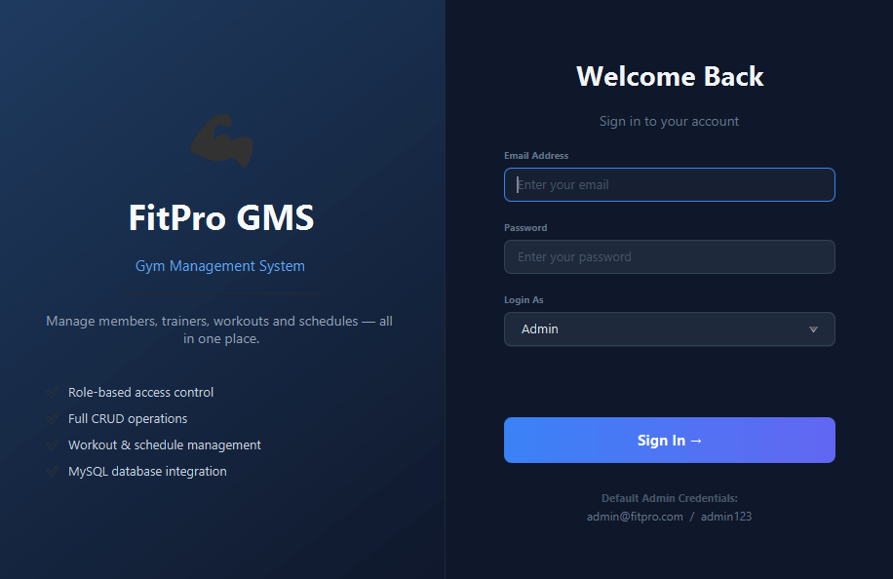
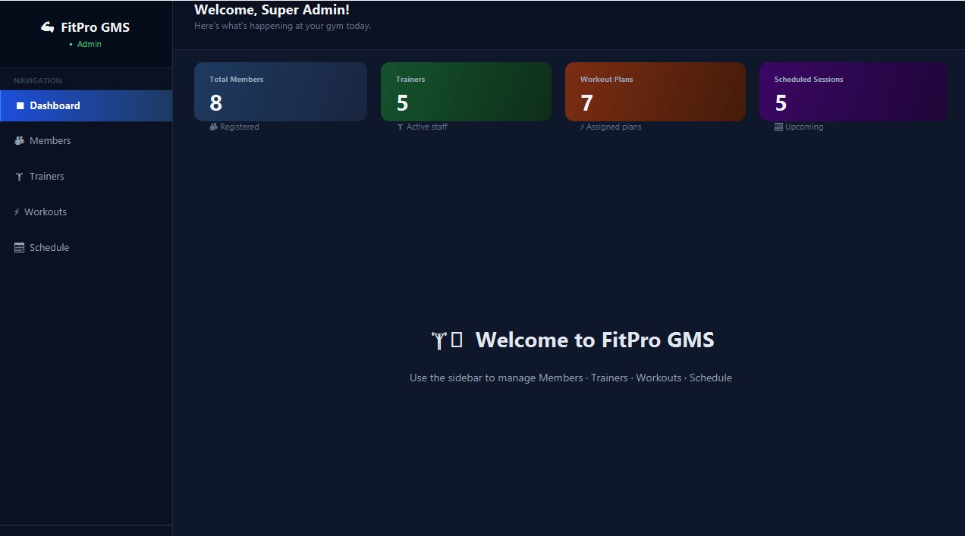
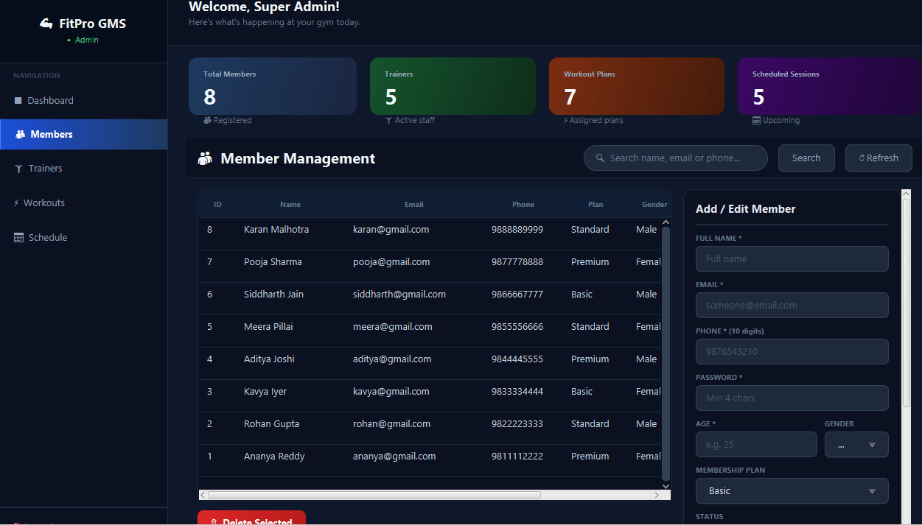
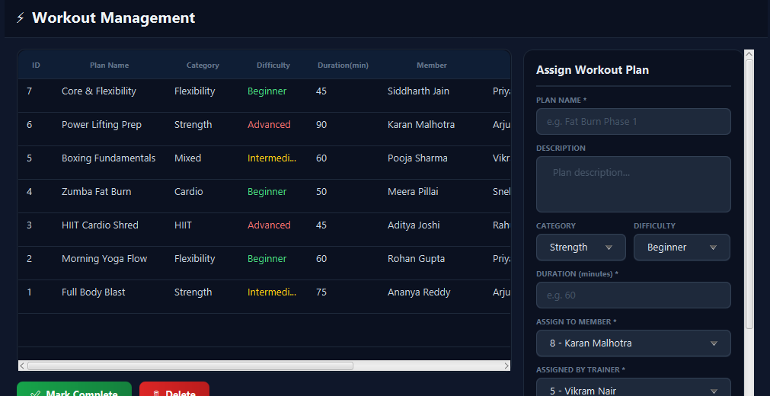
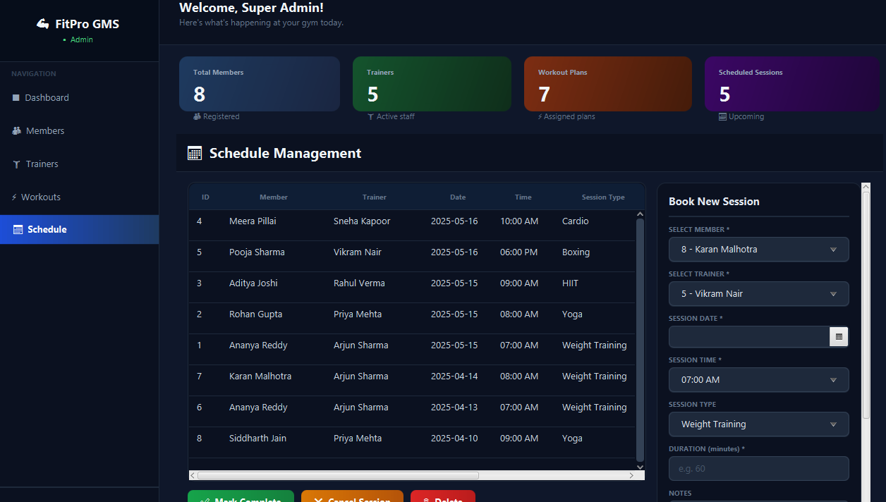
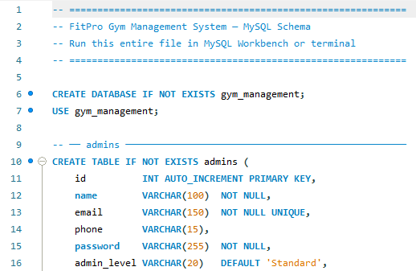
— End of Report —

