- GET Admin access in Machine.
- Download or Clone the Components available at a below Path –
https://gitlab.corporate.ge.com/groups/common-core

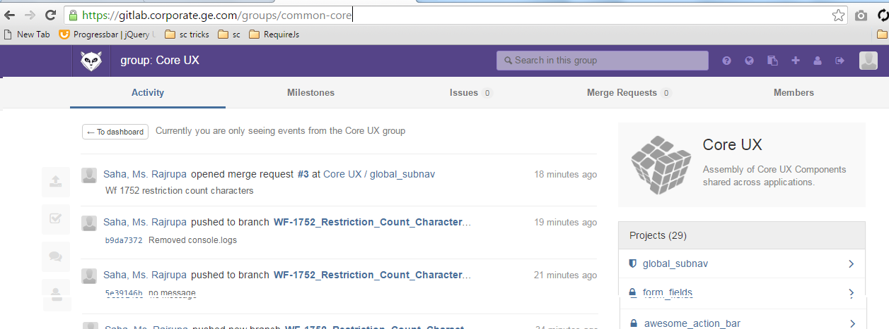

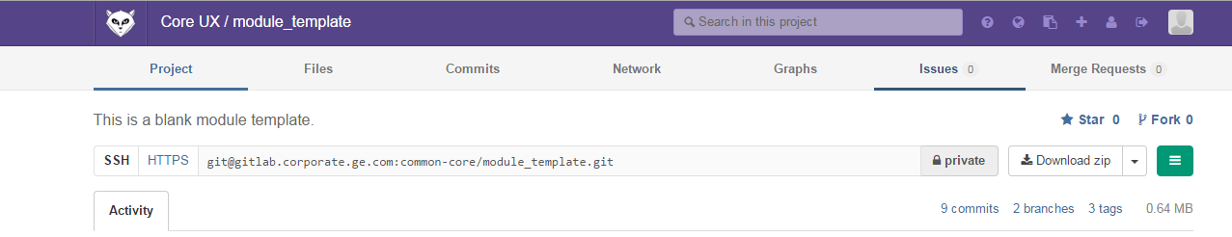
- Right click on downloaded folder and select option – “Git Bash Here” or Open CMD prompt and reach to that folder.
- Run this Command: ssh-keygen -t rsa -C your_email ID
- Run this Command: cat ~/.ssh/id_rsa.pub
Copy the text from command prompt or reach to that folder –
C:\Users\ChangethistouserID\.ssh
Open file id_rsa.pub in notepad and copy text.
- Open https://gitlab.corporate.ge.com/profile/keys path in browser.
Click on ADD SSH KEY
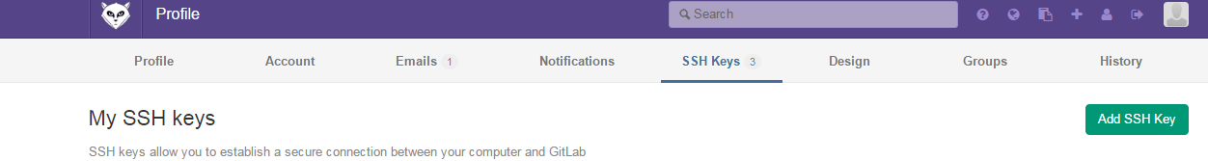
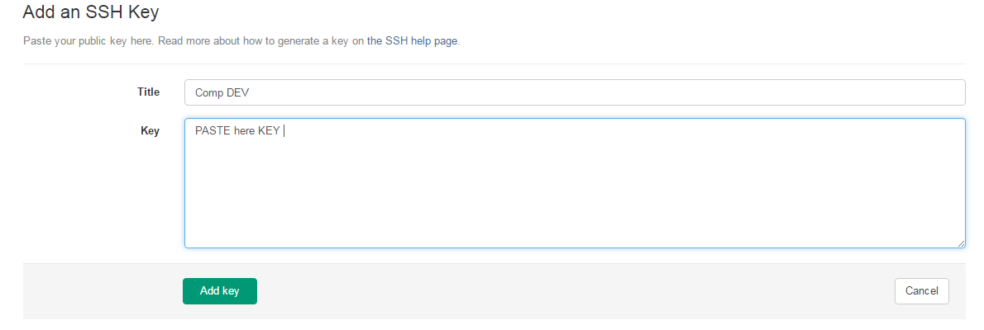
Click on ADD KEY
- Copy this known_hosts file and paste in folder C:\Users\Changeusername\.ssh
Click here to copy file
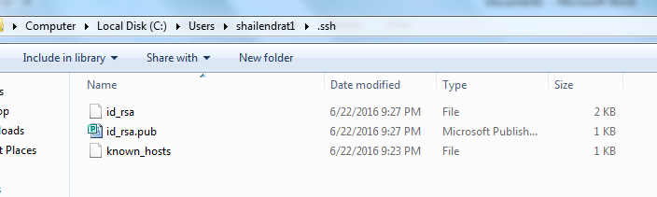

- Open Folder -
C:\Users\Change USER NAME and copy the files from below folder.

- Open the files .gitconfig and Replace your name with Shailendra name and email if line 2 and 3 . in line number 6 replace your user name.
- Set the Path in Environment variables using below method.
- Start –-> Computer Properties Advanced Systems Environment Variable

- 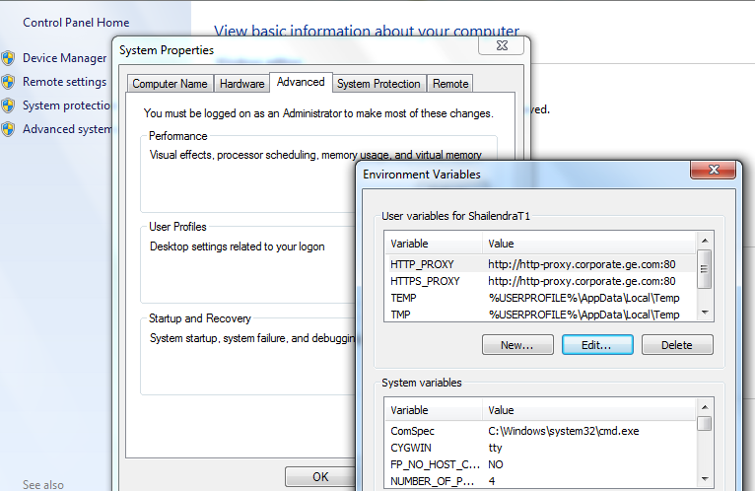
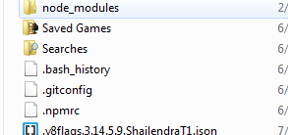
- Click on New Under the User Variables or if There is already PATH variable present then select and click edit.
- Set Variable NAMe : “PATH”
- Set Variable Value : “C:\Users\UserName\AppData\Roaming\npm”
Note : Make the hidden files visible if you are not able to see folder APPDATA

- 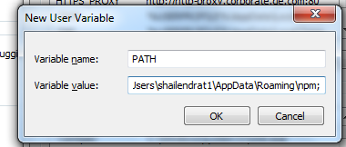

- Common Steps Required when you clone ANY projects

- Open the .bowerrc file from the folder and replace with the below content or replace file -

{
"directory": "server/bower_components",
"proxy": "http://http-proxy.corporate.ge.com:80/",
"https-proxy": "http://http-proxy.corporate.ge.com:80/",
"http-proxy": "http://http-proxy.corporate.ge.com:80/"
}
- Right Click on folder and select “GIT Bash HERE “ or open command prompt and reach to the code path
- Run Command npm install
- Run Command npm install -g bower
- Run Command bower install
- See if there is no errors in bower.
- Check the version by running these commands – All cpmmands should give versions.
npm –v
npm bower –v
bower –v
- Run Command npm cache clean
- Run Command bower cache clean
- Install grunt cli globally using command “npm install -g grunt-cli”
- Run command “grunt buildmodule”
- Run Command grunt dev
- Run Command npm start
- Open browser and run localhost:8484
- Open solution explorer and see the error in console . to remove error open server – app.js remove or comment header missing headergen refrences

Steps to setup environment on local.ge.com

First add this entry in your local hosts file
127.0.0.1 local.ge.com
( C:\Windows\System32\drivers\etc\hosts )

- Download “Module_Template” from https://gitlab.corporate.ge.com/common-core/module_template
- Find server.js from “Module_Template” and replace with your working directory.
- Find package.json and copy only dependencies attribute from “Module_Template” and replace with your working dir.
"dependencies": {
"nodeserv": "git+ssh://git@gitlab.corporate.ge.com:platform-core/nodeserv.git#1.2.5"
},
- Find bower.json and copy dependencies , devDependencies and resolutions attributes from “Module_Template” and replace with your working dir.
"dependencies": {
"CleanDX": "git@gitlab.corporate.ge.com:common-core/cleandx.git#master",
"global-header": "git@gitlab.corporate.ge.com:common-core/global_header.git#master",
"notifier_service": "git@gitlab.corporate.ge.com:common-core/notifier_service.git#master",
"power_modal": "git@gitlab.corporate.ge.com:common-core/power_modal.git#1.2.0",
"feedback_module": "git@gitlab.corporate.ge.com:common-core/feedback_module.git#master",
"responsive_grid": "git@gitlab.corporate.ge.com:common-core/responsive_grid.git#master",
"responsive_post": "git@gitlab.corporate.ge.com:common-core/responsive_post.git#master",
"global_subnav": "git@gitlab.corporate.ge.com:common-core/global_subnav.git#master",
"pagination": "git@gitlab.corporate.ge.com:common-core/paginator.git#master",
"angular": "1.4.x",
"requirejs": "~2.1.11",
"requirejs-domready": "~2.0.1",
"requirejs-text": "~2.0.12"
},
"devDependencies": {
"angular-mocks": "~1.3.11"
},
"resolutions": {
"angular": ">=1.4.0",
"power_modal": "master",
"angular-bootstrap": "~1.1.0",
"CleanDX": "master"
}
- Copy appconfig.json from “Module_Template” and paste it in your working dir.
- Open appconfig.json and replace logPath attribute value from "/app_logs/io/" to "/app_logs” (line no 4) in your working dir.
- Create app_logs folder on d: drive (To capture module related errors)
- Run again all the below command:
- Run Command npm install
- Run Command npm install -g bower
- Run Command bower install
- Run command “grunt buildmodule”
- Run Command grunt dev
- Run Command npm start
- Open browser and run local.ge.com

