A. Student’s code: ………………………………………………… Class: …………….. Data: ……………..

**Task 1**. (3p) Solve the given quadratic equations as simply as possible.

(a) $9x^{2}-100x=0$ $9x\left(x-\frac{100}{9}\right)=0$ $x_{1}=\frac{100}{9}$ $x_{2}=0$

(b) $9x^{2}-100=0$ $9\left(x-\frac{10}{9}\right)\left(x+\frac{10}{9}\right)=0$ $x_{1}=-\frac{10}{9}$ $x_{2}=\frac{10}{9}$

(c) $9x^{2}+100=0$ $x∈∅$

**Task 2**. (3p) Solve the given quadratic equations by completing the square

(a)

(b)

(c)

. **Task 3** (3p) Solve the given quadratic equations **discriminant $∆$**  .

(a) $3x^{2}-5x-2=0$ $∆ =49$ $x_{1}=2x_{2}=-\frac{1}{3}$

(b) $-3x^{2}+5x-3=0$ $∆ =-11$ $x∈∅$

(c) $x^{2}-6x+9=0$ $∆ =0$ $x_{1}=3$

**Task 4**. (2p) Calculate, for what value of $x$ is the area of the drawn triangle equal to 30?

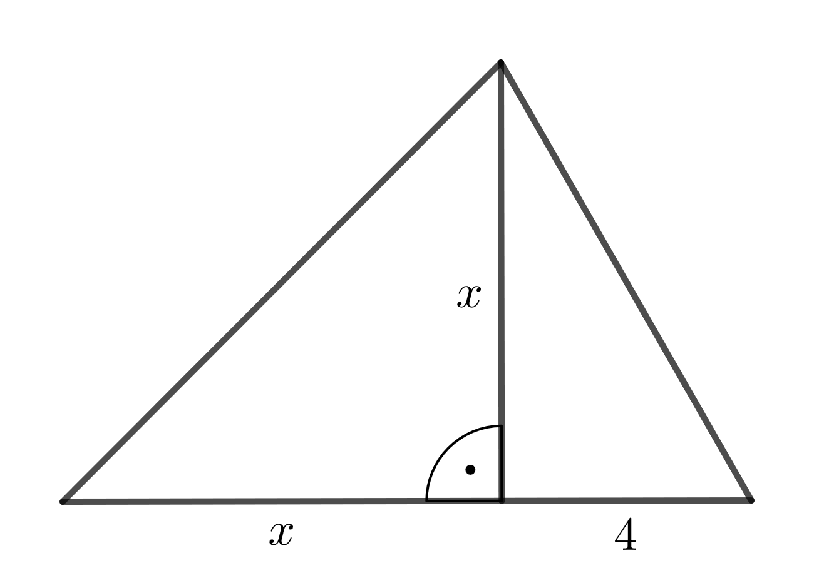

$$\frac{1}{2}x\left(x+4\right)=30$$

$$x^{2}+4x=60$$

${\left(x+2\right)}^{2}=64$/ $x+2>0$

$$x=6$$

B. Student’s code: ………………………………………………… Class: …………….. Data: ……………..

**Task 1**. (3p) Solve the given quadratic equations as simply as possible.

(a) $4x^{2}-49x=0$ $4x\left(x-\frac{49}{4}\right)=0$ $x_{1}=\frac{49}{4}$ ${ x}_{2}=0$

(b) $4x^{2}-49=0$ $4\left(x-\frac{7}{2}\right)\left(x+\frac{7}{2}\right)=0$ $x_{1}=-\frac{7}{2}$ $x_{2}=\frac{7}{2}$

(c) $4x^{2}+49=0$ $x∈∅$

**Task 2**. (3p) Solve the given quadratic equations by completing the square

(a)

(b)

(c)

**Task 3**. (3p) Solve the given quadratic equations **discriminant $∆$** .

(a) $7x^{2}+x-8=0$ $∆ =225$ $x_{1}=1 x_{2}=-\frac{8}{7}$

(b) $\frac{1}{3}x^{2}-2x+3=0$ $∆ =0$ $x_{1}=3$

(c) ${-x}^{2}+x-1=0$ $∆ =-3$ $x∈∅$

**Task 4**. (2p) Calculate, for what value of $x$ is the area of the drawn triangle equal to 39?

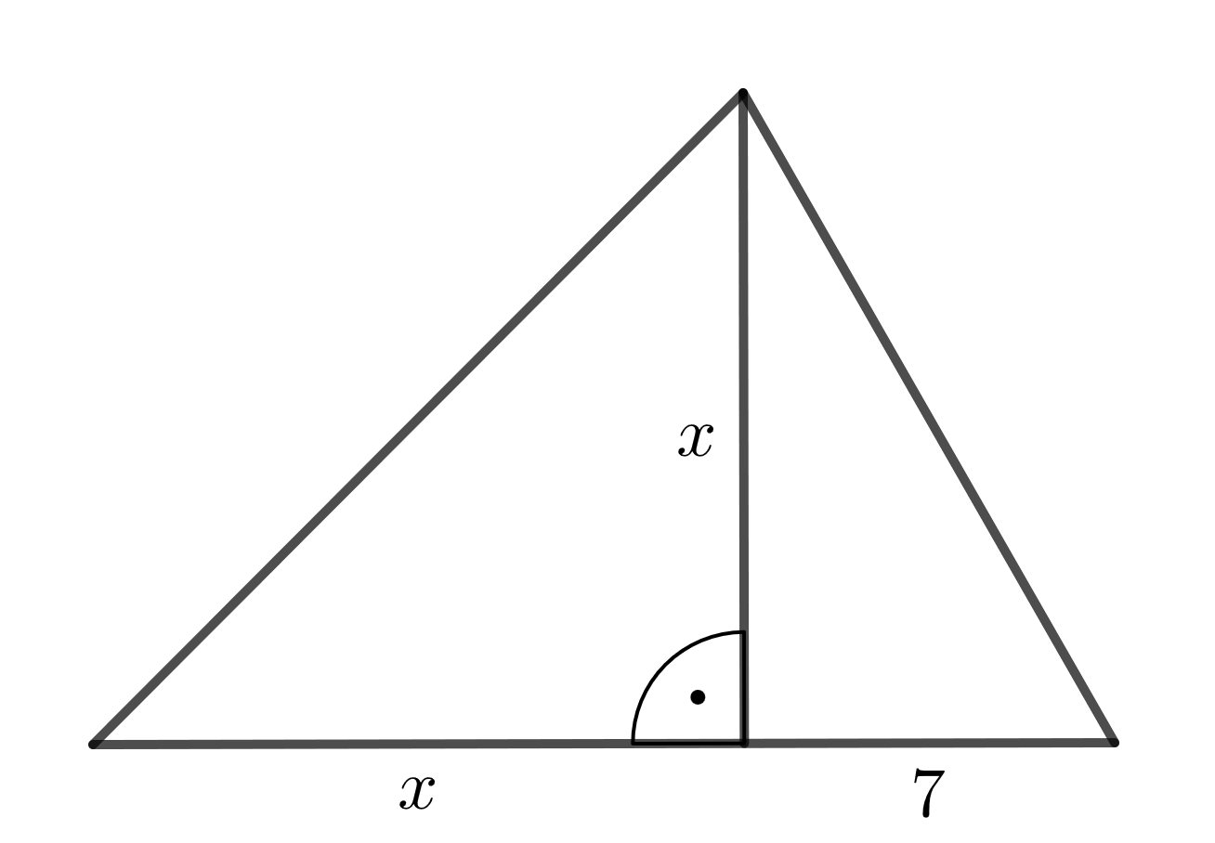

$$\frac{1}{2}x\left(x+7\right)=39$$

$$x^{2}+7x=78$$

$$x^{2}+7x-78=0$$

$∆ =361$

$x_{1}=6>0$ $x_{2}=-13<0$

$$x=6$$

C. Student’s code: ………………………………………………… Class: …………….. Data: ……………..

**Task 1**. (3p) Solve the given quadratic equations as simply as possible.

(a) $25x^{2}-4x=0$ $25x\left(x-\frac{4}{25}\right)=0$ $x_{1}=0$ $x_{2}=\frac{4}{25}$

(b) $25x^{2}-4=0$ $x_{1}=-\frac{2}{5}$ $x_{2}=\frac{2}{5}$

(c) $25x^{2}+4=0$ $x∈∅$

**Task 2**. (3p) Solve the given quadratic equations by completing the square

(a)

(b)

(c)

**Task 3**. (3p) Solve the given quadratic equations **discriminant $∆$** .

(a) $5x^{2}-x-4=0$ $Δ=81$ $x_{1}=1$ $x_{2}=-\frac{4}{5}$

(b) $-\frac{1}{2}x^{2}+x-\frac{1}{2}=0$ $Δ=0$ $x=1$

(c) $x^{2}-\frac{3}{4}x+1=0$ $Δ=-\frac{55}{16}=-3\frac{7}{16}$

**Task 4**. (2p) Calculate, for what value of $x$ is the area of the drawn triangle equal to 65?

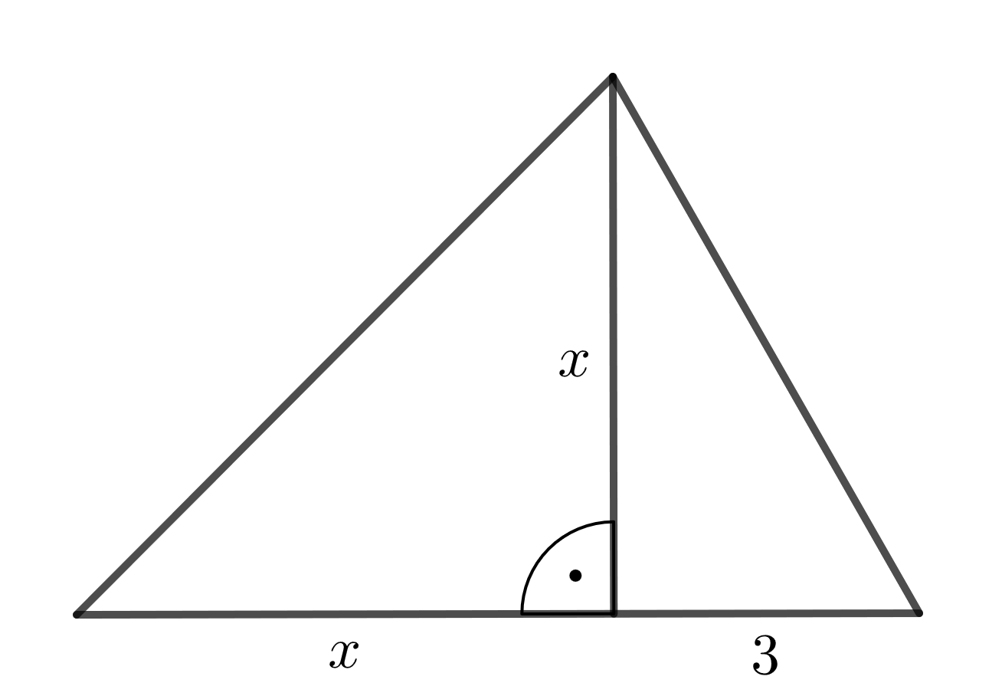

$$\frac{1}{2}x\left(x+3\right)=65$$

$$x\left(x+3\right)=130$$

$$x^{2}+3x-130=0$$

$$Δ=529$$

$x_{1}=10$ $x_{2}=-13$

$$x=13$$

D. Student’s code: ………………………………………………… Class: …………….. Data: ……………..

**Task 1**. (3p) Solve the given quadratic equations as simply as possible.

(a) $16x^{2}-9x=0$ $16x\left(x-\frac{9}{16}\right)=0$ $x_{1}=0$ $x_{2}=\frac{9}{16}$

(b) $16x^{2}+9=0$ $x∈∅$

(c) $16x^{2}-9=0$ $x_{1}=-\frac{3}{4}$ $x_{2}=\frac{3}{4}$

**Task 2**. (3p) Solve the given quadratic equations by completing the square

(a)

(b)

(c)

**Task 3**. (3p) Solve the given quadratic equations **discriminant $∆$** .

(a) $7x^{2}-5x-2=0$ $Δ=81$ $x_{1}=1$ $x_{2}=-\frac{2}{7}$

(b) $-7x^{2}+5x-2=0$ $Δ=-31$ $x∈∅$

(c) $\frac{1}{5}x^{2}-2x+5=0$ $Δ=0$ $x=5$

**Task 4**. (2p) Calculate, for what value of $x$ is the area of the drawn triangle equal to 40?

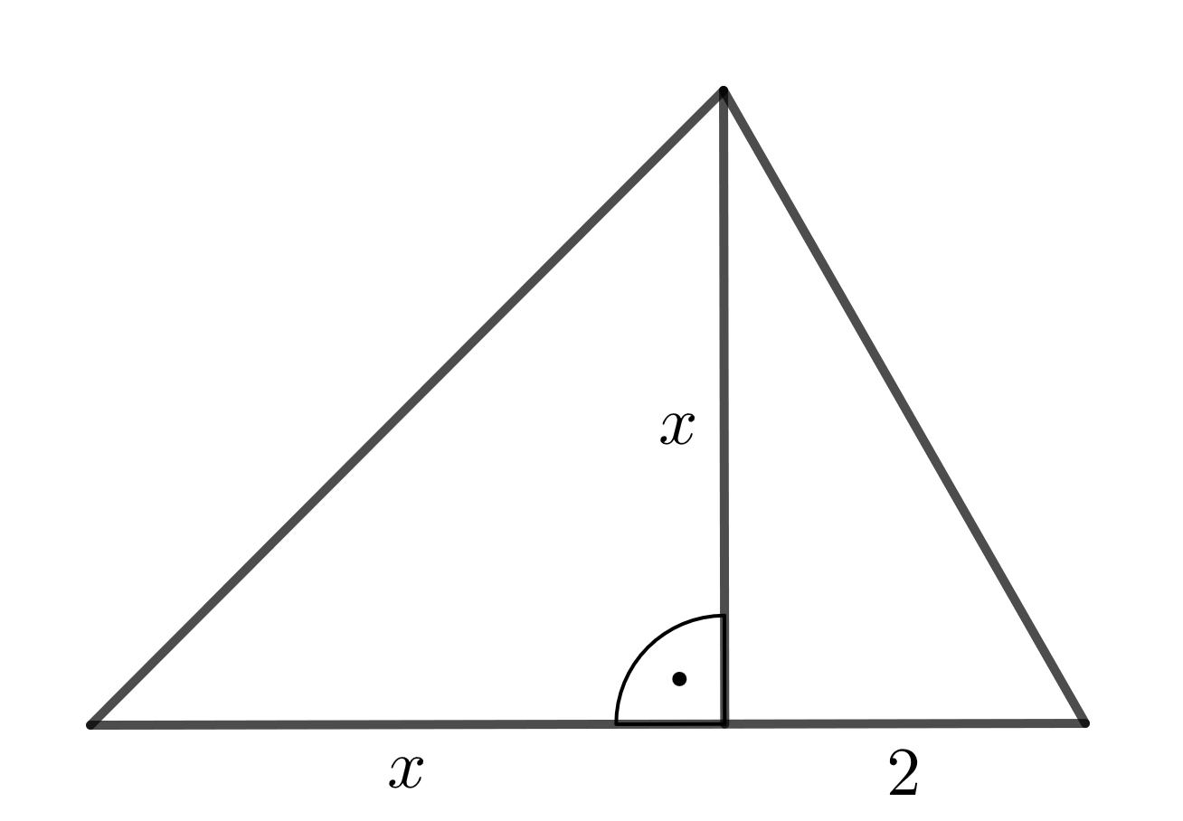 $$\frac{1}{2}x\left(x+2\right)=40$$

$$x\left(x+2\right)=80$$

$$x^{2}+2x-80=0$$

$$Δ=324$$

$x_{1}=8$ $x_{2}=-10$

$$x=8$$