**Task 1**. A quadratic function $f$ is defined by vertex form $f\left(x\right)=3{\left(x+1\right)}^{2}-4$.

1. Write down coordinates of the vertex $V$ of parabola which is the graph of the $f$. ……………
2. Write down coordinates of the point $P$, where the graph of $f$ intersects the y-axis. ……………
3. 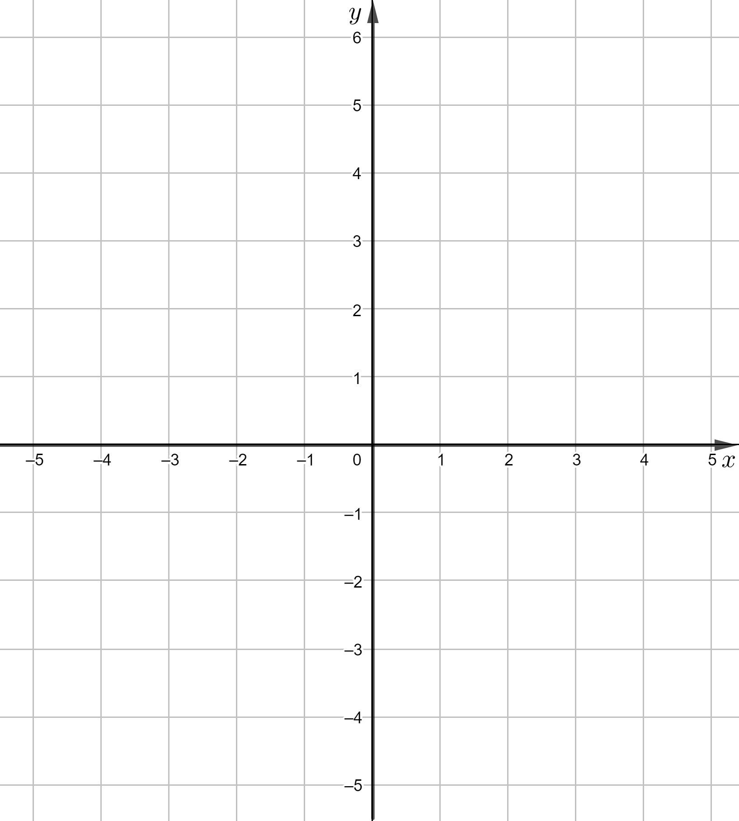 Sketch the graph of $f$.
4. Write down the equation of the line of symmetry of the graph of $f$. ……
5. Write down the range of the function $f$.   
   …………..
6. Describe monotonicity intervals of the function $f$.

The function $f$ increases in the interval ………………

The function $f$ increases in the interval

……………….

1. Write down the general form of the function $f$

$f(x) =$………………..

**Task 2**. Calculate coefficients $b$ i $c$ in the formula of a quadratic function $y={4x}^{2}+bx+c$ ,   
knowing that the points $A\left(2, 27\right)$ and $B\left(-2, 3\right)$ lie on the graph of this function.

**Task 3**. Work out the vertex form for the quadratic function $f$, knowing that the interval $\left[2, \left.∞\right)\right.$ is the range of $f$ and $f\left(-2\right)=f\left(-4\right)=5$.