**Task 1**. (7p) A quadratic function $f$ is defined by vertex form $f\left(x\right)=3{\left(x+1\right)}^{2}-4$.

1. Write down coordinates of the vertex $V$ of parabola which is the graph of the $f$. $V=\left(-1, -4\right)$
2. Write down coordinates of the point $P$, where the graph of $f$ intersects the y-axis. $P=\left(0,-1\right)$
3. 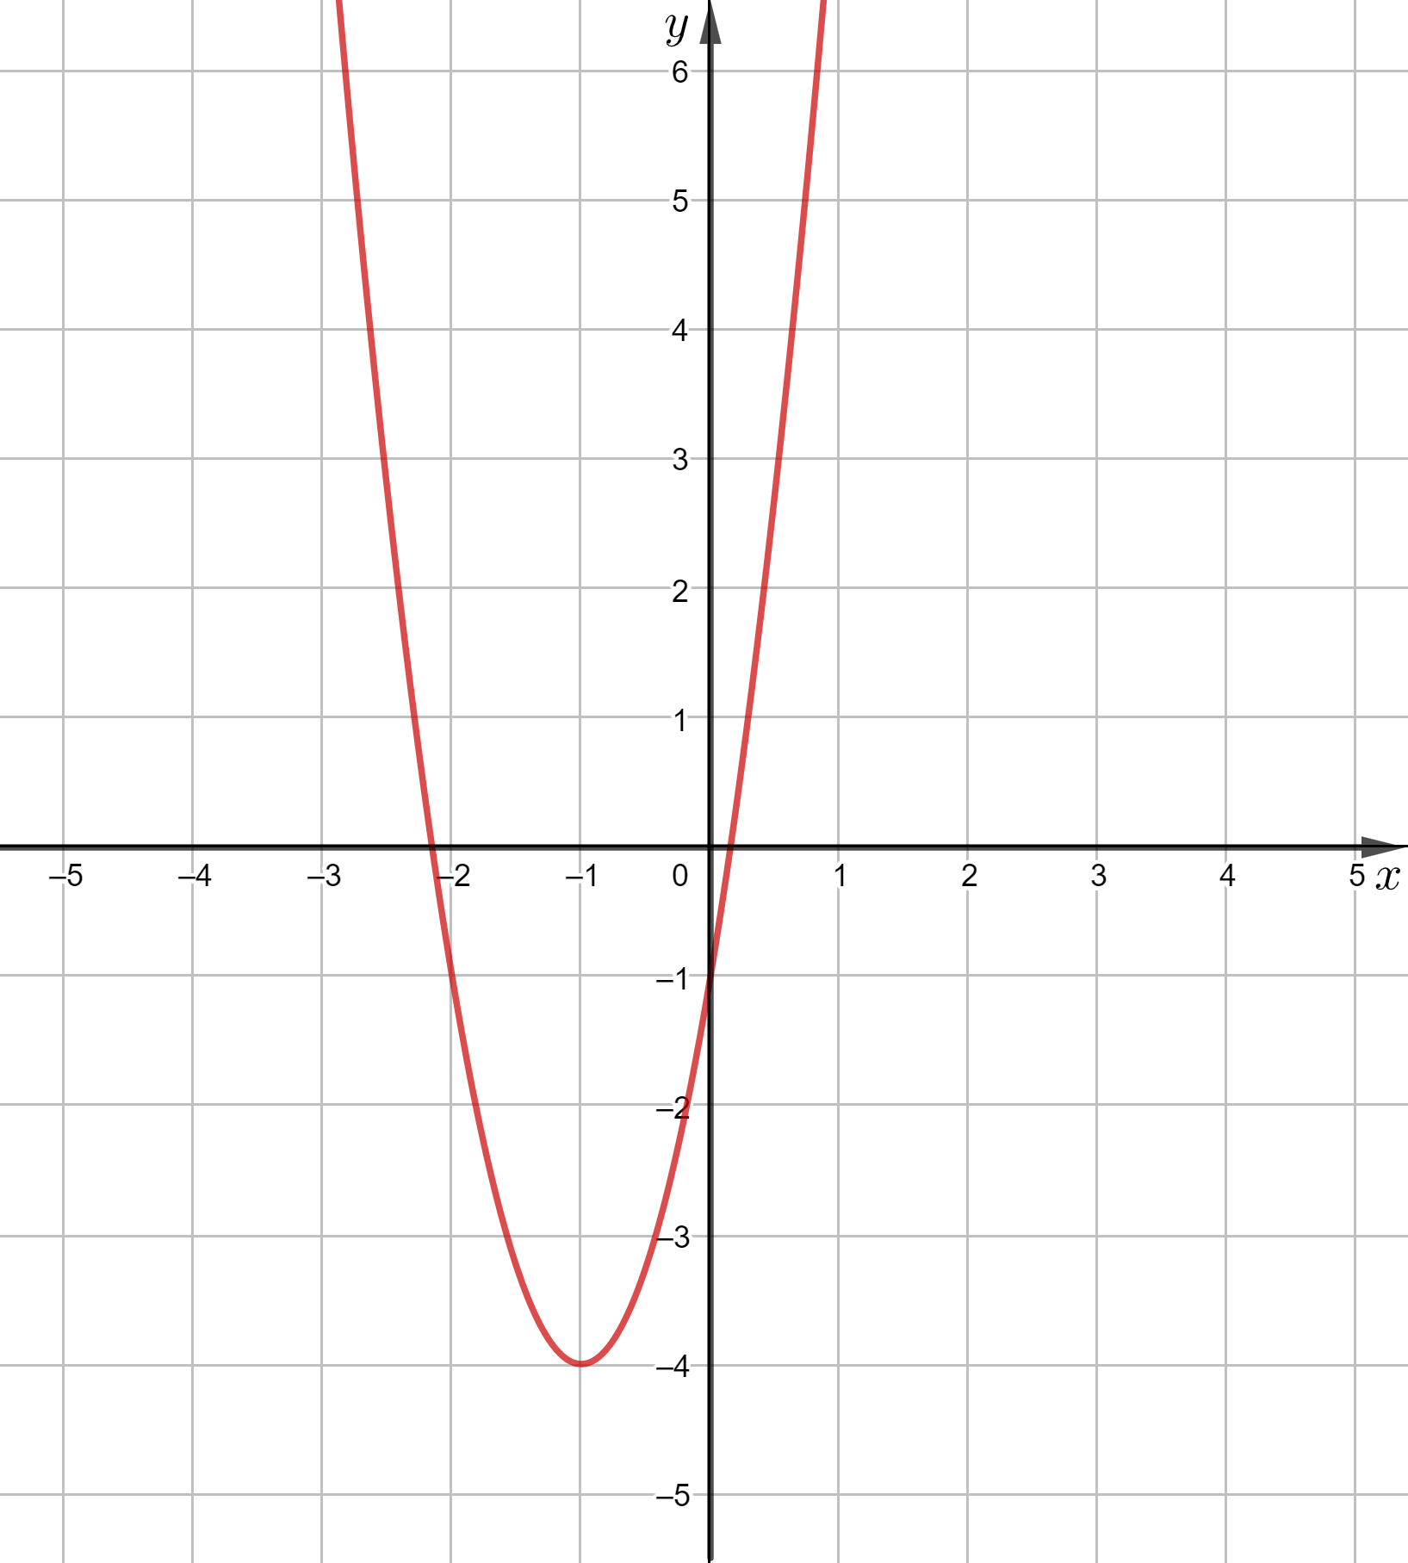 Sketch the graph of $f$.
4. Write down the equation of the line of symmetry of the graph of $f$. $x=-1$
5. Write down the range of the function $f$. ${ZW}_{f}=\left[- 4 ,\right.∞\left. \right)$
6. Describe monotonicity intervals of the function $f$.

The function $f$ increases in the interval $\left[-1,\right.\left. ∞\right)$.

The function $f$ increases in the interval $\left(-∞, \right.\left.-1\right]$.

1. Write down the general form of the function $f$ $f\left(x\right)=3x^{2}+6x-1$

**Task 2**. (3p) Calculate coefficients $b$ i $c$ in the formula of a quadratic function $y={4x}^{2}+bx+c$ ,   
knowing that the points $A\left(2, 27\right)$ and $B\left(-2, 3\right)$ lie on the graph of this function.

Solution

Let $W_{f}$ be the graph of the function $y={4x}^{2}+bx+c$.

$\left\{\begin{aligned}A\left(2, 27\right)∈W_{f}⇒27=16+2b+c \\ B\left(-2, 3\right)∈W_{f}⇒3=16-2b+c\end{aligned}\right.$

So:

$\left\{\begin{aligned}2b+c=11 \\ -2b+c=-13\end{aligned}\right.$ $\left\{\begin{aligned}c=11-2b \\ -2b+11-2b=-13\end{aligned}\right.$ $\left\{\begin{aligned}c=11-2b \\ -4b=-24\end{aligned}\right.$ $\left\{\begin{aligned}c=-1 \\ b=6\end{aligned}\right.$

Answer: $b=6, c=-1$

**Task 3**. (4p) Work out the vertex form for the quadratic function $f$, knowing that the interval $\left[2, \left.∞\right)\right.$ is the range of $f$ and $f\left(-2\right)=f\left(-4\right)=5$.

Solution



$f\left(x\right)=a{\left(x-p\right)}^{2}+q$

$f\left(-2\right)=f\left(4\right) ⇒ p=\frac{-2+(-4)}{2}=-3 ⇒$ $f\left(x\right)=a{\left(x+3\right)}^{2}+q$

$ZW_{f}=\left[2, \left.∞\right)\right.⇒q=2⇒$ $f\left(x\right)=a{\left(x+3\right)}^{2}+2$

$f\left(-2\right)=5 ⇒a{\left(-2+3\right)}^{2}+2=5 ⇒a=3⇒$ $f\left(x\right)=3{\left(x+3\right)}^{2}+2$

Answer: $f\left(x\right)=3{\left(x+3\right)}^{2}+2$.