**Task**: Work out the following features of the function given by the formula $f\left(x\right)=x^{2}+6x+5$

1. Coefficients $a, b, c$ of the standard form $f\left(x\right)=ax^{2}+bx+c$.
2. Determinant $∆$.
3. Coordinates of the vertex $W=\left(p,q\right)$ of the parabola, which the graph of the function.
4. Equation of the line of symmetry of the parabola, which is graph of the function $x=p$
5. Vertex form of the function.
6. Zeros of the function (if they exist).
7. Factored form (if exists).
8. 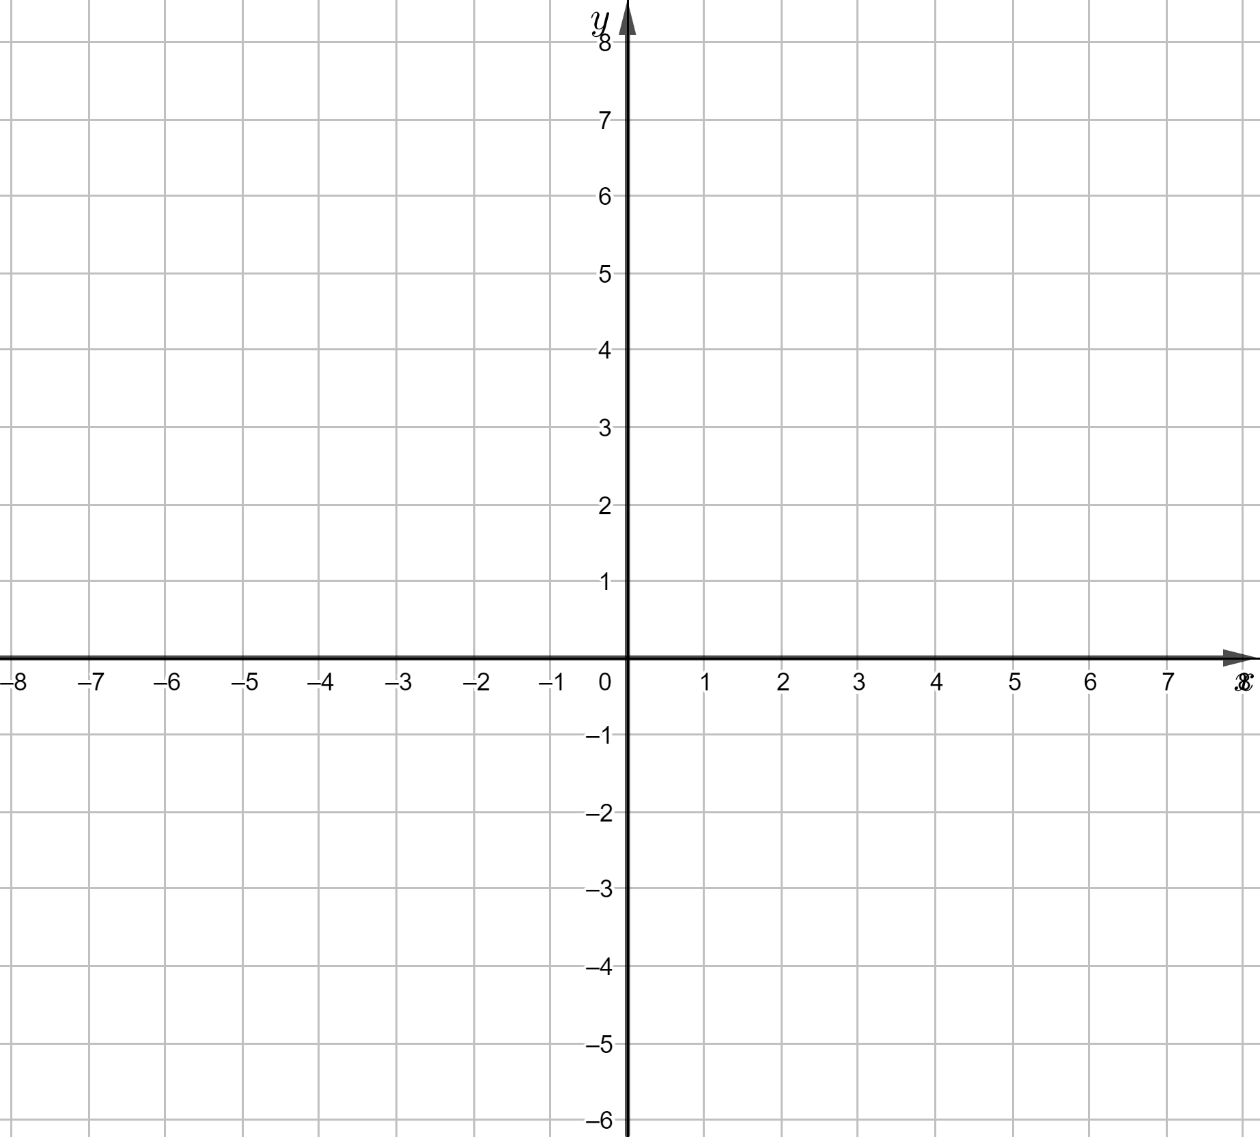Graph of the function and line of symmetry.
9. The domain of the function is ……
10. The range of the function is $\left[-4, \right.\left.∞\right)$
11. $f\left(x\right)>0$ for $x∈$…………………………...
12. $f\left(x\right)<0$ for $x∈$…………………………....
13. Maximum interval in which the function increases is. …..
14. Maximum interval in which the function decreases is …..
15. The maximum $f\left(x\right)$ for $x∈\left[-6, -2\right]$ equals ……
16. The minimum $f\left(x\right)$ for $x∈\left[-6, -2\right]$ equals ….. .