Jenkins Exam by Baris Top
GitHub Repository
https://github.com/baris1892/datascientest-jenkins_devops_exams

Dockerhub Images
- Cast Service:
https://hub.docker.com/repository/docker/baris1892/datascientest-cast-service/general
- Movie Service:
https://hub.docker.com/repository/docker/baris1892/datascientest-movie-service/general

Jenkins Screenshots
Figure 1: Docker Build
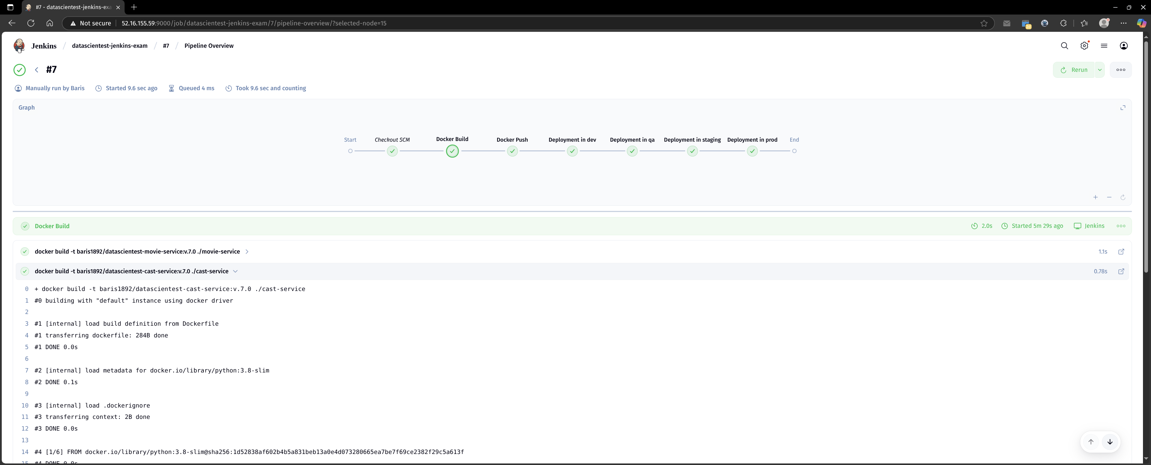
Figure 2: Docker Push
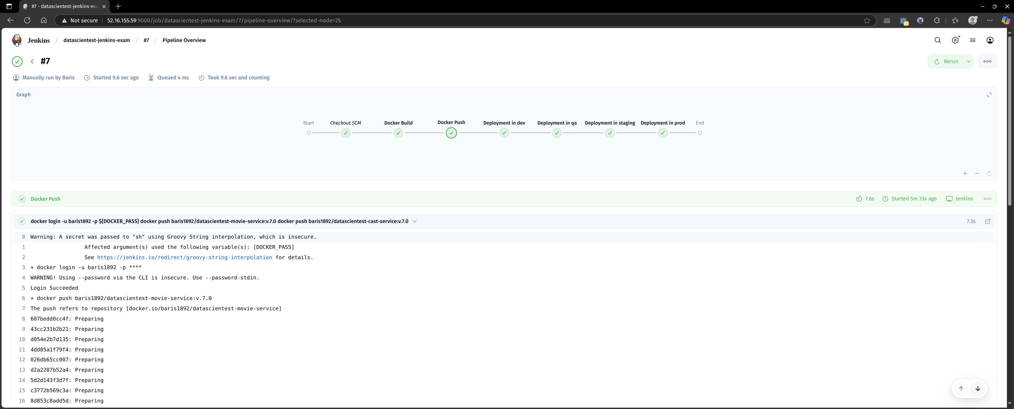

Figure 3: Deploy dev
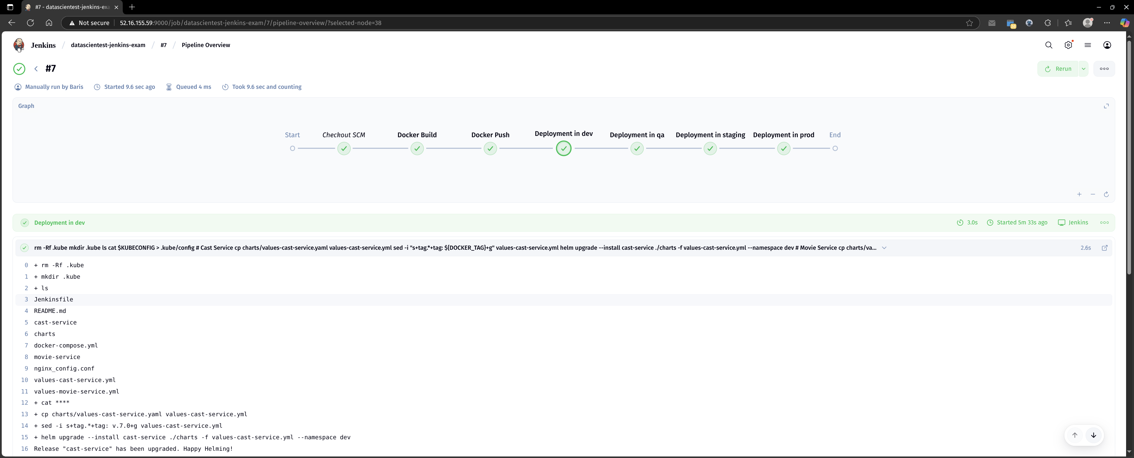

Figure 4: Deploy qa
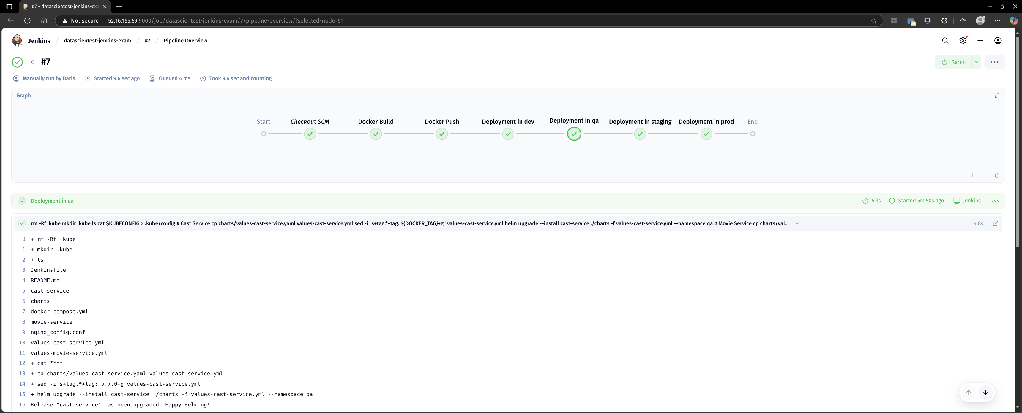

Figure 5: Deploy stage
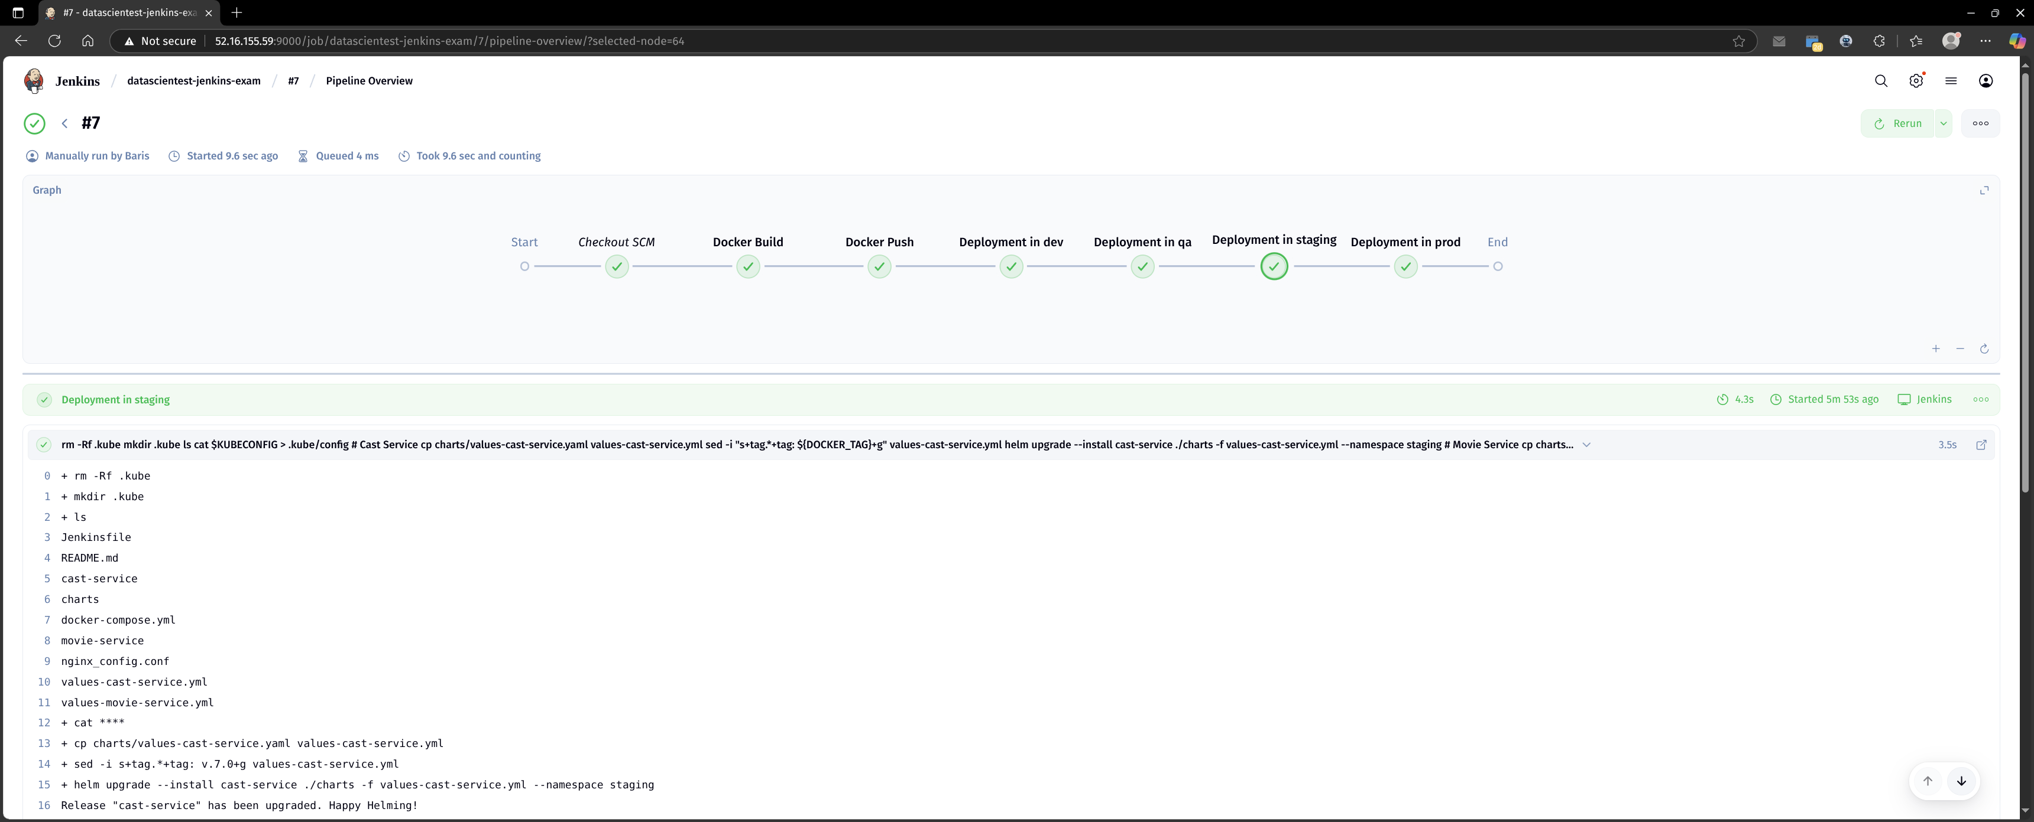

Figure 6: Deploy prod
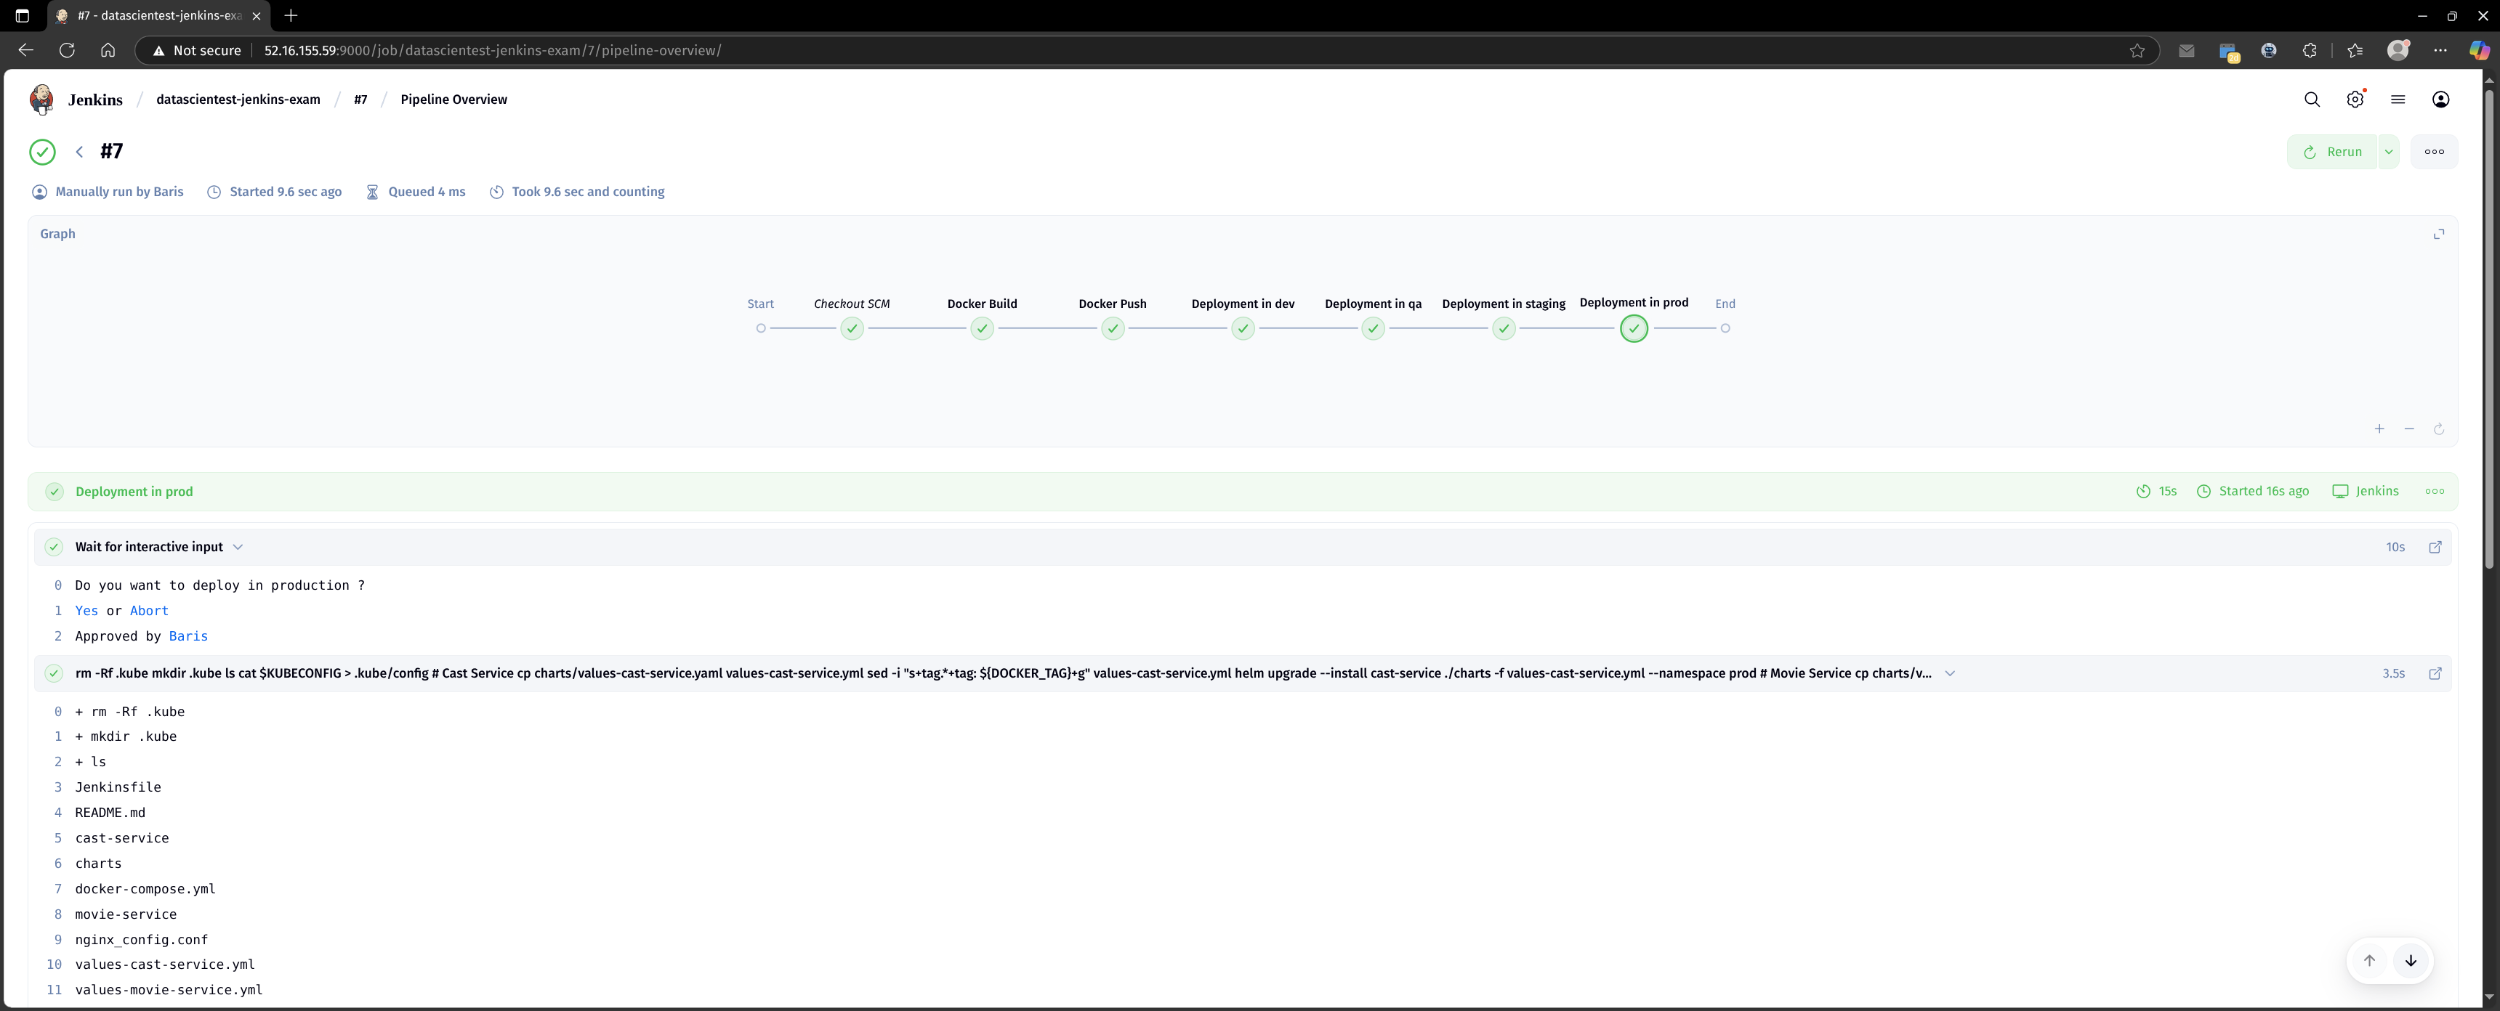

See also jenkins-logs-build-#7.txt for jenkins logs.

