Barış Ayyıldız

1901042252

**Part 1 :**

**I. Searching a product.**

Time complexity is : **Θ(n*m*l)**

n is length of stocks array,

m is length of furnitures array,

l is length of String query

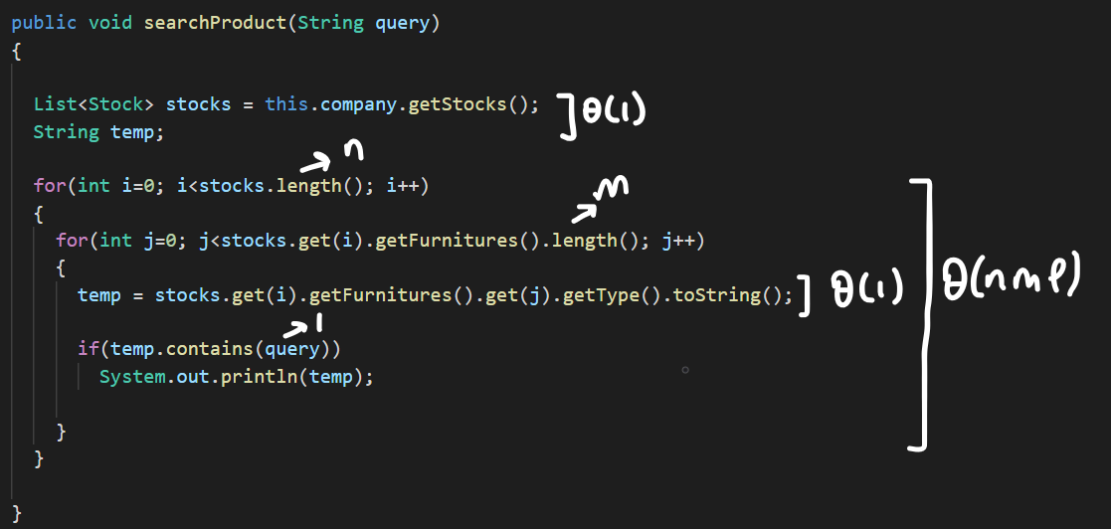

**II. Add/remove product.**

**Add Products**

O(1)+ O(1)+ O(n)+ O(1) = **O(n)**

Since there is a breaking condition, the worst case is linear

Tworst = **O(n)**

Tbest = **Ω(1)**, best case is constant time, when the algorithm iterates once inside for loop

n is equal to length of stock array in this case

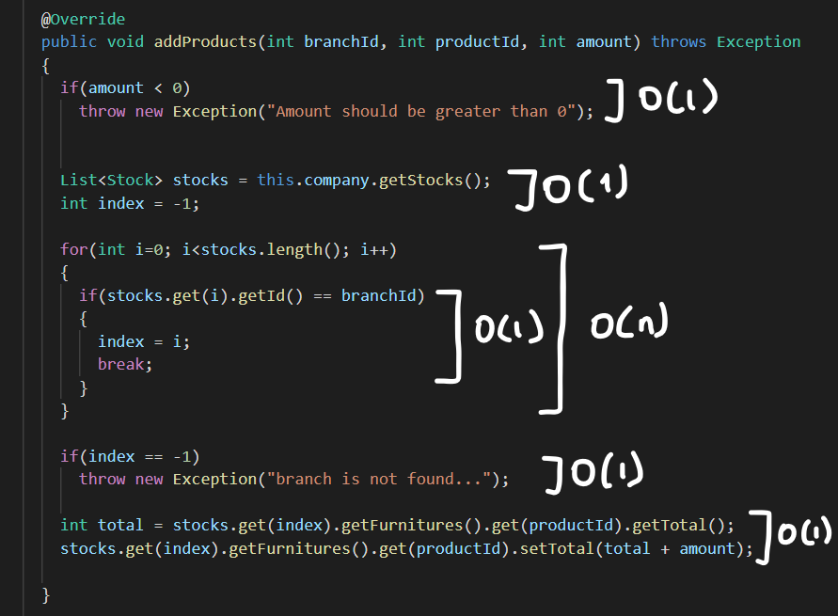

All getters and setters take constant time, Θ(1)

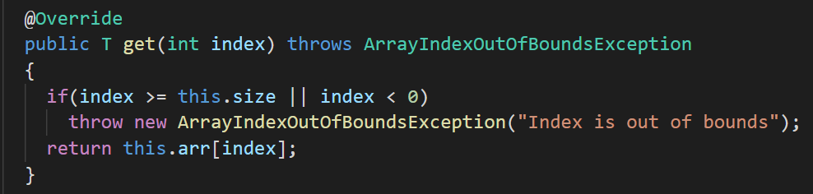

**Remove Products**

Since there is a breaking condition, the worst case is linear

Tworst = **O(n)**

Tbest = **Ω(1)**, best case is constant time, when the algorithm iterates once inside the for loop

n is equal to length of stock array in this case

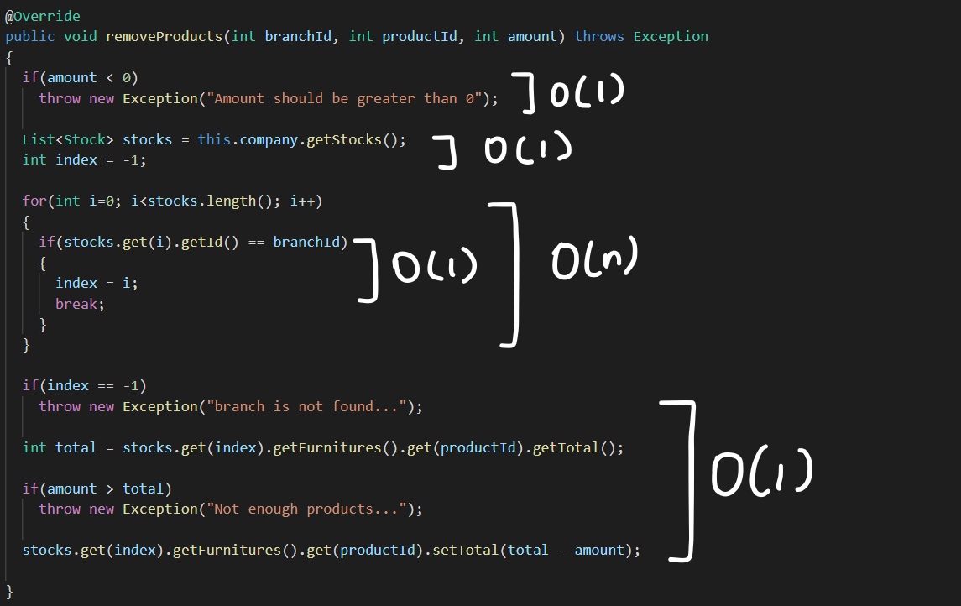

**III. Querying the products that need to be supplied.**

n is length of stocks, m is length of furnitures array

Since there is no breaking condition inside nested for loop

Θ(1) + Θ(n*m)+ Θ(1) = **Θ(n*m)**

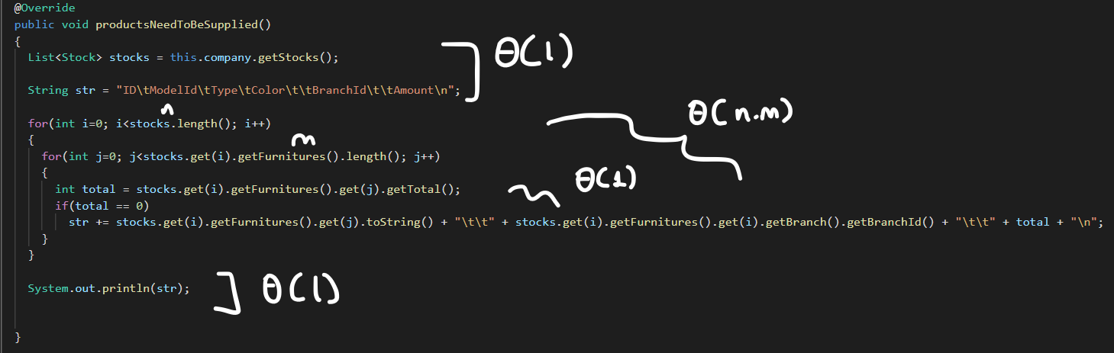

All getters and setters take constant time, Θ(1)







**Part 2 :**

1. Explain why it is meaningless to say: “The running time of algorithm A is at least O(n2 )”.

Because by definition, Big O notation refers to the worst case of an algorithm. So it is meaningless to say ‘at least’.

1. Let f(n) and g(n) be non-decreasing and non-negative functions. Prove or disprove that: max(f (n), g(n)) = Θ(f(n) + g(n)).
2. Are the following true? Prove your answer.
3. 2n+1= Θ(2n)

**true**

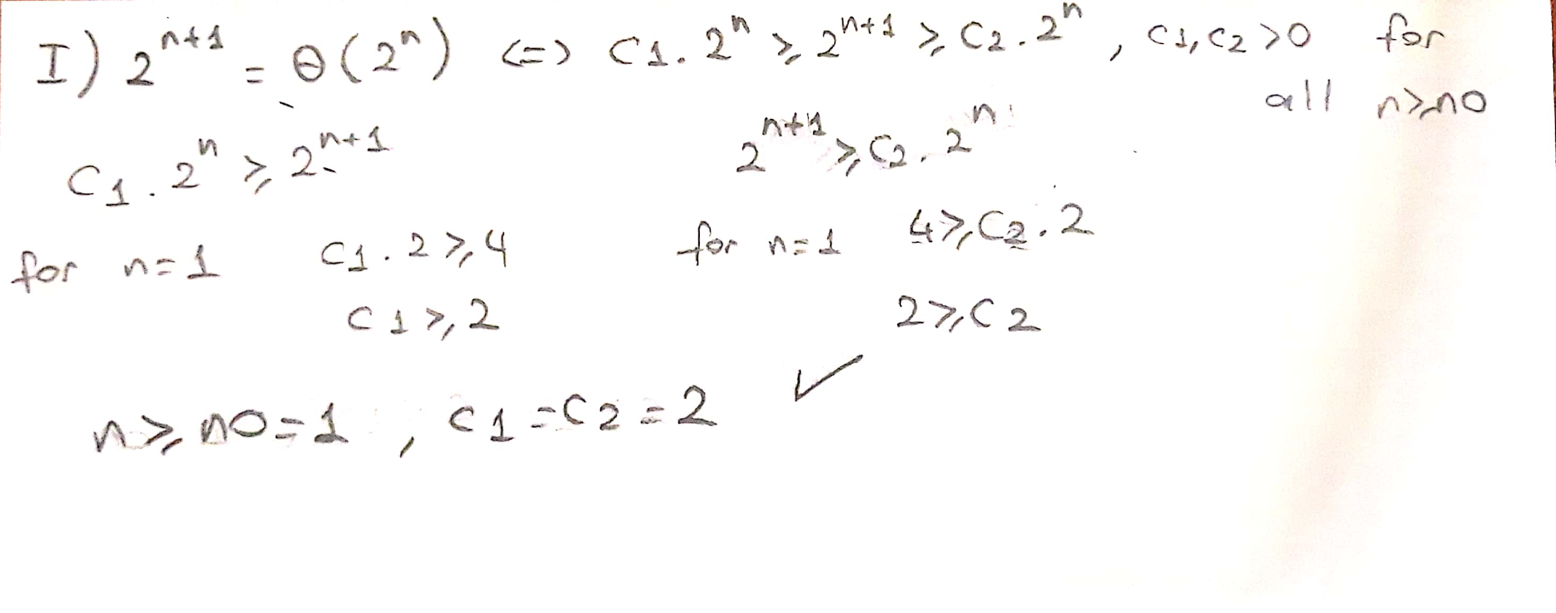

1. 22n= Θ(2n)

**false**

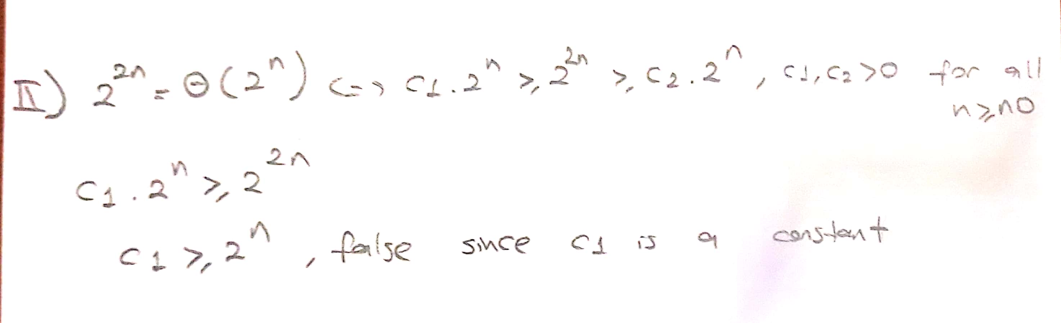

1. Let f(n)=O(n2 ) and g(n)= Θ(n2 ). Prove or disprove that: f(n) * g(n) = Θ(n4 ).

**false**

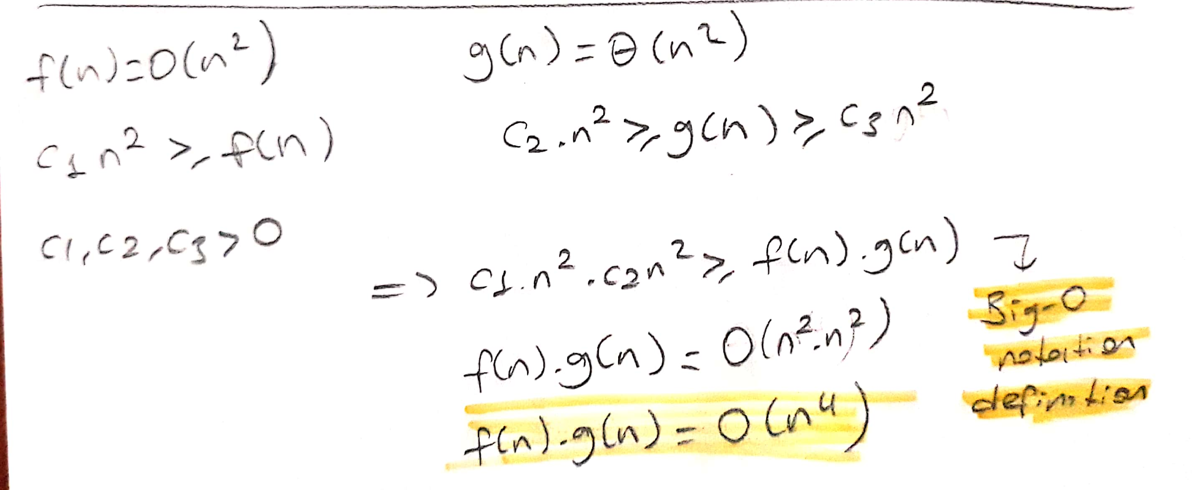

Big-O notation doesn’t tell anything about the lower bound. So for time complexity**, it is not guarenteed to be Θ(n4)**. But we can say that:

**f(n) * g(n) = O(n4)**

**Part 3 :**

List the following functions according to their order of growth by explaining your assertions.

n 1.01, nlog2n, 2n , √n, (log n)3 , n2n , 3n , 2n+1, 5 log2 n , logn

We can find growth rate by dividing two functions and taking it’s limit

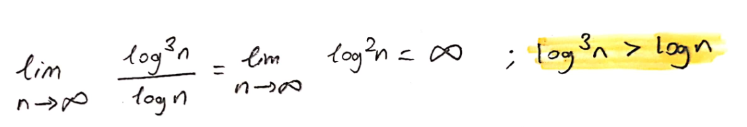

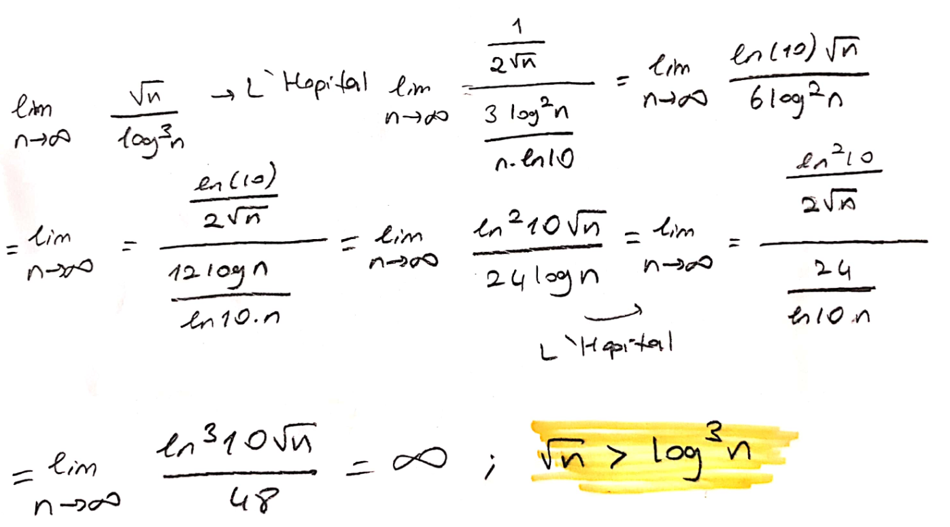

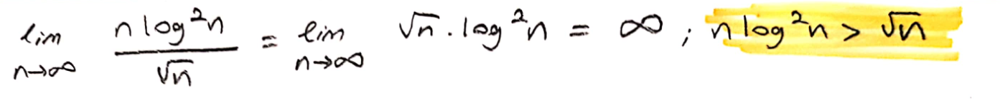

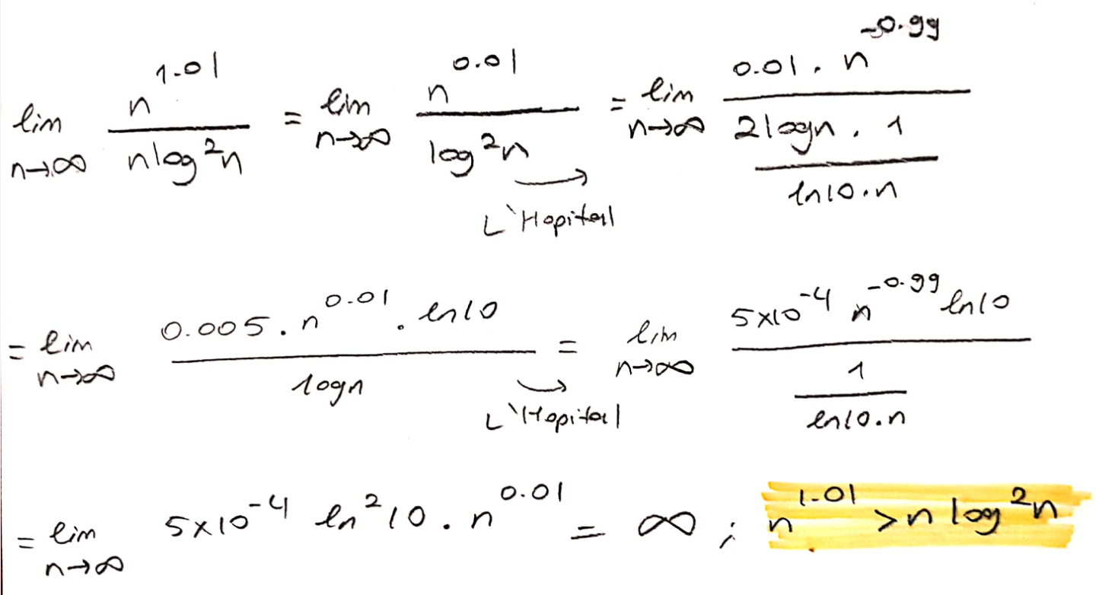

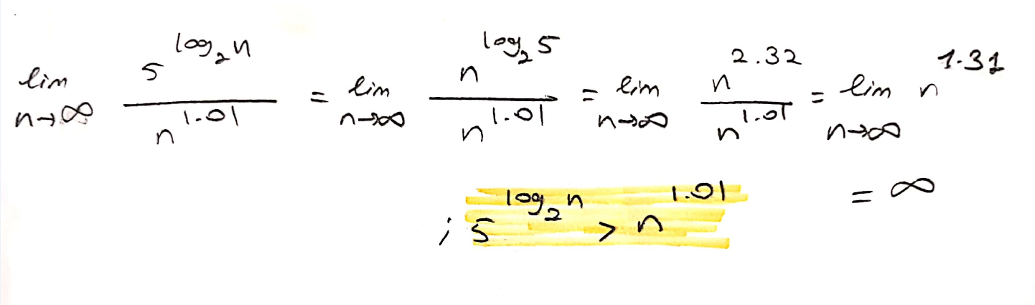

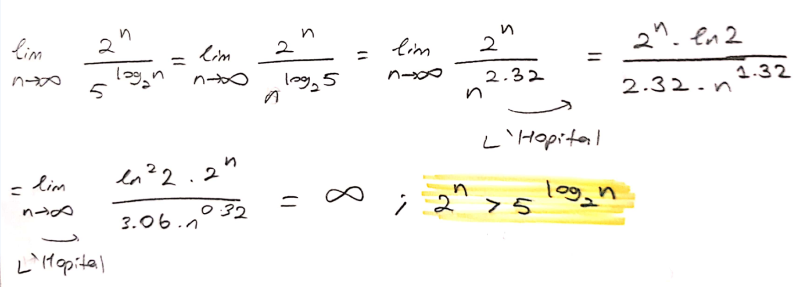

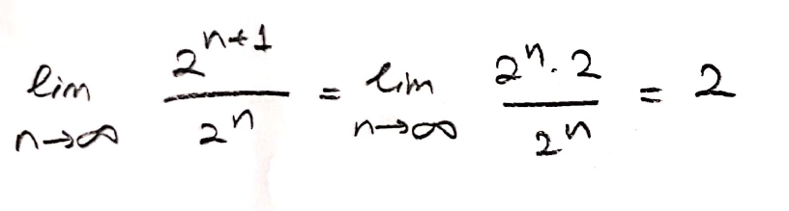

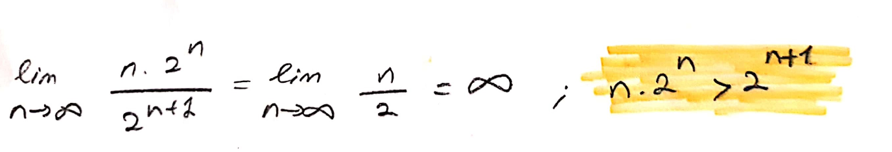

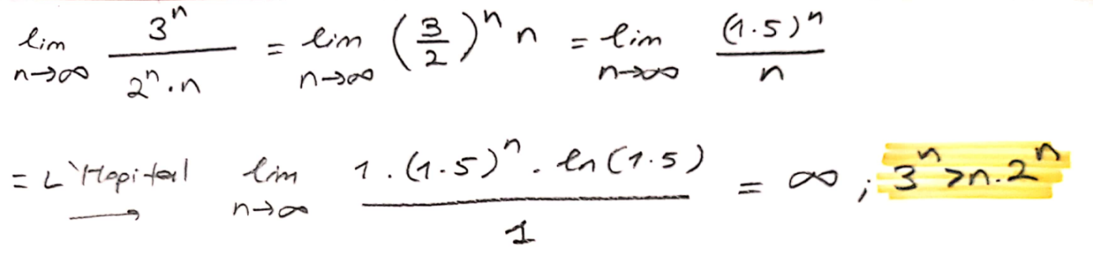

**Result :**

3n > n.2n > 2n+1 = 2n > 5log2n > n1.01 > n.log2n > **√**n > log3n > logn

**Part 4 :**

**- Find the minimum-valued item.**

It takes linear time

T(n) = **Θ(n)**

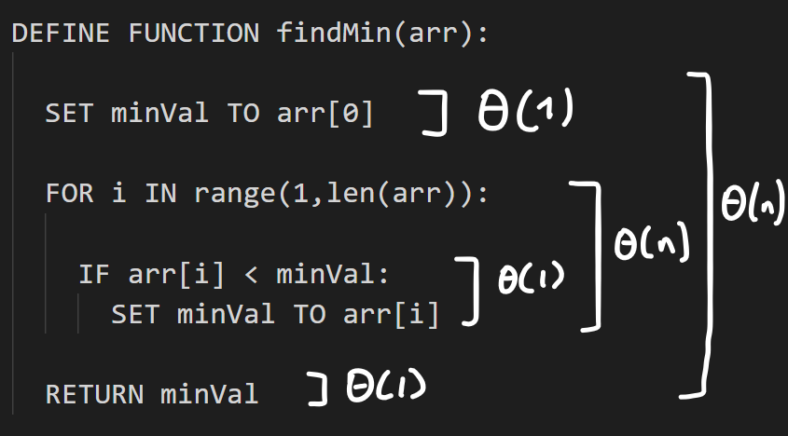

**- Find the median item. Consider each element one by one and check whether it is the median.**

Bubble sort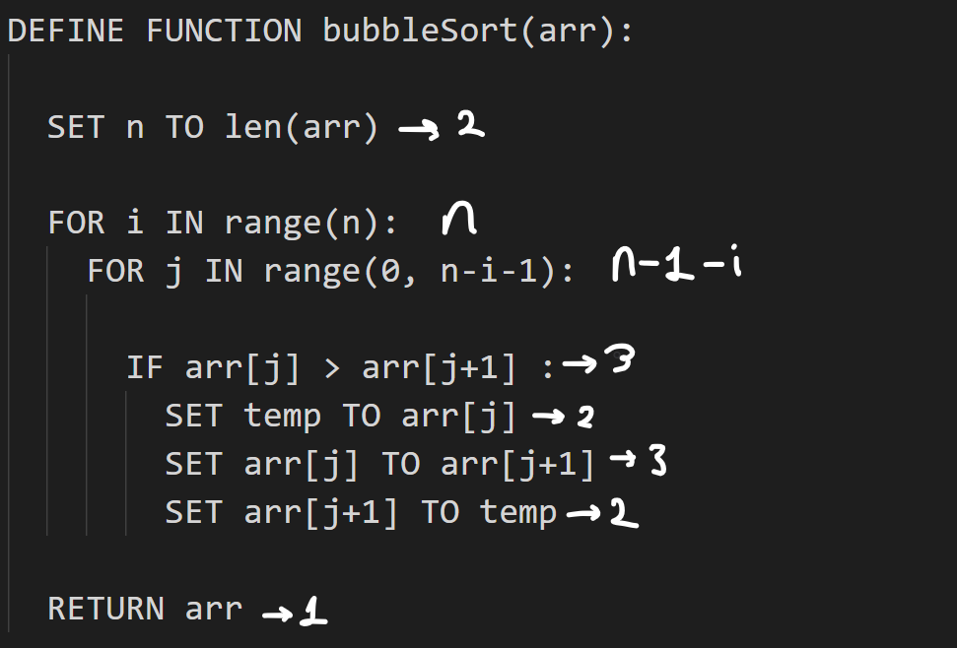

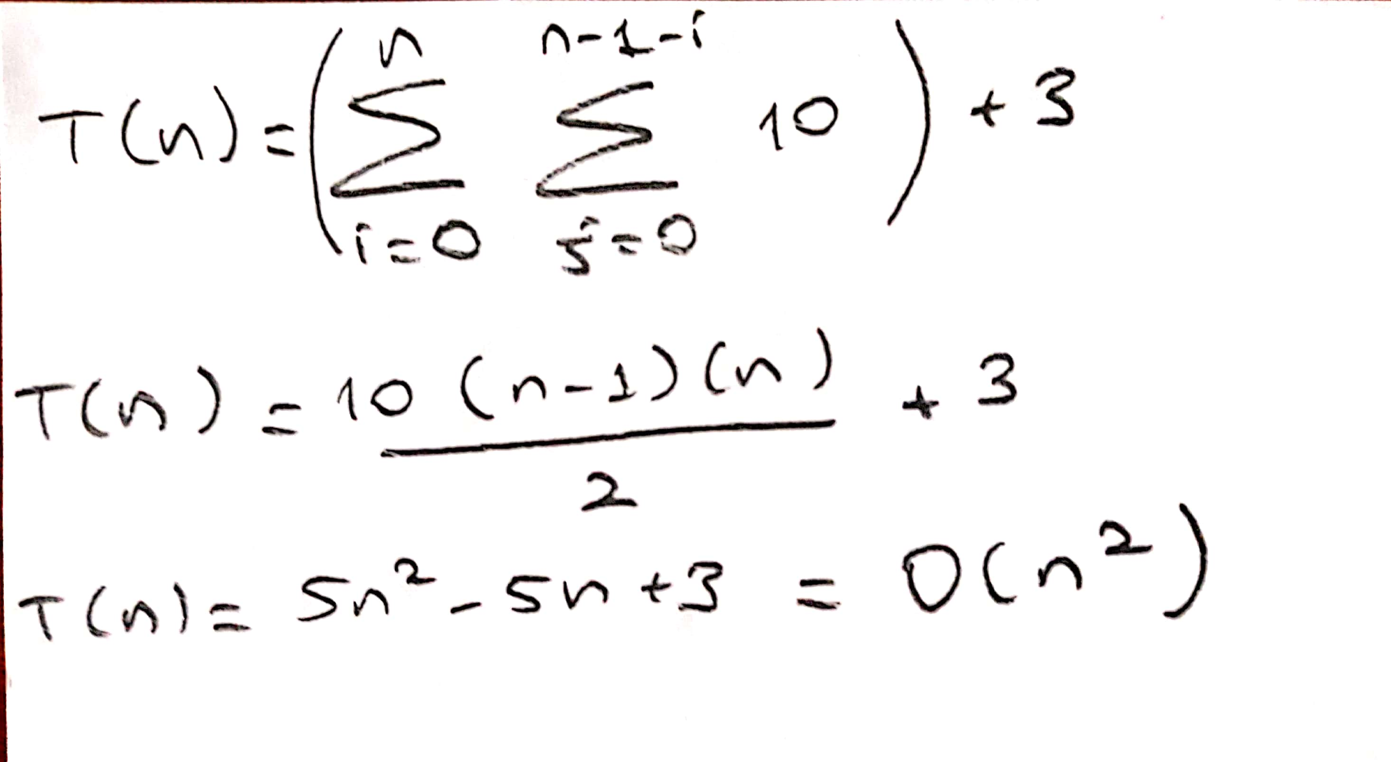

Bubble sort’s time complexity is **O(n2)**

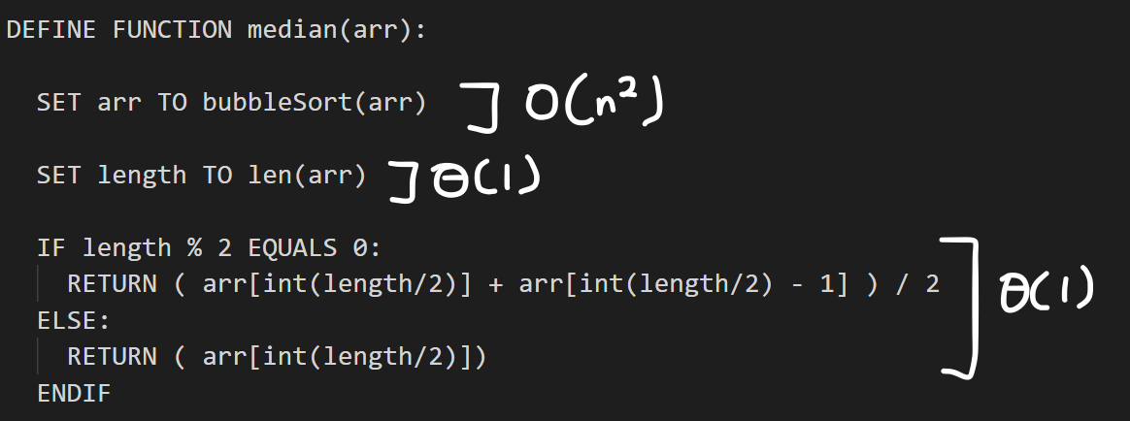

O(n2)+ Θ(1)+ Θ(1)

In worst case : Tworst = **O(n2)**

**- Find two elements whose sum is equal to a given value**

At first we sort the array with bubblesort algoritm ( O(n2) )

Inside the while loop, time complexity is O(n). When the two elements are in the middle of the array. Or two sums does not exists.

Tworst = **O(n2)**

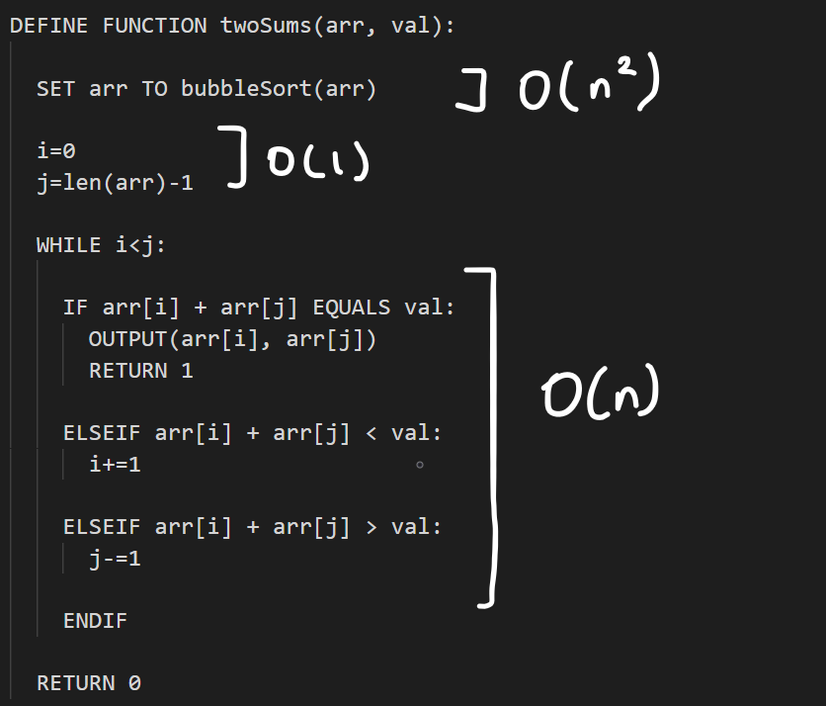

**- Assume there are two ordered array list of n elements. Merge these two lists to get a single list in increasing order.**

In this example, n is equal to the length of the first and m is equal to the length of the second array

Time complexity depends on the size of the bigger array and it takes linear time

Θ(1) + Θ(min{n,m}) + Θ(n - min{n,m}) + Θ(m - min{n,m}) = Θ(n+m) = **Θ(max{n,m})**

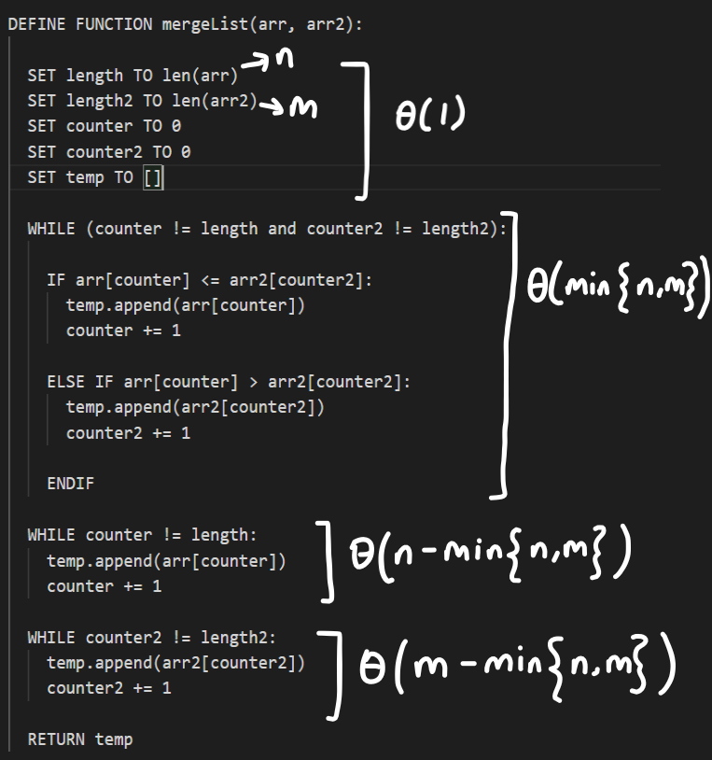

**Part 5 :**

**a)**

Time complextiy : Θ(1)

Space complexity : Θ(1)

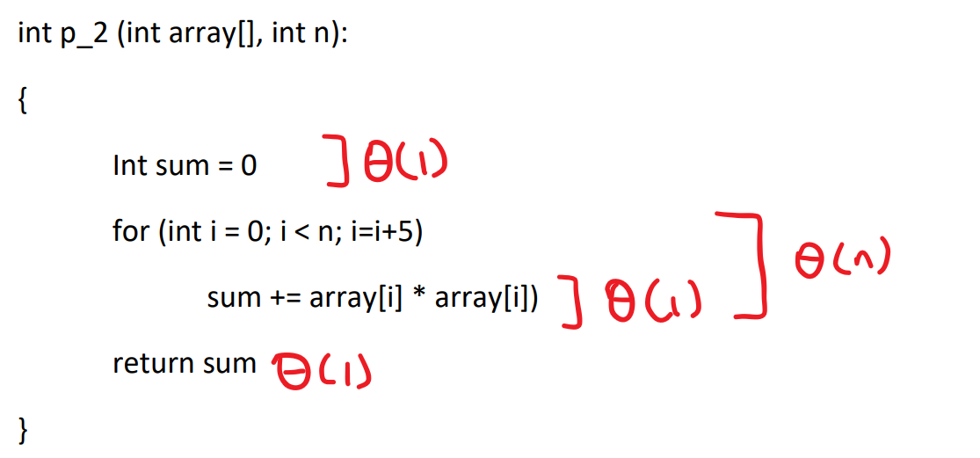

**b)**

Time Complexity : Θ(1) + Θ(n) + Θ(1) = Θ(n)

Space Complexity : Θ(1)



**c)**

Time Complexity : Θ(n log2n)

Space Complexity : Θ(1)

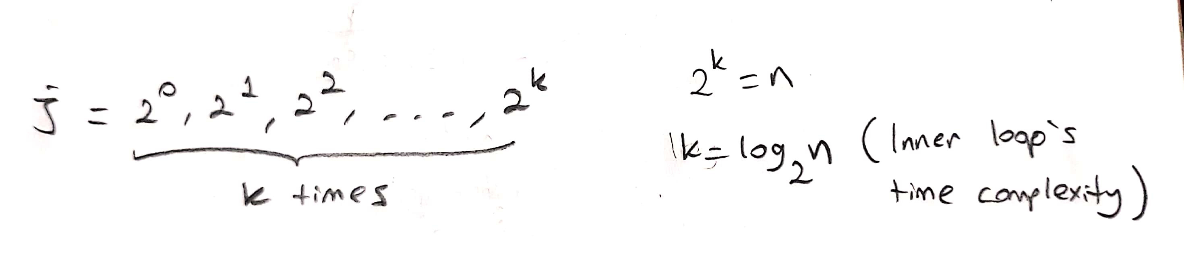

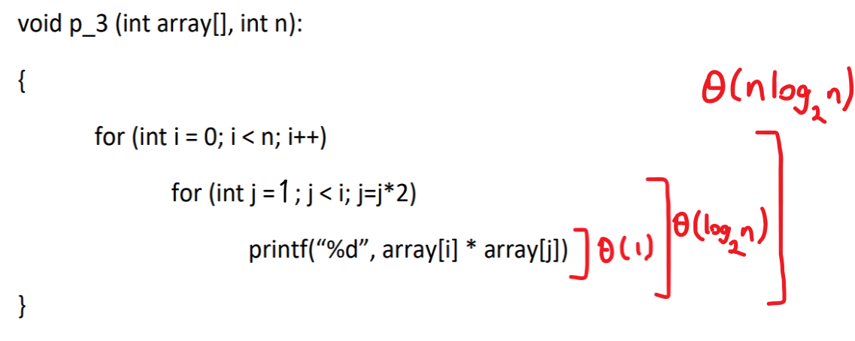

**d)**

Time Complexity :

Tworst(n) = Θ(n) + Θ(n log2n) = Θ(n log2n)

Tbest(n) = Θ(n) + Θ(n) = Θ(n)

Space Complexity : Θ(1)