Circuits and Electronic Laboratory

Experiment #2

# Purpose of Experiment

Gaining the habit of building circuits on the breadboard, learning the relation between ammeter and current on the circuit and experimenting Kirchhoff’s current law.

# General Information

**Kirchhoff’s Current Law**: This law states that on any circuit at any time *t* sum of currents that originates form the node and currents that goes into the node is zero.

Σ

*n*

*Ik* = 0 (1)

*k*=0

where *n* is the total number of branches with currents flowing towards or away from the node. Currents that goes into the node have positive sign. Vice versa currents that goes out of the node has negative sign.

A device called ammeter (**Am**per **Meter**) is a measuring instrument used to measure the current in a circuit. Electric currents are measured in amperes. Today there are two different kinds of ammeter which are analog and digital ones. Digital ones are widely used nowadays. An ideal ammeter has an internal resistance of zero. Due to this property it behaves like a short circuit. Practical ammeters usually has 0.01Ω - 0.1Ω Ammeters always connected in series to the component that needs its current to be measured. Caution do not connect ammeter parallel to component. Be sure about the current to be measured is smaller than ammeters maximum current. If

not sure, first use biggest current ratio of ammeter to measure.

**Nodes:** a node in a circuit is defined as a region between two circuit elements. An example of 3 different nodes in a circuit given Figure 1. Each color represents different node.

**Tip**: If a components current needs to be measured, follow this steps:

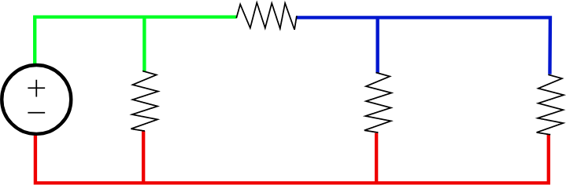Figure 1: Nodes In a Circuit, source: Wikipedia

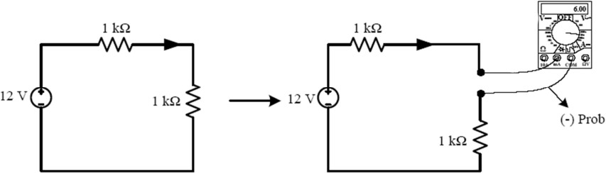Figure 2: Sample connection diagram of a ammeter

* If using a multi meter, get into the current measurement state

Put red (+) probe to mA input if current to be measured is smaller than 200ma If it’s bigger than that, or current is unknown use A input of multi meter. Put black (-) probe to com input.

*•*

* Turn off all voltage sources.
* Disconnect the cable that connects the component.
* Connect ammeter appropriately instead of the cable that disconnected.
* Turn on voltage sources. Read the current value.

# Preparations Before Experiment

For the circuit in Figure 2, calculate currents of components and show that Kirchhoff’s current law holds.

*•*

Figure 3:

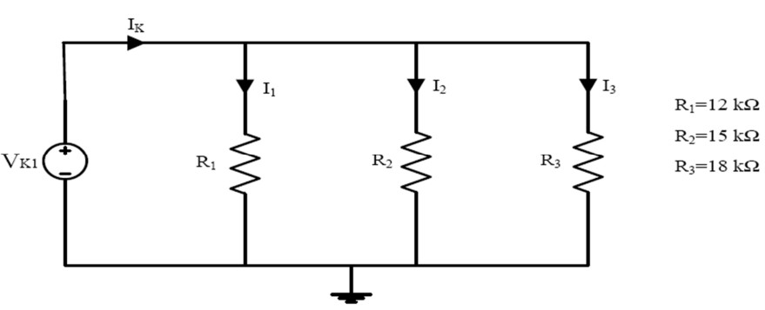

For the circuit in Figure 3, calculate currents in Table 1 with given voltages.

*•*

* Make research about relative error in circuits.

# Section 1

1. Construct the circuit given in Figure 3. Set the DC source with the help of voltmeter according to table 1. Measure *Ik*, *I*1, *I*2, *I*3 with the help of ammeter. Fill the Table 1.

|  |  |  |  |  |  |  |  |
| --- | --- | --- | --- | --- | --- | --- | --- |
| *Vk*1 | *I*1[*A*] | *I*2[*A*] | *I*3[*A*] | *I*1 + *I*2 +  *I*3[*A*] | *Ik*[*A*]  (Mea- sured) | *Ik*[*A*]  (Calcu- lated) | Relative  Error [%] |
| 5*V* | 0.417mA | 0.333mA | 0.278mA | 1.027mA | 1.027mA |  |  |
| 8*V* | 0.666 mA | 0.533 mA | 0.444 mA | 1.644 mA | 1.644 mA |  |  |
| 12*V* | 1 mA | 0.8 mA | 0.666 mA | 2.466 mA | 2.466 mA |  |  |
| Table 1 | | | | | | | |

1. In the circuit depicted in figure 4, set source voltage to 12*V* . Fill the Table 2 by measuring all component currents. Show that Kirchhoff’s current law holds.

Figure 4:

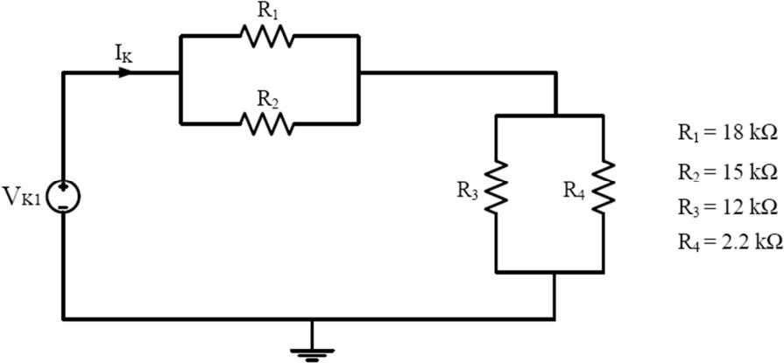

|  |  |  |  |  |  |  |
| --- | --- | --- | --- | --- | --- | --- |
| *IR*1[*A*] | *IR*2[*A*] | *IR*1 +  *IR*2[*A*] | *IR*3[*A*] | *IR*4[*A*] | *IR*3 +  *IR*4[*A*] | *Ik*[*A*] |
| 0.543mA | 0.651 mA | 1.194 mA | 0.185mA | 1.01mA | 1.196mA | 1.195mA |
| Table 2 | | | | | | |

# Section 2

1. Remove *R*1 and *R*2 in circuit 4 and insert equivalent resistor in place of *R*1 and *R*2. Connect 12*V* voltage source in series with *R*4. Calculate currents across all resistors and also calculate cycle currents. Fill the Table 3.

*−*

1. Connect *R*5 = 3*.*3*k* with parallel to equivalent resistor that connected in place of *R*1 and *R*2 Calculate currents across all resistors and also calculate node currents. Fill the Table 4. Show that Kirchhoff’s current law hold for each node. Fill the Table 5 with Kirchhoff’s current law equations for the nodes. Annotate nodes starting from voltage source with left to right. Ex: Node 1 is the node between voltage source and *R*1&2*eqv*
2. Measure all voltages across every resistor in the last circuit you built,. Fill the Table 6. Show that Kirchhoff’s voltage law holds. Fill the Table 7 with Kirchhoff’s voltage law equations.

|  |  |  |  |  |
| --- | --- | --- | --- | --- |
| *IC*1[*A*] | *IC*2[*A*] | *IR*1*,*2*eqv* [*A*] | *IR*3[*A*] | *IR*4[*A*] |
|  |  | 0.185mA | 0.873mA | -0.688mA |
| Table 3 | | | | |

|  |  |  |  |  |  |  |
| --- | --- | --- | --- | --- | --- | --- |
| *IN*1[*A*] | *IN*2[*A*] | *IN*3[*A*] | *IR*1*,*2*eqv* [*A*] | *IR*3[*A*] | *IR*4[*A*] | *IR*5[*A*] |
|  |  |  | 0.127mA | 0.913mA | -0.472mA | 0.315mA |
| Table 4 | | | | | | |

|  |  |  |  |
| --- | --- | --- | --- |
| Node | 1 |  | |
| Node | 2 |  | |
| Node | 3 |  | |
| Node | 4 |  | |
|  |  | Table | 5 |

|  |  |  |  |
| --- | --- | --- | --- |
| *VR*1*,*2*eqv* [*V* ] | *VR*3[*V* ] | *VR*4[*V* ] | *VR*5[*V* ] |
| 1.038V | 10.962V | -1.038V | 1.038V |
| Table 6 | | | |

|  |  |  |  |
| --- | --- | --- | --- |
| Cycle | 1 | 12 – 1.038 – 10.962 = 0 | |
| Cycle | 2 | 1.038 – 1.038 = 0 | |
| Cycle | 3 | 12 – 1.038 – 10.962 = 0 | |
|  |  | Table | 7 |

Barış Ayyıldız 1901042252