Circuits and Electronic Laboratory

Experiment #5

# Purpose of Experiment

In this experiment we will see how RC, RL and RLC circuit works.

# General Information

There are three basic, linear passive lumped analog circuit components: the resistor (R), the capacitor (C), and the inductor (L). These may be combined in the RC circuit, the RL circuit, the LC circuit, and the RLC circuit, with the acronyms indicating which components are used. These circuits, among them, exhibit a large number of important types of behaviour that are fun- damental to much of analog electronics. In particular, they are able to act as passive filters.

To specify the behavior of an electrical circuit as a function of time, the equations related to the circuit must be acquired and solved. Circuit equations, in their general form, include integrals, derivatives and algebraic relations.

Circuits can be grouped as first order and second order circuits. First order circuits consist of a resistor with a capacitor or a inductor but not both. Second order circuits can be made from using both capacitor and inductor.

Let’s consider circuit depicted in Figure 1. Derivation of RC circuit equa- tions is as follows:

*Vr* = *iR* (1)

*q*

*Vc* =

(2)

*C*

*i* = *dq dt*

*V* = *dq R* + *q*

(3)

(4)

*dt C*

*V C* = *dq RC* + *q* (5)

*dt*

*V C q* = *dq RC* (6)

*−*

*dt*

*dt*

*RC*

∫ *t dt*

*dq*

=

*−*

*V C q*

= ∫ *q dq*

(7)

(8)

0 *RC*

0 *V C − q*

*t*

*−RC*

*t*

= *ln*( *V C − q* )(9)

*V C*

*V Ce−RC* = *V C − q* (10)

*V C*(1 *− e−RC* ) = *q* (11)

*t*

*V t*

*e−*

*RC* = *i* (12)

*R*

In equations (13) and (14) *t*

*RC*

*t*

*Vc* = *V* (1 *− e RC* )(13)

*−*

*Vr* = *V e−RC* (14)

*t*

is called time constant *τ* .

RL and RLC circuits equations can be derived similarly.

# Part List

* *R* = 330Ω
* *C* = 100*uF*
* *L* = 1*H*

# Preparations Before Experiment

* Revise time derivation of *ln*(*f* (*x*)) and *ef*(*x*)*functions*
* What is a capacitor and how it behaves?
* What is an inductor and how it behaves?

Construct and analyze all circuits given in this document on a simula- tion program.

*•*

Figure 1: RC Circuit

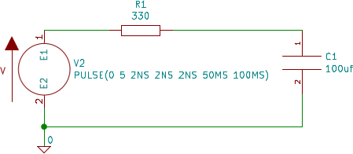

# Section 1

* Construct the circuit depicted in Figure 1 on the board.
* Use signal generator to generate *V* as -5V to 5V 10Hz square wave.
* Connect first channel of oscillator to *C*1
* Calculate time constant *τ* = *...*
* Calculate *Vc* = *...* at *t* = 0*.*05 using the equations derived above.
* Plot the *Vc* wave as seen on oscillator to Table 1.

Figure 2: RL Circuit

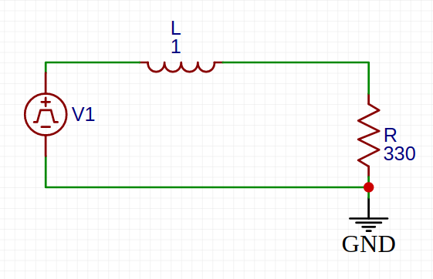

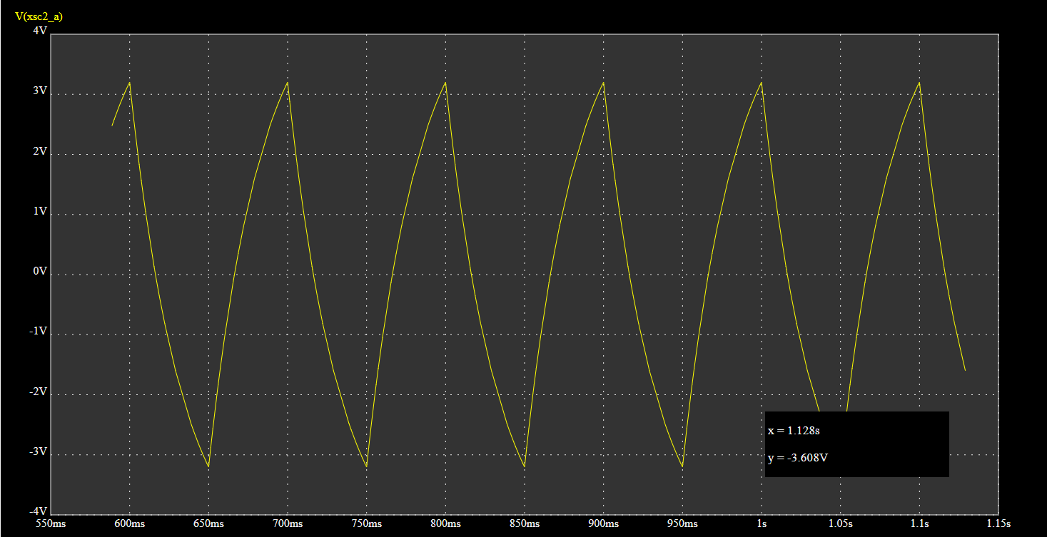

Table 1: *Vc* Plotted Using Experimental Data

# Section 2

* Construct the circuit depicted in Figure 2 on the board.
* Use signal generator to generate *V* as -5V to 5V 10Hz square wave.
* Connect first channel of oscillator to *R*1
* Calculate time constant *τ* = *...*
* Plot the *Vr* wave as seen on oscillator to Table 2.

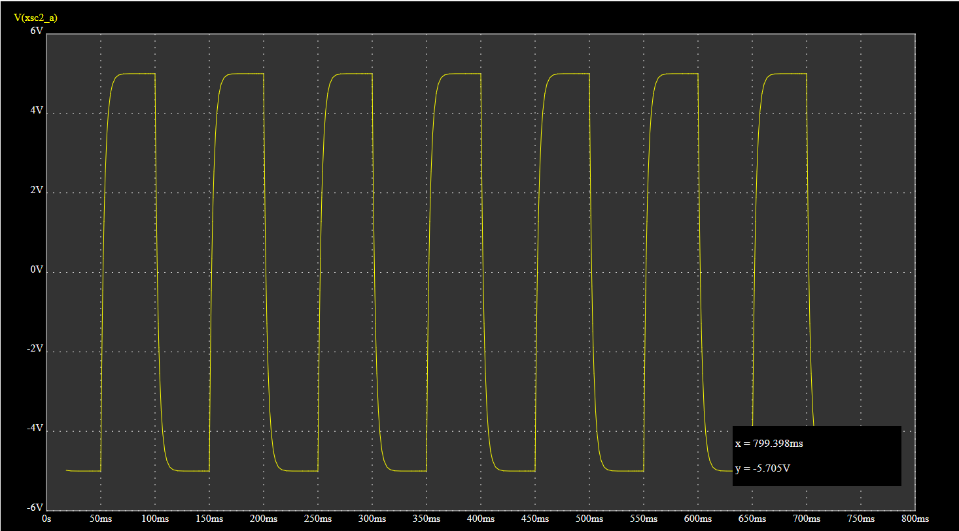

Table 2: *Vr* Plotted Using Experimental Data

# Section 3

* Construct the circuit depicted in Figure 3 on the board.
* Use signal generator to generate *V* as -5V to 5V 10Hz square wave.
* Connect first channel of oscillator to *C*3
* Plot the *Vc* wave as seen on oscillator to Table 3.

Table 3: *Vc* Plotted Using Experimental Data

Figure 3: RLC Circuit

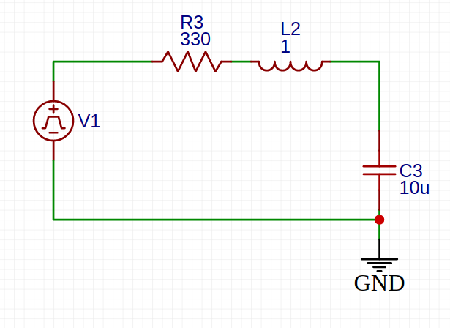

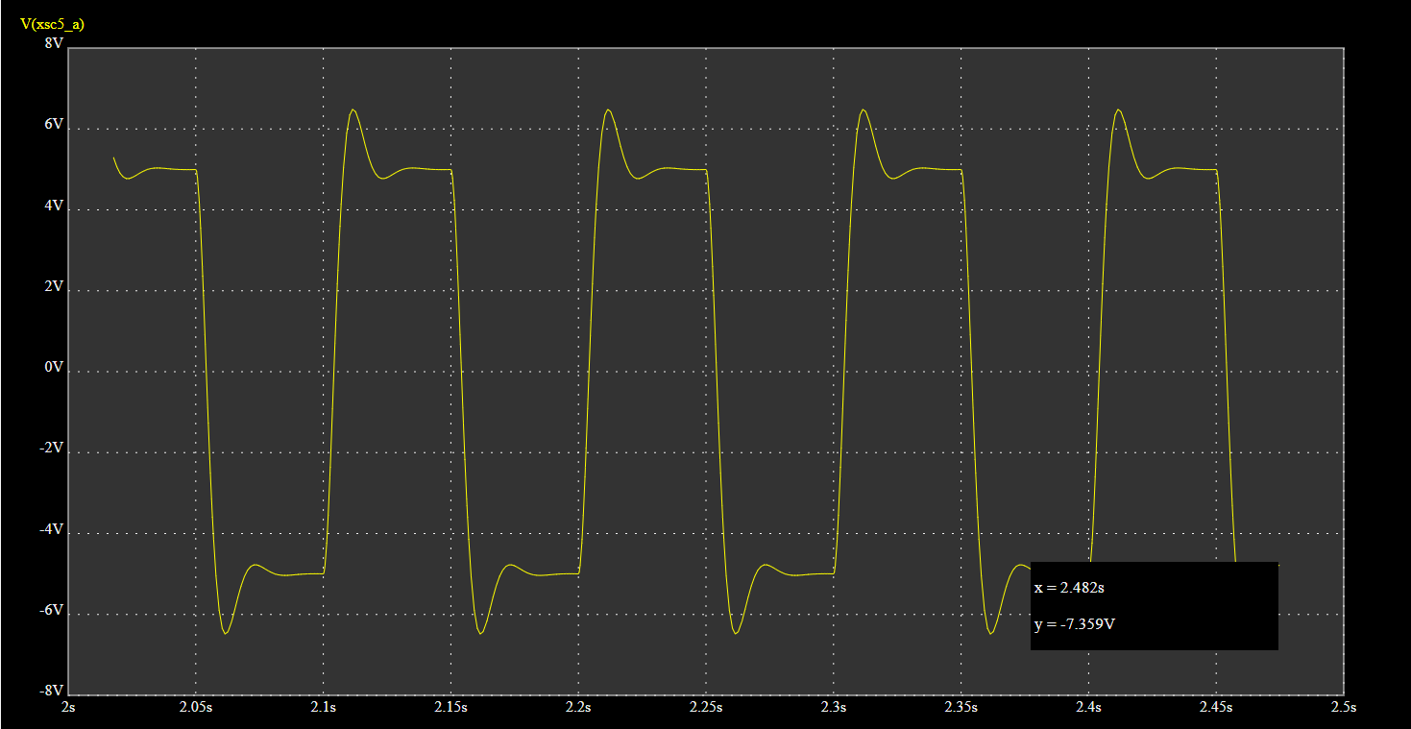

|  |  |  |  |  |  |  |  |  |  |  |  |  |  |  |  |  |  |  |  |
| --- | --- | --- | --- | --- | --- | --- | --- | --- | --- | --- | --- | --- | --- | --- | --- | --- | --- | --- | --- |
|  |  |  |  |  |  |  |  |  |  |  |  |  |  |  |  |  |  |  |  |
|  |  |  |  |  |  |  |  |  |  |  |  |  |  |  |  |  |  |  |  |

Barış Ayyıldız 1901042252