Circuits and Electronic Laboratory

Experiment #1

# Purpose of Experiment

Gaining the habit of building circuits on the breadboard, learning what volt- meter is and experimenting Kirchhoff’s voltage law.

# General Information

**Kirchhoff’s Voltage Law**: This law states that on any circuit at any time

*t* sum of directed voltages around any closed loop is zero.

*n*

Σ

*Vk* = 0 (1)

*k*=0

where *n* is the total number of voltages measured. Voltages with a same reference direction with the circuit loop has positive sign. Vice versa voltages with opposite reference direction with the circuit loop has negative sign.

**Ohm’s Law**: states the relationship between the current that goes through

a conductor between two points and its voltage across two points. This rela- tionship is called as the resistance

*V*

*I* =

*R*

**Measurement Errors**:

(2)

* **Absolute Error**: It is the difference between the actual value of a measured physical quantity and its measured value.

∆*x* = *xcalculated − xmeasured* (3)

* **Relative Error**: The ratio of absolute error to actual value is called relative error.

∆

*β* =

*xcalculated*

%100 (4)

A device called voltmeter (or multimeter which is in voltage mode) is a measuring instrument used to measure the voltage in a circuit. Voltages are measured in volts. Today there are two different kinds of voltmeter which are analog and digital ones. Digital ones are widely used nowadays. An ideal voltmeter has an internal resistance of infinity. Due to this property it behaves like an open circuit. However, practical voltmeters usually has very high resistance but not infinity. Voltmeters always connected in parallel to the component that wanted to be measured.

**Tip**: If a components or nodes voltage needs to be measured, follow this

steps:

* If using a multi meter, get into the voltage measurement state
* If DC voltage wanted to be measured, then get in the DC state of multimeter
* If AC voltage wanted to be measured, then get in the AC state of multimeter
* Put red (+) probe to (Ω - V) input, put black (-) probe to com input.
* Since we don’t know the exact value of the voltage that will be mea- sured, put the multimeter highest voltage state.
* Turn off all voltage sources.
* Put (+) probe of multimeter to the node where current flows through.
* Put (-) probe to the reference node of the circuit if you measure node voltage
* Put (-) probe to the opposite side of the component if you want to measure the component voltage
* Turn on voltage sources. Read the voltage value.

# Preparations Before Experiment

* Learn how to read resistor values by their color code.
* Research about how a voltmeter measures the volts.
* Research about how breadboard works

Figure 1: Sample connection diagram of a voltmeter

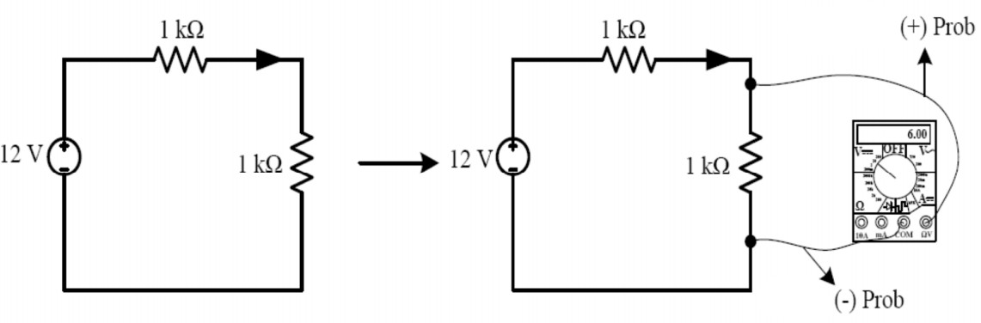

* Research about how to connect circuit components serial or parallel to breadboard
* Write appropriate color names to the Table 1.
* Write appropriate resistor values in the Table 2.

|  |  |  |  |  |
| --- | --- | --- | --- | --- |
| Resistor  Value | 1. Color | 2. Color | 3. Color | 4. Color |
| 560 Ω *±* %10 | Green | Blue | Brown | Silver |
| 20 *k*Ω *±* %5 | Red | Black | Orange | Gold |
| 33 *k*Ω *±* %20 | Orange | Orange | Orange | Colorless |
| 47 *k*Ω *±* %5 | Yellow | Purple | Orange | Gold |
| 1 *k*Ω *±* %20 | Brown | Black | Red | Colorless |
| Table 1 | | | | |

|  |  |  |  |  |
| --- | --- | --- | --- | --- |
| 1. Color | 2. Color | 3. Color | 4. Color | Resistor  Value |
| Brown | Gray | Black | Colorless | 18 Ω, *±* %20 |
| Green | Blue | Purple | Silver | 56x10^7 Ω, *±*%10 |
| Yellow | Purple | Brown | Gold | 470 Ω, *±*%5 |
| White | Green | Black | Gold | 95 Ω, *±*%5 |
| Red | White | Orange | Colorless | 29 *k*Ω, *±* %20 |
| Table 2 | | | | |

Figure 2:

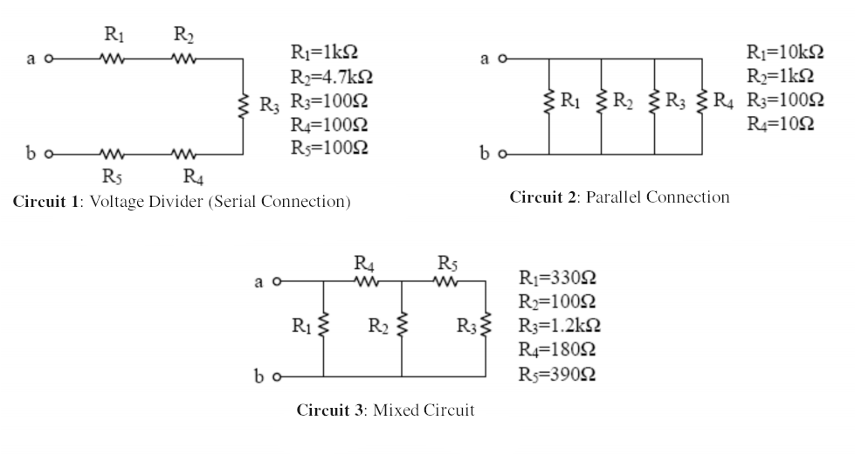

# Section 1

1. Construct the Circuit 1, Circuit 2 and Circuit 3 at Figure 2 on breadboard, calculate the equivalent resistance and fill the Table 3

|  |  |  |  |  |
| --- | --- | --- | --- | --- |
| Circuit | *Rab*[Ω] Cal-  culated | *Rab*[Ω]  Measured | Absolute  Error [Ω] | Relative  Error % |
| Circuit 1 | 6 *k*Ω |  |  |  |
| Circuit 2 | 9 Ω |  |  |  |
| Circuit 3 | 194.94 Ω |  |  |  |
| Table 3 | | | | |

1. Construct the circuit given in the Figure 3 to the breadboard, fill the Table 4 and Table 5 accordingly.

Figure 3:

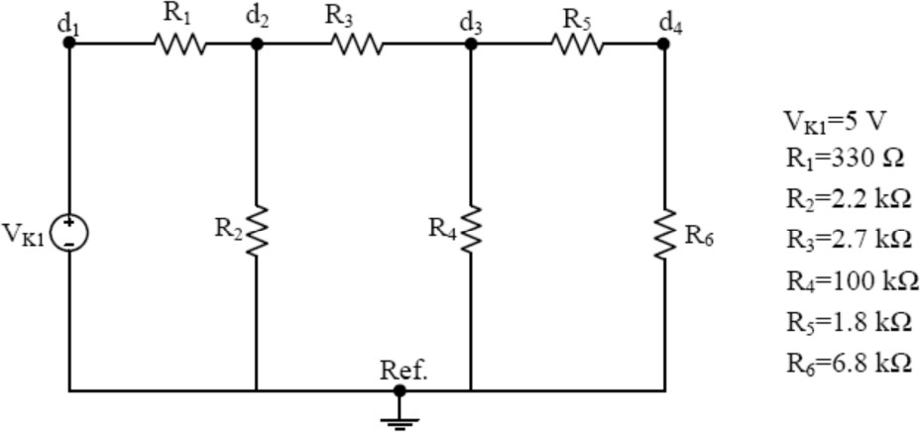

|  |  |  |  |  |
| --- | --- | --- | --- | --- |
| Node Voltage | *V* [*V olt*]  Calculated | *V* [*V olt*]  Measured | Absolute  Error [Ω] | Relative  Error % |
| *Vd*1 | 5 | 5 |  |  |
| *Vd*2 | 3.944 | 3.944 |  |  |
| *Vd*3 | 0.139 | 0.139 |  |  |
| *Vd*4 | 0.11 | 0.11 |  |  |
| Table 4 | | | | |

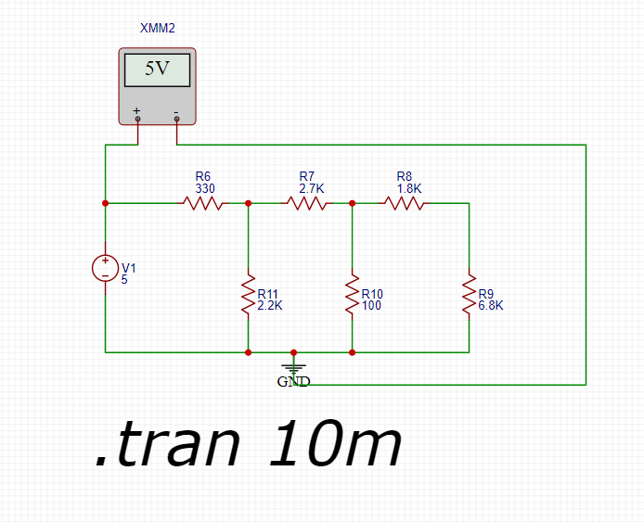

Vd1 =>

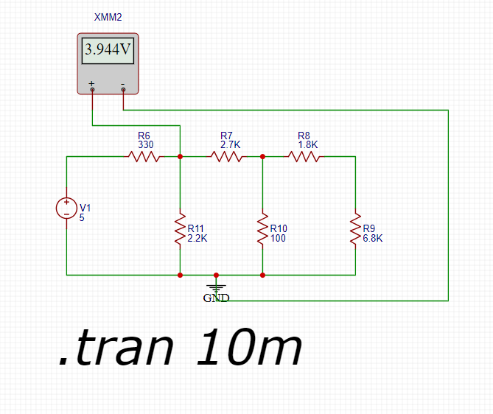

Vd2 =>

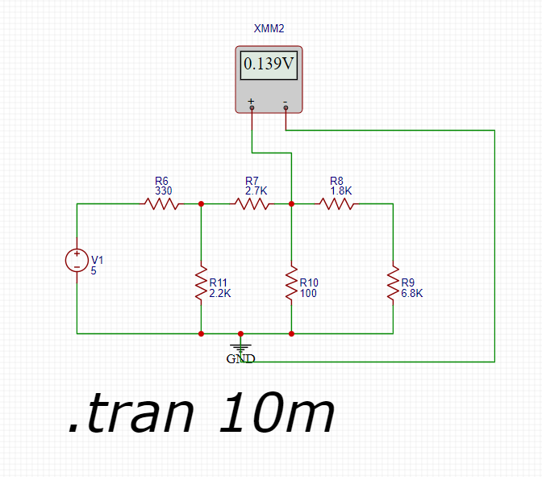

Vd3 =>

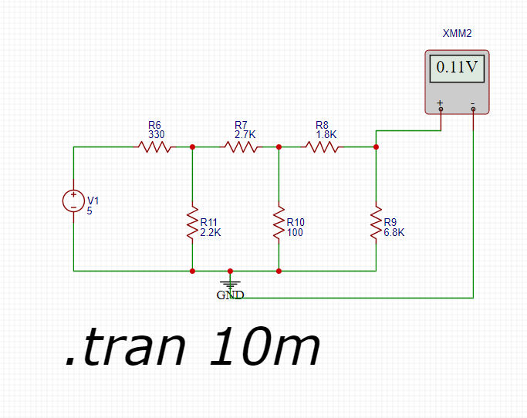

Vd4 =>

|  |  |  |  |  |
| --- | --- | --- | --- | --- |
| Component | *V* [*V olt*]  Calculated | *V* [*V olt*]  Measured | Absolute  Error [Ω] | Relative  Error % |
| *VK*1 | 5 | 5 |  |  |
| R1 | 0.767 | 0.767 |  |  |
| R2 | 4.233 | 4.233 |  |  |
| R3 | 1.076 | 1.076 |  |  |
| R4 | 3.157 | 3.157 |  |  |
| R5 | 0.661 | 0.661 |  |  |
| R6 | 2.496 | 2.496 |  |  |
| Table 5 | | | | |