Circuits and Electronic Laboratory

Experiment #3

# Purpose of Experiment

Some of the important theorems of the circuit theory are superposition and multiplicativity. In this experiment, better understanding of these theorems is aimed.

# General Information

Multiplicativity and superposition depend on linearity property of circuits. Another way of saying this is if superposition and multiplicativity are valid in a circuit then that circuit is linear.

**Superposition Theorem:** It helps us to analyze circuits that have mul- tiple sources. In short, it is to calculate the current and voltage for each source independently and then summing the results. There are several key points to consider when using this approach:

All sources except for the source to be analyzed should be switched off. For voltage sources, this means setting the voltage 0*V* which is short circuit. For current sources, this means setting the current 0*A* which means open circuit.

*•*

Sources that are depend other circuit members should be leaved as they are.

*•*

**Steps to apply superposition theorem:**

1. All sources should be switched off at first, then select a source and activate it. Calculate all node voltages and cycle currents.
2. Repeat the first step for the rest of the sources.
3. Find the results by summing all results for a node current or a cycle voltage.

**Multiplicativity Theorem:** This is made of just linear elements like resistors, if amplitudes of all sources increased *α* times then amplitudes of current and voltage outputs of the circuit increases *α* times.

**Tip:** The formula *V* = *IR* states that if *R* goes to 0, then the current goes to infinity. Another way of saying this is, current increases as resistance decreases. Most conductors have nearly 0 internal resistance. Due to this fact connecting a wire parallel to a circuit element makes the element **short circuit**ed. **Open circuit** is where *R* goes to infinity *I* goes to 0. If two nodes has no connection than it means they have infinity resistance between them. There will be no current flowing.

# Preparations Before Experiment

What are open and short circuit and how to implement them on cir- cuits?

*•*

Why ammeters connected serial to the circuit? What happens when we connect them in parallel?

*•*

* What are superposition and multiplicativity theorems?
* Make *VK*2 source short circuit in the circuit depicted in Figure 1. Cal- culate *IR*2 for *VK*1 values given in Table 1. Fill the Table 1. Check if results holds for multiplicativity theorem.

Analyze and calculate currents in the circuit depicted in Figure 1 with the superposition aspect. Fill the Table 2. Check if results holds for superposition theorem.

*•*

Simulate all circuits given in this document by considering each demand in the tables. (You should have results for each entry in the tables.)

*•*

* Fill *calculated* sections in all tables. Bring results with you.

The preparation section has great value since you will compare your mea- surements with simulations you made.

# Section 1

1. Construct the circuit depicted in Figure 1 on the board. Make *VK*2 source short circuit (0*V* ). With the help of a multimeter set *VK*1 source voltage according to Table 1. Measure *IR*2 currents. Fill the Table 1. Show multiplicativity theorem holds.

Figure 1: Circuit 1

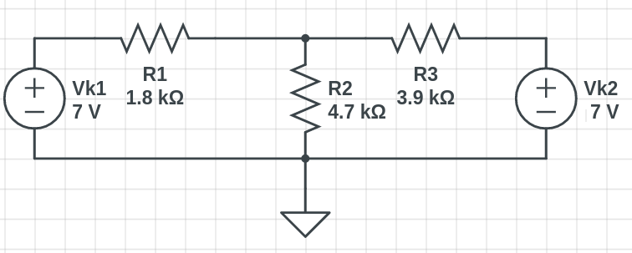

1. Construct the circuit depicted in Figure 1 on the board. Measure *IR*2 current while both voltage source active. Then measure *IR*2 current while making voltage sources short circuit one by one. Show superpo- sition theorem holds. Fill the Table 2.

|  |  |  |  |
| --- | --- | --- | --- |
| Multiplicativity Theorem | | | |
| *VK*1[*V* ]  Source Volt- age | *IR*2[*mA*]  Calculated | *IR*2[*mA*]  Measured | Relative  Error [%] |
| 1 |  | 0,488 |  |
| 2 |  | 0,603 |  |
| 4 |  | 0,835 |  |
| Table 1 | | | |

Figure 2: Circuit 2

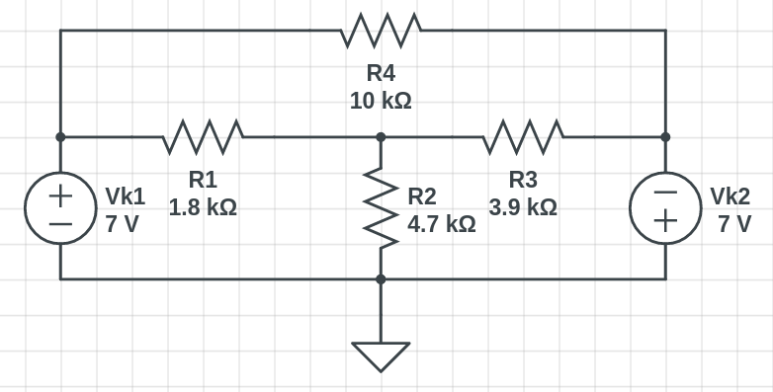

|  |  |  |  |  |  |  |  |  |  |
| --- | --- | --- | --- | --- | --- | --- | --- | --- | --- |
| Superposition Theorem | | | | | | | | | |
| *VK*1[*V* ]  Source age | Volt- | | *VK*2[*V* ]  Source Volt- age | | *IR*2[*mA*]  Calculated | | *IR*2[*mA*]  Measured | | Relative  Error [%] |
| 7 | | | 0 | | *Ij*  *R*2 | = | *Ij*  *R*2 | =0.807 |  |
| 0 | | | -7 | | *I*”  *R*2 | = | *I*”  *R*2 | =0.373 |  |
| *Ij*  *R*2 | | + *I*”  *R*2 | | = |  | | | | |
| 7 | | | -7 | | *IR*2 = | | *IR*2 =1.18 | |  |
| Table 2 | | | | | | | | | |

# Section 2

* Construct the circuit depicted in Figure 2 on the board. Measure *IR*2 and *IR*4 currents while both voltage source active. Then, measure *IR*2 and *IR*4 currents while short circuiting voltage sources one by one. Show superposition theorem holds. Fill the Table 3.
* Construct the circuit depicted in Figure 3 on the board. First, calcu- late, then measure *IR*4 current while both voltage source active. Then, measure *IR*4 current while short circuiting voltage sources one by one. Show superposition theorem holds. Fill the Table 4.

Figure 3: Circuit 3

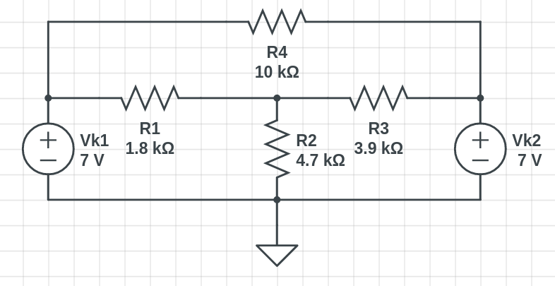

|  |  |  |  |  |  |  |  |  |  |
| --- | --- | --- | --- | --- | --- | --- | --- | --- | --- |
| *VK*1[*V* ]  Source age | Volt- | | *VK*2[*V* ]  Source Volt- age | | *IR*2[*mA*]  Measured | | *IR*4[*mA*]  Measured | | Relative  Error [%] |
| 7 | | | 0 | | *Ij*  *R*2 | =0.807 | *Ij*  *R*4 | =0.7 |  |
| 0 | | | -7 | | *I*”  *R*2 | =-0.373 | *I*”  *R*4 | =0.7 |  |
| *Ij*  *R*2 | | + *I*”  *R*2 | | = |  | | | | |
| *Ij*  *R*4 | | + *I*”  *R*4 | | = |  | | | | |
| 7 | | | -7 | | *IR*2 =0.435 | | *IR*4 =1.4 | |  |
| Table 3 | | | | | | | | | |

|  |  |  |  |  |
| --- | --- | --- | --- | --- |
| *VK*1[*V* ]  Source Volt- age | *VK*2[*V* ]  Source Volt- age | *IR*4[*mA*]  Calculated | *IR*4[*mA*]  Measured | Relative  Error [%] |
| 7 | 0 | *Ij* =  *R*4 | *Ij* =0.7  *R*4 |  |
| 0 | 7 | *I*” =  *R*4 | *I*” =-0.7  *R*4 |  |
| 7 | 7 | *IR*4 = | *IR*4 =0 |  |
| Table 4 | | | | |