Circuits and Electronic Laboratory

Experiment #6

# Purpose of Experiment

In this experiment we will see how diodes work. Learn more about AC/DC and rectifiers.

# General Information

Alternating current (AC) is an electric current which periodically reverses direction, in contrast to direct current (DC) which flows only in one direc- tion. Alternating current is the form in which electric power is delivered to businesses and residences, and it is the form of electrical energy that con- sumers typically use when they plug kitchen appliances, televisions, fans and electric lamps into a wall socket. A common source of DC power is a battery cell in a flashlight. The abbreviations AC and DC are often used to mean simply alternating and direct, as when they modify current or voltage.

i,v

pulsating

direct variable

t

alternating

Figure 1: Types of Current Sources

A diode is an electronic component that allows one directional current flow only. Using this property a lot of useful applications such as rectifiers, clippers/clappers, voltage multipliers, etc. can be realized.

Rectifiers are AC-DC converters. They provide time varying but unidirec- tional current at their output. Capacitors are generally used with rectifiers to filter the time varying output of them and obtain a smooth signal instead.

# Part List

* *R*1 = 12*K*
* *D*1 = 4*.*7*V* Zener Diode for circut 1
* *D*1 1N4001 Diode for circuit 2

# Preparations Before Experiment

* Make research about AC and DC current sources.
* What is a diode? What does it do on a circuit?
* Make research about rectifiers.
* Construct the circuit given in Figure 1 on a simulation program.

Vary *Vin* on the simulation tool according to the values in the first row of Table 1 and record the voltage across the diode and the current passing through the diode on Table 1 to *Calculated* rows.

*•*

# Section 1

Construct the circuit depicted in Figure 1 on the board. Be aware that the diode in the circuit is a zener diode.

*•*

Vary *Vin* according to the values in the first row of Table 1 and record the voltage across the diode and the current passing through the diode on Table 1 on measured row.

*•*

Using the data in the 2nd and the 3rd rows of table 1, plot the charac- teristic curve of the zener diode.

*•*

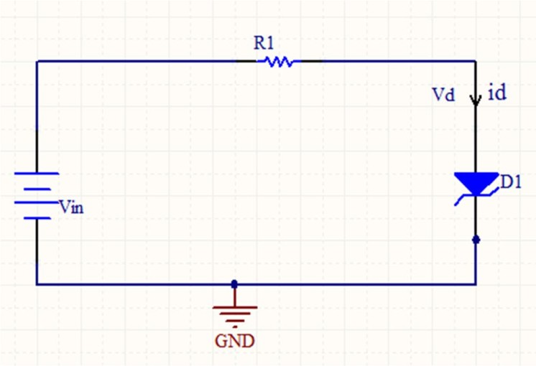Figure 2: Circuit 1

|  |  |  |  |  |  |  |  |  |  |  |  |  |  |  |
| --- | --- | --- | --- | --- | --- | --- | --- | --- | --- | --- | --- | --- | --- | --- |
| *Vin*(*V* ) | -12 | -11 | -10 | -9 | -8 | -7 | 0 | 0.6 | 0.65 | 0.7 | 0.75 | 0.8 | 0.85 | 0.9 |
| *Vd*(*V* ) Cal-  culated | -10 | -10 | -10 | -9 | -8 | -7 | 0 | 0.6 | 0.65 | 0.7 | 0.75 | 0.8 | 0.85 | 0.9 |
| *Id*(*A*) Cal-  culated | 1.67e^-4 | 8.33e^-5 | 0 | 0 | 0 | 0 | 0 | 0 | 0 | 0 | 4.17e^-5 | 8.33e^-6 | 1.2e^-5 | 1.66e^-5 |
| *Vd*(*V* )  Measured | -9.782 | -9.711 | -9.57 | -8.995 | -8 | -7 | 3.1e^-33 | 0.277 | 0.281 | 0.284 | 0.286 | 0.289 | 0.291 | 0.293 |
| *Id*(*A*) Mea-  sured | -184.853µ | -107.377µ | -35.865µ | -422.2n | -880.2p | -676.8p | -2.62e^-37 | 26.912 µ | 30.788 µ | 34.697 µ | 38.632 µ | 42.589 µ | 45.563 µ | 50.552 µ |
| Table 1 | | | | | | | | | | | | | | |

Characteristic Curve using Experimental Data

# Section 2

Construct the circuit given in Figure 2 without connecting the capaci- tor. Use a function generator to supply source voltage.

*•*

* Use a scope to observe the voltage signal on *V*1 (with respect to the ground) and *V*2 (with respect to the ground); connect *V*1 to the 1st channel and V2 to the 2nd channel of the scope. Choose the same volts/div value for both channels. Record volts/div and time/div val- ues. Plot the observed graph.
* Connect *C*1 to the circuit and repeat step 2.

Calculate the effective value of *V*1. *V eff* = 1 / sqrt(2)

*V*2 Plot without *C*1 using Experimental Data

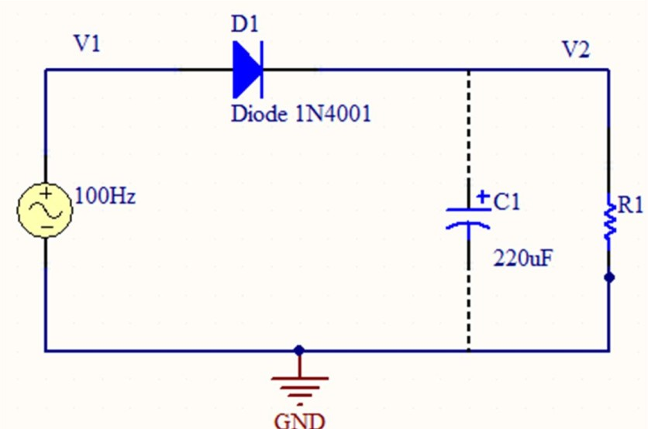Figure 3: Half-Wave Rectifier

|  |  |  |  |  |  |  |  |  |  |  |  |  |  |  |
| --- | --- | --- | --- | --- | --- | --- | --- | --- | --- | --- | --- | --- | --- | --- |
|  |  |  |  |  |  |  |  |  |  |  |  |  |  |  |
|  |  |  |  |  |  |  |  |  |  |  |  |  |  |  |
|  |  |  |  |  |  |  |  |  |  |  |  |  |  |  |
|  |  |  |  |  |  |  |  |  |  |  |  |  |  |  |
|  |  |  |  |  |  |  |  |  |  |  |  |  |  |  |
|  |  |  |  |  |  |  |  |  |  |  |  |  |  |  |
|  |  |  |  |  |  |  |  |  |  |  |  |  |  |  |
|  |  |  |  |  |  |  |  |  |  |  |  |  |  |  |
|  |  |  |  |  |  |  |  |  |  |  |  |  |  |  |
|  |  |  |  |  |  |  |  |  |  |  |  |  |  |  |
|  |  |  |  |  |  |  |  |  |  |  |  |  |  |  |
|  |  |  |  |  |  |  |  |  |  |  |  |  |  |  |
|  |  |  |  |  |  |  |  |  |  |  |  |  |  |  |
|  |  |  |  |  |  |  |  |  |  |  |  |  |  |  |
|  |  |  |  |  |  |  |  |  |  |  |  |  |  |  |

*V*2 Plot with *C*1 using Experimental Data

|  |  |  |  |  |  |  |  |  |  |  |  |  |  |  |
| --- | --- | --- | --- | --- | --- | --- | --- | --- | --- | --- | --- | --- | --- | --- |
|  |  |  |  |  |  |  |  |  |  |  |  |  |  |  |
|  |  |  |  |  |  |  |  |  |  |  |  |  |  |  |
|  |  |  |  |  |  |  |  |  |  |  |  |  |  |  |
|  |  |  |  |  |  |  |  |  |  |  |  |  |  |  |
|  |  |  |  |  |  |  |  |  |  |  |  |  |  |  |
|  |  |  |  |  |  |  |  |  |  |  |  |  |  |  |
|  |  |  |  |  |  |  |  |  |  |  |  |  |  |  |
|  |  |  |  |  |  |  |  |  |  |  |  |  |  |  |
|  |  |  |  |  |  |  |  |  |  |  |  |  |  |  |
|  |  |  |  |  |  |  |  |  |  |  |  |  |  |  |
|  |  |  |  |  |  |  |  |  |  |  |  |  |  |  |
|  |  |  |  |  |  |  |  |  |  |  |  |  |  |  |
|  |  |  |  |  |  |  |  |  |  |  |  |  |  |  |
|  |  |  |  |  |  |  |  |  |  |  |  |  |  |  |
|  |  |  |  |  |  |  |  |  |  |  |  |  |  |  |