Report for lab:11

The History of Don Quixote

Miguel de Cervantes Saavedra

Baris Balli

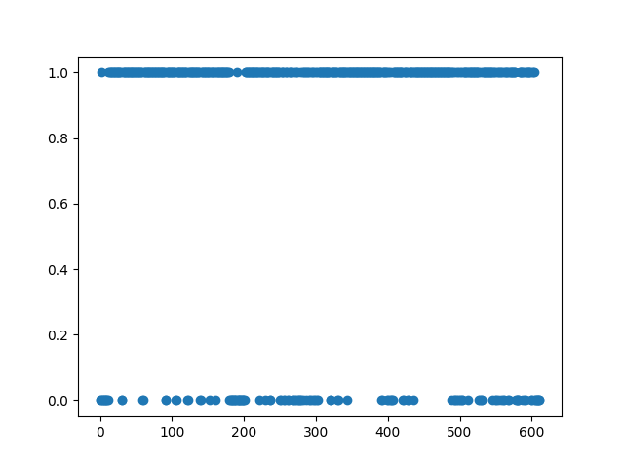



Number of paragraphs: 612

Number of words in first chapter: 479

Min number of words in first chapter: 1

Max number of words in first chapter: 17

Number of zero values in the plot: 133

Number of one values in the plot: 479

Average number of words in first chapter: 10.58

Source for the book analyzed : https://www.gutenberg.org/ebooks/996