Title: The Tiny EARS (Ears Above for Radiation Searching)
Primary POC: Tahir DENGIZ
Organization: TAMSAT - TURKEY
POC email: ta2t@tamsat.org.tr

Need
There are many RF (Radio Frequency) energy emitters on the earth surface radiating in different frequency ranges (HF, VHF, UHF, SHF, and MicroWave) and serving different purposes (communication, radar, broadcasting, etc.). It is assumed that this radiated RF energy has an impact on human health and there are ongoing experiments/researches on this subject. It may be possible to prove the relation between the human health and RF radiation of high power emitters by collecting and correlating emitter information from a top-to-bottom looking eye. Collecting RF emitter data will also help regulatory organizations to organize the usage of RF spectrum locally or globally which is a highly important issue to plan the usage of RF spectrum.

Mission Objectives
The very first objective of this project is, to prepare a color-coded RF energy map of the earth surface, using 3 (three) 4U sized CUBESATs carrying broadband SDRs (Software Defined Radio) for a multi-satellite operation. The satellites will collect the emitter information radiating from the earth surface. This emitter data collected will be used for these purposes;
- The data will be correlated with human health statistics to prove the relation between RF energy and diseases (e.g. cancer).
- The data will also be a useful database for planning the future use of the limited and tightly fulfilled RF spectrum efficiently.
- Evaluating an alternative way to have a research on human population daily activities using the collected mobile GSM cellular phone signal data density.
- On the other hand, gathered RF energy data will be used for environment organizations to prepare maps of environmental pollution created by the radiated RF.
The traditional receivers occupying a lot of space in the satellites to gather this information will be replaced with small sized SDR receivers. The digitized received spectrum information will be stored, evaluated and forwarded to ground station for correlation with the data gathered by the other member satellites of this mission. All the operations and calculation that require high computer CPU power will be done on the ground segment computer systems. The location of the emitters will be calculated at the ground segment computer systems using the reversed algorithms used in traditional GPS (Global Positioning System) solutions (the transmitter is on the ground and the receivers are flying, interferometry techniques will be used).

Concept of Operations
Supporting the mission objectives the satellite constellation will have 3 (three) main segments containing different subsystems as illustrated below;

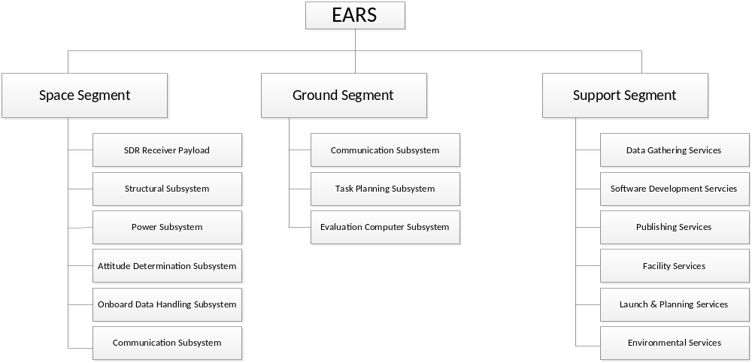
Diagram-1: Subsystems

The basic idea of the system is to have multiple satellites flying over the same region at the same time. The flying part will have the role to collect as much as possible data and store it before forwarding down to ground segment.
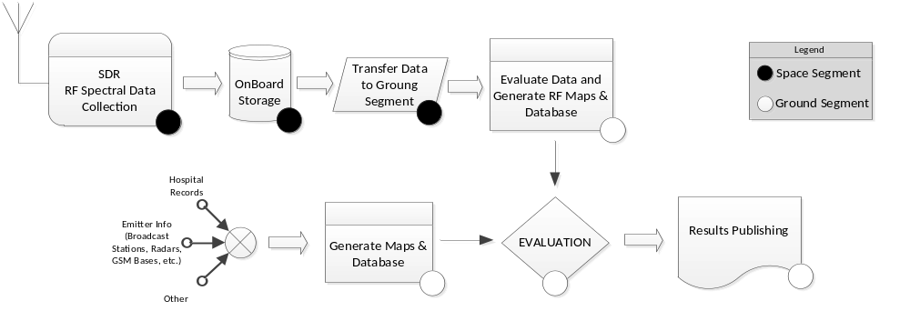
Diagram-2: Concept of Operations
The satellites will collect RF spectral data of a pre-defined band using a very wide-band SDR receivers onboard. Examples for the investigation bands and purposes are as follows;
Name | Band/Frequency
GSM Emitters | ~1Ghz, ~2ghz
Radar Emitters | L-Band >1Ghz, X-Band>10Ghz, etc.
Radio Broadcast Emitters | VHF ~100Mhz
TV Broadcast Emitters | V/UHF 100-500Mhz
Table-1: Examples for Investigation Bands
The emitter data collected on the space segment will be transferred to ground segment for further analyses. The ground segment will consist of computer systems to evaluate and correlate the collected data.
The computer systems will include BI (Business Intelligence) solutions to correlate the data, and on-purpose developed software to analyze the data to achieve these goals;
- Determine the location of the emitter on the earth surface,
- Determine the signal characteristics of the signal (modulation, pulse-width, etc.)
- Compare the records of the same emitter with the previously captured information for the same emitter,
- Define a behavior model for the emitter (radiation direction, moving, turning, etc.)
- Define the coverage area and power distribution for the emitter,
- Draw 2D and 3D RF color-map of the earth surface,
- Define the RF pollution and risky areas of the earth surface,
- Correlate the data with gathered health records and incident reports to define a relation model,
- Define RF spectrum usage characteristics and statistics for popular bands (Radio/TV Broadcast, communication, ISM, etc.) for spectrum planning,
- Generate reports for the organizations (Healthcare, civilization, technical research groups, etc.)

Key Performance Parameters
List and explain the technical rationale for 3-5 key performance parameters that enable the successful conduct of your mission idea. For example, tsunami detection may depend on better than 20 m spatial resolution in the visible spectrum.

Space Segment Description
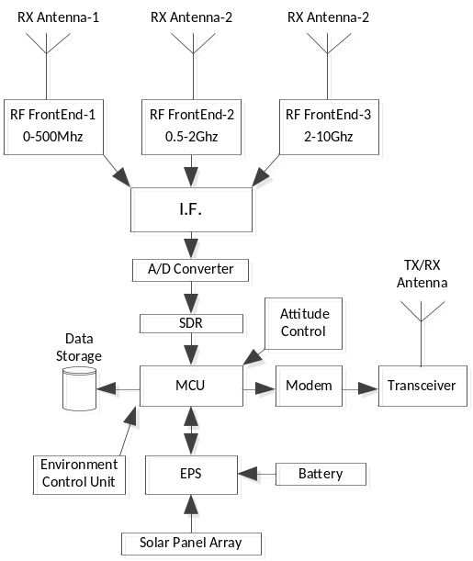
Diagram-3 : Space Segment Blocks
Describe the conceptual design for your satellite system or systems. List key specifications (e.g. mass, volume, peak and average power, link budget, delta-V, etc.). Diagrams or simple CAD drawings are encouraged.

Orbit/Constellation Description
Describe the orbital elements for the desired mission constellation and explain the technical rationale for its selection. Presentation of analytical results ground coverage or user access computations or simulations is encouraged.

Implementation Plan

Item/Description | Estimated Total Cost
Satellite Components to be procured (Structure, Battery, etc.) | USD 300.000
Electronic Components | USD 75.000
Laboratory Equipment | USD 250.000
Testing | USD 30.000
Launch | USD 250.000
Facility | USD 200.000
Computer Hardware (Servers, storage, rack, backup, etc.) | USD 300.000
Ground Stations | USD 100.000
Computer Software for Development Environment | USD 150.000
Staffing | USD 500.000
Total | USD 2.155.000
Table-2 : Estimated Costs
Describe how your organization, or your organization working with others, could implement your idea. Provide a reasonable estimate of total life cycle cost to include design, development, assembly, integration, testing, launch, operations and disposal. Provide considerations about project sustainability where applicable (e.g. "the next round constellations")".List any facilities or other infrastructure to be used or needed. Describe the project organization. Present a top-level project schedule starting from authority to proceed. List and describe the top 5 project risks (technical or programmatic).

References
List any technical references for your idea

