Title: The Tiny EARS (Ears Above for Radiation Searching)
Primary POC: Tahir DENGIZ
Organization: AMSAT-TR / TAMSAT
POC email: ta2t@tamsat.org.tr

Need
There are many RF (Radio Frequency) energy emitters on the earth surface radiating in different frequency ranges (HF, VHF, UHF, SHF, and MicroWave) and serving different purposes (communication, radar, broadcasting, etc.). It is assumed that this radiated RF energy has an impact on human health and there are ongoing experiments/researches on this subject. It may be possible to prove the relation between the human health and RF radiation of high power emitters by collecting and correlating emitter information from a top-to-bottom looking eye/ear. Collecting RF emitter data will also help regulatory organizations to organize the usage of RF spectrum locally or globally which is a highly important issue to plan the usage of tight RF spectrum.

Mission Objectives
The very first objective of this project is, to prepare a color-coded RF energy map of the earth surface for different wavelengths, using 3 (three) 2U sized CUBESATs carrying broadband SDR (Software Defined Radio) receivers for a multi-satellite operation. The purpose of the satellites will be collecting the emitter information radiating from the earth surface. This emitter data collected will be used for these purposes;
- The data will be correlated with human health statistics to investigate the relation between RF energy and diseases (e.g. cancer).
- The data will also be a useful database for planning the future use of the limited and tightly fulfilled RF spectrum efficiently.
- Evaluating an alternative way to have a research on human population daily activities using the collected mobile GSM cellular phone signal data density.
- Gathered RF energy data will be used for environment organizations to prepare maps of environmental pollution created by the radiated RF.
- Both the collected raw emitter data collected by the satellites and the evaluated results will be published to related organizations (research groups, universities, etc.)
The following picture might be an illustration of the 2D map output of the system;
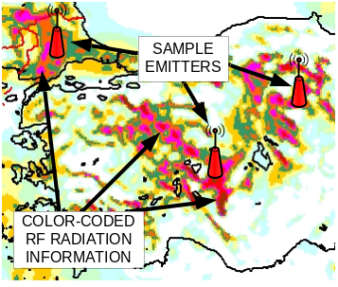
Diagram-1: Illustration of 2D Map Output for a Selected RF Band
The traditional receivers occupying a lot of space in the satellites’ volume for gathering this emitter information. This traditional receivers will be replaced with small sized SDR receivers which consume less electricity power. The digitized received spectrum information will be stored onboard, organized and forwarded to ground station for correlation with the data gathered by the other member satellites of this mission. All the operations and calculation that require high computer CPU power will be done on the ground segment computer systems. The location of the emitters will be calculated at the ground segment computer systems using the reversed algorithms used in traditional GPS (Global Positioning System) solutions (the transmitter is on the ground and the receivers are flying, interferometry techniques will be used).

Concept of Operations
Supporting the mission objectives the satellite constellation will have 3 (three) main segments containing different subsystems as illustrated below;
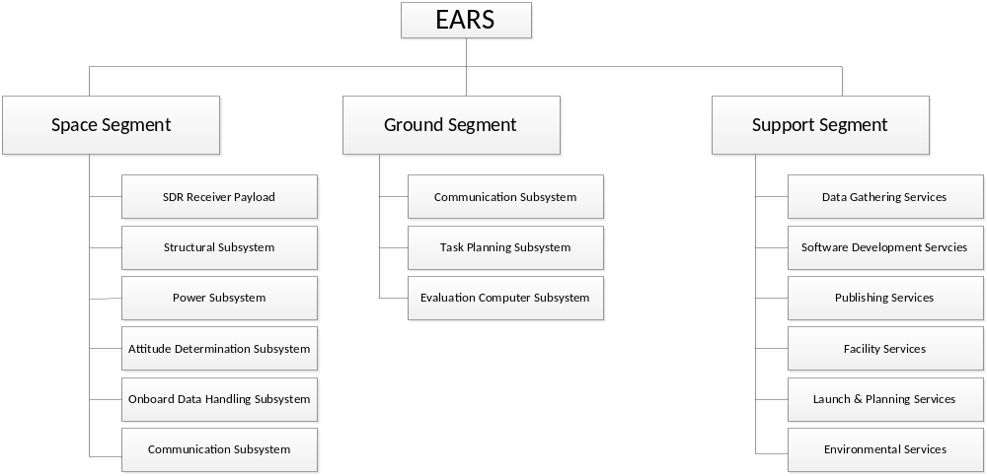
Diagram-2: Subsystems
The basic idea of the system is to have multiple satellites flying over the same region at the same time. The flying part will have the role to collect as much as possible data and store it before forwarding down to ground segment.
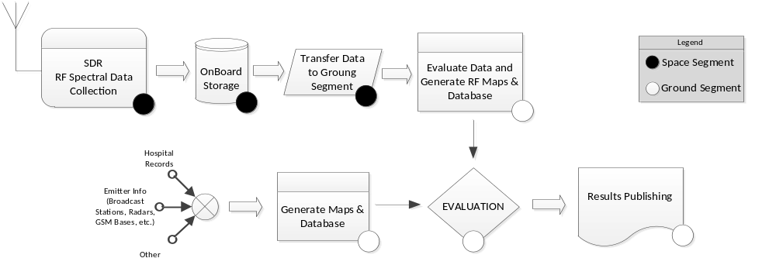
Diagram-3: Concept of Operations
The satellites will collect RF spectral data of a pre-defined band using a very wide-band SDR receivers onboard. Examples for the investigation bands are as follows;
- GSM Emitters (SHF ~1Ghz, ~2ghz)
- Radio Broadcast Emitters (VHF ~100Mhz)
- TV Broadcast Emitters (V/UHF 100-500Mhz)
- Radar Emitters (L-Band ~1Ghz, X-Band ~10Ghz).
The emitter data collected on the space segment will be transferred to ground segment for further analyses. The ground segment will consist of computer systems to evaluate and correlate the collected data. The computer systems will include BI (Business Intelligence) solutions to correlate the data, and on-purpose developed software to analyze the data to achieve these goals;
- Determine the location of the emitter on the earth surface,
- Determine the signal characteristics of the signal (modulation, pulse-width, etc.)
- Compare the records of the same emitter with the previously captured information for the same emitter,
- Define a behavior model for the emitter (radiation direction, moving, turning, etc.)
- Define the coverage area and power distribution for the emitter,
- Draw 2D and 3D RF color-map of the earth surface,
- Define the RF pollution and risky areas of the earth surface,
- Correlate the data with gathered health records and incident reports to define a relation model,
- Define RF spectrum usage characteristics and statistics for popular bands (Radio/TV Broadcast, communication, ISM, GSM, etc.) for spectrum planning,
- Generate reports for the organizations (Healthcare, civilization, technical research groups, universities, etc.)
An organization of people will be held on the ground segment to collect necessary information from other organizations (e.g. hospitals, universities, newspapers, etc.). This data is very important to give meaning to the gathered digital emitter information.

Key Performance Parameters
To achieve a successful operation the following KPIs (Key Performance Indicators) will be used;
- The color-coded RF map resolution should be not less than 1 pixel per square kilometer,
- The emitter location estimation error will not be greater than 0.5 kilometer,
- The emitter properties (modulation, characteristics, etc.) will be determined with a percentage of not less than 70%,
- Detailed investigation on a single emitter will not last longer than 5 days or 20 passes over the target emitter.

Space Segment Description
The space segment will consist of 3 (three) 2U sized (10cmX10cmX20cm) microsatellites (cubesats). After the launch there will be no solar-panel expansion, but antenna construction frame expansion. Illustration of the physical and functional blocks properties of the a satellite frame is as below;
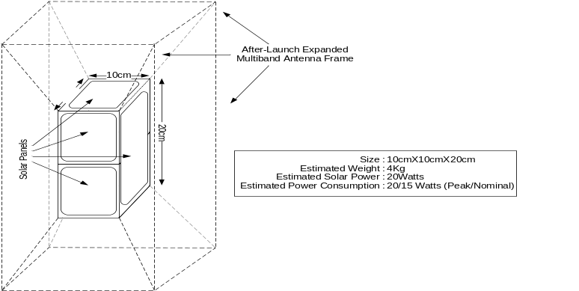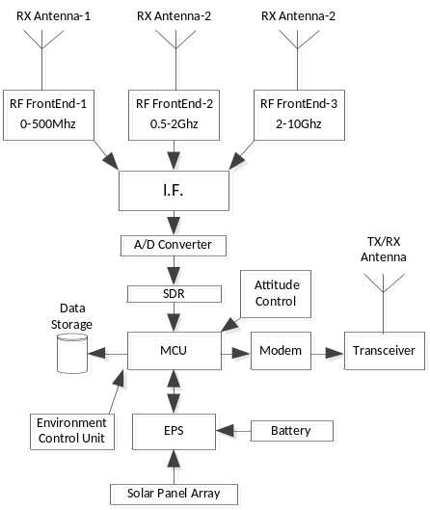
Diagram-5 : Physical and Functional Blocks of Space Segment
There will be different sized antennas connected to the related frontends for different frequency bands. The I.F. (Intermediate Frequency) stage will carry the signals down to a A/D (Analog to Digital) convertible frequency range. Beyond this point everything will be in digital space and the MCU will store all received RF information on the onboard disk system. The disk system should have no turning parts to operate in space environment (solid state disk systems will be preferred).
The MCU will compress the data (the SDR data is a highly compressible data) and organize it on the disk with the timestamp information. When the system is in contact with the ground control station, the MCU will forward the stored (not downloaded) data to ground station and delete the local copy. Ground station will be capable to send the next mission information up to the satellite.

Orbit/Constellation Description
All three satellites will be on the same polar LEO (Low Earth Orbiting) orbit with an acceptable space between satellites to support interferometering for location calculations of the earth surface RF emitters. Evaluating the previous cubesat launch trends we decided to have a sun-synchronous reference orbit with an inclination of 98 degrees and an altitude of 850 km.
Using LEO polar orbit will allow the satellites to approach the same location on the earth with different approach angles many times in a day period. Also using a polar orbit will allow the system to cover most part of the earth surface for investigation, which will allow different type of missions to be conducted using our system.

Implementation Plan
AMSAT-TR/TAMSAT is a local branch of The Radio Amateur Satellite Corporation (a.k.a. AMSAT) in Turkey. TAMSAT organization is settled to conduct space targeted researches (e.g. satellite communication, radio astronomy, space sciences, etc.). TAMSAT is in contact with universities, high schools, social and government organizations and research groups in Turkey who are interested in technology and space. TAMSAT incorporates engineers, scientists, students and amateur radio volunteers within the organization. All knowledge base of these participants will be supporting this project.
The development lifecycle of the project will be based on systems engineering processes and standards. A basic cost estimation plan is as follows;
Item/Description | Estimated Total Cost
Satellite Components to be procured (Structure, Battery, etc.) | 400.000
Laboratory Equipment & Electronic Components | 350.000
Testing | 80.000
Launch & Disposal | 250.000
Facility & Operations | 300.000
Computer Hardware (Servers, storage, rack, backup, etc.) | 300.000
Ground Stations | 100.000
Computer Software for Development Environment | 150.000
Staffing | 500.000
Total | USD 2.430.000
Table-1 : Estimated Project Costs
TAMSAT is in contact with Istanbul Technical University Space Systems Design and Test Laboratory (ITU SSDTL) who have the required facilities to evaluate, develop and test satellites. Starting with a basic understanding of emitter observation from space, the next step will be to have more accurate EARS in the space.
The total estimation of the project schedule is 14 months (2 months requirement analyses, 6 months system design, 4 months for development and construction and 2 months testing and refinement before launch).
The top most risks of the project are;
- The required health data determination process may take long time,
- The collected health data may need heavy work to convert into required form,
- Orbit orientation of three synchronous satellites might be difficult,
- A new antenna expansion model may be needed for a ultra-wide spectrum coverage, this might reduce the targeted spectrum bandwidth (e.g. 100-999Mhz).
References
1) R. Beard, T. Mclain, D. Nelson, and D. Kingston. Decentralized cooperative aerial surveillance using fixed-wing miniature uavs. IEEE Proceedings: Special Issue on Multi-Robot Systems
2) L. Bertuccelli and J. How. Search for dynamic targets with uncertain probability maps. In IEEE American Control Conference, 2006.
3) P. DeLima, G. York, and D. Pack. Localization of ground targets using a flying sensor network. In SUTC (1), pages 194–199, 2006.
4) D. Pack, G. York, and G. Toussaint. Localizing mobile RF targets using multiple unmanned aerial vehicles with heterogeneous sensing capabilities. In IEEE International Conference on Networking, Sensing, and Control, 2005.
5) M. Wax. Detection and estimation of superimposed signals. PhD thesis, Stanford Univ, 1985.

