Speech to text conversion is a rapidly growing field in artificial intelligence, and there are several reasons why it is important.

* Increased accessibility: Speech to text conversion technology can make a wide range of information and services more accessible to people with disabilities, including those who are deaf or hard of hearing.
* Improved efficiency: By allowing people to speak rather than type, speech to text conversion technology can increase productivity and efficiency in a variety of settings, including business, healthcare, and education.
* Enhanced user experience: Speech to text conversion technology can improve the user experience by making it more natural and intuitive for people to interact with devices and systems.
* Improved data analysis: By converting speech to text, it becomes easier to analyze and extract valuable insights from audio data, this can be used for research and business intelligence.
* Advancements in other AI fields: Advancements in speech to text technology also drives other Artificial intelligence fields like natural language processing, and machine learning which are critical for developing advanced AI applications.

Overall, speech to text conversion technology has the potential to have a significant impact on a wide range of industries and applications, and it is an area of artificial intelligence that is likely to continue to evolve and improve in the coming years.

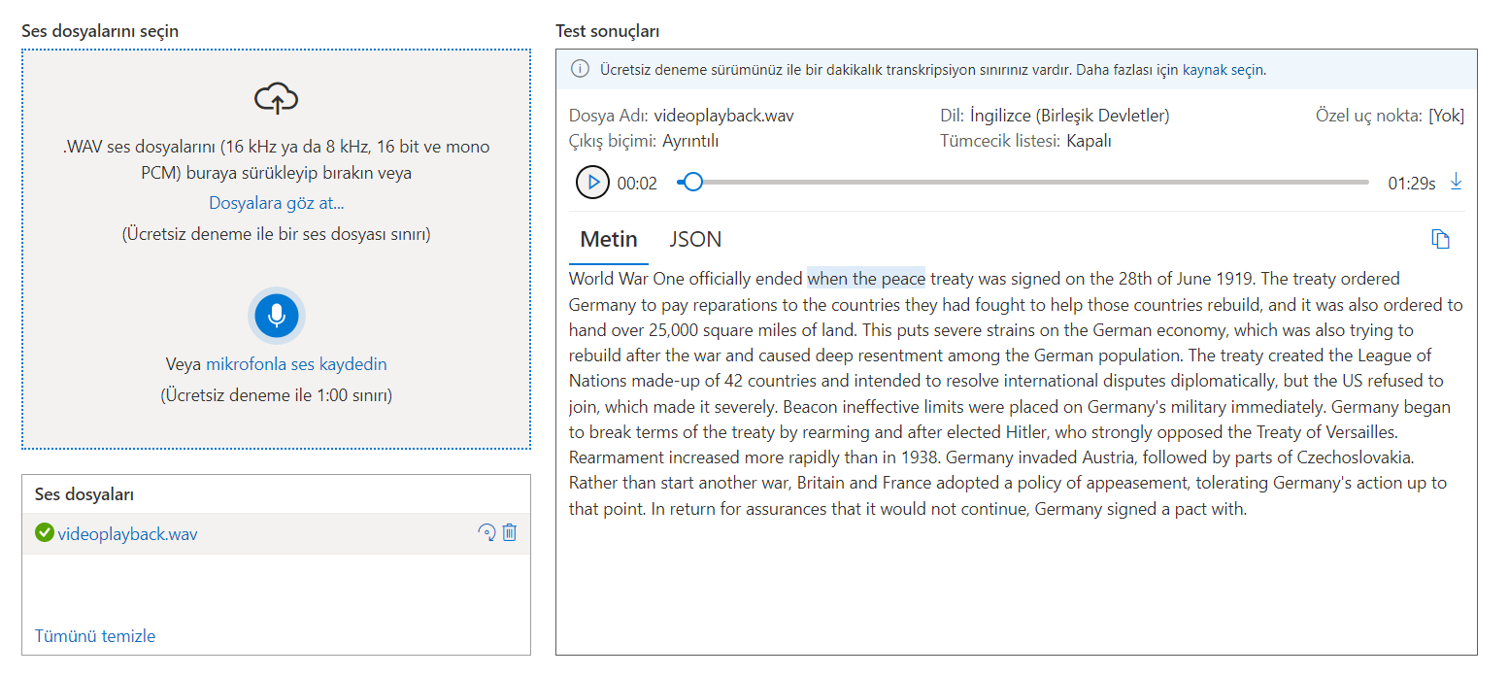Azure Cognitive Services Speech-to-Text is a cloud-based speech recognition service that enables developers to transcribe spoken audio into written text. We have used this service for speech-to-text conversion in our organization. One of the key benefits of using Azure Cognitive Services Speech-to-Text is its ease of use. With just a simple API call, the service can transcribe spoken audio into written text, making it easy to integrate into a wide range of applications and systems. Additionally, the service is designed to handle a wide range of different languages, accents, and speaking styles, ensuring high accuracy in transcription. Another benefit of using Azure Cognitive Services Speech-to-Text is the level of customization it offers. The service provides a variety of customization options, such as custom language models, which can be used to improve accuracy in specific domains or industries. We were able to fine-tune the speech-to-text conversion process to suit our specific needs. In conclusion, Azure Cognitive Services Speech-to-Text is an efficient, accurate and cost-effective option for speech-to-text conversion, which we have successfully implemented in our organization. Its ease of use and customization options, along with its compliance features, make it an ideal choice for businesses and organizations looking to integrate speech-to-text technology into their operations.

Storing voice files in a MySQL database in Azure is a common practice for many organizations. By using Azure as the platform for hosting the MySQL database, and storing voice files in the database, it allows for easy access and management of the voice files. One of the key benefits of using Azure to host a MySQL database is the level of scalability it offers. Azure allows for easy scaling of the database to accommodate an increase in the number of voice files or users accessing the database. This ensures that the database remains performant even when the number of voice files stored in the database increases. Another benefit of storing voice files in a MySQL database in Azure is the level of security it offers. Azure provides robust security features such as Azure Active Directory authentication and encryption of data at rest and in transit. This helps ensure that the voice files stored in the database are secure and protected from unauthorized access.

We have successfully created a web app in Azure, leveraging the platform's capabilities for building and deploying web apps quickly and easily. The use of Azure as the platform for the web app allowed us to take advantage of its scalability, security and compliance features. The web app is able to handle an increase in the number of users or traffic due to Azure's scalability feature, this ensures that the web app remains performant. Additionally, the web app is secure and protected from unauthorized access with Azure's robust security features such as Azure Active Directory authentication and encryption of data at rest and in transit. Moreover, the compliance and regulatory compliance feature of Azure allowed us to comply with industry standards and regulations while handling sensitive data. Overall, the use of Azure in creating the web app has been a positive experience for us, and we highly recommend it to other organizations looking to build and deploy web apps.

Also in order to record your voice and test it you can record your voice in speech.py Then you can upload it to Mysql database in Azure. Later with using speech-to-text service we can convert it to text.