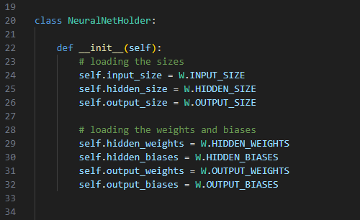
This block is the constructor of the NeuralNetHolder class.
It loads the neural network’s structure and the trained parameters from nn_weights.py.
Specifically, it imports:
- the input, hidden, and output layer sizes
- the weight matrices for each layer
- the bias vectors for each layer
In short: it prepares the neural network by loading all sizes, weights, and biases so the model is ready to make predictions.

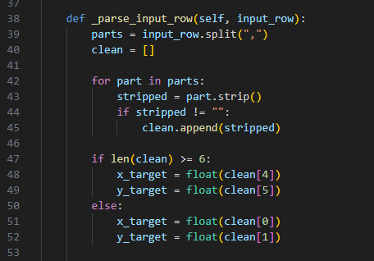
This function reads a raw text input and extracts the target X and Y values.
It works in two modes:
- If the row has 6 or more columns, it assumes it's a full game data row and takes column 4 and 5 as x_target and y_target.
- If the row is short (only “x,y”), it simply reads the first two values.
It returns (x_target, y_target) as floats.
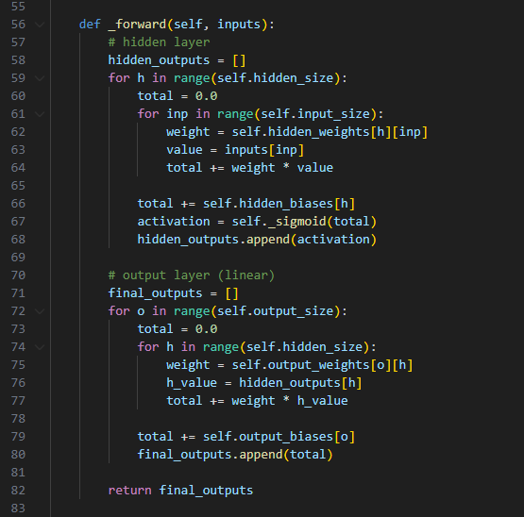
This function performs a full forward pass through the neural network:
- Hidden layer:
For each hidden neuron → compute
sum(weight * input) + bias,
then apply sigmoid, and store the result.
- Output layer:
For each output neuron → compute
sum(weight * hidden_output) + bias,
with no activation (linear).
Finally, it returns the list of output values (usually the predicted X and Y velocities).

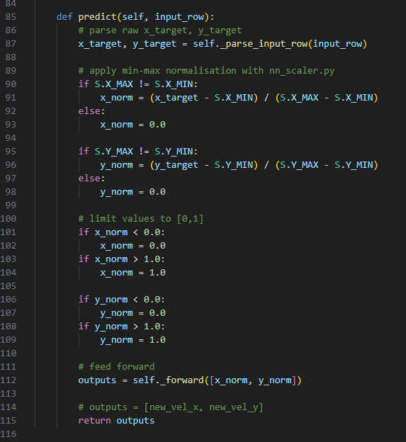
This method generates the network’s prediction:
- Extracts x_target and y_target from the input row.
- Normalizes both values using Min-Max scaling (0–1 range).
- Clamps the normalized values to stay within [0, 1].
- Runs a forward pass through the neural network.
- Returns the final outputs (usually predicted velocity X and Y).
In short: it prepares the input → normalizes it → feeds it into the network → returns the prediction.

