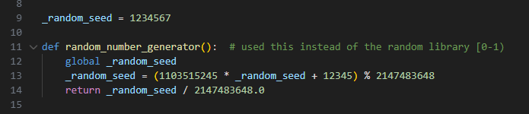
This function implements a simple Linear Congruential Generator (LCG) to produce pseudo-random numbers. It updates the global seed using the classic formula and then normalizes the result by dividing by $2^{31}$to obtain a float in the range $[0,1)$. This custom generator replaces Python’s built-in random to keep the implementation self-contained and suitable for educational purposes.

This function generates a random floating-point number within a given range by scaling a base random value r from the custom generator. Instead of using Python’s built-in random.uniform, the assignment uses this simple manual approach to avoid external libraries and keep the implementation fully self-contained. It produces deterministic results and fits the educational purpose of demonstrating how uniform sampling works.

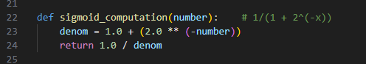
This function implements a simple Linear Congruential Generator (LCG) to produce pseudo-random numbers. It updates the global seed using the classic formula and then normalizes the result by dividing by $2^{31}$to obtain a float in the range $[0,1)$. This custom generator replaces Python’s built-in random to keep the implementation self-contained and suitable for educational purposes.

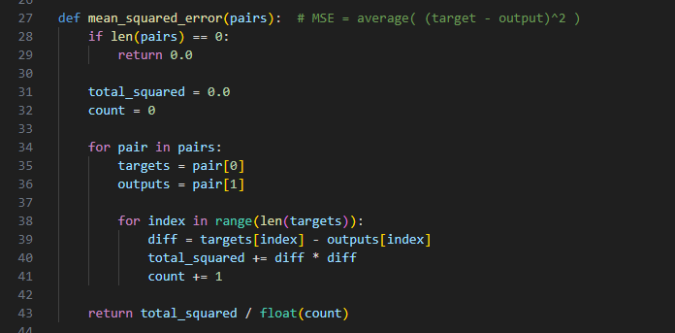
This function computes the Mean Squared Error by iterating through all target–output pairs and summing the squared differences. It then divides by the total number of values to obtain the average error. MSE is the simplest and most common loss for regression tasks, making it ideal for an educational neural-network implementation.
-Easy to take derivative
-Cross-Entropy not suitable because it is not regression
-Mean absolute error is difficult becaus derivative is sharp so hard for backprop
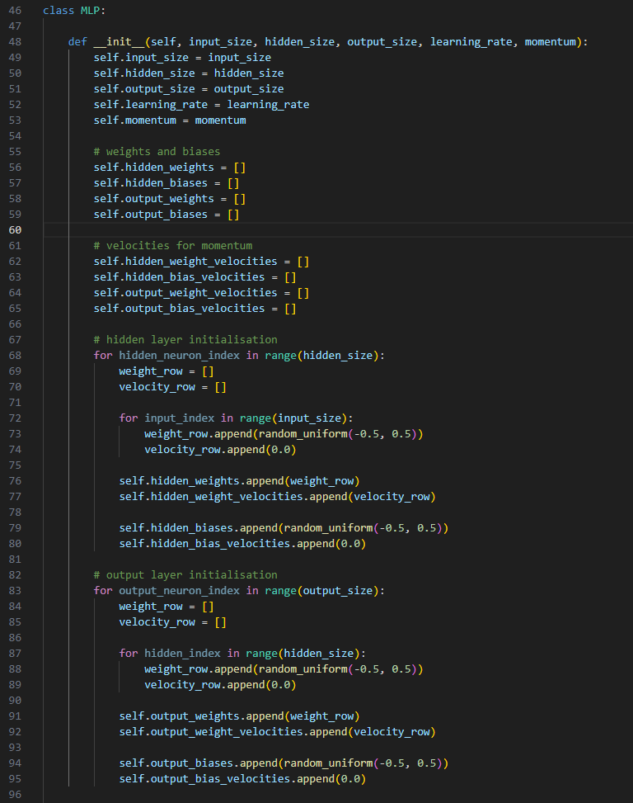
This constructor initializes all components of a small MLP: the input, hidden, and output sizes, learning rate, and momentum. It creates weight matrices and bias vectors for both layers and initializes them with simple uniform random values between −0.5 and 0.5. It also prepares zero-filled velocity matrices for momentum-based updates. Overall, this setup is a straightforward, educational implementation of neural network initialization.
-If bigger than 0.5 it will be saturation else it can not learn
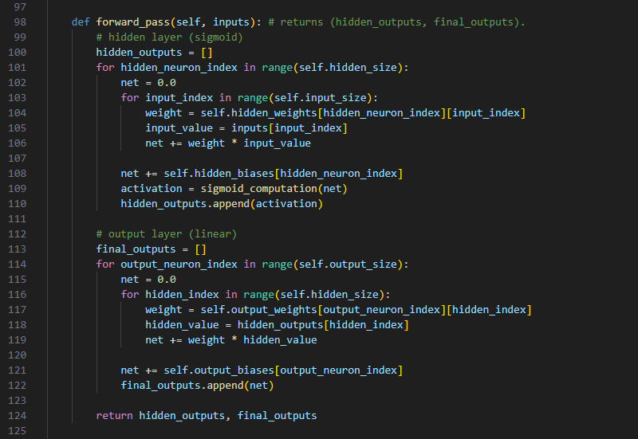
This function performs the forward pass of the MLP. It first computes each hidden neuron’s weighted input, adds a bias, and applies the sigmoid activation. Then it computes each output neuron’s weighted sum of the hidden activations, adds a bias, and leaves the output linear. This simple structure—sigmoid hidden layer + linear output—is standard for small regression networks and fits the educational goals of the assignment.
This function actually does the following:
Hidden layer:
- Weighted sum
- Bias
- Sigmoid activation
Output layer:
- Weighted sum
- Bias
- Linear activation
It returns these values as two lists.
Why not sigmoid?
Because:
- The output values are regression outputs (vel_x, vel_y)
- If sigmoid were used, the output would only be between 0–1
- Linear activation → can produce outputs in any range
(Required for the assignment)

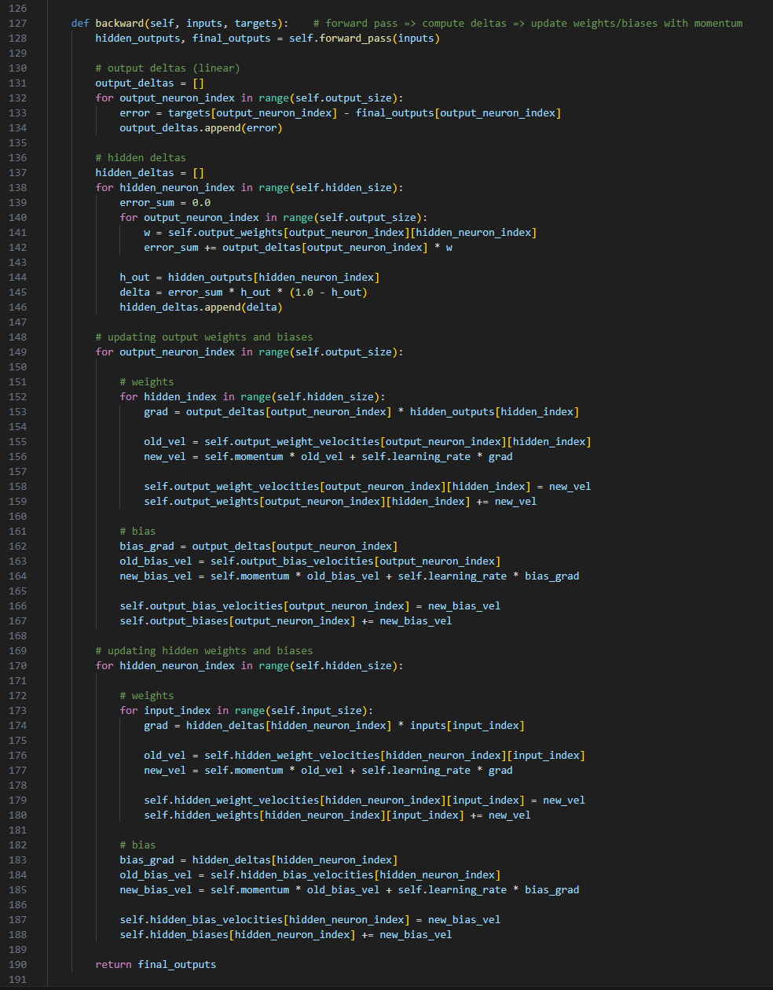
This method performs one full backpropagation step: it first runs a forward pass to get the hidden and output activations, then computes the output deltas as (target - output) and propagates these errors back to the hidden layer using the sigmoid derivative. It then updates all weights and biases using gradient descent with momentum, where each weight’s velocity is updated and added to the weight. Overall, this is a straightforward, textbook-style implementation of backpropagation for a small MLP.

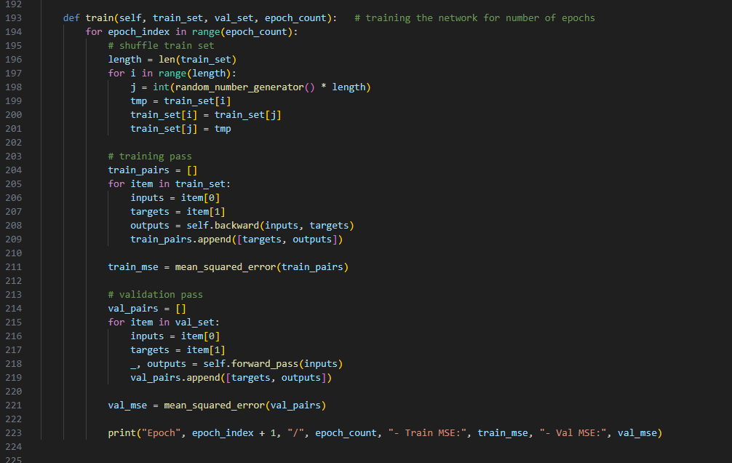
This train method runs the training loop for a given number of epochs. In each epoch, it first shuffles the training set, then iterates through all training samples, calling backward to update the weights and collecting outputs to compute the training MSE. It then runs a validation pass using only forward_pass (no updates) to compute the validation MSE. Finally, it prints both train and validation MSE per epoch, which is a simple and standard way to monitor learning and overfitting in a small educational neural network.
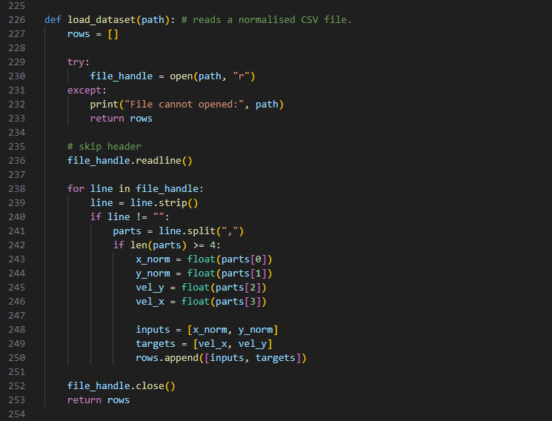
This function loads a normalized CSV file, skips the header, and reads each line into a structured format: [inputs, targets], where inputs are [x_norm, y_norm] and targets are [vel_x, vel_y]. It avoids external libraries and uses basic string processing to keep the implementation simple and suitable for an educational neural network assignment.

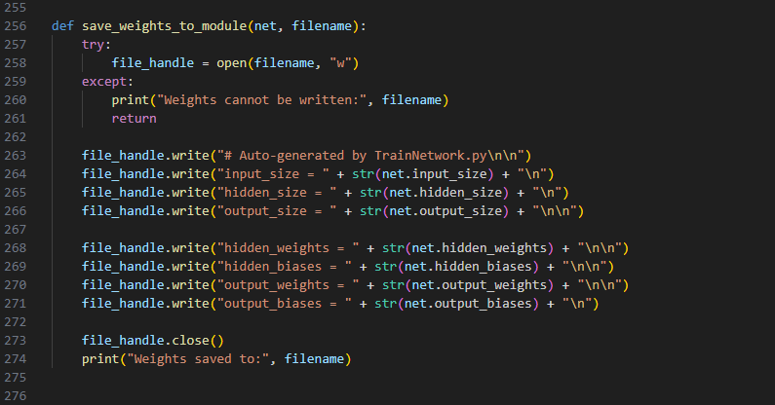
This function writes the trained network’s weights and biases into a Python file so they can be imported later during gameplay. It saves the model sizes and all weight/bias matrices in plain Python list format, making the file directly executable as a module. This approach is simple, avoids external libraries, and is perfect for a small educational assignment.

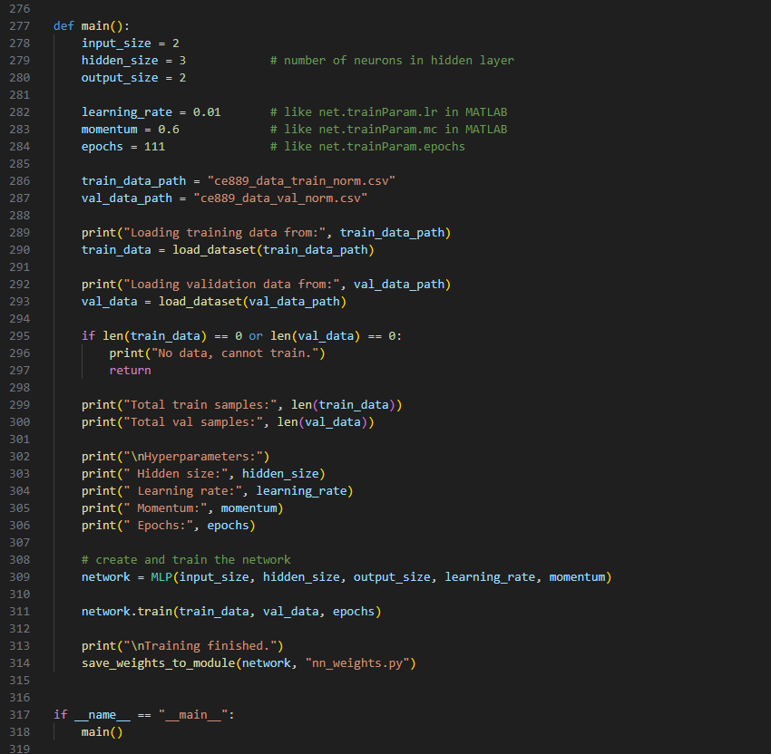
The main() function configures a simple 2–3–2 MLP by setting the input, hidden, and output sizes along with learning rate, momentum, and number of epochs. It loads the normalized training and validation data, prints some basic statistics and hyperparameters, creates the MLP, and trains it using the train method. After training finishes, it saves the learned weights into nn_weights.py so the game can later import them for inference. The if __name__ == "__main__": main() pattern makes the script runnable as a standalone trainer.

