Project structure is below.

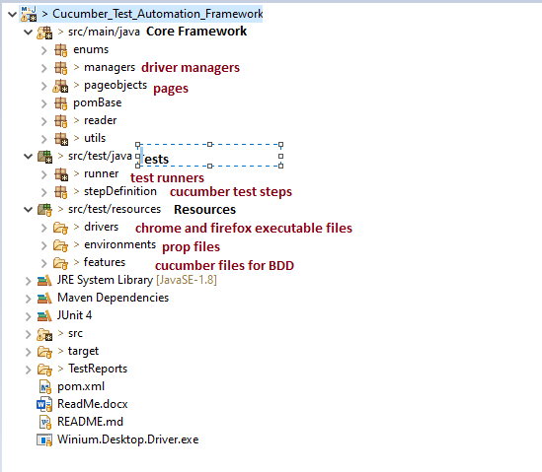

For running cucumber tests (UI) open runner test class and run as junit test as below.

