Project structure is below.

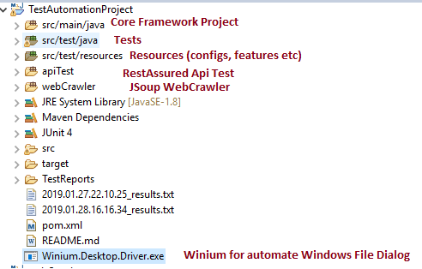

For running cucumber tests (UI and Api tests) open runner test class and run as unit test below.

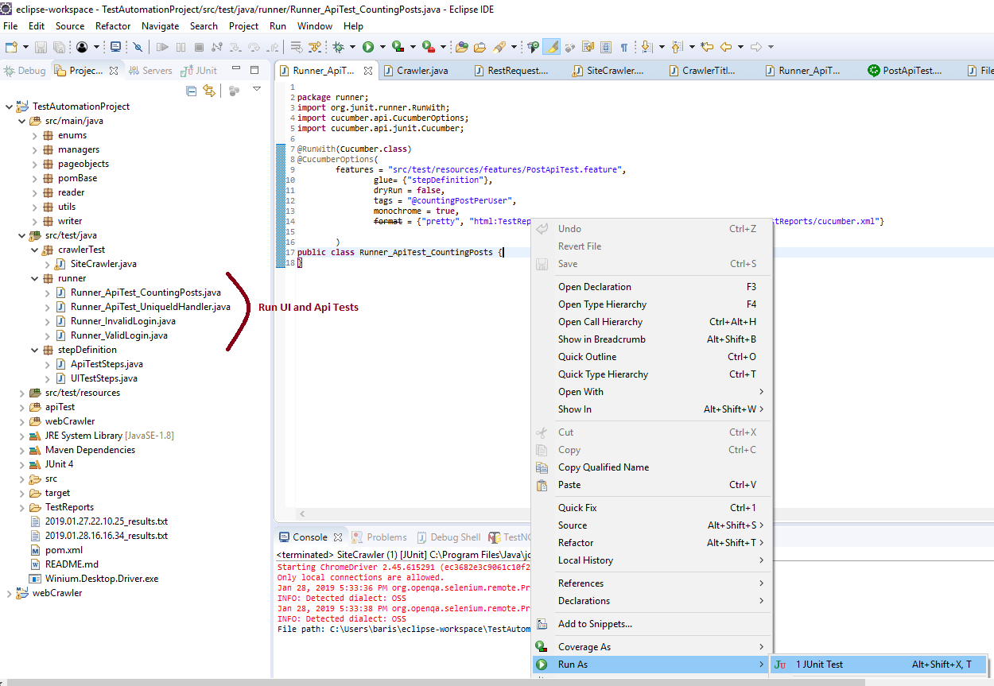

For run crawler test, Run below crawlSiteAndWriteLinksToText as Junit Test.

There is an important topic for this project. Before run this test, start Winium.Destkop.Driver.exe application with double click in project. The exe application is attached to project as below. Winium automates file upload dialogs, desktop and wpf components.

