Fine-Tuning and Deployment of a Large Language Model for Climate Change Question Answering

Abstract
In this project, the proposal will provide a complete end-to-end system adapting a pretrained Large Language Model to a domain-specific question answering task based on climate change. Fine-tuning a pretrained GPT-2 model with a curated question -answer dataset allows the model to produce contextually relevant and domain-aware responses. The system combines semantic similarity retrieval, lexical search, and controlled generative fallback to achieve better reliability and minimize hallucinations. The last system is implemented into an interactive context where one is able to query the model and compare the answers elicited by the dataset with model generated answers and evaluate the confidence levels. The project shows that fine-tuning with retrieval-augmented inference is much more useful and reliable when it comes to scientific tasks of language models.
- Introduction
Large Language Models have radically changed the nature of natural language processing because they enable machines to perform tasks such as text generation, summarization, translation, and question answering with high fluency. These models are usually trained on huge and heterogeneous corpora of text that offers general linguistic and world knowledge. Nevertheless, such a generality tends to sacrifice its accuracy as the model is projected to specific fields like climate science, medicine or law.
Climate change is both a socially important and a scientifically complicated subject matter which demands factual and well-founded data. Misunderstanding and mistrust may be the outcomes of misinformation or ambiguous explanations. Thus, general-purpose language model cannot be used reliably on the climate-related questions applied directly. This project handles this difficulty by refining a pretrained GPT-2 model on a dataset of question-answer questions on climate change and by providing retrieval-based mechanisms to the model. The output is a synthesized system that blends acquired generative skills with factual foundation on filtered information.
- Problem Statement
Although they are remarkably fluent, pretrained language models often produce answers that are factually inaccurate or otherwise insufficiently specific when they are not in their training distribution. This can also be called hallucination and is one of the major obstacles to implementing LLMs in science and education. Even a small error in a climate science can be misleading to the people or rendered useless. The main issue considered in this project is the possibility to modify a pretrained language model in such a way that it gives relevant, domain-specific responses to the queries on climate change and yet is computationally powerful enough and can be implemented on a small-scale hardware. The system should also be transparent such that the users are able to know whether the answer they are receiving is an extract of verified data or a product of the model.
- Dataset Description
The statistical sample employed in this project is the structured question answer pairs which are specifically about climate change. Each record has a question in natural language and the answer to the question written by an expert. The dataset is represented in JSON format and it is thus flexible in its parsing and can be integrated directly into the training and inference pipelines. Due to the domain-specificity and supervision of the dataset, it is specifically well-adapted to instruction-type fine-tuning. The responses are described in prose style as opposed to a brief factual expression, which invites the model to acquire factual associations besides fitting the correct styles of explanation. The size of the dataset is moderate, and this enables effective fine-tuning but at the same time in covering all major concepts of climate change namely, greenhouse gases, global warming, mitigation measures, and environmental effects.
- Model Architecture
The model that has been taken to base this project is GPT-2, which is a causal language model based on transformers. GPT-2 is made up of multiple progressive decoder layers, each having self-attention and feed-forward neural networks. The mechanism of self-attention allows the model to obtain long-range dependencies among tokens and this is necessary to understand complex questions and to generate coherent multi-sentence responses. GPT-2 is an autoregressive model, which has to make predictions about the next token in a sequence based on all the previous tokens. This structure renders it especially appropriate to question answering in the case where the task is posed as conditional text generation. This is made possible by the moderate size of GPT-2 that guarantees the fine-tuning and execution of the model on a GPU like a P100 available at Kaggle without violating the memory limitations.
- Fine-Tuning Methodology
The fine-tuning operation rephrases the question-answering problem as an answer to a causal language modelling problem. Each example of training is transformed into the structured prompt with the explicit separation of the question and the answer. This form promotes a regular learning process by the model to map the questions and the answers to them. The GPT-2 tokenizer is used to do tokenization and padding and truncation are handled carefully to generate fixed-length inputs. The model is trained with the loss of cross-entropy, the goal of which is to reduce the gap between predicted tokens and ground-truth ones. To simulate larger batch sizes, gradient accumulation is applied and to stabilize training, learning rate scheduling with warmup is used.
- Training and Evaluation
The data is split into training and validation groups to make it possible to objectively assess the functionality of models. The AdamW optimizer is a good choice in transformer architectures, and is used to update the model parameters during training. When the device has a graphics card, it can enable mixed-precision training and saves on memory and computation time. To track convergence and avoid overfitting, validation loss is calculated at the end of each training epoch. Manual implementation of the training loop is used instead of training abstractions at higher levels allowing the complete control over optimization, error handling, and hardware fallback.

- Semantic Retrieval and Inference
Recent studies indicate that encoding words and sentences is connected to retrieval and inference processes (Chedda, 2010, p. 6).<|human|>Retrieving and Inferring semantics Semantic retrieval and inference processes are linked to word and sentence encoding (Chedda, 2010, p. 6). In this project, evaluation is an integration of both quantitative and qualitative evaluation. Quantitatively, loss to validation gives an evaluation of the extent to which the model can extrapolate to PAQs that it has never encountered. On a qualitative level, generated responses are manually checked on the basis of factual and coherence and relevance to the question given. This two-fold assessment method is necessary as the low level of validation loss does not necessarily imply the quality of the response in the generative models and their correctness in factual terms. The manual verification will assist to detect any hidden problems like ambiguous explanations or false declarations.
- Generative Fallback
In order to minimize hallucinations and increase the level of factual reliability, the system will first seek an answer within the dataset before applying the generative model. Lexical matching techniques apply to find an exact or close match of the user question and that of the dataset. Semantic similarity search is used where the lexical matching is insufficient and sentence embeddings are used. A lightweight transformer encoder is used to produce semantic embeddings, and semantic proximity is determined with the help of cosine similarity. All retrieved results are given a confidence mark and are classified as high confidence, medium confidence or low confidence according to preset thresholds. This data is availed to the customer to enhance transparency.

- System Deployment
When there is no dataset record with the confidence threshold, the system would revert to the fine-tuned GPT-2 model to come up with an answer. Nucleus sampling and temperature scaling are controlled decoding strategies aimed at striking a balance between creativity and factual consistency. The penalties of repetition are implemented to avoid repeated results. The system reduces the hallucination by restricting generation to those occasions when the retrieval is not effective and further benefits of the generative power of the model. It is a hybrid system between retrieval-based and generative question answering systems.
- Interactive User Interface
Jupyter-based interactive user interface is used to allow the user to answer questions in real-time by inserting questions into the system. The interface provides various display options such as dataset-only answers, model generated answers and comparison. Similarity scores and confidence indicators are shown with the answers of the dataset in order to enable users to determine reliability. This interface converts the research model into a practical system and proves how narrow language models may be applied in user-facing systems. The input to the pipeline will be user input that is normalized and preprocessed. The first and initial step of the system is lexical matching against the dataset. In the event of a matching answer, one gets the dataset answer corresponding to the confident match. Otherwise, the input is coded into a semantic embedding and it is compared to the dataset embeddings that have been pre-computed. In case semantic similarity is beyond a threshold, a dataset response is provided with a confidence label. In case of all the methods of retrieving the information are ineffective, the fine-tuned GPT-2 model comes up with an answer which is shown to the user via the interface. The whole system can be re-created in the GPU infrastructure at Kaggle. Dependency management, random seed control and hardware fallback mechanisms guarantee the consistency in behavior between the runs. The fine-tuned model and tokenizer can be stored and re-used without re-training allowing easy evaluation and deployment. The system is restrictive due to the size of the base model and data. GPT-2 might not be able to process very technical or novel questions that have not been trained on the dataset. The computation of semantic embedding incurs preprocessing overhead and also the system only accepts English language input at the moment. Further more may involve parameter-efficient tuning, additional parameter tuning of bigger models, making the system a web application, and increasing the size of the dataset to other subdomains related to climate. It would also enhance the applicability of the system with the help of multilingual support.
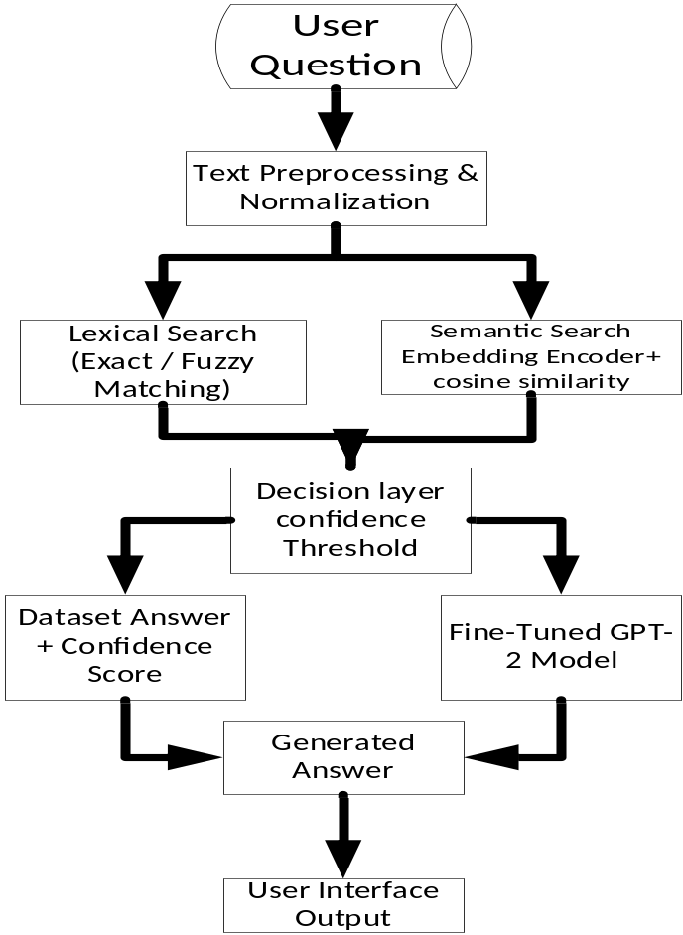
Figure 1 system architecture

- Conclusion
The proposed project shows that, when a pretrained language model is fine-tuned on a domain-specific dataset, using retrieval-augmented inference, the resulting system can be a point-to-point question-answering system that is accurate, reliable, and interactive. The hybrid architecture is a compromise between the factual base and the generative flexibility, and thus is also applicable in scientific and educational purposes involving climate change.

