**ozyegin_universitesi_logo.gifCS350 – Operating Systems**

**HOMEWORK 3 – Call Center (20 points)**

**Due Date: May 13.2020, Wednesday, 23:55**

***Instructor: Dr. Ismail Ari,*** [***ismail.ari@ozyegin.edu.tr***](mailto:ismail.ari@ozyegin.edu.tr)

**Task1: Echo Server (5 points)**

* You will write a TCP/IP-socket based client-server program with C language.
* The server (**echo\_server.c**) will **bind()** to an IP-address and a port number (localhost / 127.0.0.1 and port 8888) to **listen()** to client connection requests on this line and **accept()** connections.
* The client program (**echo\_client.c**) will **connect()** to the echo\_server (localhost:8888) to **send()** and **recv()** messages.
* The server will **recv()** textmessages from the socket and send /echo/ **write()** them back to the client without any change.

Hello

echo\_server.c

echo\_client.c

Hello

**HINT: Analyze these links.**

Echo Server: <http://www.binarytides.com/server-client-example-c-sockets-linux/>

Chat Server:<http://stackoverflow.com/questions/19349084/chatroom-in-c-socket-programming-in-linux>

**Task2: Call Center (15 points)**

* Based on the echo client/server code above, **you will simulate** a Call Center, where up to 2 clients/customers can be simultaneously accepted by the Call Center **for echo or chatting (NOT real voice)**. You need to use **pthreads** for this.
* Each client has 10 seconds to Chat/Echo with the server, after which the server will close the client connection to accept new clients. You need to use a **timer** (gettime()? jiffy?) for 10 seconds.
* A 3rd client is also accepted (3rd thread), but not allowed to echo/chat until one of the two (2) clients finishes. This represents a call center wait queue **without** an actual queue data structure.
* If a 4th client arrives, when the server is busy serving 3 clients it is NOT accepted.
* As a bonus (optional), you can write a shell script to start clients periodically, to test the server.

**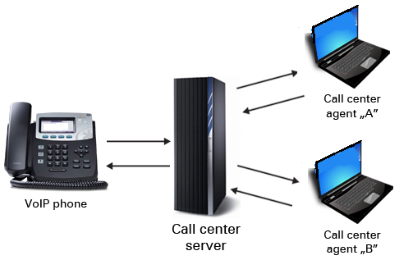**

**SUBMISSION GUIDE:**

**TAR/ZIP all \*.c \*.h files, and Makefile into *hw3\_First\_Lastname.gz***

Make sure it compiles and runs when we gunzip/untar and type **“make”**.