FAKULTÄT FÜR INFORMATIK

DER TECHNISCHEN UNIVERSITÄT MÜNCHEN

Master’s Thesis in Informatik

# Personalized Mass Email Communication

Baris Oztop



FAKULTÄT FÜR INFORMATIK

DER TECHNISCHEN UNIVERSITÄT MÜNCHEN

Master’s Thesis in Informatik

## Personalisierte Email Massenkommunikation

**Personalized Mass Email Communication**

Author: Baris Oztop

Supervisor: Prof. Dr. Johann Schlichter Advisor: Dr. Wolfgang Wörndl Submission: August 15, 2013



I assure the single handed composition of this master’s thesis only supported by declared resources.

Munich, August 13, 2013

(Baris Oztop)

Acknowledgements goes here

Reaching out to a large-scale audience via the Internet is a fast and cost-effective way compared with postal mail or telephone. Therefore, email has been used not just for research but also for marketing, customer support, and other data collection purposes. However, getting an acceptable response rate on the sent emails requires additional ef- forts on the researchers’ side. This study investigates a communication system which contributes to increasing the response rate while minimizing the burden on the re- searchers’ side.

To achieve this, the system constructs a workflow which supports the researchers in ex- tracting information, providing a rule-based and automated decision-making mechanism for respondents’ emails, and personalizes the content of the emails with the respondents’ information which is extracted from either current or earlier conversations. It also pro- vides an option to enable contributions from other researchers such as assistants to in- teract with the workflow with the permission of the initial researcher. Therefore, the distribution of the work can ease an individual’s efforts of the mass email communica- tion. This feature can be further extended by enabling crowd assistants to contribute to nearly all phases of the communication flow and getting guidance or assistance from the lead researcher when required.

This study demonstrates that by providing a proper workflow and enabling the possibil- ity of an assistant’s contribution, effective and efficient mass email communication can be achieved in a way each email was individually tailored for each recipient, which can contribute to higher response rate. As it minimizes the effort required to create emails, it maximizes the scale of people communicated with.

Acknowledgements v

Abstract v

List of Figures xiii

List of Tables xv

Listings xvii

List of Acronyms xix

1. Introduction 1

1.1 Email as a Data Collection Method . . . . . . . . . . . . . . . . . . . . . . . 2

1.2 Problem Statement . . . . . . . . . . . . . . . . . . . . . . . . . . . . . . . . 3

1.3 Outline . . . . . . . . . . . . . . . . . . . . . . . . . . . . . . . . . . . . . . . 5

1. Foundation and Related Work 7

2.1 Surveys and Data Collection . . . . . . . . . . . . . . . . . . . . . . . . . . . 7

2.1.1 Email Surveys . . . . . . . . . . . . . . . . . . . . . . . . . . . . . . . 7

2.1.2 Survey Errors 10

* 1. Response Rate Influences 11
     1. Length 12
     2. Multiple Contacts 12
     3. Personalization 13
  2. Personalization of Emails 13
  3. Conculusion 17

1. Evaluation of Existing Applications 19
   1. Application Categories and Their Relation with the Thesis 19
      1. Customer Relationship Management (CRM) 19
      2. Help Desk 20
      3. Email Marketing 21
   2. Methodology 21
   3. Results 22
      1. CRM Applications 22
      2. Help Desk Applications 25
      3. Email Marketing Applications 28
   4. Conclusion 31
2. The Initial Idea and the Prototype 35
   1. Mass Email Communication Concept 35
      1. A Mass Email Communication Scenario 35
      2. Possible Improvements to Reduce Efforts 39
   2. The Prototype 42
      1. Requirements Analysis 42
      2. System 43
      3. Architecture 48
   3. Evaluation of the Prototype 51
      1. Limitation of the Existing Application 51
      2. Limitation of the Prototype 52
   4. Conclusion 53
3. The Final Solution 55
   1. The Improved Requirements 55
      1. Assistant Support 55
      2. Dynamic Variables and Key-Value Pair (KVP)s 56
      3. Importing and Exporting Contacts and Their Information 57
      4. Interoperability with Other Email Clients 57
      5. Automated Decision-Making and Notifications 58
   2. Final System 58
      1. Log-In and Campaigns Overview 59
      2. Synchronization with Other Systems 59
      3. Creating an Email Campaign 61
      4. Composing an Email Message 63
      5. Extracting Information from Email Messages 66
      6. Enabling Assistants 67
   3. Architecture 69
      1. Keeping Track of Recipients 69
      2. The KVPs and the Templates 71
      3. A Campaign Message Identification 71
   4. The Benefits of the Final Solution 73
      1. Handling The Incoming Emails 74
      2. Handling The Outgoing Emails 75
   5. Experiences 76
      1. Statistics 76
      2. User Testimonials 79
   6. Conclusion 80
4. Conclusion and Future Work 83
   1. Conclusion 83
   2. Future Work 87

Appendices 91

Appendix A An Email to Study Volunteer’s Dilemma 91

Appendix B An Email Message Format 93

Appendix C The Necessary Google Permissions 95

Appendix D Visualization of the Communication State 99

Bibliography 101

* 1. SugarCRM Email Composer with Embeded Variables 24
  2. MailChimp Drag-and-Drop Content Editor 29
  3. An Email Campaign Scenario 37
  4. Effort vs Personalization on Composing Email 38
  5. A Sample Conversation State and Template View 41
  6. EmailValet Inbox View and Message Reading Pane 45
  7. Email Template Selection to Reuse Earlier Replies 46
  8. Extracted Key-Value Pairs and Input Fields to Add New Ones 47
  9. Model Dependency of the New Features of EmailValet 49
  10. A Nested Set Model Tree Hiererchy 50
  11. Myriad’s Campaigns Overview Screen 59
  12. A Google Spreadsheet to Import Recipients’ Information into Myriad 60
  13. Gmail’s Labels and Myriad’s Campaigns Under the Myriad Label 61
  14. Creating a Campaing in Myriad 62
  15. Contacts and Their KVPs After Synchronization in Myriad 62
  16. Filtering the Contact List in Myriad 63
  17. Compose an Email in Myriad by Reusing Earlier Messages 64
  18. Rules to Automate the Sending Process of the Emails in Myriad 66
  19. The Reading Pane and the Extracted KVPs in Myriad 67
  20. Rules to Automate the Sending Process of the Emails in Myriad 68
  21. Status Labels for Each Email in Myriad 69
  22. Model Dependency of the Myriad Compared with the Prototype 70
  23. A Scenario Using References Field in an Email 73
  24. Illustration of a Personalized Mass Email Communication 74
  25. Campaigns and Their Number of Recipients in Myriad 77
  26. Myriad Users and Their Number of Campaigns 78
  27. The Number of Campaigns per Month 79

6.1 Effort vs Personalization and the Comparison of Available Solutions 87

C.1 The Necessary Permissions From Google to User Myriad 95

D.1 A Tree Structure to Visualize a Mass Email Communication’s State 99

* 1. Summary of Survey Research Methods Using E-mail . . . . . . . . . . . . . . . 8
  2. Power, salutation and response rates (raw and %) 16
  3. Comparison Matrix for CRM Applications 23
  4. Comparison Matrix for Help Desk Applications 26
  5. Comparison Matrix for Email Marketing Applications 28

C.1 Comparison Matrix for Help Desk Applications 96

* 1. A Respondent’s Reaction Regarding Confidentiality 15
  2. An Email Message Showing the Importance of Confidentiality 15
  3. A Sample for an Over-personalized Email 17

3.1 MailChimp’s Conditional Merge Tags 30

4.1 Email Invitation to Questionnaire for Online Learning Platform 36

* 1. User Testimonial #1 about Myriad 80
  2. User Testimonial #2 about Myriad 80
  3. User Testimonial #3 about Myriad 80

B.1 An Email Message with Header and Body Sections 93

**BCC** Blind Carbon Copy

**CC** Carbon Copy

**CRM** Customer Relationship Management

**CSS** Cascading Style Sheets

**HCI** Human-Computer Interaction **HTML** HyperText Markup Language **IMAP** Internet Message Access Protocol **KVP** Key-Value Pair

**NDA** Non-Disclosure Agreement

**RoR** Ruby on Rails

**SaaS** Software as a Service

**SMTP** Simple Mail Transfer Protocol

**UI** User Interface

**UID** Unique Identifier

**URL** Uniform Resource Locator

Increased Internet usage turned email into a tool for communication replacing telephone calls and regular mail (Norman and Lutz, 2000; Madden and Rainie, 2003). Email is used in many ways, proving that it plays a huge role in the communication world. Email is popularly used in; marketing, for engaging with clients; customer support, for offering aftersales assistance; research, on gathering the opinion of people on a certain topic; and many other cases showing that email has essentially become a part of our daily lives.

However, as the amount of people you want to reach increases, the way on how you compose the emails and extract the information changes. Because, the personal effort will not be enough anymore to individually tailor the emails according to each recipient or reading all the respondent’s emails to extract the information that you seek for. As a result, researchers tend to use online tools or third-party applications on sending generic emails to their recipients with a non-adequate personalization, which is known as one of the important factor needed to increase response rates (Dillman, 1991; Schaefer and Dillman, 1998). Such emails are treated with a low priority which results to low response rates at the end (Dillman et al., 2009, page 272).

There are several products in the market focusing on email communication and data collection. A Customer Relationship Management (CRM) application keeps track of a company’s communication with their clients. A Help desk application offers a platform on helping solve customers’ problems and provide guidance regarding products. Email marketing applications help on sending out commercial messages to groups of people. Finally, survey applications aid on conducting online surveys in getting people’s views and opinions. The similarity of all these applications is that they all focus on email com- munication. However, none of these mentioned tools are capable of offering a complete

*1.1 Email as a Data Collection Method*

workflow in helping out a researcher to communicate with a great amount of people on a personalized level, as easy as possible by email.

The goal of this study is to understand the possible workflow of a personalized mass email communication, and to show that it is possible to reach a great amount of people while keeping it personalized at the same time. A complete system, named Myriad, has been developed to demonstrate the practical aspects of this idea.

## 1.1 Email as a Data Collection Method

There is nearly a 600% growth rate in the world-wide internet usage between the years 2000 to 2012 that makes Europe’s 63% and North America’s 80% overall population inter- net usage proportion (Group, 2012). Email is ranked as the most popular online activity along with search engine usage with 92% of online adult users (Purcell, 2011). Also, the connectivity and the flexibility have been increased with the introduction of smart phones and tablet devices (Madden and Jones, 2008). In addition to these facts, email is low cost and has a quick turnover compared to regular mail or telephone communication (Zikmund and Babin, 2006). Therefore, email as a part of communication is considered as a viable option for data collection as well (Zikmund and Babin, 2006).

There are several reasons for data collection depending on the situation. However, pur- poses of data collection can be classified under the following three categories (Sue and Ritter, 2011) (Babbie, 2012, pages 92–94):

1. To explore and get information about a topic
2. To describe the events and the situations
3. To explain things by questioning

To illustrate these purposes and to see how we can use email to explore, describe, and explain things, let’s suppose that we have an online learning platform offering various courses publicly:

**Exploration** Offering online courses is relatively a new trend; therefore we do not have much previous knowledge about the topic. To explore the popularity of the platform,

we would need to ask the platform’s users questions such as: Why are they attending our online courses? Have they taken any online courses before? What are their income levels? Figuring out the answers to these questions will help us to improve the system or to decide on its future. For example, the aggregated answers to the income level question will help us decide whether to charge the users for their usage or to offer it for free and find some sponsors to make it more viable.

**Description** Our goal is to describe the characteristics of the online learning platform’s users. The questions that can help us to describe this can be: Where do they come from? What age range do they belong to? Were they able to attend college? With these ques- tions, we will end up with a user profile like: between ages 16 – 22; have never attended college, and is coming from a less developed country. Knowing our users’ portfolio ac- cording to this outcome can help us to attract organizations who have already had en- gagements to support those countries’ young population. Hence, our platform can be of great help to those organizations as a tool in reaching those populations.

**Explanation** With out descriptive study, we discovered that our platform’s users’ age range is between 16 – 22. The reasons on how our platform’s users’ age range turned out to be between 16 – 22 makes up our explanatory purpose. Questions about how often they are connected to the internet or have they attended a college or a similar high level of an education institute might help us to figure out the answer on why do young people use our platform more frequently compared to older people. Collecting such statistics may help us to develop an explanation to a topic.

Since all of our registered users provided their email addresses as the primary and mandatory contact medium, we can send them emails to conduct our data collection whether the reason is to explore, describe or explain the user trends on our online learn- ing platform.

*1.2 Problem Statement*

## Problem Statement

To date, email, as a popular medium for communication, is utilized for many purposes such as reaching groups of people to explore, describe, and explain things. However, as the group’s size gets larger, it becomes harder on the researchers’ part to maintain the consistency and effectiveness of the flow of the exchange of emails as compared to that of small groups. Therefore, the researchers tend to write generic emails ignoring or using inadequate recipient specific information with the help of a third-party application or an online tool. This results into low response rates, since recipients do realize that because they are part of a large group of people being responded to means that you will feel less important and less valued, and the chance of getting a reply less likely to happen. On the other hand, if researchers individually tailor those emails according to their recipients, it will require a huge additional effort at an increased cost, hence reducing the advantages of using email as the primary communication medium.

Even though, there are many products available in the market supporting email commu- nication, there is just no available product allowing anyone to reach larger groups via email , requiring minimum effort while keeping the communication personalized at the same time.

The main goal of this study is to show that a personalized email communication with large groups is possible if a proper workflow is provided. In order to achieve this goal, this study will:

1. Examine the workflow of an email communication with large groups and possible exceptional cases on this flow.
2. Investigate the effects of an email’s content’s personalization on the response rates.
3. Describe how an adequate amount of personalization in emails can be supplied.
4. Analyze the comparison of existing products claiming to provide solutions on email communication and collection of the respondents’ information.
5. Describe the design and implementation of an application satisfying the mentioned workflow to aid the researchers, including the initial prototype.
6. Show how assistants can support the mentioned workflow.
7. Analyze real life use cases of the application and its users’ opinions about the appli- cation, and the latest statistical information giving an insight on how and in which way the application is used by its users.

This study also contributes on the following areas:

1. Email as a data collection method
2. Conducting surveys with the use of email
3. Defining a workflow on a mass email communication
4. Possible crowd sourced assistant usage
5. Personalization of email content

## Outline

**Chapter 1** The first chapter introduces the concept of the personalized mass email com- munication, defines email as a data collection medium, as well as its purposes and con- tinues with the problem statement and the contributions of this study.

**Chapter 2** The second chapter gives the necessary foundation on data collection by investigating related work about the email surveys, its errors, the factors affecting the response rates on a research and the studies on the personalization of emails.

**Chapter 3** The third chapter is about existing applications available in the market and their connection with mass email communication as well as their features useful in re- ducing the efforts of a researcher on initiating a mass email campaign.

**Chapter 4** The fourth chapter builds up a mass email communication scenario, and in- troduces the prototype built upon to reflect the initial findings on a personalized mass email communication. The prototype will be reviewed, including its requirement analy- sis and architecture and finally, its evaluation.

**Chapter 5** The fifth chapter will introduce the final solution, the developed and en- hanced idea of the initial findings on a personalized mass email communication. The final

*1.3 Outline*

solution will be reviewed, including its improved requirement analysis and architecture, and finally, the benefits of the solution will be described together with the experience of users with it brought in, with the statistical results.

**Chapter 6** The last chapter will summarize the findings according to the chapters, and mention about the future work for the provided solution.

# Foundation and Related Work

This chapter presents the related work on the data collection domain. Even though, the technology is different for email surveys in collecting data from well-established regular mail surveying methods, the nature of the communication is similar to self-administrated questionnaires (Schaefer and Dillman, 1998). In lieu with this, this chapter will also in- vestigate regular mail surveys in emphasizing points which are also related with email communications, and the earlier studies on response rate influences.

## Surveys and Data Collection

A Survey is defined as a system for collecting information (Sue and Ritter, 2011, page 3). It helps to learn about people’s opinions and behaviors (Dillman et al., 2009). The produced data during or at the completion of the survey belongs to the data collection process. Therefore, data collection is a fundamental step in producing useful data to en- able analysis on the researcher’s part (Groves et al., 2009, page 149). These researches include – but not limited to – many disciplines like sociology, statistics, psychology, mar- keting, economics, and heath sciences.

### Email Surveys

Comparing many different characteristics of surveys and interviews, the concerns re- garding speed and cost make the most powerful differences (Sproull, 1986; Schaefer and Dillman, 1998). Email surveys offer more rapid surveying than other methods including regular mail and telephone surveys. In addition to that, email surveys are inexpensive since it removes the postage, paper and printing, and interview costs (Schaefer and Dill- man, 1998).

Sproull (1986) identified the characteristics of email with an organizational research, within a Fortune 500 office products and systems manufacturer, who were using email for 12 years in the organization and over 80 percent of all employees in the selected unit had email access at the time of the research. Selected candidates were separated into two groups. The data collection protocol within the organization asked each of the group’s participants series of questions regarding their 3-day old email inbox. Both groups filled out the questionnaire and answered open-ended questions either electronically or in writ- ing.

The result of the study indicated that the average duration of the data collection process for the email version was less than a week, which is half of the duration of the written version. While the response rate of the email version was 73 percent, the conventional written version’s rate was 87. The percentage of missing data in the questionnaires was

.2 percent in the written version, and 1.4 in the email version. There were no differences in the nature of answers in the email version compared with the written questionnaire.

In another study by Sheehan and Hoy (2006), they administered an email only survey to query individuals about their online behaviors, attitudes and opinions regarding their privacy concerns. They have reached the shortest response time of 3.65 days compated with earlier studies conducted until that time (See table 2.1).

Table 2.1: Summary of Survey Research Methods Using E-mail (Sheehan and Hoy, 2006)

|  |  |  |  |  |  |  |  |  |  |  |
| --- | --- | --- | --- | --- | --- | --- | --- | --- | --- | --- |
| **Author** | | | **Response Sample** | **Survey Topic** | | **Sample**  **Size** | **Usable**  **Sample** | **Method** | **Response**  **Rate** | **Time**  **(days)** |
| Kiesler & Sproull  (1986) | | | Employees of a  Fortune 500 | Corporate  Communication | | 115 | 77 | Mail | 67% | 10.8 |
| 115 | 86 | Email | 75% | 9.6 |
| Parker (1992) | | | Employees of AT&T | Internal  Communication | | 70 | 27 | Mail | 38% | NA |
| 70 | 48 | Email | 68% | NA |
| Schuldt & Totten  (1994) | | | Marketing & MIS  Professors (US) | Shareware Copying | | 200 | 113 | Mail | 56.5% | NA |
| 218 | 42 | Email | 19.3% | NA |
| Mehta & Sivadas  (1995) | | | Usenet Users | Internet  Communication | | 309 | 173 | Mail | 56.5%* | NA |
| 182 | 99 | Email | 54.3%* | NA |
| Tse, et al (1995) | | | University  Population (HK) | Business Ethics | | 200 | 54 | Mail | 27% | 9.79 |
| 200 | 12 | Email | 6% | 8.09 |
| Bachman, Elfrink &  Vazzana (1996) | | | Business School  Deans | TQM | | 224 | 147 | Mail | 65.6% | 11.18 |
| 224 | 117 | Email | 52.5% | 4.68 |
| Sheehan (1997) | & | Hoy | University Popu- lation (Southeast  US) | Privacy and Technology | New | 580 | 274 | Email | 47.2% | 4.7 |
| Continued on next page | | | | | | | | | | |

**Table 2.1 – continued from previous page**

|  |  |  |  |  |  |  |  |
| --- | --- | --- | --- | --- | --- | --- | --- |
| **Author** | **Response Sample** | **Survey Topic** | **Sample**  **Size** | **Usable**  **Sample** | **Method** | **Response**  **Rate** | **Time**  **(days)** |
| Smith (1997) | Web presence | Business Activities | 150 | 11 | Email sur-  vey | 8% | NA |
| 150 | 42 | Email so-  licit | 11.3% | NA |
| Schillewaert, Langerak and Duhamel (1998) | Web users in Belgium | Attitudes toward the Web | 430 | 125 | Email | 31% | NA |
| 62.5M | 110 | Ad in  magazine | 0% | NA |
| 4000 | 67 | USENET  Posting | 2% | NA |
| 7500 | 51 | Hyperlinks | 0.68% | NA |
| Weible and Wallace (1998) | MIS Professors (US) | Internet Use | 200 | 70 | Mail | 35.7% | 12.9 |
| 200 | 50 | Fax | 30.9% | 8.8 |
| 200 | 48 | Email | 29.8% | 6.1 |
| 200 | 52 | Web form | 32.7% | 7.4 |
| Schaefer and  Dillman (1998) | University Faculty | Unknown | 226 | 130 | Mail | 57.5%* | 14.39 |
| 226 | 131 | Email | 58.0%* | 9.16 |
| *Differences not significant | | | | | | | |

In addition to the speedy response time of the email surveys, cost benefits have been in- dicated in Sheehan and Hoy’s (2006) study. They also concluded that email is considered as an extremely cost-efficient method for data collection, where the total cost estimated at

$470 ($30 for printing out the responses, $440 for the 22-hour computer usage on down- loading surveys for printing) while postal mail costs were estimated at $6,500 (printing, postage, survey, and reminder mailing).

In another study from Mavis and Brocato (1998), email survey was considered to be as nearly as seven times more cost efficient compared to a postal survey. This includes labor hours, survey materials like booklets, mailing labels, envelopes, and postage costs. Total time spent for the postal survey was 33 hours, but it only required 12 hours for the email survey. Final cost was $503.36 for postal survey, whose $305.36 of which for postage and the remaining $198 for student labor costs. Now on the other hand, email survey costs amounted to only $72 in total.

Moreover, Paolo et al. (2000) reported that their respondents made longer comments to open-ended questions for the email version of the survey, compared to the regular mail version. While the average number of words per comment was 58.33% in the mail ver- sion, the average for the email version was 75.40%. Bachmann et al. (1999) had similar

findings on their studies conducted on 1995 and 1998, where open-ended questions were more likely to be responded on by email recipients than by mail recipients. In the lat- ter study conducted in 1998, the researchers also found out that email respondents were more likely to expand their answers, even if it was not suggested on the survey, resulting in a more candid set of responses compared to the set of responses on mail surveys. Re- sponses to open-ended questions are one of the most important measures on determining the quality of the returned surveys.

Given these advantages and positive benefits of email surveys, the next section will pro- vide information on survey errors.

### Survey Errors

Sample surveys are quantitative estimations of the distribution of a characteristic in a population by obtaining this information from a small portion of the corresponding pop- ulation (Dillman, 1991). To generalize results from a small portion, which is a sample, to a population, following sources of errors needs to be considered (Dillman, 2006, page 9; Dillman, 1991):

**Sampling Error** The greater number of people surveyed, the larger degree of preci- sion can be achieved. Therefore, the limitations on the number of people surveyed are considered under the sampling error. For example, while public opinion of 100 people results *±*$10% of the true percent, 2,200 people results higher confidence with the percent of *±*$2% (Dillman, 2006, page 9). The surveys relying on a predefined list of recipients considers that the list is randomly generated or with a systematic sampling. Hence, it has got little research to reduce sampling errors compared with face-to-face interviews in which multistage cluster designs1 are used due to cost and time limitations (Groves et al., 2009, page 106; Dillman, 1991).

1Cluster sampling selects preexisting groups of population elements instead of a single element of the pop- ulation (Groves et al., 2009, page 106). Departments of a university or households in a block represents clusters of people. When the allocation of those sampling resources are stratified and based on multiple stages, frequently three stages, it is called multistage cluster sampling. First step selects the sample of counties, followed by the blocks within those counties, and finally the dwellings from the chosen blocks (Scott and Smith, 1969).

**Coverage Error** When the list of surveyed people does not include all elements of the population, coverage error happens (Dillman, 2006, page 9). Coverage error is considered as one of the biggest issues of surveys ever since while surveying the general public (Dillman, 1991).

**Measurement Error** When a respondent’s answer is hard to evaluate or cannot be com- pared with the other respondent’s answers or there are inconsistencies between the ob- servable variables like opinions, behaviors, or attributes and the survey responses, mea- surement error happens (Dillman, 2006, page 9; Dillman, 1991). The possible reasons might depend on poor wording, wrong order of the questions or the characteristics of the surveyed person, such as incapability to provide correct answers or motivational fac- tors (Dillman, 1991).

**Nonresponse Error** When there is a large amount of people who would not provide a response and their characteristics are different from the ones who responded, then it results to a nonresponse error (Dillman, 2006, page 9). Low responses are considered as a major problem, and many researches have focused on improving the response rates (Dillman, 1991).

## Response Rate Influences

As mentioned in the previous section, one of the survey errors is the nonresponse error. Researchers have concerns regarding response rates, since responses coming from survey participants may be substantially different from those of non-respondents, which will result in a biased estimate of representation of the population (Bogen, 1996).

Low response rate was even considered a shortfall of the email methodology despite to its advantages (Bachmann et al., 1999). In table 2.1, there are nine studies where both postal mail and email are compared side by side. Out of those nine studies, four of them showed a high response rate on the postal mail, three of them got a higher response on email and two studies did not show any significant differences. Parker’s (1992) study of AT&T employees was the only study that was able to get an acceptable high response

* 1. *Response Rate Influences*

rate by email. Schaefer and Dillman (1998) attributed this fact to the novelty of email and that sent emails were carefully examined instead of considered as a company junk email. Mavis and Brocato (1998) stated that studies cited by the others in support of email sur- veys, as also shown in table 2.1, was not able to compare email data collection with the more traditional methods, and their study design and analyses varied greatly. Sheehan and Hoy (2006) also focused the attention on many of these studies’ small and homo- geneous population; therefore it may not be applicable to represent larger population groups’ response tendencies.

Hence, researchers investigated on how to increase the response rates for email com- munications. Schaefer and Dillman (1998) concluded that even though, the technology for email is quite different from the well established postal mail surveying methods, the communication itself is considered to be similar to self-administrated questionnaires de- livered by post. Hence, the techniques used in increasing response rates on postal mail can be applied to develop an email methodology. The following techniques indicated below are where the researchers focused on to evaluate their effects on response rates.

### Length

For many people, the total amount of time spent on conducting surveys is considered the biggest cost (Dillman et al., 2009, page 26). The study from Heberlein and Baumgartner (1978) also states that the length of the survey has a negative effect on mail survey re- sponse rates, where they stated that each additional question reduces responses by .05%. On the other hand, Bradburn (1978) suggested that the length of the survey is correlated with its importance, therefore it will increase the efforts both on the researchers’ and re- spondents’ side resulting to a higher response rate. Bogen (1996), in his literature review, concluded that the relationship between the interview length and the nonresponse rate is weak and inconsistent.

### Multiple Contacts

The researchers found out that the number of attempts in contacting people increases the response rates (Heberlein and Baumgartner, 1978; Schaefer and Dillman, 1998). The sce-

narios for multiple contacts include pre-notification contact, which is a brief notice for the main request, and follow-up contacts, aimed for the people who did not respond upon the initial contact. Heberlein and Baumgertner (1978) showed that follow-up mailing has a mean return rate of 19.9% at the initial contact, and continued on with 11.9% and 10.0% for the second and third contacts, respectively (Heberlein and Baumgartner, 1978). Schaefer and Dillman (1998) also stated that the same conclusion applies for the multiple contacts for email in their literature research. According to this, the average response rate for email surveys with a single contact was 28.5% while 41% and 57% for two and more than two contacts, respectively (Schaefer and Dillman, 1998).

### Personalization

Personalization has been addressed as an important factor in increasing response rates by many researchers (Dillman, 1991; Schaefer and Dillman, 1998). It builds a connec- tion between the respondent and researcher by making the respondent feel important, and drawing the respondent from out of the group (Dillman et al., 2009, page 272). Dill- man and Frey (1974) conducted a study to see the effects of personalization, where they reached half of a university alumni sample via personalized cover letters, while the other half got impersonalized letters. The personalization treatment included personal salu- tations and real signatures affixed on the letters. They have achieved nearly 9% greater response rates for the personalized group. It is also stated that this type of personaliza- tion techniques can be also applied to emails (Schaefer and Dillman, 1998). In the next section, we will continue with the applications of personalization in emails, and give the results of some studies.

## Personalization of Emails

Studies on mail surveys showed that personalization helps increasing the response rates (Dillman, 1991; Schaefer and Dillman, 1998). Personalization is also important for email communication since it builds a connection between the respondent and researcher as in the mail surveys studies, and make them feel more important and valued (Dillman et al., 2009, page 272). With this argument, Dillman et al. (2009), emphasized the social

exchange theory2 of the personalization of the email.

On the other hand, Barron and Yechiam (2002) stressed on the socio psychological phe- nomenon, the diffusion of responsibility, which is also an outcome of a volunteer’s dilemma. With a the volunteer’s dilemma, one player is needed to volunteer in order to reach the outcome preferred by everyone else in the game. However, each person might be inclined on hoping that someone else will volunteer, resulting to a scenario of a higher instance of not volunteering, rather than volunteering. According to this, the greater the number of people in the group size, the lesser probability of volunteering will result, which will then produce the diffusion of responsibility effect. In order to experi- ment on the effect of diffusion of responsibility in the context of email requests, they sent several emails asking for help either to a single addresses, or to a list of five addresses. In the email body (see Appendix A), a fictitious graduate student asked a question to know if the university has a biology faculty, whose answer is actually a given to anyone famil- iar with the institute. The result of the study showed that the number of replies sent to a single email address per email got a 20% higher response rate than the number of replies sent o a group of email addresses per email. In addition to this, the study classified the given responses according to its level of helpfulness, and the rate of "very helpful" replies retrieved from the emails sent to a single address per instance was 187% higher compared to the responses retrieved from emails sent to a group of email address per instance.

Another outcome regarding the use of multiple email addresses in the "To" field resulted concerns from respondents in the study of Selm and Jankowski (2006). An introductory email including a link to a web-based questionnaire was sent to recipients to explore the opinions of elderly Internet users about an electronic political debate. One of the respondents raised his privacy and confidentiality concerns when the header of the email contained all the email addresses of all of the respondents, explicitly. His reaction was quoted in the study as in listing 2.1.

2Social exchange theory was considered as a frame of reference to other theories rather than a theory by itself. It implies a two-sided, mutually contingent and rewarding transactions or exchanges (Emerson, 1976).

"Well, it could be good (for you) to fill in this form, but I better not. Do you want to know why? ’All responses will be treated confidentially’, but what do I see in the address column? I see all the email addresses of those you’ve sent this message to. Do you folks call that confidentiality !? I ’ve decided not to participate in this ’ carefully composed’ study, although I do have an opinion on the subject matter."

Listing 2.1: A Respondent’s Reaction Regarding Confidentiality (Selm and Jankowski, 2006)

Even though, the authors believed that the person was just "skeptical" and his reaction displayed a "vivid skepticism". To this date, one of the biggest concerns involving the whole email medium is confidentiality, which might result into very embarrassing situa- tions, including invasion of privacy involving anything, from doing research up to busi- ness perspectives. A very recent email message (See listing 2.2 for the excerpt) dropped to my email inbox verifies the importance of confidentiality.

Dear Valued Customer,

Earlier today the email seen bellow was inadvertently sent without utilizing ’Bcc’ recipients .

Our sincerest apologies for any inconvenience this may have caused you.

Kind Regards

Listing 2.2: An Email Message Showing the Importance of Confidentiality

In another study by Heerwegh (2005), personalization is applied to the salutations in the emails. The randomly drawn 2,540 samples from the student database of Katholieke Universiteit Leuven, Belgium were separated into two equally sized groups. For the non- personalized group, the salutation of "Dear student" was used, while in the personalized group "Dear [First name] [Last name]" was used. The email content was an invitation to

a web survey which was about adolescent attitudes towards marriage and divorce. The result of the study showed that the personalization applied group got a 6.9% higher sur- vey login rate than the unpersonalized group. Therefore, they concluded that increased response rates were in line with the social exchange theory and with the diffusion of responsibility theory.

In addition to the personalization of salutations on the emails, Joinson and Reips (2007) stated the power of its combination with the power or status of the sender. In the study, groups of discussion panels composed of students from the Open University in UK were sent an email invitation to complete a survey. Panel members were assigned on one of the conditions, and salutations were modified to "Dear student", "Dear John Doe", and "Dear John". The sender power were manipulated on the first and last lines of the emails by assigning a neutral power saying that "From <name> (Strategy, Planning, and Partner- ships), The Open University" and a high power "From Professor <name>, Pro-vice chan- cellor (Strategy, Planning, and Partnerships), The Open University". The results showed that the highest response rate was achieved when a personalized invitation came from a high power source and the lowest when an impersonal one came from a neutral power source (See table 2.2). The possible reason for this was suggested that as personalized salutations increase one’s sense of identifiability, its combination with a higher power audience increases, giving them a sense of being socially desirable, a strategic behavior.

Table 2.2: Power, salutation and response rates (raw and %) (Joinson and Reips, 2007)

|  |  |  |  |
| --- | --- | --- | --- |
|  | **Dear Student** | **Dear John Doe** | **Dear John** |
| **Neutral power** | 143 (40.1) | 158 (44.4) | 166 (46.6) |
| **High power** | 150 (42.1) | 154 (43.3) | 190 (53.4) |

The aforementioned studies showed that different forms of personalization help increase the response rates on email communications. However, it has become very easy to add personalized information into emails thanks several third-party software. Dillman et al. (2009, page 237-238) stated that over-personalization using software tools can easily re- sult to impersonal messages, similar to the example given below (See listing 2.3).

Dear Don Dillman,

I am writing to inform you and your wife Joye that the XYZ Company has created a new dog food that we are sure your Boston Terrier, Crickett, will find to be very tasty .

We would like to send a free sample to your home in Pullman, Washington.

Kind regards, XYZ

Listing 2.3: A Sample for an Over-personalized Email (Dillman et al., 2009, page 237-238)

In this message, there is an overwhelmed personalization with the usage of person’s wife, their dog’s type and name, and their home address. Moreover, experienced email users can easily identify if a message is written by a person or if it is just a computer generated one by looking at the appearance of one’s name on certain locations, and similar patterns for other information (Dillman et al., 2009, page 272). Therefore, it is difficult to have a correct amount and tone of personalization. The more daily interaction with digital devices there is, the more it will make true and authentic personalization rare, hence achieving such will make it more important and effective (Dillman et al., 2009, page 238).

## Conculusion

In conclusion, the researchers conducted more mail survey studies than other survey methods to further investigate data collection (Dillman, 1991). Some of those studies tried to answer the question of the nonresponse error, which has been considered as a major problem, compared to other survey errors as discussed in section 2.1.2. According to the mail survey studies, personalization has been addressed as an important factor in increasing response rates by many researchers in addition to other influences affecting response rates as identified in section 2.2. With the advance of world-wide internet us- age, many researchers has been started to consider email as a form of adata collection method, because of its cost and speed benefits compared to other data collection meth-

*2.4 Conculusion*

ods as discussed in section 2.1.1. However, some studies showed that response rates on email surveys are lower than that of regular mail surveys despite of its advantages; in ad- dition, it may pose as a burden to the researchers during the collation of responses since email communication does not emphasize on any structure like in web forms or even re- spondents may come up with additional clarifying questions (Selm and Jankowski, 2006). Therefore, even if the technology for email is different from regular mail surveying meth- ods, the researchers considered the response rate influences of regular mail surveys for email since the communication itself is the same in nature. In section 2.3, several stud- ies applying different types of personalization were mentioned. Some of those studies modified the header of the emails to study the diffusion of responsibility. Other studies changed the salutations and signatures of the emails, which resulted to an increased on response rates to the emails. On the other hand, those studies did not consider the in- creased awareness of their recipients to the possibility of computerized personalization techniques, which resulted in over-personalized emails. Also, none of the studies gave attention to the personal efforts of a researcher while extracting information from respon- dents’ answers. This study will try to focus on the shortcomings of those studies as well, and provide a web application in attempt to overcome those issues.

In the next section, existing applications in the market, which leverages the email com- munication, will be evaluated. While some of them would just focus only on the email communication like email marketing applications, other applications like CRM and help desk applications helped this study on identifying useful features that can be deemed helpful in the area of personalized email communications.

# Evaluation of Existing Applications

After building a foundation by giving out an overview about the related work on person- alized mass email communication, this section will evaluate existing applications avail- able in the market.

## Application Categories and Their Relation with the Thesis

There are three different application categories that are related with this study that fo- cuses on email communication either directly or indirectly. The following section will give a brief description of those categories, and their relation with this study:

### Customer Relationship Management (CRM)

A CRM application helps to manage customer relationships effectively, which is a topic studied both by the academia and industry in the recent years. Such applications play an important role in the marketing field, where organizations use a more customer oriented approach instead of a product or brand oriented marketing strategies. Therefore, each customer’s economic value is different to the company, and the organizations’ customer relation strategies require adapting their customer offerings and communication strategy personalized, according to individual customers (Reinartz et al., 2004).

One of the reasons why this study considers on evaluating CRM applications is because of the communication aspect of a company with their clients. Another reason is that as mentioned on section 2.3, the adequate amount of personalization in emails is crucial on the response rates, and people’s increased daily interactions with the digital world makes true and authentic personalization rarer. Achieving such a level of personaliza- tion requires getting to know each recipient very well by considering not only the recent

* 1. *Application Categories and Their Relation with the Thesis*

conversation, but also earlier conversations. All the information that might be extracted from those conversations helps build a relationship with the respondents. Since a CRM application aims to keep track of each customer’s history regarding a product or a brand, such data storage could be leveraged to add an adequate amount of personalized infor- mation to email conversations.

### Help Desk

Another type of application form that focuses on a company and its relationship with their clients is a help desk application. Its main purpose is to provide information and support related to a company’s products and services offered to their customers. As a part of a knowledge acquisition, help desks support both sides of the communication in a way that while customers or end users find the knowledge they need, and the people who provide help by making the knowledge available and reusable (Halverson et al., 2004).

Reusing existing knowledge requires structuring of the captured knowledge. This is where it makes its connection to this study. A help desk application provides a work- flow for both parties on developing an exchange of communication wherein a person who needs assistance describes his/her problem, while people who would provide help will then identify the solution to the problem by looking for similar earlier cases or by asking additional questions to clarify the initial problem. This also requires cooperation from assistants while providing help to a problem, at which one person might have a previous experience that cab help guide the other assistants. As a result, a help desk ap- plication is similar to a mass email communication wherein a researcher initiates with an open-ended questionnaire, then extracts information from the coming replies, and orga- nizes them according to the answers that he or she seeks for. In addition, respondents might also come up with additional questions to clarify things, where existing answers can easily be reused. Having such a email conversation with large groups requires great effort from a researcher, so he might end up assigning tasks to distribute the efforts to other researchers in order to effectively deal with the demands of the large size of the group.

### Email Marketing

Organizations and marketers use email on marketing for several reasons. Some of those purposes are for brand and customer loyalty building, acquiring or converting cus- tomers, advertising the brand or the product, solicit sales or donation, communicating for promotional offers and even educational purposes. At the end, these approaches can be grouped under the following categories (Eley and Tilley, 2009):

* + - * **Educational Communication:** An educational message is given in the form of a newsletter, avoiding sale push, but it might still include some content encouraging recipients indirectly. For example, a free monthly newsletter which contains tips about digital photography, and photography accessories used in the tips might be linked to an online shopping website.
      * **News and Updates:** Used to notify the customers about important updates or changes to a business. For an instance, the release of a new product, changes on contact details or major changes on a company’s website information.
      * **Direct Sales Messages:** Emails sent out by others consists of marketing ads, and clear messages on offers.
      * **Housekeeping:** Emails such as subscriptions for confirmation messages or wel- come emails. These messages are often to be system generated or automated mes- sages. However, they can be used to promote messages as well as offering a dis- count code along with the registration of the confirmation email.

Since these categories consist of a communication with a large group of people, this study also evaluates existing tools available in the market for email marketing including their technical aspects.

## Methodology

The analysis examined two products from each of the categories that are CRM, help desk, and email marketing. The selection of the products depends on several product compar- ison websites including Toptenreviews.com1, Softwareshortlist.com2, as well as the sug-

1http://{email-marketing-software-review, crm-software-review}.toptenreviews.com/

2<http://www.softwareshortlist.com/crm/solutions/>

gestions of Stanford HCI group members3. In addition to those websites and suggestions, their demo or trial version availability was also considered, since some of the products required a fee before using them. After the products were shortlisted, the last filtering was done by getting their web traffic rankings from Compete.com4, Alexa5, and Google Trends6. Finally, the trial accounts of those applications were created, and a scenario was simulated to get the full insight from them.

## Results

Evaluation of the products will be performed according to their respective categories. A brief description of the products will be presented, as a part of its evaluation. This description will mainly focus on the product’s features, which is related to support email communication, as explained in section 3.1. Afterwards, each category will then be a conclusion, including a comparison matrix of the selected products.

### CRM Applications

SugarCRM and Highrise are the two CRM applications that were analyzed in this study. Table 3.1 shows a summary of their features, and the following paragraphs will give a more in-depth exploration for these products.

3<http://hci.stanford.edu/people/> 4[https://www.compete.com/](http://www.compete.com/)

5<http://www.alexa.com/>

6<http://www.google.com/trends/>

Table 3.1: Comparison Matrix for CRM Applications

|  |  |  |
| --- | --- | --- |
|  | **SugarCRM** | **Highrise** |
| **Versions** | On-premise and SaaS | SaaS |
| **Pricing** | $35 – $100 user/month, and a  free community edition | $24 – $99/month, and a free  plan with limitations |
| **Task Manage-**  **ment** | Calendar based, no addi-  tional view | Individual module |
| **Syncronization** | Plugins are available for Out-  look, Lotus Notes | Requires additional module  installation |
| **Email Client** | Built-in, allows email market-  ing with variable insertions | No |
| **Contact Import-**  **ing** | Via forwarding emails or plu-  gins for Outlook, Lotus Notes | Outlook, Excel, vCard, or via  forwarding emails |
| **Mobile Support** | Yes | No |
| **Analytics** | Marketing Analytics, sales  forecasting and trends | No |

**SugarCRM** SugerCRM comes in three different deployment versions. These are on- premise, Software as a Service (SaaS), and the free community edition. It has a clean User Interface (UI) with a single navigation menu. Its calendar view can be synchronized with Outlook’s calendar or any other platform’s, which supports iCalendar7. It has a built-in email management feature, as well as integrations with several platforms like Outlook and Gmail or an Internet Message Access Protocol (IMAP) based email server. Users can archive emails in the SugarCRM application by adding a unique email address into the TO, Carbon Copy (CC), or Blind Carbon Copy (BCC) fields. This address can also be used to link an email recipients’ information, including email attachments with SugarCRM by simply forwarding the emails. Therefore, it removes the additional effort on manually importing them into the SugarCRM application and reduces dependency on a platform. The SugarCRM also comes with a built-in email client. Even though, its inbox view can

7iCalendar is the calendar data exchange standard (RFC 5545) having file extension of .ics, and it allows sending meeting requests or tasks via email.

only provides basic functions, its email creation view goes a little further in supporting email marketing by providing dynamic variables that can be embedded into an email’s content that can be replaced with actual values available in the SugarCRM application. For example, a variable for "first name" will be replaced by a contact’s actual first name while email is being sent (See figure 3.1).

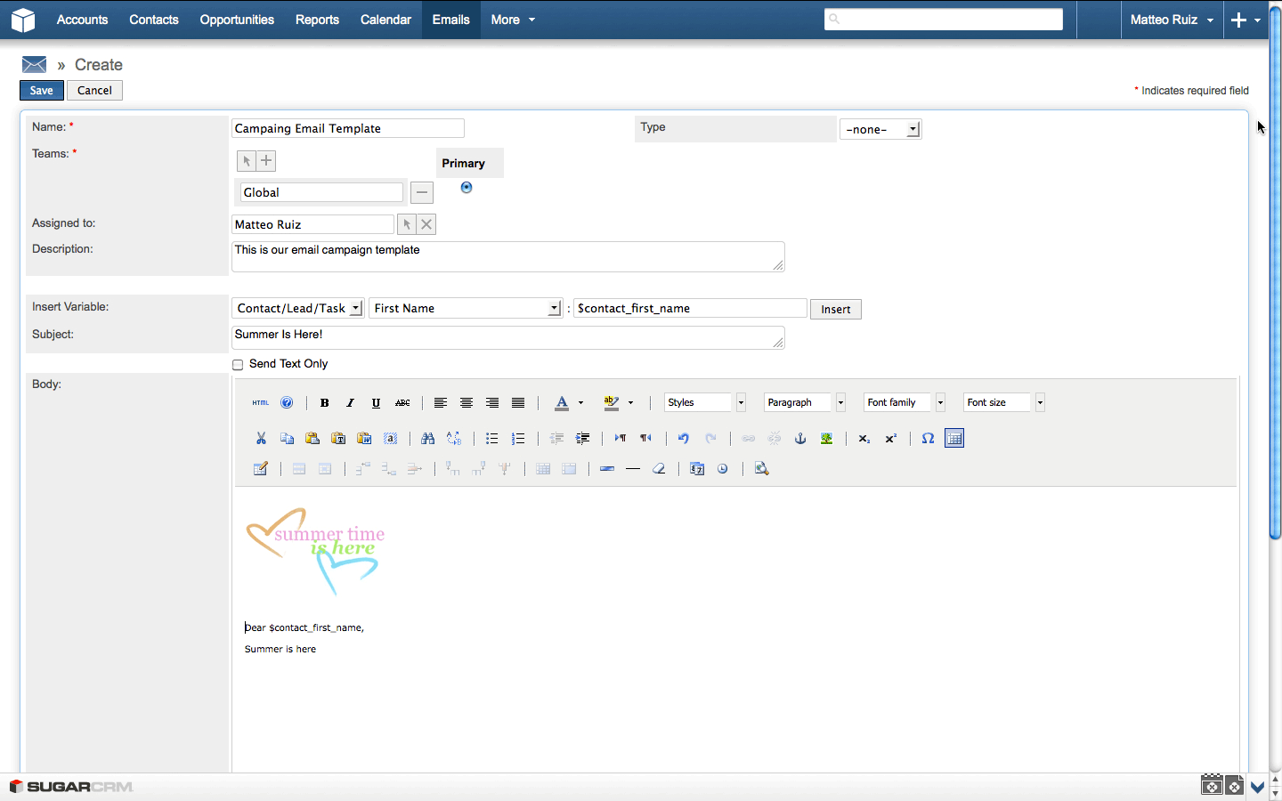

Figure 3.1: SugarCRM Email Composer with Embeded Variables (SugarCRM Inc., 2013)

Initiated email marketing can be monitored to track response rates, generated leads, and unsubscribed contacts. A marketing target lists can also be imported from third- party lists. The SugarCRM also let users save an email as a HyperText Markup Lan- guage (HTML) template, allowing the user to use it again within an email composer. Finally, it offers a mobile version, allowing users to easily access most of the application’s features using their smartphones and tablet devices (SugarCRM Inc., 2013).

**Highrise** Another SaaS application available on the market is Highrise8. It offers sev- eral purchasing plans, with a 30-day free trial period. It has a simple UI like the Sug- arCRM, but it also has quick access buttons for adding a task or a contact. The task

8<http://highrisehq.com/>

management feature on the Highrise application makes it different from the SugarCRM, since unlike the latter, instead of a calendar view, it offers a task view, which can be synchronized with iCalendar as well. In addition, users can create tasks from emails by using one of the unique email addresses for several time slots provided by Highrise, and adding them into BCC, CC, or simply by forwarding an existing email, creating a task in Highrise. Contact information can be imported from Outlook or by uploading a vCard9 file. It provides all the basic contact information fields including the social accounts, however it does not offer custom field creation on those profiles. An email, including its attachments, can also be linked to a contact profile just by simply forwarding it to the provided unique email address. If a user does not exist in the Highrise contact database when an email from him/her was forwarded to attach it to the user profile, a contact pro- file is created using any available information in that email. Adding tags to the contact profiles also makes it easier to organize contacts and browsing within them. However, the Highrise application does not offer an email composer to do an email marketing, as seen in the SugarCRM application. Therefore, users will have to depend on a different third-party application to do simple email campaigns. The provided activity view helps users on keeping track of their own or other users’ recent actions within the Highrise application. Lastly, it offers options on customizing the look and feel of the application with the use of the system provided color schemes, depending on the user’s preference (37signals LLC, 2013).

### Help Desk Applications

The two help desk applications reviewed in this study are Zendesk and Kayako. Ta- ble C.1 provides a comparison matrix of their features, and the details are described in the following paragraphs.

9vCard is a file format standard for exchanging business contact information.

Table 3.2: Comparison Matrix for Help Desk Applications

|  |  |  |
| --- | --- | --- |
|  | **Zendesk** | **Kayako** |
| **Versions** | SaaS | Software and SaaS |
| **Pricing** | $24 – $119 agent/month, with a limited free trial  version | $29 – $49 user/month, with a limited free trial version |
| **Channels** | Website, email, phone, and social platforms | Website, email, and only the Fusion version supports  phone |
| **Macros** | Yes, basic | Yes, advanced |
| **Ticket Manage-**  **ment** | Groups and tags | Types, statuses, priorities,  and tags |
| **Mobile Support** | Yes | No |
| **Analytics** | Yes | Yes |

**Zendesk** Cloud-based customer service software Zendesk 10 provides a nice and clean UI. Zendesk has more than 30,000 businesses from a wide variety of industries. Zendesk offers one-on-one support through many different communication channels including a company’s website, email, phone, and social media platforms like Facebook and Twit- ter. Hence, support requests coming from those platforms can be turned in to a support ticket, and those support tickets can be grouped under categories, and further classifi- cation can be done via tags for each ticket. This feature also helps in finding related archived resolved tickets, so they can be reused for new tickets. Thanks to the automated process coming with macros a combination of actions can be done with a one-click like setting status, priority, type of a ticket, and assign it to another person with a predefined comment for the ticket. A ticket can be merged with another one, or copied to the forum to make it available to the public, which helps creating a reliable knowledge base. Cus- tomer ticket histories and basic personal information are kept in the system. However, it does not allow adding additional custom fields on the customers’ profiles. In addition to the desktop version, Zendesk has a mobile version for smartphones and tablet devices.

10[http://www.zendesk.com](http://www.zendesk.com/)

Therefore, the support team does not have to depend on the desktop platform, as long as they have it on their mobile devices as well. Lastly, the provided analytics view by reports gives an overview of customer satisfaction, and performance of the support team (Zendesk Inc., 2013b,a).

**Kayako** Kayako’s11 complete solution for customer support is named as Kayako Fu- sion. It comes as software and SaaS. Kayako has more than 30,000 clients within the last ten years. Unlike Zendesk, using its UI seemed to be a little more complicated than the latter, and does not have a social media integration, therefore support tickets are gener- ated only over a company’s website, or via email and phone. Tickets can have customized types, statuses, priorities, and tags. Similar to Zendesk, it also supports macros to assign tickets into a department, owner, type, priority, and provide canned responses for tickets with just a single click. Kayako also keeps basic information of customers, as long as they are registered in the system. Registered customers can also participate in building knowl- edge base in a forum-like environment by answering other people’s questions together with a support team. However, Kayako does not have a native app for smartphones and tablet devices like Zendesk. Finally, it has an analytic view to keep track of ticket reports, measuring customer satisfaction and support team’s performance (Kayako Inc., 2013b,a).

11<http://www.kayako.com/>

### Email Marketing Applications

MailChimp and Constant Contact are the chosen email marketing applications to be re- viewed in this study. Table 3.3 shows an overview of their features on a side-by-side comparison to. Supporting details are provided in the following paragraphs.

Table 3.3: Comparison Matrix for Email Marketing Applications

|  |  |  |
| --- | --- | --- |
|  | **MailChimp** | **Constant Contact** |
| **Versions** | SaaS | SaaS |
| **Pricing** | $10/month with max 500 subscribers – $240/month with max 50,000 subscribers.  Pay as you go available | $15/month with max 500 subscribers – $75/month with max 10,000 subscribers. |
| **Template Editor** | Drag and drop including ad-  vanced photo editor | Drag and drop including ba-  sic photo editor |
| **Recipients List** | Conditional filtering | Grouping |
| **Variable Support** | Yes, advanced | No |
| **Permissions** | Admin, manager, author, and  viewer account types | None |
| **Mobile Support** | Yes | No |
| **Analytics** | Yes | Yes |

**MailChimp** MailChimp12 comes as SaaS, and offers either a fixed cost monthly plan or a pay as you go plan. Along with its intuitive UI, it offers a drag-and-drop function on the email content creation. It supports email marketing processes ranging from design- ing the sign up form so that users can add their desired fields and apply brandings on i to applying personalization on emails using dynamic variables. The recipients’ list can also be filtered out according to several conditions like their campaign name, location or rat- ings, as assigned by the user. There are different user account types with different levels of privileges in accessing MailChimp. A person who has an "Admin" account is the only one capable of granting permissions to other users, as well as determining one’s access

12<http://mailchimp.com/>

limitations on using MailChimp. This allows an effective way for the distribution of mail marketing tasks. For an instance, while the assigned manager manages the recipients list, the author team can focus on the email content and design (The Rocket Science Group LLC, 2013e). To design an email content, users can either decide on picking an available template from a collection provided by the MailChimp application or to create their own HTML templates with its drag-and-drop editor (See figure 3.2).

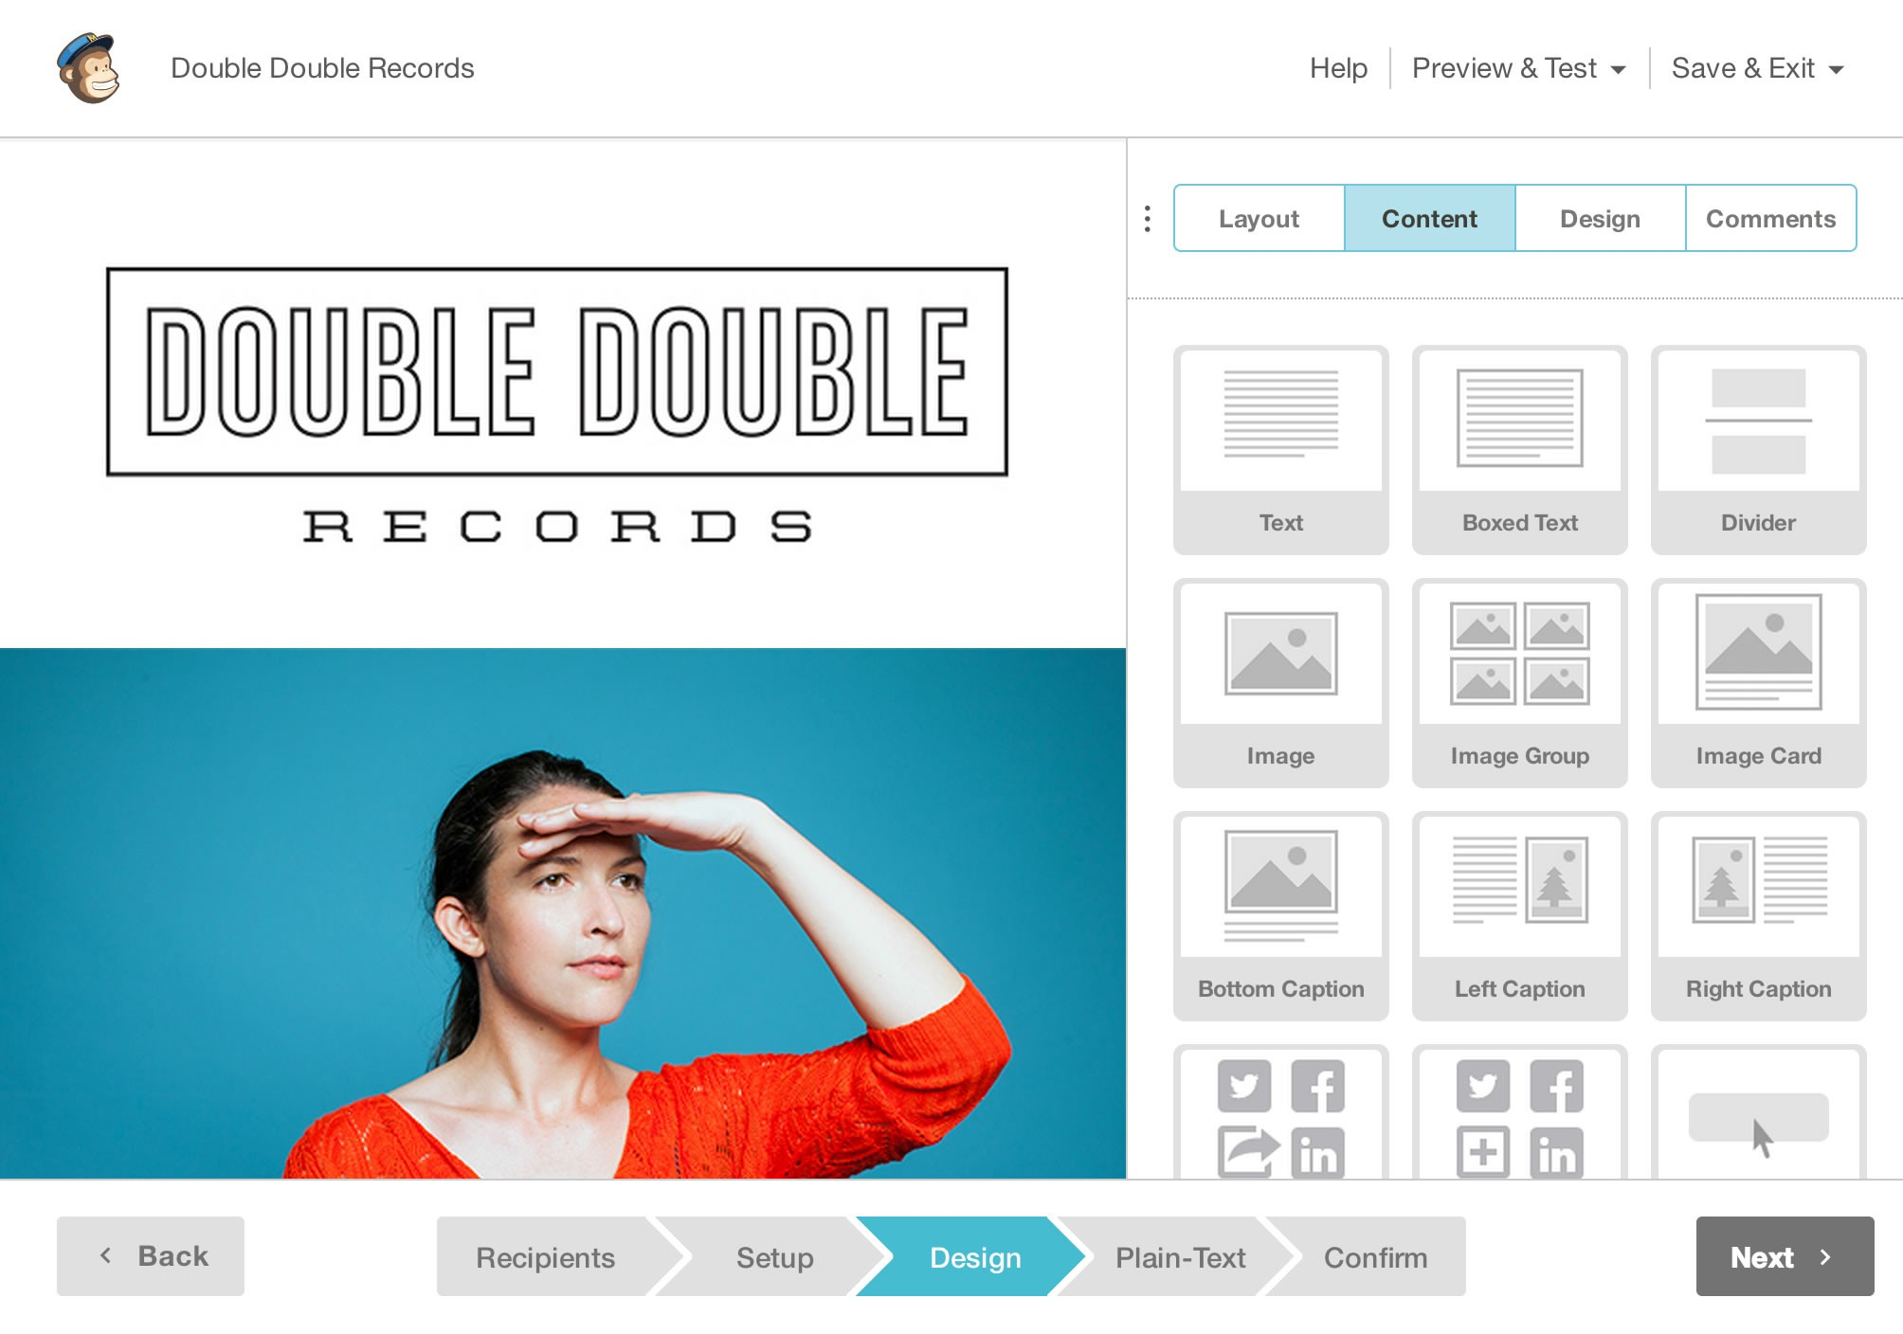

Figure 3.2: MailChimp Drag-and-Drop Content Editor (The Rocket Science Group LLC, 2013b)

The template editor has a photo editing feature, and authors can add comments to give feedback on the content and design of the templates. Created templates can be previewed as if they are viewed on either a software email client, an web-based email client, or even on a mobile web browser (The Rocket Science Group LLC, 2013b). Similar to the SugarCRM application, MailChimp allows you to use dynamic variables – merge tags – in the email content. Therefore, sending out emails can be personalized with recipient- specific information. However, it provides more different types of dynamic variables

than SugarCRM, and it is possible to add a conditional logic to them. For example, in listing 3.1, a custom discount message will be shown in the email depending on what state in the US the recipient from.

*∗*|IF:STATE=CA|*∗*

Save 20% on surf boards!

*∗*|END:IF|*∗*

*∗*|IF:STATE=GA|*∗*

Save 20% on Mountain Bikes!

*∗*|END:IF|*∗*

*∗*|IF:STATE=FL|*∗*

Save 40% on water skis!

*∗*|END:IF|*∗*

*∗*|IF:STATE=CO|*∗*

Save 50% on ski gear

*∗*|END:IF|*∗*

Listing 3.1: MailChimp’s Conditional Merge Tags (The Rocket Science Group LLC, 2013c)

MailChimp offers auto-response based on a triggering event. These events can be a link clicked in the email, being on a specific date like birthday of a contact, or scheduled dates. Finally, there exists an analytics dashboard where users can track the amount of opened emails, or the click rates of the links in the emails (The Rocket Science Group LLC, 2013a,f,d).

**Constant Contact** Another email marketing SaaS is the Constant Contact Email Mar- keting13, whose purchase plan depends on the number of contacts you have, but a free 60-day trial period is available upfront. It offers a drag-and-drop content creation on a clean UI like MailChimp’s. It offers quite a number of templates to choose from and customize. Users can embed sign-up forms into their websites or Facebook accounts. The recipients list can also be imported from different sources like Microsoft Excel, Out- look, and Gmail. In addition, recipients can be grouped into sub-lists, which can also be merged into each other easily. An option of removing duplicate contacts from the lists or delete recipients who unsubscribed from the list is also available. Users can track how many opens, clicks, forwards, and social media platform shares are done for their email campaigns. On the other hand, it does not offer any sophisticated email variables to be replaced by an actual content from the application (Constant Contact Inc., 2013b,a, 2011).

13<http://www.constantcontact.com/email-marketing>

## Conclusion

In conclusion, the aforementioned applications in three different categories provide sup- port for the email communication in several ways:

* + - * Contact User profiles kept in the CRM applications can help a researcher to get to know their respondents better and to identify basic attributes like their name, gender, address, and phone numbers. However, fields are non-customizable, and are limited to the fields provided by the application.
      * Importing contact information from other popular software, e.g. Outlook, can ease the time on creating recipient lists for email communication. SugarCRM and High- rise supports importing an email into the system by just simply forwarding it to a specific email address, making a researcher’s life easier. Providing such flexibility will reduce the dependency on a platform; therefore, as the researchers continue on using the email clients they are familiar with, they can easily switch to another platform whenever it is necessary.
      * Both CRM applications reviewed provides a module on creating tasks, which can be helpful on reminding researchers on the things they need to do, for their email campaign, depending on their priority level. It works like a task showing the next thing to do in an email campaign, as initiated by the researcher. For an instance, sending a replay to an email in which a respondent asked a question clarifying something about the initial campaign.
      * Both CRM applications provide support on the archiving of emails by simply for- warding them to a provided unique email address, and linking those emails to the users’ profile. This can be very helpful on looking for important conversations with respondents on an earlier time, to provide content or an opinion on how to initiate upcoming conversations with those people. However, forwarding an email is an additional step, which requires additional effort and time.
      * Reusability of earlier emails is important, so you do not have to write them again.

As we have seen, the SugarCRM application also allows saving emails as a template for future use. However, no filtering mechanism or a similar function is available, but by just remembering the given name of the template to helps the users find the corresponding template to reuse.

* + - * Not all the time a researcher would be the first one to initiate the communication

via email. Sometimes, a number of emails might be sent to a researcher’s email inbox for inquiries or whatnots. For example, students attending a course may ask questions or some clarifications regarding their homework. Given the scenario, similar or identical questions might be asked several times. A help desk application provides a ticketing system for customer related issues, which is also applicable to the above-mentioned scenario. Therefore, existing email replies can be reused for further recipients.

* + - * + Both help desk applications support tagging or grouping of incoming emails, which can be helpful in identifying conversations related to a specific situation where a researcher initiated more than one campaign. However, there was no available visual representation of the state of the communication of a support ticket, but just status labels like "resolved" or "assigned".
        + Another feature of a help desk application is a support ticket that can be shared or assigned among the members of the support team, which helps decrease the time needed to answer those tickets. This can be also useful in a mass email communica- tion to share the responsibility of replying or extracting information from incoming emails.
        + The email marketing application MailChimp provides dynamic variables that let users add into their email content and its variable will be replaced with actual val- ues. Such a feature can be helpful in a personalized mass email communication, where it is difficult and very time consuming on adding recipient specific person- alized information into emails. However, there is no attached information on those variables showing users what part of the communication exchange they were ex- tracted, and again they are separately created – an additional view where users are away from the actual emails where they can extract information.
        + MailChimp also provides different types of permissions to leverage in an email marketing task. For an instance, as the author creates the email content, a viewer can just follow the reports to see what is the success rate of an initiated campaign. Such functionality can also be helpful in mass email communication, where some users can extract information from the emails so others can easily reply to them.
        + Both of the email marketing and helpdesk applications provide analytic reports to keep track of the success of a campaign or a support team. This is a very useful

function in a mass email communication, as well as getting a quick overview of the current state of the communication.

As mentioned above, there are many useful features that can be helpful to ease a mass email communication. However, there is no one specific application capable of doing all of the mentioned features, or doing them in a way to support their main purposes, which are CRM, help desk, and email marketing.

In the next section, an initial prototype will be introduced to support the workflow of a personalized mass email communication.

# The Initial Idea and the Prototype

In this chapter, a mass communication schema, and possible exceptional cases will be introduced. Afterwards, the initial prototype will be reviewed, and its drawback will be discussed.

## Mass Email Communication Concept

Whenever a researcher initiates a mass email communication, several unexpected out- comes cannot be predicted beforehand, and they can affect the flow of the communi- cation. Respondents may come up with clarifications to an initial question, an email address considered current and active might not exist anymore, an auto responder might have been set since the respondent is not available at the moment are just some of the unexpected outcomes affecting the flow of the communication.

### A Mass Email Communication Scenario

In section 1.1, an online learning platform scenario was used to illustrate the possible reasons explaining the need for an email data collection. Considering it once more, as- suming that we are exploring our users in helping us improve our platform. Therefore, we started sending out emails to our registered users to obtain their permission for us to ask some questions. This initial email might be similar to listing 4.1.

Dear John,

you have recently attended the "Cryptography" and the "Natural Language Processing" courses. Do you mind if you answer some questions regarding these courses?

The questionnaire will take only 15 minutes, and it will help us a lot on improving our platform.

Kind regards,

your online course team.

Listing 4.1: Email Invitation to Questionnaire for Online Learning Platform

After the initial invitation email was sent to obtain their permission for the upcoming questionnaire, these are the possible answers that we get:

* + - 1. Yes, I would like to be involved.
      2. No, I am quite busy.
      3. I could be involved, but I am busy ’till the end of this month.
      4. An automated message from the recipients, indicating that he or she is on vacation.

Figure 4.1 shows a simplified version of this scenario. The people who would accepted our invitation will get a second email containing the questionnaire. As soon as they re- spond back with the answers to the questions, we will then send a "thank you" email for their participation. Those who opted not to accept the invitation will get a motivation email, encouraging them on joining next time. Next, we will classify the people who returned a conditional acceptance under a "maybe" case. Again, there might be several reason behind their conditional acceptance, such as they are willing to answer the ques- tionnaire but they are busy that week. With this, we can email them back, wishing them luck if they are about to take an exam and sending them a reminder email fir the ques- tionnaire, depending on their availability. After the reminder email, we expect to get an email, confirming their participation for the questionnaire. Then, the email interaction will continue with the people who initially accepted invitation for our research. Cases of an invitation with an "auto-respond" reply is not clear, therefore the interaction will not go further, unless they send us a reply confirming otherwise in the near future. However, if the auto-respond email provides some information, we can set a reminder email for the date mentioned.

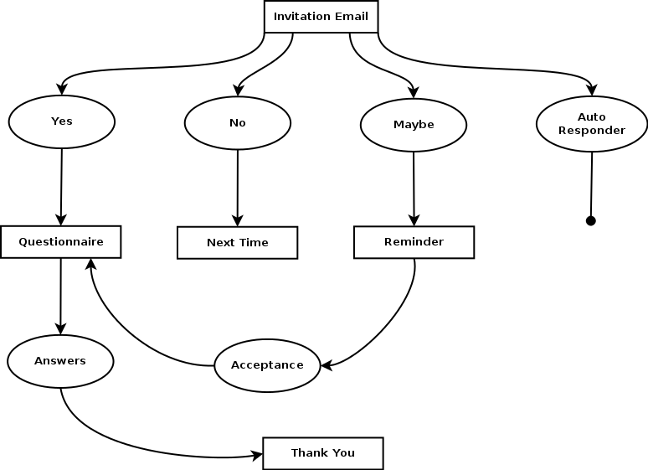

Figure 4.1: An Email Campaign Scenario

The above mentioned sample scenario can be handled manually with individual efforts for a small group of participants. These manual effort will involve the following points:

* Figure out the courses for the participants to attended in our email list, and add them to the email content for each person.
* Write a generic answer for those who accepted the invitation for the questionnaire, and write the questions.
* Write a generic motivation email to support those who did not accept the invitation.
* Go over the "maybe" cases, and record the date and other important information they mentioned involving their participation.
* Write a generic email to the "maybe" cases mention about the reminder that will be sent according to the time period they mentioned. This email may include a couple sentences encouraging them to give a feedback and share the reason why they are unable to accept the invitation for the questionnaire at the moment.
* Go over the "auto-respond" cases to figure out if they are related to a failed deliv- ery due to the problematic email addresses or if they are just automated vacation

responder, so we can setup a reminder email later on.

* + Send a thank you email to everyone who answered the questionnaire.

However, the larger the amount of participants there is, the harder it is to manually work on all of them, thus, the lesser personalization the emails will get. For example, the "maybe" cases might not get a personalized feedback, but instead just an email indication that they will be reminded on a later date. Moreover, this is just one of the possible cases. There are a lot more cases in real life situations, which might require the researchers to completely write a generic email by again ignoring the context personalizing the emails to be sent out according to each recipient, since manual efforts will not be enough to write custom emails for those cases. For extreme cases, we might even consider the need to terminate the communication forever, or results in the side effects of a diffusion of responsibility theory as mentioned in section 2.3.

In the figure 4.2, it is shown that the personalization of emails is directly proportional to the effort of composing those emails. The shaded part of the graph represents the situ- ation, when the researchers used an application to create a mass email communication, while the area marked with a star represents the gold standard, which is really hard to reach with the available applications.

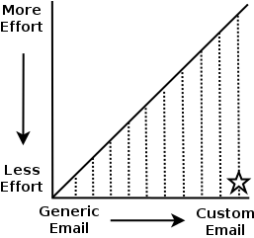

Figure 4.2: Effort vs Personalization on Composing Email

In the next section, we will see how we can help researchers to reduce the efforts while increasing the personalization of emails.

### Possible Improvements to Reduce Efforts

After a mass email communication scenario was described in the previous section, we will see the possible improvements presented on this section to reduce the efforts on the researchers’ side, while increasing the personalization of the content on some degree.

**Contact Information** The first step would be to import contacts, and their relevant in- formation. These will include some of the basic information that we asked when they filled-up the registration form to our learning platform e.g. first and last name, email address, and gender. Therefore, we can easily export these information into a different, easily-accessible file formats like Microsoft Excel or CSV1 to make it ready for use to initi- ate our mass email conversation. The application that was discussed in section 3.3 offers several options in importing data onto the mentioned systems. Therefore, the researchers do not need to manually enter those information to the system.

**Dynamic Variables** The email invitation included user specific data, like the name of the recipient at the salutation and the courses that he or she attended. As it is hard to write information manually into all of the emails, we can apply dynamic variables inser- tion approach that is used by both email marketing applications (MailChimp and Con- stant Contact) and one of the CRM application (SugarCRM), as analyzed in section 3.3. However, it is identified that SugarCRM has the limitation of allowing users to record only a limited amount of contact profile fields. Therefore, this can only help us apply the dynamic generation of the salutations in the emails, and not the course taken by the recipients. On the other hand, both Constant Contact and MailChimp support the feature of adding custom fields into a contact profile, and dynamically use them in the emails’ content. This can also help on removing the manual effort applied for the creation of the initial invitation email with the use of an email template with dynamic fields to be replaced by the application while sending them out. These dynamic fields can also add some degree of personalization into the emails.

1CSV stands for comma separated values, and is a plain-text file to store tabular data to often exchange

data between disparate applications (Repici, 2010).

**Information Extraction** As we begin getting answers from the respondents, we might need to extract some information from those emails. For example, this could be a date that we need to return an email to the recipients with a reminder as it is discussed in section 4.1.1. Storing those information as we stored contact information might allow us to easily access them again, and gives an opportunity to reuse them in the email content as a dynamic variable.

**Reusability of Existing Emails** After the initial invitation email, there will be many instances calling the need on reusing different versions of an email for further states of conversations. We mentioned the term "template" as an email with some some dynamic variables in it. Later on, these variables will get their actual values, and it will be the actual message that we want to send. From here on, we will add another meaning to the term "template" to emphasize a message’s reusability. Let us consider the "maybe" case that was mentioned in section 4.1.1 to represent respondents who were too busy to par- ticipate on answering the questionnaire at that moment, but maybe it is possible for them to participate on a later time (See figure 4.1). For instances like this, our recipients has to indicate a possible date for them to participate or provide an unclear answer about the their availability. It is definite that we cannot ignore them if they provide us a date, and we send them a reminder before that date to participate in the questionnaire in a generic email. This might give them a hint that the messages that we send are actually auto- mated, and it may result to some drawbacks that we discussed in chapter 2. However, if we create two different email templates: one with a dynamic variable in it to mention when we will send a reminder, and the other one with a more generic content including a time far enough to encourage them to participate in the questionnaire. Therefore, the next time when we encounter a "maybe" case, we have two ready-to-use email templates to send them.

**Visualization of Conversation State** At this point, we have begun on creating email templates for different conditions, to ease a researcher’s life by allowing reusability on the replies. However, it is also difficult to pick out a template since a flow of a certain conversation is different from another one, one way or the other, and we have different email templates for different conditions. This will result to an additional effort in choos- ing the appropriate template. Besides, we might not need some of the templates after

conversation’s state gets further, and just use the latest ones more frequently compared to the the older ones. Therefore, we need an overview to show us the current state of the conversation, as well as to allow us to pick the proper template by leveraging this view.

Figure 4.3 represents a view in a directory tree structure for this purpose. All the possible email messages that we have written are collected in a hierarchical way, starting with the first invitation email at the root node. After the researcher began on obtaining messages from respondents, all of the possible answers that we can write are at the second level of the tree, right after the invitation email node. Whenever we get an answer for the questionnaire, we would write an email to say thank you. This is also represented in the third level of the tree, right after the questionnaire node.

Invitation Email

Questionnaire - Graduate Version (GV) Thank You GV

Questionnaire Thank You

Questionnaire After Reminder Next Time

Next Time with Motivation Reminder with Date Reminder Generic

.

Figure 4.3: A Sample Conversation State and Template View

A view shown in the figure 4.3 can also help the researchers pick out a template to reuse according to the email of the respondents. Therefore, they can easily see the previous answers that they gave, and the level of the tree provides an idea on the overall state of the conversation. Considering existing applications in the market on section 3.3, none of them provides such a conversation view, and available templates had to be chosen from a mixed list which includes messages belonging to other conversations as well.

Finally, after reviewing these initial information gathered to figure out how can we ease the efforts of the researchers, while keeping the personalization in the emails high, the next section will discuss how this initial idea was applied into an application.

## The Prototype

A software prototype provides developers a better understanding of the requirements, what could be developed with the existing technology, and by allowing client interaction, it demonstrates to them what is functionally feasible, and revise with their imagination accordingly, which results in better inputs from them and more forward looking systems (Bernstein, 1996). In this section, we will analyze the requirements, and the actual proto- type.

### Requirements Analysis

In the section 4.1.2, we initially considered some features on improving a researcher’s personalized mass email communication. The following points will put those findings into a summary to describe them as requirements of the prototype:

* + - 1. Contact information can come from different sources, assuming we have at least the recipients’ first names, last names, and email addresses, the application must store these information under a contact list permanently.
      2. The application user can use variables in the email message for a recipient’s first name and last name. Therefore, the application must allow a user to add differ- ent dynamic variables into an email’s content to personalize the salutation of the emails.
      3. The application user can extract information from an email message into a KVP2

while reading responses. Therefore, the application must offer on obtaining KVPs from users. At the end, each contact’s record will have enough information saved in KVP to describe all details that we know about them.

* + - 1. The application must allow users to use the extracted KVPs as dynamic variables in the email content. This will allow us to personalize the email with the information specific to each recipients.
      2. The user can reuse a sent email as a template to reply to respondents or initiate

2A key-value pair (KVP) represents two conntected data items, where a key is a unique identifier for some data items, and the value can be again a data item or a pointer to the location of data (Rouse, 2008). In this context, this thesis uses KVP in the context of extracted information as values, and a unique key to represent its class. For example, "first name" can be a key, and each recipients first names will be a value for the "first name" key.

a conversation for a group of people. Therefore, the application must offer an overview for picking out templates from a list.

* + - 1. The application must show the whole flow of the conversation. Therefore, the tem- plate list can be showed in a directory tree structure as in figure 4.3. Each node must represent the templates the user created, and let the user pick out a custom name for the given template.
      2. The application must offer a template selection and conversation flow represen- tation under a specific single view. Therefore, the user should be allowed to pick which templates to reuse by looking at the nodes in the tree to figure out the current flow of the conversation.

The next section will introduce the implemented prototype to satisfy the initial idea of a personalized mass email communication system, and analyze how the aforementioned requirements are satisfied – or not – during the evaluation of the prototype.

### System

The initial system was built on top of an existing project named as EmailValet3 also known as GmailValet in the Human-Computer Interaction (HCI) group4 at the Stan- ford University. EmailValet is a SaaS application that combines an email client with a task manager. Remote assistants from an expert crowdsourcing marketplace extract tasks from incoming emails, and annotate them in a task list separated from the inbox (Kokkalis et al., 2013).

Having a ready-to-use email client to implement the first version of the personalized mass email communication system helped us to save time and effort, and make us fo- cus more on the initial requirements as discussed in section 4.2.1. From the technology point of view, we were also limited by EmailValet’s existing architecture, which was de- veloped in a Web framework Ruby on Rails (RoR)5, a JavaScript framework jQuery6, and

3[https://www.gmailvalet.com/](http://www.gmailvalet.com/) 4https://hci.stanford.edu/

5<http://rubyonrails.org/> 6<http://jquery.com/>

a Cascading Style Sheets (CSS) framework Twitter Bootstrap7.

EmailValet requires a Gmail account to register and sign in8 to the system, therefore the application’s users have to grant access to EmailValet before using it. Figure 4.4 shows EmailValet’s inbox view after a user signed in and browse to a campaign9. On the left hand side, there is the email list pane, and a selected email can be read on the reading pane on the right.

7<http://getbootstrap.com/>

8EmailValet uses an open protocol named OAuth to provide credentials for authentication with Gmail.

OAuth’s community webpage is at <http://oauth.net/>

9In this study, the word campaign is used as a shorhand for a mass email communication campaign, wherein a researcher initiates a conversation with groups of people related to one specific topic.

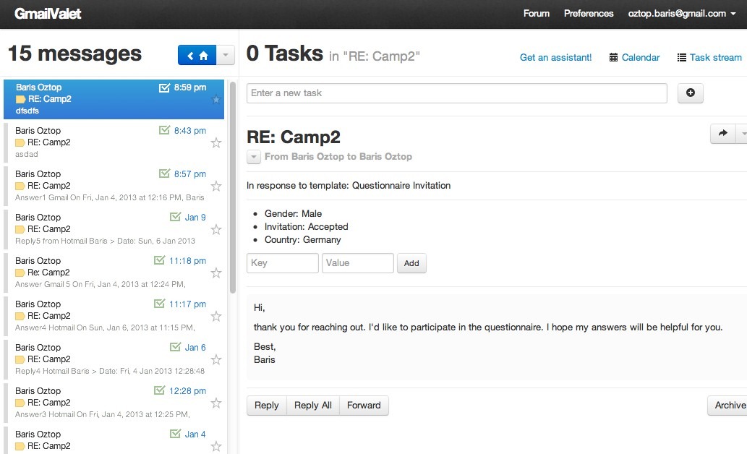

Figure 4.4: EmailValet Inbox View and Message Reading Pane

Starting a campaign is done exactly the same way as in composing an email. However, the corresponding view has two additional input fields to get the campaign’s and the template’s names from the user. A campaign name will help on identifying the groups of conversations from other campaigns, or from regular email conversations in the inbox. A template name will help us to identify which respondents’s answers correspond to which emails that we sent. For example, in the figure 4.4, a recipient’s answer is the response to the questionnaire invitation that we sent earlier. A template name will also help us to represent the template in a tree structure to pick from and reuse, and show the state of the conversation in the same tree structure.

The researchers can add their recipients list into the "Merge"10 input field as shown in figure 4.5, which corresponds to the "To" field in a regular email client. However, the format should be similar to the shown figure – first name, last name, and email address written in angle brackets. Hence, those fields can be used dynamically in the salutation of the emails by writing one of the variables of *{{first_name}}* and *{{last_name}}*. Once 10The word "merge" comes from the term "mail merge", which means a procedure to enable to combine a document with data files consisting a list of names. Therefore, the copies of the document will be

different for each person it is sent to (Collins English Dictionary, 2013).

the recipients list is entered, and the email is sent, these contacts will be recorded in the Gmail’s contacts book.

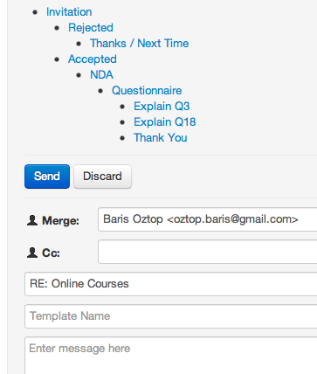

Figure 4.5: Email Template Selection to Reuse Earlier Replies

Figure 4.5 also shows the template tree used to represent the state of the conversation, and allow users to select a template from. The indentation at the nodes of the tree helps on identifying which templates are used after which one, and therefore it gives an idea about the current state and flow of the conversation. According to this sample scenario in the figure, right after we sent the invitation email and started on getting responses, there were two possible answers to give the recipients. For those who rejected the invitation, we can select the "Rejected" node from the tree to reuse an answer that we gave before. This can be a motivation email as discussed in section 4.1.2. On the same note, the peo- ple who accepted the invitation would receive a Non-Disclosure Agreement (NDA), and afterwards the questionnaire as the conversation with them carries on. After sending the questionnaire, there were cases where some respondents sent an email clarifying some questions found in the questionnaire. According to figure 4.5, these cases are related to

the questions number 3 and 18, and we explained those questions, to clear off the con- fusion or issues they are having. Again, since the system allow us to reuse our previous answers as a template; we do not need to rewrite our explanation for those questions not clear for future queries. On the other hand, if the researchers wish to create a new template, he or she can simply do so by adding the name of the template into the cor- responding input field, and send the email. The next time the researcher fires up the application, he or she will find it in the template tree under the corresponding level of the node. Also, it is possible to select a template, made some modifications on it and save it as a new template. Therefore, a slightly different version of the templates can be reused during the communication as well.

Finally, there is an option to add KVPs while reading the respondents’ answers. In the reading pane, two input fields are present, allowing users to enter a key and its value corresponding to the extracted information from those emails while reading them. As shown on figure 4.6, as a user adds a new KVPs, they can also see the existing ones added earlier to that email message.

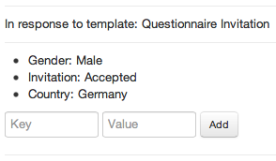

Figure 4.6: Extracted Key-Value Pairs and Input Fields to Add New Ones

In conclusion, while the prototype satisfied many of the initial requirements that was discussed in section 4.2.1, there were some drawbacks that will be discussed on the next section, section 4.3 to explain why it was discarded, instead of considering it for the consumer production. But before that, we address some implementation details about EmailValet’s mass email communication modifications in the next section.

### Architecture

Even though, we have a ready-to-use email client with EmailValet, there were quite many changes to reflect the requirements that were mentioned in section 4.2.1. Since EmailValet dealt with single email messages, and not a group of them as an email client, there were also some modifications needed to be done in order to make the prototype understand whether a message belongs to the campaign or not. In this section, we will briefly see how the changes for the prototype fit into the existing EmailValet’s design, and make a technology overview to fully understand how a mass email communication is done.

**Identification of a Campaign Message** An email message consists of a header and body sections as defined by RFC 5322. While a message’s header keeps structured infor- mation such as "From", "To", "CC", Subject, Date, and other information with a special syntax, a message’s body contains the content, which is an unstructured text and it is optional to have (Resnick, 2008). An example email message with its header fields and body can be seen in Appendix B.

One of the fields in an email message’s header is called Message-ID11, which is a unique message identifier, and set by email clients. The value of a Message-ID is used in another header field, named In-Reply-To, when a message is a reply to that message.

EmailValet had already the data model to store an email message’s related data when it is synchronized12 with Gmail. However, creating a mass email campaign requires to identify if the synchronized email belongs to a mass email campaign that was created or if it is an answer to a campaign message that was sent before. Because EmailValet’s

11The message identifier, Message-ID, is enclosed in the angle bracket characters, "<" and ">", an its syntax only permits the dot-atom-text form, which is 1*atext *("." 1*atext), on the left-hand side of the "@" and a domain name is recommended for the right-hand side of the "@" (Resnick, 2008). For example:

[<CAF2E4bfH4+GAYHcJFZJ6dTJJ+pux4mTjff2neCS_VR_zVCUY9g@mail.gmail.com>](mailto:CAF2E4bfH4%2BGAYHcJFZJ6dTJJ%2Bpux4mTjff2neCS_VR_zVCUY9g@mail.gmail.com)

12Fetching the emails from Gmail is done via the IMAP extension that Gmail provides. IMAP is a internet message access standard defined by RFC3501. It allows a client to access and manipulate mail messages on server (Crispin, 2003). On the other hand, EmailValet uses Simple Mail Transfer Protocol (SMTP) protocol to connect to the Google’s SMTP servers to send a composed email in EmailValet. SMTP is a mail transport and delivery protocol defined by RFC5321 (Klensin, 2008).

initial design was able to fetch emails from Gmail, then assigning of different properties should follow. The emails composed by EmailValet comes to an existence in the Email- Valet database after recipients send a reply to them, since EmailValet fetches them from Gmail’s inbox as a part of the thread of messages. Therefore, Message-ID and In-Reply- To fields of an email message are leveraged to keep track of a campaign message by setting a Message-ID into it, and store it in Campaign data model as illustrated on 4.7. With this, we were able to identify the type of messages during the synchronization with Gmail, whether the message is an initial campaign message, or if it is an answer to a campaign message that was created earlier. Before this, setting a message-ID was done by EmailValet’s "mail" gem13 during its execution time without allowing to get its value.

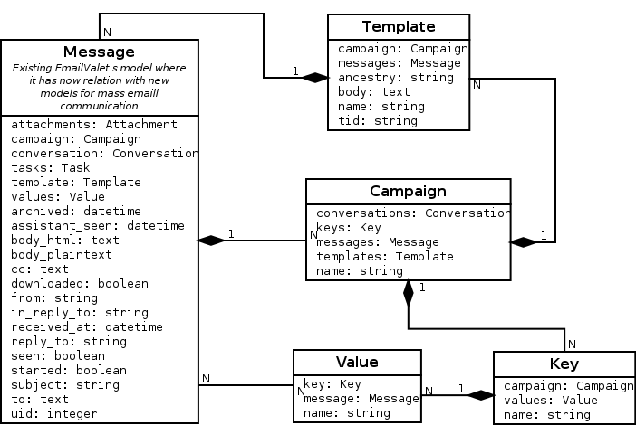

Figure 4.7: Model Dependency of the New Features of EmailValet

**Template and Email Message Relation** Each campaign message composed in EmaiValet is actually a template with dynamic variables in it. Therefore, the campaign messages fetched from Gmail corresponds to a template in EmailValet. This interaction can be seen in figure 4.7. As mentioned in the previous section, there is an available tree view when

13A Gem or a RubyGem is a software package, containing a packaged Ruby application or library (RubyGems Guides, 2013).

a user replies to a respondent’s answer. This tree view’s purpose is to let users choose earlier templates to reuse, and give an overview of the latest state of the conversation. The hierarchy between the nodes of the tree is a nested set model, in which each node has a left and a right integer values. The left and right values in a node represent a set of child nodes. The same concept applies for the each child nodes as well; hence, each child node has a left and right value that represents another set of children, as a part of outer nested set. Figure 4.8 depicts a tree in a nested set model.

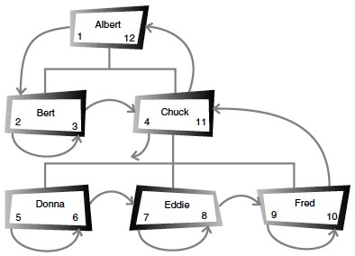

Figure 4.8: A Nested Set Model Tree Hiererchy (Celko, 2004, page 46)

Nested set model helps us on finding a node’s children faster than a usual adjacency set model, where each node only keeps information about its parent node, which is the ID (Celko, 2004, pages 45–47). For example, in order to find all the nodes of the root node named "Albert" in figure 4.8, we just need to find all nodes whose left value is greater than 1, and right value is less than 12. In the adjacency list, however, we first need to find all the nodes whose parent IDs are equal to "Albert’s", then for those nodes’ IDs, we need to find other nodes whose parent IDs are equal to them, and it continues on until all nodes are finished in the tree in the same way.

The template data model in 4.7 keeps those left and right number information in one column named "ancestry", which is populated by a gem named Ancestry14.

14https://github.com/stefankroes/ancestry

**KVPs Relation with a Campaign and a Message** As shown in figure 4.7, each email message can have more than one value corresponding to a key of KVP. This allows us to identify, when a KVP is added to a message that belongs to a respondent. Keys are organized according to the campaigns; therefore, same key’s value can be used in different campaigns for different purposes. This is mainly because, a word chosen as a key can have different meanings depending on context.

After getting an overview of the technical implementation of the prototype, the next sec- tion will focus on what was missing from this initial design comparing with the initial requirements, as described in section 4.2.1, the problems with it, and what new ideas can emerge with its development.

## Evaluation of the Prototype

In this section, we will analyze the drawbacks of the prototype, despite the fact that it was able to fulfill most of the requirements mentioned in section 4.2.1. Some of these drawbacks are related with the development of a prototype from an existing application, whose main purpose is different than that of a regular email client. One of the reasons for making a prototype is to let developers and users conceptualize different requirements or review the existing ones. In here is where we will also mention new and different requirements we realized as we went through the whole process, as well as our future ideas.

### Limitation of the Existing Application

As mentioned, using EmailValet as an email client on developing a prototype helped us to save time and effort. However, there were some limitations present with it since it focuses on crowd-assisted task manager actions, rather than a simple email client.

**Number of Message Limitation** One of the problems encountered with EmailValet was the limit on the amount of messages synchronized from Gmail. It is limited to the latest 100 messages, to maintain EmailValet’s privacy and accountability (Kokkalis et al.,

*4.3 Evaluation of the Prototype*

2013). However, a mass email campaign will quickly reach that given limit, which may ignore older emails.

**Different Inbox Purpose** EmailValet offers an email client with a task manager feature, as a replacement to everyone’s regular email client. However, a mass email communi- cation is not something a person needs to resort to for personal email communication. Moreover, a mass email communication application should be separated from a person’s regular inbox, since it does not need to show all their emails, except those related to an email campaign. Combining both inboxes also resulted to some rawbacks on the perfor- mance when it was synchronizing with Gmail to fetch new emails. It is because Email- Valet was also performing some additional steps during the synchronization on the side, such as checking and comparing message headers, checking for changes in the earlier messages up to a date, defined by the amount of the messages.

### 4.3.2 Limitation of the Prototype

**KVPs Relation** In the prototype design, each value of a key belongs to an email mes- sage of a respondent. However, we need to see that all KVPs are aggregated in a cer- tain way when we browse a set of messages belonging to a specific person. Therefore, assigning KVPs to an email message actually means assigning them to a recipient in a mass email campaign. This requires keeping each individual recipient in a separate data model, and relating it with the existing EmailValet’s design. Since we have already iden- tified the limitations of EmailValet in the previous section, the decision was to add those enhancements into a new application.

**Getting Contact List into the System** At Stanford HCI group, we realized that the people who performs such mass email communication import their recipient list from a spreadsheet, or a similar data file. Since, the prototype requires them to input a recipient list in a special syntax as was mentioned in section 4.2.2, this requires the users to change their existing contact list in a format that the prototype will be able to parse with. This reduces flexibility and adds additional effort on the researchers, whose contact list is already in a data file. With this said, it is a feature considered to be implemented on a different project, separate from EmailValet.

## 4.4 Conclusion

In this section, a mass email communication concept was introduced with an illustrative scenario. We pointed out how it could be possible to reduce the efforts on the researchers’ side while increasing the personalization of the emails at the same time. Later on, we con- verted those ideas into software requirements for the prospective prototype, where we introduced the features and their architecture. Finally, the evaluation of the prototype made the basis to the next chapter, where the mentioned limitations are removed or min- imized on the final design, and the new requirements are created from the user feedbacks of the users’ during the final application’s iterative design cycles.

*4.4 Conclusion*

# 5 The Final Solution

In this chapter, a final design of a mass communication system named Myriad will be introduced. To begin with, improvements on the requirements will be compared to those defined for the prototype from the previous chapter. Later on, the actual product features, its architecture, and the benefits of the final solution will be discussed.

## 5.1 The Improved Requirements

Seeing the prototype in action made us realize the need to revise the requirements and bring new ones. Some of those requirements are shaped according to the feedback we got during our research at the Stanford HCI group, as well as from a Stanford organization who conduct mass email communication regularly in reaching their community. The following section will discuss those new features for the final product.

### 5.1.1 Assistant Support

As described in section 4.1.1, the standard we want to achieve within a mass email com- munication is the most adequately personalized emails for every individual recipient, with a minimum effort on the researcher’s side. The initial idea, as well as the prototype, included several features for this purpose, as discussed in chapter 4. However, consid- ering the gold standard we would like to achieve as shown in figure 4.2, the prototype manages to still leave an amount of effort on the researcher’s side in accomplishing a successful mass email campaign.

In order to reduce the effort as much as possible during a mass email communication, the addition of an assistants’ involvement was considered. Therefore, a primary researcher will be able to share tasks with permitted assistants. These might be tasks such as ex- tracting information from the incoming answers, proofreading the primary researcher’s

* 1. *The Improved Requirements*

replies before sending them, or even writing replies to those answers. Therefore, the pri- mary researcher will only need to interact with the flow of a mass email campaign when the situation calls for it. However, the system would still needs to provide necessary fea- tures that will be seen in the next sections in support for the work flow in a mass email campaign, hence, assistants will only need to interact with this work flow in letting the email campaign carry on by providing answers with the provided email templates and extract information as KVPs.

### Dynamic Variables and KVPs

We introduced the use of dynamic variables at the initial prototype; however, it was only limited to the salutation of the email. As described in section 3.3.3, email marketing applications support this feature. And because it makes the personalization of emails easier, the final product will also include this feature. As a result, application users can create KVPs and use the said keys in the content of an email message to be replaced dynamically by its value, according to the recipient. Therefore, the extracted information from emails will not just help us gather information in an organized way, but also in personalizing the emails.

As a result, instead of storing the KVPs in the system according to their respective re- sponses, the system should store them according to the recipients itself. This is where the KVP-idea differs from the prototype. With this, we now have profiles of contacts for a campaign having all KVPs of a recipient visible during the whole state of the conver- sation. However, the system should offer an option to hide individual KVPs to avoid cluttering the view, and make the actively used KVP list the default view.

Importing KVPs can be done in several ways. One option is that the system should be able to synchronize with an online spreadsheet, e.g. Google Spreadsheet, in obtaining the KVPs at the beginning of a campaign. This is a convenient way for researchers, since they are already familiar with spreadsheet environments. Other options should include a campaign-wide view and a contact specific view in the system. Also, it should have an editable keys and values in a campaign.

### Importing and Exporting Contacts and Their Information

In the prototype, the application user has to enter all the basic information of the recipi- ents such as first name, last name, and email address into the system manually. However, as they perform this, they use a spreadsheet and copy the contact information from there. This was also done for their regular email client used for email campaigns. The applica- tions that were reviewed in section 3.3 all had an option to import data from spreadsheets to ease the process. Therefore, the system should also offer an option similar to this in importing contact information.

However, importing should not only be limited to the basic information of the recipi- ents. Since we already mentioned about importing KVPs from a spreadsheet in the pre- vious section, the system should also able to detect and import the contact information and KVPs related to a specific recipient, granting that they are available in the provided spreadsheet.

The system should provide a bi-directional synchronization, and not just support to im- port data from the spreadsheet. Therefore, the system should provide an option to export contact information and their created KVPs from the system to the spreadsheet as well. This gives a reporting functionality to the application users, where they can see all of their recipients, and the extracted information from a specific campaign, all in one view.

### Interoperability with Other Email Clients

Even though we provided a new system for the users in initiating their mass email com- munication, there might be other cases wherein a mass email communication was initi- ated using a regular email client, therefore the system is not aware such campaign, since it was not created with it. The application should be able to provide an option in import- ing email messages created with a different email client into the system by recognizing specific messages, as annotated by the user.

Allowing the system to import email conversations from other email clients reduces the

need for dependency on the application, and while researchers continue on using their own email clients, assigned assistants can take care of those emails, as imported by the researchers. We saw the same import feature in CRM applications presented in section

3.3.1 as well, where a user can easily forward an email to the CRM application’s provided unique email addresses, and the system then takes care of assigning the imported emails to the corresponding recipients in the system.

### 5.1.5 Automated Decision-Making and Notifications

Even though the involvement of assistants helps make the primary researcher’s life eas- ier, the system still needs to provide an automated approach in answering emails whose statuses are clear in terms of its mass email communication flow. Therefore, a rule based decision-making mechanism should be used, at which a user sets the values of the keys from KVPs, and it triggers the action of sending emails to qualified respondents whose KVPs satisfy the provided condition.

Since the only purpose of the application is managing mass email communication and each campaign results to a great amount of messages in the inbox, the system should be able to provide notifications regarding what should be done next for each recipient. Labels should be added to email conversations to indicate whose turn is the next in the communication. For an instance, by proving a label saying "You need to reply" to the application user, the state of the communication awaits for an ample action from a re- searcher, or an assistant. In the same way, unread conversations and conversations wait- ing for an answer from the recipients should also be annotated in the appropriately. The system should also provide email notifications to the assistants’ email addresses, to notify them whenever there is an action waiting to be taken care of.

## 5.2 Final System

In this section, we will see how the revised and improved requirements from the previous section reflected on the final product, named "Myriad".

### Log-In and Campaigns Overview

Similar to the prototype featured in section 4.2.2, Myriad also requires a Gmail account to work with. The reason behind this is not just the popularity of Gmail, but also given the fact that Stanford University uses Google Apps by default, university wide. Therefore, each member of the university has a Google account ready to use with Myriad. This also provides flexibility, because Myriad does not have a registration form or a sign in screen. All the requested Google’s permissions from a Myriad’s user and their descriptions can be found in appendix C.

After users sign in to the system, the first screen they will see is the campaign overview screen. All created campaigns, including the ones assigned by other user’s as an assistant are shown as in figure 5.1. It has a simple and clean UI, compared to regular email clients, emphasizing its focus on mass email communication.

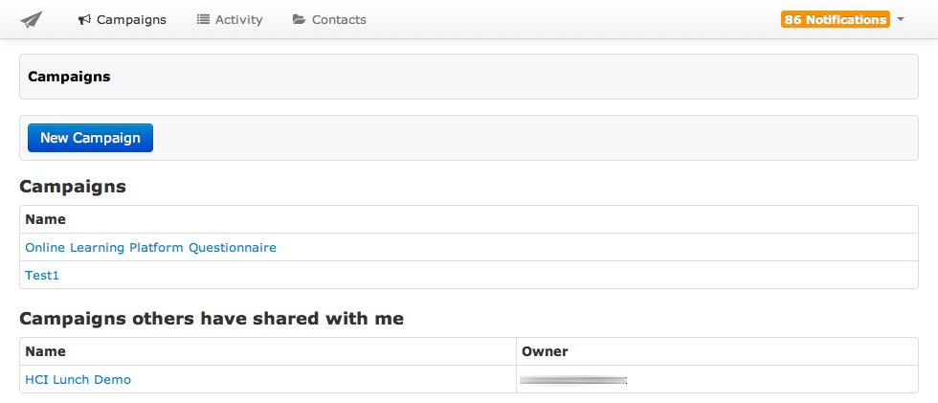

Figure 5.1: Myriad’s Campaigns Overview Screen

### Synchronization with Other Systems

Myriad has the ability to get the recipients’ information and their KVPs from Google Spreadsheet1. This is a convenient way in importing recipients’ information into the system, since many people already keep their recipients’ and related information in a spreadsheet environment as we discussed in section 5.1.3. Therefore, Myriad offers a bi-

1https://docs.google.com/spreadsheet/

directional syncing from and to a spreadsheet, defined at the beginning of the creation of a campaign. Besides this, Myriad also has an option to enter a recipient’s first name, last name, and email address into the system directly.

The corresponding columns in a Google Spreadsheet start with "first name", "last name", and "email address" as shown in the figure 5.2. The rest of the columns will be filled out as a KVP, and imported into the system as well.

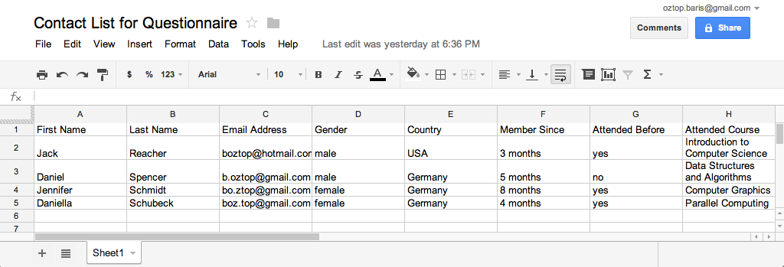

Figure 5.2: A Google Spreadsheet to Import Recipients’ Information into Myriad

As mentioned in section 5.1.4, importing existing email conversations as a campaign mes- sage into the system is an important feature. Researchers might have initiated conversa- tions using their regular email client, and if later on they decide to make them more manageable, they can import them into Myriad. Myriad takes advantage of Gmail’s la- beling feature, which is equivalent to the IMAP protocol’s folders for the same purpose (Google Inc., 2013b). Myriad creates a Gmail label in the user’s account, and the only thing a user needs to do is the enable the label syncing feature at the campaign creation screen. Next, there will be a label similar to the campaign’s name, and grouped under the root label, "myriad" in the Gmail’s inbox (see the figure 5.3). Hence, researchers will able to import email messages not considered a part of a campaign for some reasons, into Myriad.

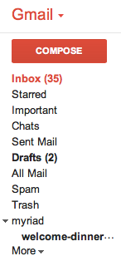

Figure 5.3: Gmail’s Labels and Myriad’s Campaigns Under the Myriad Label

### Creating an Email Campaign

The campaign creation screen (see figure 5.4) has input fields for a campaign name and Google Spreadsheet’s Uniform Resource Locator (URL) to synchronize with. Other two checkboxes for the spreadsheet are used to manage the frequency of synchronization and disabling the cascading warning messages in case of an erroneous data in the spreadsheet such as an empty email address field for a contact. The option for importing emails from Gmail’s inbox is also in this screen, labeled as "synching section".

After the campaign is created, all the contacts and their KVPs will be imported as long as the user provided a Google Spreadsheet URL like in the figure 5.5.

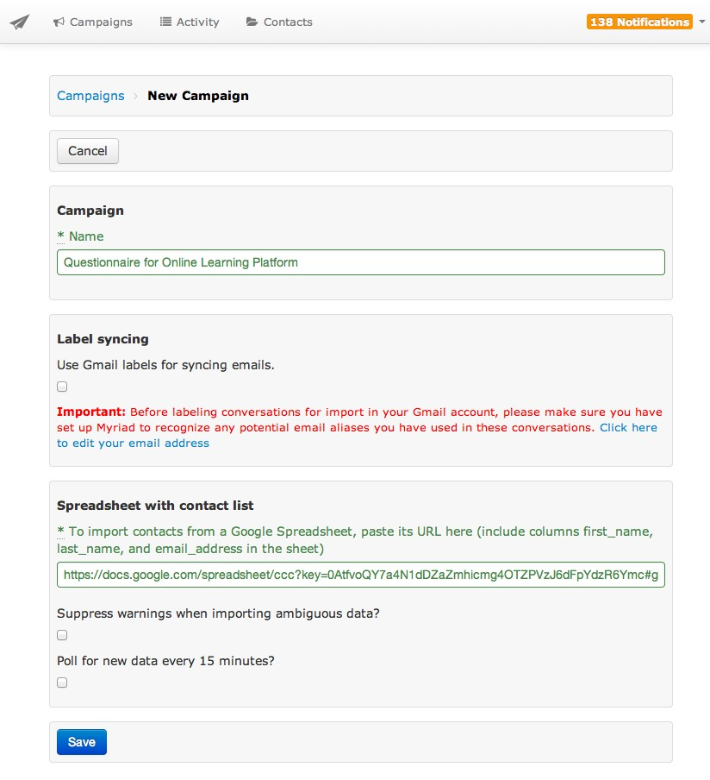

Figure 5.4: Creating a Campaing in Myriad

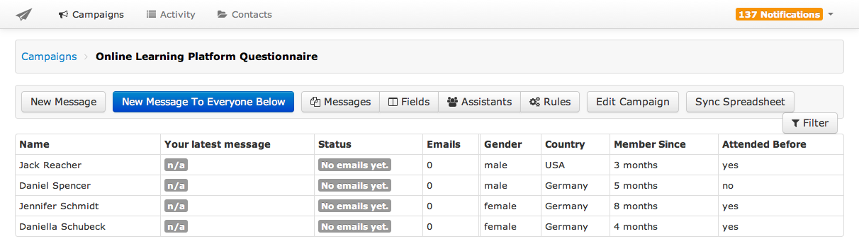

Figure 5.5: Contacts and Their KVPs After Synchronization in Myriad

### Composing an Email Message

Users can send emails to all of the contacts they entered or imported into the system, or select a subset of them by using the filtering functionality as shown in figure 5.6. Provided filtering options are according to the values of KVPs, the conversation statuses such as unread, replied, or unreplied, or the message’s template names.

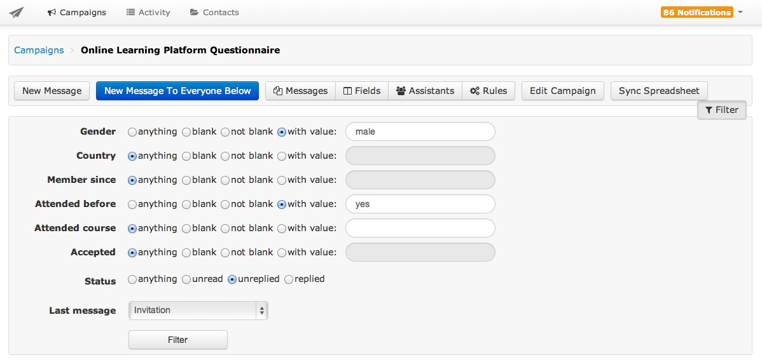

Figure 5.6: Filtering the Contact List in Myriad

By pressing the corresponding button, users can now readily compose emails for their fil- tered recipients at the compose screen. The compose email pane (see figure 5.7) contains a section that lists previously sent emails available for reuse. This is the same template concept that was introduced for the prototype in Chapter 4. Section 4.2.2. It also shows the visualization of the flow of the communication by using a tree structure, as well as the number of messages sent by using the corresponding template. A more long term cam- paign’s visualization tree can be found in appendix D. The system also suggests an email template while composing a reply by considering the nodes at the same tree structure.

The compose pane allows users to add dynamic variables in the content of messages to personalize them according to the recipients. These variables are not just limited to the first name and last name, as they can also be of any keys from the assigned KVPs in the campaign.

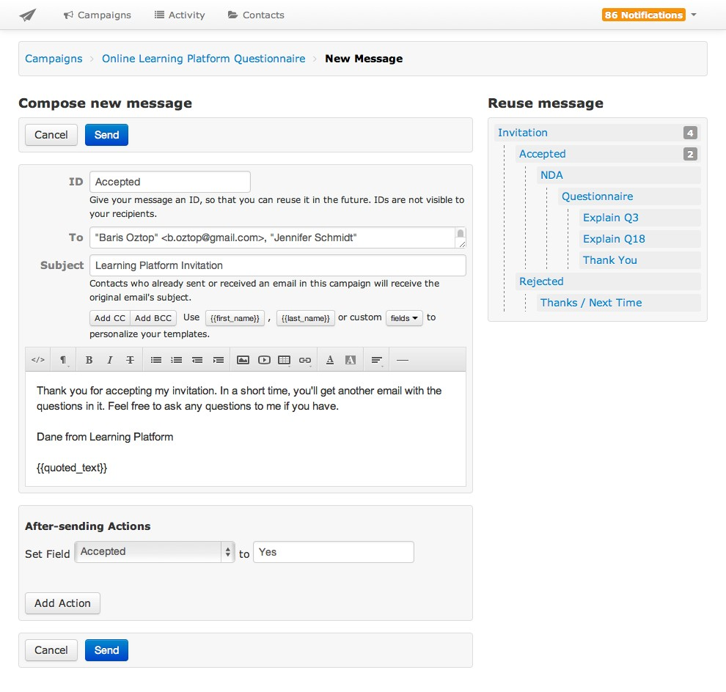

Figure 5.7: Compose an Email in Myriad by Reusing Earlier Messages

Each campaign has a link to the other campaigns, as ling as the recipient is involved in both campaigns, as featured in the next section. A researcher can access conversations and KVPs from other campaigns by switching to the campaign via the provided link. Pro- viding an option to see the earlier campaigns a recipient got involved in gives broader knowledge about a recipient that may help researchers in personalizing the content of the emails more easily and properly. For example, if we have extracted information re- garding which sports did the recipients got involved with in an earlier campaign. We can use the same information in making a friendlier and to frankly start a new campaign by mentioning details about the latest events of those sports areas in the country. Such a technique also supports the social exchange theory and the diffusion of responsibility theory as discussed in section 2.3. There is also an option to hide the KVPs in a campaign if they are not related at all or have become obsolete during the flow of a campaign to avoid cluttering the application’s view.

In the figure 5.7, at the pane of "after-sending actions", users are able to set the values of the keys right after an email is sent. Therefore, a user does not need to browse to another screen in order to change or set KVPs whose values depends on the email that was recently sent.

At the beginning of this section it was mentioned that a user can filter the recipients list, and then send an email to a subset, according to the filter’s criteria. Myriad saves those filtered criteris under the "Rules" menu as shown in figure 5.8 after the user sent the email. Therefore, the next time the system receives new emails with the same conditions as before, user will see them under the rules menu, and the earlier sent email messages can be sent to those new matching recipients automatically, if user opt to enable the auto- mated response feature or a user can simply press the send button manually in the same screen. For example, in figure 5.8, there are three recipients whose "attending" key were set to "yes", and since the system already recognized that we have already sent an email to those whose attending, new matches for the same condition applies. In this case, the user can simply press the send button, or automate the process by enabling the provided option.

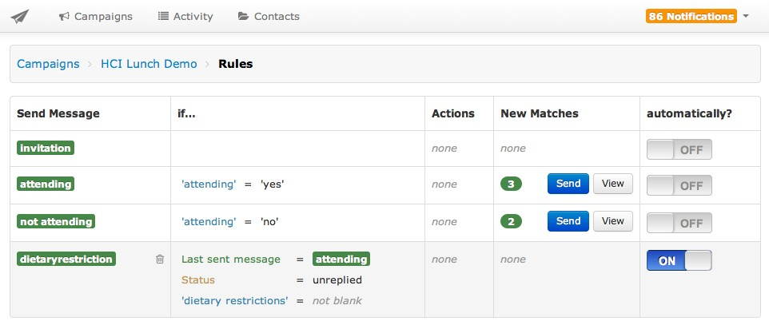

Figure 5.8: Rules to Automate the Sending Process of the Emails in Myriad

### Extracting Information from Email Messages

Myriad’s reading pane (see figure 5.9) offers a threaded view wherein all of the messages between a specific recipient and a researcher are visually grouped together. The advan- tage of a threaded view is that it allows a researcher to get a quick overview of the whole state of a conversation, therefore a researcher can write a customized message more easily by focusing on the specific personality of the individual being responded to, considering the earlier conversations with him or her at a single glance.

Each of the researcher’s message is also annotated with the name of the message template that was used with, making the latest state of the communication easily recognizable without having to look for its content. In figure 5.9, emails sent by the user have green labels writing with indicators of the name of the template used, such as "Accepted" and "Invitation".

While reading a recipient’s answer, the extracted information can be recorded as KVPs at the right-hand side of the reading pane (see figure 5.9). Earlier recorded keys’ values can also be updated at the same pane. Having KVPs along with the conversation thread gives a researcher necessary information about the person being replied to. Under the KVPs pane, the researcher can also see if the recipient is involved with another campaign, and a

link to the involved campaigns are provided with the number of emails exchanged, next to it. This is a helpful feature in reminding researchers about the existence of previous interactions with the recipient, and if necessary the researcher can switch to the other campaigns to get an overview of extracted information as KVPs.

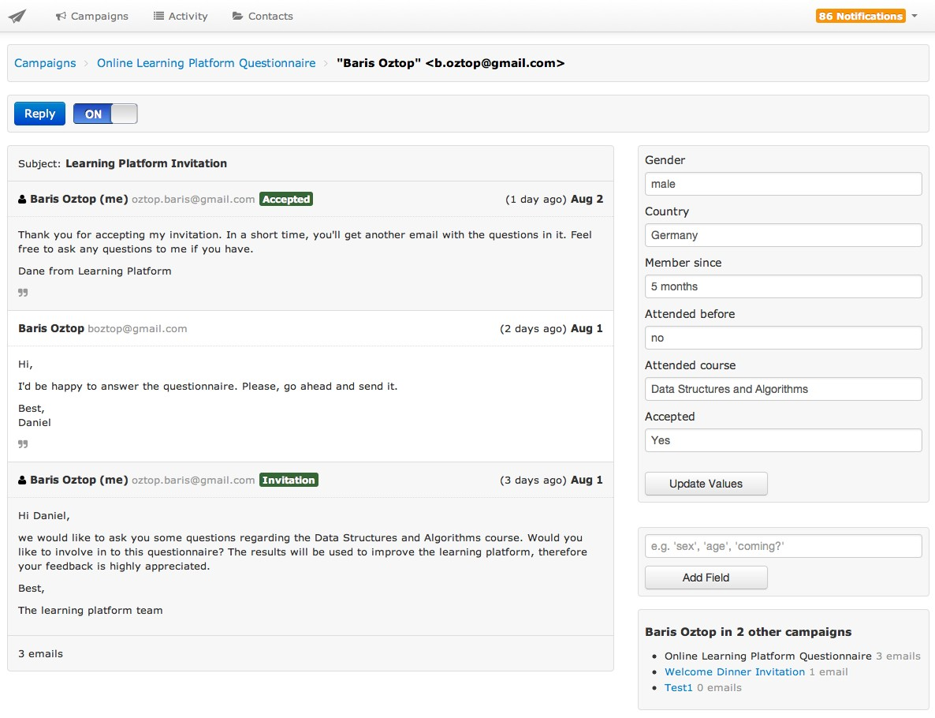

Figure 5.9: The Reading Pane and the Extracted KVPs in Myriad

### Enabling Assistants

A researcher can add other researchers as assistants into a campaign by adding their Google account associated email addresses into the Myriad application, as shown in fig- ure 5.10. The task of the assistant can range from extracting information from emails, writing answers to the recipients, to proofreading a researcher’s emails before sending them, and many other tasks that can be generated according to the type of help a re- searcher needs.

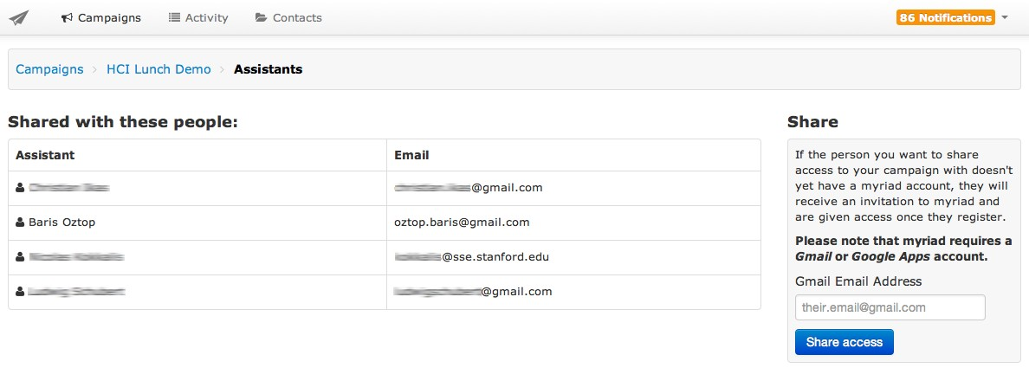

Figure 5.10: Rules to Automate the Sending Process of the Emails in Myriad

After an assistant is assigned to a campaign, he or she will get a notification email includ- ing the link to the campaign. Again, there will be a notification email for each email sent by a respondent to the assistants’ email address to let them know that they need to act on the situation.

Myriad provides status labels for each received or sent email, giving a hint on the next awaiting actions similar to what is shown in figure 5.11. These status labels give hints about the next action to be taken according to the state of the conversation, such as if the user needs to read or to send a message, or the conversation awaits for an answer from the recipient’s side to continue to the communication. There are also status labels related with Myriad’s internal state regarding to an email message, such as if Myriad was able to send the messages successfully, or if there was a failure encountered while sending them. The same view also provides a column showing the last sent by the user. With this, the researchers and the assistants will easily realize what should be done next, and see the status of the communication for each recipient.

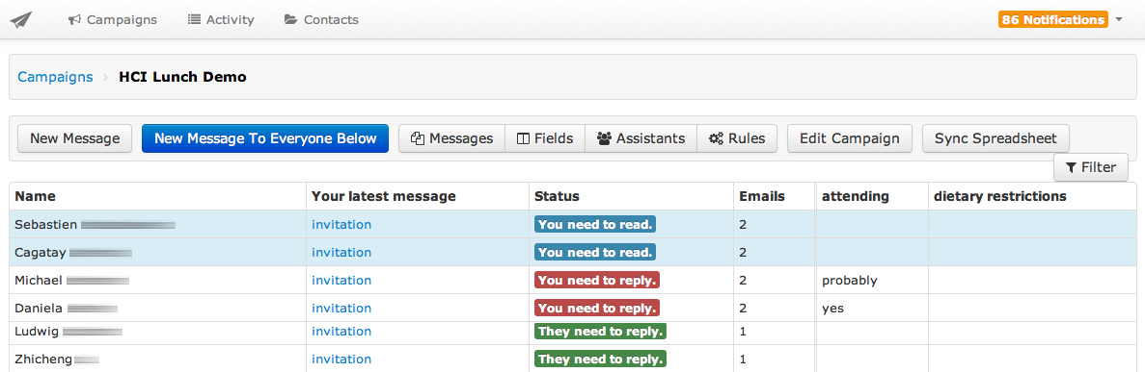

Figure 5.11: Status Labels for Each Email in Myriad

## Architecture

Similar to the prototype, Myriad was also developed using a framework stack of RoR, jQuery, Bootstrap, and OAuth2 protocol was used for the authentication with Gmail. The initial project structure was generated by a gem named Rails Apps Composer3, consisting a collection of Rails application templates to start a project. Thanks to the other gems utilized for the project development and completing it on time in a robust way. The following section will discuss the implementation details of Myriad, how it makes a mass email communication easier.

### Keeping Track of Recipients

As mentioned in section 4.2, the prototype was not able to keep information regarding the recipients, only the messages received. Therefore, the extracted information such as KVPs are only limited to email messages related to the recipients. The downside of this approach is its inability in obtaining all the KVPs of the recipients all at one glance. Instead, we need to go through earlier emails of the recipients each time we need to create the same key, since the system was not aware of an existing KVP created for a different email in the same campaign.

2OAuth is leveraged by using OmniAuth library (https://github.com/intridea/omniauth), and its Google authentication strategy is implementation by OmniAuth Google OAuth2. Details can be found at https://github.com/zquestz/omniauth-google-oauth2

3https://github.com/RailsApps/rails_apps_composer

In Myriad’s case, this issue was solved by keeping all the recipients information in a separate data model named "contact" as shown in figure 5.12. With this, we were able to keep track of the recipients among different campaigns through different conversa- tions involving them, which is another set of a data model in the Myriad system, as each campaign involves many conversations with the recipient involved with them.

Myriad keeps all of the basic profile information of the recipients, including their first names, last names, and email addresses. These information can be imported into Myriad either by spreadsheet synchronization, by adding them into "To" filed when a user com- poses an email, or by importing from Gmail’s inbox via the label synchronization. The recipients’ email addresses are unique identifiers for Myriad in order to compare already existing recipient information with the synchronized ones.

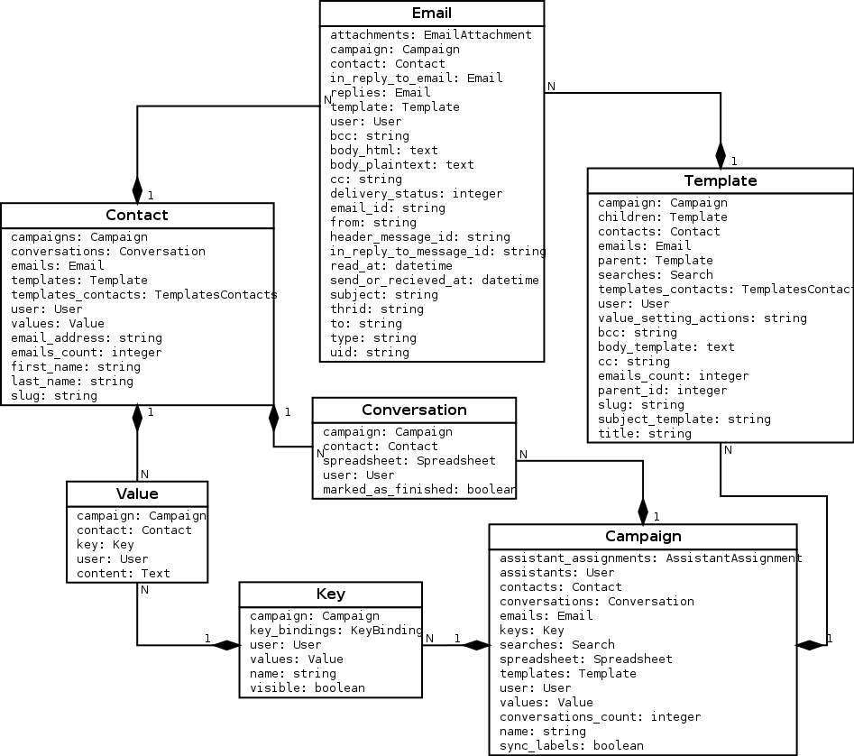

Figure 5.12: Model Dependency of the Myriad Compared with the Prototype

### The KVPs and the Templates

Having a separate contact data model in keeping track of the recipients also helped us relate each extracted information, specifically KVPs of the recipients, instead of their mes- sage in a campaign as shown in figure 5.12. Each campaign has many keys, and as well as their corresponding values, according to the recipients. One advantages of this is that as we browse a specific conversation with a recipient, we will be able to see all KVPs of the specific recipient under one view, which is the KVP pane next to the email threads, as shown in figure 5.7. The other benefit is its ability to synchronize with spreadsheets. When a new key is added to a recipient or a value of a key is updated via Myriad, it will be reflected on the spreadsheet as well. Therefore, the spreadsheet will always contain the latest changes done by the user in Myriad.

Similar to the prototype, the templates contains emails messages with dynamic variables in it, and the actual emails whose dynamic variables are filled with values are kept in the Email data model as shown in figure 5.12, after they are fetched from Gmail.

To get an overview of the conversation and let the users select templates, Myriad offers a tree structure similar to the prototype. However, the execution of the tree structure is different from the prototype. In section 4.2.3, it was mentioned that the hierarchy be- tween the nodes of the tree was a nested set model. We decided to use an adjacency list model instead of a nested set model to increase the readability of the templates’ relation- ship with the data model level from the developers’ perspective. Since the relation of the templates is not as complicated compared to hierarchical relations, the performance drawbacks on this decision was negligible.

### A Campaign Message Identification

Due to the prototype’s dependency on the existing EmailValet’s email fetching process, we identify emails if they belong to a specific campaign or are user’s regular emails, and then inserting them into the same inbox in EmailValet. With Myriad, we removed this dependency, and considered showing emails only belonging to a campaign.

The identification of the emails depends on the three different conditions:

* + - 1. The emails fetched from Gmail and responses to one of to the campaign message.
      2. The emails composed in Myriad as a part of the campaign, whether they are the emails to initiate a campaign or replies to the recipients’ emails.
      3. The emails imported in Myriad from Gmail’s inbox via label synchronization (as shown in section 5.2.2 for label synchronization)

Myriad initially retrieves all the email’s Unique Identifier (UID)s4 from Gmail’s inbox for the last 14 days, instead of all the emails in the inbox to reduce the time needed for the fetching process. For those UIDs not stored in Email data model of Myriad, Myriad retrieves the actual email along with the metadata, such as Gmail thread ID5 and Gmail labels.

For the prototype, we have set a specific message-ID on the emails composed in Myriad. With this, we are able to identify an email from Gmail was composed to initiate a cam- paign or is a reply to the one of the recipients of a campaign by a Myriad user during the aforementioned fetching process. Message-ID field is again leveraged for identifying a recipients’ message belonging to a campaign. Myriad retrieves the Message-ID written in the In-Reply-To, and checks if it matches one of the campaign messages in Myriad. Another field that Myriad checks is the "References" field6 to identify messages as a part of a campaign, but was forwarded to another person by a recipient in order to reply the message. Since the forwarded endpoint’s email client sets the Message-ID of the for- warded message into the In-Reply-To header field and sets a new Message-ID, Myriad is not familiar with neither of the Message-IDs at all after it got the forwarded or replied message. Myriad checks the "References" field to identify a Message-ID belonging to a

4UID (Unique Identifier) is 32-bit integer value to uniquely identify emails in a mailbox in IMAP. Each email added into mailbox will have a higher value than the ones added before, however they are not necessarily contiguous (Crispin, 2003). UID is used as it was in the prototype by the implementation of the EmailValet’s part. It is used to identify if a message is already fetched from Gmail, if it is not, it is

fetched since it is a new message.

5Gmail thread ID is a 64-bit integer that is part of the provided Gmail’s IMAP extension. It helps to associate

groups of messages in the same manner as in the Gmail web interface (Google Inc., 2013a).

6Reference field in another identification field along with Message-ID defined by RFC 5322. It contains one or more Message-IDs used when creating a reply to a message to identify the original message or the other messages when a reply to a message that was itself a reply (Resnick, 2008).

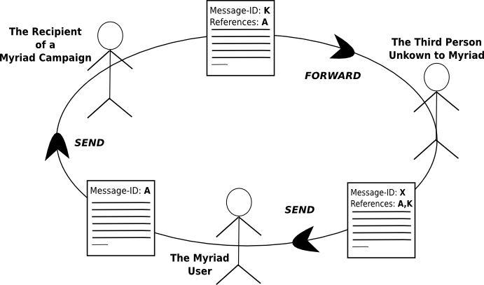

Figure 5.13: A Scenario Using References Field in an Email

If an email is not identified as a part of a campaign message by comparing the Message- IDs with the ones in Myriad’s Email data model, the next step is to evaluate those emails in case they are labeled as a part of a Myriad campaign in Gmail’s inbox. In this case, if an email has a label in the pattern of "myriad/campaign-name", and there is already a created campaign in Myriad with the name "Campaign Name", that email will be stored in the data model. Finally, an identified email will be assigned to a contact by looking at its parent email’s Message-ID if it was a reply or if it fails the contact information will be recorded from the email’s "From" header field. The rest of the emails will be ignored if no matches were found in the mentioned email header fields, specifically Message-ID, In-Reply-To, and References, or Gmail’s Label.

## The Benefits of the Final Solution

A personalized mass email communication can be illustrated as shown in figure 5.14. The information will be extracted from the recipients’ emails and then a researcher will compose personalized emails for each recipient, according to the extracted information.

After discussing what Myriad is and its features, let us see how these features fit into a

* 1. *The Benefits of the Final Solution*

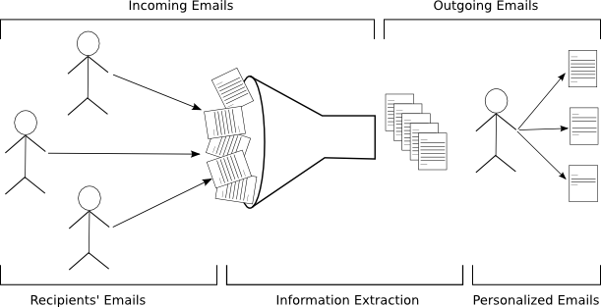

Figure 5.14: Illustration of a Personalized Mass Email Communication

personalized mass email communication, as depicted in the figure. While it decreases the effort on the researcher’s side, it increases personalization in the composed emails, which results into a higher response rate in a campaign.

### Handling The Incoming Emails

Myriad has a campaign inbox view to avoid cluttering of unrelated messages in the inbox, fetching only the campaigns related emails from the user’s email account by ignoring private emails, and grouping each email according to the campaign it belongs to.

As a researcher reads the incoming emails, he/she can also record the extracted infor- mation from those emails into KVPs at the same time. This avoids the need on using a third-party application like a spreadsheet. However, if a researcher prefers a traditional way in recording information like a spreadsheet, Myriad still offers an option in synchro- nizing those KVPs with a Google Spreadsheet.

Assistants can help a researcher with appropriate given permission on extraction of in- formation from incoming emails.

### Handling The Outgoing Emails

Myriad provides a threaded view of all the email conversations of a recipient in a cam- paign letting researchers considers the earlier conversations with a recipient, without having the need to browse through other views. This saves time and helps on getting a quick overview of the conversation history to get a better context on personalizing the succeeding new messages.

The researchers can continue on using his or her own Gmail’s account on answering or initiating a conversation. Myriad offers Gmail label synchronization to import those emails into a campaign, and make them more manageable along with other campaign emails.

The researchers can opt to reuse previously written emails as a template in composing new emails. The provided template tree also gives a direct visualization of the current campaign state and flow to let the researcher easily go through earlier given answers.

The researchers can use the recorded KVPs to personalize the outgoing emails. Since personalization has been addressed as an important factor in increasing response rates, the initiated campaign will end up with better results compared to non-personalized emails.

Myriad records the previous actions of a user as a rule in the system to notify the automa- tion of the email sending process with the matching conditions of a group of recipients. This helps to save time and increase awareness of the researcher to previously taken ac- tions for repeated or similar situations.

Assigned assistants can also help the primary researcher in composing emails or proof- reading the composed emails before they get sent out to their respective recipients.

## Experiences

To date, Myriad has 67 users since its beta launch7 last January 30, 2013. Among those 67 users, 30 of them are actively using it, since last month. In this section, statistics will be given about the created campaigns, and continued with some user’s testimonials.

### Statistics

The beta launch of Myriad has been advertised at the Stanford HCI group and to some Stanford’s organizations who performs mass email communication regularly with their communities. Some of those campaigns’ opted to use the following features of Myriad, such as:

* + - * **Invitation to an Event:** User created an initial invitation template, and another template for those who rejected the invitation to motivate them for other upcoming events. Recipient list is imported via spreadsheet. User also created KVPs to easily identify recipients needing an individual follow up. Salutations of the emails are personalized by their first name through KVPs.
      * **Survey via an External Link:** Users send an initial template including a link to an external survey. A detailed list of contact information was imported from a Google spreadsheet. Later on, users continued with a reminder email in a separate campaign.
      * **Importing via Gmail Labels** One of the user imported campaign emails from his Gmail account to Myriad via a label synchronization, and continued the campaign in Myriad.
      * **Interview Results** One user reached nearly 500 recipients through Myriad in releas- ing the result of an interview process. User created a rejection template for those who were rejected, and for the ones who were accepted, he created several tem- plates depending on the invitation date, including the specific schedule related to that date. The user also automated the email sending process by the created rules on the filtered search results.
      * **Getting User Details via Form** During one of the live demonstrations of Myriad at the Stanford HCI group, we asked to the attendees to browse to a link and fill up

7Beta version of Myriad was launched at <http://gv.stanford.edu/>and still accessible from this address.

a Google Form8 to obtain their contact information in a Google Spreadsheet, where the gathered data is recorded in Google Form by default. Therefore, we were able to easily import contact information into Myriad, and initiate a campaign. There were also 4 assistants extracting information during the live demonstration while the recipients were sending answers.

After reviewing some cases using Myriad in real time, the following paragraphs will provide usage statistics regarding Myriad, starting from its beta launch date, January 30, 2013 until August 7, 2013.

**Campaigns and Their Number of Recipients** Figure 5.15 shows campaigns9 created by Myriad, and their respective number of recipients. The average number of recipients was 105.32, and the total number of recipients was 9585. While the maximum number of recipients for one campaign was 752, the minimum amount was only one recipient.

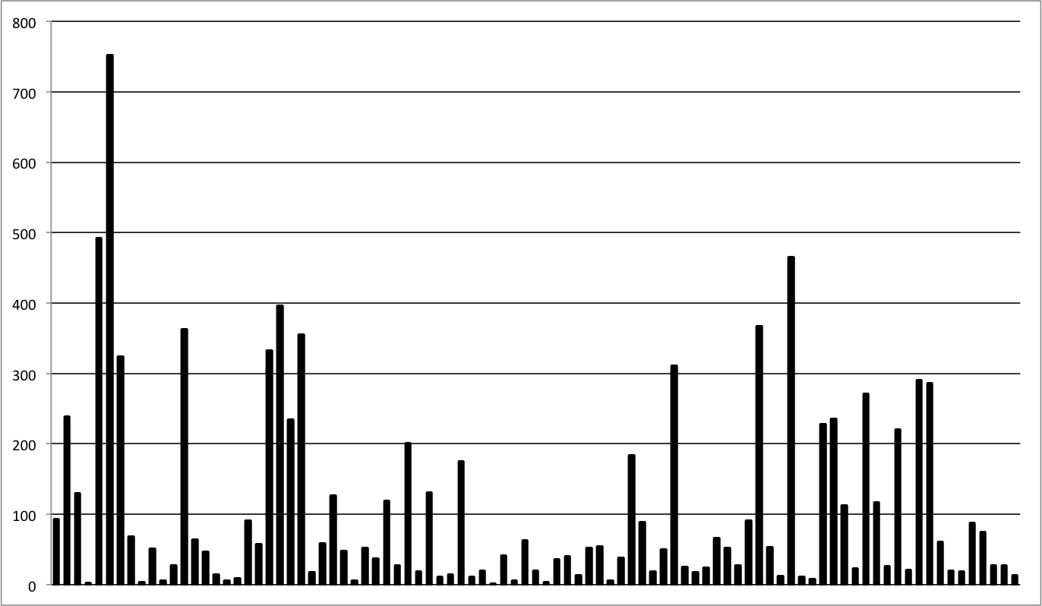

Figure 5.15: Campaigns and Their Number of Recipients in Myriad

8https://docs.google.com/forms

9Campaigns’ names are removed due to privacy reasons.

**Myriad Users and Their Number of Campaigns** Figure 5.16 shows Myriad’s total number of users10, and the number of campaigns that they created with Myriad. There are a total 96 campaigns, after the ones created for test purposes were ignored. The average was 3.92 campaigns per user. While the maximum amount of campaigns created by one user was 13, the minimum amount was one campaign.

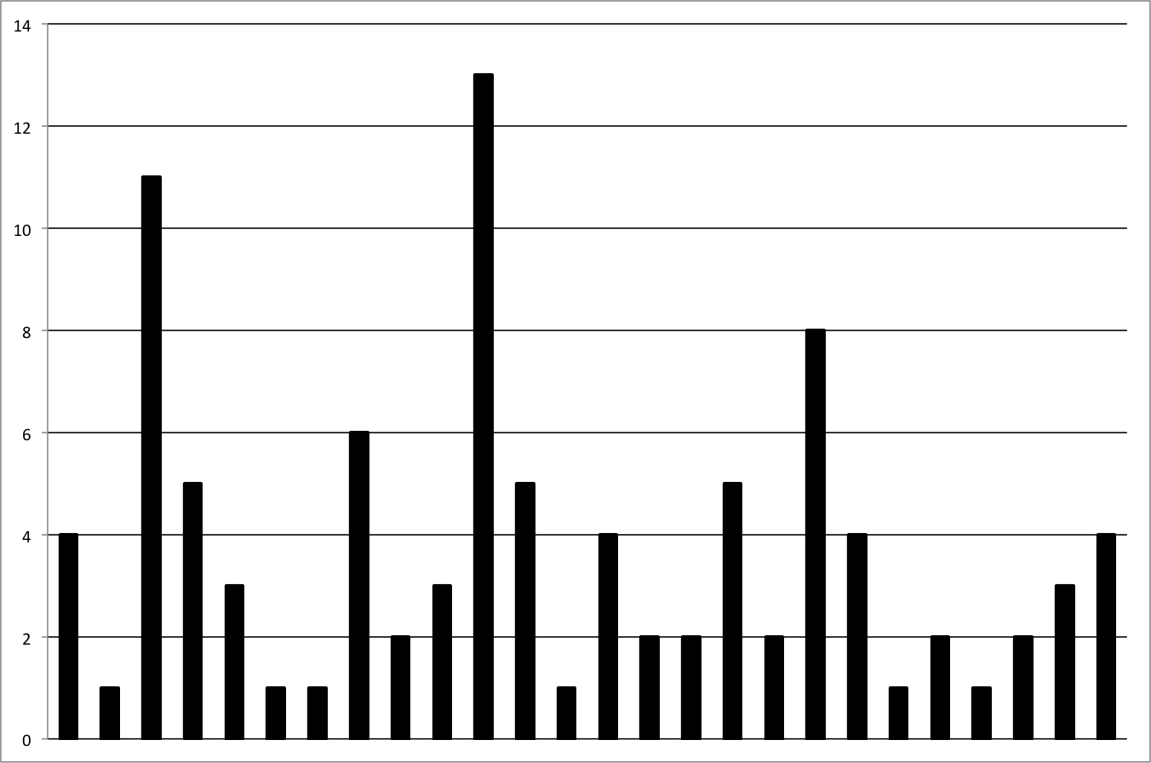

Figure 5.16: Myriad Users and Their Number of Campaigns

10Users’ names are removed due to privacy reasons.

**The Number of Campaigns per Month** Figure 5.17 shows the ratio of created cam- paigns per month. 35 campaigns out of 96 were created in April 2013, as the highest amount compared to other months. It might be because it is the middle of spring quarter at Stanford University, where lecturers and organizations need to reach their recipients more often. There were an average of 15.5 campaigns create per month if the launch month January is ignored.

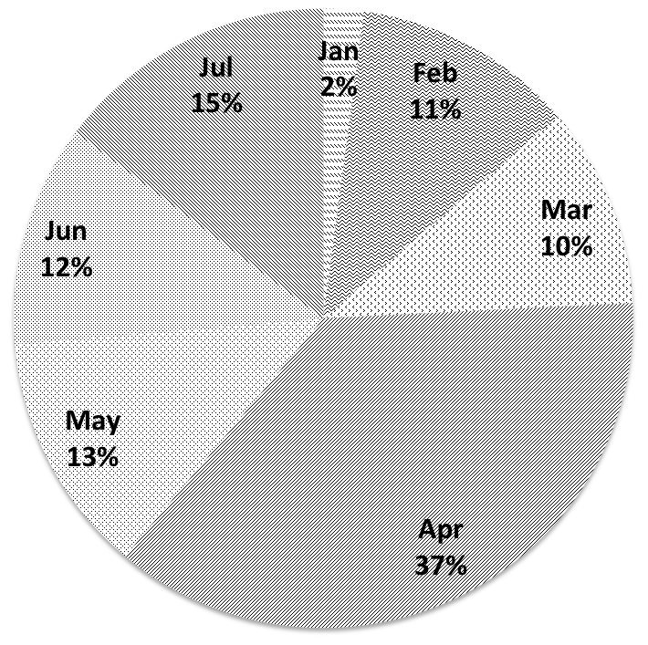

Figure 5.17: The Number of Campaigns per Month

### User Testimonials

In this section,testimonials from the very active users of Myriad will be evaluated. Users were asked to evaluate Myriad, keeping the following four questions in mind:

1. What are the scenarios you use Myriad for?
2. What were you using before Myriad?
3. How satisfied are you with Myriad?
4. How regularly do you use Myriad?

Testimonials written in listing 5.1 and 5.2 belongs to lecturers from the Stanford HCI group. The last testimonial belongs to a Stanford organization who performs mass email communication very often to reach their community.

My main use: handling a special issue. Several hundred emails ( literally ) meant that an email view was impossible. Myriad’s structured view makes everything a whole lot easier. It still needs some polishing to be ready for prime time (like it ’ s workflow emphasis is a little constrained, and it needs better handing of formatting and attachments), but as a first draft , it ’ s amazing. I hope it continues so I can use it more!

*−* Scott R. Klemmer, Stanford HCI Group

Listing 5.1: User Testimonial #1 about Myriad

I use Myriad to manage a large volume of emails about the courses that I’m teaching. I tag the email with the campaign, and the system+assistant help me respond with one of a number of common responses.

*−* Michael S. Bernstein, Stanford HCI Group

Listing 5.2: User Testimonial #2 about Myriad

I use Myriad when I’m mass*−*mailing a group of people and want to personalize the email. Before, I was using Mailchimp or BCC everyone. It’s a great tool to send personalized emails to the network! I use Myriad whenever I need to email more than 10 people and want to personalize the emails. For less than 10, the set up for Myriad may take longer than sending out the emails individually (this was discovered through trial and error) .

Listing 5.3: User Testimonial #3 about Myriad

## 5.6 Conclusion

In this section, the final solution, Myriad, for mass email communication was investi- gated. We first investigated the improved requirements, comparing them with the initial requirements, and the ones already applied to the initial prototype. Enabling assistant support, using KVPs as dynamic variables in the email, importing recipients list from a Google Spreadsheet, the ability to import email from Gmail’s inbox by annotating emails

using Myriad’s campaign labels, and automated decision-making through previously applied search filters were some of the main improvements done in Myriad.

Previous sections continued showing how those features were applied for Myriad’s UI, followed by introducing its architecture on how it was possible to enable the said features in support for mass email communication.

Finally, user and campaign statistics were given to show how actively Myriad was used during its beta stage, and the section was followed by testimonials from the active users of Myriad.

In the next section, we will see the conclusion of this study, and the possible extensions on the requirements of Myriad as a future work.

# 6 Conclusion and Future Work

In this final chapter, the study will be finalized by summarizing in under the conclusion section, and its possible extensions will be discussed in the future work section.

## 6.1 Conclusion

Increased Internet usage made email a popular medium for communication because of its low cost, quick turnover and the flexibility of connectivity through the use of mobile devices. The benefits of email communication also attracted researchers to use it as a data collection medium to explore, describe, and explain things by communicating with a large group of people.

However, the nature of communication with large groups is different compared to small ones due to the required effort in personalizing messages according to its respective recip- ient. As a result, researchers tend to write more generic emails, ignoring recipient-specific details. Researchers investigated many response rate influences, and addressed that per- sonalization of the message content is an important factor in increasing the response rates (Dillman, 1991; Schaefer and Dillman, 1998). Messages that are not personalized results in a low response rate for the answers expected from the recipients. As a result, this may end up with a nonresponse error.

Nonresponse error has been considered as a major problem by many researchers, because of the tendency of some of the respondents as a part of large group who fails to respond might result in a biased estimate for the proper representation of the population. Hence, it affects the outcome of a research (Bogen, 1996).

For this reason, the researchers investigated possible theories regarding the reason be- hind proper personalization’s effect on the response rate. While Dillman et al. (2009) emphasized the social exchange theory since the personalization of emails helps build a connection between the respondents and the researcher, Barron and Yechiam (2002) stressed on the diffusion of responsibility theory, which talks about the awareness of the availability of the other volunteers will result in a higher utility of not volunteering.

The researchers conducted studies on investigating the diffusion of responsibility. Barron and Yechiam (2002) showed that the number of replies where they used a single email address in the "To" field got a 20% higher response rate and the number of "very helpful" replies was 187% higher compared to the replies they got when they used groups of email addresses. In the study of Selm and Jankowski (2006), the recipients showed privacy concerns when the header of the email contained all the email addresses of the other respondents explicitly.

Other researchers investigated the social exchange theory. Heerwegh (2005) applied per- sonalized salutations in the the emails, and got a 6.9% higher login rate for the provided survey link in the email compared to the non-personalized group in their study. In the study of Joinson and Reips (2007), when the level of authority or status of the sender was used with the personalized salutation, they got a 53.4% response rate while non- personalized salutations with a neutral power of the sender status got a 40.1% response rate.

Even though personalization of emails helps increase the response rates, Dillman et al. (2009) emphasized that an overwhelmed personalization can also result to a low re- sponse rates. Hence, only the adequate amount of personalization and its appropriate- ness should be considered for personalizing emails. In addition to this, experienced email users can easily notice if a message is manually written by a person, or if it is computer generated. Therefore, it is hard for digital world make to achieve authentic personaliza- tion, and achieving such level of personalization requires getting to know each recipient very well.

To understand what existing applications offer in support for personalized mass email communication, CRM, Help Desk, and Email Marketing applications were evaluated in chapter 3. Several features of these applications are considered to be helpful to re- searchers for their mass email communication. Some of these features are the following:

* Storing client related information extracted from conversations in KVPs.
* Integration with popular email clients such as Gmail.
* Importing recipient lists from third-party applications.
* Assigning emails to a recipient profile.
* Using dynamic variables in the emails to be replaced by their values.
* Assigning a help desk ticket to an assistant.
* Reusability of an existing email as a template.

Moreover, none of the available products indicated above offers these mentioned fea- tures in helping a personalized mass email communication all under a single product and some of these features needs additional effort to use since their application focus is not a mass email communication. Therefore, this study came up with an initial solution as a prototype featured in chapter 4. The prototype supported following features to help a researcher reach a large groups of people in a personalized way with less effort:

* Kept extracted information in KVPs along with the recipient messages.
* Used dynamic variables to personalize the salutations of emails.
* Allowed to reuse earlier sent messages as a template.
* Provided a tree structure to get an overview of the state and flow of the conversa- tion with the used templates.

Even though the prototype provided the above mentioned features in support to a per- sonalized mass email communication, we moved the prototype from its origin product, EmailValet, to a new project after the informal user test with an organization who per- forms mass email communication regularly at Stanford University. The user test ended up with new features, and it helped us realize the drawbacks of the existing EmailValet as an email client we used for the prototype.

The improved requirements after user test brought up the final solution in chapter 5, and its features in support for mass email communication as follows:

* + Recipients’ information can be synchronized to the Myriad system through a Google Spreadsheet to remove the effort on importing and exporting recipients’ informa- tion from the researchers.
  + A researcher can assign assistants to an email campaign for them to interact with the flow of a mass email communication with tasks such as extracting information from incoming answers, proofreading the primary researcher’s replies before sending them or even composing replies to those answers.
  + Extracted respondents’ information can be recorded to the recipients’ respective profiles in the KVPs during the whole state of a campaign.
  + Those recorded KVPs can be used as dynamic variables in personalizing the content of the emails.
  + Reusability of exiting emails and getting an overview of the state of the conversa- tion.
  + Provided a decision-making mechanism to automate earlier decisions on sending out emails in a user verified manner.
  + Provided visual cues to notify users on the current state of communication with in- dividual recipients, and suggesting potential action based on the previous decisions of the user.
  + All conversations and extracted information of each recipient are provided under a single view respectively to conveniently reach all the necessary information to write recipient specific personalized emails.

Considering the features gathered in the final solution, we provided a work flow to the researchers aimed to help reduce the amount of time needed in personalizing the content of the emails. Considering the Effort vs Personalization chart from figure 4.2 after the final solution, it could be replaced in a way as shown in figure 6.1, compared with other products in the market focusing on email communication and data collection. Consider- ing the user feedbacks and the amount of people actively using Myriad during its beta stage, we believe that Myriad was able to bridge the gap in achieving the gold standard of effort vs. personalization, as annotated in the figure.

Finally, possible future work on enhancing the existing solution and remove the known existing restrictions are to be discussed in the next section.

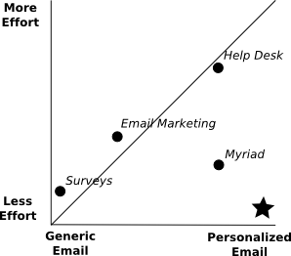

Figure 6.1: Effort vs Personalization and the Comparison of Available Solutions

## 6.2 Future Work

The provided assistant support in the final solution helps researchers share certain tasks in extracting information from emails, proofreading the primary researcher’s replies be- fore sending them, composing replies to recipients’ emails, and verifying the rule-based actions before they are acted upon.

Along with the assistant support, the system could also provide an option to allow a crowd of anonymous workers to perform the tasks of assigned assistants, as a crowd assistant. If the system would be able to provide the required functions to allow the involvement of crowd assistants, the decisions on the possible tasks in a mass email com- munication can be done by anonymous crowd workers.

Surowiecki (2005) stated that under the right conditions, groups can be remarkably smart, and even smarter than the smartest person within them. Therefore, if you try to solve a complicated problem or try to make a decision, the best thing to do is to ask a group instead of trying to find an expert. Therefore, taking advantage of crowd assistants can

minimize the work a researcher needs to do in a personalized mass email communication.

Another improvement could be about the dynamic variables in the messages. KVPs were used in the messages as dynamic variables to personalize the content of the messages as described in section 5.2.4. However, when communicating with larger groups of people, some KVPs might not be applicable to some recipients, or other irregular KVPs needs to be used to personalize messages for some recipients in a large group. When we reviewed available products in the market as featured in chapter 3, Zendesk solved this issue by adding conditional logic to the dynamic variables, as illustrated in listing 3.1. Such ex- tension would be an option for Myriad to avoid creating additional email templates for closely similar emails, with minor changes on KVPs.

In chapter 3, we saw that that CRM applications provide task management options to remind users about upcoming tasks. For example, Highrise allows association of a task to an email to let users easily browse through the source of the task in the provided task list. Currently, Myriad users can maximize the use of the KVPs for the same purpose by adding a key named "task" and a value according to the recipients. However, this contra- dicts with one design principal, separation of concerns, since the logic behind the KVPs is to store extracted information from the recipients’ emails and use them to personalize emails. Besides, KVPs connected to the recipients’ profile in a campaign is not useful in adding task messages related to a message of a recipient. Therefore, the task manage- ment feature in Myriad could be useful for researchers in attaching reminder messages as a task along with the recipients’ messages, and a list of these tasks are shown at the main page of a campaign.

One Myriad user mentioned about the email editor and its attachment handling in the user testimonials, as shown in listing 5.1. Currently, Myriad provides an HTML editor to compose an email; however, it does not provide an option for adding attachments. This is due to the limited time for the development, and adding this feature was not considered as a high priority at the time of the development since users can still use Gmail

in composing an email, and Myriad will able to import it, together with its attachment. Therefore, a better HTML editor with an email attachment feature would necessary to accomplish all email composing tasks inside the Myriad system.

Next improvement could be on the visualization tree of the communication state and flow. The current visualization tree’s nodes are arranged according to email templates and their order in the communication. However, a user can opt to create all email tem- plates at the beginning of a campaign and use them according to the recipients answer later on. In this case, all the created templates at the beginning of the campaign will be considered as individual root nodes of a tree, losing the hierarchical structure in visual- izing the communication state. Therefore, the possible improvement should let Myriad allow the rearrangement of those nodes in the visualization tree, together with a drag- and-drop ability for each node.

Lastly, a better workflow can be implemented in the future by the provided rules created according to the decision on sending emails. Currently, Myriad saves filtering conditions of a recipient search as a rule in sending emails the next time, without having the need to search for matching conditions of the recipients again. This feature is quite unintu- itive, since when user decides to browse through the rules view, no defined rules will be shown, unless the user uses the provided filtering options in getting a subset of the recipient list and then send an email to the recipients afterwards. To make this feature more intuitive and better define the workflow of a mass communication before-hand, Myriad could offer an option on creating rules right under the rules view. With this, a researcher can easily create the rules and assistants can verify and send emails according to the matching rules, or even opt to automate the process by the provided option under the rules view.

#### Single Condition

*Date:* Mon, 7 May 2001 19:26:21-0400

*From:* Sarah Feldman [<feldman@yahoo.com>](mailto:feldman@yahoo.com)

*To:* [harry@bt.technion.ac.il](mailto:harry@bt.technion.ac.il)

*Subject:* please help

#### Quintuple Institutional Condition

*Date:* Mon, 7 May 2001 19:26:21-0400

*From:* Sarah Feldman [<feldman@yahoo.com>](mailto:feldman@yahoo.com)

*To:* harry@bt.technion.ac.il,fredy@bt.technion.ac.il,jannet@bt.technion.ac.il,[frieda@bt.technion.](mailto:frieda@bt.technion) [ac.il,](mailto:ac.il%2Csusan@bt.technion.ac.il)[susan@bt.technion.ac.il](mailto:susan@bt.technion.ac.il)

*Subject:* please help

#### Quintuple Generic Condition

*Date:* Mon, 7 May 2001 19:26:21-0400

*From:* Sarah Feldman [<feldman@yahoo.com>](mailto:feldman@yahoo.com) *To:*harry@bt.technion.ac.il,david_87_5@zahav.net.il,opary76@hotmail.com,38Labovitz@hotmail. [com,](mailto:com%2Cgilad_H_G@yahoo.com)[gilad_H_G@yahoo.com](mailto:gilad_H_G@yahoo.com)

*Subject:* please help

I am a graduate student of biology and am considering continuing my studies at the Technion. Do you know if there is a biology faculty at the Technion?

Thanks in advance, Sarah Feldman

In the interest of privacy, email addresses have been changed. Source: Barron and Yechiam (2002)

Delivered*−*To: [oztop.baris@gmail.com](mailto:oztop.baris@gmail.com)

Received: by 10.112.143.99 with SMTP id sd3csp47394lbb;

Sun, 28 Jul 2013 03:35:18 *−*0700 (PDT)

Return*−*Path: [<boztop@gmail.com>](mailto:boztop@gmail.com)

Received*−*SPF: pass (google.com: domain of [boztop@gmail.com](mailto:boztop@gmail.com) designates 10.182.186.66 as

permitted sender) client*−*ip=10.182.186.66

Authentication*−*Results: mr.google.com;

spf=pass (google.com: domain of [boztop@gmail.com](mailto:boztop@gmail.com) designates 10.182.186.66 as permitted

sender) smtp.mail=boztop@gmail.com; dkim=pass [header.i=@gmail.com](mailto:header.i%3D@gmail.com)

X*−*Received: from mr.google.com ([10.182.186.66])

by 10.182.186.66 with SMTP id fi2mr49092899obc.98.1375007717111 (num_hops = 1);

Sun, 28 Jul 2013 03:35:17 *−*0700 (PDT)

X*−*Received: by 10.182.186.66 with SMTP id fi2mr49092899obc.98.1375007717106;

Sun, 28 Jul 2013 03:35:17 *−*0700 (PDT)

MIME*−*Version: 1.0

Received: by 10.76.120.234 with HTTP; Sun, 28 Jul 2013 03:34:57 *−*0700 (PDT)

From: Baris Oztop [<boztop@gmail.com>](mailto:boztop@gmail.com)

Date: Sun, 28 Jul 2013 12:34:57 +0200

Message*−*ID: [<CAF2E4bfH4+GAYHcJFZJ6dTJJ+pux4mTjf](mailto:CAF2E4bfH4%2BGAYHcJFZJ6dTJJ%2Bpux4mTjff2neCS_VR_zVCUY9g@mail.gmail.com)[f2neCS_VR_zVCUY9g@mail.gmail.com](mailto:f2neCS_VR_zVCUY9g@mail.gmail.com)

>

Subject : Questionnaire

To: Baris Oztop [<oztop.baris@gmail.com>](mailto:oztop.baris@gmail.com)

Content*−*Type: multipart/alternative; boundary=089e0153688e8aabe504e28feec4

*−−*089e0153688e8aabe504e28feec4 Content*−*Type: text/plain; charset=UTF*−*8

Hi,

thank you for reaching out. I ’d like to participate in the questionnaire. I hope my answers will be helpful for you.

Best, Baris

*−−*089e0153688e8aabe504e28feec4 Content*−*Type: text/html; charset=UTF*−*8

<div dir=" ltr ">Hi,<br><br>thank you for reaching out. I&#39;d like to participate in the questionnaire. I hope my answers will be helpful for you.<br><br>Best, <br>Baris<br></div>

*−−*089e0153688e8aabe504e28feec4*−−*

Listing B.1: An Email Message with Header and Body Sections

In the interest of privacy, email addresses have been changed.

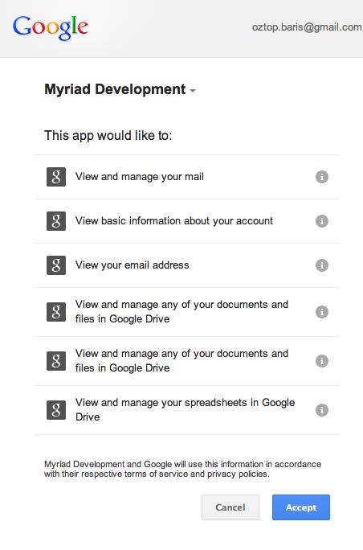

Figure C.1: The Necessary Permissions From Google to User Myriad

Table C.1: Comparison Matrix for Help Desk Applications

|  |  |
| --- | --- |
| **Permission** | **Description** |
| **View and manage your mail** | * View and manage your mail in Google Mail |
| **View basic information about your account** | * View your name, public profile URL, and photo * View your gender and birthdate * View your country, language, and time- zone |
| **View your email address** | * View the email address associated with your account |
| **View and manage any of your documents and files in Google Drive** | * List and search all of your documents and files in Google Drive * Download any of your documents and files in Google Drive * Create, move, copy, edit, or delete any of your documents and files in Google Drive * Share or unshare any of your documents and files in Google Drive |
| Continued on next page | |

*C The Necessary Google Permissions*

#### Table C.1 – continued from previous page

|  |  |
| --- | --- |
| **Permission** | **Description** |
| **View and manage any of your documents and files in Google Drive** | * List and search all of your documents and files in Google Drive * Download any of your documents and files in Google Drive * Create, move, copy, edit, or delete any of your documents and files in Google Drive * Share or unshare any of your documents and files in Google Drive |
| **View and manage your spreadsheets in Google Drive** | * Create new spreadsheets * View and modify existing spreadsheets * Share spreadsheets with others |

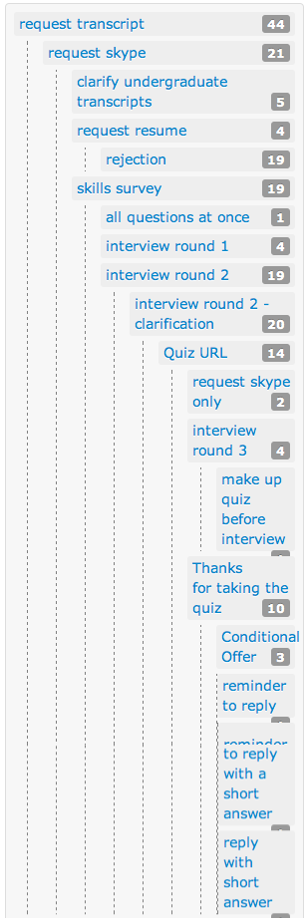

Figure D.1: A Tree Structure to Visualize a Mass Email Communication’s State

37signals LLC (2013). Highrise tour. <http://highrisehq.com/tour>.

Babbie, E. (2012). *The practice of social research*. Cengage Learning, 12th edition. Bachmann, D., Elfrink, J., and Vazzana, G. (1999). E-mail and snail mail face off in re-

match. *Marketing Research*, 11(4):11–15.

Barron, G. and Yechiam, E. (2002). Private e-mail requests and the diffusion of responsi- bility. *Computers in Human Behavior*, 18(5):507–520.

Bernstein, L. (1996). Foreword: Importance of software prototyping. *Journal of Systems Integration*, 14:9–14.

Bogen, K. (1996). The effect of questionnaire length on response rates: A review of the literature. *Proceedings of the Section on Survey Research Methods*, pages 1020–1025.

Bradburn, N. (1978). Respondent burden. *Proceedings of the Survey Research Methods Sec- tion of the American Statistical Association*, pages 35–40.

Celko, J. (2004). *Joe Celkos Trees & Hierarchies in SQL for Smarties*. Morgan Kaufmann Publishers, 1st edition.

Collins English Dictionary (2013). Definition of mail merge. [http://www.](http://www.collinsdictionary.com/dictionary/english/mail-merge_1) [collinsdictionary.com/dictionary/english/mail-merge_1](http://www.collinsdictionary.com/dictionary/english/mail-merge_1).

Constant Contact Inc. (2011). Building your email witht the advanced editor tool.

Constant Contact Inc. (2013a). Email marketing lists. [http://www.constantcontact.com/](http://www.constantcontact.com/email-marketing/features/email-list) [email-marketing/features/email-list](http://www.constantcontact.com/email-marketing/features/email-list).

Constant Contact Inc. (2013b). Email marketing software from constant contact. [http:](http://www.constantcontact.com/email-marketing/features/email-creation)

[//www.constantcontact.com/email-marketing/features/email-creation](http://www.constantcontact.com/email-marketing/features/email-creation).

Crispin, M. (2003). INTERNET MESSAGE ACCESS PROTOCOL - VERSION 4rev1.

[http://www.ietf.org/rfc/rfc3501.txt.](http://www.ietf.org/rfc/rfc3501.txt)

Dillman, D. (1991). The design and administration of mail surveys. *Annual review of sociology*, 17(1991):225–249.

Dillman, D. (2006). *Mail and Internet Surveys: The Tailored Design Method*. Wiley, 2nd edition.

Dillman, D. A. and Frey, J. H. (1974). Contribution of personalization to mail question- naire response as an element of previous tested method. *Journal of Applied Psychology*, 59(3):297–301.

Dillman, D. A., Smyth, J. D., and Christian, L. M. (2009). *Internet, mail, and mixed-mode surveys*. John Wiley & Sons, 3rd edition.

Eley, B. Y. B. and Tilley, S. (2009). *Online Marketing Inside Out*. SitePoint, 1st edition. Emerson, R. (1976). Social exchange theory. *Annual review of sociology*, 2(1976):335–362.

Google Inc. (2013a). Gmail APIs – Google Developers. [https://developers.google.com/](https://developers.google.com/gmail/imap_extensions) [gmail/imap_extensions](https://developers.google.com/gmail/imap_extensions).

Google Inc. (2013b). How actions sync in IMAP - Gmail Help. [https://support.google.](https://support.google.com/mail/answer/77657?hl=en) [com/mail/answer/77657?hl=en](https://support.google.com/mail/answer/77657?hl=en).

Group, M. M. (2012). World internet users statistics usage and world population stats. <http://www.internetworldstats.com/stats.htm>.

Groves, R., Jr, F. F., and Couper, M. (2009). *Survey Methodology*. Wiley, 2nd edition.

Halverson, C., Erickson, T., and Ackerman, M. (2004). Behind the help desk: Evolution of a knowledge management system in a large organization. *Proceedings of the 2004 ACM conference on Computer supported cooperative work*.

Heberlein, T. and Baumgartner, R. (1978). Factors affecting response rates to mailed ques- tionnaires: A quantitative analysis of the published literature. *American Sociological Review*, 43(4):447–462.

Heerwegh, D. (2005). Effects of personal salutations in e-mail invitations to participate in a web survey. *Public Opinion Quarterly*, 69(4):588–598.

Joinson, A. N. and Reips, U.-D. (2007). Personalized salutation, power of sender and response rates to web-based surveys. *Computers in Human Behavior*, 23(3):1372–1383.

Kayako Inc. (2013a). Help desk software, live chat software and customer service soft- ware. <http://www.kayako.com/>.

Kayako Inc. (2013b). Tour. <http://www.kayako.com/tour/>.

Klensin, J. (2008). Simple Mail Transfer Protocol. <http://www.ietf.org/rfc/rfc5321.txt>. Kokkalis, N., Köhn, T., Pfeiffer, C., Chornyi, D., Bernstein, M. S., and Klemmer, S. R.

(2013). Emailvalet: managing email overload through private, accountable crowd- sourcing. In *Proceedings of the 2013 conference on Computer supported cooperative work*, CSCW ’13, pages 1291–1300. ACM.

Madden, M. and Jones, S. (2008). Networked workers. *Pew Internet & American Life Project*.

Madden, M. and Rainie, L. (2003). America’s online pursuits: The changing picture of who’s online and what they do. *Pew Internet & American Life Project*, (December).

Mavis, B. E. and Brocato, J. J. (1998). Postal surveys versus electronic mail surveys: The tortoise and the hare revisited. *Evaluation & the Health Professions*, 21(3):395–408.

Norman, N. and Lutz, E. (2000). Internet and society: A preliminary report. *Stanford Institute for the Quantitative Study of Society. . . .* .

Paolo, A. M., Bonaminio, G. A., Gibson, C., Partridge, T., and Kallail, K. (2000). Re- sponse rate comparisons of e-mail-and mail-distributed student evaluations. *Teaching and Learning in Medicine*, 12(2):81–84.

Purcell, K. (2011). Search and email still top the list of most popular online activities. *Pew Internet & American Life Project*.

Reinartz, W., , Krafft, M., and Hoyer, W. (2004). The customer relationship management process: Its measurement and impact on performance. *Journal of marketing research*, 41(3):293–305.

Repici, D. J. (2010). CSV Comma Separated Value File Format. [http://www.creativyst.](http://www.creativyst.com/Doc/Articles/CSV/CSV01.htm) [com/Doc/Articles/CSV/CSV01.htm](http://www.creativyst.com/Doc/Articles/CSV/CSV01.htm).

Resnick, P. (2008). Internet Message Format. <http://www.ietf.org/rfc/rfc5322.txt>.

Rouse, M. (2008). What is key-value pair? [http://searchenterprisedesktop.techtarget.](http://searchenterprisedesktop.techtarget.com/definition/key-value-pair) [com/definition/key-value-pair](http://searchenterprisedesktop.techtarget.com/definition/key-value-pair).

RubyGems Guides (2013). What is a gem? [http://guides.rubygems.org/](http://guides.rubygems.org/what-is-a-gem/) [what-is-a-gem/](http://guides.rubygems.org/what-is-a-gem/).

Schaefer, D. and Dillman, D. (1998). Development of a standard e-mail methodology: Results of an experiment. *Public opinion quarterly*, 62(3):378–397.

Scott, A. and Smith, T. (1969). Estimation in multi-stage surveys. *Journal of the American Statistical Association*, 64(327):830–840.

Selm, M. and Jankowski, N. W. (2006). Conducting online surveys. *Quality & Quantity*, 40(3):435–456.

Sheehan, K. B. and Hoy, M. G. (2006). Using e-mail to survey internet users in the united states: Methodology and assessment. *Journal of Computer-Mediated Communication*, 4(3).

Sproull, L. (1986). Using electronic mail for data collection in organizational research.

*Academy of Management Journal*, 29(1):159–169.

Sue, V. and Ritter, L. (2011). Conducting online surveys. *Sage*.

SugarCRM Inc. (2013). Email integration - gmail, outlook, lotus notes, yahoo, imap. [http:](http://www.sugarcrm.com/feature/email-integration)

[//www.sugarcrm.com/feature/email-integration](http://www.sugarcrm.com/feature/email-integration).

Surowiecki, J. (2005). *The Wisdom of Crowds*. Anchor Books, 1st edition.

The Rocket Science Group LLC (2013a). Autoresponders. [http://mailchimp.com/](http://mailchimp.com/features/autoresponders/) [features/autoresponders/](http://mailchimp.com/features/autoresponders/).

The Rocket Science Group LLC (2013b). Drag and drop editor. [http://mailchimp.com/](http://mailchimp.com/features/drag-and-drop-editor/) [features/drag-and-drop-editor/](http://mailchimp.com/features/drag-and-drop-editor/).

The Rocket Science Group LLC (2013c). How do conditional or smart merge tags work? <http://kb.mailchimp.com/article/how-do-conditional-smart-merge-tags-work/>.

The Rocket Science Group LLC (2013d). How to use merge tags.

The Rocket Science Group LLC (2013e). Multi-user accounts. [http://mailchimp.com/](http://mailchimp.com/features/multi-user-accounts/) [features/multi-user-accounts/](http://mailchimp.com/features/multi-user-accounts/).

The Rocket Science Group LLC (2013f). Reports. [http://mailchimp.com/features/](http://mailchimp.com/features/reports/) [reports/](http://mailchimp.com/features/reports/).

Zendesk Inc. (2013a). Tour zendesk. <http://www.zendesk.com/product/key-features>. Zendesk Inc. (2013b). Why zendesk? <http://www.zendesk.com/why-zendesk>.

Zikmund, W. and Babin, B. (2006). *Exploring Marketing Research*. South-Western College Pub, 9th edition.