**PART II -- Technology Requirements (as a Word document or a pdf)**

1. **Technological Requirement**

Create a detailed tabular representation of the technology (for e.g. Database, Programming languages, Framework, Hardware, etc.) that is being planned by your team to build the application/s.

+ ------- will be used;

- ------ will not be used;

- State pros and cons why each technology is best fit for your application.

**HTML and CSS**

|  |  |
| --- | --- |
| Pros | Cons |
| 1.  Low-barrier entry | 1.  Learning. |
| 2. Complete UI. | 2. Unnecessary Code. |
| 3. Grid System. | 3. Similarity. |
| 4. Maintenance. | 4. Additional Customization. |
| 5. Stability. | 5.  Dependence. Summary. |

**JavaScript**

|  |  |
| --- | --- |
| Pros | Cons |
| 1.Speed.being client-side , JavaScript is very fast. | 1. Security. The code executes on the users' computer, in some cases it can be exploited for malicious purposes. |
| 2. Simplicity. JavaScript is relatively simple to learn and implement. | 2. Reliance on End User. JavaScript is sometimes interpreted differently by different browsers. |
| 3. Versatility. JavaScript plays nicely with other languages and can be used in a huge variety of applications. |  |
| 4. Server Load. Being client-side reduces the demand on the website server. |  |

**PHP**

|  |  |
| --- | --- |
| Pro | Cons |
| 1. **Simplify web application maintenance** | 1. **Affect Speed and performance of websites** |
| 2. **Work with databases more efficiently** | 2. **Lack of option to modify core behavior** |
| 3.**Protect websites from targeted security attacks** |  |

**React Native**

|  |  |
| --- | --- |
| Pro | Cons |
| 1. High performance | 1. Time consuming |
| 2. Specialized for specific systems, easier to work with |  |

**Machine Learning**

|  |  |
| --- | --- |
| Pros | Cons |
| 1. Trends and Patterns Are Identified With Ease. | 1. There's a High Level of Error Susceptibility. |
| 2. Machine Learning Improves Over Time. | 2. It May Take Time (and Resources) for Machine Learning to Bring Results. |
| 3. Lets You Adapt Without Human Intervention. | 3.  Automation. |

**MySql**

|  |  |
| --- | --- |
| Pros | Cons |
| 1. **MySQL products remain solid.** | **1. MySQL is open source.** |
| 2. **MySQL is designed with a focus on the Web, Cloud and Big Data** | **2.** **MySQL is Oracle-owned instead of community driven** |

1. **Learning Plan**

Create a detailed tabular representation of the technical skills required for the development of this application.

State for each team member the Responsibility and existing skill level (%).

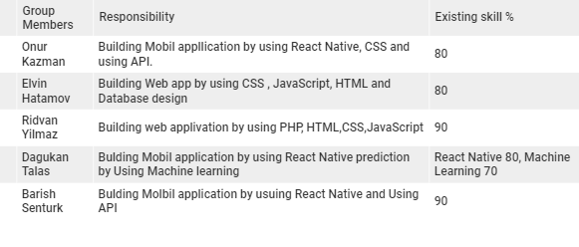

|  |  |  |  |
| --- | --- | --- | --- |
| Group members | Start date | End date | Resources |
| Elvin Hatamov | 2020/1/12 | 2020/25/12 | MySql:  <https://www.mysqltutorial.org/getting-started-with-mysql/> Learn to design efficient high quality software: <https://www.edx.org/professional-certificate/pennx-computer-science-essentials-for-software-development> |
| Ridvan Yilmaz | 2020/30/11 | 2020/23/12 | PHP with MySql:<https://www.linkedin.com/learning/php-with-mysql-essential-training-1-the-basics/use-form-parameters?u=2155426> |
| Onur Kazman | 2020/28/11 | 2020/20/12 | Build first android app coursera: <https://www.coursera.org/learn/android-app>  React Native :  <https://reactnative.dev/> |
| Barish Senturk | 2020/25/11 | 2020/25/12 | React, React Native, and JS: <https://www.linkedin.com/learning/search?keywords=MObil%20applicatin%20react&u=2155426>    React Native :  <https://reactnative.dev/> |
| Dogukan Talas | 2020/29/11 | 2020/25/12 | [Data Ingestion with Python](https://www.linkedin.com/learning/data-ingestion-with-python?u=2155426):<https://www.linkedin.com/learning/data-ingestion-with-python/why-is-data-inegstion-important?u=2155426>Machine Learning:<https://www.coursera.org/learn/machine-learning> |