Goal,

This project aims to provide you digital identity. By using this blog, you can share your personal information, your skills and your job experience.

Why creating personal home page is important because;

Whether you are applying for a new job or starting a project, most people will search for your name online. So, having the control over what information you would like to share is such a powerful thing in these days.

While you are developing the project, you can follow these steps to get help.

1. **Creating Project Folders**

* First, you should create a folder that will contain all of your files and folders. You can name it **myPersonalHomePage** etc.
* In order for your file to look clearer and more understandable, you are expected to create two more subfolders named img for images and style for CSS files inside the **myPersonalHomePage** folder.
* Under **myPersonalHomePage** folder, you should create a file that will contain your HTML code for the page. You can name it **index.html** etc.
* Under the style directory, you should create a CSS file named as **style.css** that will contain your CSS code.
* In order to upload images to our website, we will provide you some images under the img folder. (You can add you own images, in order not to have resolution problems, their sizes should be the same with the ones we provided you.)

Hint: Don’t forget to save images under img folder!

Imgler için link vermeyi unutma.

1. **Customizing index.html File**

* In the first line of the file, don’t forget to import <!DOCTYPE html> tag. Inside of this tag, remember to put <head> and <body> tags.
* After opening the <head> tag, you are expected to copy and paste this line of code in order to import a font family from google.

**<link href="http://fonts.googleapis.com/css?family=Hind:300,400,500,600,700" rel="stylesheet" type="text/css">**

* After pasting this, import your CSS file as well. Link your style.css file. (See the example 1.0 in Appendix A).
* While creating navigation bar, you can see the example 1.1 in Appendix A.
* When you done with the navigation bar, you can start body part which contains name, surname, your special interest and your image. (See 1.2 in Appendix A).
* Below the body part, there is an about part containing your information, your cv and your skills. You can divide these parts into <div> tags. (See 1.3 in Appendix A).
* After about part, there is an experience part and this part contains your personal experiences and their details. (See 1.4 in Appendix A).
* After experience part, there is a blog part where you can share your blog writings. (See 1.5 Appendix A).
* Last, in the contact part you should share your name, surname, email address and phone number(optional). (See 1.6 Appendix A).
* In the last row, don’t forget to import your JS file before closing the </body> tag. After this, you can close html tag by using </html>.

**Appendix A**

**1.0**

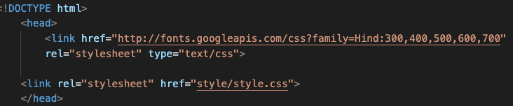

**1.2**

**1.3**

**1.4**

**1.5**

**1.6**

**1.7**

