Revision History
Date | Version | Description | Author
11.11.2015 | 0.2 | Added software architecture overview, software design descriptor | DE, BY, İA
11.11.2015 | 0.3 | Added sequence and deployment diagrams | MÖ
11.11.2015 | 1.0 | Added software requirement mapping, added cots libraries | OT, YY, BY, MO, DE, İA
17.11.2015 | 1.1 | Added new components, renewed architectural design | YY,MO,IA,DE,OT
18.11.2015 | 1.2 | Added interfaces | DE,İA
18.11.2015 | 2.0 | Completed components | BY, MO, OT, DE, YY, IA

TABLE OF CONTENTS
Revision History 1
1 Introduction 3
1.1 References 3
1.1.1 Project References 3
1.2 Abbreviations 3
2 Software Architecture overview 3
3 Software design description 3
3.1 Server Network 6
3.1.1 Component interfaces 6
3.1.2 Component design description 7
3.1.3 Workflows and algorithms 7
3.1.4 Software requirements mapping 8
3.2 Game Logic 8
3.2.1 Component interfaces 8
3.2.2 Component design description 9
3.2.3 Workflows and algorithms 9
3.2.4 Software requirements mapping 9
3.3 Server Utilities 10
3.3.1 Component interfaces 10
3.3.2 Component design description 10
3.3.3 Workflows and algorithms 11
3.3.4 Software requirements mapping 11
3.4 Client Network 11
3.4.1 Component interfaces 11
3.4.2 Component design description 11
3.4.3 Workflows and algorithms 12
3.4.4 Software requirements mapping 12
3.5 Game Engine 12
3.5.1 Component interfaces 12
3.5.2 Component design description 13
3.5.3 Workflows and algorithms 14
3.5.4 Software requirements mapping 14
3.6 GUI 14
3.6.1 Component interfaces 14
3.6.2 Component design description 15
3.6.3 Workflows and algorithms 15
3.6.4 Software requirements mapping 16
3.7 Client Utilities 16
3.7.1 Component interfaces 16
3.7.2 Component design description 16
3.7.3 Workflows and algorithms 17
3.7.4 Software requirements mapping 17
4 COTS Identification 17

Introduction
This document describes the design of the Impetum the game software system.

References

Project References

# | Document Identifier | Document Title
 | SRS 2.3 | Software Requirements Specifications

Abbreviations
IA: İsmet Aydın
MO: Murat Özçelik
DE: Dogukan Ergün
BY: Barış Yağan
OT: Ömer Turhan
YY: Yiğit Yardımcı

Software Architecture overview
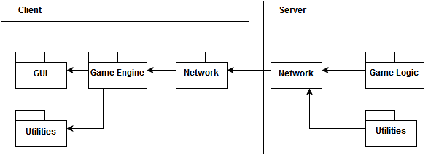

Software design description
Component #1 Server Network: Shares the game events with clients and provides player inputs to game logic.
Component #2 Game Logic: Processes player input and controls the game events.
Component #3 Server Utilities: This component is helper of other components. It provides logging and debugging features. Also saves the scores of players.
Component #4 Client Network: Client Network receives the game data from Server and sends the player inputs to Server.
Component #5 Game Engine: Game Engine handles the user input, game sounds and the game data from Server.
Component #6 GUI: GUI is the game interface that allows users to interact with game through game screen and it displays screen elements(health label, score label etc.).
Component #7 Client Utilities: This component gets mutable game informations from server as a JSON object.

Sequence Diagram

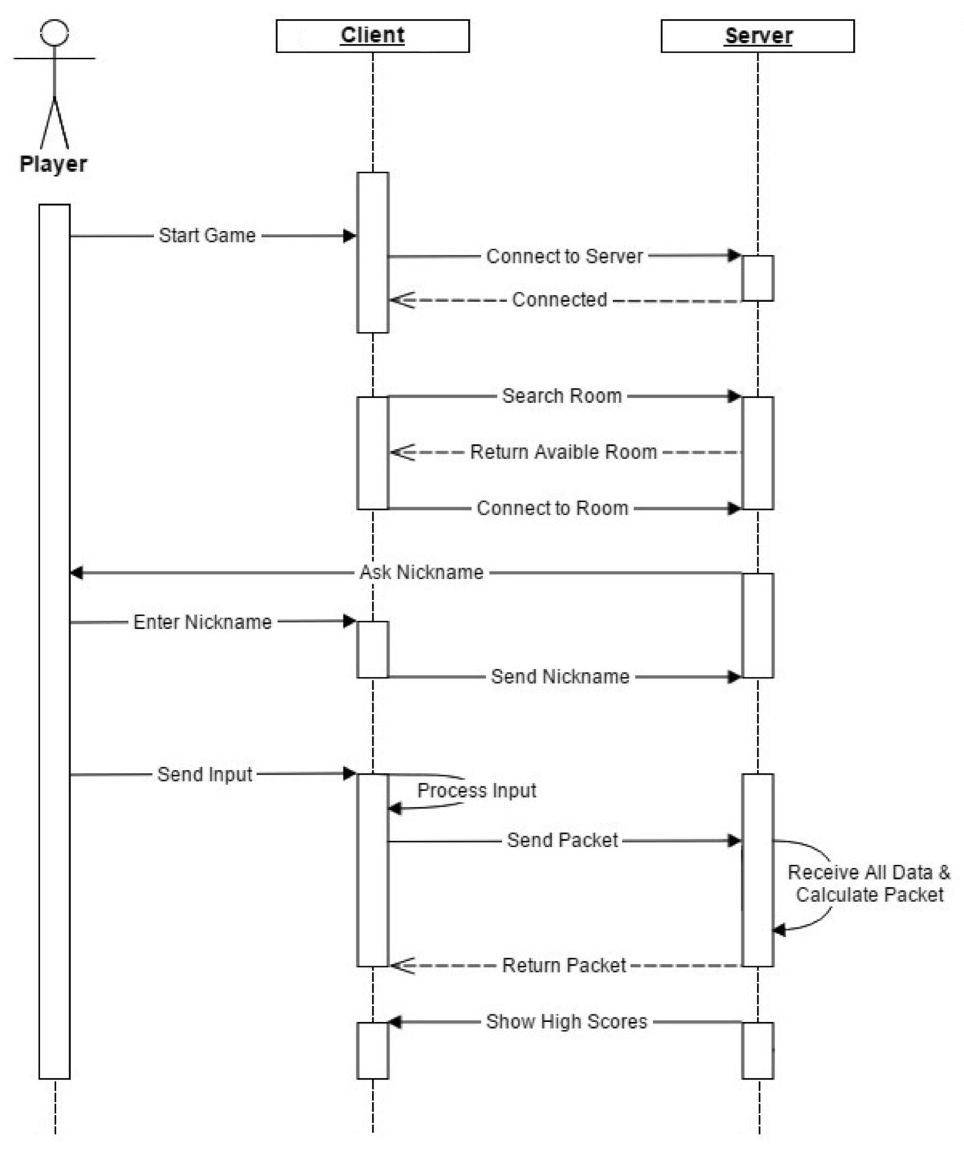

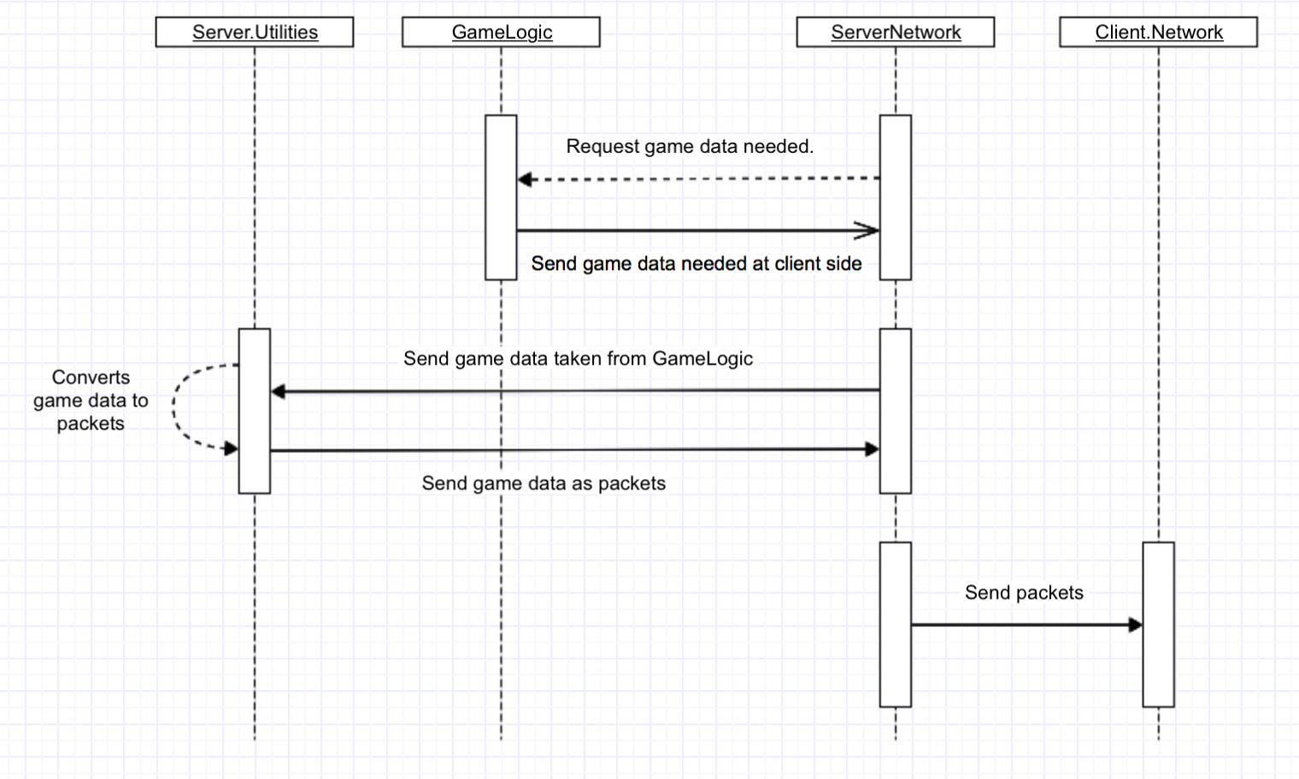
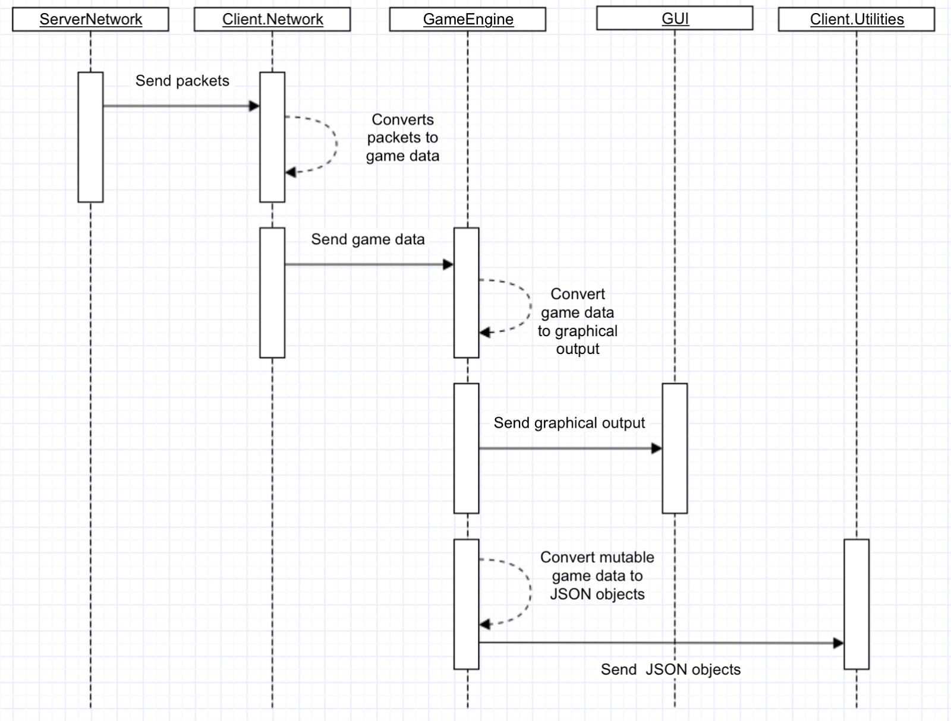

Deployment Diagram

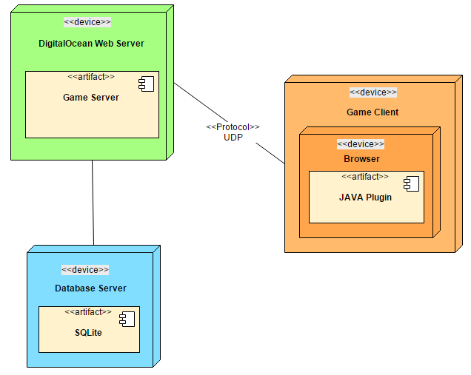

Server Network

Component interfaces
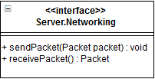

Component design description
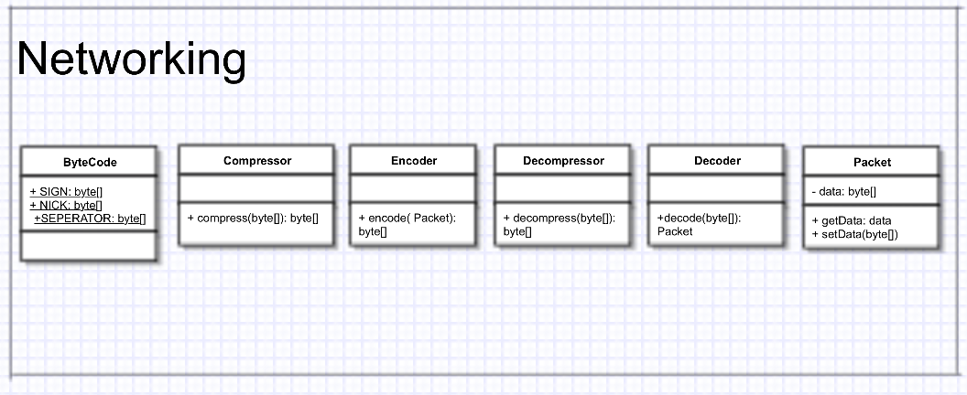

Workflows and algorithms
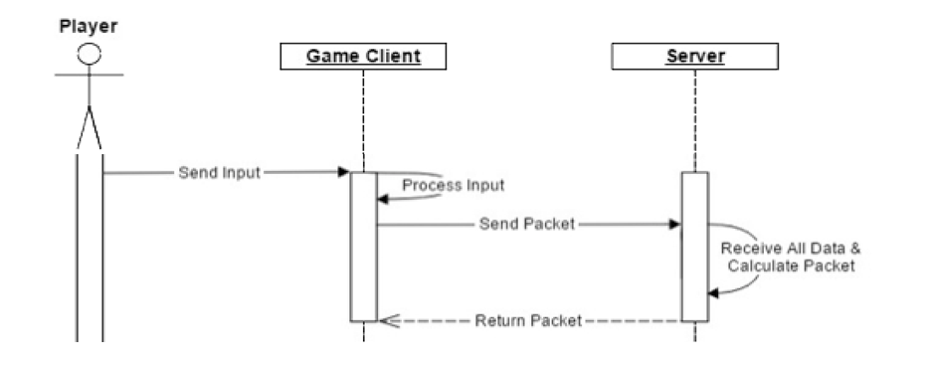

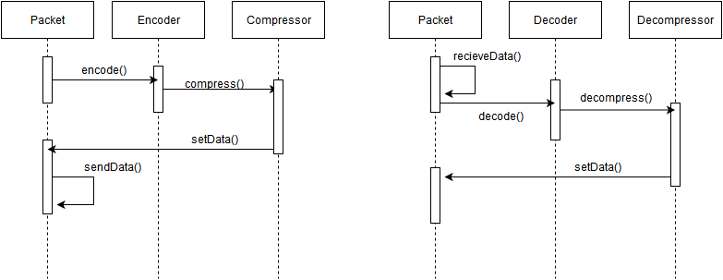

Software requirements mapping
- SRS-IMP-001.0
- SRS-IMP-001.2
- SRS-IMP-006.2

Game Logic

Component interfaces
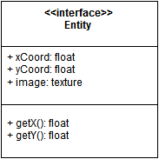

Component design description

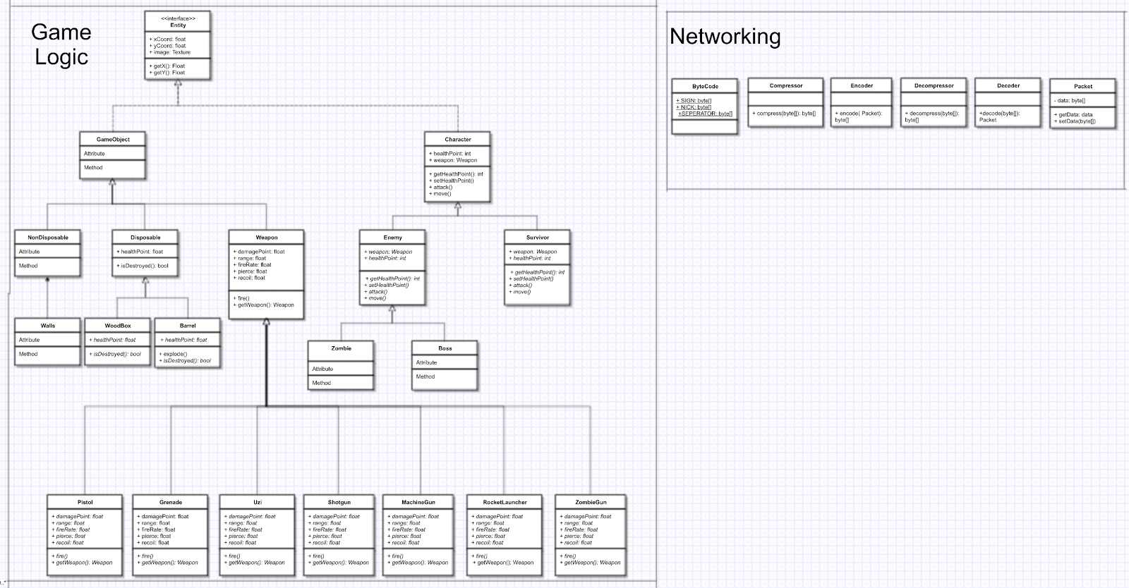

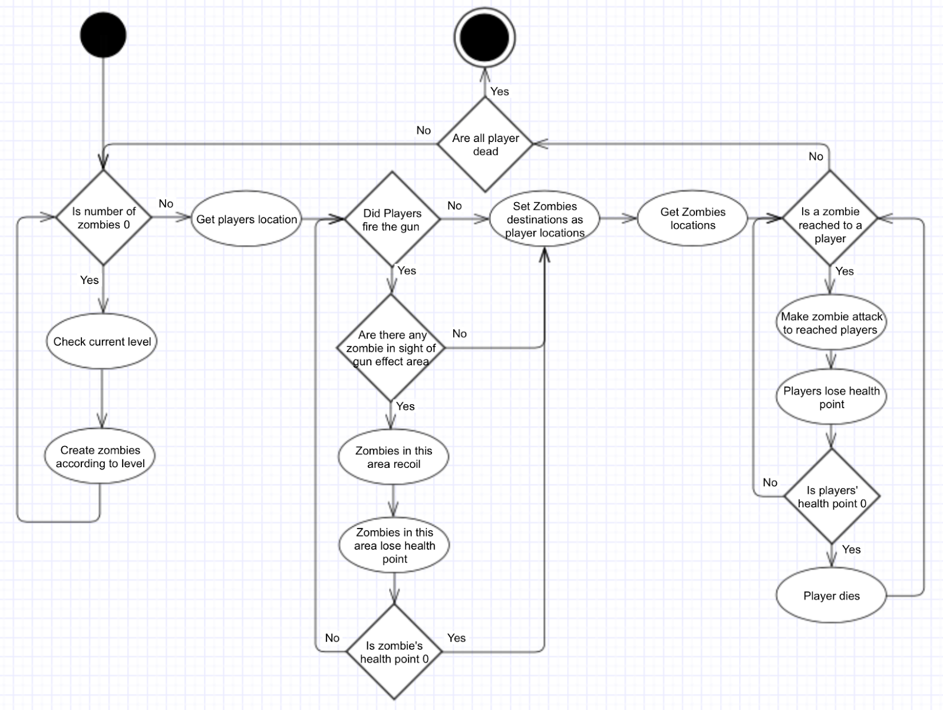
Workflows and algorithms

Software requirements mapping
- SRS-IMP-001.1
- SRS-IMP-001.3
- SRS-IMP-001.4
- SRS-IMP-002.1
- SRS-IMP-002.2
- SRS-IMP-003.1
- SRS-IMP-004.1
- SRS-IMP-004.2
- SRS-IMP-004.3
- SRS-IMP-005.1
- SRS-IMP-005.2
- SRS-IMP-006.1
- SRS-IMP-007.1

Server Utilities

Component interfaces
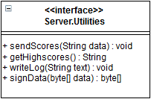

Component design description
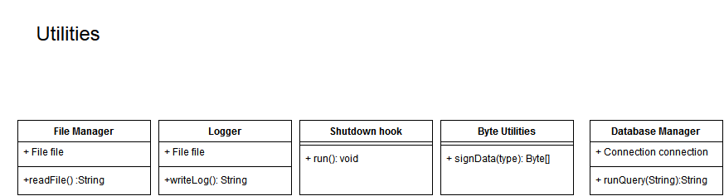

Workflows and algorithms
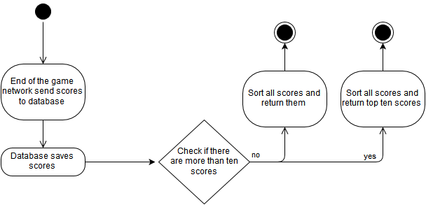

Software requirements mapping
- SRS-IMP-007.2

Client Network

Component interfaces
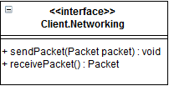

Component design description

Workflows and algorithms

Software requirements mapping
- SRS-IMP-001.0
- SRS-IMP-001.2

Game Engine

Component interfaces
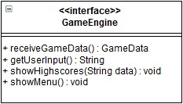

Component design description
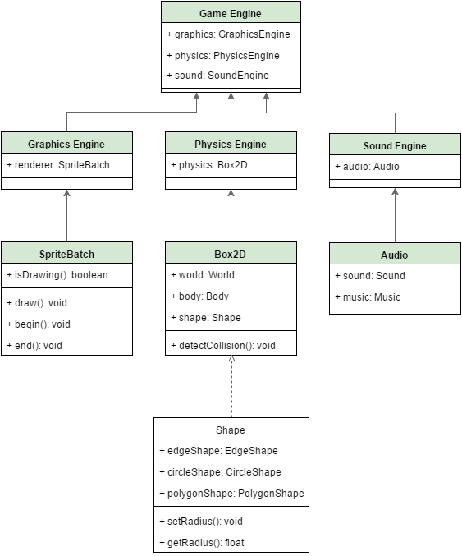

Workflows and algorithms

Renderer Activity Diagram
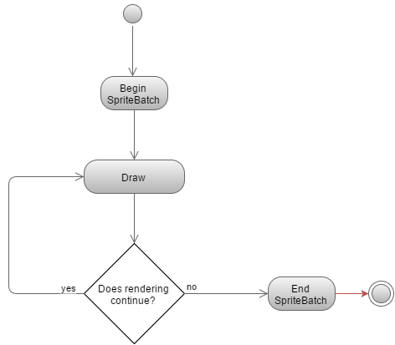

Software requirements mapping
- SRS-IMP-003.3
- SRS-IMP-004.4

GUI

Component interfaces

Component design description
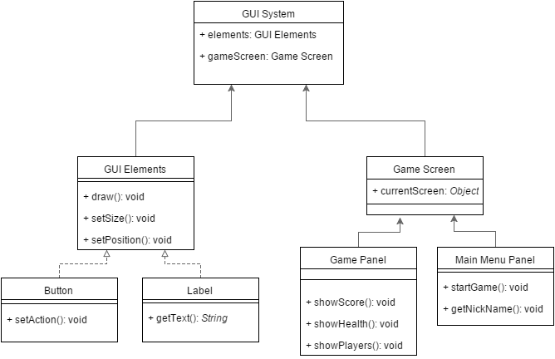

Workflows and algorithms

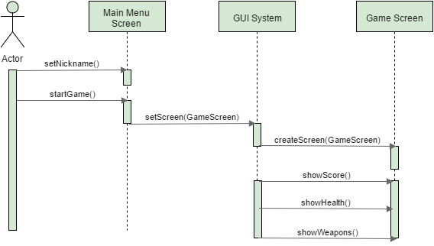

Software requirements mapping
- SRS-IMP-002.3
- SRS-IMP-007.2

Client Utilities

Component interfaces

Component design description

Workflows and algorithms

Software requirements mapping
- SRS-IMP-001.2
- SRS-IMP-003.2

COTS Identification
COTS libraries used in Impetum are the following:
- mr-udp.jar, http://lac-rio.com/mr-udp/mr-udp.jar ,
- libgdx, 1.7.1, https://libgdx.badlogicgames.com/download.html, Apache 2 Licence
- sqlite,3.9.2, https://www.sqlite.org/download.html
- sqlite-jdbc,3.8.11.2 , https://bitbucket.org/xerial/sqlite-jdbc/downloads/sqlite-jdbc-3.8.11.2.jar
- json-simple, 1.1.1, https://code.google.com/p/json-simple/

