Revision History
Date | Version | Description | Author
17.10.2015 | 0.1 | Filled introduction section.  Defined conventions  Added several URS | ÖT
20.10.2015 | 1.0 | Document overview, user requirements specification, use cases, system architecture | MO,DE,IA,ÖT, YY
21.10.2015 | 2.0 | URS revised, SRS completed | BY
27.10.2015 | 2.1 | Fix problems according to feedback | DE,MÖ,İA
28.10.2015 | 2.2 | Edited system requirements | YY, OT, BY
28.10.2015 | 2.3 | Added sequence diagram | MÖ

TABLE OF CONTENTS
Revision History 1
1 INTRODUCTION 3
1.1 Document overview 3
1.2 System overview 3
1.3 Abbreviations 3
1.4 References 3
1.5 Conventions 3
2 REQUIREMENTS 5
2.1 User Requirements Specification 5
2.2 System Architecture 6
2.3 Use Cases and Usage Scenarios 7
2.4 System Requirements Specification 8

INTRODUCTION

Document overview
This document presents the software requirements specifications of the “Impetum”, a web-based multiplayer top-view shooting game.

- Server should connect players each other to play the game together.
- Players should be able to kill enemies in order to survive and gain score.
- There is a main menu and room menu before connecting to game and also game screen.
- If these requirements are not met, the players will have poor gaming experience.

System overview
User system will be directly connected to main server with UDP. All the users will be connected to each other through a main server. Main server will handle user input. Also creation of game events and notifying all players belongs to main server.

Abbreviations
UDP : User Datagram Protocol
MS : Milliseconds
AFK : Away From Keyboard
FPS : Frame Per Second
URS: User Requirement Specification
SRS: System Requirement Specification
İA : İsmet Aydın
DE : Dogukan Ergün
MO : Murat Özçelik
BY : Barış Yağan
OT : Ömer Turhan
YY : Yiğit Yardımcı

References

# | Document Identifier | Document Title
 | SDP 0.7 | Software Development Plan

Conventions
Requirements listed in this document are constructed according to the following structure:

For user requirements:

SRS-XXX-000 User Requirement ID
Title of XXX-000 requirement
Description of XXX-000 requirement
Version of XXX-000

For system requirements like below:

SRS-XXX-000.1 System Requirement ID which is related to the user requirement XXX-000.
Title of XXX-000
Description of XXX-000 requirement
Version of XXX-000

REQUIREMENTS

User Requirements Specification

SRS-IMP-001
Taking Users to Game Room
Impetum the game shall let users to join to the game room in order to play with friends with their nicknames ,whose length will be between 2-20 characters, demanded at state of joining to the room. Rooms are automatically created by server and users are not able to see other rooms but they can see the players in the same room.
V1.0

SRS-IMP-002
Players’ Health and Score
Impetum the game shall let all players’ to see their health and score information on each player’s screen.
V1.0

SRS-IMP-003
Moving on The Map
Impetum the game shall let players to move on the map.
V1.0

SRS-IMP-004
User & Enemy Interaction
Impetum the game shall let players to see the enemies and interact with them on the map.
V1.0

SRS-IMP-005
Killing Characters and Enemies
Impetum the game shall kill the players and enemies according to health point they have.
V1.0

SRS-IMP-006
Cutting off AFK Player Connections
Impetum the game shall kill the connection of AFK player
V1.0

SRS-IMP-007
Ending The Game
Impetum the game shall end the game when all player died and let all players to see the highscore table at the end of the game.
V1.0

System Architecture

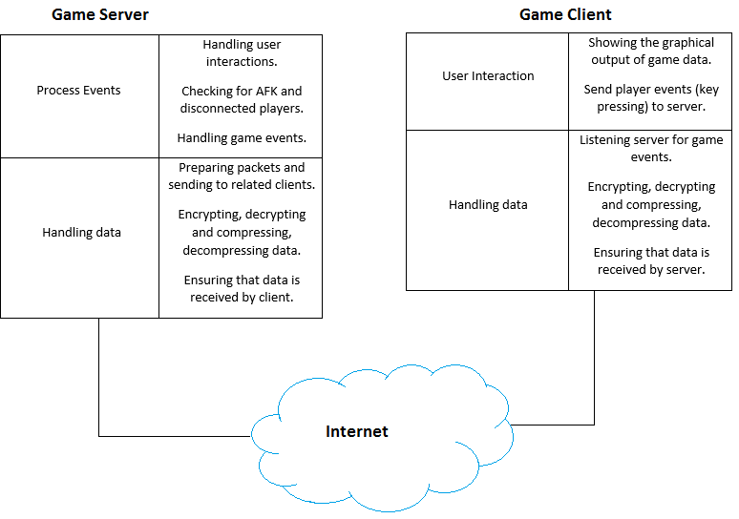

Use Cases and Usage Scenarios
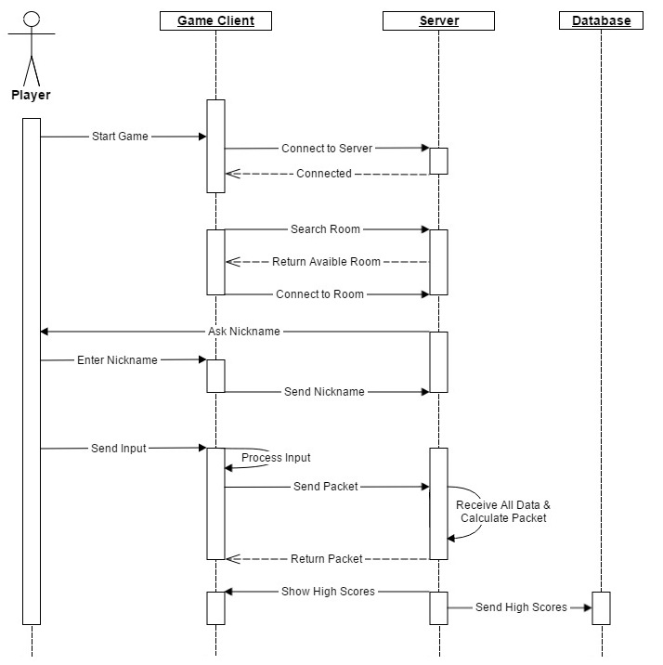

System Requirements Specification

SRS-IMP-001.0
Connecting to Server
Impetum the game client shall connect to the server through the Internet.
V1.0

SRS-IMP-001.1
Player Adding
Impetum the game shall add players to the rooms when players want to join to the rooms.
V1.0

SRS-IMP-001.2
Getting Nickname
Impetum the game shall correctly get players’ nicknames who want to join to the rooms.
V1.0

SRS-IMP-001.3
Initializing Nickname
Impetum the game shall correctly initialize stored nicknames to characters in game.
V1.0

SRS-IMP-001.4
Creating Room
Impetum the game shall create room if all rooms are full.
V1.0

SRS-IMP-002.1
Characters’ Properties Initializing
Impetum the game shall correctly initialize characters initial properties like health point, gun specification.
V1.0

SRS-IMP-002.2
Characters’ Properties Tracking
Impetum the game shall correctly track characters properties like health point, gun specification.
V1.0

SRS-IMP-002.3
Characters’ Properties Showing
Impetum the game shall correctly show characters properties like health point, gun specification on screen.
V1.0

SRS-IMP-003.1
Generating Map
Impetum the game shall generate the game map at state of creating the room.
V1.0

SRS-IMP-003.2
Getting Players’ Input
Impetum the game shall correctly get players keyboard and mouse interactions.
V1.0

SRS-IMP-003.3
Characters’ Animation
Impetum the game shall correctly animate characters according to players’ input took.
V1.0

SRS-IMP-004.1
Enemies’’ Properties Initializing
Impetum the game shall correctly initialize enemies initial properties like health point, gun specification.
V1.0

SRS-IMP-004.2
Generating Enemy Waves
Impetum the game shall correctly generate enemy attack waves which are defined for each level before.
V1.0

SRS-IMP-004.3
Enemy Health Point Tracking
Impetum the game shall track enemies health points.
V1.0

SRS-IMP-004.4
Enemies’ Animation
Impetum the game shall correctly animate enemies according to game events.
V1.0

SRS-IMP-005.1
Character Death Situation
Impetum the game shall correctly activate death situation according to tracked health point.
V1.0

SRS-IMP-005.2
Enemy Death Situation
Impetum the game shall animate enemies’ death situation according to tracked health point.
V1.0

SRS-IMP--006.1
Detection of the AFK Player
Impetum the game shall compute and track the inactivity of a player.
V1.0

SRS-IMP-006.2
Disconnecting the AFK Player
Impetum the game shall disconnect AFK the player.
V1.0

SRS-IMP-007.1
Calculating the Player Points
At the end of the game (when all players died), Impetum the game shall calculate players’ score points.
V1.0

SRS-IMP-007.2
Calculating and Showing High Scores
At the end of the game (when all players died), Impetum the game shall create and show a “High Scores” table that orders all players’ names according to their points.
V1.0

