**1. Define a Specific Business Process :**

**Business Process: Student Academic Performance and Course Enrollment Analysis**

This process focuses on tracking and analyzing student enrollments, course performance (grades), instructor assignments, class schedules, and subject details to support academic decision-making.

**Key Business Questions:**

* How are students performing across different subjects?
* Which instructors are teaching high-enrollment or high-performing courses?
* What is the average grade per subject or department?
* How does class schedule (time/day) affect student performance?
* What is the enrollment trend over time?

**2. Define the Level of Detail (Grain)**

**Grain:** *One row per student enrollment in a subject.*

Each record represents a unique enrollment of a student in a specific subject, including:

* Who enrolled (Student)
* Which subject
* When they enrolled
* The grade received
* The instructor teaching the subject
* Class schedule details (day, time, room)

This grain allows analysis of performance, enrollment trends, and instructor effectiveness at the individual student-subject level.

**3. Define Dimension Tables (Based on Grain)**

We define the following **dimension tables**:

**DimStudent**

* StudentKey (PK, surrogate key)
* StudentID (natural key from source)
* FirstName
* LastName
* Email
* DateOfBirth
* EnrollmentDate (student’s initial enrollment)
* Age (derived)
* YearEnrolled (derived)

**DimInstructor**

* InstructorKey (PK)
* InstructorID (natural key)
* FirstName
* LastName
* Email
* Department
* HireDate
* YearsAtInstitution (derived)

**DimSubject**

* SubjectKey (PK)
* SubjectID (natural key)
* SubjectName
* Credits
* Department (can be derived from instructor or stored directly if known)

**DimClassSchedule**

* ScheduleKey (PK)
* ScheduleID (natural key)
* SubjectID
* DayOfWeek
* StartTime
* EndTime
* RoomNumber
* ClassDurationMinutes (derived: EndTime - StartTime)

**DimDate (for enrollment and potentially grade date)**

* DateKey ( PK)
* Date
* Year
* Quarter
* Month
* DayOfMonth
* DayOfWeekName
* IsWeekend

**4. Define the Fact Table with Metrics and Attributes**

**FactEnrollmentPerformance (Fact Table)**

* EnrollmentKey (PK, surrogate)
* StudentKey (FK → DimStudent)
* InstructorKey (FK → DimTeacher)
* SubjectKey (FK → DimSubject)
* ScheduleKey (FK → DimClassSchedule)
* EnrollmentDateKey (FK → DimDate)
* EnrollmentID (source transaction ID)
* EnrollmentDate (actual date)
* Grade (CHAR(2), e.g., A+, B, etc.)

**Metrics (Measures):**

* GradeNumeric (computed: A=4.0, B=3.0, etc., for averages)
* IsPassed (1 if grade >= C or equivalent, else 0)
* EnrollmentCount = 1 (for counting enrollments)

**5. Physical Model: Star Schema**

* We choose the **Star Schema** for simplicity, performance, and ease of querying in analytical environments.
* **Schema Diagram (Star):**

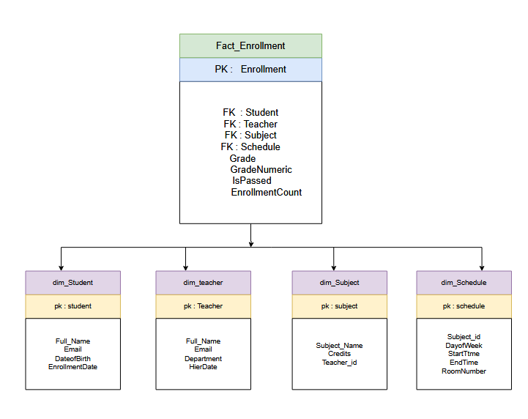

**6. Analytical Queries**

Query 1: Average Grade by Subject and Instructor

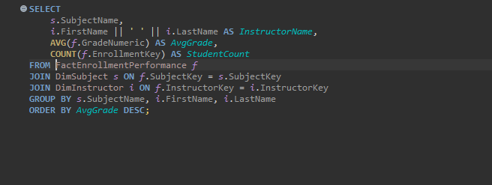

Query 2: Enrollment Trends by Month

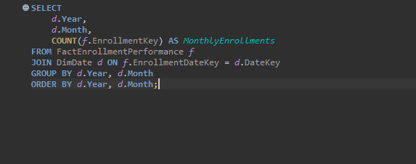

Query 3: Pass Rate by Department

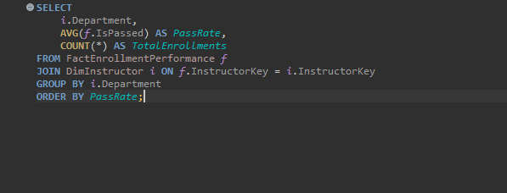

**Query 4: Performance by Class Time**

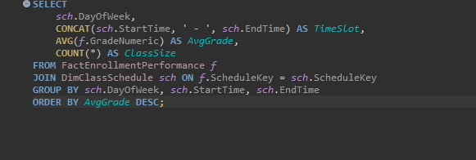

Query 5: Top 5 Students by GPA

