**Workshop in Databases:  
Final Project User Manual**

|  |  |
| --- | --- |
| Adam Aharony [Adam.Aharony@gmail.com](mailto:Adam.Aharony@gmail.com) | Bar Katash[KatashBar15@gmail.com](mailto:KatashBar15@gmail.com) |
|  |  |

**Contents**

Our Application (MealMeter) 2

Overview 2

Key Benefits 2

Application Configuration 3

Client Side 3

Server Side 3

Application Usage 4

Navigation Bar 4

Creating an Account (Optional) 5

Logging In 6

Home Page 7

Food Item Page 8

Profile Page 11

# Our Application (MealMeter)

## Overview

MealMeter is a comprehensive food and nutrition tracking application built with React for its frontend, and Flask for its backend. It provides users with detailed nutritional information, health scores, and meal tracking capabilities.

### Key Benefits

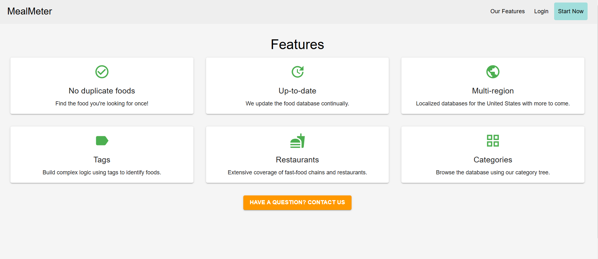

Figure 1. Features section.

* Detailed nutritional information for foods and beverages
* Personal meal tracking and history
* Health score calculations
* Activity recommendations for calorie management
* Comparative health analytics

## Application Configuration

### Client Side

1. **Environment Configuration** – In order to run the application, you must run the server script found in the app directory (app/app.py). Then, the client side of the application will be accessible on localhost, using port 5000 (we are serving a static build of the application, using the build directory).

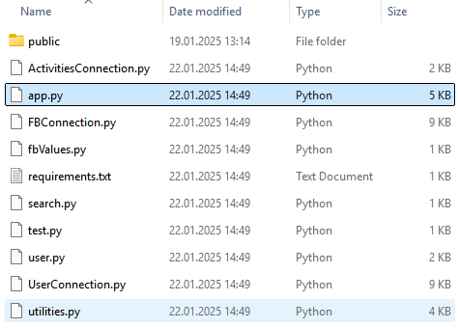

Figure 2. The app subdirectory within the project root.

### Server Side

1. **Prerequisites**
   * Python
   * pip package manager
2. **Installation Steps**

* cd app  
  py -m pip install -r requirements.txt  
  py app.py

## Application Usage

### Navigation Bar



Figure 3. Navigation bar, not logged in.



Figure 4. Navigation bar, logged in.

The navigation bar is located at the top of the page and contains the following options:

* **“MealMeter”** (*Home Page*) - takes the user to the home page.
* **“Our Features”** (*About Page*) - takes the user to the features page.
* **“Login”** (*Login Page, only if not logged in*) - allows the user to login to their account.
* **“Start Now”** (*Registration Page, only if not logged in*) - allows the user to register for an account.
* **“Profile”** (*Profile Page, only if logged in*) - takes the user to the profile page.
* **“Logout”** (*Logout Page, only if logged in*) - logs the user out of their account.

### Creating an Account (Optional)

This step is optional, but recommended for a more personalised experience. In the case that you do not wish to create an account, you can still use the application, but you will not be able to save your meal history or view your personal health score, or compare your health score to other users.

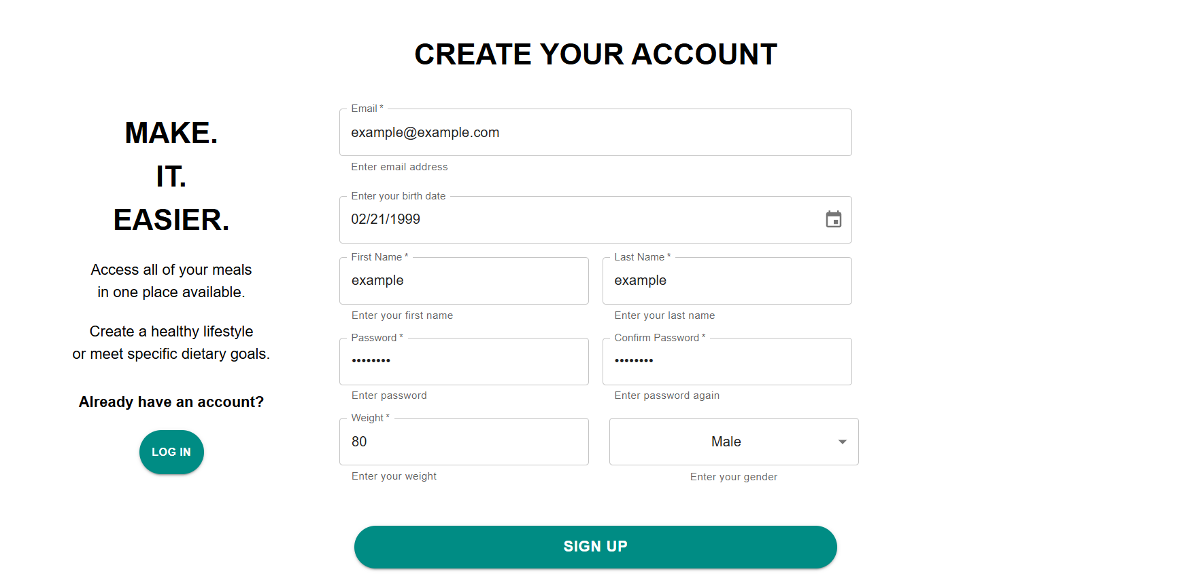

Figure 5. Sign-up page.

***NOTE:* You may use the example account provided by us, with the email “example@example.com” and the password “password”.**

1. Visit the MealMeter homepage
2. Click “Start Now” in the navigation bar
3. Fill in the registration form with:
   * First and last name
   * Email address
   * Password (minimum 8 characters)
   * Date of birth
   * Gender
   * Current weight

### Logging In

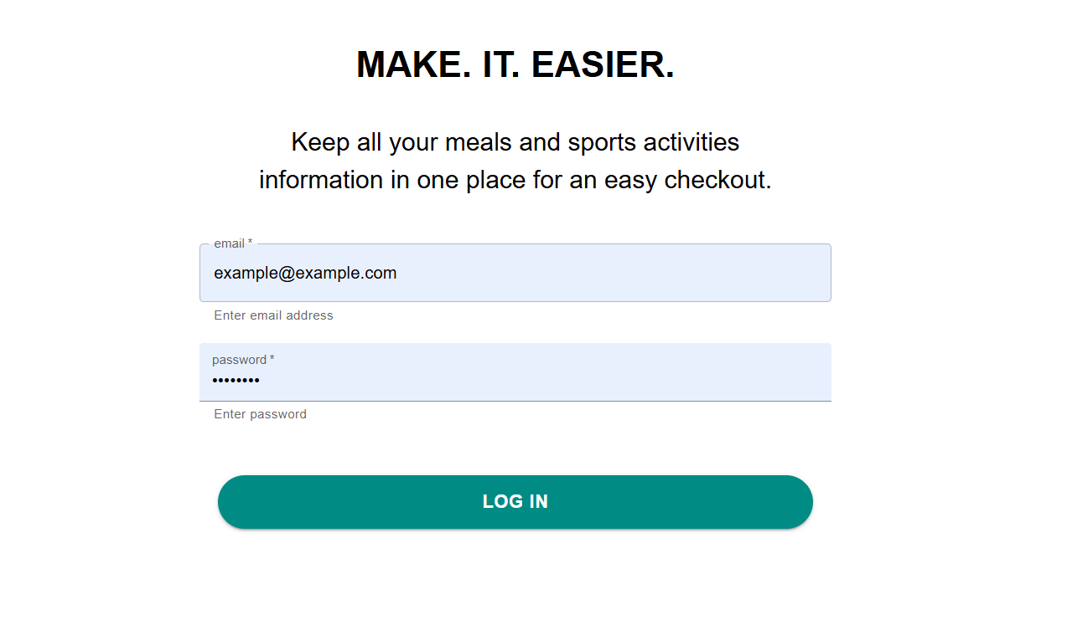

Figure 6. Log-in page.

1. Click “Login” in the navigation bar
2. Enter your email and password
3. Click “LOG IN”

### Home Page

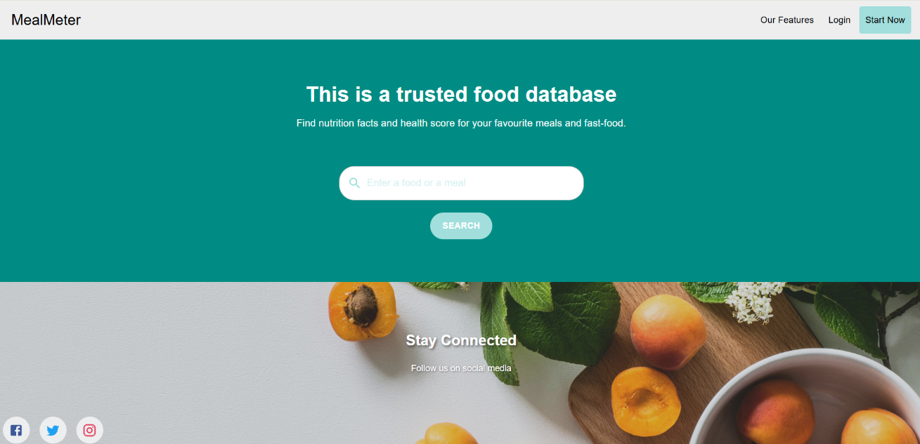

Figure 7. Home page.

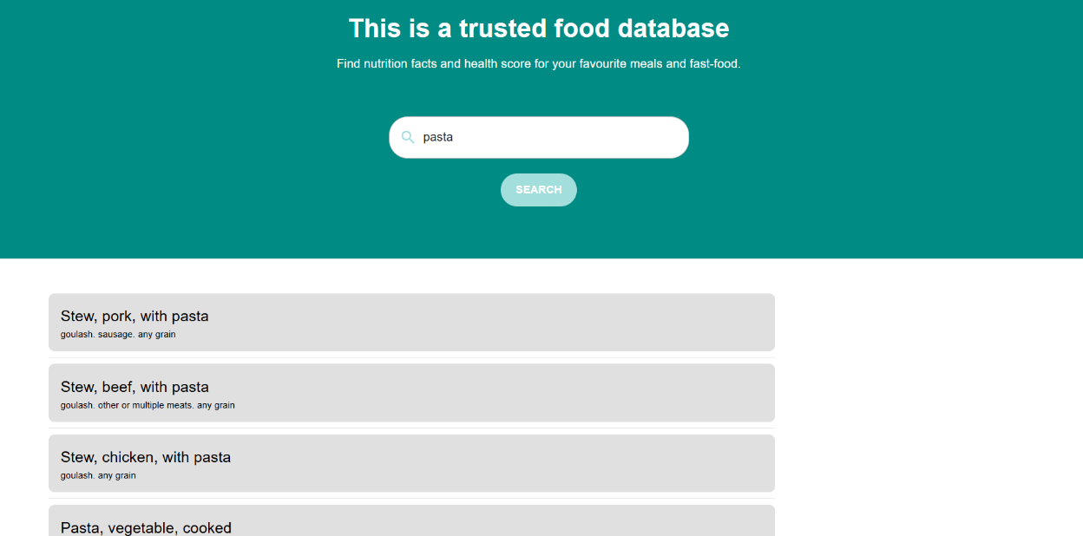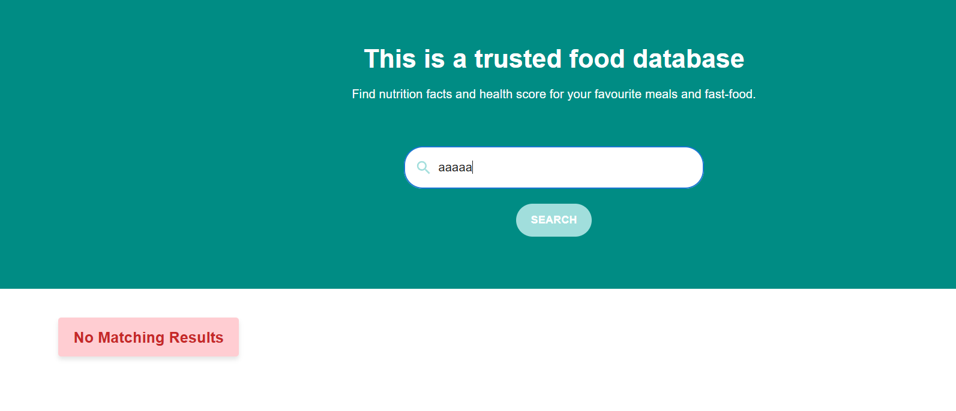

Figure 8. Search example, raises error when no foods are found.

1. Use the search bar on the homepage
2. Enter food name or description
3. Click “Search” or press Enter
4. Browse through the results list
5. Click on any item for detailed information

### Food Item Page

The food item page is divided into 3 tabs:

1. The first tab contains detailed information about the food item, including its ingredients, nutritional information, and suggested workout activities in order to burn off the calories in the food – all calculated based on the portion size selected by the user.

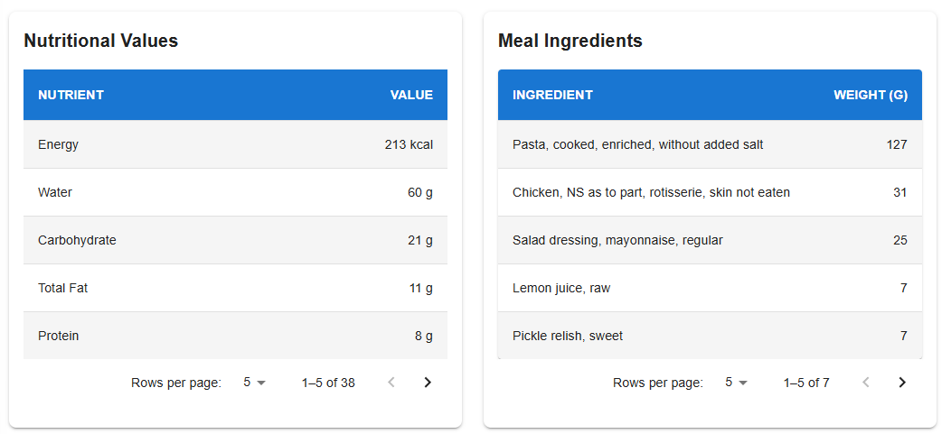

1. The second tab contains an interactive pie chart of the top 5 nutrients in the food, and a chart of the recommended daily intake (RDI).

Figure 9. Second tab of the food-item page.

* + On hover, the pie chart will show the percentage of the nutrient in the food. The RDI chart shows:
    - Percentage of daily recommended intake
    - Red line indicates 100% RDI
    - Hover over bars for exact percentages
    - Nutrients sorted by importance

1. The third tab contains the food item’s health score (0-100), where 0 is the worst possible score, and 100 is the best possible score. This score is calculated based on the food item’s nutritional information.

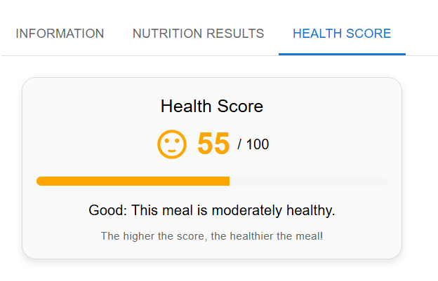

Figure 10. Third tab of the food-item page.

### Profile Page

The profile page is divided into 2 tabs.

1. The first tab contains three sections:

Figure 11. First tab of the user profile page.

* 1. **“Update Your Profile”** - allows the user to update their first name, last name, and weight.
  2. **“Input Your Meal”** - allows the user to input a meal and add it to their meal history.
  3. **“Your Meal History”** - displays a list of the user’s meal history.

1. The second tab contains two health scores:

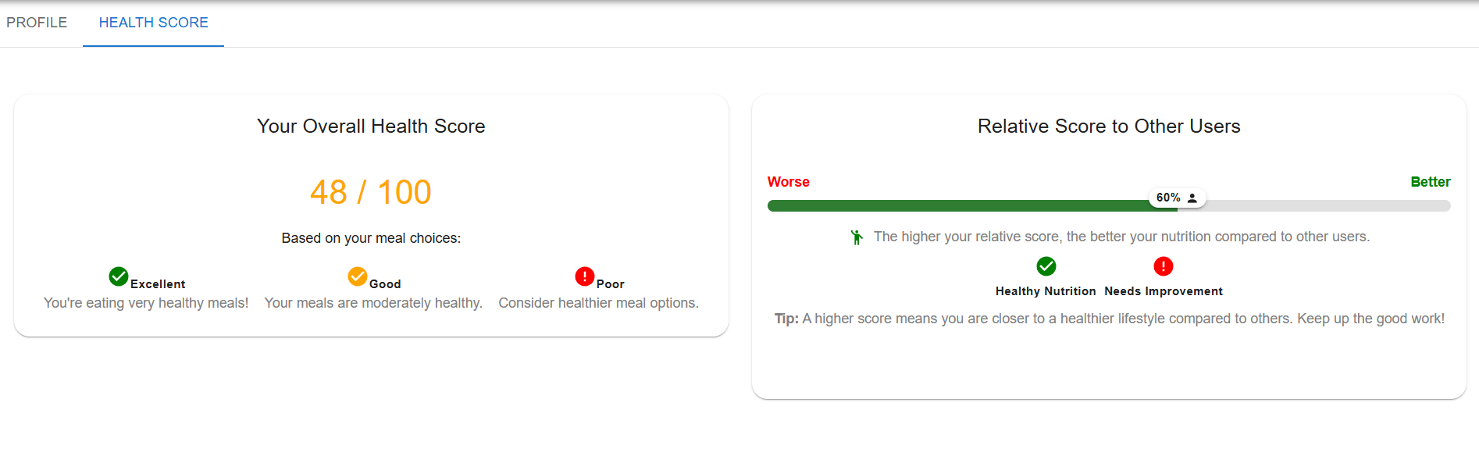

Figure 12. Second tab of the user profile page.

* 1. **“Personal Health Score”** - based on the user’s meal history, and updated as the user inputs meals.
  2. **“Relative Health Score”** - compares the user’s health score to the health scores of other users, shown as a percentile ranking.