CA-JVSPT: JavaScript

Final Project

Student Name: Barkat Ali Kamran

Student Number: 602234518

Instructor: Angie Janzen

Date: 10-09-2021

# Introduction:

This website is designed to let the employers and customers to view my skills and a gateway for both to contact me if they need me, or in other word, this website can help show my skills to employers or customers to get a better and dream job for my future. The website name is Awesome Designs. Customer and employers can easily contact me through this portal and assess my ability and skills in web development. In this module I designed and built web pages using HTML, CSS, JavaScript and Bootstrap. I have designed and built multiple web pages for this website. Every page has its own functionality and appearance. For the navbar, I have created 4 navbar with child pages. Description is below for each page with screenshot.

1. Home page
2. Blog
3. Contact
4. Sign in & Sign up

|  |  |  |  |
| --- | --- | --- | --- |
| **Home** | **Blog** | **Contact** | **Sign in/Sign up** |
| **Strategy** |
| **Creative** |
| **Marketing** |
| **Services** |
| **Technology** |
| **Agility** |

The first page which is home page should always be impressive and attractive. I started with a short navbar, logo at the left side and image for the banner. The title on the banner is beautiful and hover button over the banner makes it more attractive. Down the banner, there are to vector images related to web development with related details and descriptions. In the descriptions I added two buttons for more details which I have not created the page for them yet. Because this website is going to be my personal website, so I need to continue developing this website. Down to the vector images with details, services that we provide for our customers and the skills I have if there is any employer looking for developer. In the services, I used some attractive images look like lights and details down the lights. Below the services, my sample of work, those websites are now hosting and are online, as soon as you click on the link, it will direct you to the website. There are 6 samples of my work on this website. Down the sample of my work, I built a beautiful footer with an attractive image and hover button on it. Including social media icons. Later on I will connect the social media icons to the real page once I created the pages for them either YouTube or other social media platforms. Below are the screenshots of home page.

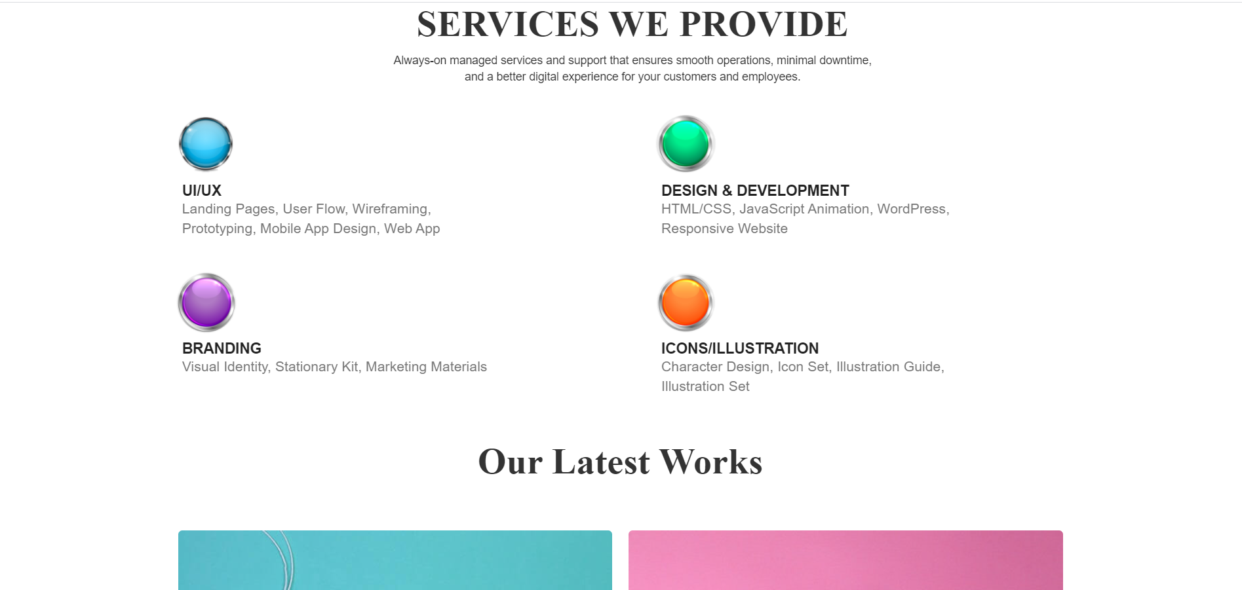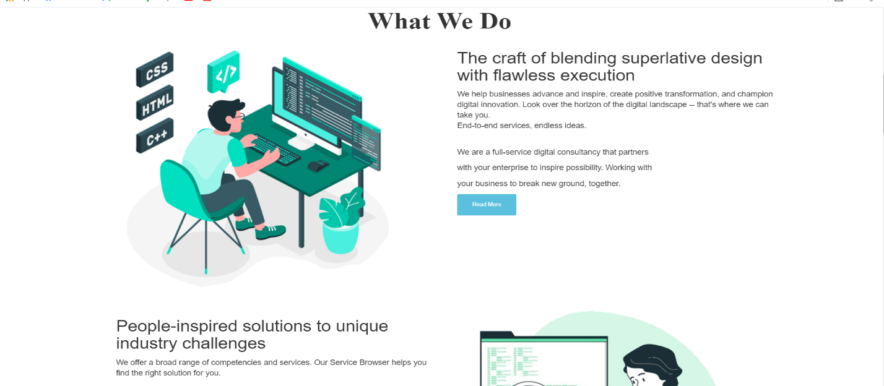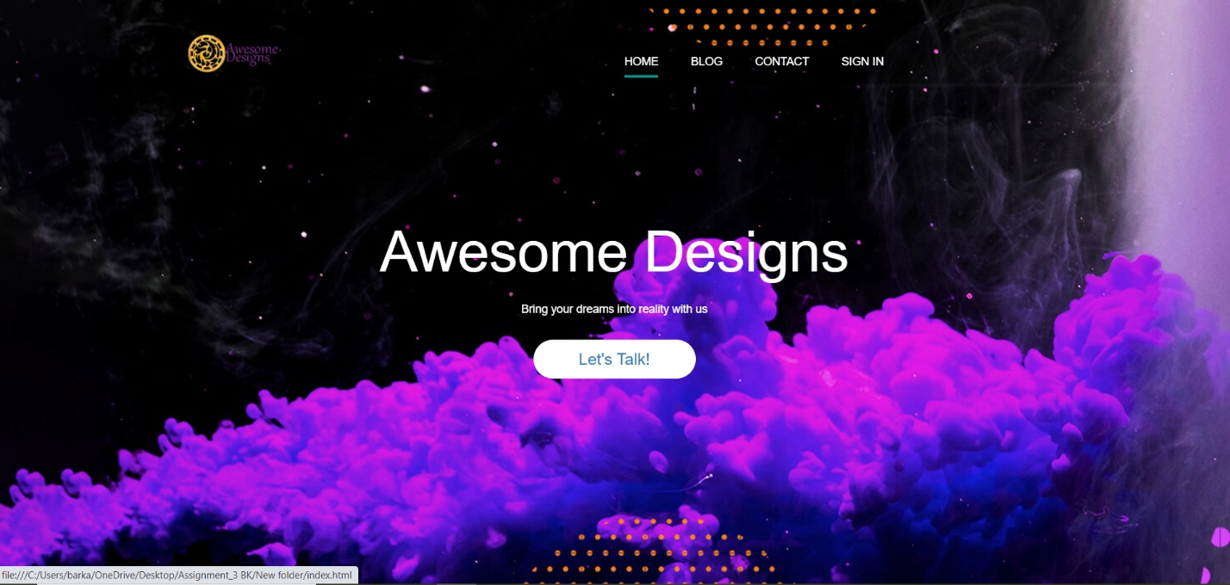

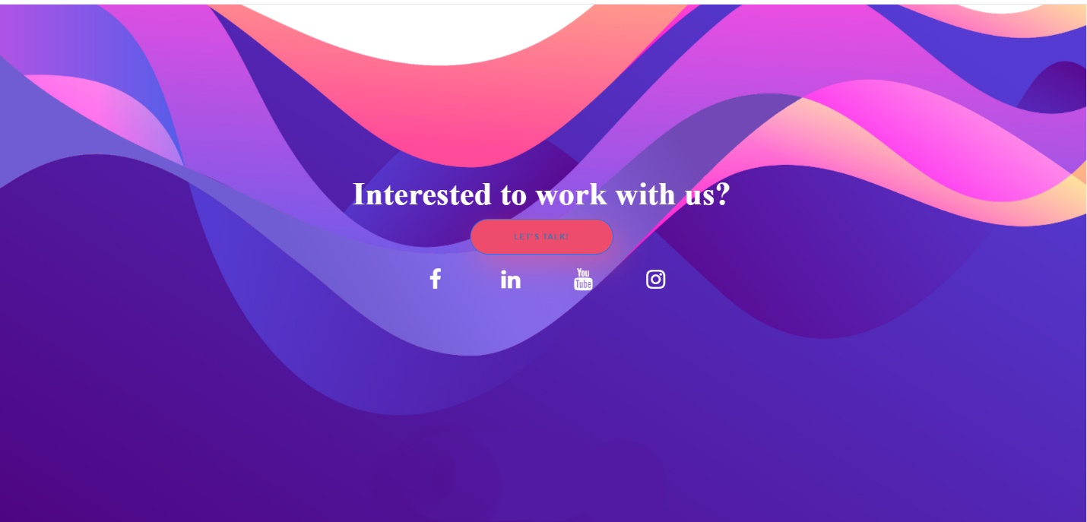our second page is Blog. And then I have contact page so give the ability to the client to contact with me. I decided to record some web development tutorials for other students to use from them, so I thought I need to have sign in and sign up pages so the student could get into the tutorials pages and download them. Sign in and sign up pages are so attractive and the effects are nice. The screenshots below show the sign in and sign up pages’ appearances.

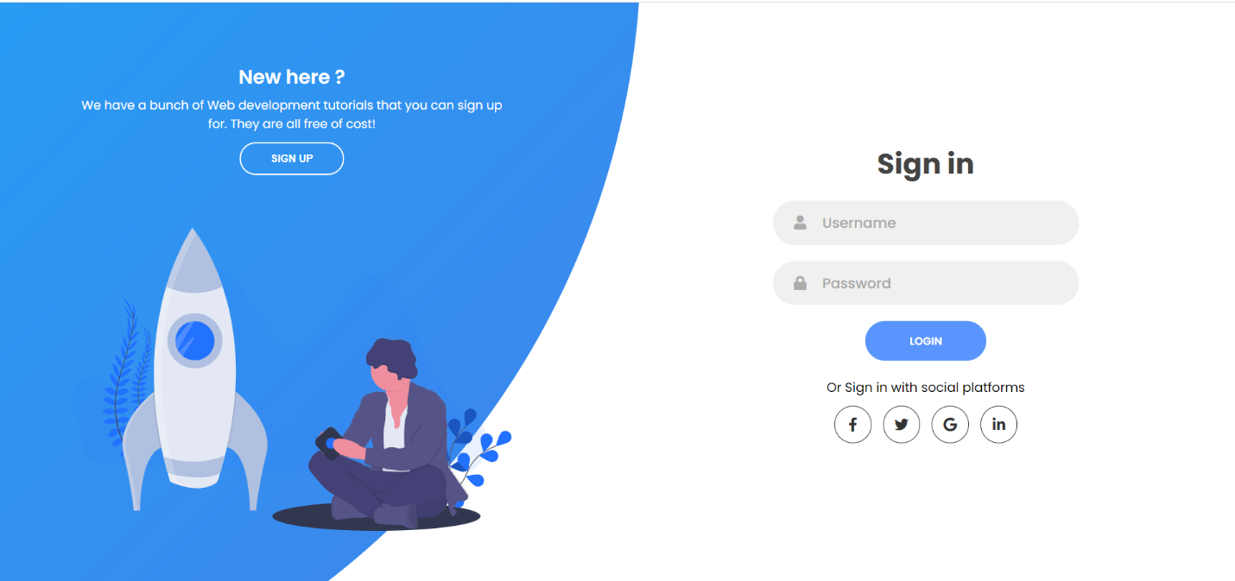

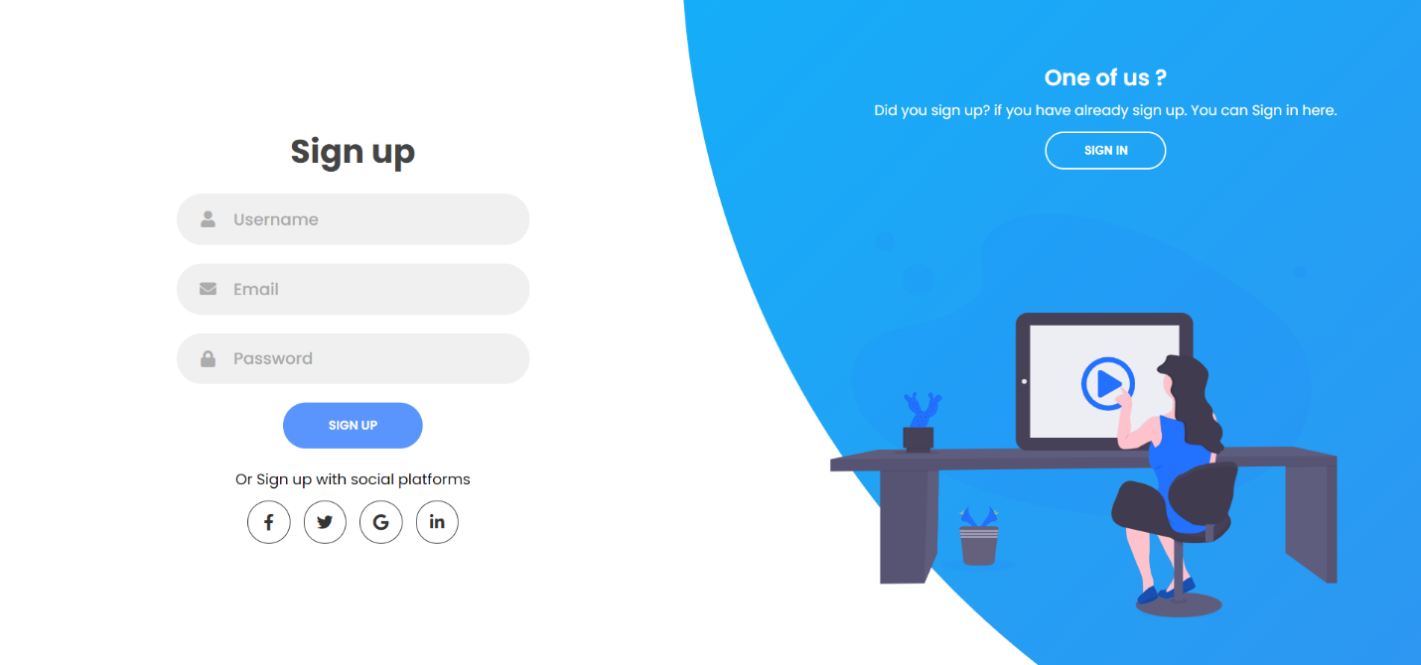contact is the other page I have created to let the clients contact me if they need to. The contact form is simple but awesome. The screenshot below shows the contact form.

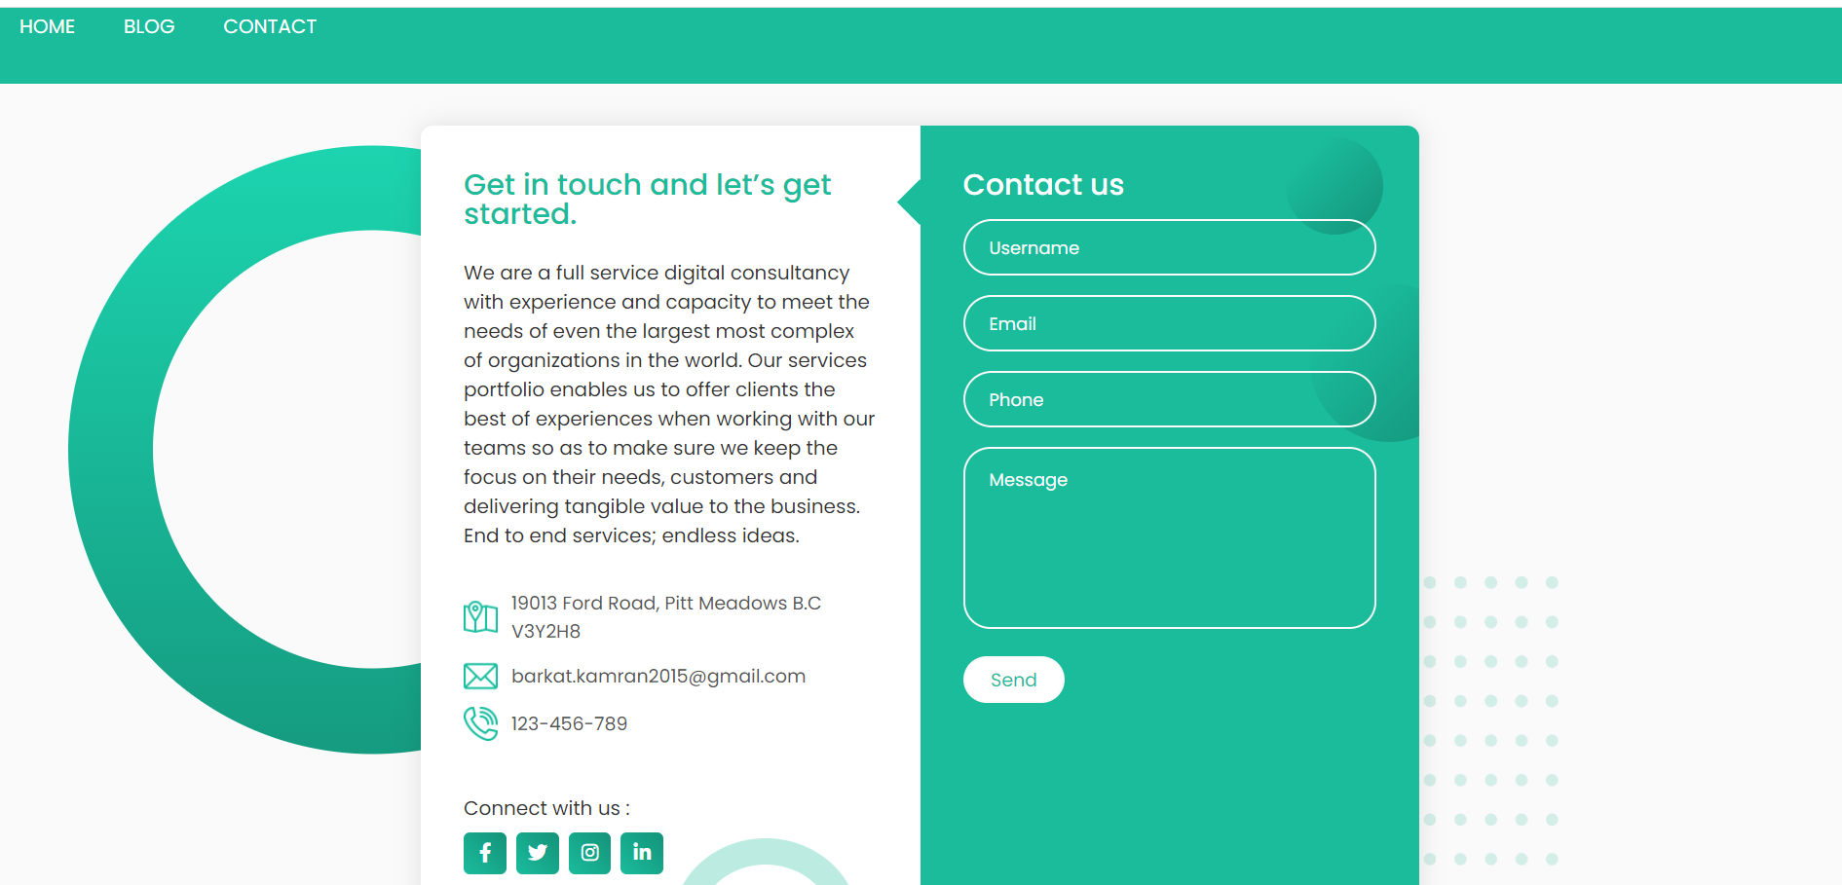

# In conclusion

Designing and building this website happened with HTML, CSS, JavaScript and Bootstrap. All the files will be submitted with source codes.