Finding_Insights_Visually_20260413a

Finding Insights Visually
Now with the dashboard completed, you should be able to use it to analyze SpaceX launch data, and answer the following questions:

- Which site has the largest successful launches? KSC LC-39A

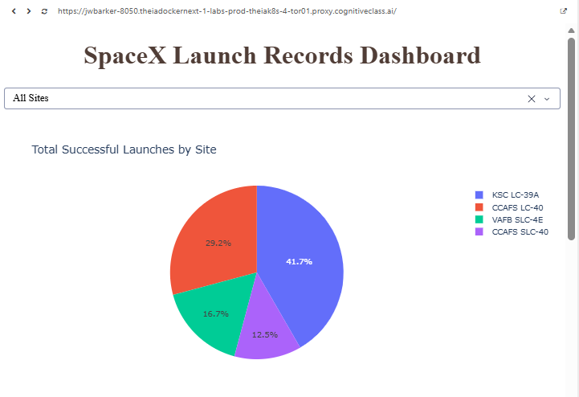

- Which site has the highest launch success rate? VAFB SLC-4E

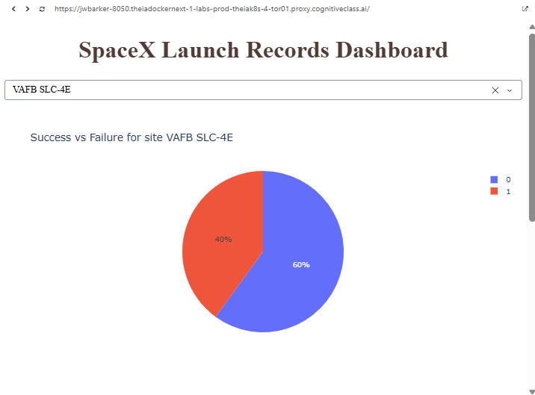

- Which payload range(s) has the highest launch success rate? 0 – 2000 Kg

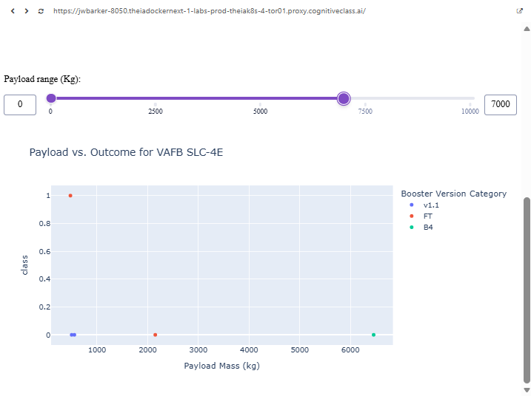

- Which payload range(s) has the lowest launch success rate? 8000 – 10000 Kg

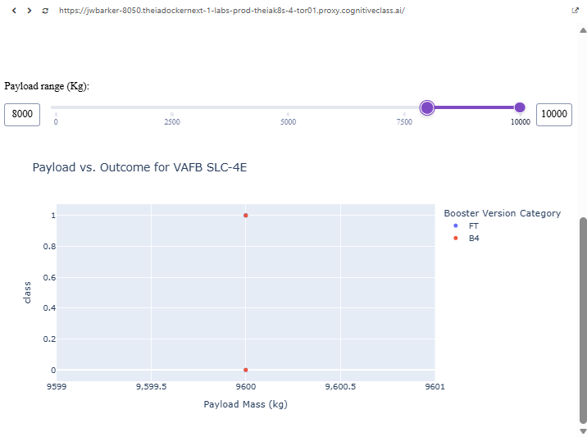

- Which F9 Booster version (v1.0, v1.1, FT, B4, B5, etc.) has the highest launch success rate? FT

