**11/09**

Show rmse before and after correction

Ridge plots for metashape shows the pixels are showing central tendency

Center and scale before the correction

Show thresholds filtering corrected data

Show mean temp between years ( we have air temp for thse days so we can show that relationship)

Wed have ridge plot (central tendency of corrected data) and rmse (uncorrected cooler tests, and corrected with oct 2023)

**11/15**

Next week look at multitemporal , comparing corrected data for 2019 pre and 2021 post-fire

Concerned with bimodal points, thought these might be in areas that were captured on consecutive days for the aug 19 flights (they are not, and I have filtered out that portion of the site)

Individually validate images to see if the different day was influencing pix value. There is no evidence of this but likely that mixing w/ land or other non-water features (in-stream woody material)

**How we calc mean absolute error**

When examining blending modes (avg, mos, dis) we first calculate mean of temps from individual orthorectified photos at each of the 100 randomly sampled points, then we take the absolute difference between the blended value (mosaic, weight, or disabled) and this value. Finally, we summarize by calculating the mean. This approach provides a more representative spread of the actual differences

MAE as follows (n = 100):

|  |  |
| --- | --- |
| Blending Mode | MAE |
| Mosaic | 1.67 |
| Weighted Average | 1.40 |
| Disabled | 2.25 |

To Do:

~~Correct wetted cells temperature imagery using the four cooler tests data~~

~~Center and scale~~

~~Find and download data from FALCON~~

Ensure methods are up to date and you are using correct datasets, catalog paths to all necessary data and scripts

~~Transform the masked orthos using 2.98 +0.92x (this is the linear model from all 4 cooler tests data)~~

Before correcting 2018 I reclassified temps <12 as NA (max temp = ~ 38C)

4 cooler analysis tests were used to generate the correction, script at: "D:\thermal_test20231010\cooler_analysis20231010.R"

Correction script at: " Box\thermal_projects\sfork\tir_raster_correction.R"

**11/21/2023**

Temperature ranges for wetted areas

|  |  |  |  |  |
| --- | --- | --- | --- | --- |
| Dataset | Uncorrected Temperature Range | Corrected Temperature Range | Mean Temperature (C) | Standard Deviation |
| 8/22/2009 | 16.9 – 23.4 | 16.9 – 23.4 (NA) | 17.5 | 0.29 |
| 8/26/2019 | 12.0 – 38.4 | 14.1 – 38.4 | 19.2 | 1.70* |
| 7/15/2021 | 16.0 – 34.0 | 17.7 – 34.3 | 19.9 | 1.00 |

* Denotes maximum standard deviation and value used as scaling factor when creating centered and scaled rasters

Note: values above are calculated on wetted cells for associated years (i.e., these are not necessarily cells shared between all three datasets).

~~Center and scaling script at: box/thermal_projects/sfork/ScaleThermal.R~~

Updated center and scaling script at: " Box\thermal_projects\sfork\scaleThermal20231121.R"

To do ridge plots:

For ridge plot points, there are some points with temps > 40 or < 10 these should be recoded to noData and drop the points as it was an issue with the sensor (8/26/2019 data only)

Blending modes (from https://www.agisoft.com/downloads/user-manuals/)

Mosaic - implies two-step approach: it does blending of low frequency component for overlapping

images to avoid seamline problem (weighted average, weight being dependent on a number of

parameters including proximity of the pixel in question to the center of the image), while high

frequency component, that is in charge of picture details, is taken from a single image - the one that

presents good resolution for the area of interest while the camera view is almost along the normal to

the reconstructed surface in that point. **I think this combines disabled and weighted average, where it uses weighted average in low frequency areas to blend along seamlines**

Disabled - the image to take the color value for the pixel from is chosen like the one for the high

frequency component in mosaic mode.

Average - uses the weighted average value of all pixels from individual photos, the weight being

dependent on the same parameters that are considered for high frequency component in mosaic mode.

High frequency component = represents good resolution for the area of

interest while the camera view is almost along the normal to the reconstructed surface in that point.

**11/22 & 11/26 Multi temporal comparisons**

Report MAD, results of ks test, results of wilcox, est diff in means from t-test, violin plots

Do these comparisons using points sampled in intersecting wetted areas extracting vals from corrected rasters (except 2009 as this was corrected by watershed sciences)

Generated two sets of 100 random points in overlapping areas (one set for 09 and 19, one set for 19 and 21, then extracted temperatures from corrected rasters at those points)

Table for 09-19 points at C:\\Users\\barkmatt\\Box\\thermal_projects\\sfork\\tables_figures\\rand_points0919new.csv

Table for 19-21 points at

D:\\smfr_08272019\\tables\\randPts1921.csv (to do: back up to box)

Code for prePost restore comparison: Box\thermal_projects\sfork\prePostRestore_20231122.R

**2009 and 2019** (pre and post-restoration condition, 2019 raster was corrected, 2009 was adjusted to 2019 by subtracting 0.95 from 2009 raster)

MAD 2009 = 0.22

MAD 2019 = 0.53 (smaller deviation compared to other 2019 sample as this is confined to main stem)

KS Test (paired) = p < 0.001, D = 0.99

Wilcoxon (paired) = p <0.001, V = 0

t-test (paired) probably ok because large – ish sample size (central limit theorem) = p < 0.001, est. mean 2.15 warmer for 2019 (2.03 – 2.28 95CI)

Code for prePost fire comparison: Box\thermal_projects\sfork\prePostFire_20231122.R

**2019 and 2021** (pre and post fire condition) (performed on corrected rasters, adjusted to 2019, subtract 1.15 from 2021)

MAD 2019 = 0.72

MAD 2021 = 0.83

KS Test (paired) = p 0.47, D = 0.12

Wilcoxon (paired) = p = 0.01, V = 3302

t-test (paired) = p = 0.01, 2019 estimated 0.37 warmer (0.10 – 0.64 95CI)

**11/27**

**Raster Analysis**

Performed following analyses on corrected (2019 & 2021) and gage adjusted rasters (2009 & 2021 adjusted to 2019)

Updated on 1/2/2024: removed top 5% warmest cells from 2019 and 2021, assumed these were potentially pixel mixing or non-wetted cells that were misclassified

Corrected rasters located at:

2009: D:\\sfmr_08272019\\raster_products\\corrected_tir_rasters20231119\\tir20090822_mask.tif then subtract 0.95

2019: D:\\sfmr_08272019\\raster_products\\corrected_tir_rasters20231119\\tir20190826_cor.tif (no adjustment because it is the reference temperature

2021: D:\\sfmr_08272019\\raster_products\\corrected_tir_rasters20231119\\tir20210715_cor.tif then subtract 1.15

Violin plot for all three rasters? Or just report MAD and results of t-tests for the three rasters?

Old plot

Updated plot:

Note: Violin plot built using 10% random sample of non-NA cells as there is a memory overflow issue with the function

MAD 2009: 0.30

MAD 2019: ~~0.88~~ 0.82

MAD 2021: ~~0.81~~ 0.75

Welch Unpaired t-test results:

2019 vs 2009: p <0.001 95 CI 2.36 – 2.37

2019 vs 2021: p < 0.001 95 CI 0.30 – 0.31

Raster statistics

|  |  |  |  |  |
| --- | --- | --- | --- | --- |
| Year | N cells | Min | Max | Mean |
| 2009 | 74632 | 15.95 | 22.45 | 16.52 |
| 2019 | 6339182 | 14.05 | 22.00 | 18.88 |
| 2021 | 2396912 | 16.56 | 20.24 | 18.58 |

Code at: "C:\Users\deadf\Box\thermal_projects\sfork\violin_plot_3years.R"

**Transect analysis 12/9/2023**

Redo the GAM (sample points along transect in wetted area where all three years intersect, do this on the corrected rasters)

Three years intersecting wetted area: E:\sfmr_08272019\wetted_area.gdb\waterInt_allyears

Wetted intersect 2019 and 2021: waterIntersect1921

Transect: D:\sfmr_08272019\wetted_area.gdb\transect20230831

All points: D:\sfmr_08272019\wetted_area.gdb\transect20230831_points

Points in three year intersect wet area: D:\sfmr_08272019\wetted_area.gdb\transect_wet_points20231209

GAM pre-processing – manually drew transect to approximate center of main channel, generated points along transect every 2m. clipped points in intersecting wetted area for the three years (n = 178). Extracted temperatures from corrected and gage adjusted rasters.

New GAM code: " Box\thermal_projects\sfork\GAM_20231209.R"

GAM results

Visualization script at: " Box\thermal_projects\sfork\transectPointViz20231209.R"

Transect figure (termperatures are corrected and gage-adjusted)

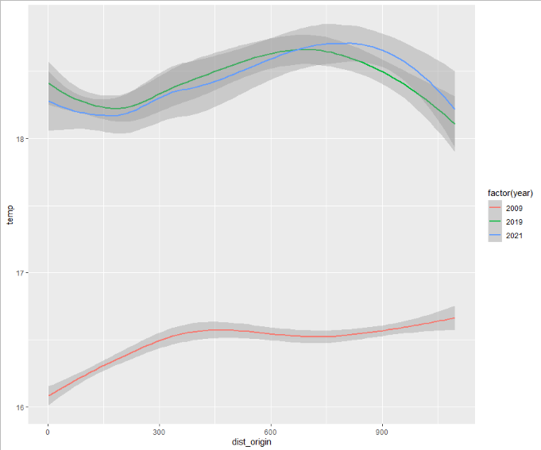

Statistics

|  |  |  |  |  |  |
| --- | --- | --- | --- | --- | --- |
| Year | Min | Max | Mean | Median | MAD |
| 2009 | 16.0 | 17.8 | 16.4 | 16.4 | 0.297 |
| 2019 | 17.6 | 19.9 | 18.4 | 18.3 | 0.458 |
| 2021 | 17.3 | 20.8 | 18.4 | 18.2 | 0.643 |

To Do for 12/20:

Habitat suitability

Calculate area and percent of wetted area in ideal temperature range for chinook salmon (14-22 C, find a citation)

To do for new year

Add an additional thermal threshold to be more certain of water cells (what is the upper limit)

Or drop the warmest ~5%

Map overlaid with the temp contours for absolute temperature (lm corrected and gage adjusted) and the gridded MAD (centered and scaled)

Example of how to do contours at : "C:\Users\deadf\imageprocessing\batch_undistort_thermal.ipynb"

Illustrates temperature suitability with abs temp and medians

**MISC**

**Canopy change figure (one figure with the three canopy conditions and their relative % cover)**

Canopy rasters at: "D:\sfmr_08272019\canopy_cov19.tif" & "D:\sfmr_08272019\canopy_cov21.tif"

**They will need to be clipped to the wetted area buffer zone….**

2009 wetted area was manually delineated using the thermal (did not do NDWI because we had no NIR, and there was little to no wood in river), then we applied a -1m buffer to remove thermal mixing

Data at: D:\sfmr_08272019\wetted_area.gdb\sforkmain09_Clip and sforkmain09_Clip_Buffer

Methods and results cleaned up by new year, intro

1/3

By 1/17 finish results and methods so we can tee up for discussion,

Drop in figures for cooler tests and final model used to calibrate flights

Create figure for visible wetted area and overlaid transect

Remove top 1 and bottom 1% of temps from all years (maybe top and bottom 5)

Recalc the raster stats and rerun t-test with these data removed

Double check statistics for the transect

Thermal contours with arc

Centered and scaled figure as well as calc area for potential habitat

Get relative humidity for flight dates