**Terrorism Analysis with Insights**

1. **Introduction**:

This project comprises both Map tool and Chart tool which consists of World data and also India data.

The Python script can be run from the command line which will open a new page in the browser with a decent and usable interface.

This web page can be closed by an option which kills/stops the script from running in the background.

The User Interface has a Map Tool to generate a Scatter Geo Map with markers for highlighting the latitude/longitude where the incident is based on combinations of Month, Day, Attack Type, Region, Country, State, and City.

We can select any Day and Month based on that Day and Month.

We can filter the 9 types of attacks from the dropdown and another filter would be for Region, Country, State, and City.

The Hovering and clicking of the mouse display some information.

There is a range slider for selecting the range of years.

Another User Interface has a Chart Tool to show Stacked Line Chart images of the frequency of terrorist incidents each year.

We would be able to Group first by Country Attacked, Region, Target, Nationality, Target Type, Type of Attack, Weapon Type, Terrorist Organisation.

We would be able to search any group based on the search box.

The range slider is also included in this for selecting a range of years.

The Hovering of the mouse displays the year and counts the data shown.

2. **Related Work:**

The Project related to the python library called Dash. In this Dash there are lots of classes in it. It includes like dash core components that the there are lots of components which includes Inputs, Text Areas, Checkboxes, Graph etc. and there are dash html components which consists of Div, Header, Area etc.. So basically i worked with Plotly along with the dash.

3. **My Work**:

In this Project Terrorist Analysis with Insights I basically worked with the plotly.express to display the maps and charts and also the ui consist of lots of dash_core_components like dropdowns, Range Slider which shows the year of 1970 to 2018. I also used some Inputs from dash core components and i have used lots of callbacks to meet our expectation. The call back is the one where the ui can change my clicking some functions in my ui. Then, I have used some dash_html_components like H1 where it gives the heading of my ui and Br, Hr etc. I have researched a lot and worked hard and finally did the project .So, that’s all about my work.

4. **Implementations**:

The screenshots of the implemented project are given below; there are a total of 14 screenshots

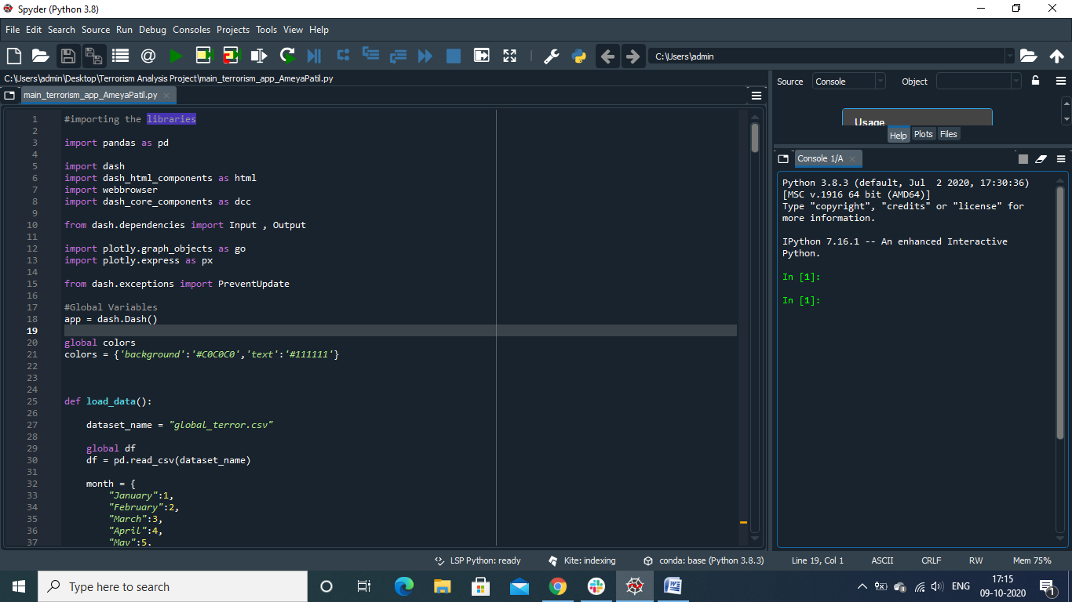

Fig.1

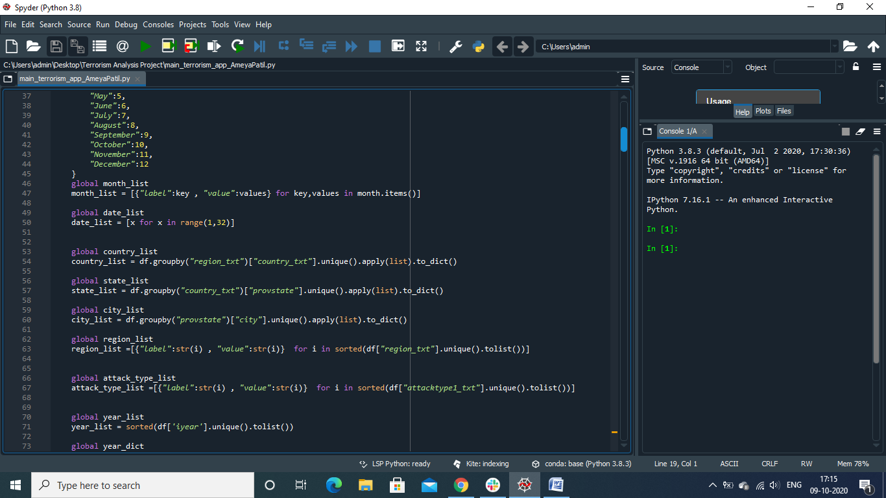

Fig.2

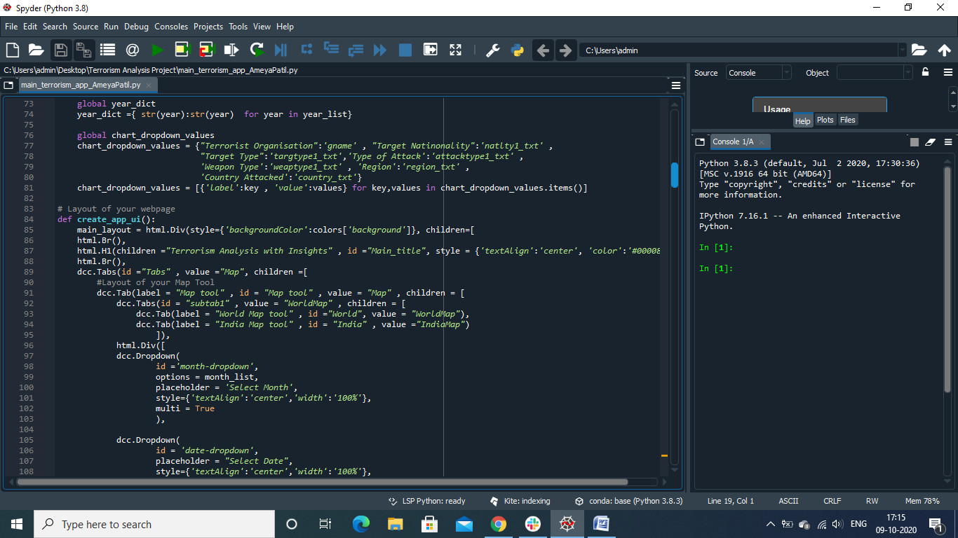

Fig.3

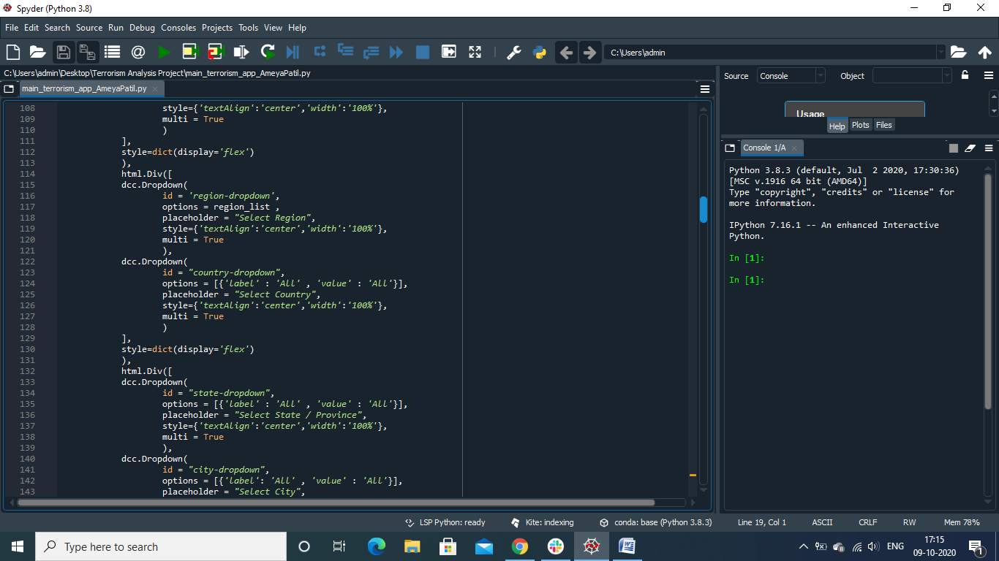

Fig.4

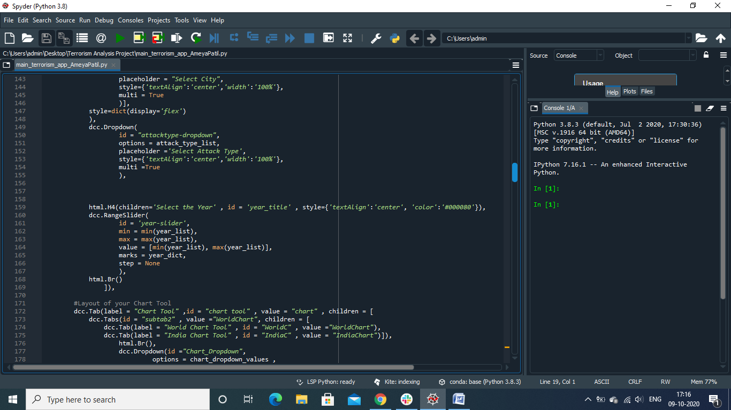

Fig.5

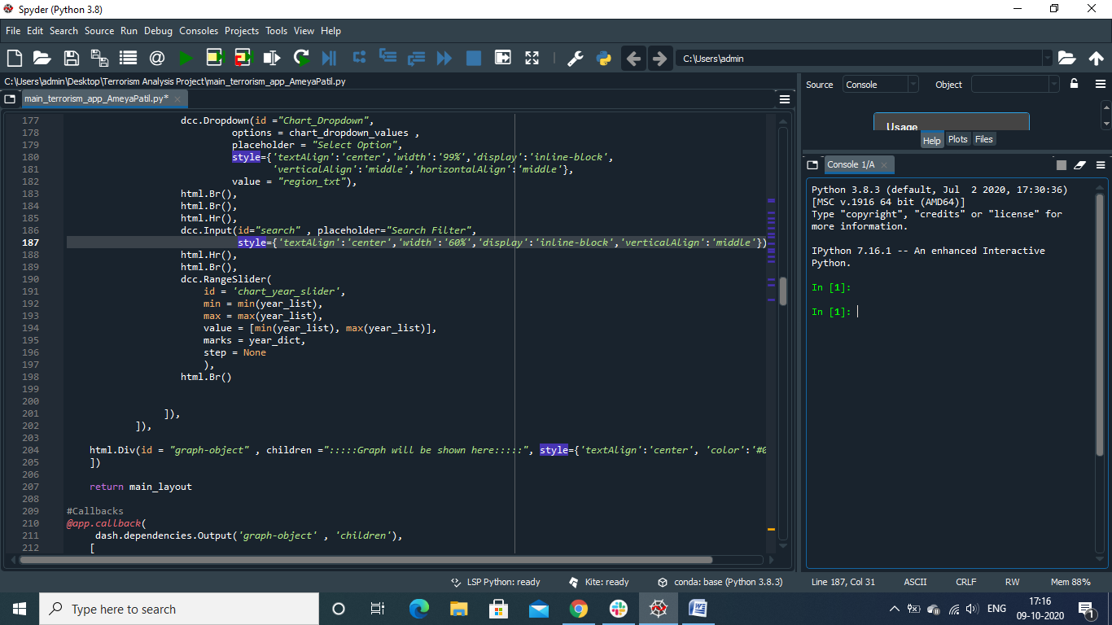

Fig.6

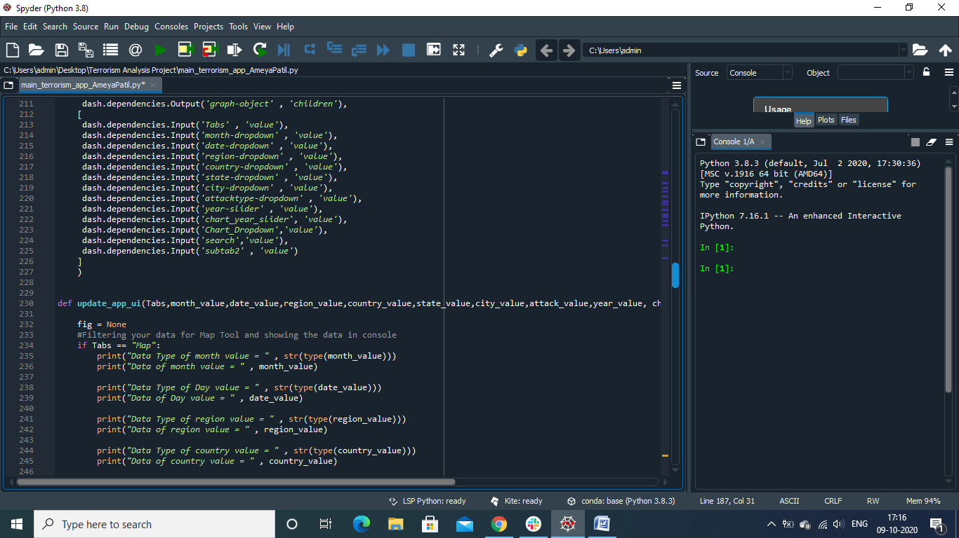

Fig.7

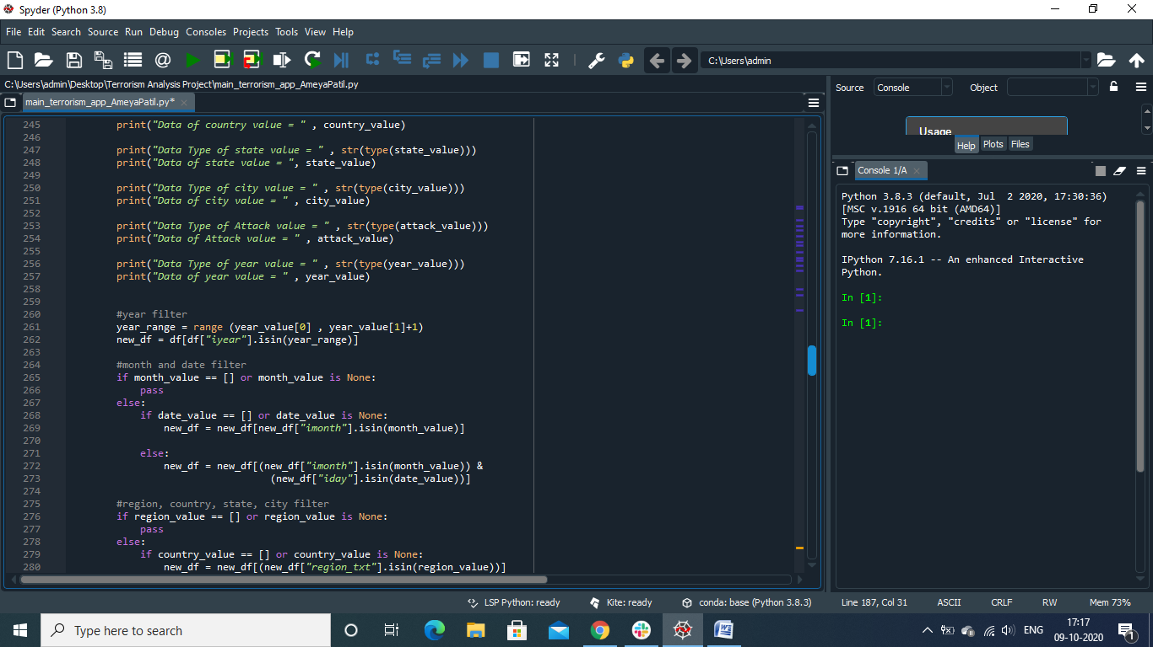

Fig.8

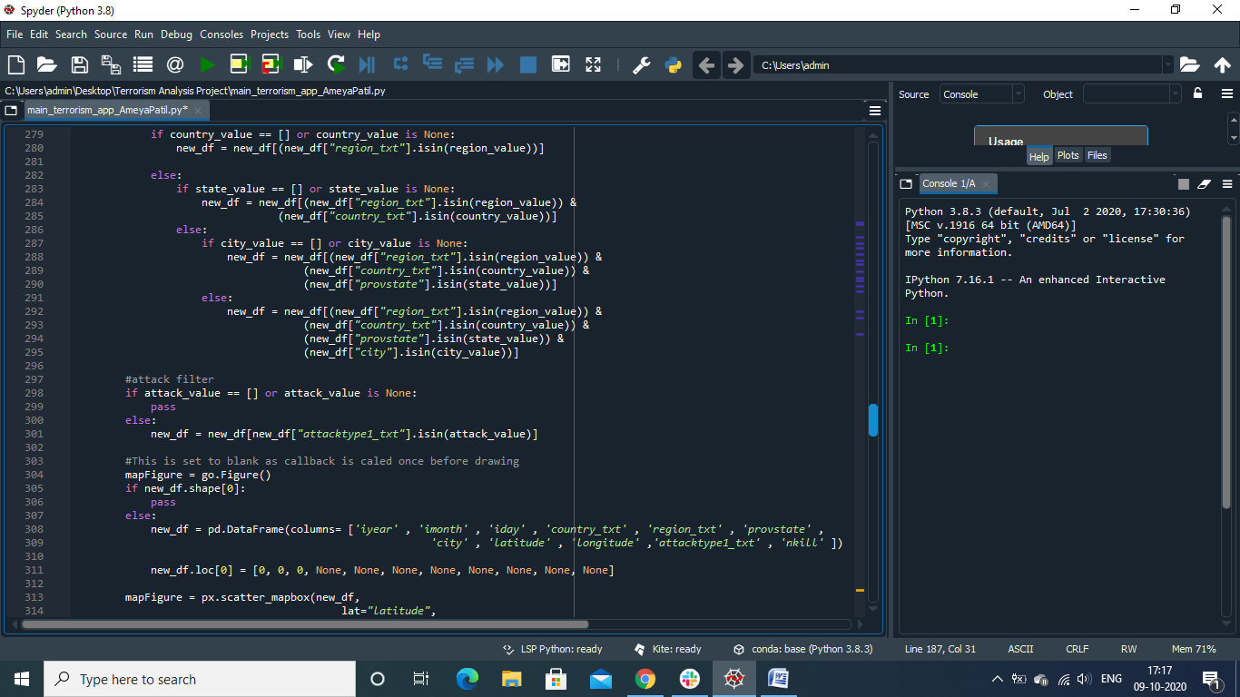

Fig.9

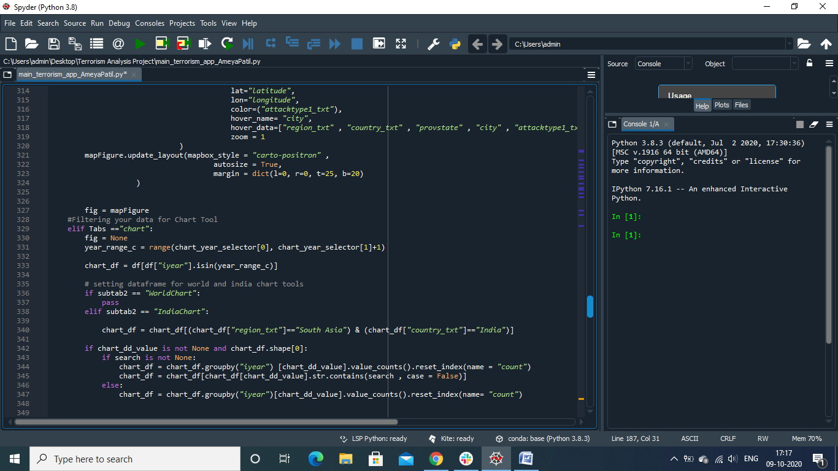

Fig.10

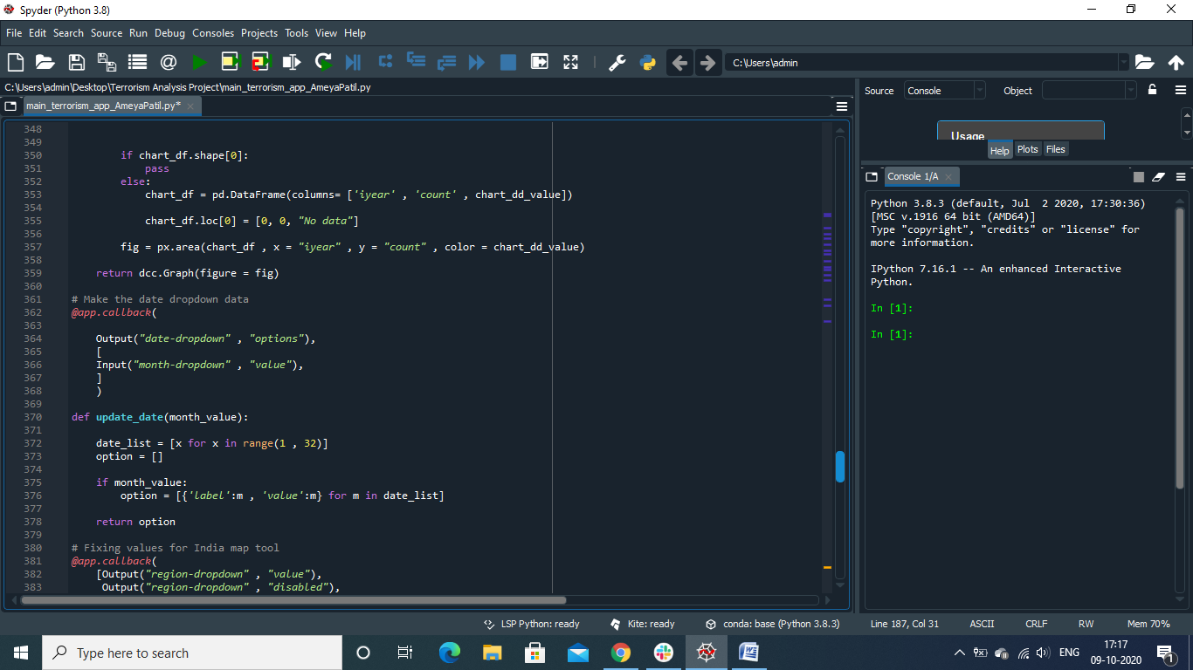

Fig.11

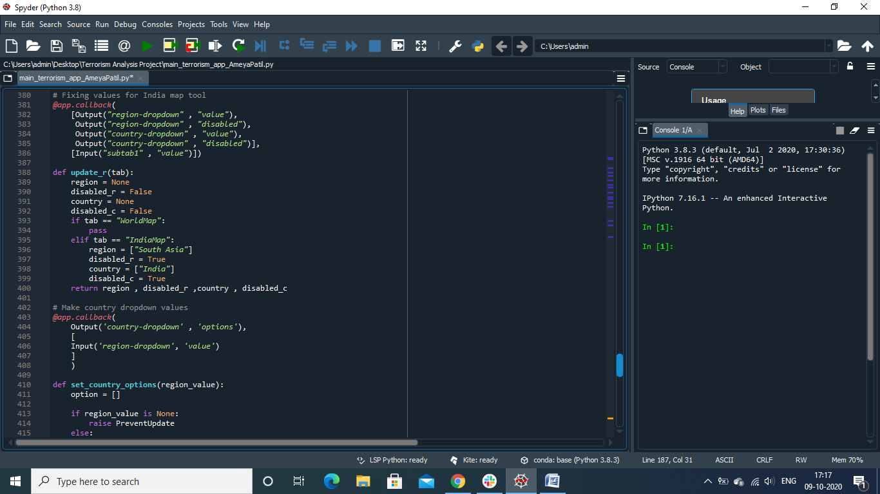

Fig.12

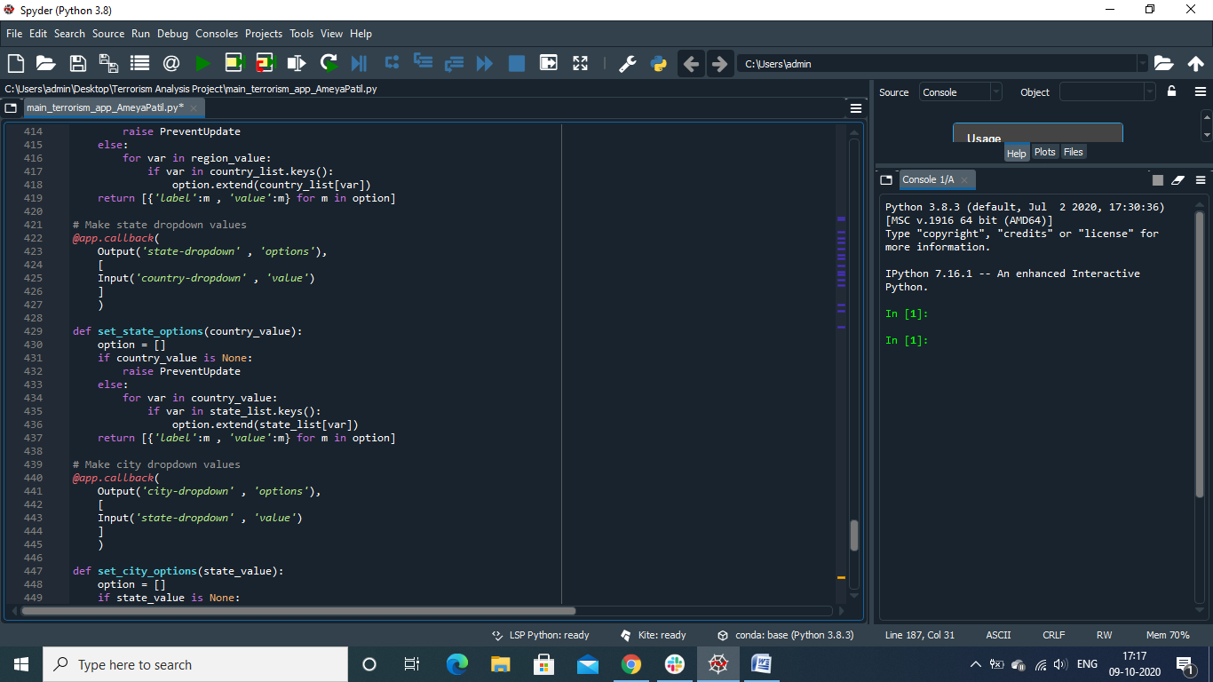

Fig.13

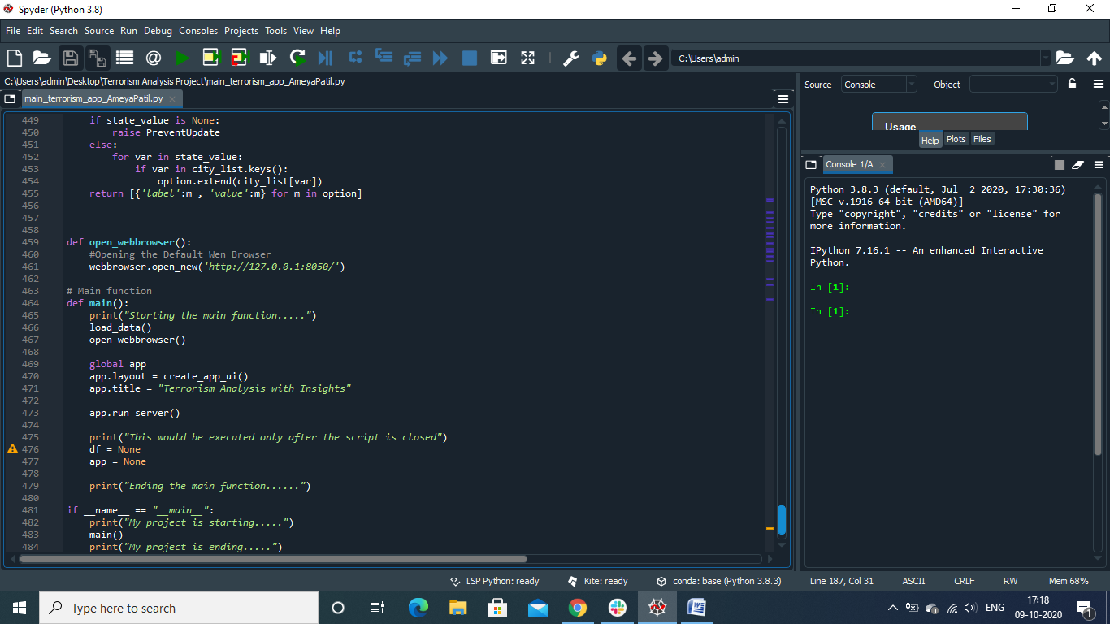

Fig.14

5. **Results**:

After implementing the above code the output screenshot is displayed below:

**THESE 4 ARE DEFAULT WITHOUT ANY INPUTS**

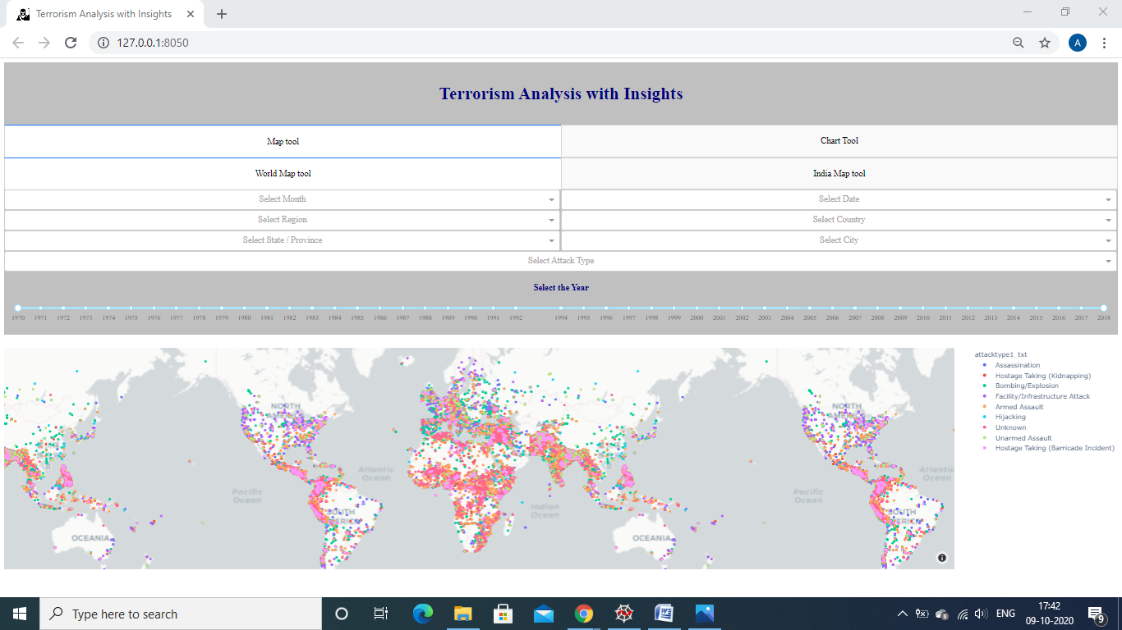

Fig.15

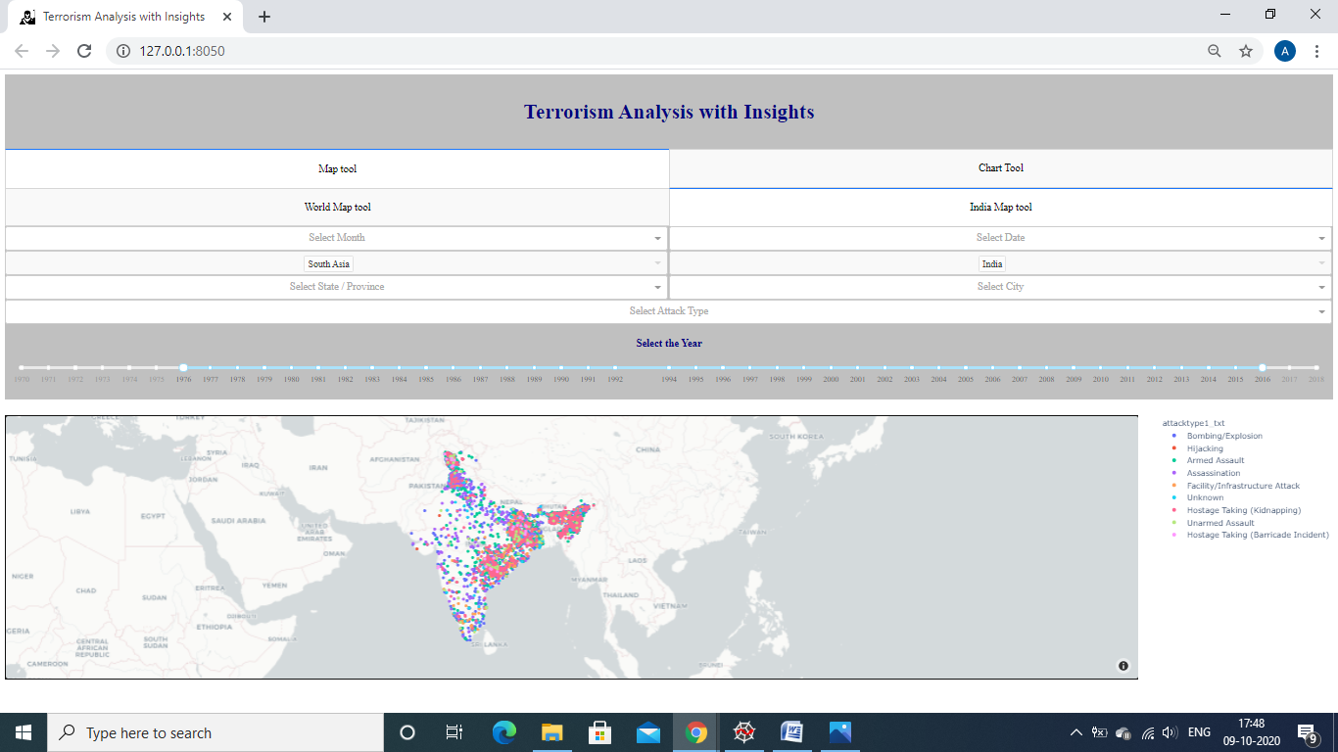

Fig.16

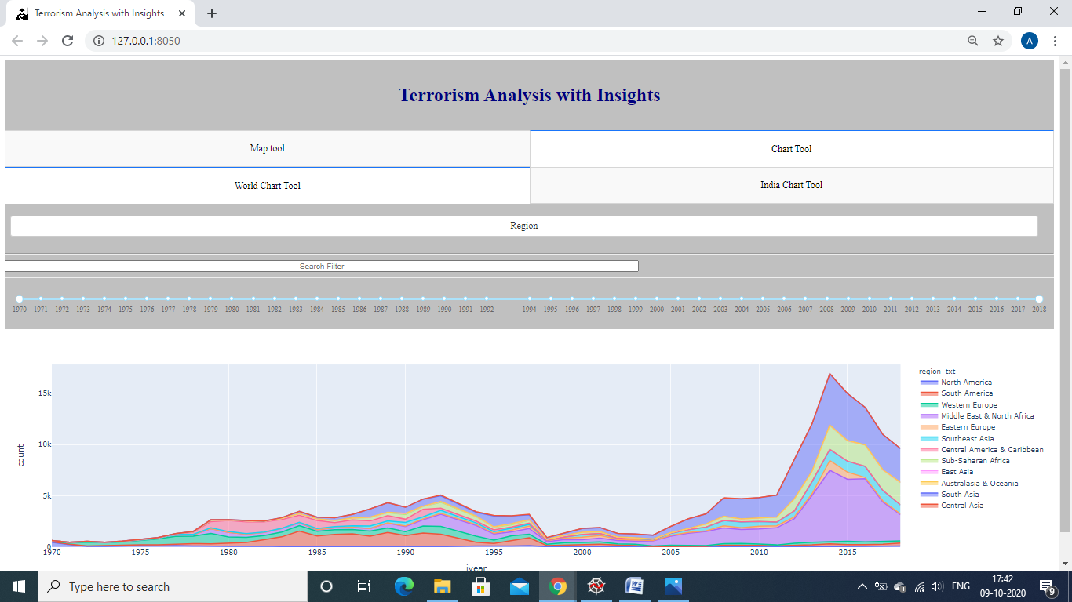

Fig.17

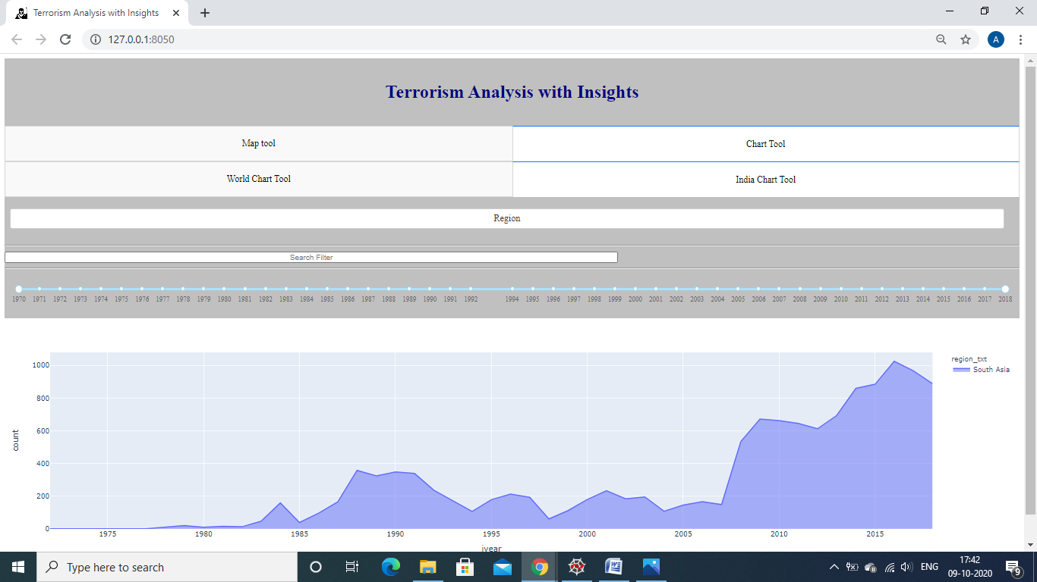

Fig.18

THESE NEXT ARE WITH SOME INPUTS IN THEM

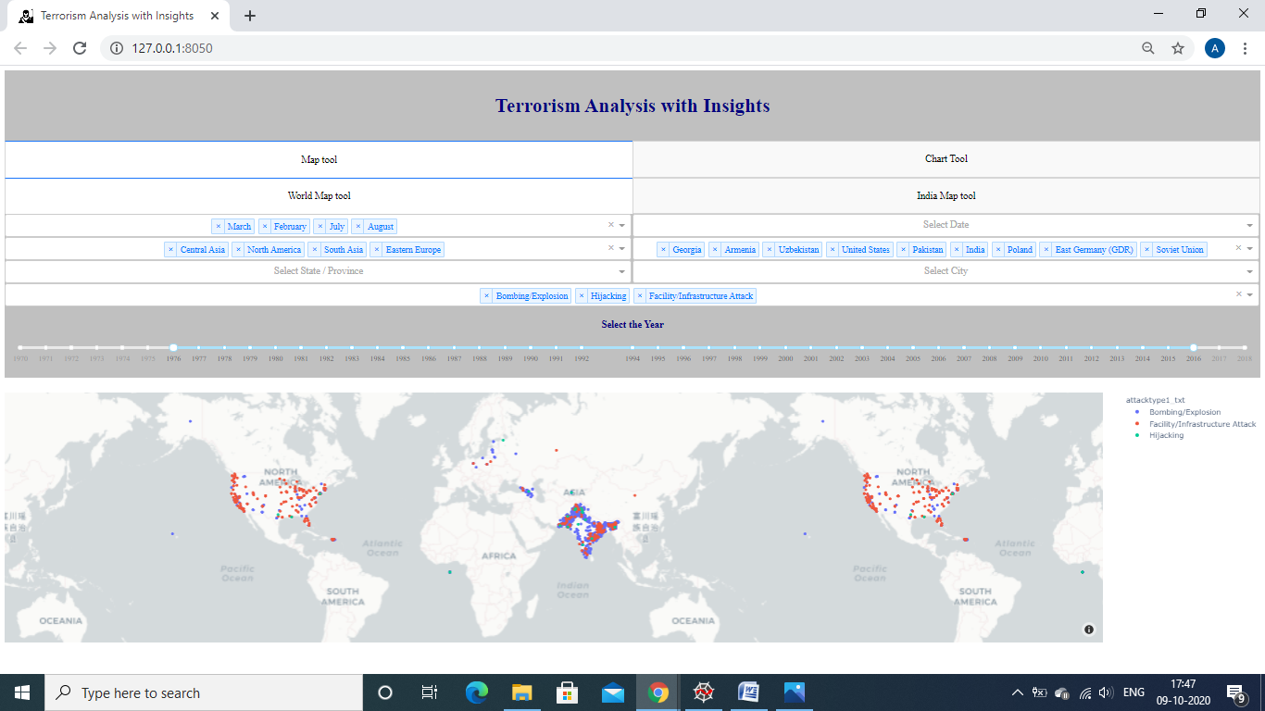

Fig.19

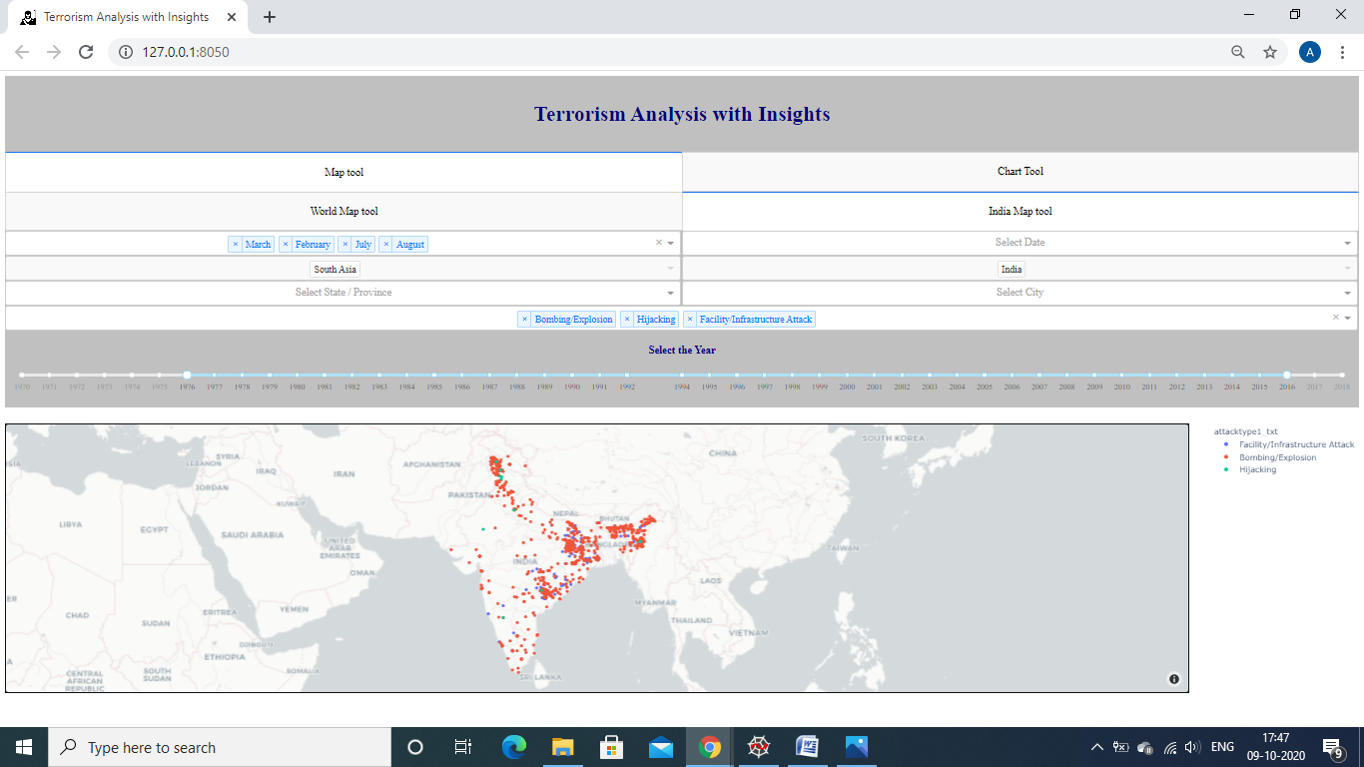

Fig.20

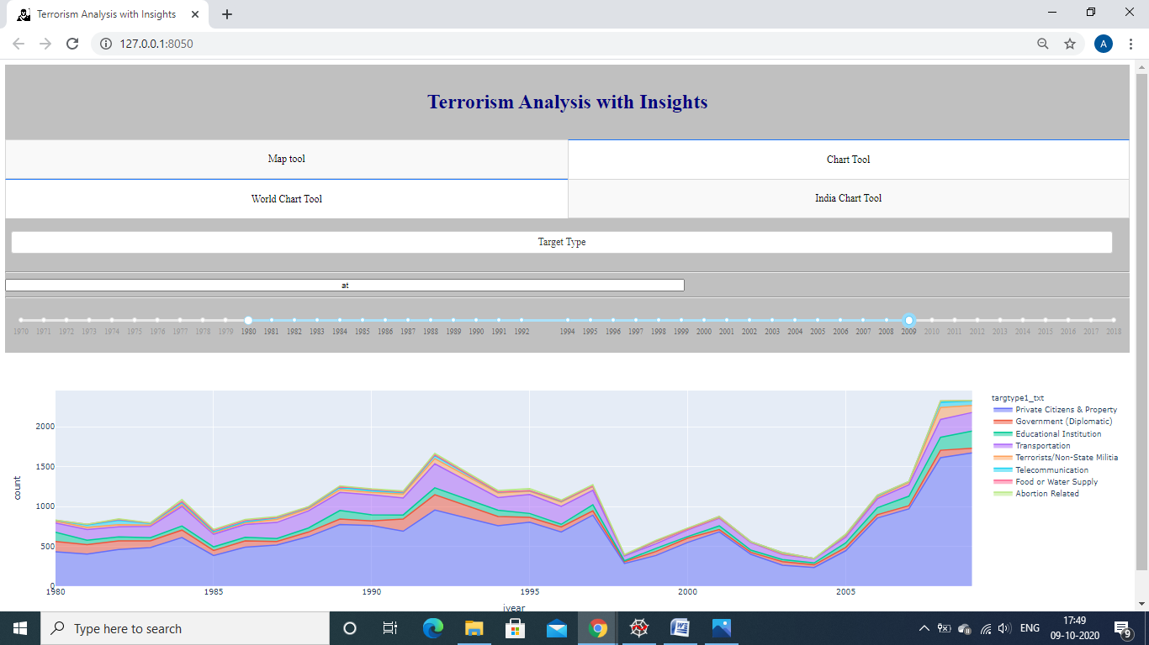

Fig.21

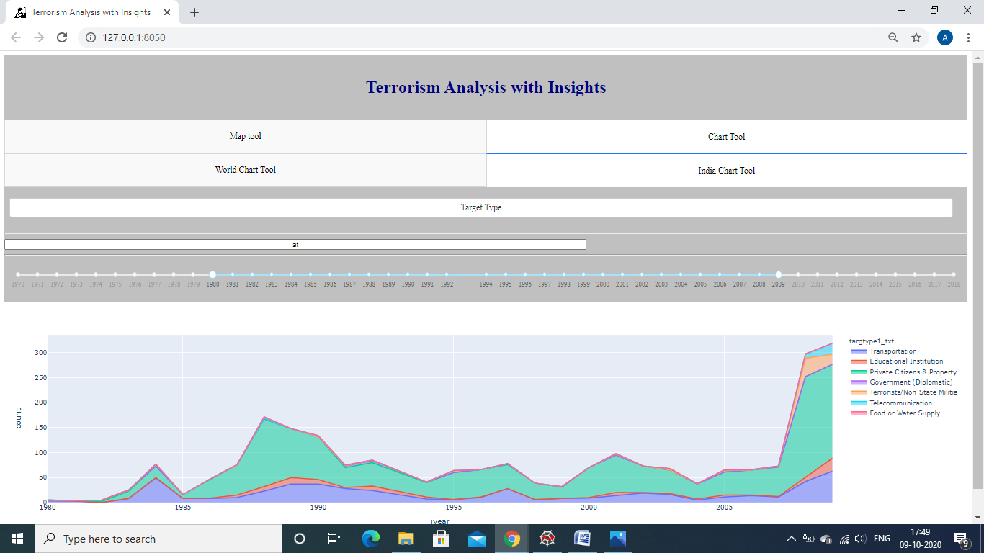

Fig.22

6. **Software Improvements**:

There are lots of improvements in this project. As the we can select any option from the dropdowns like Region, Country, State, and City. All these 4 dropdowns are interlinked to each other (i.e. Region filters the Country and so on), so if anyone is not selected the remaining will not show up any values. Similarly the Month and Date dropdowns are interlinked to each other, so if the month is not selected then the dates will not show up.

7. **Conclusion and Future Works**:

The conclusion of the project “Terrorism Analysis with Insights” is that it meets all our requirements and is ready to be used.

Future work includes using JAVASCRIPT and CSS for improving the user interface for making the web page look better.

9. **References**

* <https://www.youtube.com/watch?v=Ma8tS4p27JI&list=PLH6mU1kedUy8fCzkTTJlwsf2EnV_UvOV-&index=1>
* <https://dash.plotly.com>
* <https://dash.plotly.com/layout>
* Stack overflow
* <https://community.plotly.com/>

10. **Biography**:

Myself Barkha Verma pursuing BTECH in stream of Computer Science and engineering (Data Science) third year at Poornima University, Jaipur. My skills C, Python, MYSQL, R programming, Machine learning, deep learning.

My Kaggle profile: <https://www.kaggle.com/barkhaverma>

My Github profile: <https://github.com/barkha000>