Symbiosis Institute of Technology, Nagpur
Bachelor of Technology
in
Computer Science and Engineering
“PREDICTING SMARTPHONE PRICE AND PRICE TIER FROM HARDWARE SPECIFICATIONS USING MACHINE LEARNING”
Submitted by
Barkha Sahu
PRN: 23070521038
Semester: VII | Section: A
Course: Predictive Analytics
Guide
Dr. Deepak Asudani
Assistant Professor
October 2026

Symbiosis International (Deemed University),
Pune


DECLARATION
I hereby declare that the project report entitled “Predicting Smartphone Price and Price Tier from Hardware Specifications Using Machine Learning” is an original record of the work carried out by me as part of the Predictive Analytics course at Symbiosis Institute of Technology, Nagpur, towards the partial fulfilment of the requirements for the Bachelor of Technology degree in Computer Science and Engineering.
The project involves the analysis of three smartphone datasets (Mobiles Dataset 2025, Final Mobile Dataset and Smartphones v4), the implementation and evaluation of Random Forest and Gradient Boosting models for price-tier classification and price regression, and the interpretation of the results. The work has been carried out under the guidance of the concerned faculty member.
I further declare that the information, research papers, datasets and other sources used in preparing this report have been appropriately acknowledged through citations and references. To the best of my knowledge, this report has not been submitted, in whole or in part, to any other institution for the award of a degree or academic qualification.
I understand that I am responsible for the accuracy and integrity of the work presented in this report.
Name of Student: Barkha Sahu
PRN: 23070521038
Section: A
Course: Predictive Analytics
Institution: Symbiosis Institute of Technology, Nagpur
Date: October 2026

ACKNOWLEDGEMENT
I would like to express my sincere gratitude to Symbiosis Institute of Technology, Nagpur, for providing me with the opportunity and academic environment to undertake this Predictive Analytics project titled “Predicting Smartphone Price and Price Tier from Hardware Specifications Using Machine Learning.”
I am deeply grateful to my project guide, Dr. Deepak Asudani, Assistant Professor, for his valuable guidance, encouragement and academic support throughout the project. His guidance helped me develop a better understanding of the research process, data analysis, machine learning techniques and scientific reporting.
I would also like to thank the faculty members of the Department of Computer Science and Engineering for their teaching and support, which contributed to my learning and development throughout this work.
I acknowledge the creators and maintainers of the smartphone datasets used in this project for making the data available for study. I am also thankful to the researchers whose publications helped me understand hedonic pricing, ensemble learning and model evaluation.
I extend my appreciation to the developers and maintainers of the open-source tools used in this project, particularly Python, pandas, NumPy, SciPy, Matplotlib, Seaborn and scikit-learn, which supported data preprocessing, exploratory analysis, model development and evaluation.
Finally, I am grateful to my family and friends for their constant encouragement, patience and support throughout the completion of this project.

ABSTRACT
Smartphone prices vary enormously, from under ₹6,000 to over ₹250,000, and depend on hardware, brand and positioning. This project investigates how well the price tier and the price of a smartphone can be predicted from its hardware specifications alone, using Random Forest and Gradient Boosting within a leakage-safe Knowledge Discovery in Databases (KDD) workflow.
Three datasets were analysed independently: the Mobiles Dataset 2025 (915 unique phones, USD prices), the Final Mobile Dataset (1,049 unique phones, INR prices) and Smartphones v4 (858 phones, INR prices). The work covers data auditing and repair (duplicates, inconsistent brand labels, corrupted RAM and storage codes), parsing of text specifications into numeric features, feature engineering, exploratory analysis, statistical testing (Spearman, Kruskal-Wallis, chi-square with Cramér’s V), cross-validated tuning, evaluation on untouched test sets, calibration, permutation importance, partial dependence, error analysis and a sensitivity analysis.
For price-tier classification into Budget, Mid-Range and Premium, both models reached about 83.6% accuracy on the USD dataset (macro-F1 0.841 for Random Forest and 0.839 for Gradient Boosting) and 81.0% and 80.0% on the INR dataset, with macro ROC-AUC between 0.94 and 0.97. About 98% of errors were one tier away from the true tier, and the Mid-Range tier was the hardest. Statistical tests showed the two classifiers to be practically equivalent. For regression of the actual price, tuned Gradient Boosting achieved a mean absolute error of ₹3,887, MAPE of 10.8% and R² of 0.941, clearly better than Random Forest (₹5,537 and 0.879). RAM and storage were the strongest price signals, and engineered ratios such as battery per inch added measurable information.
The findings support market segmentation and value-for-money analysis, but the models describe launch prices in the datasets studied and require validation on new data before any commercial use.
Keywords: smartphone price prediction, price tier classification, Random Forest, Gradient Boosting, feature engineering, KDD, cross-validation.

TABLE OF CONTENTS

CHAPTER 1: INTRODUCTION

1.1 Introduction
The smartphone is one of the most widely sold consumer electronics products, and the market spans an extremely wide price range. In the datasets analysed in this project, launch prices run from about ₹5,700 to ₹260,000 in India and from $79 to almost $40,000 in the global dataset. A phone’s price is shaped by a combination of hardware (memory, storage, display, battery, cameras and processor), software, brand positioning, launch timing and marketing. Buyers, retailers and manufacturers all benefit from understanding how much of the price can be explained by the hardware specification alone [1].
Predictive analytics provides a systematic way to study this question. A supervised machine learning model is given the specifications of many phones with known prices and learns the relationship between the specifications and the price. The trained model can then estimate the price, or the price band, of a phone that it has not seen before. Two forms of the problem are studied here: classification, in which a phone is assigned to a price tier (Budget, Mid-Range, Premium), and regression, in which the actual price in rupees is estimated.
The project, titled Predicting Smartphone Price and Price Tier from Hardware Specifications Using Machine Learning, follows the Knowledge Discovery in Databases (KDD) process of selection, pre-processing, transformation, data mining and evaluation [5]. It uses three smartphone datasets, analysed separately in three Jupyter/Colab notebooks, and compares two tree-ensemble algorithms: Random Forest (a bagging ensemble) and Gradient Boosting (a sequential boosting ensemble) [2], [3].
The study is an academic predictive-analytics investigation. Its purpose is to evaluate machine learning methods on the selected data, interpret the recorded results honestly, and identify limitations. It is not a commercial pricing engine.

1.2 Background and Motivation
Economists have long modelled the price of a differentiated product as the sum of the implicit prices of its characteristics, an approach known as hedonic pricing [1]. For smartphones the characteristics are measurable: RAM, internal storage, battery capacity, display size and panel type, camera megapixels, processor family and operating system. Machine learning extends this idea by allowing non-linear effects and interactions between characteristics to be learned automatically from data instead of being specified by hand [6].
Three practical motivations drive the project. First, price benchmarking: if a model can estimate the price expected from a specification, then a phone priced far below or above that estimate can be flagged as good value or as carrying a brand premium. Second, market segmentation: assigning phones to tiers helps retailers and analysts compare like with like. Third, methodological care: smartphone datasets collected from web sources contain encoding errors, duplicates, inconsistent brand names and text-formatted numbers, so reliable results depend on careful cleaning, leakage prevention and honest validation.
The three notebooks illustrate different aspects of this work. The first (Mobiles Dataset 2025, USD prices) provides a clean tier-classification baseline; the second (Final Mobile Dataset, INR prices) is a deep KDD study with data-quality repair, statistical testing, calibration and robustness analysis; and the third (Smartphones v4, INR prices) predicts the price itself and adds a four-segment classifier and a value-for-money analysis.

1.3 Problem Statement
A smartphone’s hardware specification is only a partial description of what a customer pays for. The problem addressed in this project is to determine how well price tier and price can be predicted from hardware specifications alone, which specifications carry the most information, and how Random Forest and Gradient Boosting compare under a leakage-safe evaluation. The central task can be written as learning a function:
ŷ = f(x; θ)
where x is the vector of hardware features, f is the learning algorithm, θ are the parameters learned from training data, and ŷ is the predicted price tier (classification) or price (regression). All price columns are removed from x so that the model cannot read the answer from its inputs.

1.4 Aim and Objectives

1.4.1 Aim
To develop and evaluate Random Forest and Gradient Boosting models that predict smartphone price tier and price from hardware specifications, using three smartphone datasets and a leakage-safe KDD workflow, and to interpret what the models learn and where they fail.

1.4.2 Objectives
- To load, audit and clean three smartphone datasets, repairing encoding problems, duplicates and inconsistent labels.
- To convert text-formatted specifications into numeric features and engineer informative ratios.
- To define price tiers from price tertiles (Budget, Mid-Range, Premium) and, in one dataset, four price segments.
- To perform exploratory data analysis and statistical hypothesis testing (Spearman correlation, Kruskal-Wallis, chi-square with Cramér’s V).
- To tune and train Random Forest and Gradient Boosting models using cross-validated search.
- To evaluate classification with accuracy, balanced accuracy, macro precision/recall/F1, ROC-AUC, average precision, MCC, kappa and Brier score, and regression with MAE, RMSE, MAPE and R².
- To interpret the models using impurity importance, permutation importance and partial dependence, and to analyse errors, calibration and robustness.
- To compare the two algorithms statistically and draw conclusions, limitations and directions for future work.

1.5 Research Questions
The following research questions guide the experiments:
RQ1. Can hardware specifications and brand discriminate Budget, Mid-Range and Premium smartphones?
RQ2. Which specifications carry the most information about price tier and price?
RQ3. How do Random Forest and Gradient Boosting compare in accuracy, class-wise errors, calibration and stability when classifying price tiers?
RQ4. How accurately can the actual price be estimated by regression, and which algorithm performs better?
RQ5. Where do the models fail, and are the errors near-misses between adjacent tiers or serious mistakes?
RQ6. How sensitive are the results to data-quality decisions, such as the repair of corrupted RAM values?

1.6 Scope of the Project

1.6.1 Dataset Scope
Three smartphone datasets are used, each processed independently because their columns, currencies and units differ:
- Study 1: Mobiles Dataset 2025. 930 raw rows (915 unique phones) from 18 brands, with launch prices in five currencies. The USD price is used to create the target.
- Study 2: Final Mobile Dataset. 1,056 raw rows (1,049 unique phones) with INR prices, 14 raw columns and 27 harmonised brands.
- Study 3: Smartphones v4. 858 phones with 29 raw columns and INR prices, used for regression and for a four-segment classifier.

1.6.2 Machine Learning Scope
Two supervised algorithms are compared: Random Forest and Gradient Boosting. The project does not propose a new algorithm and does not claim that either is universally optimal.

1.6.3 Limitations and Exclusions
Prices in the datasets are launch prices and are not adjusted for inflation, exchange rates or later discounts. Brand reputation, marketing, launch timing and software features are not available as numeric predictors. The models predict price from specifications; they do not explain why a manufacturer chose a given price. No real-time deployment or external validation on new data was carried out.

1.7 Significance of the Study
The study contributes a transparent comparison of two widely used ensemble methods on three realistic, imperfect datasets. It shows concretely how data repair, feature engineering and validation choices change results; it separates statistical significance from practical importance; and it demonstrates two useful applications of the models: tier prediction for market segmentation and value-for-money detection from the difference between actual and model-predicted price.

1.8 Organization of the Report
Chapter 1: Introduction presents the background, problem, aim, objectives, research questions and scope. Chapter 2: Literature Review describes the theory of price determination, the machine learning algorithms, evaluation metrics, statistical tests and the research gap. Chapter 3: Workflow and Methodology describes the datasets, cleaning, feature engineering, exploratory analysis, target definition, models and validation. Chapter 4: Results and Discussion reports the experimental findings with tables and all project-generated figures. Chapter 5: Conclusion and Future Scope summarises findings against the research questions, limitations and future work. Chapter 6: References lists the cited sources in IEEE style.

CHAPTER 2: LITERATURE REVIEW

2.1 Price Determination and Hedonic Pricing
Rosen’s hedonic pricing model treats a product as a bundle of characteristics, each contributing implicitly to the observed price [1]. Applied to smartphones, RAM, storage, display quality, camera resolution, battery size and processor class are natural characteristics. The approach explains why price and specification are strongly related, but it also shows why specification alone cannot explain everything: brand, design, ecosystem and marketing are valued by customers yet are not captured in a spec sheet.
Two further features of smartphone pricing matter for modelling. The first is discrete, tiered specifications. RAM comes in steps (4, 6, 8, 12, 16 GB), storage in steps (64, 128, 256, 512 GB), and refresh rate in a few values (60, 90, 120, 144 Hz). Many phones therefore share identical values, which creates ties and limits how finely price can be separated. The second is right-skewed prices: a small number of foldables and flagships cost many times the median phone, so averages are pulled upward and log transforms are commonly used.

2.2 Machine Learning for Tabular Price Prediction
Supervised learning on tabular data is dominated by tree-based ensembles, which handle mixed numeric and categorical features, capture non-linear relationships and interactions, and need little feature scaling [6]. Two families are especially popular. Bagging methods such as Random Forest average many decorrelated deep trees to reduce variance [2]. Boosting methods such as Gradient Boosting build shallow trees sequentially, each correcting the errors of the current ensemble, which reduces bias [3]. Optimised boosting libraries such as XGBoost have become standard in applied work [15]. This project uses the scikit-learn implementations [4].
The choice between the two families is empirical. Bagging is robust and needs little tuning; boosting often achieves lower error when carefully tuned but can over-fit noisy data. Comparing both under identical validation is therefore a sensible way to choose a model for a given dataset.

2.3 Classification and Regression Formulations
Price can be modelled as a continuous target (regression) or as an ordered class (classification). Regression gives a rupee estimate but is sensitive to the heavy right tail of the price distribution, so training on log(price) is common. Classification into tiers is more robust to outliers and answers a decision-oriented question (“is this phone Budget, Mid-Range or Premium?”). Tiers defined by tertiles produce three nearly equal classes, which removes class imbalance but makes the tiers relative to the dataset. The middle class is intrinsically the hardest to predict, because it lies between two neighbours and any phone near a cut-off can fall on either side.

2.4 Algorithms Used

2.4.1 Random Forest
A Random Forest builds B decision trees, each on a bootstrap sample of the training data and with a random subset of features considered at every split. For classification the prediction is the majority vote (or the average of tree probabilities) [2]:
ŷ = mode{ T₁(x), T₂(x), … , T_B(x) }
For regression the tree outputs are averaged. Averaging decorrelated trees reduces variance without greatly increasing bias. Key hyper-parameters tuned in this project are the number of trees, maximum depth, minimum samples per leaf and the number of features considered at each split.

2.4.2 Gradient Boosting
Gradient Boosting builds an additive model in stages. At stage m a new shallow tree h_m is fitted to the negative gradient of the loss of the current ensemble and added with a learning rate η [3]:
F_m(x) = F_{m−1}(x) + η · h_m(x)
The tuned hyper-parameters are the number of trees, the learning rate, the tree depth and, in the regression study, the subsampling fraction, minimum leaf size and feature fraction. Smaller learning rates need more trees but often generalise better.

2.5 Evaluation Metrics

2.5.1 Classification Metrics
Accuracy is the fraction of correct predictions. Balanced accuracy averages per-class recall. Precision is TP/(TP+FP), recall is TP/(TP+FN), and F1 is their harmonic mean; macro averages give each class equal weight. The Matthews correlation coefficient (MCC) summarises the whole confusion matrix in one number between −1 and 1 [10]. Quadratic-weighted kappa penalises errors by the squared distance between ordered classes, so a Budget-to-Premium error costs more than a Budget-to-Mid error.
Balanced accuracy = (1/K) Σ_k Recall_k F1 = 2·P·R / (P + R)
ROC-AUC measures how well the model ranks positives above negatives across all thresholds [8]; in the multi-class setting it is computed one-vs-rest and averaged. Average precision (AP), the area under the precision-recall curve, is more informative for the weakest class [9]. The Brier score is the mean squared difference between predicted probabilities and outcomes and measures calibration (lower is better) [11].

2.5.2 Regression Metrics
MAE = (1/n) Σ |yᵢ − ŷᵢ| RMSE = √[(1/n) Σ (yᵢ − ŷᵢ)²]
MAPE = (100/n) Σ |yᵢ − ŷᵢ| / yᵢ R² = 1 − Σ(yᵢ − ŷᵢ)² / Σ(yᵢ − ȳ)²
MAE is the average error in rupees; RMSE penalises large errors more; MAPE expresses error as a percentage of price (useful when prices span a wide range); R² is the fraction of price variance explained. Median absolute error (MedAE) is also reported because it is robust to a few very large flagship errors.

2.6 Statistical Tests Used
- Spearman rank correlation measures monotonic association between a feature and price without assuming linearity.
- Kruskal-Wallis H test compares a numeric feature across the three tiers without assuming normality [7]. Because p-values become tiny with around 1,000 samples, the effect size ε² = H(n+1)/(n²−1) is reported to show practical strength.
- Chi-square test of independence with Cramér’s V measures the association between a categorical feature (brand, processor, panel, operating system) and tier [14].
- Wilcoxon signed-rank test compares paired cross-validation scores of two models [13].
- Exact McNemar test compares two classifiers on the same test phones using only the cases where exactly one is correct [12].

2.7 Data Leakage and Validation
Leakage occurs when information unavailable at prediction time influences training or evaluation. In price prediction the most obvious source is the price itself: the five currency columns in Study 1 are mathematically related to the USD target and must all be removed. Other sources are preprocessing steps fitted on the whole dataset before splitting (for example, imputing or scaling with full-data statistics) and tuning on the test set. The project therefore uses stratified train/test splits, places imputation inside a scikit-learn pipeline in Studies 2 and 3, tunes by cross-validation on the training split only, and reports final numbers on a test set that was never used in tuning [4].

2.8 Research Gap
Many accessible smartphone price studies report a single accuracy figure on one cleaned dataset. Three gaps motivate this project. First, data-quality handling is rarely documented or tested: real files contain corrupted RAM codes, unit errors and duplicate brand labels, and the effect of repairing them is seldom measured. Second, statistical significance is often confused with importance, and impurity-based feature importance is often presented without a permutation check. Third, error structure is rarely analysed: whether mistakes are near-misses or serious, and which brands and price bands are hardest. This project addresses these gaps by comparing two algorithms across three datasets, quantifying the effect of data repair, testing model differences statistically and analysing errors.

2.9 Summary of the Literature Review
Hedonic pricing explains why specifications predict price and why they cannot predict it perfectly. Random Forest and Gradient Boosting are well-established, complementary tree ensembles for tabular data. Rigorous evaluation requires several metrics, leakage prevention, statistical testing and error analysis. The next chapter describes the workflow used to apply these ideas to the three smartphone datasets.

CHAPTER 3: WORKFLOW AND METHODOLOGY

3.1 Overview of the Proposed Workflow
The project follows the Knowledge Discovery in Databases (KDD) process [5]: selection, pre-processing, transformation, exploratory analysis, modelling and evaluation. Three smartphone datasets are processed in three separate notebooks, because their columns, currencies and structure differ. Each notebook uses a fixed random seed (42) so the results can be reproduced.
- Select and load the dataset and document each column.
- Audit data quality: types, missing values, duplicates, inconsistent labels, implausible values.
- Clean and parse text fields into numeric features; engineer ratio features.
- Define the target (price tier or price) and remove every price column from the features.
- Explore the data visually and test the relationship of each feature with the target statistically.
- Split the data (80/20, stratified) and tune Random Forest and Gradient Boosting by cross-validated search on the training part only.
- Evaluate on the untouched test set and by repeated cross-validation.
- Interpret the models, analyse errors and test robustness.

3.2 Dataset Selection and Description
Table 3.1 summarises the three datasets. They are not merged; each is a separate experiment.
Table 3.1: Comparison of the three smartphone datasets
Characteristic | Study 1: Mobiles 2025 | Study 2: Final Mobile Dataset | Study 3: Smartphones v4
Raw size | 930 × 15 | 1,056 × 14 | 858 × 29
Clean phones | 915 | 1,049 | 858
Brands | 18 | 27 (16 groups) | multiple (top 15 shown)
Price currency | USD (5 currencies available) | INR | INR
Price range | $79 to $39,622 | ₹7,689 to ₹189,999 | ₹5,700 to ₹259,999
Target | 3 tiers (tertiles) | 3 tiers (tertiles) | Price (regression) and 4 segments
Features used | 36 | 34 | 30
Train / test | 732 / 183 | 839 / 210 | 686 / 172
Notebook | Mobiles_Price_Tier_Classification | Mobile_Price_Tier_Enhanced_Notebook | smartphone_price_prediction

3.2.1 Study 1: Mobiles Dataset 2025
The raw file has 15 columns: company, model name, weight, RAM, front and back camera, processor, battery capacity, screen size, launched prices in Pakistan, India, China, USA and Dubai, and launch year. Almost every column is text (for example “3,600mAh”, “50MP + 12MP”, “6.1 inches”), so parsing is the main preprocessing task. There were no missing cells and 15 exact duplicate rows.

3.2.2 Study 2: Final Mobile Dataset
The file has 14 columns: processor family, brand, RAM, ROM, battery, display size, display quality (AMOLED or other), refresh rate, rear and front camera MP, Android and iOS flags, OS version and price in INR. Missing values are minimal (9 rows each for rear and front camera MP) but the file has serious encoding problems described in Section 3.3.

3.2.3 Study 3: Smartphones v4
This file has 29 columns including brand, model, price, user rating, connectivity flags (dual SIM, 5G, IR blaster, NFC, eSIM), processor name, cores, clock speed, RAM, internal memory, battery capacity, maximum charging power, screen size, resolution, refresh rate, camera counts and megapixels, operating system and version, and expandable-memory information.

3.3 Data Loading and Quality Assessment

3.3.1 Study 1
The audit found no missing values, 15 duplicate rows (removed, leaving 915 phones) and 18 brands after standardising names (for example “Iqoo” to “iQOO” and “Oneplus” to “OnePlus”). Price columns contain currency symbols and commas and were converted to numbers. The USD price is strongly right-skewed (mean $632, median $449, maximum $39,622).

3.3.2 Study 2
Figure 3.4 summarises the audit. Seven exact duplicates were removed (1,056 to 1,049 rows). The 30 distinct brand labels contained variants of the same manufacturer (“Moto”/“Motorola”, “Galaxy”/“Samsung”, “Acera”/“Acer”, and capitalisation differences), which were harmonised to 27 brands. Two numeric columns were found to be corrupted:
- RAM: 266 phones had RAM stored as 1 and 2 phones as 2. These values are implausible for phones carrying 256 to 1,024 GB of storage, and their median price (₹39,999) was far above that of the 4 GB group (₹11,999). They are most likely truncated “12” or “16” GB values (first digit kept). All 267 were recoded to 12 GB.
- ROM: 15 phones stored “1”, which means 1 TB; these were recoded to 1,024 GB.
Because the RAM repair is an assumption, its effect is tested in a sensitivity analysis (Section 4.3.9).
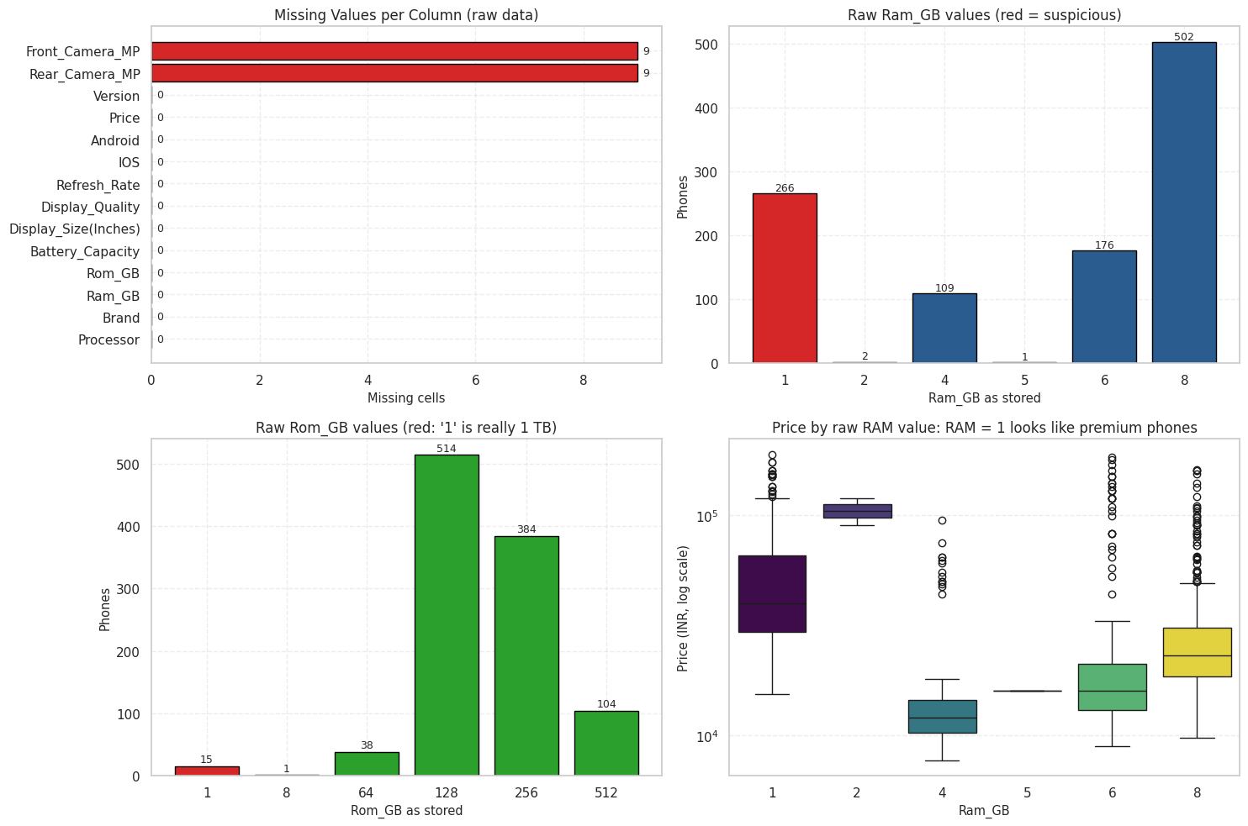
Figure 3.1: Study 2 data-quality overview: missing values per column, RAM value counts, ROM value counts and price by raw RAM value
The top-left panel confirms that only the two camera columns have gaps (9 cells each, 0.85%). The other panels expose the encoding problem: RAM = 1 occurs 266 times and its price box sits far above the 4 GB group, which is impossible for genuine 1 GB phones. This evidence is what justified the repair.

3.3.3 Study 3
The file has 858 phones with no duplicates. The user rating is missing for about 29% of phones and is a post-launch popularity score, so it was excluded from the inputs. The column extend_upto is empty (62.9% missing) when a phone has no card slot and was filled with 0.
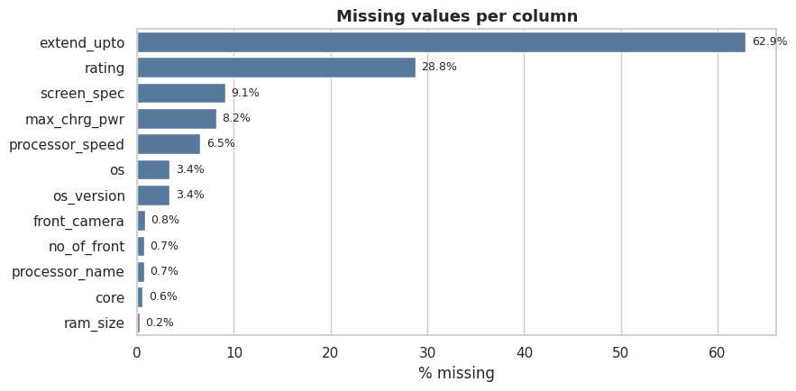
Figure 3.2: Study 3: percentage of missing values per column
The column extend_upto has the largest share missing (62.9%) because it is empty when a phone has no memory-card slot, so it is filled with 0. The rating column is 28.8% missing and is not used as an input. Screen specification (9.1%), maximum charging power (8.2%), processor speed (6.5%) and OS (3.4%) have smaller gaps that are imputed inside the modelling pipeline using training data only.

3.4 Data Preprocessing and Feature Engineering

3.4.1 Study 1: parsing text into numbers
Helper functions extract the first number from strings (“3,600mAh” becomes 3600), all “NNMP” values from camera strings (giving main rear camera MP, total rear MP and number of rear cameras), and the largest “NN GB/TB” value from the model name (storage). Storage could not be read from 152 model names and was filled with the median (128 GB). Processor names (217 distinct) were collapsed into eight families: Snapdragon (364 phones), Dimensity (209), MediaTek Helio/other (120), Apple (97), Exynos (47), Unisoc (34), Kirin (31) and Tensor (13). The final matrix has 10 numeric features (weight, RAM, front MP, main rear MP, total rear MP, number of rear cameras, battery, screen size, storage, launch year) and 26 one-hot columns (18 brands and 8 processor families), giving 36 features. All five price columns are excluded.

3.4.2 Study 2: repair and engineering
After repairs, the Android and iOS flags were found to be exact complements, so Android was dropped. Brands with fewer than 15 phones were grouped as “Other”, leaving 16 brand groups. Three features were engineered:
- camera_sum_mp = rear MP + front MP
- battery_per_inch = battery (mAh) / display size (inches)
- rom_per_ram = storage / RAM
The final matrix has 13 numeric/engineered features and 21 one-hot columns (34 features). Median imputation of the nine missing camera values is performed inside the scikit-learn pipeline so that only training-fold statistics are used.

3.4.3 Study 3: resolution, processor family and camera totals
Screen resolution text was parsed into width, height, megapixels and pixel density (ppi, computed with screen size). The 188 processor names were collapsed to processor families (Dimensity 358, Snapdragon 270, Unisoc 67, Exynos 66, Helio 42, Apple 28, Google Tensor 18, other 9). Total cameras = rear + front. Booleans became 0/1; missing OS and screen specification became “Unknown”. The result is 26 numeric and 4 categorical features (30 in total). Imputation (median for numbers, constant “Unknown” for categories) and one-hot encoding are inside the pipeline.

3.5 Target Definition

3.5.1 Price tiers (Studies 1 and 2)
The price is split into three equal-sized groups at its 33rd and 67th percentiles. In Study 1 the cut-offs are $310 and $699 (305 Budget, 325 Mid-Range, 285 Premium phones). In Study 2 they are ₹18,990 and ₹30,999 (352, 348 and 349 phones). Because the classes are almost perfectly balanced, class imbalance is not a concern, but the tiers are relative to each dataset and the Premium tier is internally heterogeneous (a ₹35,000 phone and a ₹190,000 flagship share a label).
Table 3.2: Price-tier definition and class sizes
Study | Budget | Mid-Range | Premium
Study 1 (USD) | ≤ $310 (305) | $310–$699 (325) | > $699 (285)
Study 2 (INR) | ≤ ₹18,990 (352) | ₹18,990–₹30,999 (348) | > ₹30,999 (349)
Study 2 median price | ₹14,340 | ₹23,772 | ₹51,799

3.5.2 Regression target and segments (Study 3)
The target is the price in rupees, modelled as log(1 + price) and converted back to rupees for reporting. The raw price has skewness 2.63, which falls to 0.52 after the log transform. For the bonus classification, four segments are used: Budget (under ₹15k, 138 phones), Mid (₹15k–30k, 363), Upper-mid (₹30k–60k, 227) and Flagship (above ₹60k, 130).

3.6 Exploratory Data Analysis

3.6.1 Study 1 EDA
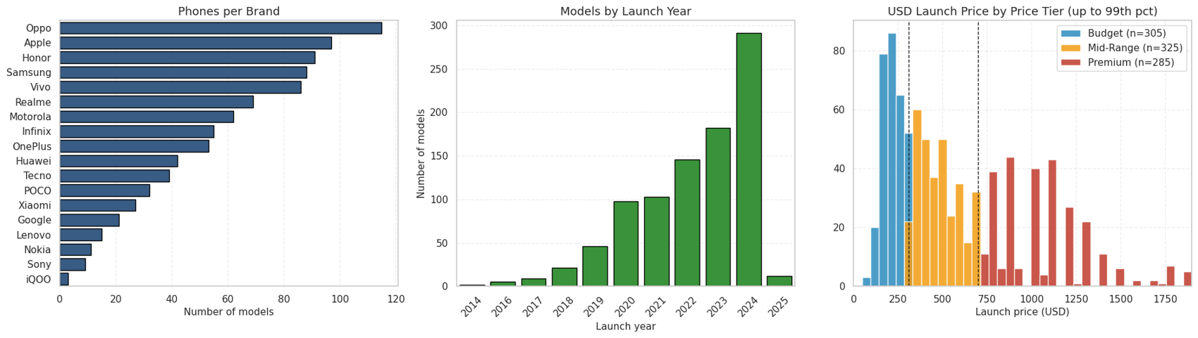
Figure 3.3: Study 1 dataset overview: phones per brand, models by launch year and USD price distribution by tier
The dataset is concentrated in recent years and in a handful of brands; most models were launched between 2021 and 2025. The right panel shows the USD price histogram coloured by tier with the dashed cut-offs at $310 and $699; it is heavily right-skewed, with a long Premium tail.
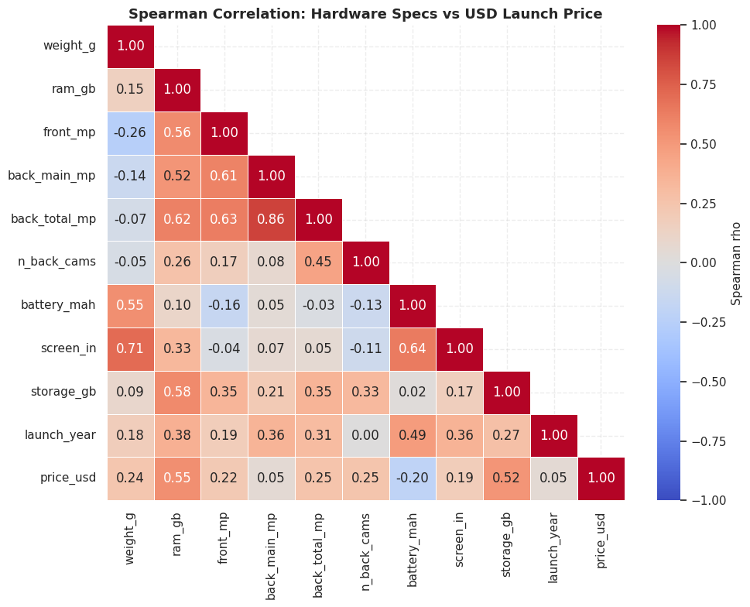
Figure 3.4: Study 1 Spearman correlation heatmap between hardware specifications and USD launch price
RAM (ρ = 0.550) and storage (ρ = 0.520) have the strongest positive rank correlation with price, followed by total rear camera MP (0.252), number of rear cameras (0.249), weight (0.236), front camera (0.216) and screen size (0.186). Battery capacity is negatively correlated (−0.203): cheaper phones often carry larger batteries.
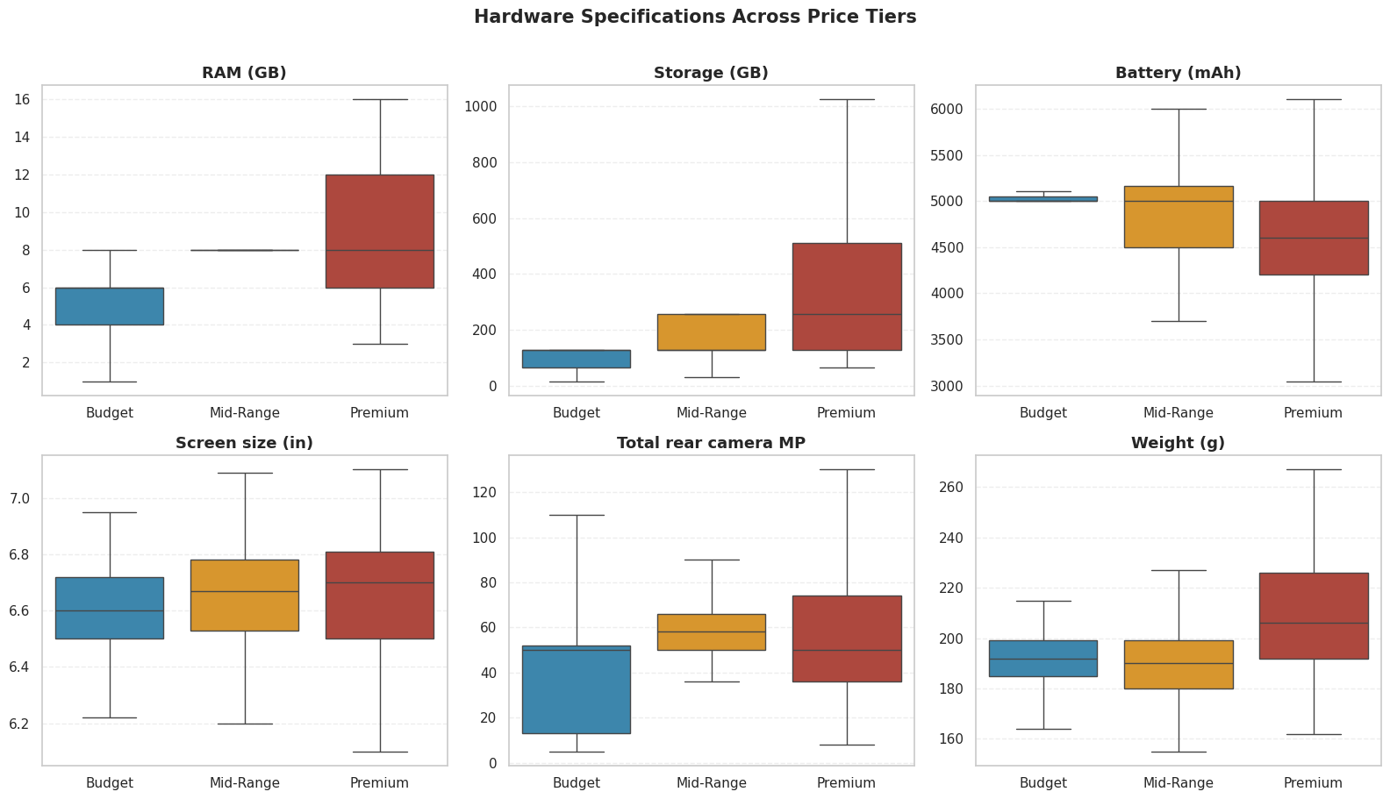
Figure 3.5: Study 1 key hardware specifications across price tiers (box plots)
RAM and storage rise clearly from Budget to Premium. Weight and screen size also increase slightly. Battery capacity is similar or lower in the Premium tier. A Kruskal-Wallis test confirmed that the differences are significant (p < 0.001) for every feature reported: RAM (H = 265.2), storage (223.8), front camera (151.8), weight (87.0), total rear MP (68.5), main rear MP (56.6), number of cameras (49.8), battery (36.7) and screen size (24.7).

3.6.2 Study 2 EDA
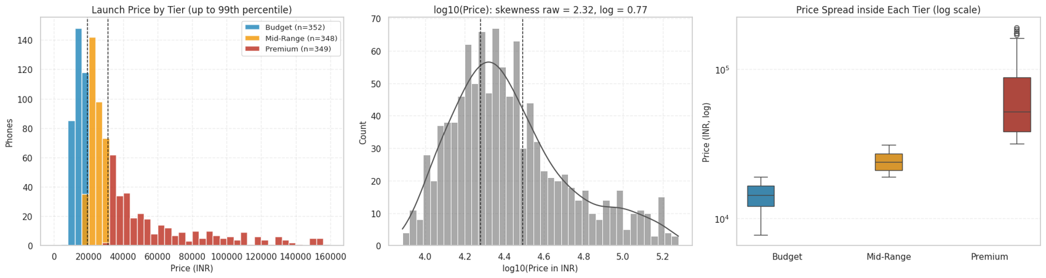
Figure 3.6: Study 2 price distribution: launch price by tier, log10 price and price spread inside each tier
Prices run from ₹7,689 to ₹189,999; the mean (₹34,997) is well above the median (₹23,747), a right-skewed distribution that is more symmetric on a log scale. The Premium tier is by far the widest (₹31,500 to ₹189,999) while Budget spans only ₹7,689 to ₹18,990.
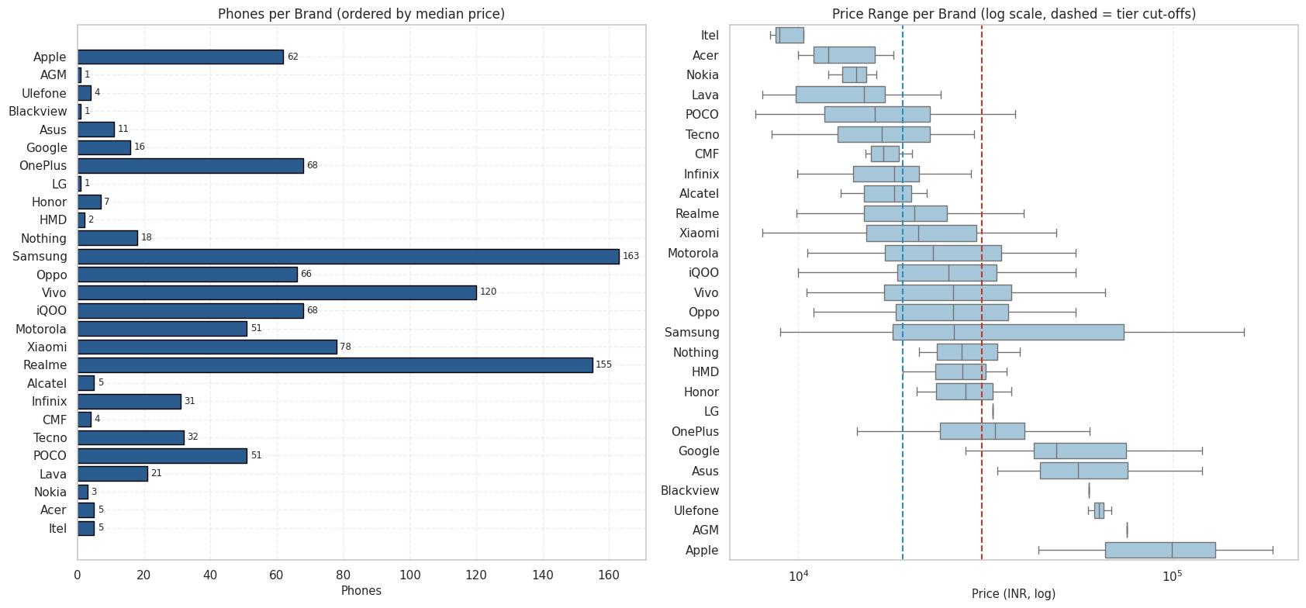
Figure 3.7: Study 2 brand positioning: phones per brand and price spread by brand
Median prices rise from Lava (₹14,999) and POCO (₹15,990) through Realme (₹20,390), Samsung (₹25,999) and OnePlus (₹33,495) to Google (₹48,999) and Apple (₹99,700). Mainstream brands overlap heavily: Samsung splits 48 Budget, 48 Mid-Range and 67 Premium, and Realme 70, 69 and 16. Brand alone therefore cannot decide the tier. Apple is the exception: all 62 Apple phones are Premium.
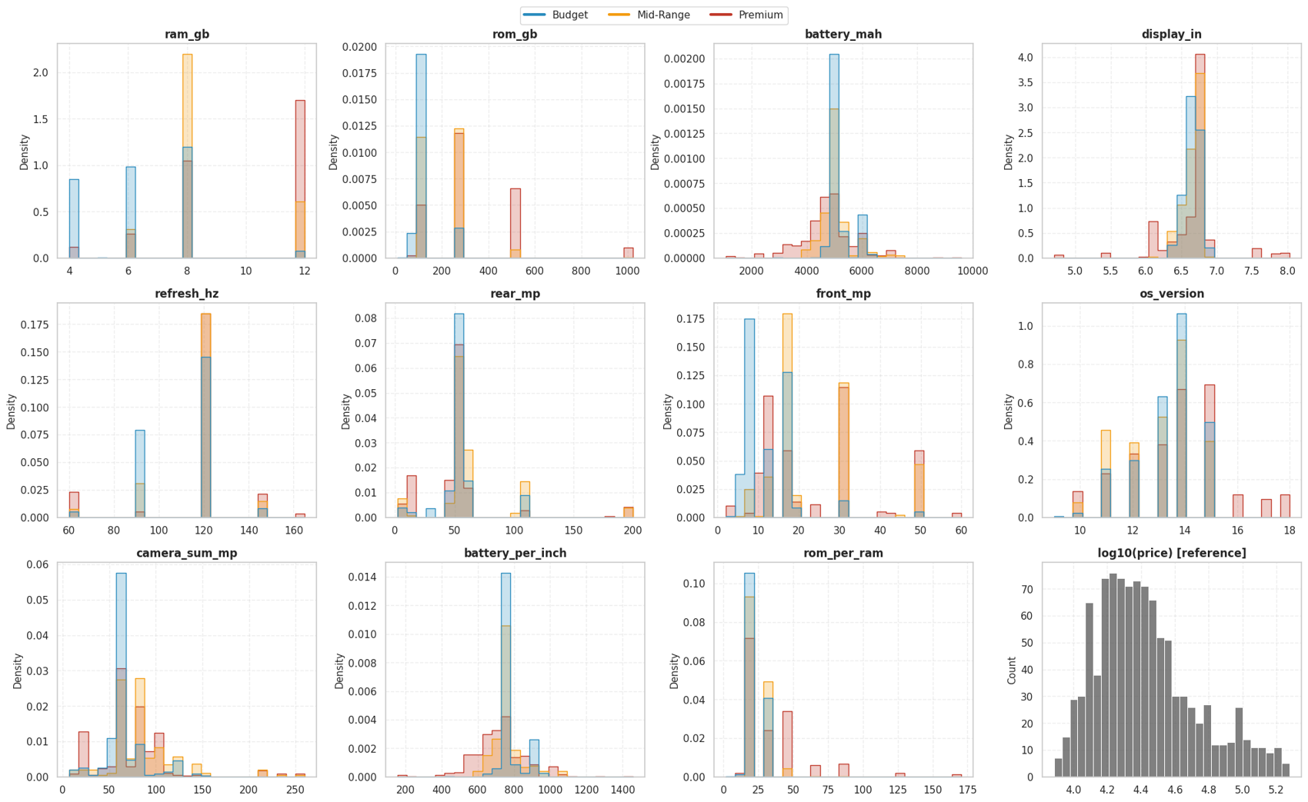
Figure 3.8: Study 2 distribution of every numeric feature split by price tier
RAM and storage take only a few discrete values, so their histograms are spikes. They separate the tiers best: Budget sits on low values and Premium on high values. Battery, display size, refresh rate and rear camera overlap almost completely, because nearly every phone has a 120 Hz screen and a 50 MP main camera. The engineered battery_per_inch separates tiers slightly better than raw battery.
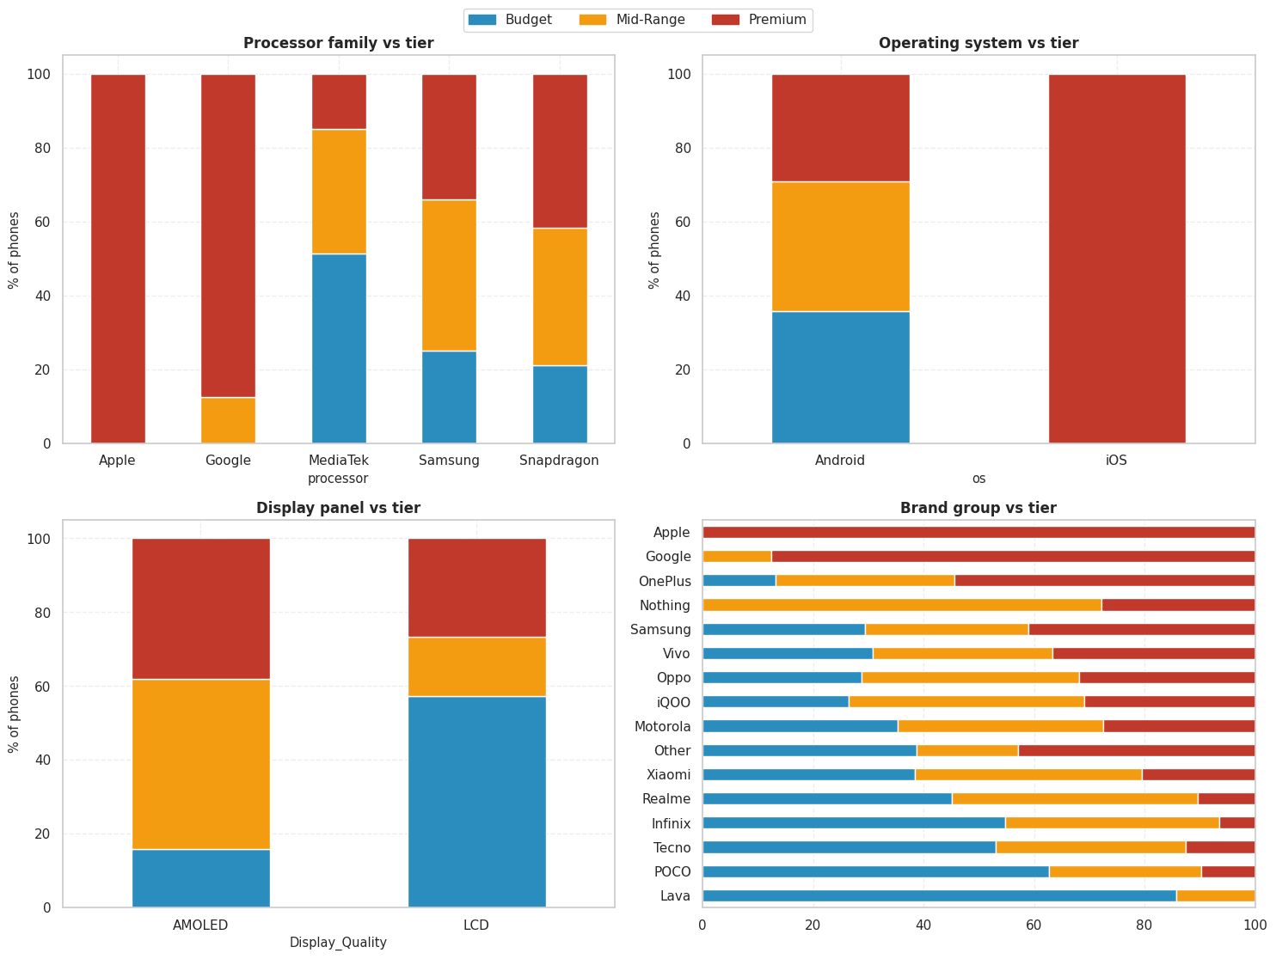
Figure 3.9: Study 2 categorical drivers of price tier: processor, operating system, display panel and brand (100% stacked bars)
Apple processors are 100% Premium and Google (Tensor) 87.5% Premium. MediaTek is the Budget workhorse (51.4% Budget, only 15.0% Premium), while Snapdragon leans Premium (41.7%). All iOS phones are Premium. The AMOLED share rises from 27.3% of Budget phones to 79.3% of Mid-Range and 65.9% of Premium phones.
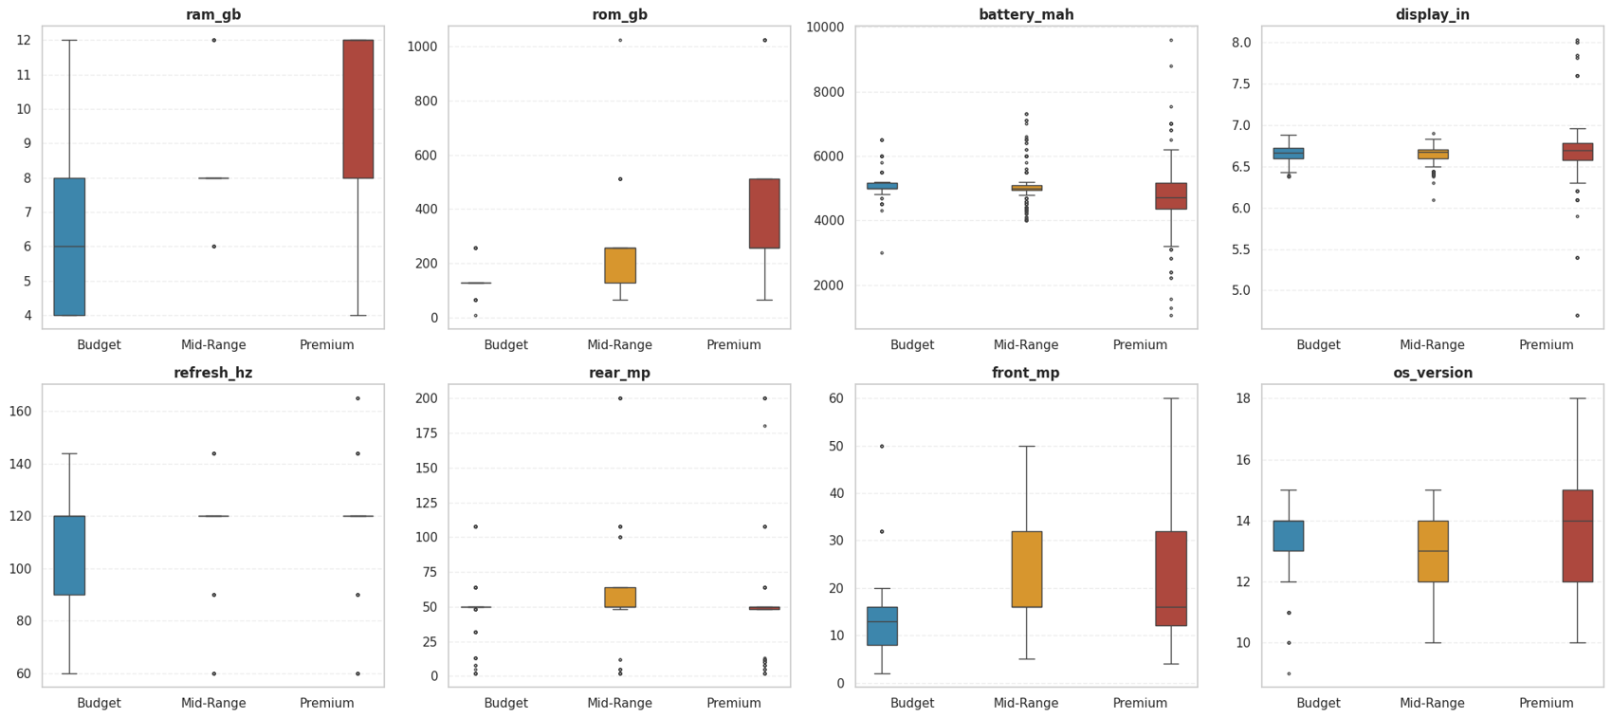
Figure 3.10: Study 2 box plots of the eight core specifications by tier
The median RAM climbs 6, 8, 12 GB from Budget to Premium. Median storage is 128, 256 and 256 GB. Premium phones have slightly smaller batteries (4,720 mAh against 5,000 mAh) because flagships trade battery size for slimness and iPhones carry comparatively small batteries. Refresh rate and rear camera MP have identical medians in all tiers and therefore carry almost no tier information on their own.
Table 3.3: Median value of core specifications by tier (Study 2)
Tier | RAM (GB) | Storage (GB) | Battery (mAh) | Front MP | Refresh (Hz)
Budget | 6 | 128 | 5,000 | 13 | 120
Mid-Range | 8 | 256 | 5,000 | 16 | 120
Premium | 12 | 256 | 4,720 | 16 | 120

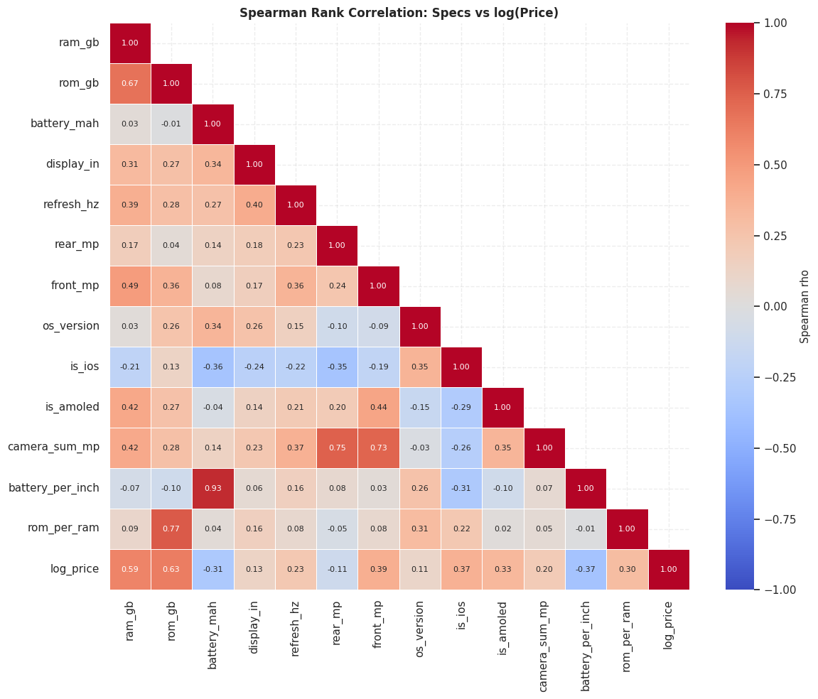
Figure 3.11: Study 2 Spearman correlation heatmap of specifications versus log price
Storage (ρ = 0.63) and RAM (0.60) are the strongest positive correlates, followed by front camera (0.39), iOS (0.37), AMOLED (0.33), rom_per_ram (0.30) and refresh rate (0.23). Battery_per_inch (−0.37) and battery (−0.32) correlate negatively. No feature exceeds |ρ| = 0.63, so no single specification determines price and models must combine many weak-to-moderate signals.
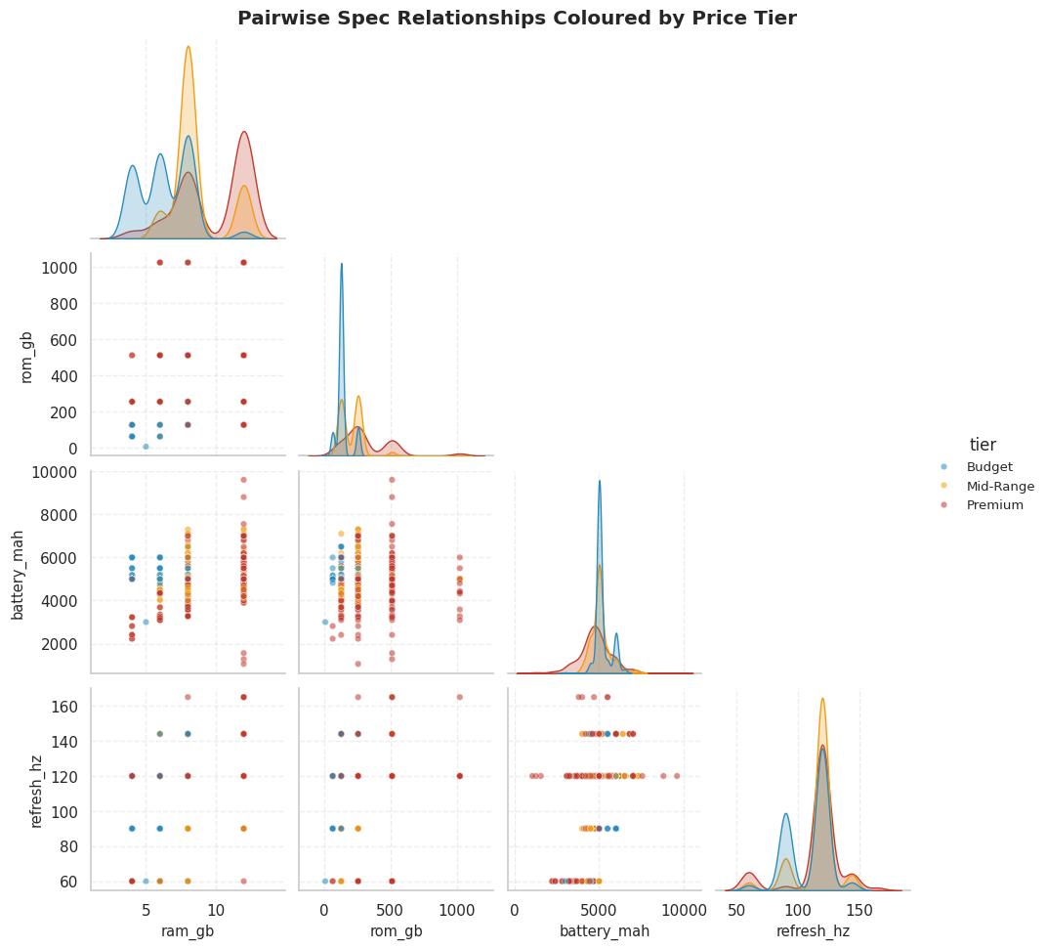
Figure 3.12: Study 2 pairwise relationships between RAM, storage, battery and refresh rate, coloured by tier
Points lie on a grid because the specifications are discrete. Premium (red) clusters at high RAM and storage; Budget (blue) at low RAM and 128 GB or less. The colours overlap in the middle (8 GB, 128–256 GB), which is exactly where Mid-Range phones live and why that tier is hardest. Battery and refresh rate show almost no colour separation.
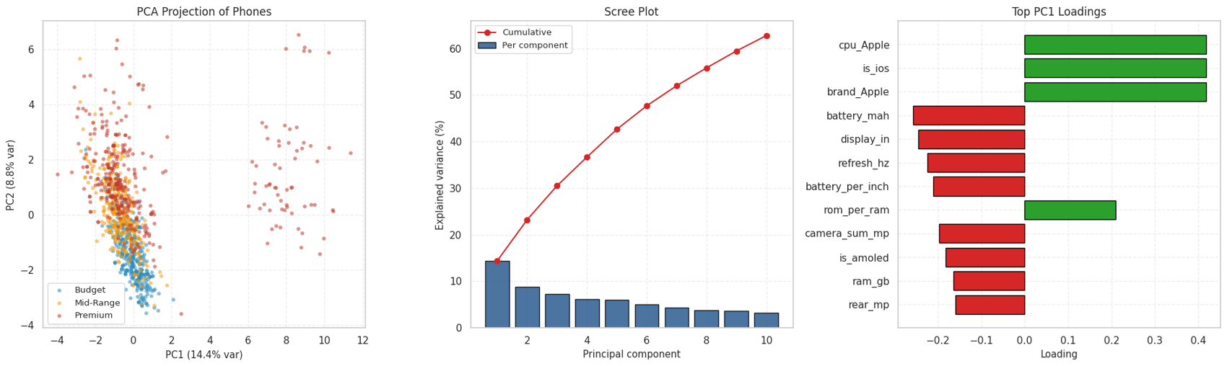
Figure 3.13: Study 2 PCA projection of the standardised feature space and explained variance
The first two principal components explain only 23.2% of the variance (42.6% for five), so there is no dominant direction. PC1 is essentially the Apple/iOS axis (iPhones form an isolated Premium cluster). Among Android phones Budget sits lower on PC2, while Mid-Range and Premium overlap heavily. A straight line in this view cannot separate the tiers, which supports using non-linear tree models.

3.7 Statistical Hypothesis Testing (Study 2)
Every numeric feature was tested across the three tiers with the Kruskal-Wallis test, and the effect size ε² was computed. Categorical features were tested with chi-square and Cramér’s V. Table 3.4 and Table 3.5 summarise the strongest results.
Table 3.4: Kruskal-Wallis tests and effect sizes for numeric features (Study 2)
Feature | Median Budget | Median Mid | Median Premium | H | ε²
rom_gb | 128 | 256 | 256 | 368.2 | 0.35
ram_gb | 6 | 8 | 12 | 349.8 | 0.33
front_mp | 13 | 16 | 16 | 245.4 | 0.23
is_amoled | 0 | 1 | 1 | 209.1 | 0.20
camera_sum_mp | 63 | 80 | 66 | 137.2 | 0.13
is_ios | 0 | 0 | 0 | 132.0 | 0.13
battery_per_inch | 757.6 | 746.3 | 716.4 | 118.2 | 0.11

Table 3.5: Chi-square tests for categorical features (Study 2)
Feature | χ² | dof | p-value | Cramér’s V
Display panel | 209.3 | 2 | 3.59e-46 | 0.447
Brand group | 302.9 | 30 | 7.06e-47 | 0.380
Processor family | 273.0 | 8 | 2.25e-54 | 0.361
Operating system | 132.2 | 2 | 2.00e-29 | 0.355

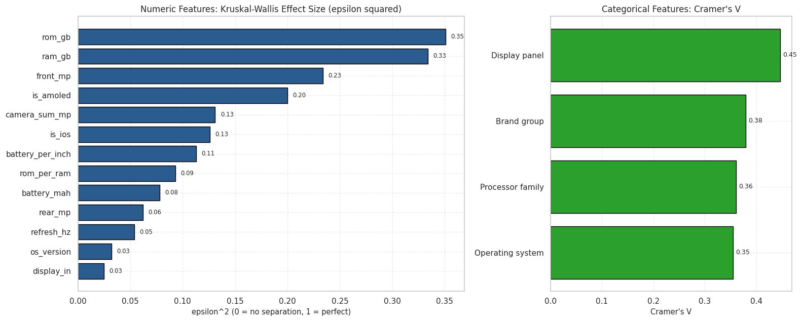
Figure 3.14: Study 2 effect sizes: Kruskal-Wallis ε² for numeric features and Cramér’s V for categorical features
All numeric features are significant at p < 0.001, but with 1,049 samples significance is not importance. Storage (0.35) and RAM (0.33) show large effects; front camera (0.23) and AMOLED (0.20) moderate; refresh rate (0.05), OS version (0.03) and display size (0.02) are negligible. Among categorical features the display panel (V = 0.45) is strongest, followed by brand, processor and operating system.

3.8 Machine Learning Models and Validation

3.8.1 Models
Random Forest and Gradient Boosting (scikit-learn implementations [4]) are used in both the classification and regression versions. Studies 2 and 3 wrap each model in a pipeline with imputation (and, for Study 3, one-hot encoding and a log-target transformer) so that all preprocessing is fitted on training data only.

3.8.2 Train/test split and tuning
Table 3.6: Splits and hyper-parameter search used in each study
Item | Study 1 | Study 2 | Study 3
Split | 80/20 stratified (732/183) | 80/20 stratified (839/210) | 80/20, stratified on price quintiles (686/172)
Task | 3-class | 3-class | Regression + 4-class
RF search | GridSearch, 8 candidates × 5 folds | GridSearch, 36 × 5 = 180 fits | RandomizedSearch, 25 × 5 folds
GB search | GridSearch, 8 candidates × 5 folds | GridSearch, 24 × 5 = 120 fits | RandomizedSearch, 25 × 5 folds
Scoring | macro-F1 | macro-F1 | MAE (regression), macro-F1 (classes)

3.8.3 Additional validation
Beyond the test set, each study uses repeated or k-fold cross-validation on the data: 5-fold on all data in Study 1, 5×3 repeated stratified CV and out-of-fold (OOF) predictions for all 1,049 phones in Study 2, and 10-fold CV plus OOF predictions for all 858 phones in Study 3. Hyper-parameters were tuned on the training split only, so the test-set metrics are the unbiased headline numbers.

3.9 Implementation Environment and Reproducibility
Table 3.7: Implementation environment and tools
Component | Tool
Language / environment | Python in Google Colab / Jupyter notebooks
Libraries (Study 1/2) | NumPy 2.4.4, Pandas 3.0.2, SciPy 1.17.1, scikit-learn 1.8.0, Seaborn 0.13.2, Matplotlib
Models | RandomForestClassifier/Regressor, GradientBoostingClassifier/Regressor
Pipelines | Pipeline, ColumnTransformer, SimpleImputer, OneHotEncoder, TransformedTargetRegressor
Search / validation | GridSearchCV, RandomizedSearchCV, StratifiedKFold, RepeatedStratifiedKFold, cross_val_predict
Interpretation | feature_importances_, permutation_importance, PartialDependenceDisplay, learning_curve, PCA
Reproducibility | random_state = 42, saved models (joblib) and CSV outputs

3.10 Study 3 Exploratory Data Analysis
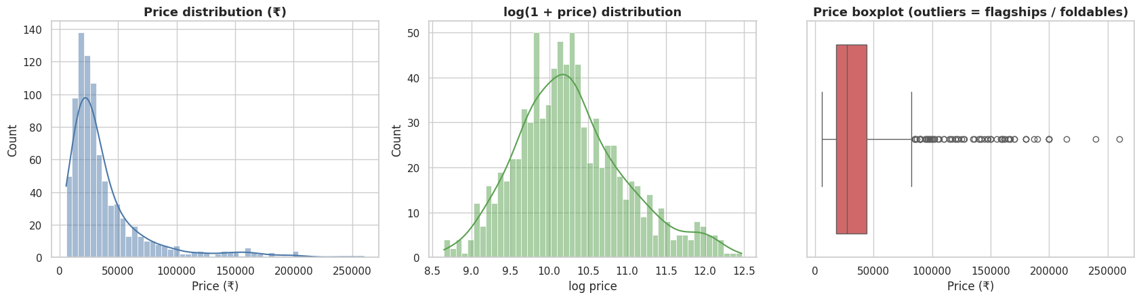
Figure 3.15: Study 3 price distribution: raw price, log(1 + price) and box plot
Price is heavily right-skewed (skewness 2.63; mean ₹38,670, median ₹27,230, range ₹5,700 to ₹259,999) and the box plot shows many flagship and foldable outliers. After a log transform the skewness falls to 0.52, so models are trained on log(price) and converted back to rupees.
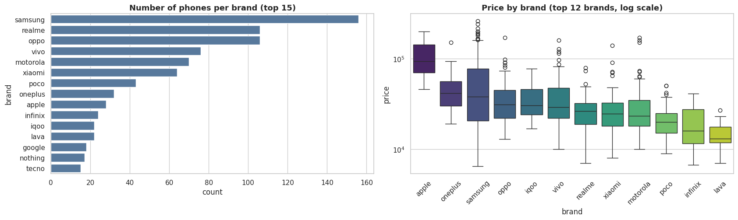
Figure 3.16: Study 3 phones per brand and price by brand (top 12, log scale)
The brand count shows which manufacturers dominate the data; the price box plots on a log scale show that median price differs strongly between brands (premium brands sit well above value brands) while mainstream brands still overlap, so specifications must explain most of the remaining variation.
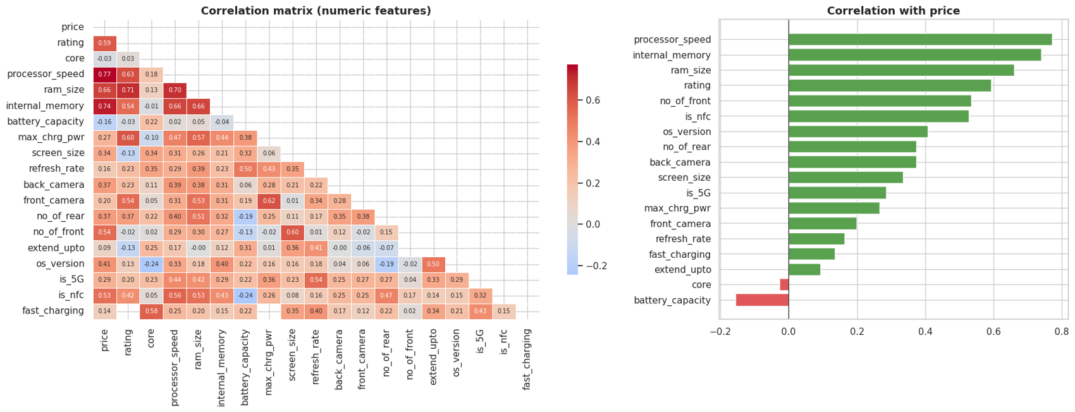
Figure 3.17: Study 3 correlation matrix of numeric features and correlation of each feature with price
The left panel shows relationships among specifications (for example RAM, storage and processor speed move together) and the right panel ranks each feature by its correlation with price, giving a first view of which features matter before modelling.
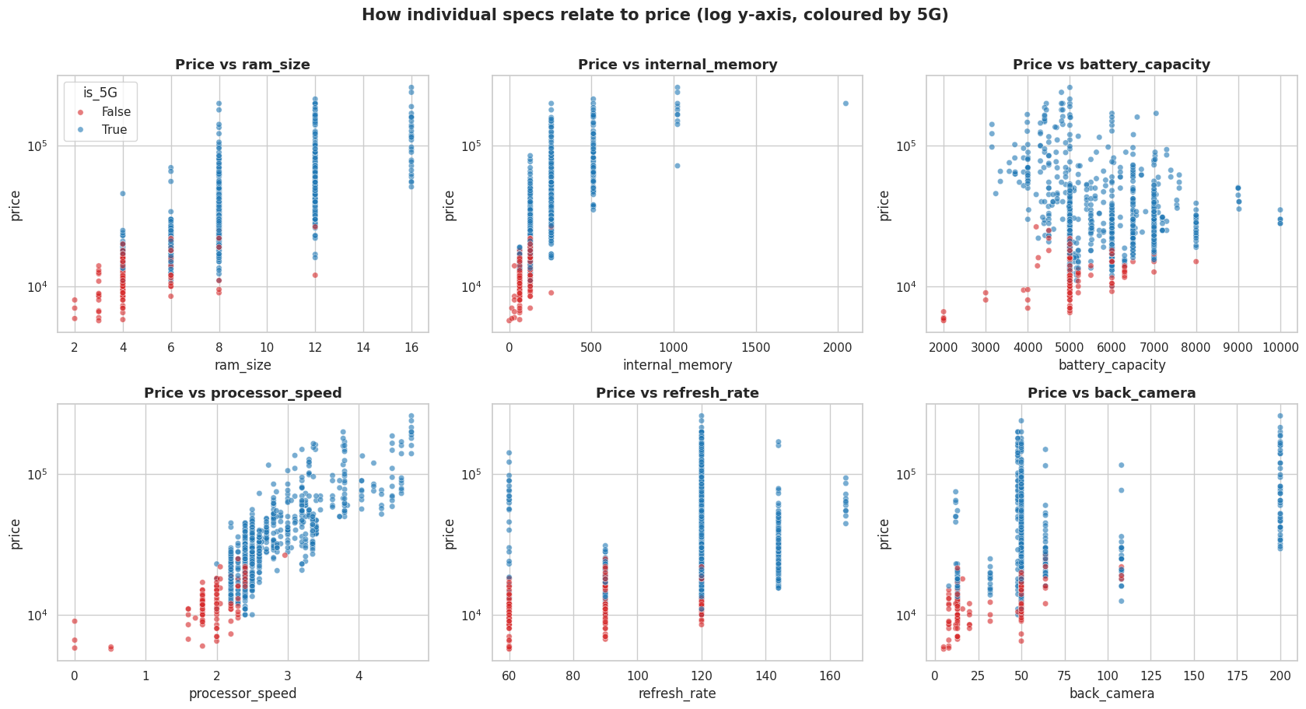
Figure 3.18: Study 3 price versus six key specifications (log price axis, coloured by 5G support)
Each panel plots price against one specification (RAM, internal memory, battery, processor speed, refresh rate and rear camera). Price rises clearly with RAM, internal memory and processor speed (the processor-speed panel is almost a straight upward band). Battery capacity shows only a weak relationship, and refresh rate and rear camera MP separate low-priced phones from the rest but show a wide price spread at the common values of 120 Hz and 50 MP. Phones without 5G (red) cluster at the low-price end.
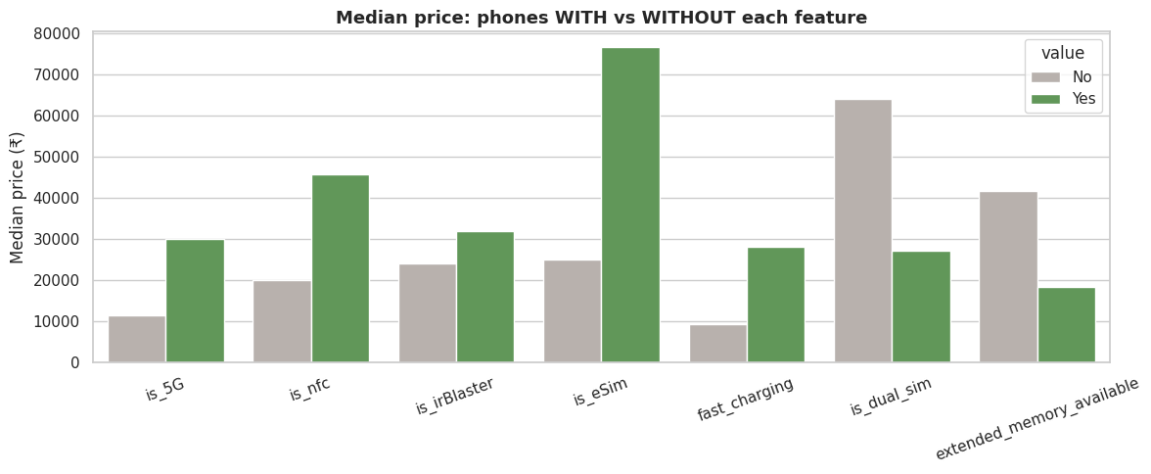
Figure 3.19: Study 3 median price of phones with and without selected features (5G, NFC, IR blaster, eSIM, fast charging, dual SIM, expandable memory)
The bars compare the median price of phones that have a feature with those that do not. Phones with 5G, NFC, IR blaster, eSIM and fast charging have a higher median price than phones without them; eSIM (about ₹76,000 vs ₹25,000) and NFC (about ₹45,000 vs ₹20,000) show the largest gaps. The opposite holds for dual SIM and expandable memory, whose presence is associated with lower median prices, because budget and mid-range phones keep card slots and dual-SIM trays while many flagships drop them.
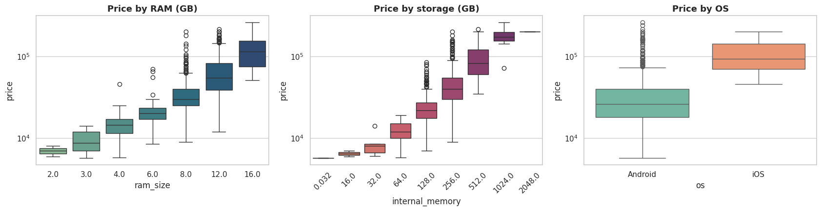
Figure 3.20: Study 3 price by RAM, internal memory and further specification groups (box plots, log scale)
Median price increases step by step with RAM (2 to 16 GB) and with internal storage (up to 2 TB), confirming that memory configuration is a primary pricing lever. The third panel shows that iOS phones are priced higher than Android phones at the median, while Android covers the whole price range with many high-priced outliers.

3.11 Chapter Summary
This chapter described three datasets, their quality problems and repairs, the construction of numeric features, the definition of price tiers and segments, the exploratory and statistical analysis and the validation design. The key methodological choices are: removal of every price column from the features, imputation inside pipelines, stratified splits, tuning on training data only and reporting on an untouched test set. The next chapter presents the model results.

CHAPTER 4: RESULTS AND DISCUSSION

4.1 Introduction
This chapter reports the results of Random Forest (RF) and Gradient Boosting (GB) on the three datasets. Study 1 and Study 2 are three-class price-tier problems; Study 3 is a regression problem with a four-segment classification as a bonus. All headline numbers are measured on test phones that were never used in tuning. The results of the three studies are presented separately because their currencies, features and sample sizes differ.

4.2 Study 1: Mobiles Dataset 2025 (USD tiers)

4.2.1 Hyper-parameter tuning
Table 4.1: Best hyper-parameters found by 5-fold stratified grid search (Study 1)
Model | Best parameters | CV macro-F1
Random Forest | n_estimators = 400, max_depth = None, min_samples_leaf = 1 | 0.8582
Gradient Boosting | n_estimators = 300, learning_rate = 0.05, max_depth = 3 | 0.8640

4.2.2 Test-set performance
Table 4.2: Held-out test performance on 183 phones (Study 1)
Model | Accuracy | Balanced acc. | Macro precision | Macro recall | Macro F1 | ROC-AUC (OvR)
Random Forest | 0.8361 | 0.8346 | 0.8597 | 0.8346 | 0.8409 | 0.9647
Gradient Boosting | 0.8361 | 0.8367 | 0.8428 | 0.8367 | 0.8387 | 0.9490

Both models classify about 83.6% of the 183 test phones correctly, compared with 33% expected by chance. Random Forest has the higher macro-F1 (0.841 vs 0.839), precision and ROC-AUC; Gradient Boosting has marginally higher balanced accuracy and recall. The differences are tiny.
Table 4.3: Class-wise results on the test set (Study 1)
Model / class | Precision | Recall | F1 | Support
RF · Budget | 0.923 | 0.787 | 0.850 | 61
RF · Mid-Range | 0.716 | 0.892 | 0.795 | 65
RF · Premium | 0.940 | 0.825 | 0.879 | 57
GB · Budget | 0.893 | 0.820 | 0.855 | 61
GB · Mid-Range | 0.761 | 0.831 | 0.794 | 65
GB · Premium | 0.875 | 0.860 | 0.867 | 57

Mid-Range has the lowest precision for both models (0.72 for RF and 0.76 for GB), as expected for a class sitting between two neighbours. Budget and Premium precision for Random Forest are above 0.92.
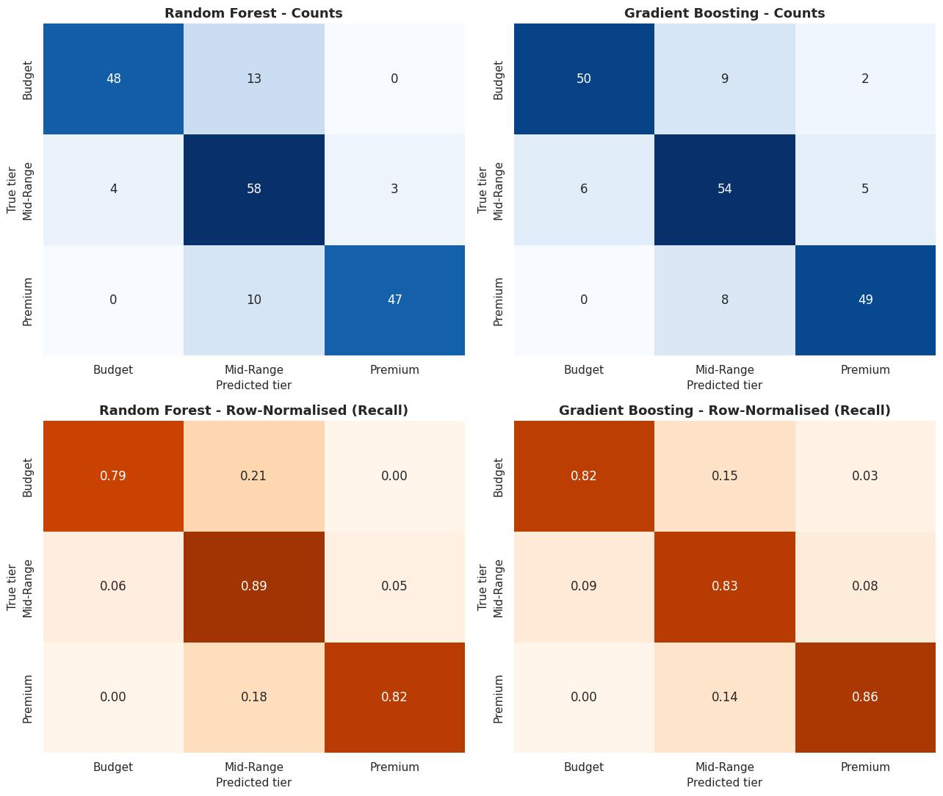
Figure 4.1: Study 1 confusion matrices (counts and row-normalised recall) for Random Forest and Gradient Boosting
The diagonal dominates in both models. The errors are concentrated in the Mid-Range row and column, i.e. confusion with the adjacent tiers. In total 34 of 183 test phones were misclassified by at least one model and 26 by both, which means the two models make largely the same mistakes.
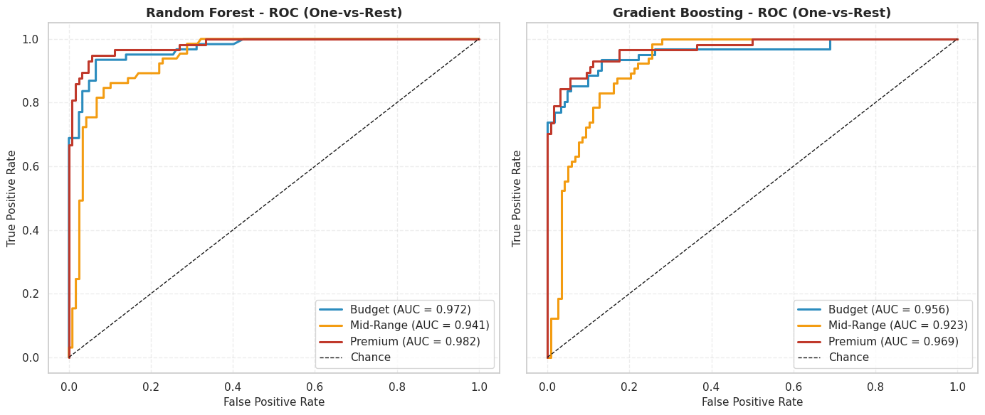
Figure 4.2: Study 1 one-vs-rest ROC curves for each price tier
The curves lie far above the chance diagonal. The macro one-vs-rest AUC is 0.965 for Random Forest and 0.949 for Gradient Boosting, showing that both models rank phones by tier very well even where the hard label is wrong.

4.2.3 Stability and feature importance
Table 4.4: 5-fold cross-validation macro-F1 on the full dataset (Study 1)
Model | Fold 1 | Fold 2 | Fold 3 | Fold 4 | Fold 5 | Mean ± SD
Random Forest | 0.883 | 0.870 | 0.877 | 0.814 | 0.866 | 0.8621 ± 0.0246
Gradient Boosting | 0.857 | 0.832 | 0.876 | 0.817 | 0.861 | 0.8484 ± 0.0211

Table 4.5: Top eight impurity-based feature importances (Study 1)
Rank | Random Forest | Gradient Boosting
1 | ram_gb (0.1195) | ram_gb (0.1885)
2 | weight_g (0.1153) | weight_g (0.1354)
3 | front_mp (0.1023) | front_mp (0.1339)
4 | screen_in (0.0897) | battery_mah (0.0780)
5 | battery_mah (0.0815) | cpu_mediatek helio/other (0.0779)
6 | back_total_mp (0.0681) | cpu_apple (0.0716)
7 | storage_gb (0.0570) | brand_Apple (0.0704)
8 | cpu_mediatek helio/other (0.0469) | screen_in (0.0453)

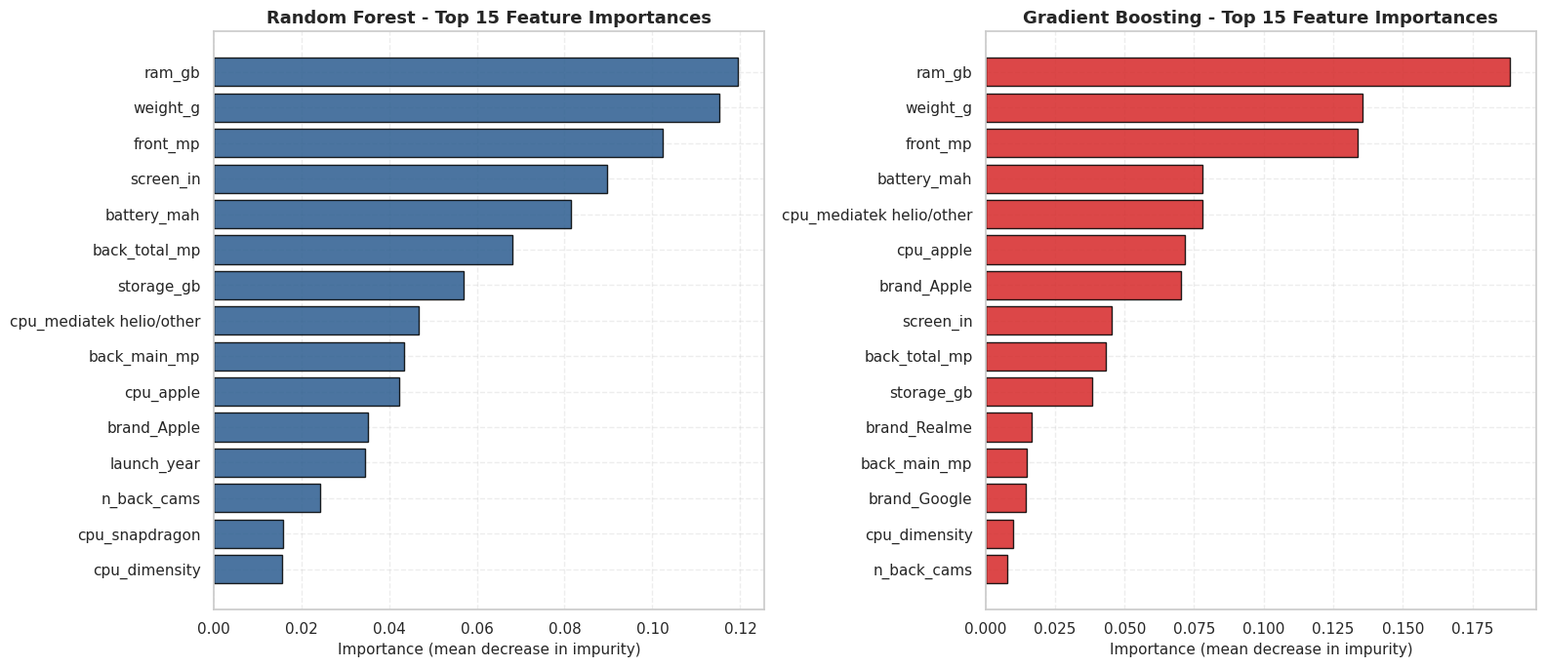
Figure 4.3: Study 1 top-15 feature importances for Random Forest and Gradient Boosting
RAM is the most important feature in both models, followed by weight and front camera. Gradient Boosting also relies strongly on Apple brand and processor indicators, which identify an entire Premium group, while Random Forest spreads importance more evenly across many continuous specifications.
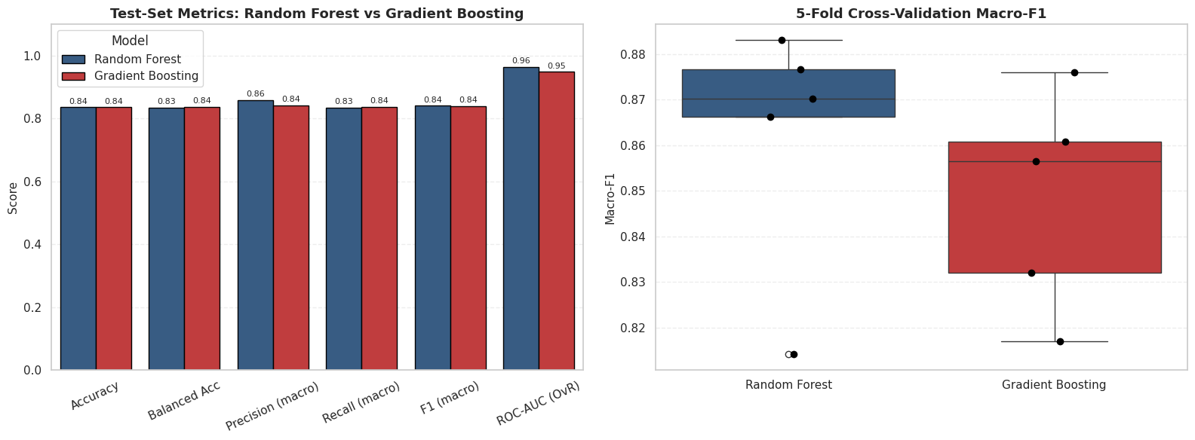
Figure 4.4: Study 1 model comparison: test-set metrics and 5-fold cross-validation stability
The left panel shows nearly identical bars for the two models on all six metrics; the right panel shows Random Forest with the slightly higher cross-validated macro-F1 (0.862 vs 0.848) and a similar spread. Random Forest is marginally ahead on ROC-AUC and stability, but the difference is small.
Summary of Study 1. RAM, storage and weight are the strongest hardware signals of price tier. The two models perform almost identically (about 84% accuracy and macro-F1 about 0.84); most errors are Mid-Range phones confused with neighbouring tiers.

4.3 Study 2: Final Mobile Dataset (INR tiers)

4.3.1 Hyper-parameter tuning
Table 4.6: Best hyper-parameters from 5-fold stratified grid search optimising macro-F1 (Study 2)
Model | Candidates × folds | Best parameters | CV macro-F1
Random Forest | 36 × 5 = 180 fits (62 s) | 200 trees, max_depth = 10, min_samples_leaf = 2, max_features = sqrt | 0.7889
Gradient Boosting | 24 × 5 = 120 fits (49 s) | 200 trees, learning_rate = 0.1, max_depth = 2, subsample = 1.0 | 0.8051

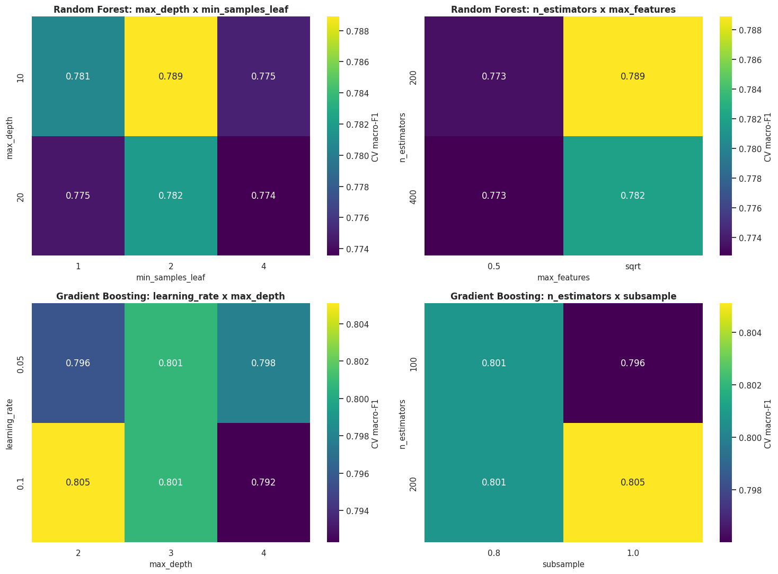
Figure 4.5: Study 2 hyper-parameter search landscape: best CV macro-F1 for pairs of settings for Random Forest and Gradient Boosting
The landscape is flat. The eight best Random Forest settings span only 0.778 to 0.789 macro-F1 and the eight best Gradient Boosting settings 0.796 to 0.805, so neither model is fragile to its settings. The preference of Gradient Boosting for very shallow trees (depth 2) suggests that price is driven by many small additive effects rather than deep interactions.

4.3.2 Test-set performance
Table 4.7: Held-out test performance on 210 phones (Study 2)
Metric | Random Forest | Gradient Boosting
Accuracy | 0.8095 | 0.8000
Balanced accuracy | 0.8095 | 0.8000
Macro precision | 0.8078 | 0.7986
Macro recall | 0.8095 | 0.8000
Macro F1 | 0.8083 | 0.7990
ROC-AUC (OvR) | 0.9411 | 0.9471
MCC | 0.7146 | 0.7003
Quadratic kappa | 0.8481 | 0.8410
MAE in tier steps | 0.1952 | 0.2048
Mean Brier score | 0.0936 | 0.0847

Table 4.8: Class-wise results on the test set (Study 2)
Model / class | Precision | Recall | F1
RF · Budget | 0.851 | 0.900 | 0.875
RF · Mid-Range | 0.731 | 0.700 | 0.715
RF · Premium | 0.841 | 0.829 | 0.835
GB · Budget | 0.824 | 0.871 | 0.847
GB · Mid-Range | 0.716 | 0.686 | 0.701
GB · Premium | 0.855 | 0.843 | 0.849

Table 4.9: Confusion matrices on 210 test phones (rows = true tier, columns = predicted)
True tier | RF Budget | RF Mid | RF Premium | GB Budget | GB Mid | GB Premium
Budget | 63 | 7 | 0 | 61 | 8 | 1
Mid-Range | 10 | 49 | 11 | 13 | 48 | 9
Premium | 1 | 11 | 58 | 0 | 11 | 59

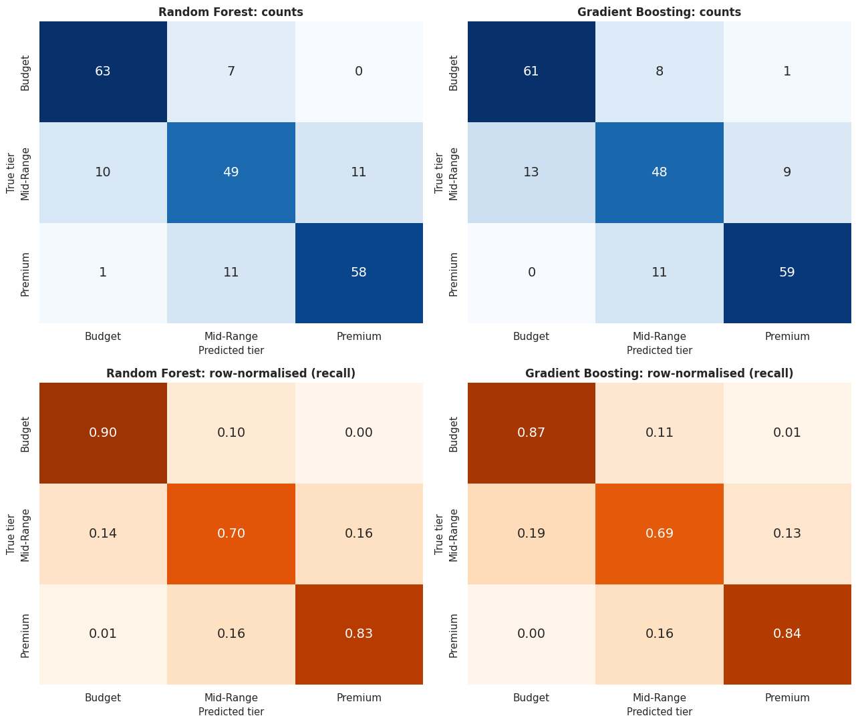
Figure 4.6: Study 2 confusion matrices (counts and row-normalised) for both models
Almost all errors are adjacent-tier mistakes. Random Forest labels a Budget phone as Premium zero times and a Premium phone as Budget once; Gradient Boosting does so once and zero times. Mid-Range is the hardest class (recall 0.70 for RF and 0.69 for GB) because it is sandwiched between the other two tiers; Budget (0.90 / 0.87) and Premium (0.83 / 0.84) are identified well.

4.3.3 Ranking quality and calibration
Table 4.10: Per-class ROC-AUC and average precision (Study 2)
Model | AUC Budget | AUC Mid | AUC Premium | AP Budget | AP Mid | AP Premium | Mean AP
Random Forest | 0.972 | 0.888 | 0.963 | 0.957 | 0.726 | 0.935 | 0.873
Gradient Boosting | 0.968 | 0.900 | 0.973 | 0.949 | 0.795 | 0.952 | 0.899

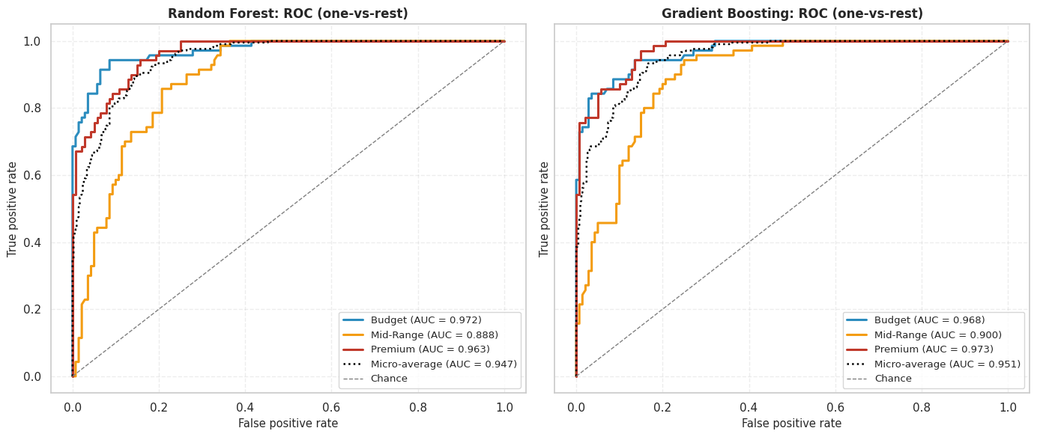
Figure 4.7: Study 2 one-vs-rest ROC curves with micro-average for both models
Macro one-vs-rest AUC is 0.941 (RF) and 0.947 (GB). Both models rank phones far above chance for every tier; the Mid-Range curve is visibly lower, matching the confusion matrix. The AUC ordering (GB slightly higher) differs from the accuracy ordering (RF slightly higher) because AUC measures ranking over all thresholds while accuracy measures only the final decision.
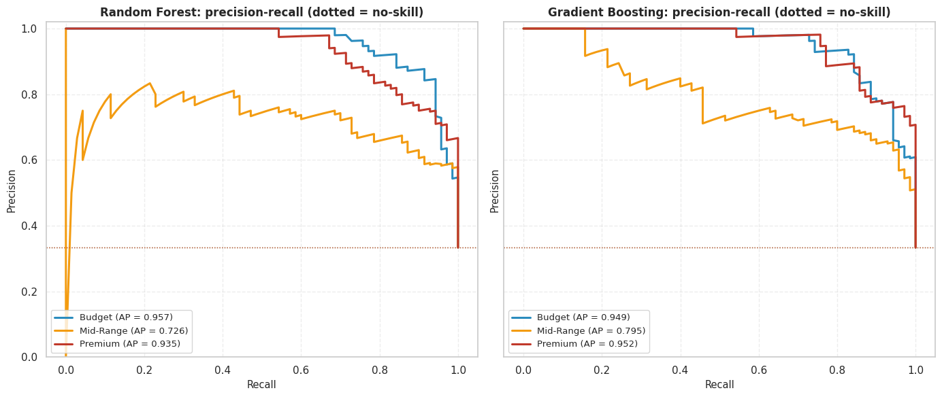
Figure 4.8: Study 2 precision-recall curves for each tier (dotted lines = no-skill level)
Mid-Range is again the weakest (AP 0.73 to 0.80) but still more than twice the no-skill level of about 0.33. Gradient Boosting has the better Mid-Range average precision (0.795 vs 0.726), so its probabilities rank Mid-Range phones better even though its hard Mid-Range recall is similar.
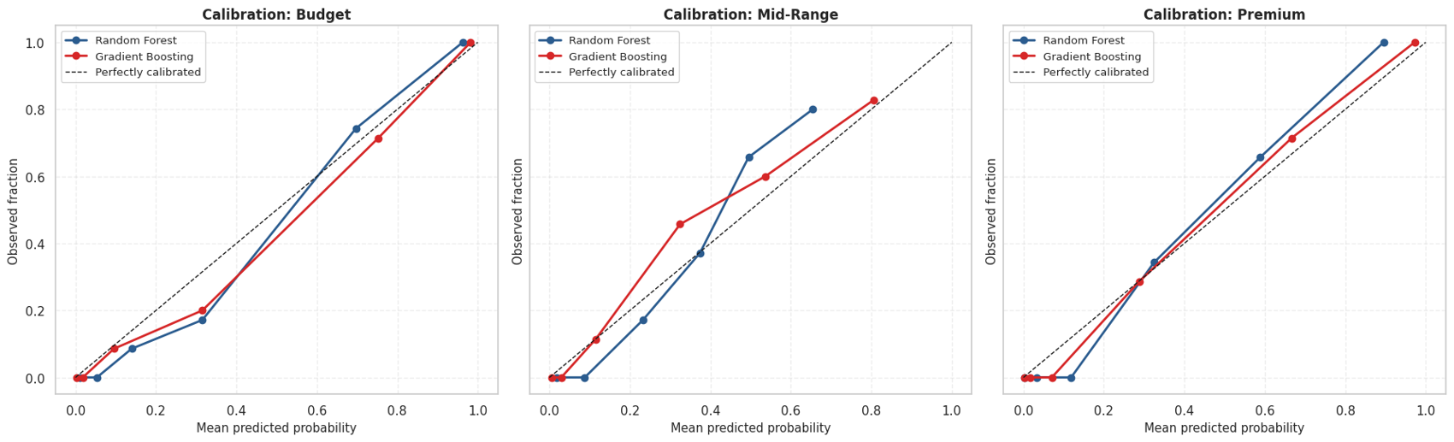
Figure 4.9: Study 2 calibration (reliability) diagrams for each tier
A perfectly calibrated model follows the dashed diagonal. The mean Brier score is 0.0847 for Gradient Boosting and 0.0936 for Random Forest (lower is better), so Gradient Boosting’s probabilities are somewhat better calibrated. Random Forest probabilities are less extreme, a known property of bagged ensembles; isotonic or Platt calibration would be a sensible next step if probabilities are used directly.

4.3.4 Learning curves
Table 4.11: Learning-curve summary at full training size (macro-F1, Study 2)
Model | Train | CV | Gap | CV gain in last step
Random Forest | 0.9029 | 0.7831 | 0.1198 | +0.0066
Gradient Boosting | 0.9149 | 0.8049 | 0.1100 | +0.0100

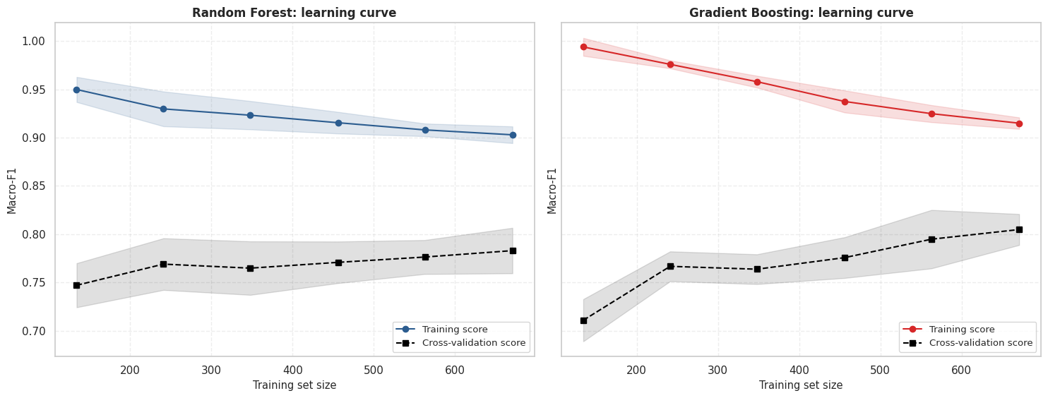
Figure 4.10: Study 2 learning curves for Random Forest and Gradient Boosting
There is a train-validation gap of about 0.11 to 0.12 macro-F1 (training about 0.90 to 0.91 against CV about 0.78 to 0.80), a moderate degree of over-fitting typical of tree ensembles. The CV curve is still rising slowly, so more data would help a little but not dramatically; the remaining error is probably dominated by information the specifications do not contain.

4.3.5 Feature importance and interpretation
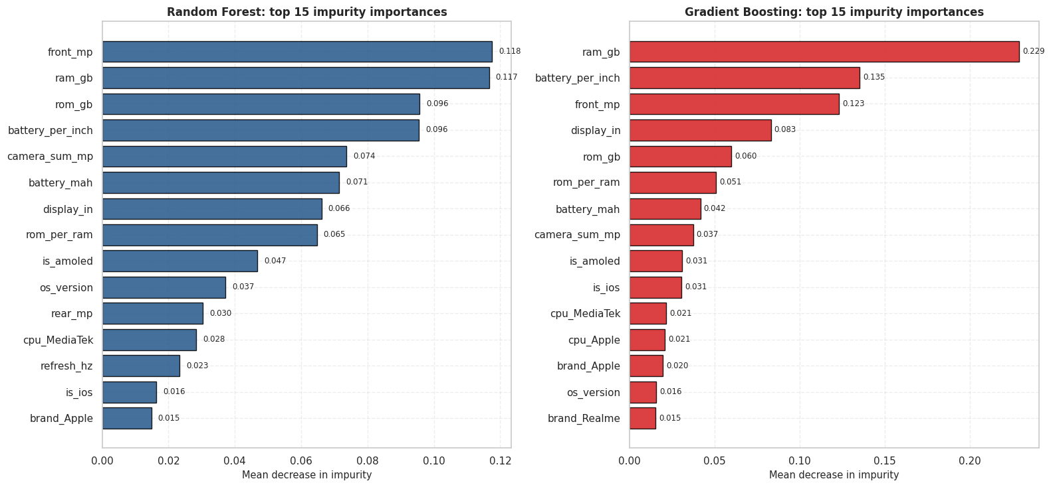
Figure 4.11: Study 2 built-in (impurity-based) top-15 feature importances
Random Forest spreads importance across front_mp (0.118), ram_gb (0.117), rom_gb (0.096) and battery_per_inch (0.096). Gradient Boosting concentrates on ram_gb (0.229), then battery_per_inch (0.135) and front_mp (0.123). Both rank the engineered battery_per_inch in the top four, which confirms that feature engineering added signal. Impurity importance favours features with many distinct values, so it is checked with permutation importance.
Table 4.12: Permutation importance on the test set: mean drop in macro-F1 (Study 2)
Feature | Random Forest | Gradient Boosting
battery_per_inch | 0.0403 | 0.0517
display_in | 0.0323 | 0.0468
front_mp | 0.0339 | 0.0434
is_amoled | 0.0239 | 0.0216
rom_gb | 0.0062 | 0.0295
camera_sum_mp | 0.0176 | 0.0169
cpu_MediaTek | 0.0149 | 0.0165
brand_OnePlus | 0.0136 | 0.0175
battery_mah | 0.0208 | 0.0009
ram_gb | 0.0025 | 0.0184

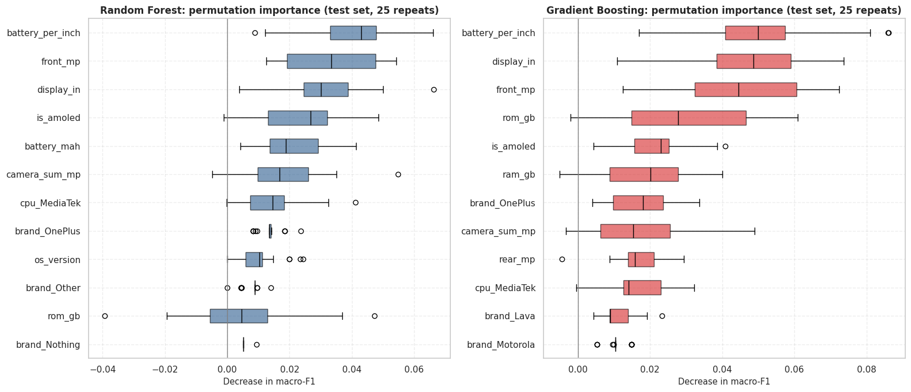
Figure 4.12: Study 2 permutation importance on the test set (25 shuffles)
For both models the most relied-upon features are battery_per_inch, display_in, front_mp and is_amoled, with rom_gb important for Gradient Boosting. RAM and storage have large univariate effect sizes but modest permutation importance for Random Forest because of feature redundancy (RAM, storage, rom_per_ram and brand/processor indicators overlap, so shuffling one barely hurts). High association is therefore not the same as high marginal contribution.
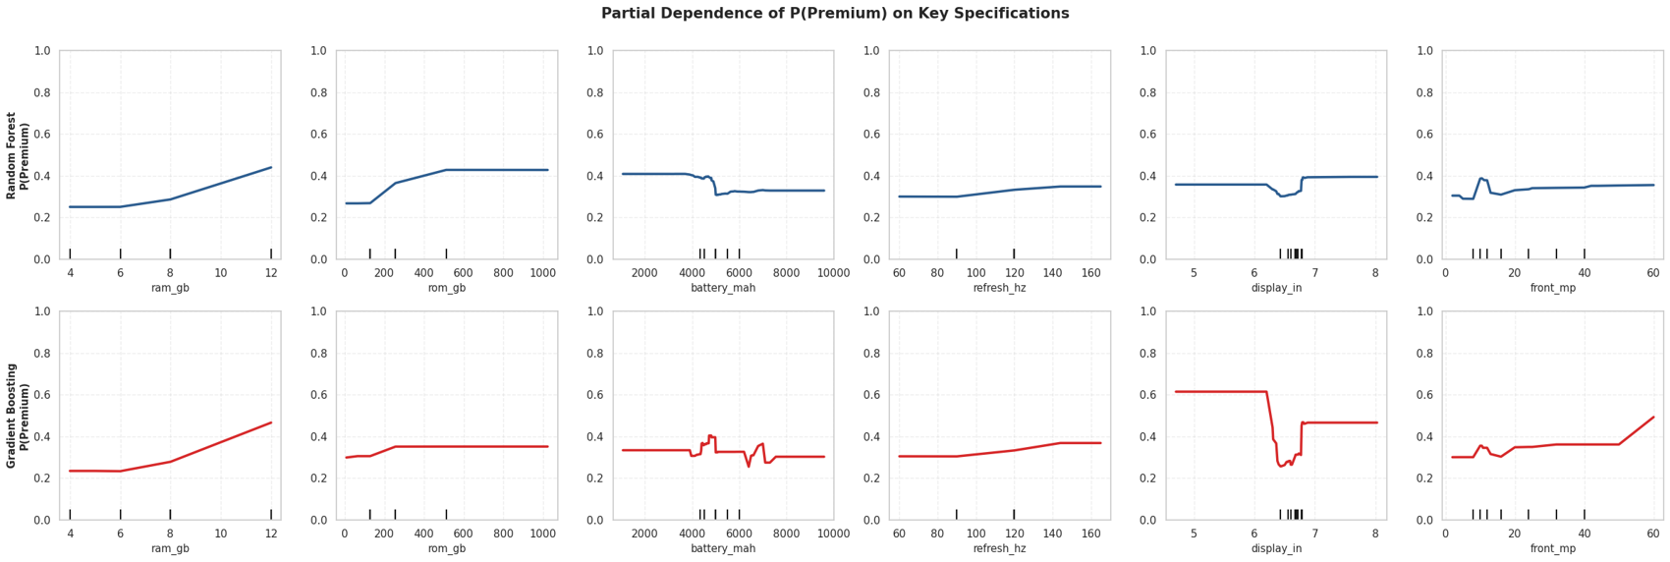
Figure 4.13: Study 2 partial dependence of P(Premium) on key specifications for both models
The probability of Premium rises with RAM (roughly 0.25 at 4–6 GB to 0.45 at 12 GB) and with storage up to 256 GB, then plateaus. Refresh rate and front camera have weak, nearly flat effects. The jump below about 6.3 inches of display size reflects iPhones (small screens, all Premium), not a causal effect of screen size, a reminder that partial dependence can reflect confounding.

4.3.6 Model comparison and statistical testing
Table 4.13: Repeated stratified cross-validation (5 folds × 3 repeats = 15 scores, Study 2)
Model | Mean macro-F1 | SD | Min | Max | 95% CI
Random Forest | 0.7923 | 0.0249 | 0.7534 | 0.8397 | 0.7781–0.8066
Gradient Boosting | 0.8061 | 0.0208 | 0.7635 | 0.8387 | 0.7942–0.8180

Table 4.14: Statistical tests of the difference between the two models (Study 2)
Test | Result | Interpretation
Paired Wilcoxon on 15 CV scores | W = 14.0, p = 0.0067 (mean diff RF − GB = −0.0138) | Small difference; optimistic because folds overlap
Exact McNemar on 210 test phones | RF-only correct = 11, GB-only correct = 9, p = 0.8238 | No significant difference
Both correct / both wrong | 159 / 31 | Models largely agree

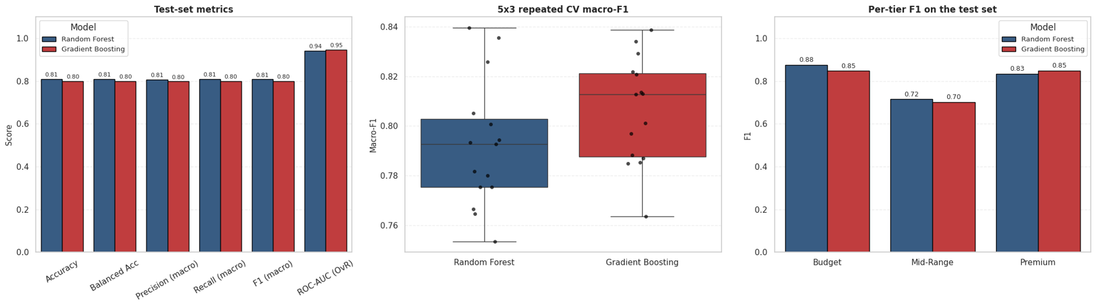
Figure 4.14: Study 2 model-comparison dashboard: test metrics, repeated-CV macro-F1 and per-tier F1
On the test set Random Forest leads on accuracy (0.810 vs 0.800), macro-F1 and MCC; Gradient Boosting leads on ROC-AUC and Brier score and on repeated-CV macro-F1 (0.806 vs 0.792, with overlapping intervals). Random Forest is slightly better on Budget and Mid-Range F1, Gradient Boosting on Premium. The two tests give mixed evidence, so the models are treated as practically equivalent.

4.3.7 Prediction confidence
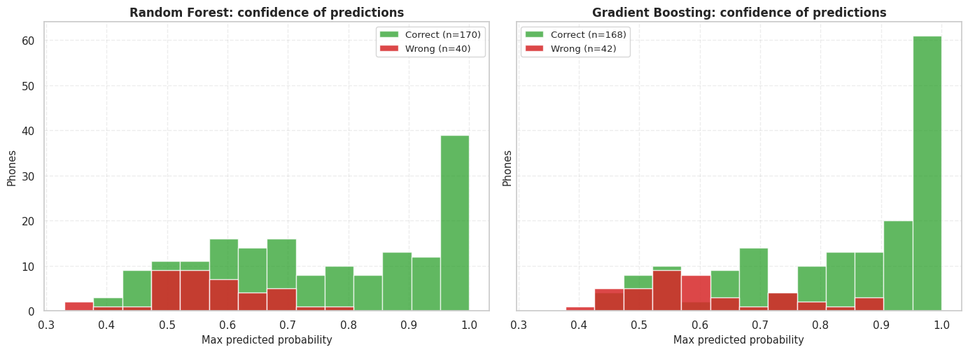
Figure 4.15: Study 2 prediction confidence for correct and wrong test predictions
Both models are more confident when they are right: mean top probability 0.749 (correct) vs 0.565 (wrong) for Random Forest and 0.831 vs 0.605 for Gradient Boosting. Wrong predictions pile up at low confidence (0.4 to 0.6), so confidence is a usable warning signal; predictions below about 0.6 deserve a manual check or a “borderline” label.

4.3.8 Error analysis
Table 4.15: Out-of-fold performance on all 1,049 phones (Study 2)
Model | Accuracy | Macro-F1 | ROC-AUC | Off by 1 tier | Off by 2 tiers
Random Forest | 0.7931 | 0.7950 | 0.9308 | 213 | 4
Gradient Boosting | 0.7979 | 0.7988 | 0.9351 | 209 | 3

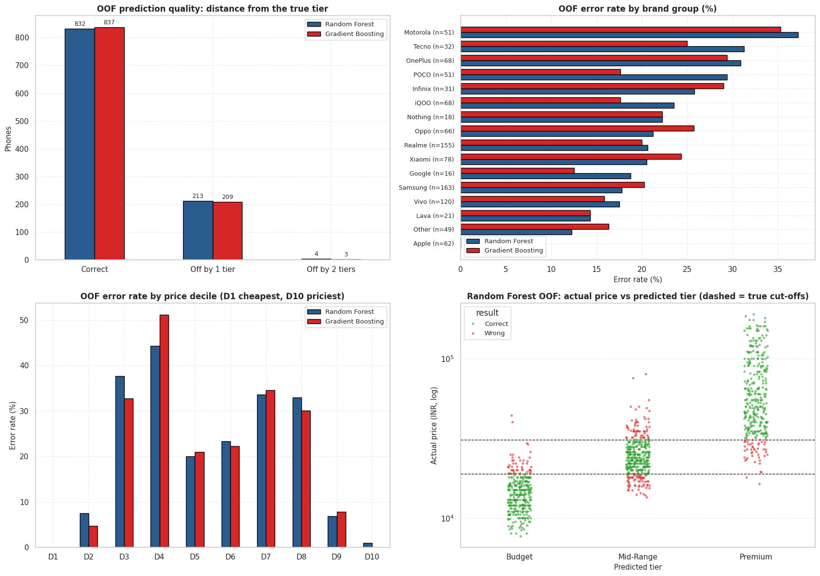
Figure 4.16: Study 2 out-of-fold error analysis: distance from true tier, brand error rates and price-decile errors
Of roughly 215 mistakes per model, 213 (RF) and 209 (GB) are off by exactly one tier; only 4 and 3 are off by two. Error rates spike in price deciles D3–D4 and D7–D8, the phones on the tier boundaries, while the cheapest and most expensive deciles are almost error-free. Apple has no errors; the hardest brands are Motorola (35–37% errors), OnePlus (29–31%), Tecno (25–31%) and Infinix (26–29%), brands that price across tier boundaries.

4.3.9 Robustness to the RAM repair
Table 4.16: Sensitivity of Random Forest to the RAM repair strategy (Study 2)
RAM treatment | CV macro-F1 (train) | Test accuracy | Test macro-F1
A. Raw RAM as stored (1 and 2 kept) | 0.7667 | 0.8000 | 0.7978
B. Recoded to 12 GB (used) | 0.7889 | 0.8095 | 0.8083
C. Treated as missing (median-imputed) | 0.7823 | 0.8381 | 0.8388

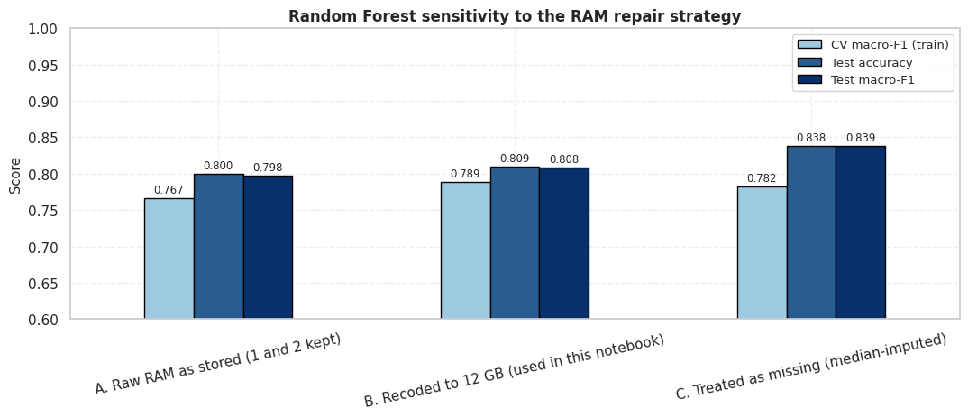
Figure 4.17: Study 2 sensitivity of Random Forest performance to the RAM repair strategy
Leaving the corrupt values in gives the lowest CV macro-F1 (0.767 against 0.789 and 0.782). On the 210-phone test set one standard error is about 2.7 percentage points, so B and C cannot be told apart; only the cleaner treatments clearly beat leaving the errors in. Repairing RAM matters (about 2 points), but the exact repair choice does not change the conclusions.

4.3.10 Predicting new phones
Table 4.17: Predicted tier probabilities for three hypothetical phones (Study 2)
Phone | Model | Budget | Mid-Range | Premium
Entry (4 GB/64 GB, LCD, 5000 mAh, 60 Hz) | RF | 0.925 | 0.068 | 0.007
 | GB | 0.997 | 0.002 | 0.001
Mid (8 GB/128 GB, AMOLED, 5500 mAh, 120 Hz) | RF | 0.400 | 0.555 | 0.045
 | GB | 0.127 | 0.868 | 0.006
Flagship (12 GB/512 GB, AMOLED, 144 Hz) | RF | 0.031 | 0.096 | 0.873
 | GB | 0.019 | 0.035 | 0.945

Summary of Study 2. About 80–81% accuracy and macro-ROC-AUC of 0.94–0.95; almost all errors are one tier away; Mid-Range is hardest; engineered ratios contribute; the two algorithms are statistically indistinguishable on the test set.

4.4 Study 3: Smartphones v4 (INR price regression)

4.4.1 Baseline models
Table 4.18: Baseline 5-fold cross-validation on the training data (Study 3)
Model | CV R² | R² SD | CV MAE (₹) | CV RMSE (₹) | Fit time / fold (s)
Random Forest | 0.897 | 0.039 | 5,585 | 10,773 | 1.09
Gradient Boosting | 0.919 | 0.036 | 5,064 | 9,424 | 0.45

4.4.2 Hyper-parameter tuning
Table 4.19: Best hyper-parameters from RandomizedSearchCV (25 candidates × 5 folds, optimising MAE)
Model | Best parameters | CV MAE (₹) | Time
Random Forest | 300 trees, max_depth = None, min_samples_split = 2, min_samples_leaf = 1, max_features = 0.3 | 5,515 | 91 s
Gradient Boosting | 500 trees, learning_rate = 0.08, max_depth = 5, subsample = 1.0, min_samples_leaf = 1, max_features = sqrt | 4,410 | 64 s

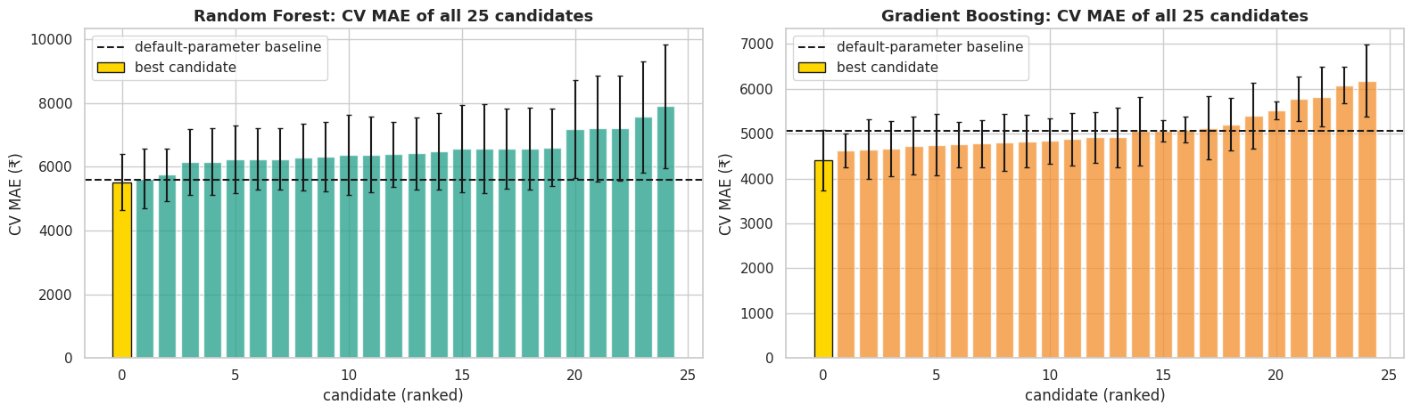
Figure 4.18: Study 3 cross-validated MAE of all 25 tuning candidates against the default baseline
Each bar is one ranked candidate with its fold standard deviation; the gold bar is the best candidate and the dashed line is the baseline. Tuning lowered the error for both models, with the larger improvement for Gradient Boosting (best CV MAE ₹4,410 against ₹5,064 baseline).

4.4.3 Test-set performance
Table 4.20: Held-out test performance on 172 phones (Study 3)
Model | MAE (₹) | RMSE (₹) | MedAE (₹) | MAPE (%) | R² | R² (log) | Train R²
RF (baseline) | 5,790 | 11,414 | 2,500 | 13.98 | 0.882 | 0.932 | 0.988
GB (baseline) | 4,430 | 8,882 | 1,857 | 11.25 | 0.929 | 0.951 | 0.989
RF (tuned) | 5,537 | 11,555 | 2,371 | 13.54 | 0.879 | 0.936 | 0.987
GB (tuned) | 3,887 | 8,088 | 1,918 | 10.75 | 0.941 | 0.956 | 0.999

Tuned Gradient Boosting has the lowest error on every regression metric except median absolute error, where the baseline Gradient Boosting is marginally lower. Its average error is ₹3,887 and it explains 94.1% of price variance, compared with ₹5,537 and 87.9% for tuned Random Forest. Tuning improved Gradient Boosting (MAE ₹4,430 to ₹3,887) more than Random Forest (₹5,790 to ₹5,537).
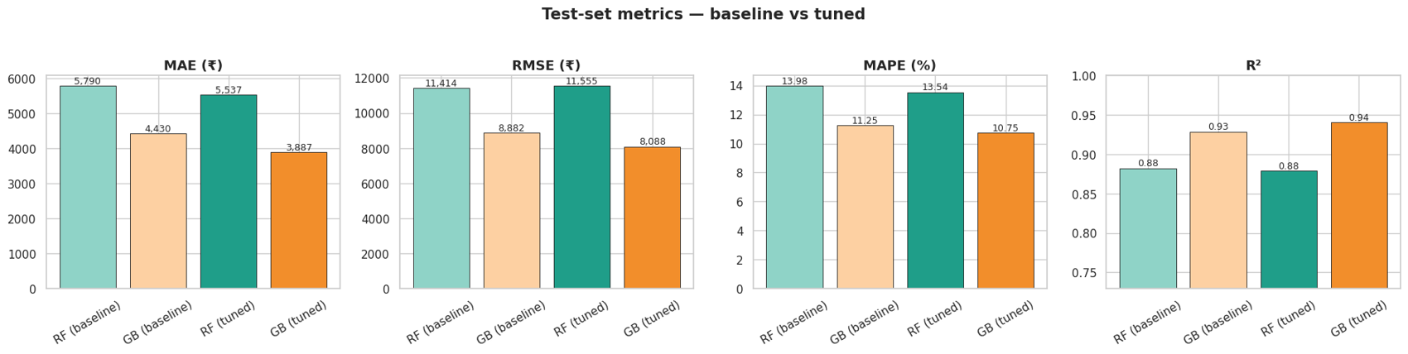
Figure 4.19: Study 3 test-set metrics for baseline and tuned models (MAE, RMSE, MAPE and R²)
Gradient Boosting (tuned) has the lowest MAE, RMSE and MAPE and the highest R². Random Forest is not improved much by tuning.
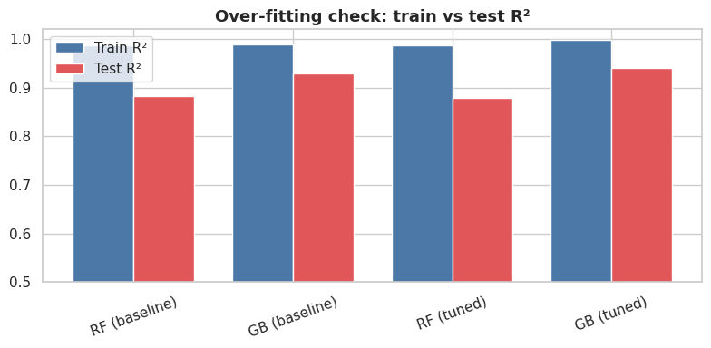
Figure 4.20: Study 3 overfitting check: training R² versus test R²
All models fit the training data almost perfectly (train R² 0.987–0.999) but score lower on the test set (0.879–0.941). The gap between training and test R² is about 0.06 for Gradient Boosting and about 0.11 for Random Forest. Some over-fitting is normal for tree ensembles on only 858 rows.
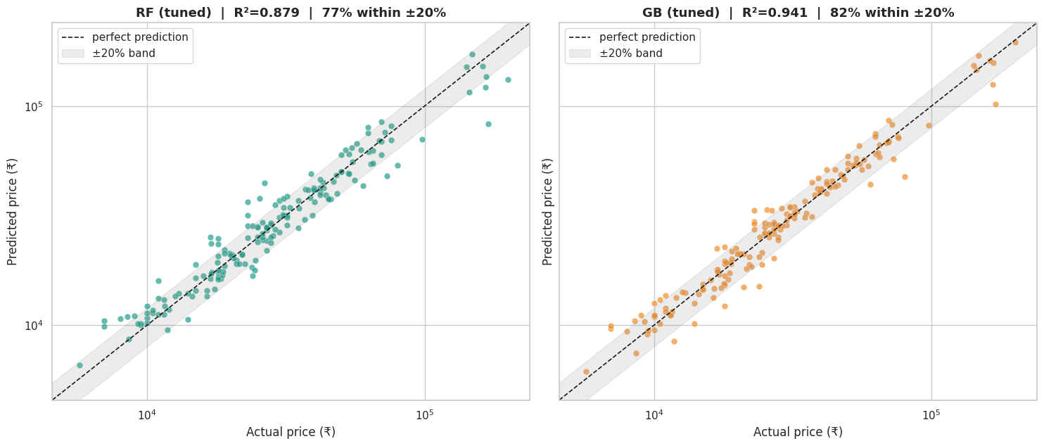
Figure 4.21: Study 3 predicted versus actual price for tuned Random Forest and Gradient Boosting (log axes, ±20% band)
Points close to the dashed diagonal are accurate predictions and the shaded band marks ±20% error. Gradient Boosting’s points are tighter around the diagonal; larger scatter appears at the high-price end, where flagships and foldables are rare.
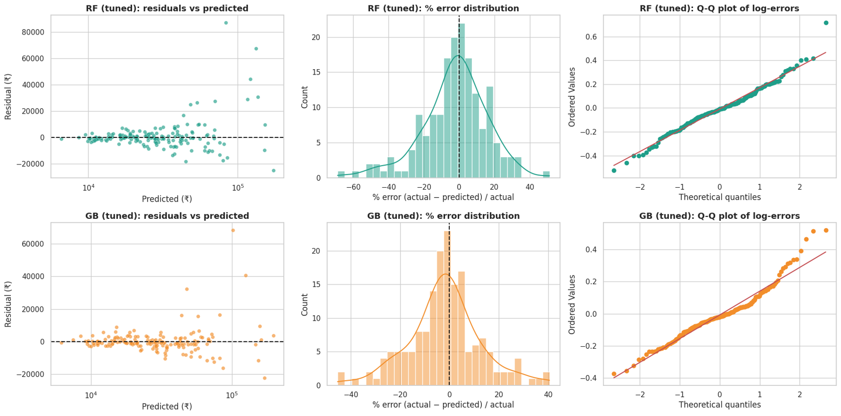
Figure 4.22: Study 3 residual analysis: residuals versus predicted price, percentage error distribution and Q-Q plot of log error
The residual plots check for systematic bias and heteroscedasticity: absolute residuals grow with price, which is why percentage error (MAPE) is also reported. The error histograms are centred near zero and the Q-Q plots of the log error show whether errors are close to normal.

4.4.4 Cross-validation stability
Table 4.21: 10-fold cross-validation of the tuned models on the training set (Study 3)
Model | Mean R² | Mean MAE (₹)
Random Forest | 0.917 ± 0.055 | 5,233
Gradient Boosting | 0.940 ± 0.045 | 4,256

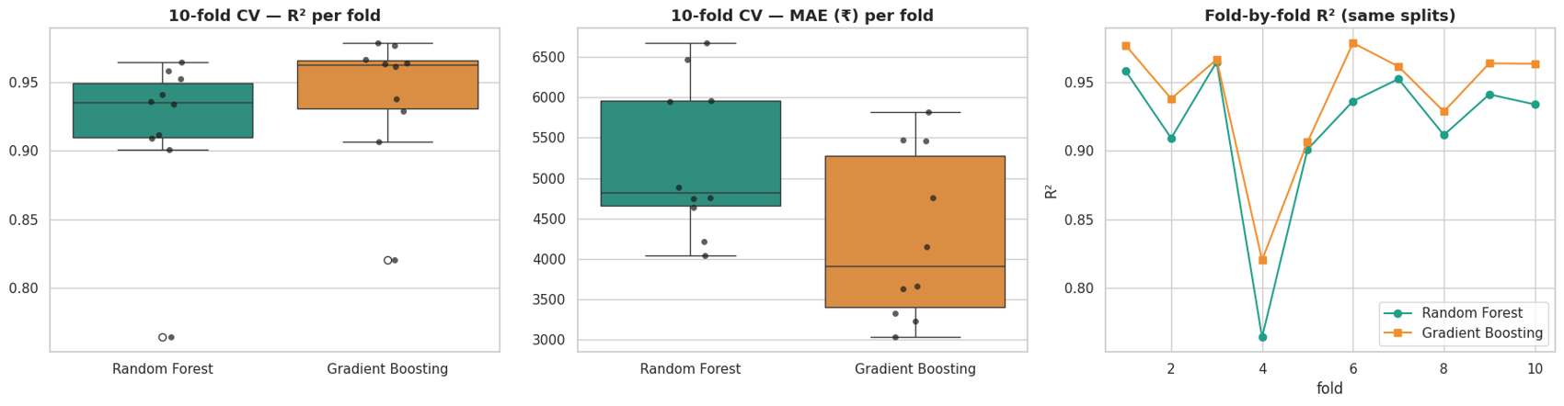
Figure 4.23: Study 3 10-fold cross-validation R² and MAE per fold for both models
Gradient Boosting has higher R² and lower MAE in cross-validation too. A paired t-test on fold MAE gave t = 11.30 (p < 0.001), so the difference is statistically significant, although an informal test because the folds share training data.

4.4.5 Interpretation
Table 4.22: Top-5 impurity importances (Study 3)
Rank | Random Forest | Gradient Boosting
1 | processor_speed | ram_size
2 | megapixels (screen) | megapixels (screen)
3 | internal_memory | internal_memory
4 | ram_size | ppi
5 | ppi | res_w

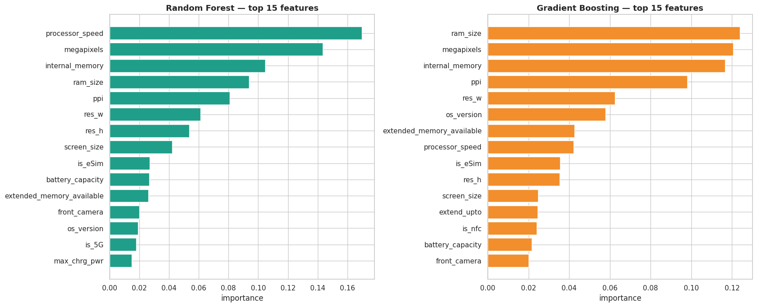
Figure 4.24: Study 3 top-15 impurity-based feature importances for both models
The most important features are RAM, screen megapixels (resolution), internal memory, pixel density and processor speed. Display resolution features appear because high-end phones have sharper screens.
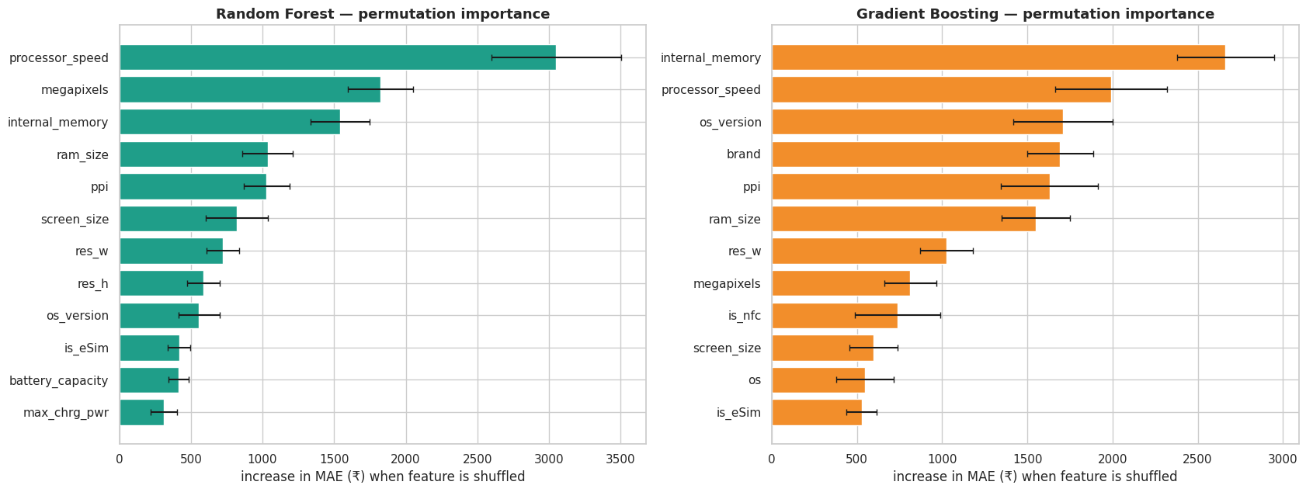
Figure 4.25: Study 3 permutation importance on the unseen test set (increase in MAE in ₹ when a feature is shuffled)
Shuffling a feature and measuring how much the error increases shows what the models actually rely on. Because it is computed on unseen data, it shows which raw columns the trained models truly depend on, and it is a more reliable guide than the impurity ranking.
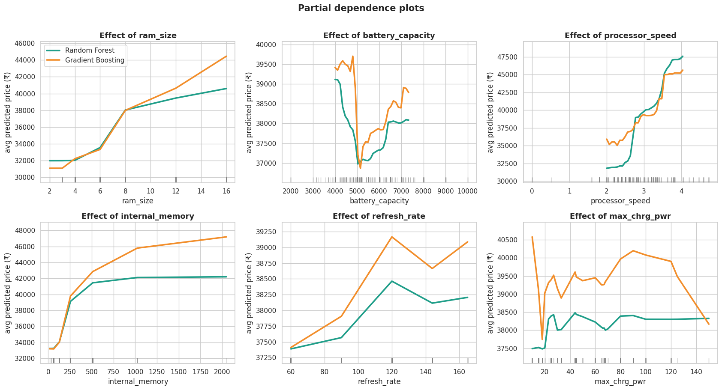
Figure 4.26: Study 3 partial dependence of average predicted price on RAM, battery, processor speed, internal memory, refresh rate and charging power
The curves show the shape of each feature’s effect with both models overlaid: predicted price rises with RAM, storage, processor speed and refresh rate, while battery capacity has a weaker effect. The rug marks show where data are sparse, where the curves are less reliable.
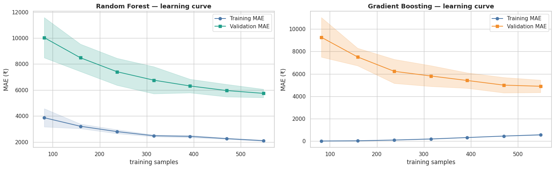
Figure 4.27: Study 3 learning curves (training and validation MAE against training size)
The validation error is still falling as the training set grows and a gap remains between training and validation MAE, which indicates mild over-fitting and suggests that more data would help.

4.4.6 Error analysis by price segment and brand
Table 4.23: Out-of-fold error by price segment for all 858 phones (Study 3)
Segment | n | MAE RF (₹) | MAE GB (₹) | MAPE RF (%) | MAPE GB (%)
Budget < ₹15k | 138 | 1,725 | 1,546 | 16.2 | 14.7
Mid ₹15–30k | 363 | 2,660 | 2,228 | 12.1 | 10.1
Upper-mid ₹30–60k | 227 | 4,405 | 3,728 | 10.4 | 8.5
Flagship > ₹60k | 130 | 17,428 | 12,964 | 15.5 | 12.2

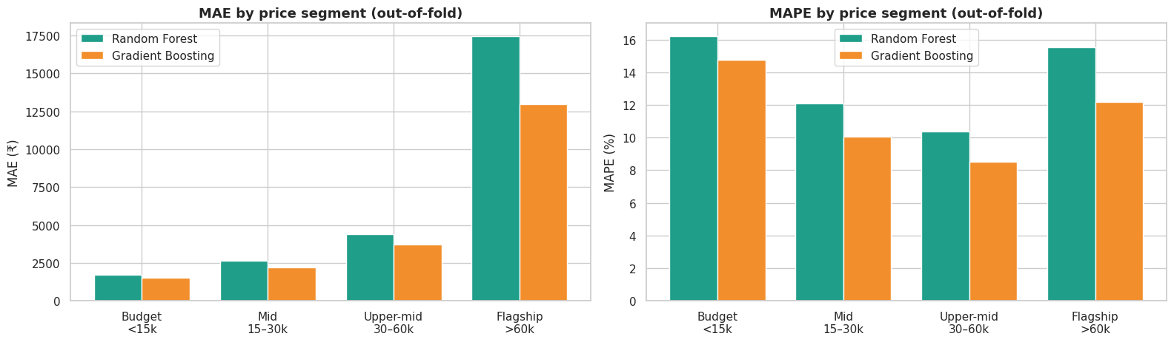
Figure 4.28: Study 3 prediction error by price segment (MAE and MAPE) for Random Forest and Gradient Boosting
Absolute error is largest for flagships (about ₹13,000 for GB against about ₹1,500 for budget phones), but relative error is similar across segments. Gradient Boosting is better in every segment, and its percentage error is lowest (8.5%) in the upper-mid segment.
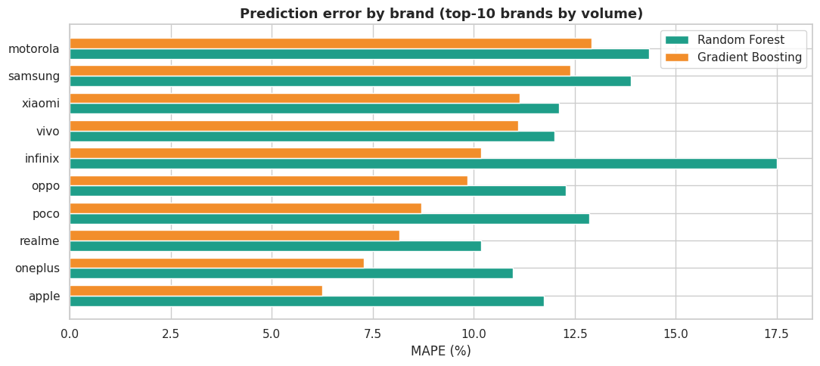
Figure 4.29: Study 3 prediction error by brand (MAPE of the top-10 brands)
The chart ranks the ten most frequent brands by mean absolute percentage error for both models, showing that prediction accuracy differs between brands; brands that carry a brand or design premium (see the value-for-money analysis below) are the natural candidates for larger errors.

4.4.7 Value-for-money analysis
Using out-of-fold Gradient Boosting predictions as the “fair price” implied by the specifications, the gap between actual and fair price highlights phones that are cheap or expensive for what they offer.
Table 4.24: Phones priced furthest below their spec-implied price (Study 3)
Phone | Price (₹) | Fair price (₹) | Gap
Motorola Edge 20 Pro 5G | 20,750 | 37,600 | −44.8%
Samsung Galaxy F05 | 6,499 | 11,500 | −43.5%
Nothing Phone 3 (16 GB + 512 GB) | 54,999 | 93,300 | −41.1%
Tecno Spark Go 5G | 9,999 | 16,500 | −39.4%
Samsung Galaxy F16 5G (8 GB + 128 GB) | 15,499 | 24,500 | −36.7%

Table 4.25: Phones priced furthest above their spec-implied price (Study 3)
Phone | Price (₹) | Fair price (₹) | Gap
Realme C63 5G | 24,999 | 12,800 | +95.3%
Nothing Phone 3 5G | 79,999 | 45,300 | +76.6%
OPPO Find X9 Ultra | 169,999 | 96,300 | +76.5%
Vivo V60 5G | 50,302 | 28,700 | +75.3%
Google Pixel 9 Pro | 109,999 | 67,700 | +62.5%

Phones with positive gaps are priced above what their specifications alone imply, consistent with a brand or design premium; negative gaps indicate good value on specifications.

4.4.8 Bonus: four-segment classification
Table 4.26: Price-segment classification on 172 test phones (Study 3)
Model | Accuracy | Balanced acc. | Macro F1 | Weighted F1 | MCC | CV macro-F1
Random Forest | 0.866 | 0.877 | 0.867 | 0.865 | 0.812 | 0.817
Gradient Boosting | 0.808 | 0.799 | 0.804 | 0.806 | 0.725 | 0.818

Table 4.27: Class-wise results of the segment classifiers (Study 3)
Model / class | Precision | Recall | F1 | Support
RF · Budget | 0.806 | 0.893 | 0.847 | 28
RF · Mid | 0.877 | 0.877 | 0.877 | 73
RF · Upper-mid | 0.897 | 0.778 | 0.833 | 45
RF · Flagship | 0.862 | 0.962 | 0.909 | 26
GB · Budget | 0.821 | 0.821 | 0.821 | 28
GB · Mid | 0.810 | 0.877 | 0.842 | 73
GB · Upper-mid | 0.775 | 0.689 | 0.729 | 45
GB · Flagship | 0.840 | 0.808 | 0.824 | 26

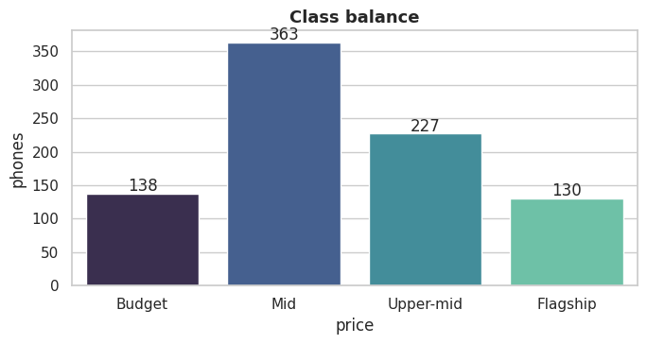
Figure 4.30: Study 3 class balance of the four price segments
The segments are Budget (138), Mid (363), Upper-mid (227) and Flagship (130); the Mid segment is the largest, so class weights and macro-averaged metrics are used.
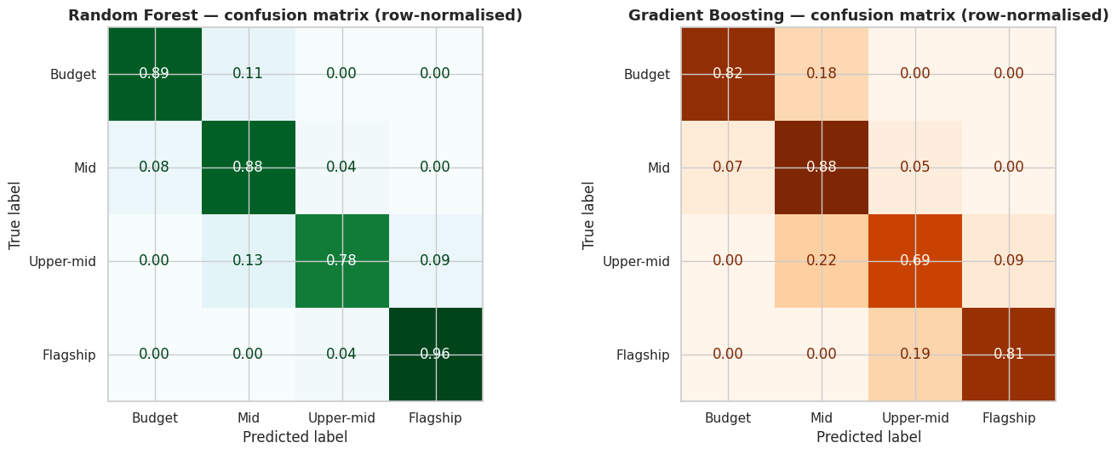
Figure 4.31: Study 3 normalised confusion matrices for the Random Forest and Gradient Boosting segment classifiers
Random Forest identifies 96% of Flagship and 89% of Budget phones; Upper-mid is the hardest segment (recall 0.78 for RF and 0.69 for GB), as it lies between Mid and Flagship.
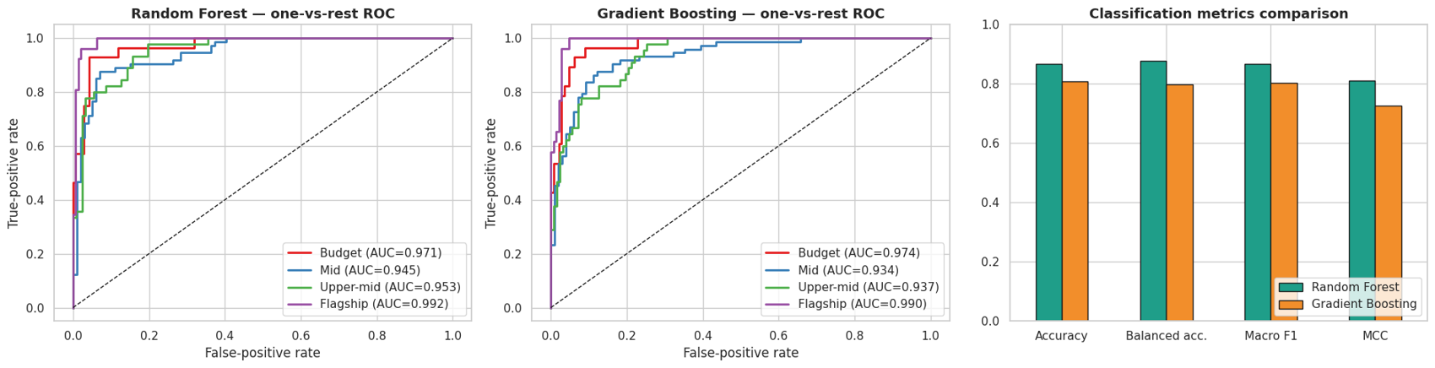
Figure 4.32: Study 3 one-vs-rest ROC curves for the four segments and classification-metric comparison
The ROC curves (AUC per segment in the legend) show how well each segment is ranked, and the bar chart shows that Random Forest scores higher than Gradient Boosting on accuracy, balanced accuracy, macro-F1 and MCC in this task.

4.4.9 Overall comparison and prediction demo
Table 4.28: Final comparison of tuned models (Study 3)
Metric | Random Forest | Gradient Boosting | Winner
Test MAE (₹) | 5,537 | 3,887 | Gradient Boosting
Test RMSE (₹) | 11,555 | 8,088 | Gradient Boosting
Test MAPE (%) | 13.54 | 10.75 | Gradient Boosting
Test R² | 0.879 | 0.941 | Gradient Boosting
Test R² (log price) | 0.936 | 0.956 | Gradient Boosting
10-fold CV R² | 0.917 | 0.940 | Gradient Boosting
Segment accuracy | 0.866 | 0.808 | Random Forest
Segment macro-F1 | 0.867 | 0.804 | Random Forest

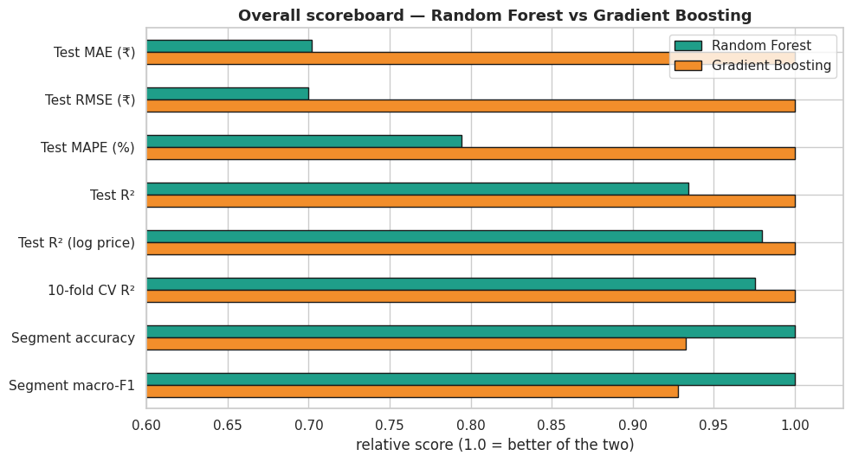
Figure 4.33: Study 3 final comparison summary: number of metrics won by each model
Gradient Boosting wins six of the eight comparison metrics (all regression metrics), whereas Random Forest wins the two segment-classification metrics.
As a demonstration, a hypothetical Samsung phone (Snapdragon 8 Gen 3, 12 GB RAM, 256 GB storage, 5,000 mAh, 200 MP camera, 6.7-inch 1440 × 3120 120 Hz display) was priced: Random Forest predicted ₹83,044, Gradient Boosting ₹83,655, and their average is ₹83,350; the spread of the individual Random Forest trees gives an 80% range of about ₹55,999 to ₹119,999.

4.5 Comparative Discussion across the Three Studies
Table 4.29: Best result by study
Study | Task | Random Forest | Gradient Boosting | Better model
1: Mobiles 2025 | 3 tiers (USD) | Acc 0.836, F1 0.841, AUC 0.965 | Acc 0.836, F1 0.839, AUC 0.949 | Equivalent (RF slightly)
2: Final Mobile Dataset | 3 tiers (INR) | Acc 0.810, F1 0.808, AUC 0.941 | Acc 0.800, F1 0.799, AUC 0.947 | Equivalent
3: Smartphones v4 | Price regression | MAE ₹5,537, R² 0.879 | MAE ₹3,887, R² 0.941 | Gradient Boosting
3: Smartphones v4 | 4 segments | Acc 0.866, F1 0.867 | Acc 0.808, F1 0.804 | Random Forest

Answers to the research questions.
RQ1 (discrimination). Yes. Specifications and brand reach 81–84% accuracy on three balanced tiers and 81–87% on four segments, with macro ROC-AUC of 0.94–0.97, far above chance.
RQ2 (key specifications). RAM and storage have the strongest univariate relationship with price in all studies (ρ about 0.5–0.6; ε² 0.33–0.35). Inside trained models the most relied-upon features are RAM, storage, front camera, display features and the engineered battery_per_inch ratio. Processor family and the iOS flag are decisive for the brands they identify (Apple is 100% Premium).
RQ3 (RF vs GB for tiers). Practically equivalent: about one percentage point apart in different directions depending on the metric, and the McNemar test (p = 0.82) finds no significant difference. Random Forest has slightly better test accuracy and macro-F1; Gradient Boosting has better calibration and cross-validated macro-F1.
RQ4 (regression). Tuned Gradient Boosting estimates price with an average error of ₹3,887 (10.8%) and R² = 0.941, significantly better than Random Forest.
RQ5 (failures). Failures occur mainly in the Mid-Range tier and for phones priced within a few thousand rupees of a tier boundary; 98% of errors in Study 2 are one tier off. In regression the error is largest in absolute terms for flagships.
RQ6 (data-quality sensitivity). Repairing the corrupted RAM values improves CV macro-F1 by about 2 points; whether they are recoded to 12 GB or treated as missing makes no measurable difference on a 210-phone test set.

4.6 Chapter Summary
The experiments show that smartphone price tier can be predicted from hardware specifications with about 80–84% accuracy, that the two ensemble algorithms are nearly interchangeable for tier classification, and that tuned Gradient Boosting is the better regressor of actual price. The errors are mostly near-misses at tier boundaries. The next chapter summarises the conclusions, limitations and future work.

CHAPTER 5: CONCLUSION AND FUTURE SCOPE

5.1 Conclusion
This project investigated whether the price tier and the price of a smartphone can be predicted from its hardware specifications, using three datasets and two tree-ensemble algorithms, Random Forest and Gradient Boosting, within a leakage-safe KDD workflow.
Tier classification. On the Mobiles Dataset 2025 (USD tiers) both models classified 83.6% of 183 test phones correctly (macro-F1 0.841 for Random Forest and 0.839 for Gradient Boosting; ROC-AUC 0.965 and 0.949). On the Final Mobile Dataset (INR tiers), after repairing the corrupted RAM and storage fields, Random Forest reached 81.0% accuracy (macro-F1 0.808) and Gradient Boosting 80.0% (macro-F1 0.799), with macro ROC-AUC of 0.941 and 0.947. The tests of model difference (Wilcoxon p = 0.007 on cross-validation folds, McNemar p = 0.82 on the test set) support treating the two as practically equivalent.
Price regression. On Smartphones v4, tuned Gradient Boosting predicted price with a mean absolute error of ₹3,887 (MAPE 10.8%) and R² = 0.941, clearly better than tuned Random Forest (₹5,537; R² = 0.879). Random Forest was better for the four-segment classification (accuracy 0.866 against 0.808).
What drives price. RAM and storage are the strongest signals in all three studies. Engineered ratios such as battery per inch and ROM per RAM contributed measurable signal, and display, front camera and processor features add information; Apple/iOS identifies the Premium tier almost perfectly. Refresh rate and rear camera megapixels carry little information because almost every phone shares the same values.
How the models fail. About 98% of misclassifications are one tier away from the truth and cluster at tier boundaries; Mid-Range is the hardest class. Regression error is largest for flagships in absolute terms but similar across segments in percentage terms. The models are more confident when they are right, so low-confidence predictions can be flagged for manual review.
Data quality matters. Leaving the corrupted RAM values in the data lowered cross-validated macro-F1 by about 2 points, while the exact repair choice did not change the conclusions. The practical lesson is that auditing and repairing the data deserves as much attention as model choice.
Overall, the work shows that hardware specifications explain a large part of smartphone pricing but not all of it: brand strategy, design and marketing remain outside the features, which is why roughly one phone in five is placed in the wrong tier.

5.2 Limitations
- Launch prices only. Prices are not adjusted for inflation, exchange rates or later discounts, and tiers are relative to each dataset.
- Dataset size and representativeness. The datasets hold 858 to 1,049 phones and test sets of 172 to 210 phones, so one test phone changes accuracy by about half a percentage point and small differences between models are not meaningful.
- Assumption in Study 2. The recoding of RAM = 1 and 2 to 12 GB is an assumption; it was tested in a sensitivity analysis but not verified against an external source.
- Missing explanatory factors. Brand reputation, design, marketing, launch timing and software features are not captured by the specification columns.
- Three separate datasets. The datasets have different currencies, features and time periods and were not combined, so cross-dataset transfer was not tested.
- Over-fitting. Training scores are consistently higher than test scores (a train–validation gap of about 0.11 macro-F1 in Study 2), indicating moderate over-fitting typical of tree ensembles on small data.
- Model scope. Only two algorithms were compared; other learners such as XGBoost, LightGBM, ordinal regression or neural networks were not tested.

5.3 Future Scope
- Combine the datasets into one larger collection with a common feature schema and test cross-dataset generalisation (train on one market, test on another).
- Add features such as launch date, brand tier, chipset benchmark scores, display brightness, camera sensor size and user reviews.
- Adjust prices for inflation and exchange rates so that tiers are comparable across years and markets.
- Use ordinal classification or regression-based tiers so that Budget-to-Premium errors are penalised more than adjacent-tier errors.
- Calibrate probabilities (isotonic or Platt) and flag predictions with confidence below about 0.6 as borderline.
- Compare with XGBoost, LightGBM and stacking ensembles, and test SHAP values for explanations of individual predictions.
- Package the saved models into a small web application that returns a price estimate, a tier and a value-for-money indicator for a given specification.

5.4 Final Remarks
The project provides a rigorous comparison of Random Forest and Gradient Boosting on three smartphone datasets. Its main contributions are the documented repair and sensitivity analysis of corrupted data, the combination of statistical testing with model interpretation, the error analysis that shows errors are mostly near-misses, and the value-for-money application of the regression model. The findings are useful for market segmentation and price benchmarking, but they describe the particular datasets analysed and should be validated on new data before any commercial use.

CHAPTER 6: REFERENCES
[1] S. Rosen, “Hedonic prices and implicit markets: Product differentiation in pure competition,” Journal of Political Economy, vol. 82, no. 1, pp. 34–55, 1974.
[2] L. Breiman, “Random forests,” Machine Learning, vol. 45, pp. 5–32, 2001. doi: 10.1023/A:1010933404324.
[3] J. H. Friedman, “Greedy function approximation: A gradient boosting machine,” The Annals of Statistics, vol. 29, no. 5, pp. 1189–1232, 2001. doi: 10.1214/aos/1013203451.
[4] F. Pedregosa et al., “Scikit-learn: Machine learning in Python,” Journal of Machine Learning Research, vol. 12, pp. 2825–2830, 2011.
[5] U. Fayyad, G. Piatetsky-Shapiro, and P. Smyth, “From data mining to knowledge discovery in databases,” AI Magazine, vol. 17, no. 3, pp. 37–54, 1996.
[6] T. Hastie, R. Tibshirani, and J. Friedman, The Elements of Statistical Learning, 2nd ed. New York, NY, USA: Springer, 2009.
[7] W. H. Kruskal and W. A. Wallis, “Use of ranks in one-criterion variance analysis,” Journal of the American Statistical Association, vol. 47, no. 260, pp. 583–621, 1952.
[8] T. Fawcett, “An introduction to ROC analysis,” Pattern Recognition Letters, vol. 27, no. 8, pp. 861–874, 2006.
[9] T. Saito and M. Rehmsmeier, “The precision-recall plot is more informative than the ROC plot when evaluating binary classifiers on imbalanced datasets,” PLoS ONE, vol. 10, no. 3, Art. no. e0118432, 2015.
[10] B. W. Matthews, “Comparison of the predicted and observed secondary structure of T4 phage lysozyme,” Biochimica et Biophysica Acta, vol. 405, no. 2, pp. 442–451, 1975.
[11] G. W. Brier, “Verification of forecasts expressed in terms of probability,” Monthly Weather Review, vol. 78, no. 1, pp. 1–3, 1950.
[12] Q. McNemar, “Note on the sampling error of the difference between correlated proportions or percentages,” Psychometrika, vol. 12, no. 2, pp. 153–157, 1947.
[13] F. Wilcoxon, “Individual comparisons by ranking methods,” Biometrics Bulletin, vol. 1, no. 6, pp. 80–83, 1945.
[14] H. Cramér, Mathematical Methods of Statistics. Princeton, NJ, USA: Princeton University Press, 1946.
[15] T. Chen and C. Guestrin, “XGBoost: A scalable tree boosting system,” in Proc. 22nd ACM SIGKDD Int. Conf. Knowledge Discovery and Data Mining, 2016, pp. 785–794.
[16] “Mobiles Dataset (2025),” file Mobiles_Dataset__2025_.csv, dataset supplied for this project (930 phones, 15 columns).
[17] “Final Mobile Dataset,” file final_mobile_dataset.csv, dataset supplied for this project (1,056 phones, 14 columns, INR prices).
[18] “Smartphones v4,” file smartphones_v4.csv, dataset supplied for this project (858 phones, 29 columns, INR prices).

