A
Synopsis on

Walmart Sales Data Analysis and Forecasting Dashboard

in partial fulfilment of the requirement for the degree of
BACHELOR OF TECHNOLOGY
In

COMPUTER SCIENCE AND ENGINEERING (DATA SCIENCE)
Submitted By :-

Barkha Jha (2201331540064)

Under the supervision of

Ms. Garima Dhawan



NOIDA INSTITUTE OF ENGINEERING AND TECHNOLOGY
GREATER NOIDA

The main report (After the content page) must consist of following chapters:

Chapter 1- Introduction
  - Objective
  - Problem Definition
  - Definitions, Acronyms and Abbreviations
  - Technologies to be used

Chapter 2- Software Requirement Specifications
  - Introduction
    - Purpose
    - Project Scope
  - Overall Description
    - Product/Project Perspective
    - Product/Project Function
    - User Classes and Characteristics
    - Operating Environment
    - Architecture Design

    - Constraints
    - Use Case Model Description
    - Assumptions and Dependencies

Chapter 3- System Implementation (not req for synopsis)
  - Coding
  - Testing
  - Snapshots

Chapter 4- Conclusions and future scope
  - Conclusion
  - Future Scope

STUDENT’S DECLARATION

I hereby certify that the work which is being presented in the major project report entitled “Walmart Sales Data Analysis and Forecasting Dashboard” in fulfillment of the requirement for the award of the Degree of Bachelor of Technology in Department of Data Science of Noida Institute of Engineering and Technology, Greater Noida ,Uttar Pradesh is an authentic record of my own work carried out during 8th semester.

Date: 17/3/2026 Barkha Jha

The major project viva-voce examination of Ms. Barkha Jha, Roll No 2201331540064 Of
B.TECH ( Branch) has been held on .

Signature of:

Project Guide: Ms. Garima Dhawan Head of Dept:
(Stamp of organization)

External Examiner: Internal Examiner

ACKNOWLEDGEMENT

I would like to express my sincere gratitude to Noida Institute of Engineering & Technology, Department of Computer Science and Engineering (Data Science), for providing me with the opportunity to work on the project titled "Walmart Sales Data Analysis and Forecasting Dashboard".
I am deeply thankful to my project guide Ms. Garima Dhawan, for his valuable guidance, continuous encouragement, and constructive suggestions throughout the development of this project. His support helped me successfully complete this work.
I would also like to extend my gratitude to all faculty members of the Department of CSE (Data Science) for their continuous support and motivation during the course of this project.
I would also like to thank my friends and classmates for their suggestions, cooperation, and encouragement during the project development.
Finally, I express my heartfelt gratitude to my family for their constant support, motivation, and encouragement throughout this project.
This project has helped me gain practical knowledge in Data Analysis, Machine Learning, Power BI, and Data Visualization, and enhanced my technical and analytical skills

Barkha Jha

B.Tech CSE (Data Science)

CHAPTER-1 INTRODUCTION

INTRODUCTION

T Retail businesses generate a large volume of transactional data every day through customer purchases, product sales, and payment transactions. This data contains valuable insights that can help organizations understand business performance, customer behavior, and product demand. However, extracting meaningful insights from raw data is challenging without proper analytical tools and techniques.
With the growth of data science and business intelligence tools, organizations can now analyze historical data to identify patterns and make data-driven decisions. Retail companies such as Walmart operate across multiple locations and deal with thousands of products and customers daily. Analyzing such data manually is difficult and inefficient. Therefore, automated data analytics systems are required to improve decision-making and operational efficiency.
The Walmart Sales Data Analysis and Forecasting Dashboard project aims to develop a complete analytics solution that analyzes retail sales data and provides meaningful insights. The project focuses on understanding sales performance across different branches, product categories, customer segments, and payment methods. It also analyzes time-based sales trends such as hourly and monthly sales patterns.
In addition to data analysis, this project also implements machine learning forecasting models to predict future sales trends. Forecasting helps businesses in planning inventory, managing staffing, improving marketing strategies, and increasing profitability.
This project integrates multiple technologies including:
- Python for data analysis
- Machine learning models for forecasting
- Power BI for interactive dashboards
- Streamlit for web-based deployment
The system follows a complete data science workflow:
Dataset Collection → Data Preprocessing → Exploratory Data Analysis → Forecasting Models → Dashboard Development → Web Application
The final output of this project is an interactive sales analytics dashboard that helps business stakeholders monitor performance, identify trends, and make strategic decisions.
This project demonstrates how data science and business intelligence can be used together to solve real-world retail problems and improve business performance.

Objective:
The main objective of the Walmart Sales Data Analysis and Forecasting Dashboard project is to develop a data-driven system that analyzes retail sales data and provides meaningful insights to support business decision-making. The project focuses on understanding sales performance, customer behavior, product demand, and predicting future sales trends using data analytics and machine learning techniques.
Retail businesses generate large amounts of transactional data every day. However, without proper analysis, this data cannot be effectively utilized for improving business strategies. Therefore, this project aims to transform raw sales data into actionable insights through visualization and predictive analytics.

Primary Objectives
- To analyze sales performance
  - Evaluate overall revenue, gross income, and sales volume.
  - Identify high-performing branches and cities.
  - Understand overall business growth patterns.
- To understand customer behavior
  - Analyze customer demographics such as gender and customer type.
  - Identify purchasing trends and customer preferences.
  - Evaluate customer satisfaction using rating analysis.
- To analyze product performance
  - Identify top-selling product categories.
  - Compare performance across product lines.
  - Understand demand distribution among products.
- To analyze payment methods
  - Identify preferred payment modes.
  - Understand digital payment adoption trends.
  - Evaluate revenue contribution by payment method.
- To analyze time-based sales trends
  - Identify peak sales hours.
  - Analyze monthly sales growth.
  - Understand daily and hourly sales patterns.
- To develop forecasting models
  - Use machine learning techniques to predict future sales.
  - Apply ARIMA and Linear Regression models.
  - Evaluate model performance using error metrics.
- To develop an interactive dashboard
  - Build Power BI dashboard for visualization.
  - Provide interactive filters and insights.
  - Enable easy data exploration.
- To deploy the system
  - Develop Streamlit web application.
  - Integrate dashboard and forecasting models.
  - Create user-friendly analytics platform.

Secondary Objectives
- Improve business decision-making
- Increase operational efficiency
- Optimize inventory planning
- Improve customer satisfaction
- Support strategic planning
The overall objective of this project is to build a complete end-to-end sales analytics and forecasting system that helps businesses understand past performance and predict future trends.

  - Problem Definition:
Retail businesses such as Walmart generate a large amount of transactional data from daily sales activities. This data includes information about products, customers, payment methods, and sales performance. However, many organizations face difficulties in analyzing this data effectively to derive meaningful insights.
Traditional reporting systems often provide static reports that do not allow dynamic analysis. These systems make it difficult for business managers to monitor performance, identify trends, and make data-driven decisions. As a result, businesses may face challenges in improving operational efficiency and maximizing profitability.

Definitions, Acronyms and Abbreviations:
The following definitions and abbreviations are used in this project:
AI (Artificial Intelligence)
Artificial Intelligence refers to the simulation of human intelligence in machines that are programmed to think and make decisions.
ML (Machine Learning)
Machine Learning is a subset of Artificial Intelligence that allows systems to learn patterns from data and make predictions.
EDA (Exploratory Data Analysis)
EDA is the process of analyzing datasets using statistical techniques and visualization to identify patterns and trends.
BI (Business Intelligence)
Business Intelligence refers to technologies and tools used to analyze business data and support decision-making.
KPI (Key Performance Indicator)
KPIs are measurable values used to evaluate business performance such as revenue, customer count, and profit.
ARIMA (AutoRegressive Integrated Moving Average)
ARIMA is a time series forecasting model used to predict future values based on historical data.
DAX (Data Analysis Expressions)
DAX is a formula language used in Power BI for creating calculated measures and columns.
RMSE (Root Mean Square Error)
RMSE is a metric used to measure prediction error in forecasting models.
MAE (Mean Absolute Error)
MAE is used to measure the average prediction error in forecasting models.
Power BI
Power BI is a business intelligence tool used for creating interactive dashboards and reports.
Streamlit
Streamlit is a Python framework used for building interactive web applications.

Technologies to be Used:

The Walmart Sales Data Analysis and Forecasting Dashboard project uses various technologies for data processing, analysis, visualization, and forecasting. These technologies help in building an end-to-end analytics system that provides meaningful business insights and predictions.

1. Programming Language

Python
Python is used as the primary programming language for this project. It is widely used in data science and machine learning due to its simplicity and powerful libraries. Python is used for data preprocessing, exploratory data analysis, and building forecasting models.

2. Python Libraries

Pandas
Pandas is used for data manipulation and preprocessing. It helps in handling datasets, cleaning data, and performing operations such as filtering, grouping, and aggregation.

NumPy
NumPy is used for numerical computations and mathematical operations. It provides support for arrays and helps in performing calculations efficiently.

Matplotlib
Matplotlib is used for data visualization. It helps in creating graphs and charts to understand sales trends and patterns.

Seaborn
Seaborn is used for advanced data visualization. It helps in creating visually appealing statistical charts.

Scikit-learn
Scikit-learn is used for machine learning implementation. It is used for building regression models and evaluating performance.

Statsmodels
Statsmodels is used for time-series forecasting models such as ARIMA.

3. Business Intelligence Tool

Power BI
Power BI is used for creating interactive dashboards and visualizing sales insights. It helps in analyzing branch performance, product performance, customer behavior, and payment trends.

4. Web Application Framework

Streamlit
Streamlit is used to develop a web-based interface for presenting the dashboard and forecasting results. It allows users to interact with the analytics system easily.

5. Machine Learning Models

ARIMA Model
The ARIMA model is used for time-series forecasting. It predicts future sales trends based on historical data.

Linear Regression
Linear Regression is used as a baseline model for forecasting sales values.

6. Development Tools

Jupyter Notebook
Jupyter Notebook is used for data analysis, model building, and visualization.

Google Colab
Google Colab is used as a cloud-based development environment for running Python code.

Power BI Desktop
Power BI Desktop is used for developing interactive dashboards.

7. Dataset

Walmart Sales Dataset
The Walmart dataset contains transaction-level data including:
- Branch
- City
- Customer Type
- Gender
- Product Line
- Quantity
- Total Sales
- Payment Method
- Rating
- Date and Time
This dataset is used for analysis and forecasting.

Chapter 2- Software Requirement Specifications

1 Introduction-
Software Requirement Specification (SRS) describes the functional and non-functional requirements of the Walmart Sales Data Analysis and Forecasting Dashboard. It provides a detailed understanding of the system functionality, features, constraints, and architecture.
This project focuses on developing a Sales Analytics and Forecasting System that analyzes Walmart retail sales data and provides insights for business decision-making. The system integrates data analysis, machine learning, and visualization to create an end-to-end analytics solution.
The SRS document helps in:
- Defining system objectives
- Understanding system requirements
- Planning system architecture
- Identifying system constraints
- Describing system functionality
The Walmart Sales Analytics System is designed to:
- Analyze sales performance
- Understand customer behavior
- Evaluate product performance
- Compare branch performance
- Predict future sales
- Provide interactive dashboards
The system processes historical sales data and generates insights using data analytics techniques. Machine learning models are used to forecast future sales trends. The results are visualized using Power BI dashboards and presented through a Streamlit web application.
This system helps business users and analysts make data-driven decisions and improve operational efficiency.

Purpose-
T The purpose of the Walmart Sales Data Analysis and Forecasting Dashboard is to develop a data-driven system that analyzes retail sales data and provides meaningful insights to improve business performance.
Retail businesses generate large volumes of data daily. However, without proper analysis, this data cannot be utilized effectively. The purpose of this project is to transform raw sales data into actionable insights using data analytics and machine learning techniques.
The key purposes of this project are:

1. Sales Performance Analysis
The system analyzes revenue, gross income, and sales volume to understand overall business performance.

2. Customer Behavior Analysis
The system analyzes customer demographics, purchasing patterns, and customer satisfaction.

3. Product Performance Analysis
The system identifies top-performing products and analyzes product demand.

4. Branch Performance Analysis
The system compares performance across different branches and cities.

5. Time-based Analysis
The system identifies peak sales hours and monthly sales trends.

6. Sales Forecasting
The system uses machine learning models to predict future sales trends.

7. Dashboard Visualization
The system provides interactive dashboards for easy data exploration.
The purpose of this project is to create an end-to-end analytics system that supports business decision-making and improves operational efficiency.

Project Scope-

The purpose of the Walmart Sales Data Analysis and Forecasting Dashboard is to develop a data-driven system that analyzes retail sales data and provides meaningful insights to improve business performance.
Retail businesses generate large volumes of data daily. However, without proper analysis, this data cannot be utilized effectively. The purpose of this project is to transform raw sales data into actionable insights using data analytics and machine learning techniques.
The key purposes of this project are:

1. Sales Performance Analysis
The system analyzes revenue, gross income, and sales volume to understand overall business performance.

2. Customer Behavior Analysis
The system analyzes customer demographics, purchasing patterns, and customer satisfaction.

3. Product Performance Analysis
The system identifies top-performing products and analyzes product demand.

4. Branch Performance Analysis
The system compares performance across different branches and cities.

5. Time-based Analysis
The system identifies peak sales hours and monthly sales trends.

6. Sales Forecasting
The system uses machine learning models to predict future sales trends.

7. Dashboard Visualization
The system provides interactive dashboards for easy data exploration.
The purpose of this project is to create an end-to-end analytics system that supports business decision-making and improves operational efficiency.

OVERALL DESCRIPTION:

The Walmart Sales Data Analysis and Forecasting Dashboard is designed as an end-to-end analytics system that processes sales data and generates insights. The system integrates data analysis, machine learning, and visualization components.
The system performs the following tasks:
- Data collection and preprocessing
- Exploratory data analysis
- Machine learning forecasting
- Dashboard development
- Web application deployment
The system architecture consists of multiple components that work together to provide meaningful insights.

System Workflow
- Data Collection
Sales data is collected from the Walmart dataset.
- Data Preprocessing
The dataset is cleaned and prepared for analysis.
- Exploratory Data Analysis
Data is analyzed to identify patterns and trends.
- Forecasting Models
Machine learning models are applied to predict future sales.
- Dashboard Development
Power BI dashboards are created to visualize insights.
- Web Application
Streamlit web application is developed for easy access.
This system provides an interactive and user-friendly interface that helps users analyze sales data efficiently.

PROJECT PERSPECTIVE:

The Walmart Sales Data Analysis and Forecasting Dashboard is developed as a data-driven business intelligence system designed to analyze retail sales data and provide meaningful insights. The project is developed as a standalone analytics system that integrates data analysis, forecasting, and visualization components.
This system is designed to assist business managers, analysts, and decision-makers in understanding sales performance and predicting future trends. The system collects sales data, processes it using data analytics techniques, and presents the results in the form of interactive dashboards and forecasting reports.
The project follows a modular architecture, where each component performs a specific task. These modules include:

1. Data Collection Module
This module collects the Walmart sales dataset containing transactional data such as product details, customer information, and sales values.

2. Data Preprocessing Module
This module performs data cleaning, handling missing values, and converting date and time formats. Feature engineering is also performed to create new attributes such as month, day, and hour.

3. Exploratory Data Analysis Module
This module analyzes sales patterns, customer behavior, product demand, and branch performance using statistical analysis and visualization techniques.

4. Forecasting Module
This module applies machine learning models such as ARIMA and Linear Regression to predict future sales trends.

5. Dashboard Module
This module uses Power BI to create interactive dashboards that display insights and trends.

6. Web Application Module
This module uses Streamlit to deploy the analytics system as a web application for easy access.
The system architecture can be summarized as:
Dataset → Data Preprocessing → Data Analysis → Forecasting → Dashboard → Web Application
This modular structure ensures that the system is scalable, maintainable, and easy to extend in the future.

Product/Project Function:

The Walmart Sales Data Analysis and Forecasting Dashboard performs several key functions to analyze retail sales data and provide insights.

1. Data Processing Function
The system processes raw sales data and prepares it for analysis. This includes:
- Data cleaning
- Handling missing values
- Feature engineering
- Data transformation

2. Sales Analysis Function
The system analyzes sales performance across different dimensions such as:
- Branch performance
- Product performance
- Customer behavior
- Payment methods
- Time-based trends

3. Visualization Function
The system creates visual representations of data using charts and graphs. These include:
- Bar charts
- Line charts
- Pie charts
- KPI cards

4. Forecasting Function
The system predicts future sales using machine learning models such as:
- ARIMA Model
- Linear Regression
Forecasting helps businesses plan inventory and marketing strategies.

5. Dashboard Function
The system provides an interactive dashboard that allows users to:
- Apply filters
- Compare performance
- View insights
- Analyze trends

6. Reporting Function
The system generates reports and summaries to support business decision-making.
The overall function of this system is to transform raw sales data into actionable insights and predictions.

User Classes And Characteristics:

The Walmart Sales Data Analysis and Forecasting Dashboard is designed for multiple types of users. Each user interacts with the system differently depending on their requirements.

1. Business Managers
Business managers use the system to monitor sales performance and make strategic decisions. They use dashboards to understand revenue trends, branch performance, and product demand.
Characteristics:
- Basic knowledge of business analytics
- Focus on high-level insights
- Uses dashboard for decision-making

2. Data Analysts
Data analysts use the system to analyze detailed sales data and generate insights. They focus on trends, patterns, and forecasting results.
Characteristics:
- Technical knowledge of data analysis
- Uses dashboards and reports
- Performs deeper analysis

3. Retail Store Managers
Store managers use the system to analyze branch-level performance and customer behavior.
Characteristics:
- Limited technical knowledge
- Uses system for operational decisions
- Focus on store performance

4. Students and Researchers
Students and researchers can use this system to understand data analytics and machine learning applications.
Characteristics:
- Learning-oriented users
- Uses system for educational purposes
- Focus on analytics workflow

Operating Environment:

The Walmart Sales Data Analysis and Forecasting Dashboard is developed using a Python-based environment and business intelligence tools.

Software Requirements
- Python 3.x
- Power BI Desktop
- Streamlit
- Jupyter Notebook / Google Colab

Libraries Required
- Pandas
- NumPy
- Matplotlib
- Seaborn
- Scikit-learn
- Statsmodels

Hardware Requirements
- Minimum 4GB RAM
- 8GB RAM recommended
- Standard laptop or desktop

Platform Requirements
- Windows / Linux / MacOS
- Internet connection (optional for deployment)
The system is lightweight and can run on standard systems without requiring high-end hardware.

2.2.5Architecture Design:
The architecture of the Walmart Sales Data Analysis and Forecasting Dashboard follows a data science pipeline structure. The system consists of multiple components that work together to generate insights.

System Architecture Flow
Step 1: Data Collection
The Walmart dataset is collected containing sales transactions.
Step 2: Data Preprocessing
Data cleaning and feature engineering are performed.
Step 3: Exploratory Data Analysis
Sales patterns and trends are analyzed.
Step 4: Machine Learning Forecasting
ARIMA and Linear Regression models are used to predict future sales.
Step 5: Dashboard Development
Power BI dashboards are created.
Step 6: Web Application Deployment
Streamlit is used to deploy the system.

Architecture Diagram Flow

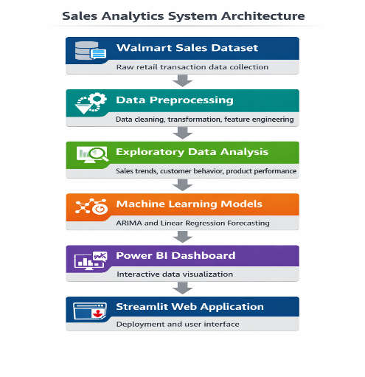
This architecture ensures:
- Scalability
- Flexibility
- Modular design
- Easy maintenance

Constraints:
The Walmart Sales Data Analysis and Forecasting Dashboard system has certain limitations and constraints that may affect system performance and implementation.

1. Data Constraints
- The dataset used in this project contains limited historical data.
- Limited data affects long-term forecasting accuracy.
- Missing or inconsistent data may impact analysis results.

2. Technical Constraints
- Machine learning models require computational resources.
- Forecasting models may take time to train.
- Power BI dashboard performance depends on dataset size.

3. Time Constraints
- Project development time is limited.
- Model optimization and testing time is restricted.

4. System Constraints
- Real-time data integration is not implemented.
- System depends on historical dataset.

5. External Dependencies
- Project depends on Python libraries and Power BI tools.
- Software updates may affect system performance.
Despite these constraints, the system provides meaningful insights and forecasting capabilities.

Use Case Model Description:

The Use Case Model describes how users interact with the system. The system allows users to analyze sales data and generate insights.

Primary Use Case

Actor
- Business Manager
- Data Analyst
- Store Manager

Use Case Flow
- User loads Walmart dataset
- System preprocesses data
- System performs analysis
- System generates insights
- System applies forecasting models
- System displays dashboard
- User interacts with dashboard
- User extracts insights

Use Case Diagram Flow
User
↓
Upload Dataset
↓
Data Preprocessing
↓
Sales Analysis
↓
Forecasting Model
↓
Dashboard Visualization
↓
User Insights This use case ensures smooth interaction between users and system.

Assumptions And Dependencies:
The following assumptions and dependencies are considered in this project:

Assumptions
- The dataset is accurate and reliable
- Users have basic knowledge of dashboards
- Required software tools are installed
- Internet connection available for deployment

Dependencies

Software Dependencies
- Python
- Power BI
- Streamlit
- Jupyter Notebook

Library Dependencies
- Pandas
- NumPy
- Matplotlib
- Seaborn
- Scikit-learn
- Statsmodels

Hardware Dependencies
- Standard laptop or desktop
- Minimum 4GB RAM
- Internet connection
These assumptions ensure proper functioning of the system.

Chapter-3 System Implementation

3.1 Coding

The Walmart Sales Data Analysis and Forecasting Dashboard was implemented using Python, Power BI, and Streamlit. The development process involved data preprocessing, exploratory data analysis, forecasting model implementation, and dashboard development.

Data Preprocessing
The dataset was processed using Python libraries such as Pandas and NumPy. The following steps were performed:
- Handling missing values
- Removing duplicate records
- Converting date and time formats
- Feature engineering (Month, Day, Hour)
- Data validation

Exploratory Data Analysis
Exploratory data analysis was performed to understand sales trends and patterns. Various visualizations were created such as:
- Sales trend analysis
- Branch performance analysis
- Product performance analysis
- Customer behavior analysis
- Payment method analysis

Forecasting Model Implementation
Machine learning models were implemented using Python:
- ARIMA Model
- Linear Regression Model
These models were trained on historical sales data to predict future sales.

Dashboard Development
Power BI was used to create interactive dashboards including:
- Sales Overview Dashboard
- Branch Performance Dashboard
- Product Analysis Dashboard
- Customer Analysis Dashboard
- Payment Analysis Dashboard

Web Application Deployment
Streamlit was used to deploy the analytics system as a web application. The application provides:
- Dashboard integration
- Forecast visualization
- Business insights
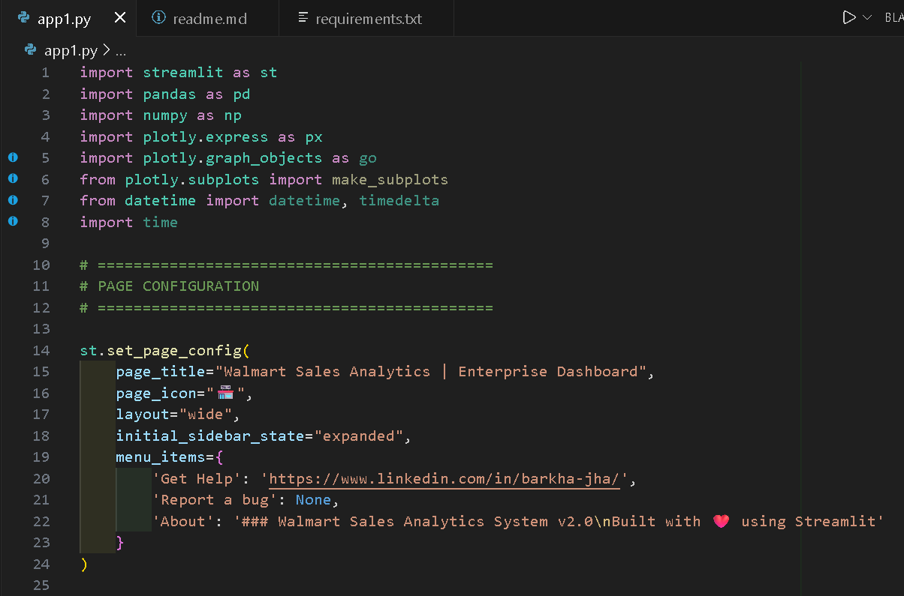
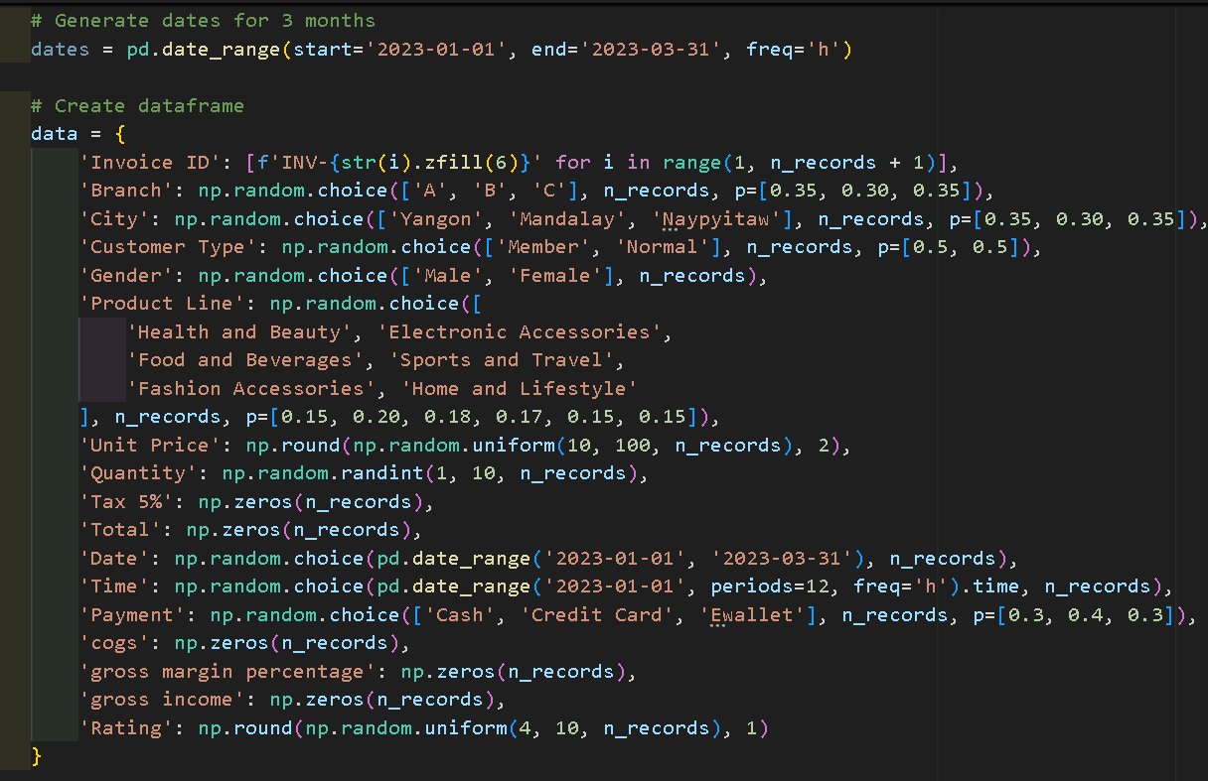
3.2 Testing

Testing was performed to ensure the system functions correctly and provides accurate results.

Testing Methods
- Data Validation Testing
The dataset was checked for missing values and inconsistencies.
- Model Testing
Forecasting models were evaluated using performance metrics:
- Mean Absolute Error (MAE)
- Root Mean Square Error (RMSE)
- Dashboard Testing
The Power BI dashboard was tested for:
- Interactive filters
- Data accuracy
- Visualization performance
- System Testing
The Streamlit web application was tested to ensure smooth functionality.
The testing process ensured that the system provides reliable and accurate insights.

3.3 Snapshots

The following snapshots were included in the project:
- Power BI Dashboard Overview
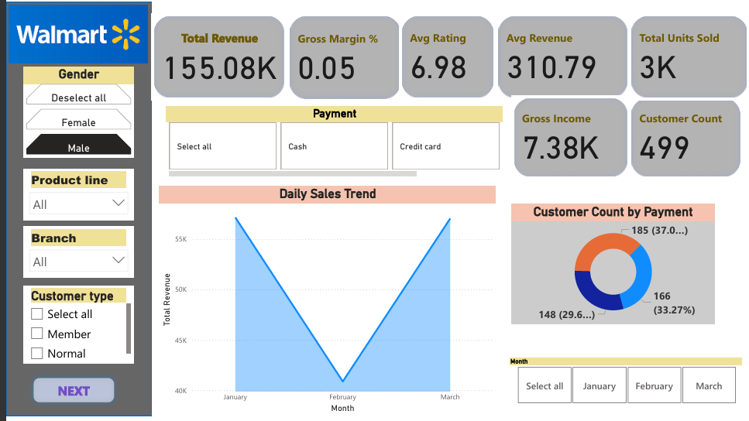

- Branch Performance Dashboard
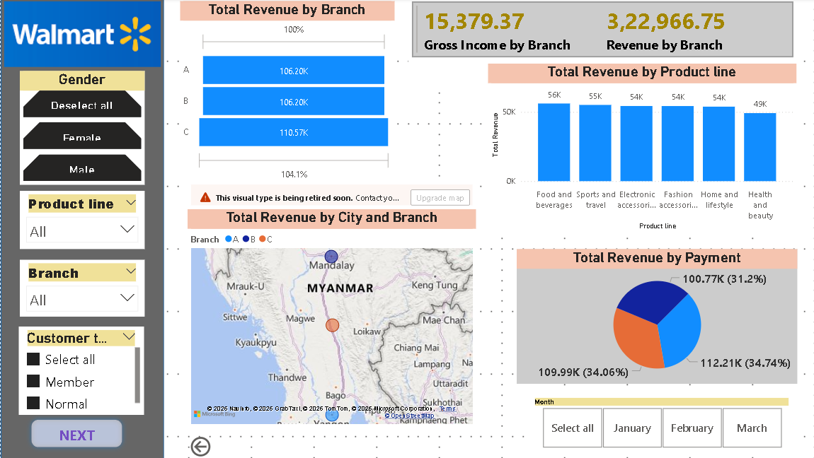
- Product Analysis Dashboard
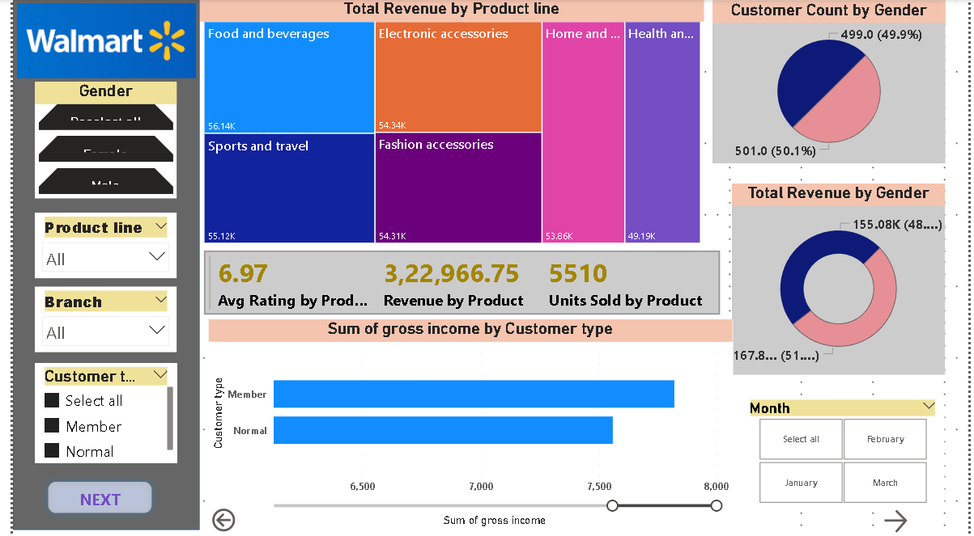
- What if Analysis Dashboard
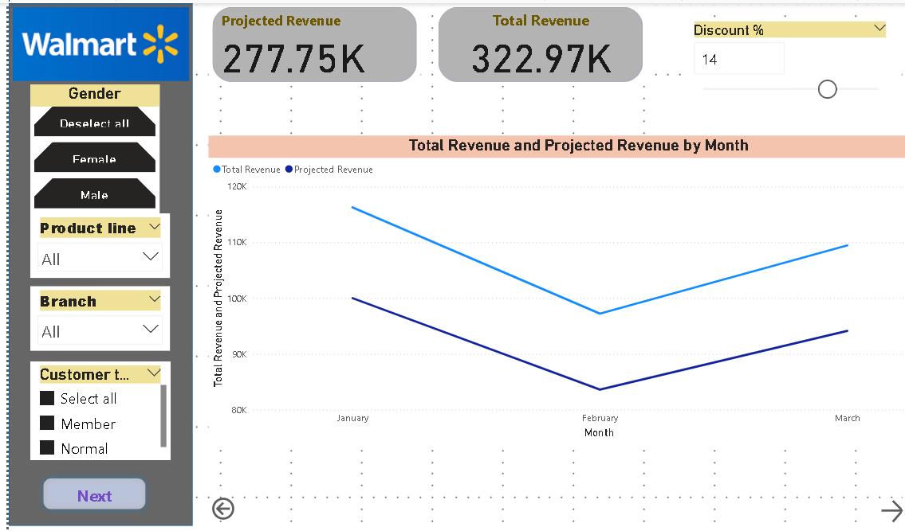
- Forecasting Model Output
- 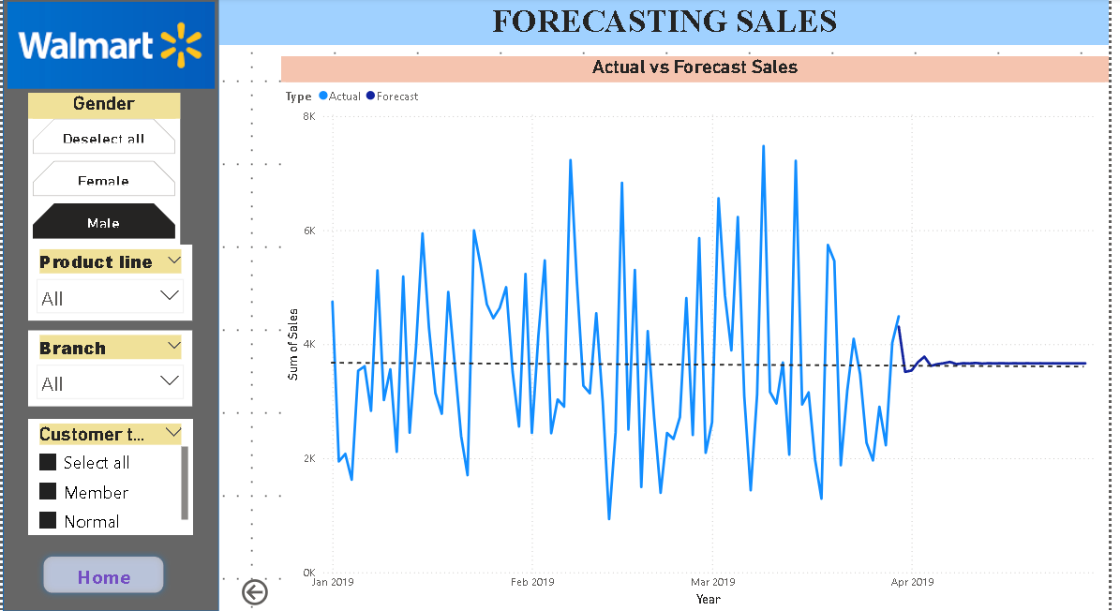
- Streamlit Web Application Interface
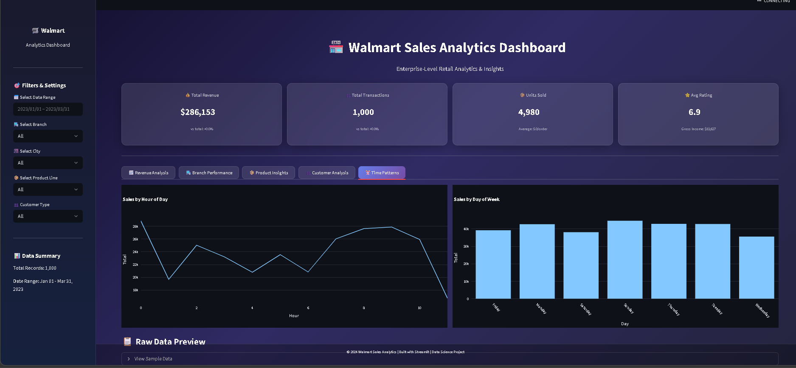
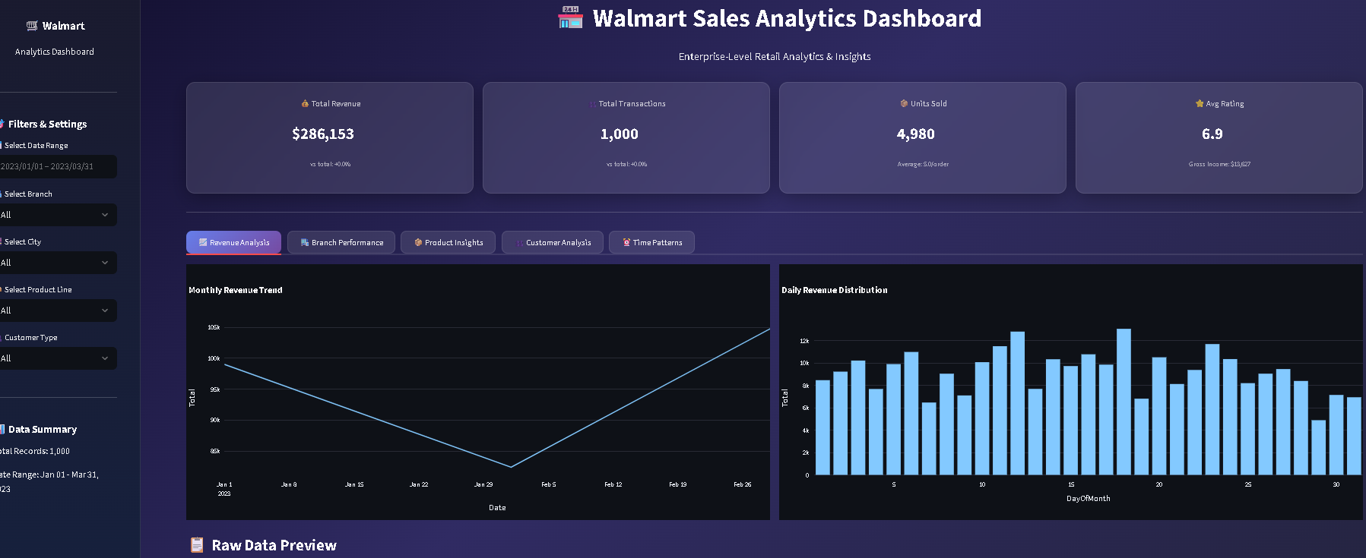
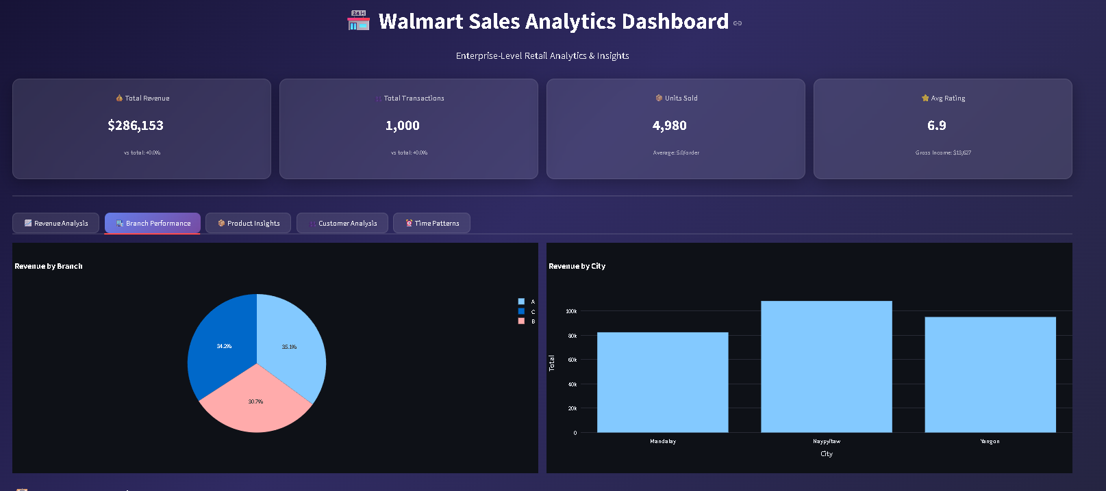
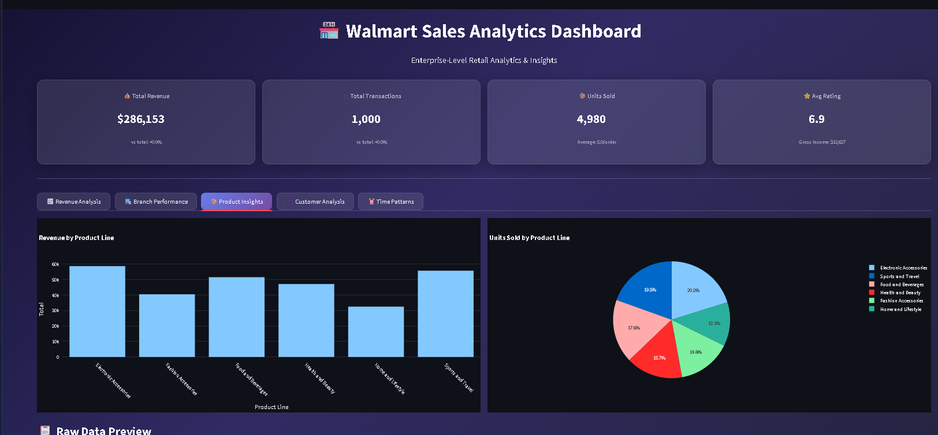
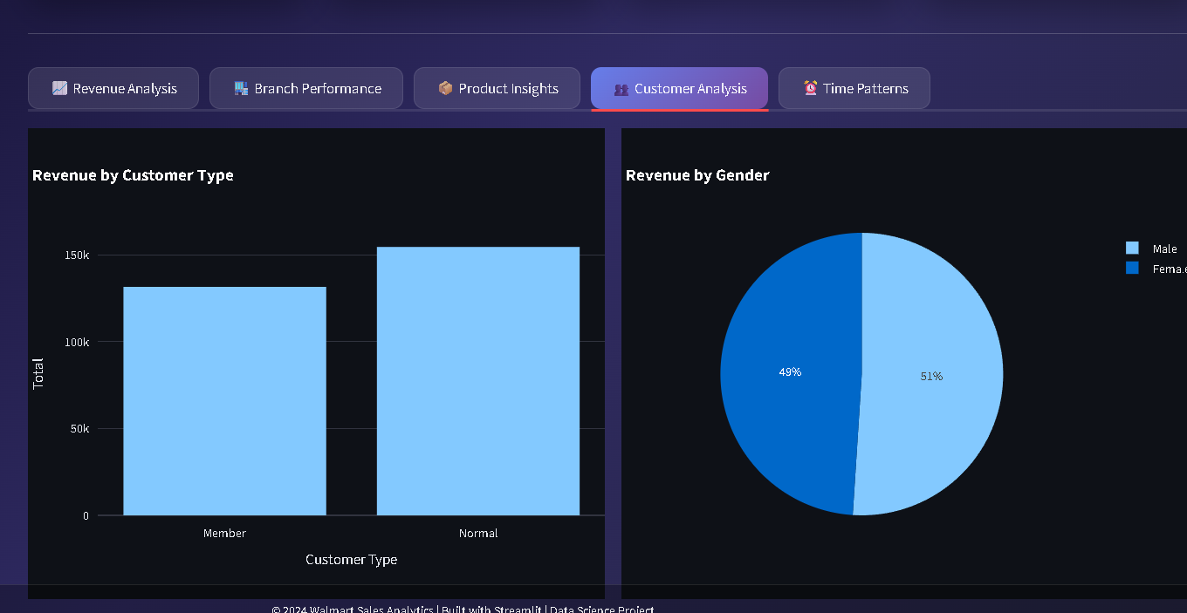

These snapshots demonstrate the implementation and functionality of the system.

Chapter 4 System Implementation

  - Conclusion:

The Walmart Sales Data Analysis and Forecasting Dashboard project successfully developed an end-to-end analytics system for retail sales data. The system integrates data analysis, machine learning, and business intelligence tools to generate meaningful insights and predictions.
The project analyzed Walmart sales data to understand business performance across different dimensions such as branch performance, product demand, customer behavior, and payment methods. The analysis helped identify key business insights such as top-performing branches, popular product categories, and peak sales hours.
The forecasting models implemented in this project helped predict future sales trends. These predictions assist businesses in inventory planning, staffing decisions, and marketing strategies. The forecasting models such as ARIMA and Linear Regression were used to analyze time-series data and generate future sales predictions.
The Power BI dashboard provided interactive visualizations that helped users explore sales data efficiently. The Streamlit web application further enhanced accessibility by providing a user-friendly interface for interacting with the analytics system.
This project demonstrated the practical implementation of data science techniques in solving real-world business problems. It also helped improve skills in data preprocessing, exploratory data analysis, machine learning, dashboard development, and web deployment.
Overall, the Walmart Sales Data Analysis and Forecasting Dashboard project successfully achieved its objectives by building a complete data-driven decision support system for retail businesses.

4.2 Future Scope

The Walmart Sales Data Analysis and Forecasting Dashboard can be further enhanced with additional features and improvements.

1. Real-Time Data Integration
Future work can include integrating real-time sales data to provide live analytics and monitoring.

2. Advanced Machine Learning Models
Advanced models such as LSTM, Prophet, and Random Forest can be implemented to improve forecasting accuracy.

3. Cloud Deployment
The system can be deployed on cloud platforms such as AWS, Azure, or Google Cloud for better scalability and accessibility.

4. Mobile Dashboard
Mobile-friendly dashboards can be developed for better accessibility.

5. Automated Reporting
Automated report generation can be implemented to generate daily or weekly reports.

6. Customer Segmentation
Customer segmentation techniques can be implemented to improve marketing strategies.

7. Inventory Optimization
Forecasting models can be used for inventory planning and stock management.

8. Advanced Visualizations
More advanced interactive dashboards can be developed for deeper insights.
The future improvements will enhance the system and make it suitable for real-world business deployment.

