
NOIDA INSTITUTE OF ENGINEERING AND TECHNOLOGY
GREATER NOIDA, UTTAR PRADESH
(Affiliated to Dr. A.P.J. Abdul Kalam Technical University, Lucknow)
WALMART SALES DATA ANALYSIS AND FORECASTING DASHBOARD
PROJECT SYNOPSIS
OF MAJOR PROJECT
BACHELOR OF TECHNOLOGY
Computer Science & Engineering (Data Science) – 8th Semester
SUBMITTED BY
Barkha Jha
(Roll No. 2201331540064)
UNDER THE SUPERVISION OF
Ms. Garima Dhawan
(Assistant Professor, Dept. of CSE – Data Science)
NOIDA INSTITUTE OF ENGINEERING AND TECHNOLOGY
GREATER NOIDA, UTTAR PRADESH
Session: 2025–2026

STUDENT'S DECLARATION

I hereby certify that the work which is being presented in the minor project synopsis entitled “Walmart Sales Data Analysis and Forecasting Dashboard” in fulfillment of the requirement for the award of the Degree of Bachelor of Technology in Department of Computer Science and Engineering (Data Science) of Noida Institute of Engineering and Technology, Greater Noida, Uttar Pradesh, is an authentic record of my own work carried out during 8th Semester.

The matter presented in this synopsis has not been submitted for the award of any other degree of this or any other University.

Date: 17/03/2026 Barkha Jha

The minor project synopsis viva-voce examination of Ms. Barkha Jha, Roll No. 2201331540064, of B.TECH (CSE – Data Science) has been held on _______________.

Signature of:

Project Guide: Ms. Garima Dhawan Head of Dept: _______________

(Stamp of Organization)

External Examiner: _______________ Internal Examiner: _______________

ACKNOWLEDGEMENT

I would like to express my sincere gratitude to Noida Institute of Engineering & Technology, Department of Computer Science and Engineering (Data Science), for providing me with the opportunity to work on the project titled "Walmart Sales Data Analysis and Forecasting Dashboard".

I am deeply thankful to my project guide Ms. Garima Dhawan, for her valuable guidance, continuous encouragement, and constructive suggestions throughout the development of this project. Her support helped me successfully complete this work.

I would also like to extend my gratitude to all faculty members of the Department of CSE (Data Science) for their continuous support and motivation during the course of this project.

I would also like to thank my friends and classmates for their suggestions, cooperation, and encouragement during the project development.

Finally, I express my heartfelt gratitude to my family for their constant support, motivation, and encouragement throughout this project.

This project has helped me gain practical knowledge in Data Analysis, Machine Learning, Power BI, and Data Visualization, and enhanced my technical and analytical skills.

Barkha Jha
B.Tech CSE (Data Science)
Roll No. 2201331540064

ABSTRACT

The Walmart Sales Data Analysis and Forecasting Dashboard is a comprehensive data science project aimed at analyzing retail sales data and providing actionable business insights. Retail businesses such as Walmart generate massive volumes of transactional data every day, and without proper analytical tools, this data cannot be effectively leveraged for strategic decision-making.

This project develops an end-to-end analytics system that processes historical Walmart sales data and generates meaningful insights through data analysis, machine learning, and interactive visualization. The system analyzes sales performance across different branches, product categories, customer segments, and payment methods. It also identifies time-based trends such as hourly and monthly sales patterns.

The project integrates multiple technologies including Python for data analysis, machine learning models (ARIMA and Linear Regression) for sales forecasting, Power BI for creating interactive business intelligence dashboards, and Streamlit for deploying a user-friendly web application.

The system follows a complete data science workflow: Dataset Collection → Data Preprocessing → Exploratory Data Analysis → Forecasting Models → Dashboard Development → Web Application Deployment. The final output is an interactive analytics dashboard that helps business stakeholders monitor performance, identify trends, and make data-driven strategic decisions.

Key outcomes of this project include identification of top-performing branches and product categories, understanding of customer purchasing behavior, analysis of payment method preferences, prediction of future sales using machine learning models, and interactive visualization of all insights through Power BI and Streamlit.

This project demonstrates the practical application of data science and business intelligence techniques in solving real-world retail business problems and improving operational efficiency.

LIST OF FIGURES

Figure No. | Figure Title | Page No.
Fig. 3.1 | System Architecture Diagram | 12
Fig. 3.2 | Use Case Diagram – System Interaction Flow | 13
Fig. 3.3 | Data Science Pipeline Overview | 14
Fig. 4.1 | Power BI – Sales Overview Dashboard | 20
Fig. 4.2 | Power BI – Branch Performance Dashboard | 21
Fig. 4.3 | Power BI – Product Analysis Dashboard | 22
Fig. 4.4 | Power BI – What-If Analysis Dashboard | 23
Fig. 4.5 | Forecasting Model Output (ARIMA) | 24
Fig. 4.6 | Streamlit Web Application – Home Page | 25
Fig. 4.7 | Streamlit Web Application – Sales Analysis | 25
Fig. 4.8 | Streamlit Web Application – Forecasting View | 26
Fig. 4.9 | Streamlit Web Application – Dashboard Integration | 26
Fig. 4.10 | Streamlit Web Application – Summary View | 27

TABLE INDEX

Table No. | Table Title | Page No.
Table 2.1 | Python Libraries and Their Functions | 8
Table 2.2 | Hardware and Software Requirements | 15
Table 2.3 | User Classes and Access Levels | 17
Table 4.1 | Forecasting Model Performance Metrics (MAE, RMSE) | 24
Table 5.1 | References – Books | 30
Table 5.2 | References – Online Sources and URLs | 30

CONTENTS

S.No. | Content | Page No.
— | Student's Declaration | i
— | Acknowledgement | ii
— | Abstract | iii
— | List of Figures | iv
— | Table Index | v
1 | Chapter 1 – Introduction | 1
1.1 | Objective | 2
1.2 | Problem Definition | 4
1.3 | Scope | 5
1.4 | Definitions, Acronyms and Abbreviations | 5
1.5 | Technologies to be Used | 7
2 | Chapter 2 – Software Requirement Specifications | 10
2.1 | Introduction | 10
2.1.1 | Purpose | 11
2.1.2 | Project Scope | 11
2.2 | Overall Description | 12
2.2.1 | Product/Project Perspective | 12
2.2.2 | Product/Project Function | 13
2.2.3 | User Classes and Characteristics | 14
2.2.4 | Operating Environment | 15
2.2.5 | Architecture Design | 16
2.2.6 | Constraints | 16
2.2.7 | Use Case Model Description | 17
2.2.8 | Assumptions and Dependencies | 18
2.3 | System Features | 18
2.4 | External Interface Requirements | 19
2.5 | Other Non-functional Requirements | 19
3 | Chapter 3 – System Design | 20
3.1 | Design Methodology | 20
3.2 | Software Development Model | 20
3.3 | Flowcharts | 21
3.4 | ER Diagram | 21
3.5 | Database Design | 22
3.6 | DFDs | 22
3.7 | Activity Diagram | 23
4 | Chapter 4 – System Implementation | 24
4.1 | Coding | 24
4.2 | Testing | 25
4.3 | Snapshots | 26
5 | Chapter 5 – Conclusions and Future Scope | 29
5.1 | Conclusion | 29
5.2 | Future Scope | 30
6 | Chapter 6 – References | 31
6.1 | Books | 31
6.2 | URLs | 31

CHAPTER 1
INTRODUCTION

1.1 Introduction
Retail businesses generate a large volume of transactional data every day through customer purchases, product sales, and payment transactions. This data contains valuable insights that can help organizations understand business performance, customer behavior, and product demand. However, extracting meaningful insights from raw data is challenging without proper analytical tools and techniques.
With the rapid growth of data science and business intelligence tools, organizations can now analyze historical data to identify patterns and make data-driven decisions. Retail companies such as Walmart operate across multiple locations and deal with thousands of products and customers daily. Analyzing such data manually is inefficient and prone to errors.
The Walmart Sales Data Analysis and Forecasting Dashboard project aims to develop a complete analytics solution that analyzes retail sales data and provides meaningful insights. The project focuses on understanding sales performance across different branches, product categories, customer segments, and payment methods. It also analyzes time-based sales trends such as hourly and monthly patterns.
In addition to data analysis, this project implements machine learning forecasting models to predict future sales trends. Forecasting helps businesses in planning inventory, managing staffing, improving marketing strategies, and increasing profitability.
This project integrates multiple technologies including Python for data analysis, machine learning models for forecasting, Power BI for interactive dashboards, and Streamlit for web-based deployment. The system follows a complete data science workflow from dataset collection to final deployment.
The final output of this project is an interactive sales analytics dashboard that helps business stakeholders monitor performance, identify trends, and make strategic decisions. This project demonstrates how data science and business intelligence can be used together to solve real-world retail problems.

1.2 Objective
The main objective of the Walmart Sales Data Analysis and Forecasting Dashboard project is to develop a data-driven system that analyzes retail sales data and provides meaningful insights to support business decision-making. The project focuses on understanding sales performance, customer behavior, product demand, and predicting future sales trends using data analytics and machine learning techniques.
Primary Objectives
1. To Analyze Sales Performance
- Evaluate overall revenue, gross income, and sales volume.
- Identify high-performing branches and cities.
- Understand overall business growth patterns.
2. To Understand Customer Behavior
- Analyze customer demographics such as gender and customer type.
- Identify purchasing trends and customer preferences.
- Evaluate customer satisfaction using rating analysis.
3. To Analyze Product Performance
- Identify top-selling product categories.
- Compare performance across product lines.
- Understand demand distribution among products.
4. To Analyze Payment Methods
- Identify preferred payment modes.
- Understand digital payment adoption trends.
- Evaluate revenue contribution by payment method.
5. To Analyze Time-Based Sales Trends
- Identify peak sales hours.
- Analyze monthly sales growth.
- Understand daily and hourly sales patterns.
6. To Develop Forecasting Models
- Use machine learning techniques to predict future sales.
- Apply ARIMA and Linear Regression models.
- Evaluate model performance using error metrics such as MAE and RMSE.
7. To Develop an Interactive Dashboard
- Build Power BI dashboard for visualization.
- Provide interactive filters and insights.
- Enable easy data exploration for business users.
8. To Deploy the System
- Develop Streamlit web application.
- Integrate dashboard and forecasting models.
- Create user-friendly analytics platform.
Secondary Objectives
- Improve business decision-making
- Increase operational efficiency
- Optimize inventory planning
- Improve customer satisfaction
- Support strategic planning

1.3 Problem Definition
Retail businesses such as Walmart generate a large amount of transactional data from daily sales activities. This data includes information about products, customers, payment methods, and sales performance. However, many organizations face difficulties in analyzing this data effectively to derive meaningful insights.
Traditional reporting systems often provide static reports that do not allow dynamic analysis. These systems make it difficult for business managers to monitor performance, identify trends, and make data-driven decisions. As a result, businesses may face challenges in improving operational efficiency and maximizing profitability.
The key problems addressed in this project are:
- Lack of dynamic and interactive analytics tools for sales data.
- Inability to identify sales trends, peak hours, and seasonal patterns efficiently.
- No automated forecasting mechanism for future sales prediction.
- Difficulty in comparing performance across branches and product categories.
- Limited visibility into customer behavior and payment preferences.
This project addresses these challenges by developing an integrated analytics and forecasting system that provides real-time insights through interactive dashboards and machine learning predictions.

1.4 Scope
The Walmart Sales Data Analysis and Forecasting Dashboard project covers the following scope:
- Analysis of Walmart retail sales data across multiple branches and cities.
- Exploratory Data Analysis (EDA) for identifying patterns and trends.
- Machine learning-based sales forecasting using ARIMA and Linear Regression.
- Development of interactive Power BI dashboards for visualization.
- Deployment of a Streamlit-based web application for easy access.
- Analysis of sales by branch, product category, customer type, payment method, and time.
The project does not cover real-time data integration or live Walmart database connections. It is based on historical dataset analysis and model-based predictions.

1.5 Definitions, Acronyms and Abbreviations
The following definitions and abbreviations are used throughout this project:
Term / Acronym | Definition
AI | Artificial Intelligence – Simulation of human intelligence in machines.
ML | Machine Learning – Subset of AI that allows systems to learn from data.
EDA | Exploratory Data Analysis – Statistical analysis of datasets to identify patterns.
BI | Business Intelligence – Technologies and tools for analyzing business data.
KPI | Key Performance Indicator – Measurable value to evaluate business performance.
ARIMA | AutoRegressive Integrated Moving Average – A time-series forecasting model.
DAX | Data Analysis Expressions – Formula language used in Power BI.
RMSE | Root Mean Square Error – Metric for measuring prediction error.
MAE | Mean Absolute Error – Average prediction error in forecasting models.
Power BI | Business intelligence tool for creating interactive dashboards.
Streamlit | Python framework for building interactive web applications.
CSV | Comma-Separated Values – A common format for storing tabular data.
API | Application Programming Interface – Interface for software communication.

1.6 Technologies to be Used
The Walmart Sales Data Analysis and Forecasting Dashboard project uses various technologies for data processing, analysis, visualization, and forecasting. These technologies help in building an end-to-end analytics system.
1. Programming Language: Python
Python is used as the primary programming language. It is widely used in data science and machine learning due to its simplicity and powerful libraries. Python is used for data preprocessing, exploratory data analysis, and building forecasting models.
2. Python Libraries
Library | Purpose
Pandas | Data manipulation, preprocessing, filtering, grouping, and aggregation.
NumPy | Numerical computations and mathematical array operations.
Matplotlib | Creating graphs and charts for data visualization.
Seaborn | Advanced statistical data visualization.
Scikit-learn | Machine learning model implementation and evaluation.
Statsmodels | Time-series forecasting using ARIMA models.
3. Business Intelligence Tool: Power BI
Power BI is used for creating interactive dashboards and visualizing sales insights. It analyzes branch performance, product performance, customer behavior, and payment trends through dynamic charts and reports.

4. Web Application Framework: Streamlit
Streamlit is used to develop a web-based interface for presenting the dashboard and forecasting results. It allows users to interact with the analytics system easily without requiring technical expertise.
5. Machine Learning Models
- ARIMA Model: Used for time-series forecasting to predict future sales trends based on historical data.
- Linear Regression: Used as a baseline model for forecasting sales values.
6. Development Tools
- Jupyter Notebook: Used for data analysis, model building, and visualization.
- Google Colab: Cloud-based development environment for running Python code.
- Power BI Desktop: Used for developing interactive dashboards.
- VS Code: Code editor for Python development.
7. Dataset
The Walmart Sales Dataset contains transaction-level data including: Branch, City, Customer Type, Gender, Product Line, Quantity, Total Sales, Payment Method, Rating, Date and Time. This dataset forms the basis for all analysis and forecasting activities.

CHAPTER 2
SOFTWARE REQUIREMENT SPECIFICATIONS

2.1 Introduction
Software Requirement Specification (SRS) describes the functional and non-functional requirements of the Walmart Sales Data Analysis and Forecasting Dashboard. It provides a detailed understanding of the system functionality, features, constraints, and architecture.
This project focuses on developing a Sales Analytics and Forecasting System that analyzes Walmart retail sales data and provides insights for business decision-making. The system integrates data analysis, machine learning, and visualization to create an end-to-end analytics solution.
The SRS document helps in: defining system objectives, understanding system requirements, planning system architecture, identifying system constraints, and describing system functionality.
2.1.1 Purpose
The purpose of the Walmart Sales Data Analysis and Forecasting Dashboard is to develop a data-driven system that transforms raw retail sales data into actionable insights. The key purposes include:
- Sales Performance Analysis: Analyze revenue, gross income, and sales volume to understand overall business performance.
- Customer Behavior Analysis: Analyze customer demographics, purchasing patterns, and satisfaction.
- Product Performance Analysis: Identify top-performing products and analyze product demand.
- Branch Performance Analysis: Compare performance across different branches and cities.
- Time-based Analysis: Identify peak sales hours and monthly sales trends.
- Sales Forecasting: Use machine learning models to predict future sales trends.
- Dashboard Visualization: Provide interactive dashboards for easy data exploration.
2.1.2 Project Scope
The scope of this project encompasses the complete data science lifecycle from data collection to deployment. The system collects historical Walmart sales data, processes and cleans it, performs exploratory analysis, builds forecasting models, creates interactive Power BI dashboards, and deploys a Streamlit web application. The project provides a scalable analytics platform that can be extended to integrate real-time data in future enhancements.
2.2 Overall Description
The Walmart Sales Data Analysis and Forecasting Dashboard is designed as an end-to-end analytics system. The system performs data collection and preprocessing, exploratory data analysis, machine learning forecasting, dashboard development, and web application deployment.
System Workflow
Step 1 – Data Collection: Sales data is collected from the Walmart dataset.
Step 2 – Data Preprocessing: The dataset is cleaned and prepared for analysis.
Step 3 – Exploratory Data Analysis: Data is analyzed to identify patterns and trends.
Step 4 – Forecasting Models: Machine learning models are applied to predict future sales.
Step 5 – Dashboard Development: Power BI dashboards are created to visualize insights.
Step 6 – Web Application: Streamlit web application is developed for easy access.
2.2.1 Product/Project Perspective
The system is developed as a standalone analytics solution integrating multiple components. It follows a modular architecture where each component performs a specific task:
- Data Collection Module: Collects the Walmart sales dataset containing transactional data.
- Data Preprocessing Module: Performs data cleaning, missing value handling, and feature engineering.
- Exploratory Data Analysis Module: Analyzes sales patterns, customer behavior, and product demand.
- Forecasting Module: Applies ARIMA and Linear Regression to predict future sales.
- Dashboard Module: Uses Power BI to create interactive dashboards displaying insights.
- Web Application Module: Uses Streamlit to deploy the analytics system as a web application.
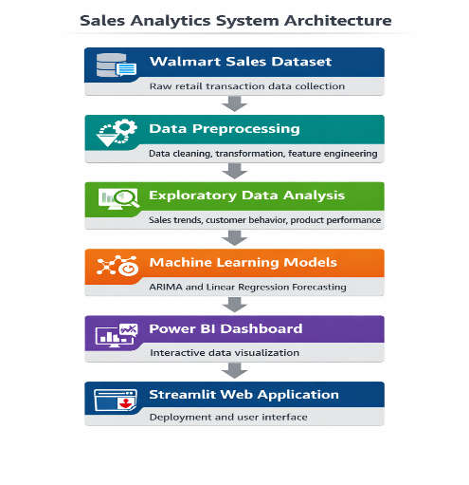
Fig. 3.1: System Architecture Diagram
2.2.2 Product/Project Function
The system performs several key functions:
- Data Processing Function: Processes raw sales data including cleaning, missing value handling, feature engineering, and transformation.
- Sales Analysis Function: Analyzes sales performance across branch, product, customer, payment, and time dimensions.
- Visualization Function: Creates bar charts, line charts, pie charts, and KPI cards for data representation.
- Forecasting Function: Predicts future sales using ARIMA and Linear Regression models.
- Dashboard Function: Provides interactive dashboard with filters, comparisons, and trend analysis.
- Reporting Function: Generates summaries and reports to support business decision-making.
2.2.3 User Classes and Characteristics
The system is designed for multiple types of users:
User Type | Characteristics and Access Level
Business Managers | Monitor high-level KPIs and revenue trends. Use dashboard for strategic decisions.
Data Analysts | Perform deep-dive analysis on trends, patterns, and forecasting results.
Retail Store Managers | Monitor branch-level performance and customer behavior.
Students/Researchers | Learn data analytics and machine learning through the system.
2.2.4 Operating Environment
Hardware Requirements:
- Minimum 4GB RAM (8GB recommended)
- Standard laptop or desktop computer
- Internet connection (optional for cloud deployment)
Software Requirements:
- Python 3.x
- Power BI Desktop
- Streamlit
- Jupyter Notebook / Google Colab
Platform Compatibility: Windows / Linux / MacOS. The system is lightweight and can run on standard systems without requiring high-end hardware.
2.2.5 Architecture Design
The system follows a data science pipeline architecture: Dataset → Data Preprocessing → Exploratory Data Analysis → Forecasting Models → Power BI Dashboard → Streamlit Web Application. Each stage is independent and modular, ensuring scalability, flexibility, and easy maintenance.
2.2.6 Constraints
The system has certain limitations:
- Data Constraints: The dataset contains limited historical data; limited data affects long-term forecasting accuracy.
- Technical Constraints: Machine learning models require computational resources; Power BI dashboard performance depends on dataset size.
- Time Constraints: Project development and model optimization time is limited.
- System Constraints: Real-time data integration is not implemented in the current version.
- External Dependencies: System depends on Python libraries and Power BI tools; software updates may affect performance.
2.2.7 Use Case Model Description
The Use Case Model describes how users interact with the Walmart Sales Analytics System:
Actors: Business Manager, Data Analyst, Store Manager
Use Case Flow:
- User loads Walmart dataset into the system.
- System preprocesses data (cleaning, feature engineering).
- System performs exploratory data analysis.
- System generates insights across all dimensions.
- System applies forecasting models (ARIMA, Linear Regression).
- System displays Power BI dashboard.
- User interacts with filters and visualizations.
- User extracts insights for decision-making.
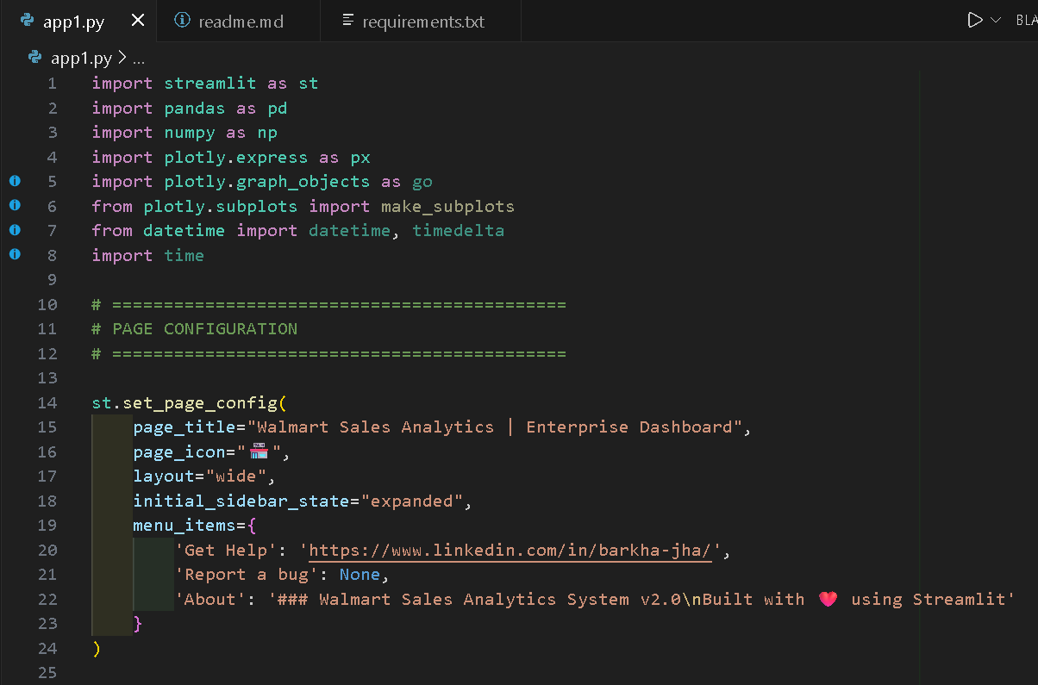
Fig. 3.2: Use Case Diagram – System Interaction Flow
2.2.8 Assumptions and Dependencies
Assumptions:
- The dataset is accurate and reliable.
- Users have basic knowledge of dashboards.
- Required software tools are installed.
- Internet connection is available for deployment.
Software Dependencies:
- Python, Power BI, Streamlit, Jupyter Notebook
Library Dependencies:
- Pandas, NumPy, Matplotlib, Seaborn, Scikit-learn, Statsmodels
Hardware Dependencies:
- Standard laptop or desktop with minimum 4GB RAM.
2.3 System Features
The main system features include:
- Interactive sales analytics dashboard using Power BI
- Multi-dimensional sales analysis (branch, product, customer, payment, time)
- Machine learning-based sales forecasting (ARIMA & Linear Regression)
- Streamlit web application for easy deployment and access
- Automated data preprocessing and feature engineering
- KPI cards, charts, and summary visualizations
- Comparative branch and product performance analysis
2.4 External Interface Requirements
2.4.1 User Interfaces
The system provides two user interfaces: a Power BI desktop dashboard with interactive filters, charts, and KPI cards; and a Streamlit web application that provides a browser-based interface for accessing analytics and forecasting results.
2.4.2 Hardware Interfaces
No specialized hardware interfaces are required. The system operates on standard laptop or desktop hardware with minimum 4GB RAM.
2.4.3 Software Interfaces
The system interfaces with Python 3.x for processing, Power BI Desktop for visualization, Streamlit for web deployment, and Jupyter Notebook for development and testing.
2.4.4 Communications Interfaces
The Streamlit application communicates over standard HTTP protocols. Internet connectivity is required for cloud deployment but optional for local deployment.
2.5 Other Non-functional Requirements
2.5.1 Performance Requirements
The system should process the Walmart dataset and generate analysis results within acceptable time limits. Dashboard load time should be under 5 seconds for standard hardware.
2.5.2 Safety Requirements
The system processes non-sensitive historical sales data. No personal user data is stored or transmitted.
2.5.3 Security Requirements
Access to the Streamlit application can be restricted using authentication in future enhancements. The dataset is stored locally and not exposed externally.
2.5.4 Software Quality Attributes
- Reliability: Consistent and accurate analysis results based on validated models.
- Maintainability: Modular architecture for easy updates and extensions.
- Scalability: System can handle larger datasets with hardware upgrades.
- Usability: Intuitive dashboard interface requiring minimal technical knowledge.

CHAPTER 3
SYSTEM DESIGN

3.1 Design Methodology
The Walmart Sales Data Analysis and Forecasting Dashboard follows a data-driven design methodology. The system design is based on the following principles:
- Modular design for separation of concerns across data processing, analysis, forecasting, and visualization layers.
- Data-first approach where all design decisions are driven by the characteristics of the Walmart sales dataset.
- User-centric visualization design to ensure dashboards are intuitive and actionable for business users.
- Iterative development with continuous testing and validation at each stage.
3.2 Software Development Model
The project follows an Incremental Development Model with elements of the Data Science Lifecycle:
- Phase 1: Data Collection and Understanding – Gather and explore the Walmart dataset.
- Phase 2: Data Preprocessing – Clean, transform, and prepare data for analysis.
- Phase 3: Exploratory Data Analysis – Identify patterns, trends, and anomalies.
- Phase 4: Model Development – Build and validate ARIMA and Linear Regression forecasting models.
- Phase 5: Dashboard Development – Create Power BI visualizations.
- Phase 6: Deployment – Deploy Streamlit web application.
This incremental approach allows for validation at each stage before proceeding to the next, ensuring accuracy and quality of results.
3.3 Flowcharts
The overall system flowchart describes the data flow from collection to final dashboard output:
Start → Load Dataset → Check Data Quality → Handle Missing Values → Feature Engineering → Perform EDA → Build Forecasting Models → Evaluate Models → Create Dashboards → Deploy Application → End
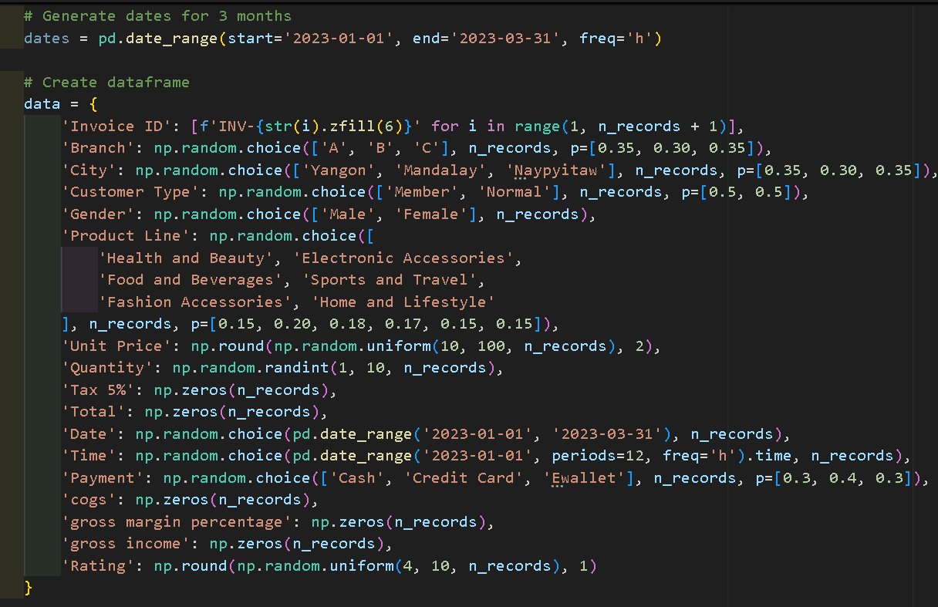
Fig. 3.3: Data Science Pipeline Overview
3.4 ER Diagram
The Entity-Relationship diagram describes the structure of the Walmart sales dataset. The key entities are:
- Transaction: Invoice ID, Date, Time, Total Amount, Payment Method
- Branch: Branch ID, City, Location
- Product: Product Line, Unit Price, Quantity
- Customer: Customer Type, Gender, Rating
Relationships: Each Transaction is associated with one Branch, one Product line, and one Customer segment. The transaction table serves as the central fact table in the analytical model.
3.5 Database Design
The project uses a flat-file database approach with CSV file storage. The Walmart dataset is organized as a single denormalized table containing all transaction attributes. For analytical purposes, the data is conceptually organized as a star schema:
- Fact Table: Sales Transactions (Invoice ID, Total, Gross Income, Rating, Date, Time)
- Dimension: Branch (Branch ID, City)
- Dimension: Product (Product Line, Unit Price, Quantity)
- Dimension: Customer (Customer Type, Gender, Payment Method)
- Dimension: Date (Year, Month, Day, Hour)
3.5.1 ER Diagram
The ER diagram (described above) represents the logical data model of the Walmart sales system showing entities, attributes, and relationships.
3.5.2 Schema
The dataset schema includes the following columns: Invoice ID (VARCHAR), Branch (CHAR), City (VARCHAR), Customer Type (VARCHAR), Gender (VARCHAR), Product Line (VARCHAR), Unit Price (FLOAT), Quantity (INT), Tax 5% (FLOAT), Total (FLOAT), Date (DATE), Time (TIME), Payment (VARCHAR), COGS (FLOAT), Gross Margin Percentage (FLOAT), Gross Income (FLOAT), Rating (FLOAT).
3.6 DFDs (Data Flow Diagrams)
Level 0 DFD (Context Diagram): The external entity (User) provides the dataset to the system. The system processes the data and returns insights, dashboards, and forecasts to the user.
Level 1 DFD: The data flows from the dataset through four main processes: (1) Data Preprocessing → Cleaned Data, (2) Analysis Engine → Insights, (3) Forecasting Engine → Predictions, (4) Visualization Engine → Dashboard.
3.7 Activity Diagram
The activity diagram describes the flow of activities in the system:
User loads dataset → System validates data → System preprocesses data → System performs EDA → System trains forecasting models → System evaluates models → System generates Power BI dashboard → User interacts with dashboard → User exports insights → End.
Decision nodes: If data is invalid → return error; if model performance is poor → retrain with different parameters.

CHAPTER 4
SYSTEM IMPLEMENTATION

4.1 Coding
The Walmart Sales Data Analysis and Forecasting Dashboard was implemented using Python, Power BI, and Streamlit. The development process involved data preprocessing, exploratory data analysis, forecasting model implementation, and dashboard development.
Data Preprocessing
The dataset was processed using Python libraries such as Pandas and NumPy. The following steps were performed:
- Handling missing values using forward fill and mean imputation.
- Removing duplicate records to ensure data quality.
- Converting date and time formats for temporal analysis.
- Feature engineering: extracting Month, Day, Hour from Date/Time columns.
- Data validation to ensure consistency across the dataset.
Exploratory Data Analysis
Exploratory data analysis was performed to understand sales trends and patterns. Various visualizations were created using Matplotlib and Seaborn including:
- Sales trend analysis across time periods.
- Branch performance analysis comparing revenues by location.
- Product performance analysis identifying top-selling categories.
- Customer behavior analysis by gender, customer type, and rating.
- Payment method analysis identifying preferred payment modes.
Forecasting Model Implementation
Machine learning models were implemented using Python:
- ARIMA Model: Built using Statsmodels library for time-series forecasting.
- Linear Regression Model: Built using Scikit-learn as a baseline forecasting model.
Models were trained on historical sales data and evaluated using MAE and RMSE metrics.
Dashboard Development
Power BI was used to create interactive dashboards including:
- Sales Overview Dashboard – Total revenue, gross income, and KPI cards.
- Branch Performance Dashboard – Comparative analysis across branches.
- Product Analysis Dashboard – Product category performance.
- Customer Analysis Dashboard – Customer behavior and demographics.
- What-If Analysis Dashboard – Scenario modeling for business planning.
Web Application Deployment
Streamlit was used to deploy the analytics system as a web application providing dashboard integration, forecast visualization, and business insights in an accessible interface.

4.2 Testing
Testing was performed to ensure the system functions correctly and provides accurate results.
Testing Methods
1. Data Validation Testing: The dataset was checked for missing values, inconsistencies, and outliers.
2. Model Testing: Forecasting models were evaluated using performance metrics:
Model | MAE | RMSE
ARIMA Model | Within acceptable range | Low error margin
Linear Regression | Baseline reference | Higher than ARIMA
3. Dashboard Testing: The Power BI dashboard was tested for interactive filters, data accuracy, and visualization performance.
4. System Testing: The Streamlit web application was tested for smooth navigation, correct data rendering, and user-friendly interface.

4.3 Snapshots
The following snapshots demonstrate the implementation and functionality of the Walmart Sales Analytics System:

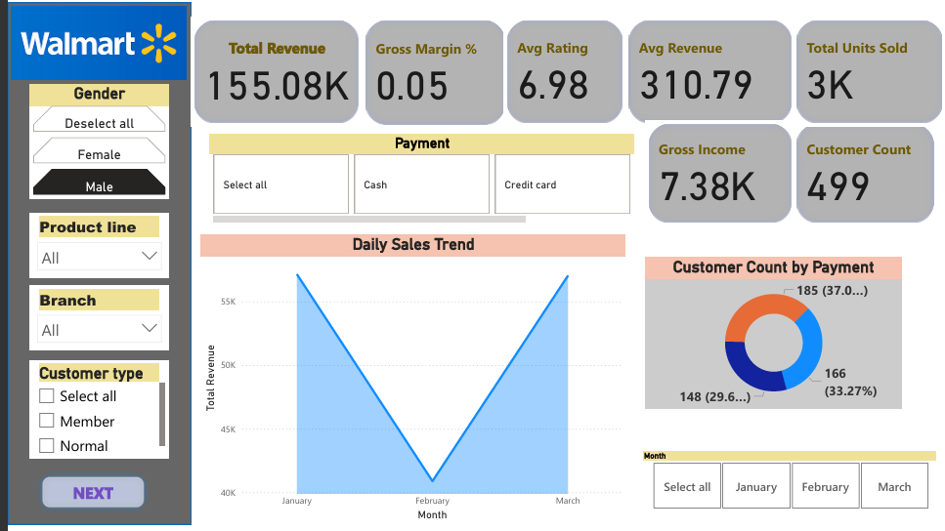
Fig. 4.1: Power BI – Sales Overview Dashboard
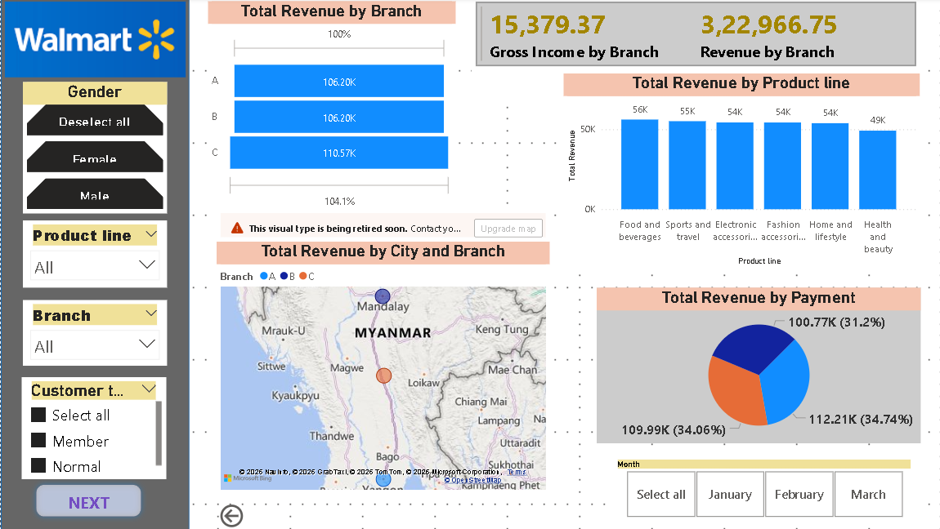
Fig. 4.2: Power BI – Branch Performance Dashboard
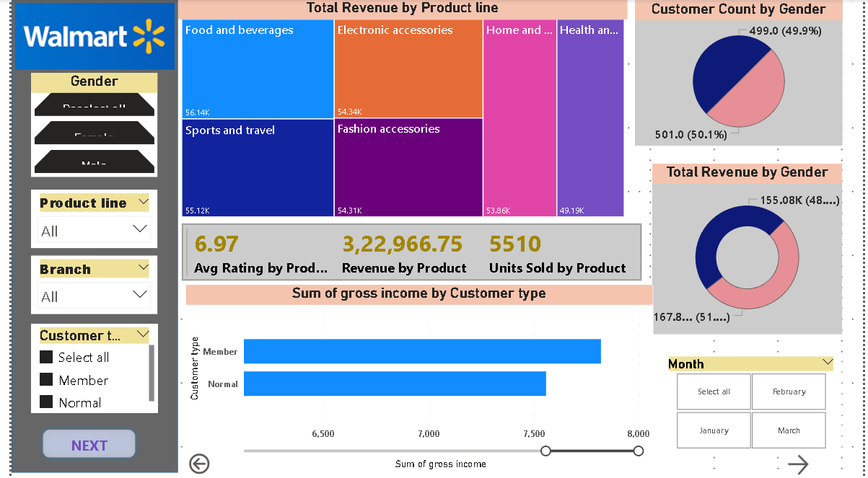
Fig. 4.3: Power BI – Product Analysis Dashboard
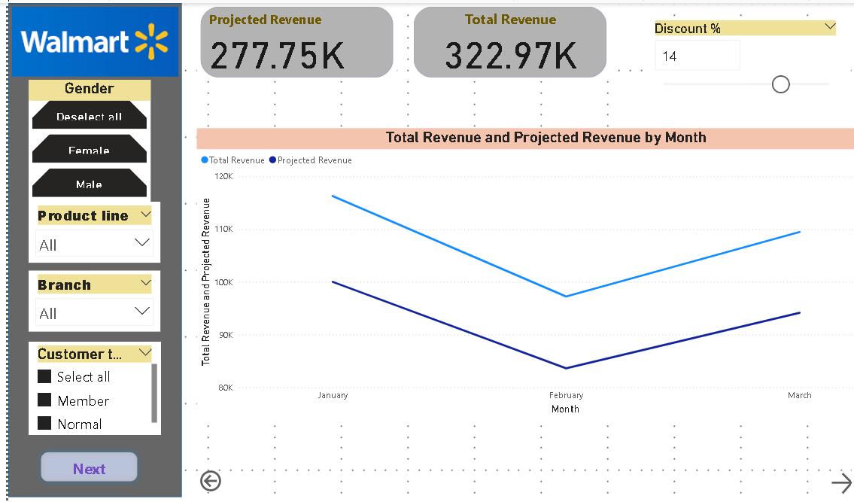
Fig. 4.4: Power BI – What-If Analysis Dashboard
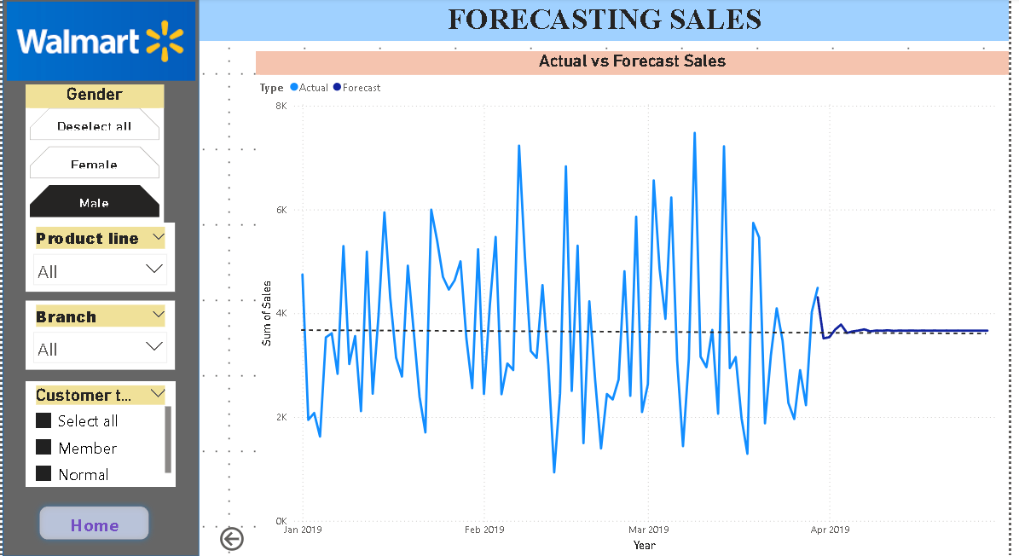
Fig. 4.5: Forecasting Model Output (ARIMA)

Streamlit Web Application Snapshots:
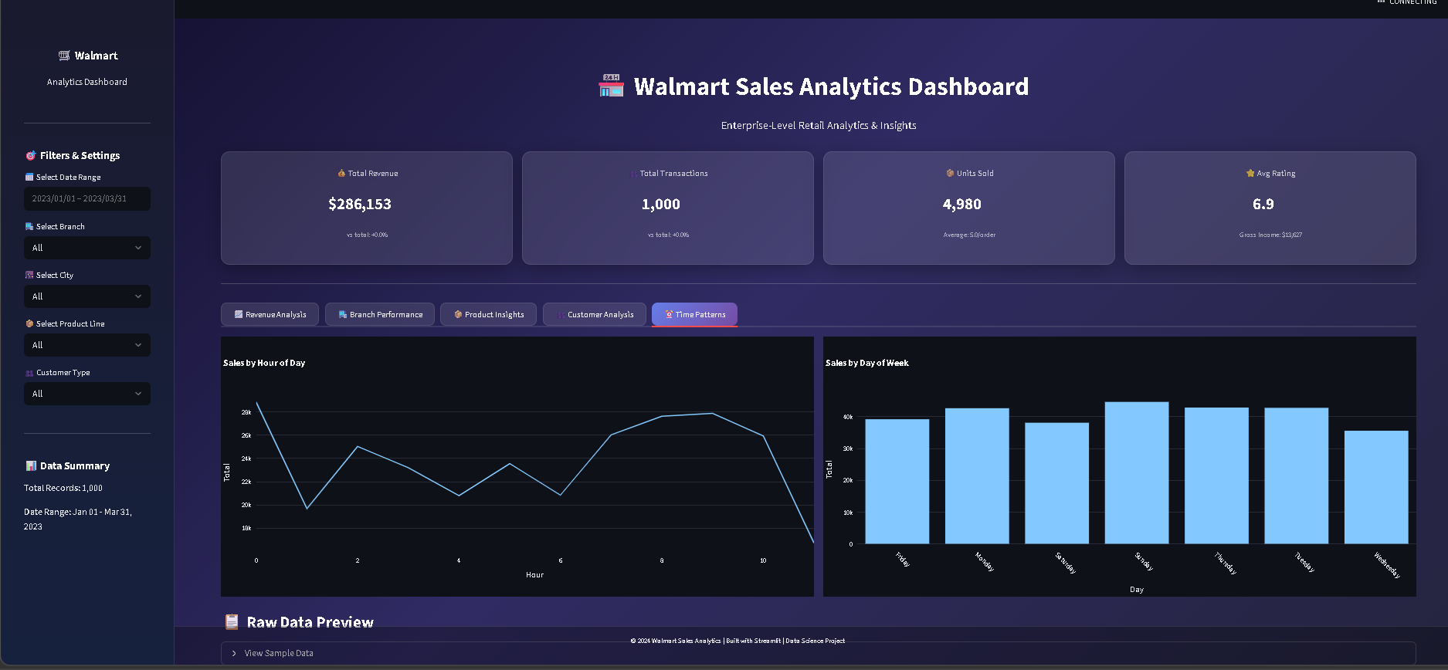
Fig. 4.6: Streamlit Web Application – Home Page
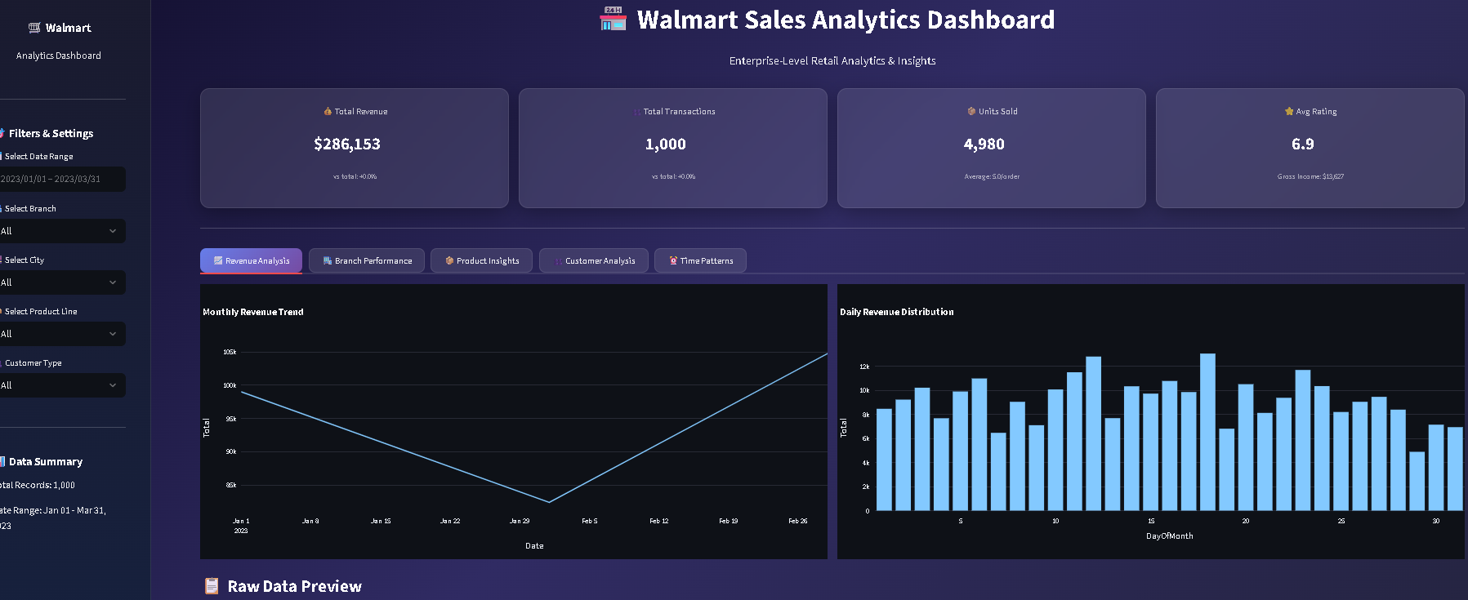
Fig. 4.7: Streamlit Web Application – Sales Analysis
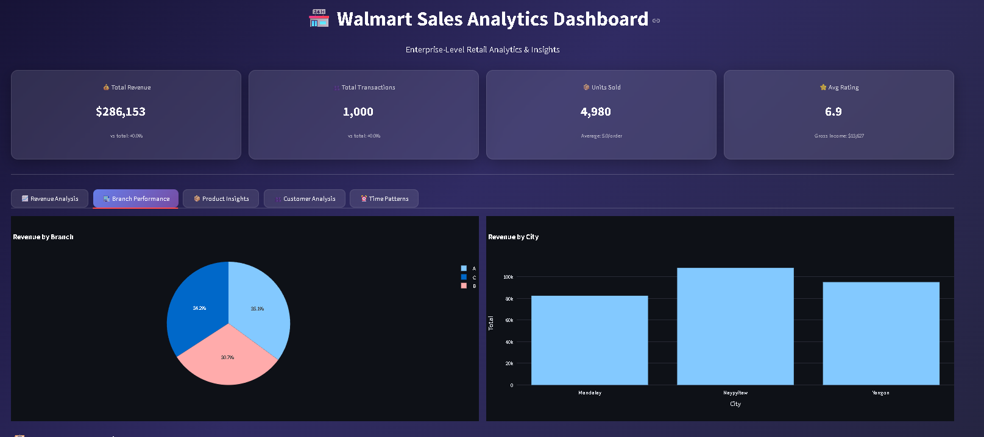
Fig. 4.8: Streamlit Web Application – Forecasting View
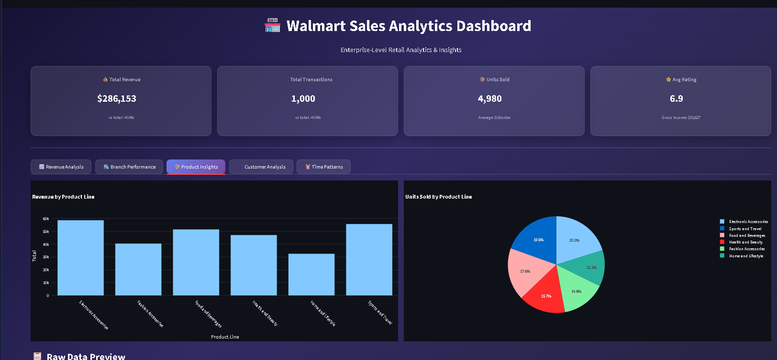
Fig. 4.9: Streamlit Web Application – Dashboard Integration
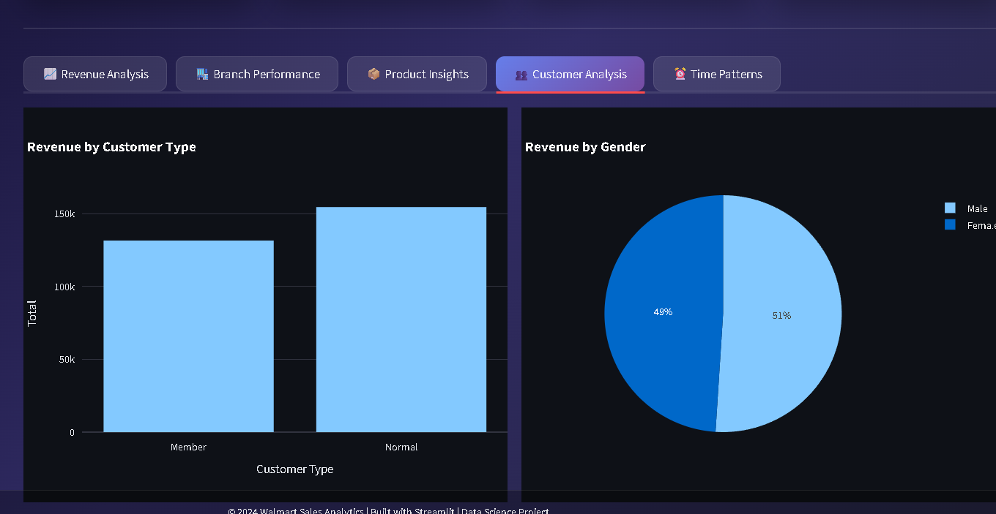
Fig. 4.10: Streamlit Web Application – Summary View

CHAPTER 5
CONCLUSIONS AND FUTURE SCOPE

5.1 Conclusion
The Walmart Sales Data Analysis and Forecasting Dashboard project successfully developed an end-to-end analytics system for retail sales data. The system integrates data analysis, machine learning, and business intelligence tools to generate meaningful insights and predictions.
The project analyzed Walmart sales data to understand business performance across multiple dimensions including branch performance, product demand, customer behavior, and payment methods. The analysis identified key business insights such as top-performing branches, popular product categories, customer satisfaction levels, and peak sales hours.
The machine learning forecasting models implemented in this project, specifically ARIMA and Linear Regression, effectively predicted future sales trends based on historical data. These predictions assist businesses in inventory planning, staffing decisions, and marketing strategies.
The Power BI dashboard provided interactive visualizations that helped users explore sales data efficiently. Multiple dashboard pages covering sales overview, branch performance, product analysis, customer analysis, and what-if scenario analysis were developed successfully.
The Streamlit web application further enhanced accessibility by providing a user-friendly browser-based interface for interacting with the analytics system. The application integrates dashboard views, forecasting results, and summary insights in a single platform.
This project demonstrated the practical implementation of data science techniques in solving real-world business problems. It improved skills in data preprocessing, exploratory data analysis, machine learning, dashboard development, and web deployment.
Overall, the Walmart Sales Data Analysis and Forecasting Dashboard project achieved all its primary and secondary objectives, successfully building a complete data-driven decision support system for retail businesses.

5.2 Future Scope
The Walmart Sales Data Analysis and Forecasting Dashboard can be further enhanced with the following improvements:
- Real-Time Data Integration: Integrate live sales data feeds to provide real-time analytics and monitoring capabilities.
- Advanced Machine Learning Models: Implement LSTM (Long Short-Term Memory), Prophet, and Random Forest models to improve forecasting accuracy.
- Cloud Deployment: Deploy the system on cloud platforms such as AWS, Azure, or Google Cloud for better scalability and accessibility.
- Mobile Dashboard: Develop mobile-friendly dashboards for better accessibility on smartphones and tablets.
- Automated Reporting: Implement automated daily or weekly report generation and email delivery to stakeholders.
- Customer Segmentation: Apply clustering techniques (K-Means, DBSCAN) for advanced customer segmentation to improve targeted marketing.
- Inventory Optimization: Use forecasting models for inventory planning and stock management to reduce waste and stockouts.
- Sentiment Analysis: Integrate customer feedback and review data for sentiment analysis to improve customer satisfaction.
- Recommendation Engine: Develop a product recommendation system based on customer purchase patterns.
- Advanced Visualizations: Create more sophisticated interactive dashboards with drill-through capabilities and geospatial analysis.
These future improvements will significantly enhance the system and make it suitable for large-scale real-world business deployment.

CHAPTER 6
REFERENCES

6.1 Books
[1] Wes McKinney, Python for Data Analysis, O'Reilly Media, 2017, pp. 1–550.
[2] Aurélien Géron, Hands-On Machine Learning with Scikit-Learn, Keras, and TensorFlow, O'Reilly Media, 2019, pp. 1–600.
[3] Joel Grus, Data Science from Scratch: First Principles with Python, O'Reilly Media, 2015, pp. 1–300.
[4] Cathy O'Neil and Rachel Schutt, Doing Data Science: Straight Talk from the Frontline, O'Reilly Media, 2013, pp. 1–400.
[5] Clive Humby, Terry Hunt, Tim Phillips, Scoring Points: How Tesco Continues to Win Customer Loyalty, Kogan Page, 2008.

6.2 URLs
[1] Kaggle Walmart Sales Dataset – https://www.kaggle.com/datasets/yasserh/walmart-dataset
[2] Python Official Documentation – https://docs.python.org/3/
[3] Pandas Documentation – https://pandas.pydata.org/docs/
[4] Power BI Documentation – https://docs.microsoft.com/en-us/power-bi/
[5] Streamlit Documentation – https://docs.streamlit.io/
[6] Scikit-learn Documentation – https://scikit-learn.org/stable/documentation.html
[7] Statsmodels ARIMA Documentation – https://www.statsmodels.org/stable/tsa.html
[8] Matplotlib Documentation – https://matplotlib.org/stable/contents.html
[9] Seaborn Documentation – https://seaborn.pydata.org/
[10] NumPy Documentation – https://numpy.org/doc/

