**Preconsultation form**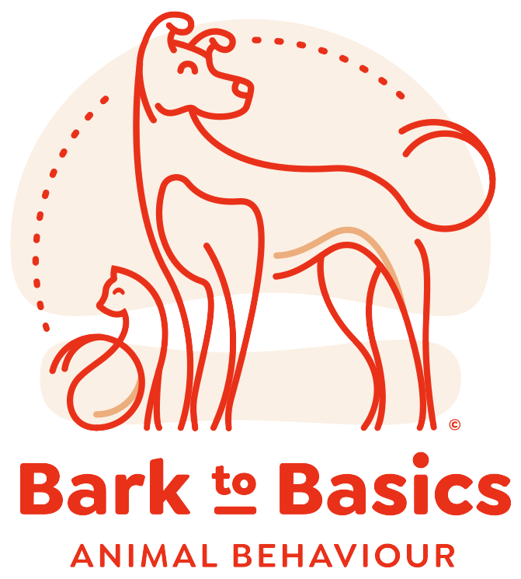

Kindly return this form before the consultation date. If you have any questions, please don’t hesitate to get in touch. You can reach me by email, phone, or WhatsApp.

|  |  |
| --- | --- |
| **Contact me:**  Email: [nancy](mailto:nancy.elizabeth.payne@gmail.com)p@coape.org  Phone and WhatsApp: +27 (0)767766138 | **Payment details:** Nancy Payne  ABSA cheque account  Account number: 4085859412  Branch code: 632005 |

***Owner’s details***

|  |  |
| --- | --- |
| Name |  |
| Address |  |
| Email |  |
| Phone number |  |

***Pet’s details***

|  |  |  |
| --- | --- | --- |
| Name |  | |
| Sex |  | |
| Age |  | |
| Breed |  | |
| Is your pet sterilised? | Y / N | Sterilisation age: |
| How old was your pet when you got him/her? |  | |
| Where did you get your pet? (e.g., breeder, shelter) |  | |
| How would you describe your pet’s personality? |  | |

***Home and nutrition***

|  |  |  |
| --- | --- | --- |
| How many adults and children live at home? | Adults: | Children and their age(s): |
| Do you have any other animals? | Y / N | If yes, type(s) and age(s): |
| What do you feed your pet? |  | |

***Medical details***

|  |  |  |
| --- | --- | --- |
| Name of vet |  | |
| Vet contact number |  | |
| Does your pet have any health issues? |  | |
| Has your pet had any recent or past injuries or surgeries? |  | |
| Is your pet on any medication? | Y / N | If yes, what medication(s)? |

***Training (if applicable)***

|  |  |
| --- | --- |
| Please describe your training goal(s). |  |
| Do you or your pet had any previous experience with training? |  |

***Behaviour (if applicable)***

|  |  |
| --- | --- |
| Please describe the main behaviour problem(s) you wish to address. |  |
| When did the problem first start? |  |
| How often does the behaviour occur? |  |
| What have you tried so far (if anything) and what were the results? |  |
| What are your aims regarding your pet’s behaviour? |  |
| Are there any other problem behaviours you would like to address? |  |
| Do you have any other comments you feel may be relevant? |  |

**Behaviour consultation**

**Nancy Payne**

**Waiver, Agreement and Assumption of Risk**

1. I hereby understand the risks involving all activities regarding dog rehabilitation sessions. I do take full responsibility for my and my dog’s actions and recognise the possible hazards that may occur concerning other dogs and handlers in unfamiliar circumstances.

2. I fully understand that things do not always go according to plan. This includes unpredictable dog behaviour, weather changes and unforeseen circumstances. Different approaches might be needed depending on the dog’s responses.

3. I hereby agree to safeguard Nancy Payne, all personnel and animals. No person or dogs associated with Nancy Payne will be liable for any loss, damages or injury occurring on the session premises whatsoever or on my premises in the case of distance training.

___________________________ ___________________________

Name Signature

___________________________

Date