Lab 5: Simulating discrete probability models

Spring 2020

## Task 1: Roulette wheel simulation

A roulette wheel has 38 slots of which 18 are red, 18 are black, and 2 are green. If a ball spun on to the wheel stops on the color a player bets, the player wins. Consider a player betting on red. Winning streaks follow a Geometric(*p* = 20/38) distribution in which we look for the number of red spins in a row until the first black or green. Use the derivation of the Geometric distribution from the Bernoulli distribution to simulate the game. Namely, generate Bernoulli(*p* = 20/38) random variates (0 = red; 1 = black or green) until a black or green occurs.

### Code set-up

A while loop allows us to count the number of spins until a loss. If we use indicator variable lose to note a win (1) or loss (0), the syntax is “while we have not lost (i.e., lose==0), keep spinning.” Once you win, the while loop ends and the variable streak has counted the number of spins. Try running a few times.

streak = 0  
lose = 0  
p = 20/38  
while(lose==0){  
 lose = (runif(1) < p) # generate Bernoulli with probability p  
 streak = streak + 1 # tally streak  
}  
streak

## [1] 3

### The problem

The code chunk above performs the experiment once: spin the roulette wheel until you lose and record the number of spins. Simulate 1000 experiments. As usual, do this by wrapping the code chunk above within a for-loop and storing the number of spins streak in a vector.

simnum = 1000;  
winstreak <- numeric(simnum)  
for (i in 1: simnum) {  
streak = 0  
lose = 0  
p = 20/38  
while(lose==0){  
 lose = (runif(1) < p) # generate Bernoulli with probability p  
 streak = streak + 1 # tally streak  
}  
winstreak[i] = streak  
}  
  
mean(winstreak)

## [1] 1.887

sd(winstreak)

## [1] 1.363852

max(winstreak)

## [1] 10

hist(winstreak, br=seq(min(winstreak)-0.5, max(winstreak+0.5)), main="")

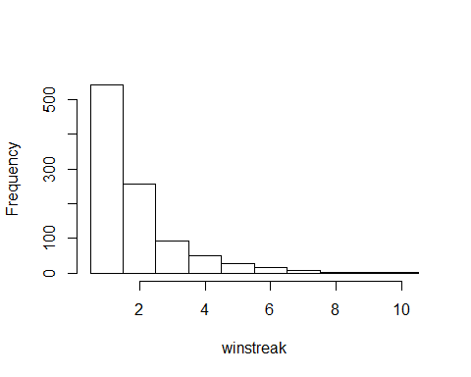

### Report the following:

* Histogram of the win streak length. Note that this is a discrete distribution so should place histogram bars at discrete values {0, 1, 2, …}. This may be done with the breaks option within hist. If your storage variable is called winstreak:

hist(winstreak, br=seq(min(winstreak)-0.5, max(winstreak+0.5)), main="")

* Average length of the win streak. *1.887*
* Standard deviation of the winning streak lengths. *1.36*
* Compare the empirical average and standard deviation in the previous two bullets to the true values from the Geometric(*p* = 20/38) distribution.

*The empirical averages are accurate when compared to the true values.*

* Longest winning streak. *10*

## Task 2: Simulating negative binomial distributions

In this task, we will compare two different algorithms for simulating from a negative binomial distribution.

### Problem (a)

Recall that a negative binomial random variable *NB(r, p)* is the sum of *r Geometric(p)* random variables. Use the algorithm from Task 1 to simulate 1000 *NB(10, 0.6)* random variates.

### Code set-up

Note that we merely need to wrap the core code from Task 1 within a for-loop. Here is the core of the code chunk, where we are thinking of a for-loop over a variable sims to replicate the single negative binomial draw. Note that this code chunk will not run since the for-loop over sims is not coded, thus the eval=FALSE option. **Note that this code has the eval=FALSE option just to present the code without output. Your code will not use this option.**

r = 10  
p = .6  
nbvar1 <- numeric(1000)  
nbvar2 <- numeric(10)  
x = proc.time()  
for (sims in 1:1000){  
for(nbsims in 1:r){  
 # for-loop allows us to simulate until r successes;  
 # in this problem, r=10 and p=0.6  
 tossnum = 0  
 success = 0  
 while(success==0){  
 success = (runif(1)<p)  
 tossnum = tossnum + 1  
 }  
 nbvar1[sims] = nbvar1[sims] + tossnum  
 nbvar2[r] = nbvar1[sims]  
 }  
   
 nbvar1[sims] = mean(nbvar2)  
   
}  
  
timer = proc.time() - x  
algtime = timer[3]  
algtime

## elapsed   
## 0.25

mean(nbvar1)

## [1] 1.6673

sd(nbvar1)

## [1] 0.3385489

hist(nbvar1)

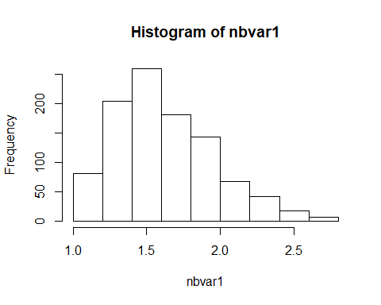

### Problem (b)

The negative binomial pmf induces the following recursion relation. If $X∼B(r, p)$, then

$$P(X=i+1)=\frac{i(1-p)}{(i+1-r)}⋅P(X=i).$$

Use this recursion relation to generate 1000 $NB(10, 0.6)$ random variates.

### Code set-up

Below is binomial.R, the binomial simulator used in the video lectures and found also on the class Blackboard site.

simnum = 1000  
p = 0.6   
r = 10 # for point of comparison with the negative binomial, we will use r here  
y=0  
x = proc.time()  
for(sims in 1:simnum){  
 pmf=p^r; cdf=pmf; # pmf and cdf  
 j=r;  
 u=runif(1) # uniform random variate  
 # find Binomial variate  
 while(u >= cdf){  
 pmf =(j*(1-p)/(j+1-r))*pmf  
# pmf=((r-j)/(j+1))*(p/(1-p))*pmf # recursion relation  
 cdf=cdf + pmf # compute cdf  
 j=j+1  
 }  
 y[sims]=j  
}  
timer = proc.time() - x  
algtime = timer[3]  
algtime

## elapsed   
## 0.08

mean(y)

## [1] 16.875

sd(y)

## [1] 3.399254

hist(y)

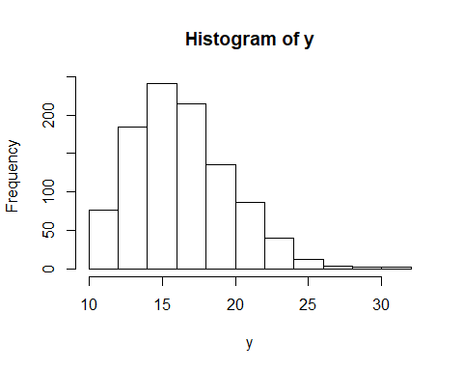

This binomial simulator may be applied directly after changing just three lines:

$j=r$

* the recursion relation formula
* pmf = p^r

### Report the following for each of the simulations in problems (a) and (b)

* Histogram of the variates
* Mean and standard deviation of the simulated variates
* Run time: compare computing speed between the two algorithms. In R, can wrap your algorithm or sequence of operations as follows to time your code.

x = proc.time()  
# [the code you want to time here]  
timer = proc.time() - x  
algtime = timer[3] # algtime will store the algorithm run time in seconds

### Questions

* How do the histograms compare?

*The histograms look remarkably similar in shape.*

* How do the mean and standard deviation from the simulations compare to the true mean and standard deviation of a $NB(0.6,\10)$ distribution?

*The mean and standard deviation of the geometric simulation is closer to the true values than the binomial simulation.*

* How do the computing times compare? Which algorithm is faster?

*The geometric simulation is slower than the binomial simulaiton.*

* “Simulation flops”: Which simulator do you think uses more uniform random numbers (call to the runif() function)? Why?

*The gemoetric simulator calls the runif() function more as the function is found in a loop within a loop, while the binomial simulator has that same function in only one loop.*