Software Design Document (SDD)
Assignment #2 DIS Disassembler for XE computer
CS530, Fall 2020

Team:
Brian Arlantico, cssc3010, 821125494 – Test Manager, S/W Engineer
Nicholas Dollick, cssc3046, 815970305- CM Lead, S/W Engineer

Overview & Goals:
- Traditional Requirements Driven Methods to be used for development and rationale
- Development: Traditional Requirements Driven Methods, Evolutionary Programming
- Rationale: The project has set requirements with no ambiguity. Establishing core functionality is crucial to achieving the end goal of this program, hence evolutionary programming will help us meet all the dependencies while also being able to consistently test our system.

- Methodologies/techniques to be used in development and rationale
- Functions in the C++ library will help us parse the object file and symbol file. Use of ofstream objects will enable us to write the source code, object code, addresses to the respective sic source file and listing file.
- We are provided object and sym files from an assembled sic source file which assists us in checking if our system produces the correct sic/lis files. With knowledge of the assembler, we may also create our own object and sym files to further ensure that the output of our system is correct.

Project Description:
- The overall functionality to be provided by the software system is that users will be able to disassemble their SIC XE program by providing an object file and symbol file (which includes the symbol table and literal table). The system will then create the source file (.sic) and the listing file (.lis) correlating to the object and symbol file that was provided.

Plan of Action and Milestones:

Gantt Chart for development of system (Note – 4 periods = 1 week)
- All steps in the development of our system are necessary for the system to meet the final requirements
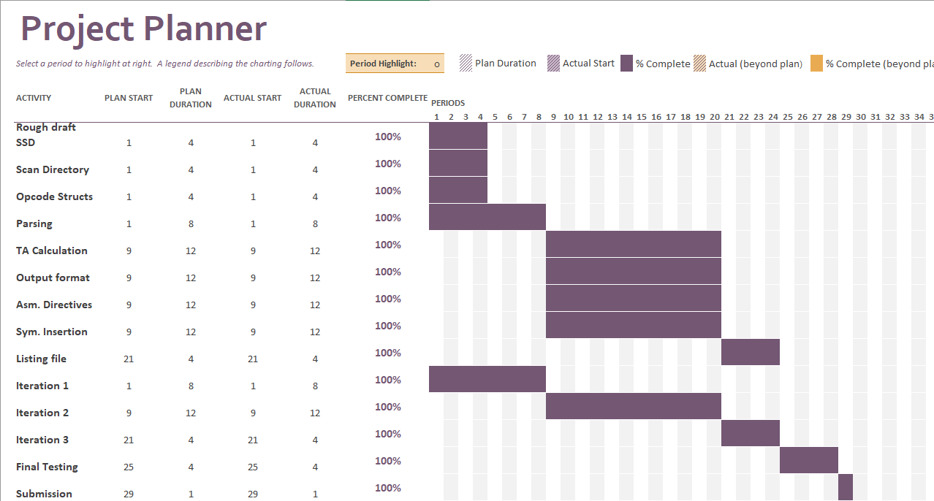

Estimate of labor hours
Item Time Estimate
Iteration 1 7 – 12 (1 week)
Iteration 2 23 – 40 (2-3 weeks)
Iteration 3 4-10 (1 week)

1. Iteration 1
a. 1 hour – Scanning directory for files
b. 1 hour – Structures for opcodes, registers, and mnemonics
c. 5-10 hours – Parsing and breakdown of nixbpe for format and addressing
d. 2-5 hours – SDD draft
2. Iteration 2
a. 8-10 hours – Conversion of hex string addresses/displacement to int and calculation of target address.
b. 5-10 hours – Formatting columns and inserting correct source code into .sic file
c. 5-10 hours – Identifying placement of assembler directives
d. 5-10 hours – Using addresses to parse values from symbol/literal table and inserting into .sic file
3. Iteration 3
a. 2-5 hours – Inserting address properly into listing file
b. 2-5 hours – Inserting object code properly into listing file

Requirements:
- Statement of Scope of Effort/Understanding of Problem
  - To program the disassembler, we must understand how the object file and symbol file are used in conjunction to ultimately output the sic source file as well as the listing file. With that in mind, we need to search the current directory of where the system is called by concatenating “.sic” and “.lis” to the filename passed by the user. If we can find those files, we must open both as they are necessary for our output files. The listing file is based off the sic source file, so naturally we will work on getting a correct output file for the sic file before proceeding to the listing file. We must continuously refer to the symbol table after each iteration of parsing the object code to know if we must insert a symbol at that line. A program counter and location counter will also be necessary for reading the object code so we can dissect which value is being referred to in the symbol table. Things to keep in mind when reading the object code include breaking down nixbpe, so that we can insert # and @ for the addressing modes if necessary, as well as checking if it is a format 3 or 4 instruction, which we need so that we traverse the text records appropriately without cutting an object code off short. We also need structures for the OP codes, mnemonics, and registers so we know which instructions and operands to enter in the line associated with the object code. Another aspect of this system that needs to be considered are assembler directives, and when to properly insert them into the sic source code. Once we can accurately produce the sic source code, the listing file will follow in a similar fashion, with changes that include the location address as well as displaying the object code.

System Design/Specification:

Basic high level diagram of our system

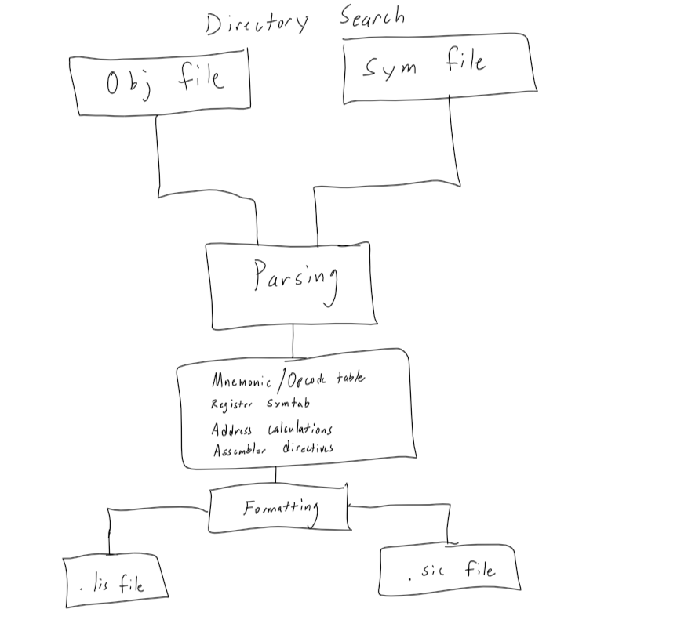

“Whiteboard” work on how to print symbols with RESW/RESB
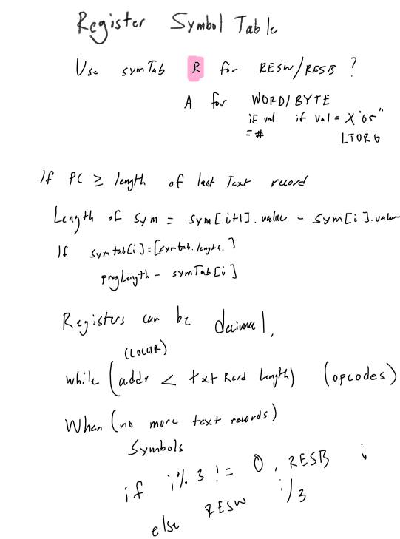

Development Environment:
- Platform/operating system
  - CentOS 7 server (edoras)
- Implementation language
  - C++
- Rationale for selection
- Project requirements ask for the system to be coded in C/C++. However, we chose C++ due to its features that allow us to smoothly meet the requirements of the system as opposed to if we used C. CentOS 7 is the Linux platform in which we are submitting our final system.

Run/Test Environment:
1. Unit Testing
- Testing loops for reading records
- Ensuring loops handling string buffers do not exceed buffer length
- Gracefully exiting when files could not be found.

2. Evolutionary iteration testing
a. Iteration 1 testing
- If obj and sym files can be opened
- Gracefully exiting if files cannot be found
- If opcode can be relayed to correct mnemonic.
- Ensuring nixbpe are being parsed correctly.

b. Iteration 2 testing
- Hex strings are being converted to proper signed integers for arithmetic operations
- If arithmetic operations result in correct target address.
- If assembler directives are placed properly after op codes (i.e. BASE after LDB)
- If correct symbols are being placed at the proper addresses.
- Testing if opcodes are correct with flags (i.e. immediate/indirect, indexing)

c. Iteration 3 testing
- Proper formatting of both addresses and object codes in the listing file
- If the correct values are being inserted for addresses and object codes

3. Integration Test Plan
- Once iteration 3 testing has finished, we will continuously test the final system with different object and symbol files to ensure correctness.

Configuration Management
- Github.com, used branches to manage versions
- Coding of different components ensured file check in and check out
- Visual Studio Code with remote server on edoras (C++)
- Ultimately three different builds as planned, however fourth build is just finalized comments

Independent System Test:
- Test Plan/Strategy
    - Thoroughly tested functions in each file with different file inputs/XE instructions to ensure they performed as expected
    - Test files used were corrected versions off canvas that were double checked with the textbook
- Test Procedures
    - searchDirectory(vector<string> &files)
      - Running on a Linux server, ensures all files in the current directory are pushed onto the vector
      - Input is a “.” Indicating the current directory in Linux
      - Expected results are all the files in the current directory pushed onto the string vector
    - getFiles(vector<string> &files, ifstream &symfile, ifstream &objfile, string file)
      - Ensuring the string vector contains all the files in the directory
      - Input stream files of both .sym and .obj extensions and the string vector
      - Expected results are that the function returns 1 if both the sym and obj file are present in the directory, and 0 otherwise
    - char* hex_char_to_bin(char c)
      - Testing that all the hex characters are returned their binary representation as a string
      - ASCII character that is one of the 16 hex digits
      - Returns the binary representation of the hex character (for example, A returns 1010).
    - char* getRegister(int num)
      - Tests that each register number returns their correlating mnemonic
      - int of the register number
      - register mnemonic is returned from int index (i.e. 0 returns register A)
    - string bin_string_to_hex(string bin)
      - testing that a binary string returns its hex representation
      - string of the binary value
      - binary string should return a hex string (i.e. 1111 returns F)
    - void getMnemonic(string stropCode, struct opCodeStruct &opCode)
      - returns the instruction mnemonic given the op code string
      - op code in string format and the opcode struct to save relevant information
      - Will differentiate between format 2 vs format3/4 depending on the instruction, and sets the opMnemonic data field in the struct to the op code mnemonic found in the function.
    - void disassemble(ifstream &objfile, ifstream &symfile, string file)
      - called by main to perform the disassemble process
      - input stream files for both the obj and sym files as well as a string
      - when this function finishes there should be sic and lis files produced
    - void endDirective(struct objCodeStruct &objStruct, struct symbolTable symStruct, ofstream & sicFile, ofstream &lisFile)
      - called at the end of the disassembling process when all text records have been processed.
      - objStruct, symStruct, and both output stream files are needed since we must find the symbol the end directive’s address holds as well as printing that to both the output files
      - one line of the end directive printed on both files with the correct symbol from the symbol table.
    - void insertVars(struct objCodeStruct &objStruct, struct symbolTable symStruct, ofstream &sicFile, ofstream &lisFile, int maxAdr)
      - ensuring that the correct symbols are inserted at the addresses as well as checking if RESB/RESW is used correctly
      - both the objStruct and symStruct, both files, as well as the maxAdr, which represents where the variables will be declared up until
      - the variables should be grabbed from the symbol table depending on the LOCCTR and from there the size of the variables can be determined by the beginning address of the next symbol
    - int getVarLength(struct objCodeStruct &objStruct, struct symbolTable symStruct)
      - testing that the calculation performed on the symbol table returns the correct length of a symbol
      - objStruct and symStruct needed to perform the length calculation
      - returns an integer value for the amount of bytes a particular symbol will hold
    - void readobjFile(ifstream &objfile, vector<string> &objVector)
      - testing that each line of a particular object file is pushed onto the string vector
      - a proper object file to be passed to the function
      - each line of the object code should correlate to an index in the string vector
    - void readsymFile(ifstream &symfile, struct symbolTable &symTabStruct)
      - tests that all the literals and symbols are pushed onto the correct string vectors of the symTabStruct
      - the symfile and the symTabStruct need to be passed to the function
      - the string vectors should have all symbols/literals and the lengths of each table
    - void startDirective(struct objCodeStruct &objStruct, ofstream &sicFile, ofstream &lisFile)
      - tests that the correct program name and starting address are printed from the object file
      - objStruct and both output file streams needed to identify and print what is required by START
      - START should be properly printed with the correct information on both files
    - void readObjCode(struct objCodeStruct &objStruct, struct opCodeStruct &opCode, int index)
      - tests that different object codes produce the correct information (flags, format)
      - objStruct and opCodeStruct, as well as the index which represents the line of object file
      - format and flag bits should be specified after this function is called
    - void printFormat2/3/4(struct symbolTable symStruct, struct objCodeStruct &objStruct, struct opCodeStruct &opCode, ofstream &sicFile, ofstream &lisFile, int index)
      - test all instructions to ensure that they print either format 2, 3, or 4.
      - Inputs needed include each of the three structs, both output file streams, and the index of the object file
      - The correct LOCCTR, instruction mnemonic, operands, and object code should be printed in their respective sic or lis files correctly
    - string insertSymbol(struct symbolTable symStruct, struct objCodeStruct &objStruct)
      - tests that the correct symbol is printed at the current LOCCTR
      - symStruct and objStruct needed since we will be referring to the tables and LOCCTR
      - the symbol at that current LOCCTR should be returned from the function
    - string findOperand(struct symbolTable symStruct, int TA)
      - tests that the correct operand is retrieved from the addressing type (direct, immediate, etc)
      - symbolTable and TA needed to retrieve the symbol given the TA
      - a string of the symbol that is being used as an operand should be returned from the function
    - void insertDirective(struct symbolTable symStruct, struct objCodeStruct &objStruct, struct opCodeStruct &opCode, ofstream &sicFile, ofstream &lisFile, int trIndex)
      - tests that the correct directives are printed after certain instructions
      - all three structs are needed, as well as both files and the index of the object file (more specifically the text record)
      - the corresponding directive should be printed after specific instructions (for example, BASE after LDB)

