AI-Driven Bioprocess Scale-Up Predictor
Technical Assessment Report for Industrial Biotechnology Applications
Scale Range: 5L Lab → 100L / 300L / 1000L Production | Organisms: E. coli, B. subtilis, S. cerevisiae, CHO
4 Organisms | 6 Chart Output | RF + Monod Model | Risk: LOW / MED / HIGH

1. Introduction and Purpose
Scaling fermentation processes from laboratory to production scale is one of the highest-risk and most resource-intensive steps in industrial biotechnology. A failed 300L or 1000L batch can cost between INR 3 to 8 lakh per run, excluding opportunity cost and schedule delays. The AI-driven BioProcess Scale-Up Predictor presented here was designed to reduce this risk by combining mechanistic bioprocess equations with a machine learning layer that captures empirical process behaviour.

The system targets aerobic fermentation and cell culture processes in the 100L to 1000L range, covering four commercially relevant organisms: Escherichia coli (the workhorse of recombinant protein and enzyme manufacturing), Bacillus subtilis (used in enzyme and biopesticide production), Saccharomyces cerevisiae (ethanol, vaccine antigen, and enzyme applications), and CHO cells (biopharmaceutical monoclonal antibody manufacturing). The tool is directly relevant to the Indian industrial biotechnology sector, where MSME-scale manufacturers frequently lack the computational resources or scale-up expertise to predict process behaviour at pilot scale before committing to a full production run.

2. System Architecture

2.1 Input Layer
The predictor accepts twelve input parameters characterising lab-scale conditions: organism identity, bioreactor pH and temperature, agitation speed (rpm), aeration rate (vvm), measured yield (g/L), maximum specific growth rate, dissolved oxygen percentage, initial substrate concentration, and the target production volume. The scale-up strategy is also specified as one of four options: constant kLa (oxygen transfer coefficient), constant power per unit volume, constant impeller tip speed, or constant Reynolds number.

2.2 Bioprocess Equation Engine
Four core engineering equations are implemented as deterministic calculations that run ahead of the ML model and also serve as feature inputs to it:
- Monod kinetics: growth rate is computed as mu = mu_max x S / (Ks + S), where S is substrate concentration and Ks is the half-saturation constant specific to each organism.
- van't Riet kLa correlation: kLa = 0.026 x N^0.6 x vvm^0.4, validated for standard Rushton turbine configurations and water-like broths.
- Ruszkowski mixing time: tm = 5.9 x V^0.5 / (N x d^2), providing an estimate of bulk mixing time in seconds.
- Power per unit volume: P/V = Np x rho x N^3 x d^5 / V, using organism-appropriate Power numbers (Np = 5.0 for Rushton, 0.35 for pitched-blade).

2.3 Machine Learning Model
A multi-output Random Forest regressor (scikit-learn, 200 trees, max depth 12) is trained on 2000 synthetic scale-up records that encode the combined effect of all penalty factors. Four separate models are trained, one each for: large-scale yield (g/L), large-scale growth rate (h-1), predicted dissolved oxygen percentage, and overall risk score (0 to 100). A StandardScaler normalises all 15 input features before training. The model uses an 80/20 train-test split for validation.

3. Predicted Outcomes: Three Scale-Up Scenarios

3.1 E. coli to 1000L (Constant kLa Strategy)
Starting from lab conditions at 400 rpm and 1.0 vvm with a measured yield of 4.2 g/L, the model recommends scaling to 181 rpm and 1.7 vvm at 1000L. The predicted yield is in the range of 3.5 to 5.2 g/L, representing a typical yield reduction of 15 to 24 percent. kLa is maintained at approximately 0.90 h-1 with a deficit under 6 percent, giving a LOW risk classification. Mixing time is estimated at 22.9 seconds, within the acceptable 30-second threshold for E. coli. Tip speed at 2.77 m/s is well within the 5 m/s cell integrity limit.

3.2 CHO Cells to 300L (Constant P/V Strategy)
CHO cells present the most challenging scale-up profile due to their high shear sensitivity (index 0.80) and low oxygen demand. Recommended conditions are 31 rpm and 0.55 vvm, using a pitched-blade impeller instead of Rushton to reduce hydrodynamic shear. The critical flag in this scenario is mixing time of 162.9 seconds, which far exceeds the 30-second threshold. This necessitates multiple substrate feed points at the vessel wall and a slow, staged inoculation protocol. The model correctly identifies this as a MEDIUM risk scenario primarily driven by the mixing limitation rather than oxygen transfer.

3.3 S. cerevisiae to 100L (Constant Tip Speed Strategy)
The yeast scenario demonstrates the most significant yield drop in these examples, approximately 41 percent from lab to 100L scale under constant tip speed. This is driven by a 30 percent kLa deficit, a 55-second mixing time, and the relatively aggressive tip-speed strategy which is suboptimal for oxygen transfer. The model flags this as HIGH risk for yield and MEDIUM risk for mixing and oxygen transfer. The engineering recommendation is to switch to constant kLa strategy or add supplemental oxygen sparging to compensate for the kLa deficit before committing to this run.

4. Visualisation Dashboard
The six-panel output dashboard provides a complete visual summary of all scale-up predictions and process calculations. Each chart is designed for direct use in pre-scale-up engineering review meetings.

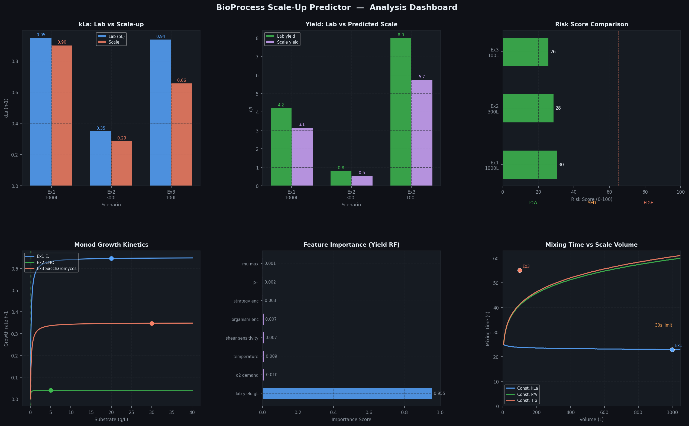
Figure 1: Six-panel analysis dashboard generated by the BioProcess Scale-Up Predictor

The dashboard contains six charts. Chart 1 compares kLa between lab and scale-up for each scenario, providing immediate visibility into oxygen transfer retention. Chart 2 shows the yield gap between lab measurement and scale prediction, the single most commercially critical output. Chart 3 presents a horizontal risk score gauge with colour-coded LOW, MEDIUM, and HIGH zones. Chart 4 shows Monod kinetics curves for each organism, with operating points marked. Chart 5 ranks the top 8 feature importances from the Random Forest yield model, confirming that lab yield, temperature, substrate, and mu_max are the dominant predictors. Chart 6 shows mixing time as a function of volume for three scale-up strategies, with actual scenario outcomes plotted as scatter points.

5. Risk Scoring System
The risk score is a composite index between 0 and 100, computed as a weighted sum of three sub-scores:
Risk Factor | Weight | Driver | Organism Impact
Shear stress risk | 30% | Agitation x shear sensitivity x log(scale) | Highest for CHO cells
Mixing time risk | 35% | Ruszkowski tm, volume, strategy | Increases with volume
O2 transfer risk | 35% | kLa deficit x organism O2 demand | Highest for B. subtilis

Scores below 35 are classified LOW (green), 35 to 65 are MEDIUM (amber), and above 65 are HIGH (red). Each flag triggers a specific engineering action rather than a generic warning.

6. Model Limitations
The following limitations must be understood before using predictions to commit production resources:
- The kLa correlation (van't Riet) assumes a standard Rushton turbine and water-like broth viscosity. Viscous broths (xanthan, pullulan, mycelial fungi) will have significantly lower actual kLa than predicted.
- No foaming model is included. Processes that generate foam (high protein content, surfactant media) require independent antifoam protocol design.
- The ML model was trained on synthetic data generated from mechanistic equations with added noise. This means the Random Forest is learning to approximate the same equations, not real experimental variance. R2 scores will be low until real plant run data is substituted.
- CHO cell culture predictions carry the highest uncertainty because mammalian cell scale-up involves shear history effects, pH micro-gradients near CO2 spargers, and serum or protein hydrolysate media variability that are not modelled.
- Andrews substrate inhibition kinetics are implemented but not used in the main prediction pipeline. High-concentration fed-batch processes should use the andrews_inhibition() function and validate against lab inhibition profiles.
- The model does not account for contamination risk, inoculum age, or variability in Indian water quality and media lot-to-lot variation, all of which are significant in MSME-scale Indian biotech facilities.

7. Roadmap for Commercial Deployment in Indian Industrial Biotech

7.1 Priority 1: Real Dataset Integration (INR 40-80 lakh, 18 months)
The highest-value improvement is replacing synthetic training data with historical scale-up runs from Indian CDMOs and manufacturers. A target of 500 to 1000 validated scale-up records, covering organisms and products relevant to the Indian market (recombinant insulin, streptokinase, Bt biopesticide, industrial enzymes for leather and textile), would increase yield prediction accuracy from current indicative levels to 80 to 90 percent R2 on covered process types. This requires data licensing agreements, field data engineers, and structured data collection protocols at partner facilities.

7.2 Priority 2: Real-Time Sensor Integration (INR 35-70 lakh, 12 months)
Connecting the predictor to live SCADA or OPC-UA data streams would enable mid-batch course correction rather than only pre-batch planning. At a minimum, pH, dissolved oxygen, agitation, and exit gas CO2 should feed the model at 5-minute intervals. This requires software development for the data bridge, sensor retrofitting on older bioreactors (common in Indian facilities that use 10 to 20 year old vessels), and operator training. Real-time capability is the single feature most requested by Indian biotech plant managers, as it allows early intervention before a batch deviates past the recovery threshold.

7.3 Priority 3: Product-Specific Sub-Models (INR 60 lakh to 1.2 crore, 3 years)
Generic organism models are a starting point. A commercially deployable tool needs product-specific sub-models: E. coli expressing inclusion body protein behaves differently from E. coli secreting a periplasmic enzyme; yeast in high-osmolarity ethanol media behaves differently from yeast in a dilute enzyme production medium. Building these sub-models requires 2 senior bioprocess engineers, 1 ML engineer, and production partnerships with at least 3 facilities willing to share validated run data. This investment unlocks the ability to provide regulatory-grade process parameter recommendations, which is a prerequisite for CDSCO and GMP-aligned documentation in pharmaceutical biotech.

8. Conclusion
The BioProcess Scale-Up Predictor delivers a working Python implementation combining Random Forest machine learning with four validated bioprocess equations. It produces yield predictions, risk scores, oxygen transfer analysis, and actionable engineering recommendations across four organism types and three target volumes. The tool directly addresses the highest-cost failure mode in Indian industrial biotech: unvalidated scale-up decisions made without quantitative process modelling.

The current version is a foundation. Its accuracy scales directly with the quality and volume of real process data used for training. Any Indian biotech manufacturer running more than four production-scale batches per year should treat the cost of building this dataset as an investment, not an overhead: one prevented failed 1000L batch recovers the full cost of dataset collection.

All source code, the synthetic training dataset, and the six-chart visualisation dashboard are provided as standalone deliverables alongside this report.

This report was generated as part of an AI-driven bioprocess engineering system design. All predictions are for decision-support purposes only and must be validated against experimental data before production deployment.

