This is a copy of the “Arcade.exe” MAME frontend that I wrote sometime around 2001 and last updated in 2005 (I think).
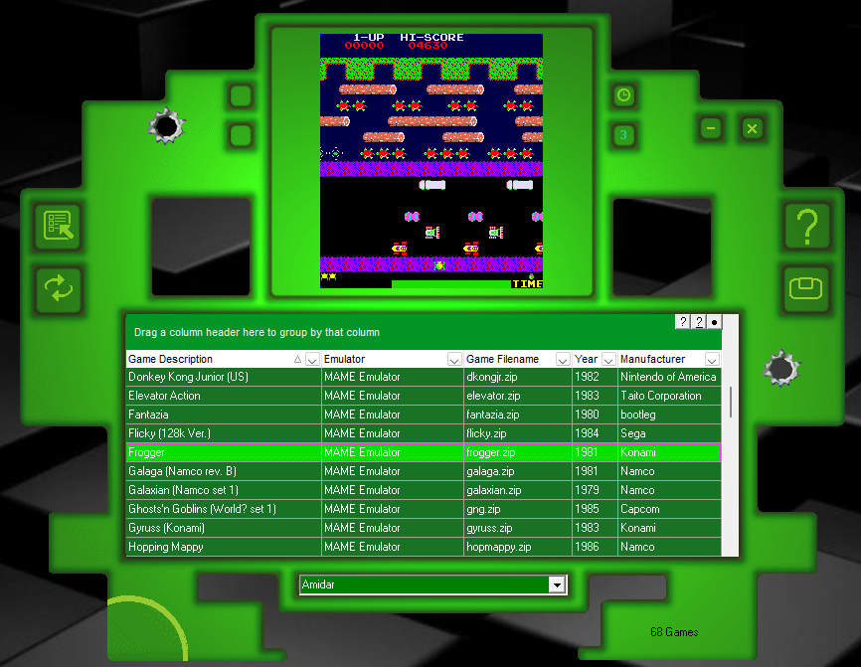
I have kept a copy of this on all of my various windows PCs and laptops over the years and can confirm that “Arcade.exe” works on all versions of windows from 95 to windows 11 (so that’s windows 98, windows millennium, windows 2000, windows XP, windows 7, windows 8, windows 10 and windows 11).

Sadly I lost the source code some time ago due to a hard drive failure but at least the .exe still exists so I decided to put it on Github to ensure its survival which is the best I can do but obviously it’s frozen in time.

It was coded in Delphi (2005/2007 version) and originally also had a “skin designer” app which people used to create alternative “skins” but that has sadly also been lost to time.

In its day it was quite popular and the now defunct website (http://www.barlicktaylorst.btinternet.co.uk/arcade1.htm) registered over 30,000 downloads. It was also made available on several emulation related websites and is still available from Zophar’s Domain (https://www.zophar.net/frontends/mame.html). So I suspect that the true number of downloads was probably much higher.

Fun story: Back in 2004, a friend came back from a local computer fair with a CD labelled as “Arcade Games” which he’d bought from a shady character for £5.00. He said it was “brilliant” and urged me to try it on my PC so against my better judgement I fired it up and was amazed to see it started up Arcade.exe!

Anyway, to “install” Arcade.exe, download the “arcade.zip” file. The zip file contains a folder “ARCCFG” and also “arcade079.exe” extract those to a suitable folder e.g. “Documents”.

You should then be able to run “arcade079.exe” and it should start up OK.

Obviously I haven’t included any game rom files to avoid any copyright issues so you will need to obtain the MAME game rom files yourself. I do not condone the illegal copying of games.

The version of the MAME emulator mame.exe in the "ARCCFG" folder is a custom build but is based on MAME v0.95 (May 4th 2005). So you will need MAME Roms dated from around 2005 and copy your .zip rom files into the ARCCFG\Games\roms folder. Arcade.exe should then auto detect those games when you re-start it and be able to run them.

For reference, these are the game rom files that were generally used so I'd suggest that you try and copy these specific .zip files into the ARCCFG\Games\roms folder:

amidar.zip
astdelux.zip
asteroid.zip
astrob.zip
bagman.zip
bombjack.zip
bublbobl.zip
bzone.zip
carnival.zip
ccastles.zip
centiped.zip
ckong.zip
commando.zip
congo.zip
crush.zip
cvs.zip
defender.zip
digdug.zip
dkong.zip
dkongjr.zip
docastle.zip
elevator.zip
esb.zip
fantazia.zip
flicky.zip
frogger.zip
galaga.zip
galaxian.zip
gng.zip
gyruss.zip
hopmappy.zip
hustler.zip
invaders.zip
joust.zip
junglek.zip
ladybug.zip
ldrun.zip
llander.zip
locomotn.zip
lrescue.zip
mappy.zip
marble.zip
metrocrs.zip
missile.zip
mooncrst.zip
mplanets.zip
mrdo.zip
mspacman.zip
pengo.zip
phoenix.zip
pleiads.zip
polepos.zip
pooyan.zip
puckman.zip
qbert.zip
qix.zip
robotron.zip
rocnrope.zip
scramble.zip
spacefb.zip
spyhunt.zip
starwars.zip
tapper.zip
tempest.zip
thepit.zip
timeplt.zip
trackfld.zip
xsleena.zip
zaxxon.zip

That’s about it. Have fun!

