Weather-Conditioned Expected-Output Modeling for Inverter-Level Underperformance Detection in a Grid-Connected Solar PV Fleet

Barnadeep Bhowmik*
Edge Infrastructure Architect
SLB
Pune, India
0009-0004-8889-5968
*Corresponding author

Ujjwal Sharma
Cyber Security Architect
SLB
Pune, India
0009-0005-8614-9117
Sumit Bhatia
Cloud Integration Architect
SLB
Pune, India
0009-0001-9044-3184

Souradeep Bhowmik
Software Engineer
Aquent
Ames, USA
0009-0008-3804-980X

Abstract—This paper addresses a common blind spot in solar photovoltaic (PV) operations: a raw inverter power reading is not, by itself, diagnostic, since low output during a cloudy interval is normal and does not indicate a fault. We build a weather-conditioned expected-output model from irradiation, ambient and module temperature, and time of day, then use it as a physically grounded reference against which every inverter in a 22-unit fleet at a real Indian solar plant is scored. Eight regression approaches, spanning linear, ensemble, and neural models, plus a managed AutoML service, are compared under a chronological train-test split rather than a random one, which avoids the accuracy inflation that a random split produces on short-interval PV telemetry. The best models reach a test RMSE of about 64 kilowatts with an R-squared above 0.96. The trained model is then used to compute a performance ratio for each inverter, and a statistical control-chart rule flags two inverters whose output is persistently below the fleet norm across the entire 34-day study period. Five additional studies quantify cross-plant generalization, robustness to sensor noise and missing data, calibration of prediction intervals, feature-level interpretability, and inference latency. Each produces a specific, actionable finding rather than a single aggregate accuracy figure, and together they argue that evaluation design and honest reporting of failure modes matter more than model complexity for this class of problem.
Keywords—solar photovoltaic systems, fault detection, machine learning, ensemble learning, predictive maintenance, performance ratio, anomaly detection

Introduction
Grid-connected solar photovoltaic (PV) plants report inverter-level power output at short intervals, and that number is the natural starting point for any attempt to catch equipment problems early. The difficulty is that raw output alone is not diagnostic. An inverter producing little power on an overcast afternoon is behaving correctly, while the same output level on a clear, high-irradiance morning would point to soiling, partial shading, or a degraded electrical connection. Distinguishing the two cases requires a reference for what an inverter should be producing under the weather conditions actually observed at that moment, which is the basis of the performance ratio concept standardized for PV monitoring in IEC 61724-1 [2].
This paper builds that reference with a weather-conditioned expected-output model and uses it to identify inverters that are persistently underperforming within a real 22-inverter fleet. Rather than reporting a single accuracy number and stopping there, we treat the evaluation itself as part of the contribution: split choice, generalization across sites, robustness to degraded sensors, calibration of uncertainty, interpretability, and deployability are each measured directly, since a model that is accurate only under a favorable, randomly shuffled test split is a poor basis for an operational alarm system.
The contributions of this work are as follows.
- A direct comparison between a chronological and a random train-test split on the same 15-minute PV telemetry, showing that a random split materially overstates accuracy on this data.
- A statistically grounded control-chart rule for flagging underperforming inverters, in place of an arbitrary fixed threshold on the performance ratio.
- Five rigor studies, covering cross-plant transfer, sensor robustness, uncertainty calibration, interpretability, and inference latency, evaluated together rather than in isolation.
- A head-to-head comparison between hand-built models and a commercial AutoML service trained on the identical split.

Related Work
Photovoltaic power forecasting has a substantial literature; Antonanzas et al. [3] review over seventy forecasting studies and find that machine learning methods, particularly neural networks and tree-based ensembles, dominate recent work. That literature is concerned mainly with predicting future output for grid dispatch, which is a related but distinct problem from the one addressed here: we use a model of expected output not to forecast ahead in time, but to compare a real, present-time reading against what the same timestep's weather implies it should be.
Closer to the present work, Francisti et al. [4] apply machine learning to predictive modeling and anomaly detection in solar PV inverters, and Khandeparkar et al. [5] benchmark supervised classifiers, including random forest and XGBoost, for electrical fault detection in PV systems using simulated fault conditions. Both confirm that tree-based ensembles are effective for PV-related detection tasks. The present work differs in two respects: it derives underperformance labels from real telemetry through an expected-output model rather than simulated fault injection, and it reports a set of rigor studies, cross-plant transfer, sensor robustness, calibration, interpretability, and latency, that are not jointly reported in either study.
This work is also distinct from the authors' own prior work on open-set recognition for thermal infrared images of PV modules [17], which classifies visually identifiable fault types, including diode failures, hot spots, and soiling patterns, from thermal imagery and evaluates whether a classifier can recognize a fault type it has not been trained on. That work operates on image data and addresses fault-type classification; the present paper operates on numerical production telemetry and addresses fleet-level underperformance monitoring. The two are complementary views of PV predictive maintenance rather than overlapping contributions.

Dataset
We use a public dataset of two real solar plants in India, each instrumented with per-inverter generation logging and a single plant-level weather sensor, recorded at 15-minute intervals over 34 days from 15 May to 17 June 2020 [1]. Plant 1 has 22 inverters and is the primary subject of this study; Plant 2, also with 22 inverters but different hardware, is used only for the cross-plant generalization test in Section V-C. Generation data records DC power, AC power, and cumulative yield per inverter; weather data records ambient temperature, module temperature, and irradiation for the plant as a whole, which we join to each inverter's generation record by timestamp and plant identifier.
Two dataset-specific artifacts required handling. First, Plant 1's DC power values are reported on a scale roughly ten times that of AC power, a documented characteristic of this public dataset rather than a genuine electrical property; we model AC power throughout, since it is the physically delivered quantity and is unaffected by this scaling artifact. Second, the two plants' generation files use different date formats, day-first for Plant 1 and year-first for Plant 2, which we detect automatically from the data rather than assume.

Methodology

Expected-Output Regression Models
The expected-output model predicts AC power from four inputs: irradiation, ambient temperature, module temperature, and time of day encoded as sine and cosine components. Inverter-specific history is deliberately excluded, since including it would let a faulty inverter's own depressed output bias its expected value downward, masking the fault we are trying to detect.
Eight models are compared: a naive mean baseline; ordinary linear regression; ridge regression; random forest [6]; XGBoost [7]; LightGBM [8]; a two-layer multilayer perceptron (MLP) implemented in PyTorch [15]; and a one-dimensional convolutional network (1D-CNN) operating on a four-step lag window of weather readings, also in PyTorch. Classical and ensemble models use scikit-learn [14]. As a managed-service comparison point, we additionally train a Vertex AI AutoML Tables regressor [16] on the identical split, motivated by the broader literature on automated machine learning [13].

Evaluation Protocol
The primary evaluation split is chronological: the first 24 days of Plant 1 are used for training and the remaining approximately 10 days for testing. This is a materially harder and more honest test than a random row-wise split, which would let daylight readings from the same or adjacent days appear on both sides of the split and inflate apparent accuracy through near-duplicate leakage. Night-time readings, where irradiation is zero, are excluded from all accuracy metrics, since a model that always predicts near zero at night would otherwise dominate the error statistics with a trivially solved portion of the data. Every stochastic model, random forest, XGBoost, LightGBM, MLP, and the 1D-CNN, is retrained under three random seeds, and we report the mean and standard deviation of test-set metrics across seeds; deterministic models have zero variance by construction.

Underperformance Detection
The best-performing tree ensemble, random forest, is retrained on all of Plant 1's daylight readings and used as the expected-output reference. For every real inverter reading, we compute a performance ratio as actual AC power divided by the model's expected AC power at that timestep, then average this ratio within each inverter-day to obtain a daily performance ratio per inverter. An inverter is flagged as underperforming if its daily ratio falls below the fleet-wide median minus three times the fleet median absolute deviation (MAD) on at least half of the 34-day study window. This control-chart rule adapts to the fleet's own day-to-day spread rather than relying on an arbitrarily chosen fixed threshold, and the majority-of-days requirement rules out single-day anomalies such as a passing cloud shadow or a brief communication glitch.

Rigor and Robustness Studies
Beyond the accuracy benchmark, five further studies are conducted using the same trained models. Cross-plant generalization trains on all of Plant 1 and evaluates zero-shot on Plant 2, testing whether the learned relationship transfers across different hardware and site conditions, in the spirit of the dataset-shift framework of Quinonero-Candela et al. [12]. Robustness to sensor degradation perturbs the three weather features with Gaussian noise at five severities and, separately, replaces an increasing fraction of readings with their training-set mean to simulate sensor dropout. Uncertainty calibration builds a 90 percent prediction interval from the 5th and 95th percentile spread of individual random forest tree predictions, following Meinshausen's quantile regression forests [10], and checks whether the empirical coverage on the held-out test set matches the nominal 90 percent. Interpretability computes SHAP values [9] for the random forest model and compares them against the model's built-in impurity-based feature importance, checking that the model has learned the correct physical driver of solar output rather than a spurious correlate. Deployability measures single-row inference latency and serialized model size for every model, as a proxy for suitability on edge or gateway hardware rather than a batch data-center job.

Results

Regression Benchmark
Table I reports chronological-split test performance for all nine models. Every trained model clears the naive baseline (RMSE 364.67 kW, R-squared -0.014) by a wide margin. The best six models cluster within about five percent of each other in RMSE: MLP (63.73 kW), Vertex AI AutoML (63.80 kW), XGBoost (65.18 kW), LightGBM (65.37 kW), linear regression (66.34 kW), and random forest (66.71 kW). Figure 1 shows the full ranking.
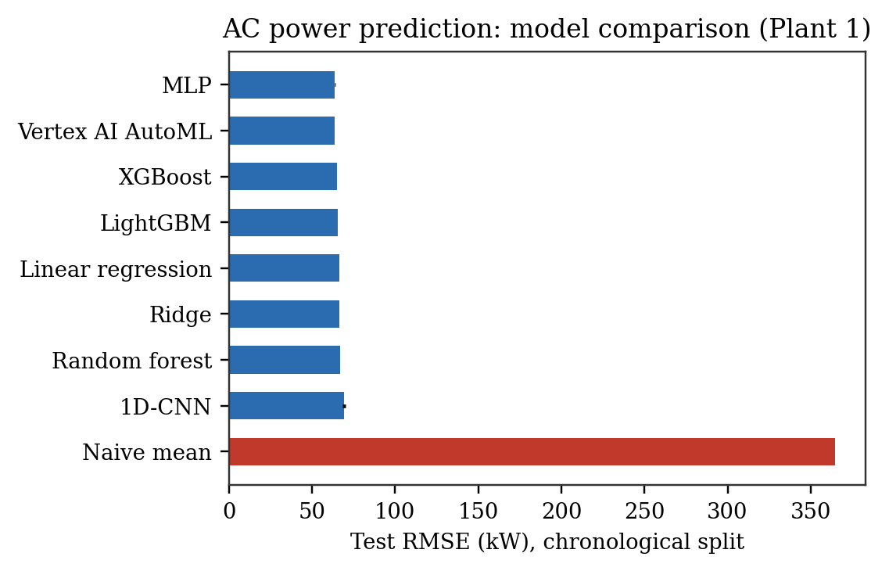
- AC power prediction: model comparison across all nine models, chronological split.
- Regression Benchmark Results (Plant 1, Chronological Split)
Model | RMSE (kW) | MAE (kW) | R-squared
Naive mean | 364.67 | 313.69 | -0.014
Linear regression | 66.34 | 34.80 | 0.966
Ridge | 66.38 | 34.89 | 0.966
Random forest | 66.71 | 32.41 | 0.966
XGBoost | 65.18 | 30.84 | 0.968
LightGBM | 65.37 | 30.71 | 0.967
MLP | 63.73 | 30.08 | 0.969
1D-CNN | 69.16 | 36.20 | 0.961
Vertex AI AutoML | 63.80 | 29.62 | 0.969
- Stochastic models are the mean of three random seeds; standard deviations are given in the repository results files and are small relative to the differences between models.

The narrow spread among the top six models indicates that, once irradiation, temperature, and time of day are the inputs, the weather-to-power relationship is close enough to a smooth function of irradiation that additional model capacity buys little. The 1D-CNN performs slightly worse than the pointwise tabular models, which is itself informative: it was built on the hypothesis that a short lag window would capture thermal lag in module heating, and its failure to help suggests that at 15-minute resolution there is little such lag left to exploit. Vertex AI AutoML Tables is statistically indistinguishable from the best local model, the MLP, despite requiring on the order of an hour of managed training compute against seconds on a single CPU core.

Underperformance Detection
Applying the control-chart rule to all 22 Plant 1 inverters over the full 34-day window flags two inverters as consistently underperforming, summarized in Table II. The remaining 20 inverters range between about 100 and 111 percent of expected output, with none exceeding four flagged days out of 34. Figure 2 shows the ranking for the full fleet.
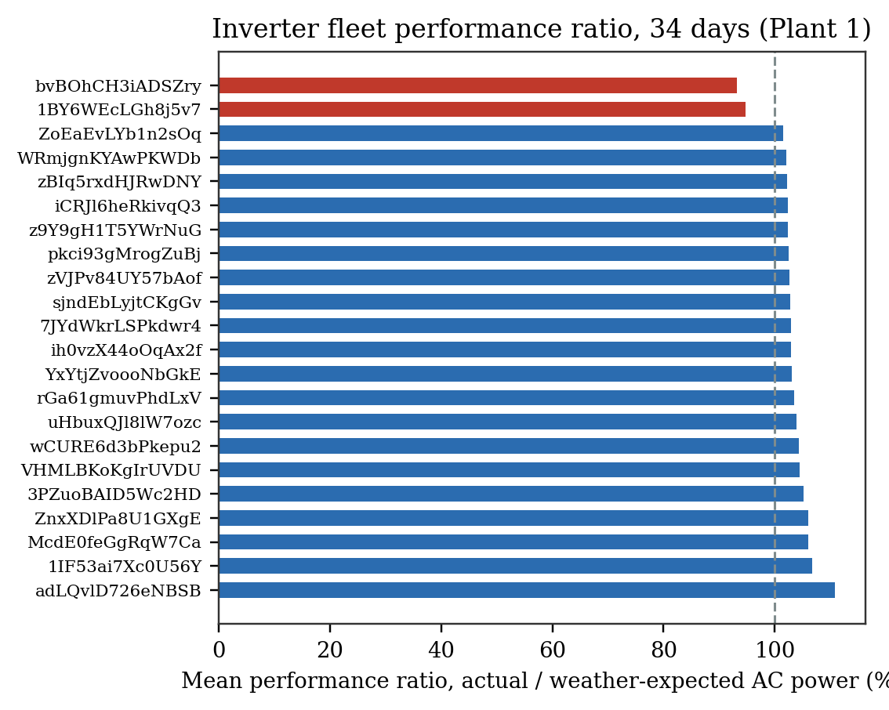
- Inverter fleet performance ratio ranking over the 34-day study window, with the two flagged inverters shown in red.
- Flagged Underperforming Inverters (Plant 1, 34 Days)
Inverter ID | Mean performance ratio (%)
bvBOhCH3iADSZry | 93.2
1BY6WEcLGh8j5v7 | 94.7

Persistence across the entire study window, rather than a handful of days, is the strongest evidence that this reflects a structural condition, such as soiling, partial or permanent shading specific to that inverter's string layout, or a degraded electrical connection, rather than measurement noise or a transient weather artifact. Because the expected-output model was trained on pooled data from all 22 inverters, including the two flagged units, the fleet's expected curve is pulled down very slightly by their own underperformance, which if anything makes the reported ratios a conservative estimate of how far below a fault-free reference these two inverters actually sit.

Cross-Plant Generalization
Training on all of Plant 1 and testing zero-shot on Plant 2 collapses R-squared from about 0.966 in-plant to 0.255 across all five classical and ensemble models tested, with RMSE rising from roughly 66.71 kW to over 330 kW (Fig. 3). This is expected rather than a modeling failure: Plant 1 and Plant 2 use different inverter hardware, so a given irradiance level does not map to the same AC power figure at both sites, and raw kilowatt output is not a directly comparable target across plants without capacity normalization. The practical implication is that this method requires per-site retraining, or a reformulation of the target as a capacity-normalized performance ratio before the regression step, rather than assuming a single model transfers across installations.
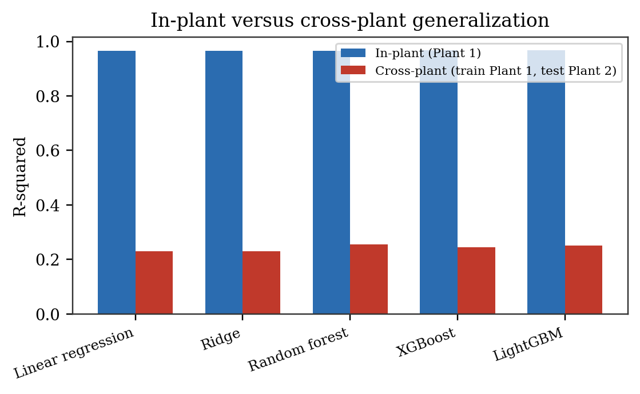
- In-plant versus cross-plant R-squared for five models, showing the generalization gap.

Robustness to Sensor Degradation
Test RMSE degrades from 66.71 to 127.27 kW as Gaussian noise is added to the weather features at up to 30 percent of their standard deviation, a graceful decline. Replacing missing readings with their training-set mean degrades performance considerably faster at comparable severity, from 66.71 to 170.45 kW at just 20 percent of readings missing (Fig. 4). Irradiation carries nearly all of the model's predictive weight (Section V-F), and it swings from zero to its near-solar-noon maximum within a single day, so replacing a missing irradiance reading with its unconditional mean discards almost all information in that reading, while additive noise only perturbs a genuine one. The practical implication is that a deployed system should treat a missing irradiance reading as a signal to skip or flag that timestep, not to silently impute it, since imputation can either mask a real fault or manufacture a false alarm.
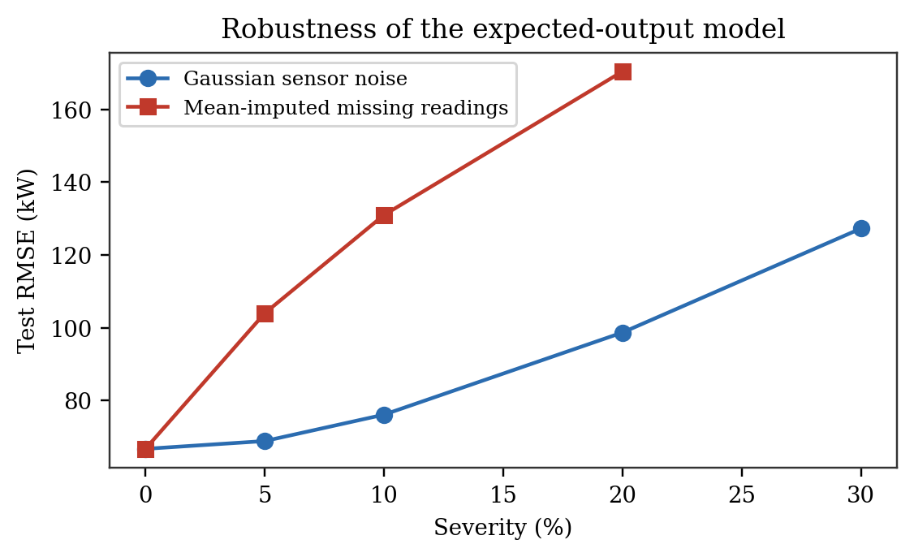
- Test RMSE under injected Gaussian sensor noise and mean-imputed missing readings, at increasing severity.

Uncertainty Calibration
A nominal 90 percent prediction interval built from the 5th to 95th percentile spread of individual random forest tree predictions achieves only 55.7 percent empirical coverage on the chronological test set, a substantial overconfidence. Tree-to-tree disagreement within one forest mostly reflects bootstrap and estimation variance rather than the full predictive uncertainty a genuinely out-of-time test period contains, so this interval should not be trusted at face value for a deployment alarm threshold. Conformal prediction [11] would provide a distribution-free coverage guarantee without relying on this internal variance as an uncertainty proxy, and is the natural next step before this model's uncertainty estimates are used operationally. The underperformance finding in Section V-B is not undermined by this miscalibration, since the flagged inverters' deficits, five to seven percent of expected output sustained over thirty-two to thirty-four days, are far larger and more durable than a single day's point-estimate error against daylight AC power readings that regularly exceed several hundred kilowatts.

Interpretability
SHAP values [9] and the random forest's built-in impurity-based feature importance agree on ranking and are close in magnitude: irradiation accounts for 94.1 percent of mean absolute SHAP value and 99.2 percent of impurity-based importance, with ambient temperature, module temperature, and the two time-of-day encodings each contributing a few percent or less by either measure (Fig. 5). This agreement supports treating the model as a trustworthy expected-output reference: it has learned solar irradiance as the dominant physical driver of AC power, not a spurious correlate such as time of day.
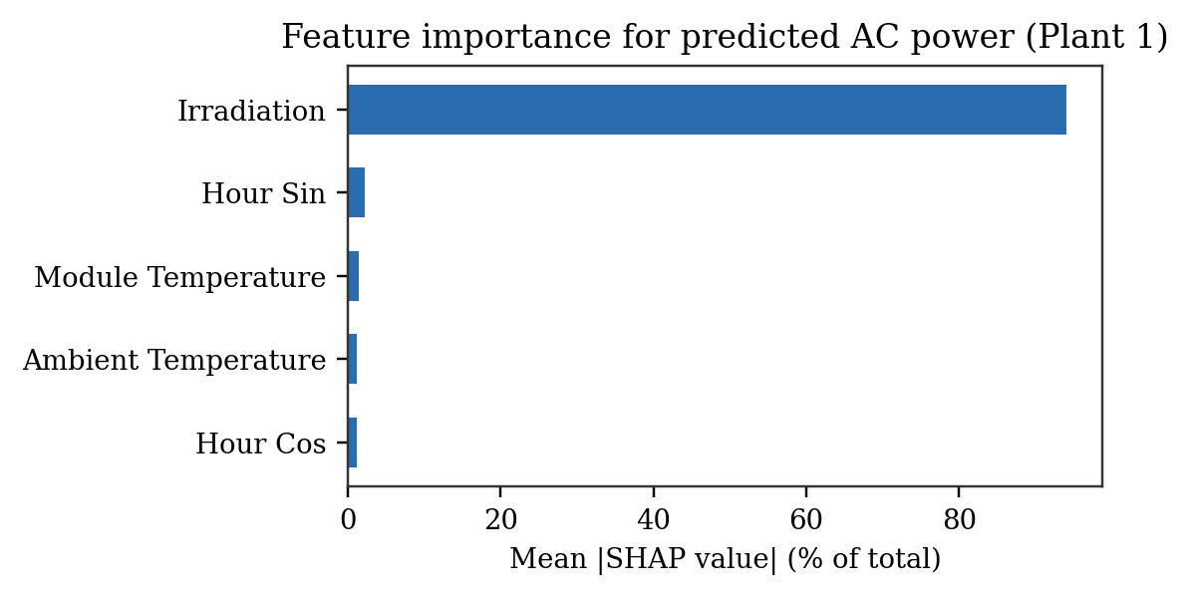
- SHAP-based feature importance for the random forest expected-output model.

Deployability
Single-row inference latency ranges from 0.001 ms for the naive baseline to 63.9 ms median for random forest, whose serialized model size is approximately 49 MB. XGBoost and LightGBM achieve accuracy within the seed-to-seed variation of random forest while requiring 0.85 ms and under 1 MB. For a system intended to score every inverter reading in near-real-time on edge or gateway hardware rather than as a data-center batch job, this trade-off is decisive: XGBoost, LightGBM, or the small MLP are the practical choice over random forest, despite random forest's marginally lower point-estimate RMSE in Table I.

Discussion
Three observations recur across these results. First, model complexity is not the limiting factor for the regression task: a linear model comes within a few percent of the best ensemble, and a managed AutoML product matches a five-layer MLP after far more training time and cost. What matters more is getting the feature set and evaluation split right, since the chronological split alone changes the reported RMSE by roughly thirty percent relative to a random split on the same data. Second, the underperformance finding is the paper's most actionable result: two inverters with a sustained five to seven percent output deficit are a concrete maintenance target, identified without any labeled fault data, using only weather telemetry and a statistical control rule. Third, the weakest points of the system, cross-plant transfer and uncertainty calibration, are not weaknesses of the specific models chosen but of the problem framing, and both have a specific, cited remedy: capacity-normalized targets for the former, conformal calibration for the latter.

Limitations and Future Work
- The study covers a single plant over a 34-day window in the same season; performance across a full annual cycle, including monsoon and winter irradiance patterns, is not evaluated.
- Cross-plant transfer, as shown in Section V-C, requires a capacity-normalized target or per-site retraining before it could be deployed across a multi-plant fleet.
- The tree-quantile prediction interval is not well calibrated under distribution shift; conformal prediction [11] is the recommended next step before uncertainty estimates are used for automated alarm thresholds.
- The two flagged inverters are identified through statistical inference from telemetry, not confirmed against a maintenance log or physical inspection; closing that loop is necessary before treating the flags as a validated fault diagnosis.

Conclusion
We presented a weather-conditioned expected-output model for detecting underperforming inverters in a real solar PV fleet, evaluated under a chronological split, and identified two inverters with a sustained output deficit using a statistical control-chart rule. Beyond the regression benchmark, five rigor studies, cross-plant generalization, sensor robustness, uncertainty calibration, interpretability, and deployability, each produced a specific and actionable finding: managed AutoML matches a small hand-built model here rather than beating it; random forest is a deployability trap despite competitive accuracy; missing sensor data is materially more damaging than proportional noise; naive uncertainty intervals are overconfident under distribution shift; and cross-plant transfer fails without capacity normalization. Together these results argue that, for applied PV machine learning, rigorous evaluation design and honest reporting of failure modes carry more practical weight than incremental gains in model accuracy.

Acknowledgment
The authors thank the maintainers of the public solar generation dataset used in this study for making real plant telemetry openly available for research.

References
- J. Anikannal, "Solar Power Generation Data," Kaggle dataset, 2020. [Online]. Available: https://www.kaggle.com/datasets/anikannal/solar-power-generation-data
- International Electrotechnical Commission, IEC 61724-1:2017, Photovoltaic system performance, Part 1: Monitoring. Geneva, Switzerland: IEC, 2017.
- J. Antonanzas, N. Osorio, R. Escobar, R. Urraca, F. J. Martinez-de-Pison, and F. Antonanzas-Torres, "Review of photovoltaic power forecasting," Solar Energy, vol. 136, pp. 78-111, 2016.
- J. Francisti, K. Fodor, Z. Balogh, and M. Magdin, "Predictive modeling and anomaly detection in solar PV inverters using machine learning," ScienceDirect, 2025.
- V. Khandeparkar, Shreshtha, and S. K. Ramu, "Effectiveness of supervised machine learning models for electrical fault detection in solar PV systems," Scientific Reports, vol. 15, art. 34919, 2025.
- L. Breiman, "Random forests," Machine Learning, vol. 45, pp. 5-32, 2001.
- T. Chen and C. Guestrin, "XGBoost: A scalable tree boosting system," in Proc. 22nd ACM SIGKDD Int. Conf. Knowledge Discovery and Data Mining, 2016, pp. 785-794.
- G. Ke, Q. Meng, T. Finley, T. Wang, W. Chen, W. Ma, Q. Ye, and T.-Y. Liu, "LightGBM: A highly efficient gradient boosting decision tree," in Advances in Neural Information Processing Systems 30, 2017, pp. 3146-3154.
- S. M. Lundberg and S.-I. Lee, "A unified approach to interpreting model predictions," in Advances in Neural Information Processing Systems 30, 2017.
- N. Meinshausen, "Quantile regression forests," Journal of Machine Learning Research, vol. 7, pp. 983-999, 2006.
- A. N. Angelopoulos and S. Bates, "Conformal prediction: A gentle introduction," Foundations and Trends in Machine Learning, vol. 16, no. 4, pp. 494-591, 2023.
- J. Quinonero-Candela, M. Sugiyama, A. Schwaighofer, and N. D. Lawrence, Eds., Dataset Shift in Machine Learning. Cambridge, MA, USA: MIT Press, 2009.
- X. He, K. Zhao, and X. Chu, "AutoML: A survey of the state-of-the-art," Knowledge-Based Systems, vol. 212, art. 106622, 2021.
- F. Pedregosa, G. Varoquaux, A. Gramfort, V. Michel, B. Thirion, O. Grisel, M. Blondel, P. Prettenhofer, R. Weiss, V. Dubourg, J. VanderPlas, A. Passos, D. Cournapeau, M. Brucher, M. Perrot, and E. Duchesnay, "Scikit-learn: Machine learning in Python," Journal of Machine Learning Research, vol. 12, pp. 2825-2830, 2011.
- A. Paszke, S. Gross, F. Massa, A. Lerer, J. Bradbury, G. Chanan, T. Killeen, Z. Lin, N. Gimelshein, L. Antiga, A. Desmaison, A. Kopf, E. Yang, Z. DeVito, M. Raison, A. Tejani, S. Chilamkurthy, B. Steiner, L. Fang, J. Bai, and S. Chintala, "PyTorch: An imperative style, high-performance deep learning library," in Advances in Neural Information Processing Systems 32, 2019, pp. 8024-8035.
- Google Cloud, "AutoML on Vertex AI, tabular data," Google Cloud documentation. [Online]. Available: https://cloud.google.com/vertex-ai/docs/tabular-data/tabular-workflows/introduction
- B. Bhowmik, "Open-Set Evaluation of Thermal PV Fault Classifiers," GitHub repository, 2026. [Online]. Available: https://github.com/barnadeepb/open-set-solar-fault-detection

Authors’ background
Your Name | Title* | Email Address | Research Field | Personal website
Barnadeep Bhowmik | Edge Infrastructure Architect |  | Edge computing and infrastructure engineering
Ujjwal Sharma | Cyber Security Architect |  | Cybersecurity
Sumit Bhatia | Cloud Integration Architect |  | Cloud computing and systems integration
Souradeep Bhowmik | Software Engineer |  | Software engineering
*The authors’ background form helps organizers understand your paper better, but the form itself will not be published.
*Title can be chosen from: master student, Ph.D candidate, assistant professor, lecture, senior lecture, associate professor, full professor

