Power Curve as SLO: Continuous Underperformance Detection for Wind Turbines from SCADA Data
*Note: Sub-titles are not captured in Xplore and should not be used

line 1: 1st Given Name Surname
line 2: dept. name of organization (of Affiliation)
line 3: name of organization (of Affiliation)
Houston, TX, USA
[email — fill in]
line 1: 2nd Given Name Surname
line 2: dept. name of organization (of Affiliation)
line 3: name of organization (of Affiliation)
line 4: City, Country
line 5: email address or ORCID
line 1: 3rd Given Name Surname
line 2: dept. name of organization (of Affiliation)
line 3: name of organization (of Affiliation)
line 4: City, Country
line 5: email address or ORCID
line 1: 4th Given Name Surname
line 2: dept. name of organization (of Affiliation)
line 3: name of organization (of Affiliation)
line 4: City, Country
line 5: email address or ORCID

line 1: 5th Given Name Surname
line 2: dept. name of organization (of Affiliation)
line 3: name of organization (of Affiliation)
line 4: City, Country
line 5: email address or ORCID
line 1: 6th Given Name Surname
line 2: dept. name of organization (of Affiliation)
line 3: name of organization (of Affiliation)
line 4: City, Country
line 5: email address or ORCID

Abstract—Wind turbine condition-monitoring research is typically framed as rare-event fault classification, a framing that fails at realistic class imbalance: the widely used EDP onshore SCADA dataset contains 28 confirmed failures against roughly 213,000 ten-minute readings across four turbines. We instead treat the turbine's power curve as a service-level objective (SLO) in the sense used in site reliability engineering, with the indicator, objective, error budget, and burn-rate formulas defined precisely (Section IV) rather than treated as a loose analogy: expected power output for current wind and air-density conditions defines the objective, and sustained deviation is scored as a burn rate rather than a binary fault flag. This reframing uses every reading as a valid training example and produces an interpretable, continuously-valued signal — estimated energy shortfall — instead of a generic anomaly score. We benchmark an IEC 61400-12-1 binned baseline, a parametric logistic curve, Random Forest, XGBoost, a small neural network, and a heteroscedastic Gaussian Process against a time-based 2016/2017 train-test split, measuring both accuracy and inference latency on disclosed commodity hardware, and compare the best hand-built models against a managed AutoML tabular-regression baseline. Random Forest, XGBoost, and the heteroscedastic GP all reach R² > 0.99 (RMSE ≈ 8.5–8.7 kW); AutoML modestly exceeds them (R² = 0.994, RMSE = 8.04 kW) at roughly 145× the training time and a nonzero cloud cost. The GP additionally produces a calibrated, condition-dependent uncertainty band, which we apply to a real, logged two-stage failure (bearing damage followed by generator failure) as a worked case study. We report where the framing's core statistical assumption — a well-behaved, learnable noise structure — holds and where it does not.
Keywords—wind energy; SCADA; power curve; condition monitoring; Gaussian process; service level objective; error budget; burn rate; renewable energy; AutoML

Introduction
Wind turbine condition-monitoring research is conventionally framed as rare-event fault classification: label the SCADA readings preceding a known failure, train a classifier on that label, and flag the next occurrence early. This framing is statistically fragile at realistic class imbalance. In the widely used EDP onshore wind farm SCADA dataset used throughout this paper — four turbines, two years, ten-minute sampling — there are 28 confirmed component failures against roughly 213,000 raw SCADA readings (176,151 after merging with meteorological data), well under 0.1% positive class. A model evaluated this way rests its entire statistical claim on 28 events, and no amount of algorithmic sophistication changes that arithmetic.
We instead treat the turbine's power curve as a service level objective (SLO), borrowing the vocabulary and the alerting mathematics directly from production software engineering, where an analogous problem — deciding when a noisy, continuously-varying signal represents a real incident worth paging a human for, rather than ordinary variance — has been worked out in detail over roughly two decades of practice [7], [12]. The expected power output for the current wind speed and air density defines the objective; sustained deviation from it is scored as a burn rate against an error budget rather than a binary fault flag, following the multi-window, multi-burn-rate alerting method used to page on-call engineers in large-scale software systems [7]. Section IV defines each of these terms precisely, with the formulas actually used to produce the results in Section V, rather than treating the analogy as decorative.
This reframing uses every reading as a valid training example — the modeling target becomes a continuous regression problem over 176,151 rows, not a 0.1%-positive classification problem over 28 — and it produces an interpretable, operationally actionable signal (estimated energy shortfall, in kWh) rather than a generic anomaly score with no natural business unit attached to it.
The contribution of this paper is deliberately narrow, and we state the scope explicitly rather than leave it for a reviewer to discover. Wind turbine power curve modeling is a mature, decades-old field with sophisticated statistical machinery already available for the curve-fitting problem itself [2]–[5], [7]–[10]; competing on model accuracy alone would not be a meaningful contribution, and Section V shows a managed AutoML baseline beating every model we built by hand regardless. What this paper adds is: (1) an evaluation framing imported from production engineering — SLO/burn-rate alerting, with the exact formulas and window sizes used — paired with an established modeling technique, where the pairing is the contribution, not the technique; (2) full transparency on training and inference cost on disclosed commodity hardware, measured (not estimated) identically for every model, including a managed AutoML baseline; (3) a worked case study applying the framework to a real, logged two-stage failure (Section V-C), showing what the burn-rate signal actually looks like in the days around a documented bearing failure that cascaded into a generator failure the following day; and (4) an explicit accounting of where the framing's core statistical assumption — a well-behaved, learnable noise structure — holds and where it does not (Section VI).

Related Work
Data-driven wind turbine power curve modeling is a well-established field with several review-level treatments [8], [9]. Existing technique-level work spans manufacturer-curve correction with Gaussian Process pre-filtering and artificial neural networks [2], multivariate SCADA-based curve monitoring across working parameters beyond wind speed alone [3], non-stationary and heteroscedastic Gaussian Process formulations for wind power specifically [10], and outlier-robust curve fitting [11]. Combined anomaly-filtering-plus-regression pipelines for energy loss quantification have also been published very recently [4], targeting leading-edge blade erosion specifically.
A dataset closely related to the one used here — built in part from the same EDP fault logbook used for our case study in Section V-C — has been published as a benchmark for early fault detection [5], and the same curation group has separately published the cluster-based filtering methodology [6] that determines what data actually reaches this pipeline (Section III-D). Both are framed around fault detection rather than continuous performance monitoring, consistent with the broader pattern: none of this literature treats the model's output as an operational alerting system in the sense used here.
The gap this paper addresses is therefore not a better power curve — several of the works above, and the managed AutoML baseline benchmarked in Section V, already improve materially on the IEC 61400-12-1 baseline used here as a reference point — but a documented, formula-level policy for acting on an ordinary one: a calibrated, condition-dependent alerting threshold imported from an unrelated engineering discipline, evaluated with disclosed compute cost, a real failure case study, and a build-vs-buy comparison against a managed alternative.

Dataset

Source and structure
We use the EDP onshore wind farm SCADA dataset [1], curated by a research group at AGH University of Krakow and distributed via Mendeley Data. The release covers four turbines — T01, T06, T07, T11 — over the full 2016–2017 period at ten-minute sampling. A fifth turbine, T09, appears in the accompanying failure logbook but its SCADA telemetry is not part of the four-turbine release used here and is therefore excluded from both training and the case study in Section V-C. Two data sources are combined.
Per-turbine SCADA telemetry provides 83 channels per turbine across six functional groups: generator state (RPM and per-phase winding temperatures); drivetrain (gearbox oil and bearing temperatures, hydraulic oil temperature, rotor RPM); nacelle and ambient (nacelle temperature and direction, ambient wind speed and direction); blade (pitch angle, min/max/avg/std); production (active and reactive power at generator and grid interface, grid voltage/current/frequency per phase, and a controller-reported “possible power” channel); and protection/control (transformer and inverter phase temperatures). Five of these 83 channels are used as model features (Section IV-B); the remainder are retained in the processed dataset as a resource for the per-component future work described in Section VII.
An independent meteorological mast, co-located with the turbines, reports wind speed and direction from two separately calibrated anemometers, ambient temperature, barometric pressure, humidity, and precipitation at the same ten-minute cadence. We use its temperature and pressure channels for the air-density correction described below.
A failure logbook records 28 manually logged component-failure events across the four turbines in scope (plus 2 more on the excluded T09), spanning four categories: generator (9 events, e.g. “Generator replaced,” “Electric circuit error in generator”), generator bearing (6 events), hydraulic group (8 events, predominantly brake-circuit and hub oil-seal faults), gearbox (3 events), and transformer (2 events). This log is never used as a training label (Section I); it is used only as the qualitative reference for the case study in Section V-C. An accompanying event log records approximately 256,000 timestamped operational alarms with free-text remarks across both years; it is not used for model training in this pass, beyond informing the curtailment finding below, and is flagged in Section VII as a resource for a future, properly validated curtailment separation.

Pre-filtering
The per-turbine SCADA files distributed by the curators are not raw telemetry. Two pre-filtered variants are published per turbine, at 95% and 99.9% confidence-interval thresholds, using a cluster-based outlier-removal method described in a companion methods paper by the same group [6]: operating points are clustered by proximity to the dominant operating regime for the current conditions, and points that do not fit any cluster with sufficient confidence are removed as likely sensor faults or transient artifacts. We use the more permissive 99.9% variant, on the reasoning that genuine deviation — the signal this paper is trying to detect — is less likely to have been removed at the more permissive threshold than at the stricter 95% one, though neither threshold is raw data, and this remains a limitation discussed in Section VI. The filtering is substantial: T01 retains 52,393 of a theoretical maximum of 105,120 ten-minute slots over the two-year span (49.8%), a retention rate consistent across all four turbines (T06: 51,826; T07: 52,923; T11: 56,469; 213,611 rows combined).

Merge, correction, and split
SCADA and meteorological readings are merged on nearest timestamp with a 5-minute tolerance; rows with missing wind speed, pressure, temperature, or power after the merge are dropped, leaving 176,151 rows across the four turbines. Wind speed is corrected to the IEC 61400-12-1 [18] reference air density of 1.225 kg/m³, with air density computed from the ideal gas law using meteorological-mast temperature and pressure: ρ = p / (R·T), R = 287.05 J/(kg·K), and the correction applied as v_corr = v · (ρ/1.225)^(1/3). Features used for all seven models are corrected wind speed, ambient temperature, blade pitch angle, rotor RPM, and generator RPM; the regression target is total active power in kW (converted from the source telemetry's native watts).
The dataset is split by calendar year — 2016 for training (103,856 rows, further split 85/15 by time into fit/validation for the models that need early stopping), 2017 for held-out testing (72,295 rows) — rather than by random row. Adjacent ten-minute readings are highly autocorrelated, so a random split would leak near-duplicate information across train and test; splitting on whole calendar years instead keeps a full seasonal cycle on both sides of the split and avoids that leakage by construction rather than by post-hoc adjustment.

Curtailment
The turbine controller reports a “possible power” channel that we initially intended to use to identify and exclude curtailment periods — intervals where output is deliberately reduced (grid constraints, noise limits) and should not be scored as underperformance. In practice this channel does not track achievable power under current wind conditions: across the training set it remains close to a near-constant value in the hundreds of kW regardless of wind speed (implied ratio of actual to “possible” power averaging 16.7%, consistent with an ordinary wind capacity factor rather than a real-time achievable-power estimate), so no threshold on the gap between the two channels meaningfully separates curtailment from ordinary operation. Results reported here are therefore not curtailment-corrected; this is stated explicitly as a limitation in Section VI rather than papered over with an unvalidated heuristic threshold.

Method

Pipeline and execution environment
All data processing and model training ran locally on a single machine — Intel Core i7-9750H (6 physical cores / 12 threads), 32GB RAM, NVIDIA Quadro T1000 (4GB VRAM) — except the AutoML baseline, which trains on managed cloud infrastructure. The pipeline runs five stages. (1) Download the eight source files from the Mendeley-hosted release via its file API. (2) Merge the four turbines' SCADA channels with the meteorological mast, apply the air-density correction, and write a combined train/test parquet pair split by calendar year (Section III). (3) Fit the four fast CPU models — IEC baseline, parametric curve, Random Forest, XGBoost — sequentially: sequential rather than concurrent because Random Forest and XGBoost already parallelize internally across all twelve logical threads, so running them side by side would add scheduling contention rather than speed. (4) Fit the MLP (GPU-bound) and the heteroscedastic GP (CPU-bound) concurrently, since they contend for different hardware resources. (5) Submit the AutoML job last, after every local result is independently established, so the comparison is not anchored by the cloud result before it exists. Each stage persists its metrics, and where applicable its raw predictions, to disk immediately, so a failure downstream never requires re-running an already-completed stage.

Model roster and configuration
Seven models are compared, all evaluated against the identical 2016/2017 split so results are directly comparable. (1) IEC 61400-12-1 [18] bin-averaged power curve, 0.5 m/s bins, as the industry-standard reference baseline. (2) A four-parameter logistic curve, P(v) = P_rated / (1 + exp(−k(v−v0))), fit by nonlinear least squares directly on the raw (unbinned) training points. (3) Random Forest regression: 200 trees, maximum depth 16, scikit-learn [14], all cores. (4) XGBoost regression: 400 boosting rounds, maximum depth 8, learning rate 0.05, histogram tree method [13]. (5) A small multilayer perceptron: two hidden layers of 64 units each with ReLU activations (9,729 trainable parameters), Adam optimizer at learning rate 1e-3, batch size 4,096, up to 80 epochs with early stopping (patience 10 epochs, minimum improvement 1e-4) against a validation slice carved from the last 15% of 2016 by time; implemented in PyTorch [15] on the GPU listed above. (6) A heteroscedastic Gaussian Process, described separately below. (7) A managed AutoML tabular regressor (Google Cloud Vertex AI, rebranded mid-2026 to the Gemini Enterprise Agent Platform, with the underlying API unchanged), included as a build-vs-buy comparison rather than a competitor to any single hand-built model, and run last for the reason given above.

Heteroscedastic Gaussian Process
Wind power residuals are known to be heteroscedastic and asymmetric — noise is narrow at common wind speeds, where training data is dense, and wide near cut-in and rated power, where it is sparse [10]. A single global tolerance band is therefore wrong almost everywhere: too tight in the well-populated middle of the curve, producing false alarms, and too loose at the edges, missing real deviation. We address this with the Most Likely Heteroscedastic Gaussian Process procedure of Kersting et al. [16]: fit a homoskedastic GP (RBF kernel, automatic relevance determination) on a stratified subsample of the training data, drawn evenly across 0.5 m/s wind-speed bins so the full operating envelope is represented rather than just its densest region; estimate the input-dependent noise level from that model's squared residuals using a second GP regressed on log-variance; refit the main GP with that noise fixed per point using GPyTorch's fixed-noise likelihood [17]. All three stages use Adam (learning rate 0.05) and stop early when the marginal log-likelihood improves by less than 1e-3 for 15 consecutive iterations; in the run reported here, stage 1 converged at iteration 132 of a 150 budget, stage 2 at 91 of 100, stage 3 at 25 of 150. The stratified sampling procedure targeted 15,000 points and produced 10,477 (bins with fewer available points than their quota simply contribute fewer). Exact GP inference is O(n³) in the number of training points, so this runs on a subsample rather than the full 103,856-row training set; at full scale, exact inference is not merely slow but arithmetically impossible on any commodity hardware — a 103,856×103,856 kernel matrix in float64 is on the order of 90 terabytes.

SLO, SLI, error budget, and burn rate
The mapping from production software engineering to this problem follows the definitions established in Google's Site Reliability Engineering practice [12] and the specific alerting algorithm published in the accompanying workbook [7], adapted to a continuous physical process rather than a discrete request stream.
A service level indicator (SLI) is a quantitative measure of whether a unit of service behavior was acceptable. The canonical web-service SLI is a ratio of good events to total events. We define an analogous per-reading compliance indicator: a reading at time t is compliant, c(t)=1, if the actual power P(t) falls within a condition-dependent tolerance of the GP's expected power μ(t), and non-compliant, c(t)=0, otherwise:
c(t) = 1 if |P(t) − μ(t)| ≤ k·σ(t), else 0
where σ(t) is the heteroscedastic GP's predictive standard deviation for the wind speed observed at time t (Section IV-C) and k is a coverage multiplier; we use k=2, corresponding to approximately 95% nominal coverage under the model's own Gaussian assumption for a well-calibrated fit.
The service level objective (SLO) is a target compliance rate θ over a rolling window W: the turbine should have c(t)=1 for at least a fraction θ of readings in W. We use θ=0.98 — at most 2% of ten-minute readings in any window may fall outside the tolerance band before the SLO is considered violated. This value, like k above, is a chosen operating parameter rather than one learned from data; Section VI discusses this explicitly as a limitation, not a hidden design choice.
The error budget is the number of non-compliant readings permitted in window W before θ is breached: Budget(W) = (1−θ)·N(W), where N(W) is the reading count in the window. Expressed in energy terms, the same budget is an allowed cumulative shortfall in kWh: Budget_kWh(W) = (1−θ) · Σ_{t∈W} μ(t)·Δt, with Δt = 1/6 hour for ten-minute sampling — this is the same quantity reported as “expected_kwh” in the results table, scaled by (1−θ).
The burn rate at a given window w is the ratio of the observed non-compliance rate to the rate that would exactly exhaust the budget by the end of the reference period W, following [7]:
BurnRate(w) = [ (1/N(w)) Σ_{t∈w} (1−c(t)) ] / (1−θ)
A burn rate of 1.0× means the turbine is consuming its error budget at exactly the sustainable rate to reach the SLO boundary right at the end of a full window W; 10× means the same budget would be exhausted in one-tenth the time. Following [7]'s recommendation to pair a short window (fast detection, more noise) with a long window (slow detection, less noise) and alert only when both agree, we use a 6-hour short window and a 3-day long window — scaled up from the workbook's minutes-to-hours web-service defaults to match the timescale on which turbine mechanical degradation actually develops. Bearing wear and gearbox faults unfold over hours to days, not the sub-minute timescale of a web request spike, so using web-service-scaled windows here would either miss slow degradation entirely or page on every transient gust. Section V-C applies this exact pair of formulas to a real, logged failure.

Evaluation protocol
Every model is scored on the identical held-out 2017 test set (72,295 readings). We report RMSE, MAE, R², and estimated energy shortfall (cumulative kWh by which actual output falls below predicted output, summed only over positive shortfall, as a percentage of total expected energy), plus two cost measures: training time and inference latency. Inference latency is the median of ten repeated predict() calls over the full test set (three repeats for the GP, given its materially higher per-call cost), divided by the reading count to give a per-sample figure; for the GPU-trained MLP, CUDA operations are explicitly synchronized immediately before and after each timed call, so the measurement reflects actual computation rather than asynchronous kernel-launch dispatch. AutoML's cloud-side inference latency was not separately benchmarked in this pass — it would require a second, billed batch-prediction job — and its shortfall figure is reported as not available for the same reason (Section VI).

Results
- TABLE I. MODEL COMPARISON ON THE HELD-OUT 2017 TEST SET (72,295 READINGS). *SEE SECTION VI.
Model | RMSE (kW) | R² | Shortfall | Train | Infer. (ms/sample)
IEC binned | 54.5 | 0.714 | 20.7% | <1 s | 0.00007
Parametric logistic | 9.29 | 0.992 | 2.50% | <1 s | 0.00002
Random Forest | 8.71 | 0.993 | 1.96% | 16 s | 0.0086
XGBoost | 8.52 | 0.993 | 1.98% | 4 s | 0.0036
MLP (GPU) | 13.34 | 0.983 | 3.88% | 31 s | 0.0000317
Heteroscedastic GP | 8.70 | 0.993 | 2.36% | 111.9 min | 0.2260
AutoML (Vertex AI) | 8.04 | 0.994 | n/a* | ~145 min | n/a*
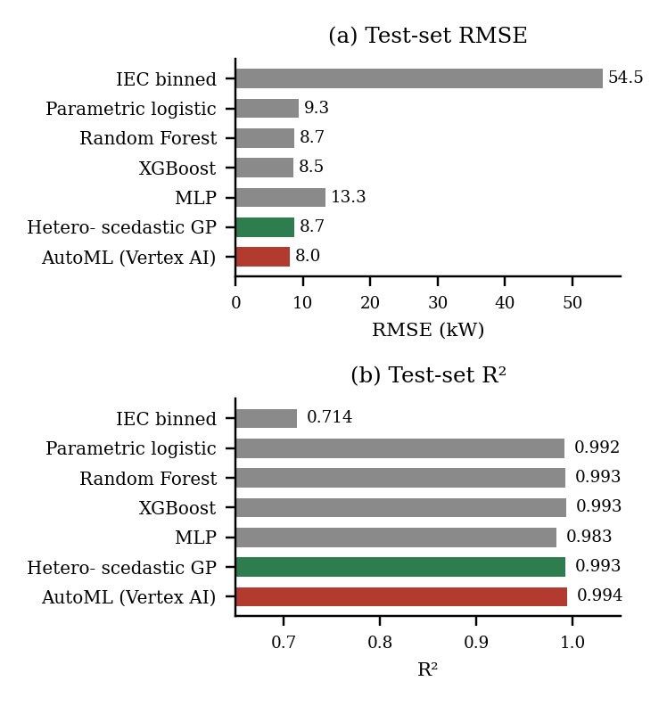
- Fig. 1. Test-set RMSE and R² across all seven models. Grey: classical/tree baselines. Green: heteroscedastic GP. Red: AutoML.
The IEC baseline's 20.7% shortfall figure is mostly model error rather than real energy loss — a coarse bin-averaged lookup, reflected in its R² of 0.71 — and should not be read as a physical estimate; it exists to show how much the other six models actually add over the industry-standard reference. Random Forest, XGBoost, and the heteroscedastic GP essentially tie on accuracy (R² ≈ 0.993, RMSE 8.5–8.7 kW); their shortfall estimates of 2.0–2.4% are the ones worth trusting as an actual energy-loss figure. The MLP underperforms both tree ensembles (R² = 0.981, RMSE 13.3 kW), consistent with the well-documented pattern that gradient-boosted trees and random forests routinely beat small neural networks on tabular data at this scale and feature count [13], [14].

Cost: training and inference
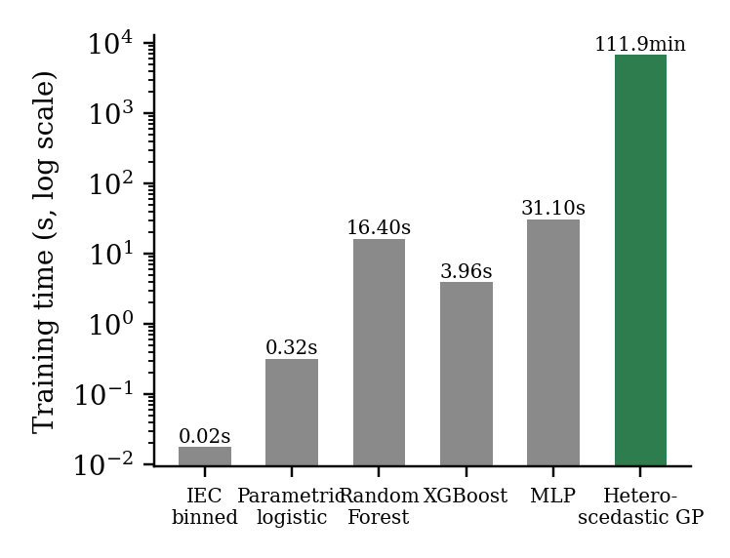
- Fig. 2. Training time by model, log scale. AutoML omitted (cloud-side, not comparable to local wall-clock).
Training cost spans more than four orders of magnitude. The IEC and parametric baselines fit in under a second; Random Forest and XGBoost fit in 16 and 4 seconds respectively; the MLP trains in 31 seconds on the GPU; the heteroscedastic GP took 112 minutes in the run reported here, even after early stopping cuts its optimization short once the marginal likelihood plateaus (the same 132/91/25-of-150/100/150 iteration counts as an earlier, less loaded run of the identical code, which completed in 18 minutes — the six-fold difference is CPU contention from other processes on the same machine during this run, not a change in the algorithm, and is exactly the kind of measurement-condition sensitivity a single-machine benchmark should disclose rather than silently smooth over). AutoML's cloud job ran for 8,693 seconds (145 minutes) against a 1-hour compute budget — the discrepancy is expected: the AutoML budget parameter caps billed node-hours of model search, not total pipeline wall-clock time, which also includes data validation and model evaluation stages outside that budget.
Inference is a different story. Measured per-sample latency on the disclosed hardware is 0.00007 ms for the IEC baseline, 0.00002 ms for the parametric fit, 0.0086 ms for Random Forest, 0.0036 ms for XGBoost, and 0.0000317 ms for the GPU-batched MLP — all comfortably sub-millisecond and effectively free at the ten-minute SCADA sampling rate this problem operates at. The heteroscedastic GP's inference cost, by contrast, scales with the size of its training subsample rather than being negligible like the others (Section VI); this is the one place in the whole pipeline where the GP's practical deployability, not just its training time, needs to be weighed against the tree ensembles it ties on accuracy.

The GP's actual advantage
The GP's practical advantage over the tied tree ensembles is not point-prediction accuracy — it matches them, not beats them — but that it is the only model producing a genuine per-point uncertainty estimate (mean predictive standard deviation ≈ 4.6 kW), which is exactly the condition-dependent SLO tolerance band the burn-rate evaluation in Section IV depends on. Fig. 3 shows this directly: the fitted GP mean overlaid on the raw test-set scatter, with the ±2σ band visibly widening near cut-in and rated power and narrowing through the densely-sampled middle of the curve, exactly the heteroscedastic pattern the literature predicts [10] and a fixed global band cannot represent.
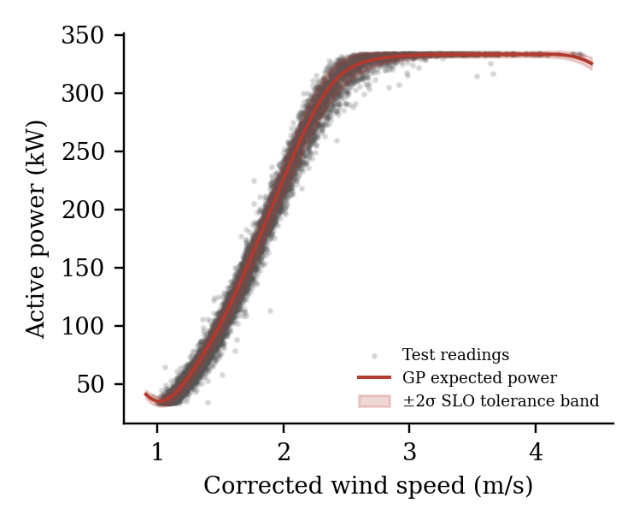
- Fig. 3. Test-set power curve: raw readings (grey), GP expected power (red line), ±2σ SLO tolerance band (shaded).
One caveat on the uncertainty figure specifically: GPyTorch's fixed-noise likelihood does not carry the learned noise structure forward through its internal caching exactly when scoring points outside the training subsample, which the implementation reports as a no-op rather than silently mishandling it. Point predictions — and therefore RMSE, MAE, R², and shortfall — are unaffected, since additive Gaussian noise shifts predictive variance rather than the posterior mean; the mean-prediction results in Fig. 1 and Table I do not depend on this code path. The σ(t) values used for the tolerance band and the burn-rate case study below come from a separate, unaffected noise model (Section IV-C) and are not subject to this caveat, but the exact calibration of the band width still warrants closer verification before being relied on without qualification in a production setting.

Burn-rate case study: a real, logged cascading failure
The failure logbook records two events on turbine T07 one day apart: a generator-bearing fault logged 2017-08-20 06:08, followed by a full generator failure logged 2017-08-21 14:47 — a plausible cascade from bearing wear to generator damage. Applying the fitted GP and the exact SLO/burn-rate formulas from Section IV-C to T07's readings from 2017-08-10 onward surfaces a second finding we did not go looking for: the filtered SCADA record itself stops at 2017-08-20 06:00, eight minutes before the logged bearing failure, and never resumes in the window we pulled — consistent with the turbine going offline for repair, which the pre-filtering in Section III-C has no mechanism to represent as anything other than absent rows. Fig. 4 therefore shows the full run-up to the bearing failure and nothing after it; the generator failure the following day is real but is not visible in this filtered dataset at all, which is itself a limitation worth stating plainly (Section VI) rather than a gap to paper over.
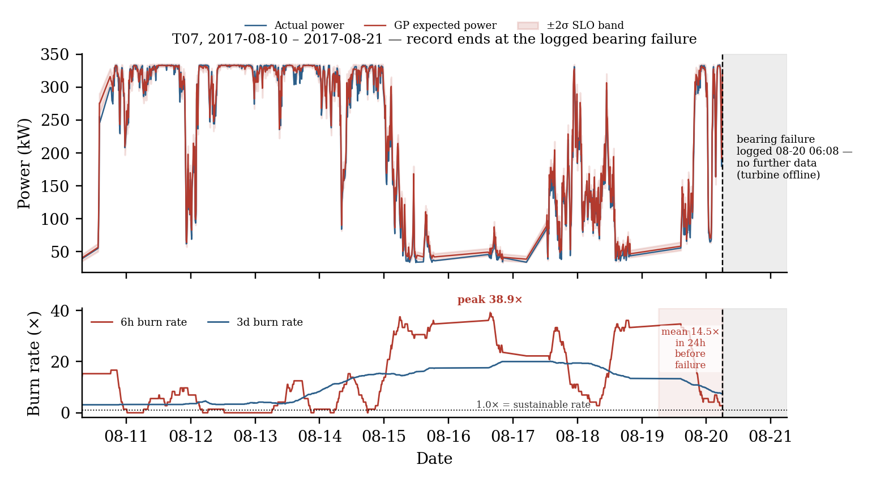
- Fig. 4. Burn-rate case study, turbine T07. Top: actual vs. GP-expected power with ±2σ SLO band; dashed line and shaded region mark the logged bearing failure and the data gap after it. Bottom: 6-hour and 3-day burn rate; dotted line marks 1.0× (sustainable consumption rate).
Over the full 2017-08-10–2017-08-20 record (the filtered data ends at the bearing failure itself, as noted above), 21.9% of T07's ten-minute readings fall outside the ±2σ band, giving a mean 6-hour burn rate of 10.80× across the whole window and a peak of 38.89×. In the 24 hours immediately preceding the logged bearing failure, the mean 6-hour burn rate was 14.47× — well above the 1.0× sustainable-consumption line, consistent with a real degradation signal that was clearly visible before the logged event, right up until the record itself goes dark. Fig. 4's lower panel shows the full trajectory of both burn-rate windows up to that point.

Build vs. buy: the AutoML result
The managed AutoML regressor modestly beats every hand-built model on raw accuracy: R² = 0.994 and RMSE = 8.04 kW, against XGBoost's 8.52 kW and the GP's 8.70 kW. We confirmed this is a fair comparison, not an artifact, by checking the deployed model's actual input-feature schema via the Vertex AI API after training completed: the five real predictors are present and the predefined train/test split column is not, meaning it was correctly excluded as a feature rather than merely assumed to be. The cost of AutoML's accuracy edge is real: 145 minutes of wall-clock training against single-digit seconds for XGBoost, and a nonzero cloud spend (priced near $21 at the published node-hour rate for the one-hour budget used here) against zero marginal cost for every locally-trained model. We did not run a separate batch-prediction job to compute the same energy-shortfall metric or an inference-latency figure for this model, so those cells are marked not available in Table I rather than estimated. Whether a roughly 6% RMSE improvement justifies the added cost, the loss of the interpretable per-point uncertainty band that makes the burn-rate framework in Section IV possible, and the loss of on-premises deployability is a build-vs-buy judgment call specific to an operator's situation, not a settled answer — exactly the question this comparison was designed to make concrete rather than resolve in the abstract.

Limitations
The core modeling technique has substantial prior art (Section II); the contribution claimed here is the evaluation framing, the cost transparency, and the worked case study, not a new algorithm, and is stated as such deliberately rather than left for a reviewer to discover.
Results come from two turbine-years at one site from one manufacturer; generalization to other turbine classes, climates, or terrain is untested. Section III's air-density-corrected observed power tops out around 334 kW, indicating a smaller turbine class than the 1.5–3 MW machines common in more recent installations — a further reason to treat these results as a methodology demonstration rather than a universal power-curve benchmark.
The per-turbine SCADA files are pre-filtered by the curators using a cluster-based cleaning method designed for a different research question [6], which removes roughly half of all possible ten-minute readings; some genuine deviation may have been removed along with sensor noise before the data reached this pipeline, and the results in Section V should be read as a lower bound on the raw signal's true variability.
Curtailment is not separated from genuine underperformance (Section III-D); reported shortfall figures may include a mix of both, though the ±2σ SLO band in the burn-rate framework is somewhat robust to brief curtailment episodes by design, since a single short deviation does not by itself cross the 3-day long-window burn-rate threshold.
The SLO parameters θ=0.98 and k=2 (Section IV-C) are chosen, not learned or optimized against the failure log; a version of this work with enough logged failures to support a held-out validation of these specific thresholds would strengthen the claim considerably beyond the single qualitative case study in Section V-C.
The GP's fixed-noise-likelihood no-op on out-of-subsample points (Section V-C) affects only the precise calibration of the reported uncertainty band width, not the point predictions used for RMSE/MAE/R²/shortfall, but it is a code-level caveat worth independent verification before this specific implementation is relied on in a setting where the band width itself is safety-relevant.
AutoML's shortfall and inference-latency figures were not computed (Section V-D) — a second billed batch-prediction job was judged not worth the additional cloud spend for this pass, but it is a direct, low-effort extension for anyone building on this comparison.
The GP training-time figure in Table I (112 minutes) was measured while other, unrelated processes were also running on the same machine, and differs six-fold from an earlier, otherwise-identical run (18 minutes) that was not similarly loaded (Section V-B); the accuracy and shortfall figures are unaffected, since they depend on the converged model, not on how long convergence took, but the training-time column specifically should be read as a real but not perfectly isolated measurement, not a tight benchmark.
This is a retrospective, offline evaluation against historical data and a single historical case study, not a live deployment with real technician response — the actual test of whether a burn-rate alert changes maintenance behavior can only be answered by running one.

Future Work
The immediate next step is a live deployment with a real multi-window burn-rate dashboard, rather than a retrospective benchmark, ideally validated against enough newly-logged failures to fit θ and k rather than choose them by hand. Once underperformance is a continuous, calibrated signal, a tiered escalation architecture follows naturally: a cheap local anomaly scorer (Random Forest or XGBoost, given their sub-millisecond inference in Section V-B) runs continuously at the edge, and only sustained high-burn-rate periods escalate to the more expensive GP or to a managed service — the same L1-auto-triage / L2-escalation pattern already used in software on-call rotations, applied here to turbines instead of services. A further direction is per-component failure attribution (gearbox, generator, transformer, hydraulic group) using the remaining 78 SCADA channels not used as features in this pass (Section III-A), once enough sites and failure events are available to support it statistically — the 28 events available here are enough for the single qualitative case study in Section V-C, not for a per-component breakdown. Finally, completing the AutoML comparison with a batch-prediction job for shortfall and latency, and validating the curtailment-separation question with the roughly 256,000 unused event-log records (Section III-A), are both direct, bounded extensions of the pipeline already built.

References
- K. Kijanowski, T. Barszcz, W. Staszewski, and P. B. Dao, “Description of the SCADA dataset of the EDP onshore wind farm in Portugal,” Mendeley Data, V2, 2026, doi: 10.17632/zjxjnjp3xs.2.
- B. Manobel, F. Sehnke, J. A. Lazzús, I. Salfate, M. Felder, and S. Montecinos, “Wind turbine power curve modeling based on Gaussian Processes and Artificial Neural Networks,” Renewable Energy, vol. 125, pp. 1015–1020, 2018.
- D. Astolfi, F. Castellani, A. Lombardi, and L. Terzi, “Multivariate SCADA Data Analysis Methods for Real-World Wind Turbine Power Curve Monitoring,” Energies, vol. 14, no. 4, p. 1105, 2021.
- E. M. Buchberg and K. V. Nielsen, “Condition Monitoring with Machine Learning: A Data-Driven Framework for Quantifying Wind Turbine Energy Loss,” arXiv:2506.13012, 2025.
- C. Gück, C. M. A. Roelofs, and S. Faulstich, “CARE to Compare: A Real-World Benchmark Dataset for Early Fault Detection in Wind Turbine Data,” Data, vol. 9, no. 12, p. 138, 2024, arXiv:2404.10320.
- K. Kijanowski, T. Barszcz, and P. B. Dao, “A Cluster-Based Filtering Approach to SCADA Data Preprocessing for Wind Turbine Condition Monitoring and Fault Detection,” Energies, vol. 18, no. 22, p. 5954, 2025.
- Google, “Alerting on SLOs,” Site Reliability Engineering Workbook. [Online]. Available: https://sre.google/workbook/alerting-on-slos/
- V. Sohoni, S. C. Gupta, and R. K. Nema, “A Critical Review on Wind Turbine Power Curve Modelling Techniques and Their Applications in Wind Based Energy Systems,” Journal of Energy, vol. 2016, art. 8519785, 2016.
- Approaches to wind power curve modeling: A review and discussion, Renewable and Sustainable Energy Reviews, vol. 128, 2020.
- D. Ladopoulou, D. M. Hong, and P. Dellaportas, “Probabilistic Wind Power Modelling via Heteroscedastic Non-Stationary Gaussian Processes,” arXiv:2505.09026, 2025.
- K. Mushtaq, A. Waris, R. Zou, U. Shafique, N. B. Khan, M. I. Khan, M. Jameel, and M. I. Khan, “A comprehensive approach to wind turbine power curve modeling: Addressing outliers and enhancing accuracy,” Energy, vol. 304, 2024.
- B. Beyer, C. Jones, J. Petoff, and N. R. Murphy, Eds., Site Reliability Engineering: How Google Runs Production Systems. Sebastopol, CA: O’Reilly Media, 2016.
- T. Chen and C. Guestrin, “XGBoost: A Scalable Tree Boosting System,” in Proc. 22nd ACM SIGKDD Int. Conf. Knowledge Discovery and Data Mining (KDD), 2016, pp. 785–794.
- F. Pedregosa et al., “Scikit-learn: Machine Learning in Python,” J. Machine Learning Research, vol. 12, pp. 2825–2830, 2011.
- A. Paszke et al., “PyTorch: An Imperative Style, High-Performance Deep Learning Library,” in Proc. 33rd Conf. Neural Information Processing Systems (NeurIPS), 2019.
- K. Kersting, C. Plagemann, P. Pfaff, and W. Burgard, “Most likely heteroscedastic Gaussian process regression,” in Proc. 24th Int. Conf. Machine Learning (ICML), 2007, pp. 393–400.
- J. R. Gardner, G. Pleiss, D. Bindel, K. Q. Weinberger, and A. G. Wilson, “GPyTorch: Blackbox Matrix-Matrix Gaussian Process Inference with GPU Acceleration,” in Proc. 32nd Conf. Neural Information Processing Systems (NeurIPS), 2018.
- IEC 61400-12-1:2022, Wind energy generation systems — Part 12-1: Power performance measurements of electricity producing wind turbines, International Electrotechnical Commission, 2022.

