Lay Odds Equalizer Betting Calculator Software

My bet calculator program, Lay Odds Equalizer, is now released to the public domain license on Microsoft GitHub. I would like to upload the setup program and example usage document to the files section of the PM facebook group for use my fellow PMers. Although written for windows it runs under Wine for linux or apple equivalent. You may need VB6 runtime if not on windows. It calculates normal bets, free bets, underlays and overlays, as well as multi-leg dutching.
Download the zip file, extract, then run the Setup.exe.

Pictures replace a thousand words so here are pictorial examples of using the software

Default screen
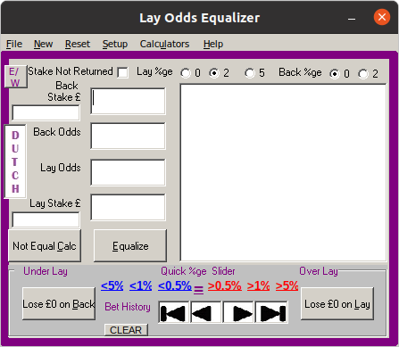

Corporate colours
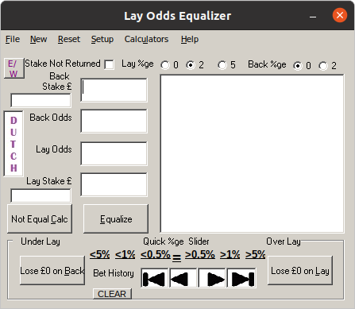

Right click to change a custom lay %ge
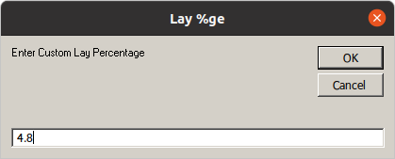

Liverpool draw example then click Equalize
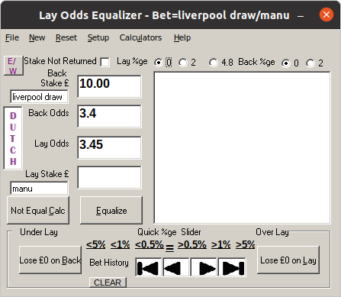

Profit/Losses are then shown
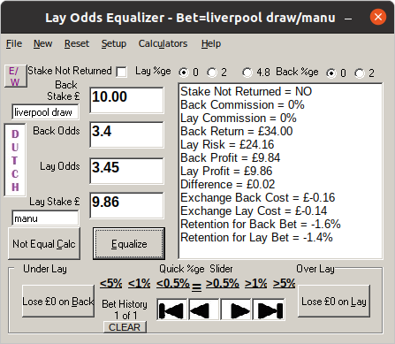

Example not equal calculation for ‘what if bets’ eg what if I layed £10.50
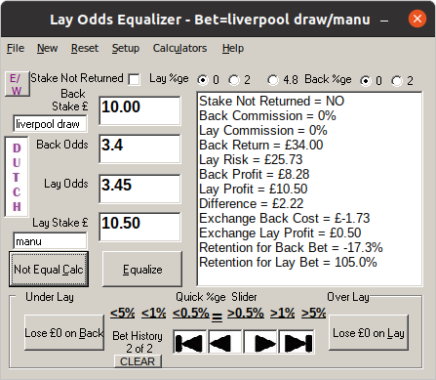

Lose nothing on the lay, 2% commission
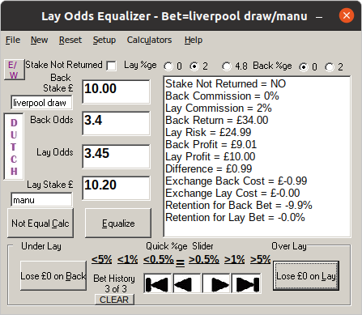

Lose nothing on the back
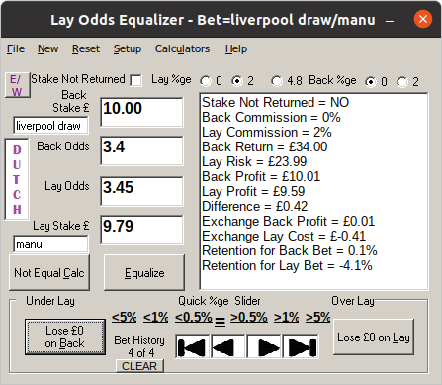

Use arrow keys to move between bet history items this session eg 3 of 4
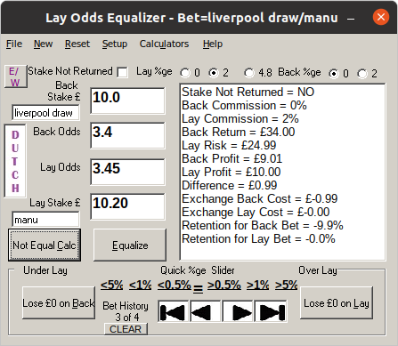

Use 0.5%, 1% and 5% links to under/overlay in small steps
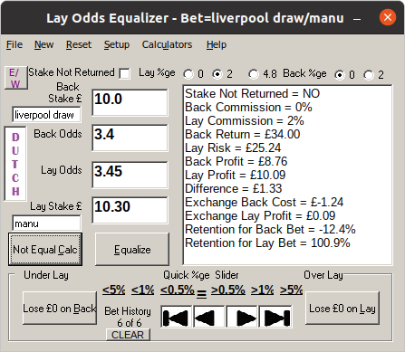

Fractional Odds are automatically changed to Decimal when to move out of field
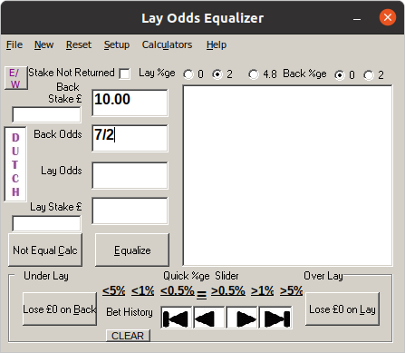

Use stake not returned for free bets and look at profit figures
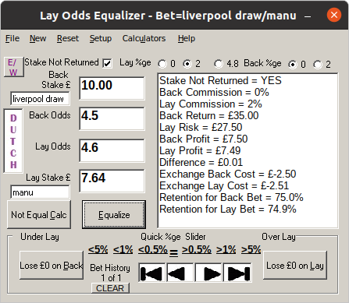

Click Dutch button
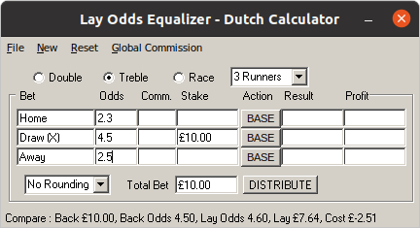

This is dutch result entering £10 and clicking Base next to it
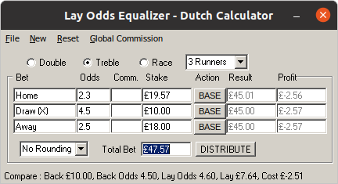

Distribute £50 between the odds like this
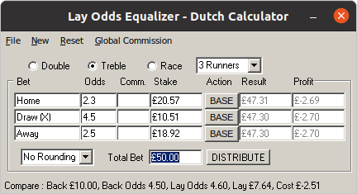

Rounding drop down is a useful option for Dutching.

New Edition E/W betting!

New for this version is the ability to calculate Each Way horse racing bets. The idea behind this stems from using the Each Way Sniper automated bot where you lay the bets off some time after the bookie bets have been taken as usually the odds would have moved lower on the exchange. I have three buttons if you want to predict a win, predict a place or predict a losing horse. It also works out the extra place value.

Click E/W button. Equalize both win and place bets
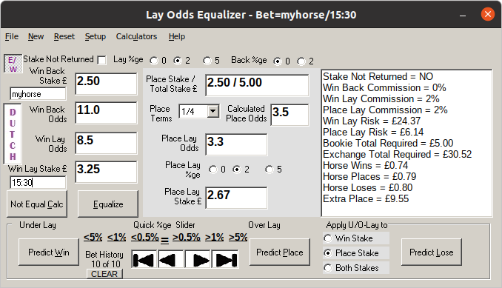

If you want to see results when laying win market only, put zero in the play lay stake and click Not Equal Calc
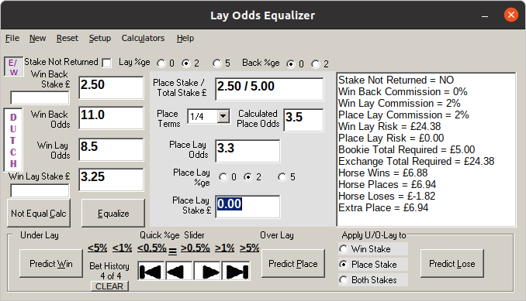

Try the Predict Win option!
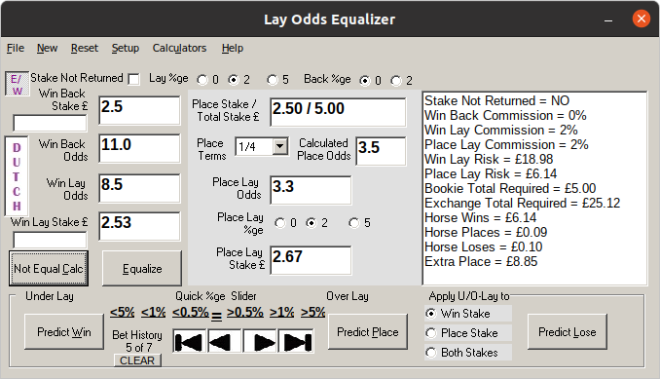

Try the Predict Place option!
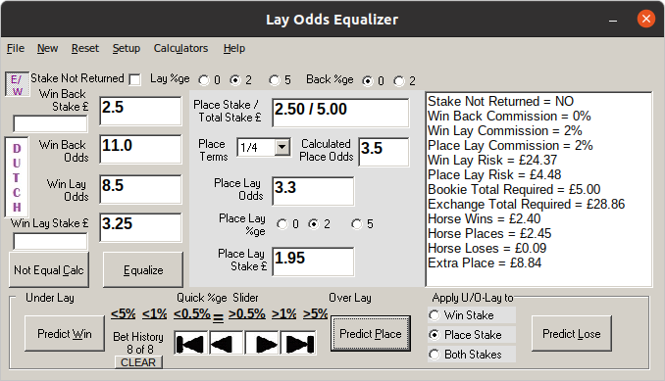

Try the Predict Lose option!
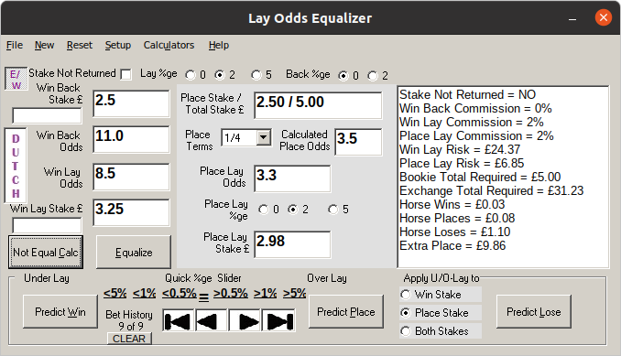

That’s it!

regards
David J. Barnes

