Stat 511 HW 1

Max Barnes

9/3/2020

I’m still working on figuring out some of the intricacies of R, so please bear with me while I perfect my formatting skills using R Markdown.

## 1-2

It is difficult to prove sex discrimination mainly due to the difficulty associated with gaining a truly random sample of the population. There are so many factors that effect how people are hired, that even if discrimination does occur, it would be hard to determin so.

## 1-6

1. No, a genuine causal relationship cannot be established from from this study. This is because causal relationships can only be established for randomized relationships, of which this study is not.
2. This study is observational in nature, and could be generalized toward the population of 14-16 year olds, however the inferences made are purely observational.
3. Potential confounding factors about this study are that the Marijuana gropu was not randomly taken from a random population. The group was drawn from a group of people already enrolled in a drug abuse program (not random by any means). Due to the observational nature of the study, any findings are purely speculative and have little to no statistical significance. This study really only applies to the participants in the study.

## 1-11

It can be said that the difference in treatments likely had an impact on the differences in cold rates, however, the study should be carried out again with a tasteless Vitamin C. The participants who correctly guessed that they were not taking the placebo could have used this knowledge to behave differently than they would have if they hadn’t known which of the two pills they were taking.

## 1-12

This study is important given the lack of random selection for the same reasons that the study involving males with Chinese and European heritage was still important. For males with highblood pressure, it appears that fish oil dramatically reduces diastolic pressure levels, just like for men who were studied to understand the effects of a blood pressure reducing drug. The study provides important information to doctors who have patients with highblood pressure.

## 1-16

1. 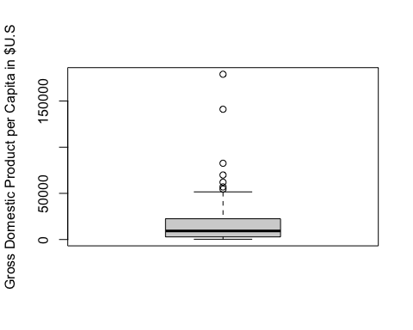
2. My display generates and empty box plot for “Rank” and “Country” unless I tell it not to, while Display 1.11 in the book does not. Otherwise, they look fairly similar otherwise.
3. The bin width is 20,000. 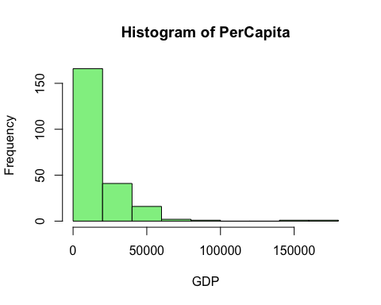
4. 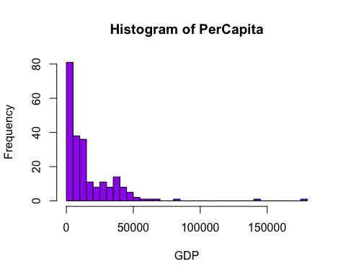

## 1-18

set.seed(47)  
case <-(case0101)  
number <-rnorm(47)  
df <-data.frame(number)  
data <- cbind(df, case)  
data1 <- data[with(data, order(number)),]  
data1

## number Score Treatment  
## 28 -2.3223722950 16.6 Intrinsic  
## 29 -1.9672191815 17.2 Intrinsic  
## 14 -1.8282291682 17.5 Extrinsic  
## 27 -1.6081599298 13.6 Intrinsic  
## 21 -1.5661620762 21.2 Extrinsic  
## 10 -1.4657503001 16.8 Extrinsic  
## 33 -1.2004406274 19.3 Intrinsic  
## 6 -1.0857374702 12.0 Extrinsic  
## 7 -0.9854821582 12.3 Extrinsic  
## 11 -0.9224562385 17.2 Extrinsic  
## 46 -0.9202418805 26.7 Intrinsic  
## 26 -0.8902940235 12.9 Intrinsic  
## 19 -0.7033881930 19.5 Extrinsic  
## 37 -0.6932373819 20.6 Intrinsic  
## 45 -0.4876963974 24.3 Intrinsic  
## 23 -0.3404159885 24.0 Extrinsic  
## 25 -0.3264667881 12.0 Intrinsic  
## 4 -0.2817650147 10.9 Extrinsic  
## 9 -0.2520458977 15.0 Extrinsic  
## 43 -0.1546952364 23.1 Intrinsic  
## 42 -0.1085646171 22.6 Intrinsic  
## 17 -0.0810780515 18.7 Extrinsic  
## 20 -0.0405781737 20.7 Extrinsic  
## 36 0.0006863592 20.5 Intrinsic  
## 8 0.0151308601 14.8 Extrinsic  
## 30 0.0275268104 17.5 Intrinsic  
## 12 0.0396024331 17.2 Extrinsic  
## 41 0.0611627527 22.2 Intrinsic  
## 15 0.0914729119 18.5 Extrinsic  
## 5 0.1087755466 11.8 Extrinsic  
## 32 0.1443376363 19.1 Intrinsic  
## 3 0.1854052843 6.1 Extrinsic  
## 22 0.2491481681 22.1 Extrinsic  
## 38 0.2608364805 21.3 Intrinsic  
## 24 0.4171908387 12.0 Intrinsic  
## 31 0.4836041107 18.2 Intrinsic  
## 13 0.4938201830 17.4 Extrinsic  
## 39 0.5066869590 21.6 Intrinsic  
## 40 0.5643018376 22.1 Intrinsic  
## 16 0.6707792190 18.7 Extrinsic  
## 2 0.7111425051 5.4 Extrinsic  
## 34 0.8852306473 19.8 Intrinsic  
## 35 0.8869350447 20.3 Intrinsic  
## 47 0.8979752611 29.7 Intrinsic  
## 44 0.9504841749 24.0 Intrinsic  
## 18 1.2642410898 19.2 Extrinsic  
## 1 1.9946963377 5.0 Extrinsic

first <- data1[1:24, 2:2]  
second <- data1[25:47, 2:2]  
meanfirst <- mean(first)  
meansecond <- mean(second)  
meandifference <- meanfirst-meansecond

The average of the first 24 scores is **18.1333333**, while the average of the second group of 23 scores is **17.5652174**. The difference between the two averages is **0.5681159**.

## 1-26

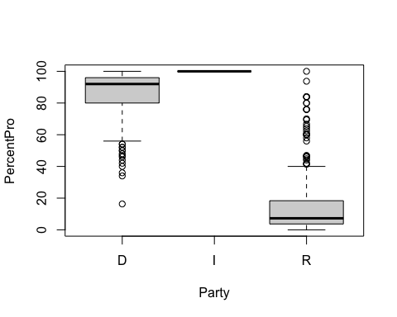

## D I R   
## 85.89794 100.00000 16.17260

From the boxplot and mean data above, it is relatively easy to see where the median lies for each party. For the Democratic party, the the median lies at about 90%, while the median lies at less than 20% for Republicans. The mean for the Republican party is 16.17%, while the mean for the Democratic party is approximately 85.89%. Democrats more often vote positively for environmental policies than Republicans do. Interestingly, the single Independent voter (Bernie Sanders) always voted positively for environmental policies.

## 1-27

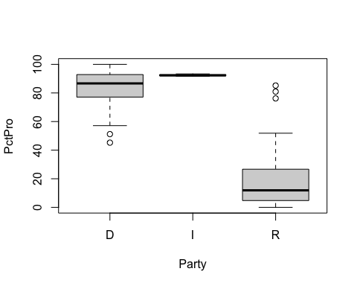

## D I R   
## 83.64135 92.43667 18.54579

From the boxplot and mean data shown above, it is relatively easy to see where the mean median lie for each party in the Senate. For the Republican party, the median lies below 20% again, while the mean is approximately 18.54% as well, while for the Democrat Party, the median lies at around 90% pro votes on environmental votes, and the mean is 83.64%.